Rezolvare ex JS
<script>
document.write("<table border=1>");
for (var i = 1; i <= 20; i++) {
document.write("<tr>");
for (var j = 1; j <= 20; j++) {
document.write("<td>" + i * j + " <\/td>");
}
document.write("<\/tr>");
}
document.write("<\/table>");
</script>

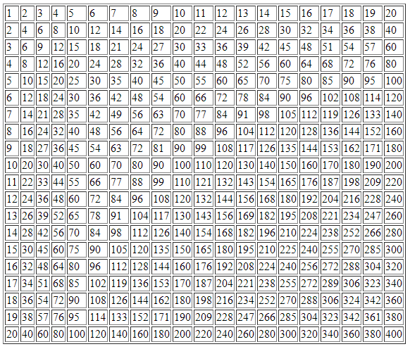

Rezolvari jquery
Rezolvare ex 1
<form>
<input type="button" value="Butonas" onclick="var divul = document.getElementById('textu');
divul.innerHTML == 'S-a apasat butonul.' ?
divul.innerHTML = 'Apasati butonul'
: divul.innerHTML = 'S-a apasat butonul.';">
</form>

Rezolvare ex 2.1
var textSize = 10;
function functieCrestere() {
$("#divcutext").css("font-size", textSize++);
}
$("#btnschimbator2").click(functieCrestere);

Ex 2.2
function hoverIn() {
$("#btnschimbator").css("background-color", "green");
}
function hoverOut() {
$("#btnschimbator").css("background-color", "#D3D3D3");
}
$("#btnschimbator").hover(hoverIn, hoverOut);

Ex 6.1 -> la eliminarea comentariului se misca acea casuta
6.2
$(document).ready(function () {
$("#btnschimbator2").click(function () {
$("#divcutext").animate({ left: "0px" });
});
});

<input type="button" id="btnschimbator2" value="Reset" />

6.3
function hoverIn() {
$("#btnschimbator2").css("font-size", 10);
$("#btnschimbator2").css("height", "12em");
$("#btnschimbator2").css("width", "12em");
}
function hoverOut() {
$("#btnschimbator2").css("font-size", 9);
$("#btnschimbator2").css("height", "10em");
$("#btnschimbator2").css("width", "10em");
}
$(document).ready(function () {
$("#btnschimbator2").hover(hoverIn, hoverOut);
});

Ex 8.1/8.2
<script>
$(function () {
// varianta scurtă; s-a schimbat doar acest rând (în loc de "$(document).ready(function() {", avem "$(function(){").
var clicknumber = 0;
$("#Products").click(function () {
console.log($("#submenu1").css("display"));
if ($("#submenu1").css("display") == "none") {
console.log("ascuns");
$("#submenu1").slideDown("slow");
} else {
$("#submenu1").hide();
}
});
$("#Contacts").click(function () {
console.log($("#submenu2").css("display"));
if ($("#submenu2").css("display") == "none") {
console.log("ascuns");
$("#submenu2").slideDown("slow");
} else {
$("#submenu2").hide();
}
});
});
</script>
<div id="wrapper">
<ul id="menu">
<li id="Home">Home</li>
<li id="Products">Products</li>
<ul id="submenu1" style="display: none;">
<li id="mobiles">mobiles</li>
<li id="smartTVs">smartTvs</li>
<li id="laptops">laptops</li>
</ul>

<li id="Contacts">Contact</li>
<ul id="submenu2" style="display: none;">
<li id="mobiles">trimite-ne un mesaj</li>
<li id="smartTVs">localizare pe harta</li>
</ul>
</ul>
</div>

