CS585: Cryptography
Student: Ovidiu Mura
Email: mura@pdx.edu
Due: March 11, 2020

Elliptic Curve Cryptography (ECC)
- term paper -

Elliptic curve cryptography is used in public-key cryptography. In this paper, I will present the algebraic structure of elliptic curves over finite fields and how they are used in cryptography. The elliptic-curve cryptography (ECC) is an approach to public-key cryptography based on the algebraic structure of elliptic curves over finite fields.

Finite Fields

A finite field has a finite set of objects called field elements and the description of two operations, addition and multiplication. The operations can be performed on pairs of field elements and the operations must have some specific properties. Finite fieldcontaining q field elements exist if and only if q is a power of a prime number and for each q there is one finite field. There are two types of finite fields: first, prime finite fieldswith q = p an odd prime and second, characteristic 2 finite fields finite fieldswith for some m >= 1.

Prime finite field.is the prime finite field containing p elements. The elements ofare represented by a set of integers such as {0,1,..p-1} and there is only onefor each odd prime p. Operations which can be performed on:
- Addition: if a,b in , then a+b = r in , where r in {0,..p-1} is the remainder when the integer a+b is divided by p; a+b congruent to r (mod p).
- Multiplication: if a,b in , then a*b = s in , where s in [0,..p-1] is the remainder when the integer a*b is divided by p; a*b congruent to s (mod p).
- Additive inverse: if a inthe the additive inverse (-a) of a inis the unique solution to the equation a + x congruent to 0 (mod p).
- Multiplicative inverse: if a in,, then the multiplicative inverse ofof a inis the unique solution to the equation a*x congruent to 1 (mod p).

Characteristic 2 finite field.containselements and there is only onefor each power of 2 withelements should be represented by the set of binary polynomials of degree m-1 or less, {∈ {0, 1}}.

Operations which can be performed on
- Addition: if∈ , then a + b = r in, where
- Multiplication: if a = a_(m−1)*x^(m−1) + · · · + a_0, b = b_(m−1)*x^(m−1) + · · · + b_0 ∈ , then a*b = s in, whereis the remainder when the polynomial ab is divided by f(x) with all coefficient arithmetic performed modulo 2.
- Additive inverse: if a ∈, then the additive inverse (−a) of a inis the unique solution to the equation a + x = 0 in. Note that −a = a for all a ∈
- Multiplicative inverse: If a ∈ then the multiplicative inverseof a inis the unique solution to the equation ax = 1 in

For m ∈ {163, 233, 239, 283, 409, 571}, we get the representation of The rule used to pick acceptable reduction polynomials was that if a degree m binary irreducible trinomial exist, k as small as possible, otherwise we use the degree m binary irreducible pentanomial, withas small as possible,as small as possible givenandas small as possible givenand k

Field | Reduction Polynomial(s)
 | F(x) =
 | F(x) =
 | F(x) =
 | F(x) =
 | F(x) =
 | F(x) =

Elliptic curve over: Letbe a prime finite field so that p is an odd prime number, and let a, b ∈satisfy Then an elliptic curveoverdefined by the parameters a, b ∈consists of the set of solutions or points P = (x, y) for x, y ∈to the equation:together with an extra point O called the point at infinity. For is the number of points on, the Hasse Theorem states that for a given elliptic curve module p, the number of points are bonded by. The number of points is close to the prime p.

Define addition rule to add points on E:

- Add the point at infinity to itself: O + O = O.
- Add the point at infinity to any other point: (x, y) + O = O + (x, y) = (x, y) for all (x, y) ∈
- Add two points with the same x-coordinates when the points are either distinct or have y-coordinate 0: (x, y) + (x, −y) = O for all (x, y) ∈the negative of the point (x, y) is −(x, y) = (x, −y)

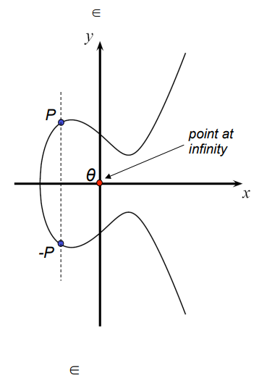
- Add two points with different x-coordinates: Let∈ and∈ be two points such thatThenwhere:

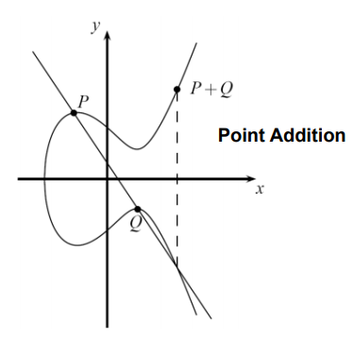

- Add a point to itself (double a point): Let∈be a point withThen where:

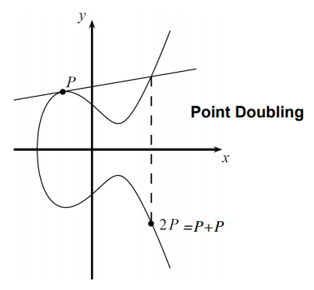

The set of points onforms an abelian group under the addition rule, meaning that P1 + P2 = P2 + P1 for all points P1, P2 ∈Given an integer k and a point P inscalar multiplication is the process of adding P to itself k times, denoted kP. The scalar multiplication of elliptic-curve points can be computed efficiently using the addition rule together with the double-and-add algorithm, which I will present later in this paper.
Doubling a point, P = (5,1), on a curve over the small field given the elliptic-curve E:

2P = (5,1) + (5,1) = (6,3)

To verify that (6,3) is a point on the curve, I insert the coordinates in the curve equation:

Discrete Logarithm Problem with Elliptic Curves

The discrete logarithm problem for elliptic curve (ECDLP) is defined as following: Let E be an elliptic curve over a finite filed, where q = and p is prime. Given the points P and Q ∈find an integer k, if it exists, such that Q = kP = P + P + .. + P , k times, where 1<= k <= #E.
This problem is the fundamental building block for elliptic curve cryptography. The discrete logarithm problem is defined over the class group of prime numbers. Another class of groups important for cryptography is given by groups consisting of points on elliptic curves. The groups of points on elliptic curves are very interesting for cryptography because there are not known sub-exponential time algorithms for solving the discrete-logarithm problem in elliptic-curve groups when is chosen appropriately. For example, the key length that elliptic-curve groups can be used to realize any given level of security with smaller parameters than for RSA or subgroups of multiplicative group of finite field, . Cryptography systems are based on the idea that k is large and kept secret and attackers cannot compute it easily.
An efficient algorithm for counting the number of points on an elliptic-curve is square-and-multiply algorithm, which is modified by replacing the square operation with doubling (add a point to itself) and multiplication with addition.

Double-and-Add Algorithm for point multiplication: The algorithm scans the bit representation of the scalar k from left to right and perform a doubling in every iteration, and only if the current bit has the value 1, it perform an addition of P.
Input: E – elliptic-curve, P – elliptic-curve point, k – a scalarwith ∈ 0,1 and , p – modulo of elliptic-curve
Output: Q = kP

- Initialize Q = P
- FOR i = t-1 DOWNTO 0
  - Q = Q + Q mod p
  - IF
    - Q = Q + P mod p
- RETURN(Q)

The geometric interpretation of the elliptic curve discrete logarithm is that for a given starting point P on an elliptic-curve, we compute 2P, 3P, 4P, …, kP = Q, moving back and forth on the elliptic-curve. The starting point P is published and the final point Q is the public-key. The cryptographic system can be broken by an attacker finding how many times we moved on the elliptic-curve. The number of hops on the elliptic-curve is the secret k, the private key.
There are some classes of curves considered cryptographically weak and should be avoided such as elliptic-curve groups over with order equal to p, anomalous curves, or with order equal to p+1, supersingular curves, or with order divides for some small scalar k. The curves which should be used are the standardized curves recommended by NIST.

Elliptic Curve Cryptographic Schemes

Elliptic curves can be applied to key agreements, digital signatures, pseudo-random generators, integer factorization algorithms and they can be combining the key agreement with a symmetric encryption scheme to form an hybrid encryption scheme. Several discrete logarithm based protocols have been adapted to elliptic curves replacing the groupwith an elliptic curve such as the Elliptic Curve Diffie-Hellman (ECDH) key agreement scheme, the Elliptic Curve Integrated Encryption Scheme (ECIES), the Elliptic Curve Digital Signature Algorithm (ECDSA), the Edwards-curve Digital Signature Algorithm (EdDSA), the ECMQV key agreement scheme, and The ECQV implicit certificate scheme. Next, I will present the Elliptic Curve Diffie-Hellman Key Exchange.
The Elliptic Curve Diffie-Hellman Key Exchange is an anonymous key agreement scheme, which allows two parties to establish a shared secret over an insecure channel. Each party have an elliptic-curve public key and private key pair. In contrast to classical Diffe-Hellman Key Exchange (DHKE) algorithm, Elliptic Curve Diffie-Hellman (ECDH) uses elliptic curve point multiplication instead of modular exponentiation. The parties need to agree on the ECDH domain parameters. First, the both parties chose a prime p and the elliptic curve E:, then they choose a primitive elementThe prime p, the curve with the coefficients a, b, and the primitive element P are the domain parameters.
Elliptic-Curve Diffie-Hellman is based on the following property of elliptic-curve points: (a * G) * b = (b * G) * a. Let's say Alice has the private key a secret number a and Bob has the private key a secret number b and an Elliptic Curve Cryptography with generator point G. Then the values (a * G), the public key of Alice, and (b * G), the public key of Bob, can be exchanged over an insecure channel which produce a shared secret – (a * G) * b = (b * G) * a.

The shared secret is equivalent to AlicePubKey * BobPrivKey = BobPubKey * AlicePrivKey. Next, the Elliptic Curve Diffie-Hellman Key Exchange algorithm steps are the following:

- Alice generates a random elliptic-curve cryptography key pair (AlicePrivKey, AlicePubKey=AlicePrivKey*G)
- Bob generates a random elliptic-curve cryptography key pair (BobPrivKey, BobPubKey=BobPrivKey*G)
- Alice and Bob exchange their public keys through the insecure channel
- Alice calculates SharedKey = BobPubKey * AlicePrivKey
- Bob calculates SharedKey = AlicePubKey * BobPrivKey
- Alice and Bob have the same SharedKey == BobPubKey * AlicePrivKey == AlicePubKey * BobPrivKey

Parameters for elliptic curves, 160-256 bit, are significantly smaller than the RSA, 1024-3076 bit, and this result in attacks on groups of elliptic curves being weaker then available factoring algorithms or integer discrete logarithm attacks. There are known attacks against elliptic curves called Baby-Step Giant-Step and Pollard-Rho method which require roughlysteps on average to solve the elliptic curve discrete logarithm problem (ECDLP). For example, an elliptic-curve using a prime p with 160 bit, which can representpoints, provides a security ofsteps that required by an attacker on average. Shor's algorithm can be used to break the elliptic-curve cryptography by computing discrete-logarithm on a hypothetical quantum computer, and ECC is easier target for quantum computers than RSA.
In this paper, I presented the prime finite fields, and the characteristic 2 finite fields and how elliptic-curve is defined over the prime finite fields. Next, I defined and presented the addition rules which can be performed on elliptic-curve. Then I discussed how discrete logarithm problem is defined for elliptic-curve, classes of curve considered cryptographically weak and an efficient algorithm to perform scalar multiplication on elliptic-curve called Double-and-Add algorithm. I presented examples of elliptic curves cryptographic schemes, and I talked in details how Elliptic Curve Diffie Hellman protocol works. Finally, I discussed the security properties of elliptic-curve in contrast to RSA, elliptic-curve provides the same security with less bits, and known successful attacks against elliptic curve cryptography.

References

[1] WikipediA free encyclopedia. (Jan 8, 2020). Elliptic-curve cryptography. WikipediA. https://en.wikipedia.org/wiki/Elliptic-curve_cryptography

[2] Brown, D. R. L. (May 21, 2009). SEC 1: Elliptic Curve Cryptography. March 9, 2020, from http://www.secg.org/sec1-v2.pdf

[3] WolframMathWorld. (Feb 17, 2020). Elliptic Curve. WolframMathWorld. March 9, 2020, from
http://mathworld.wolfram.com/EllipticCurve.html

[4] Nakov, S. (November 2018). Practical Cryptography for Developers. Wizardforcel.gitbooks.io. March 9, 2020, from
https://wizardforcel.gitbooks.io/practical-cryptography-for-developers-book/asymmetric-key-ciphers/elliptic-curve-cryptography-ecc.html

[5] Demos. Elliptic Curve Points. March 9, 2020, from https://www.desmos.com/calculator/ialhd71we3

[6] Paar C., Pelzl J. (2010). Understanding Cryptography. Berlin Heidelberg: Springer.

[7] Katz J., Lindell Y. (2015). Introduction To Modern Cryptography, Second Edition. Boca Raton: CRC Press Taylor & Francis Group.

