Ovidiu Mura
git repo: https://github.com/ovimura/pacteraedge-hackathon

1.
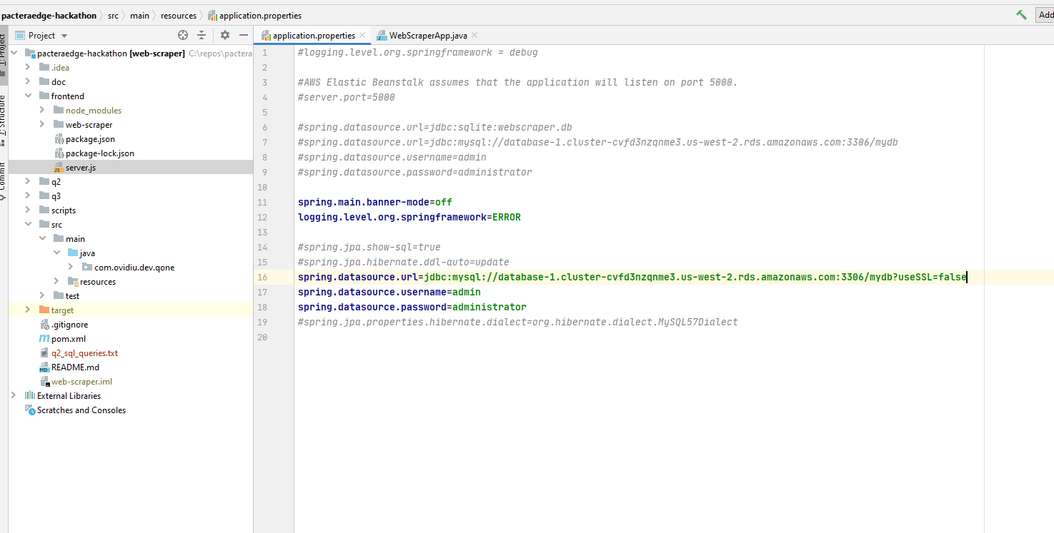





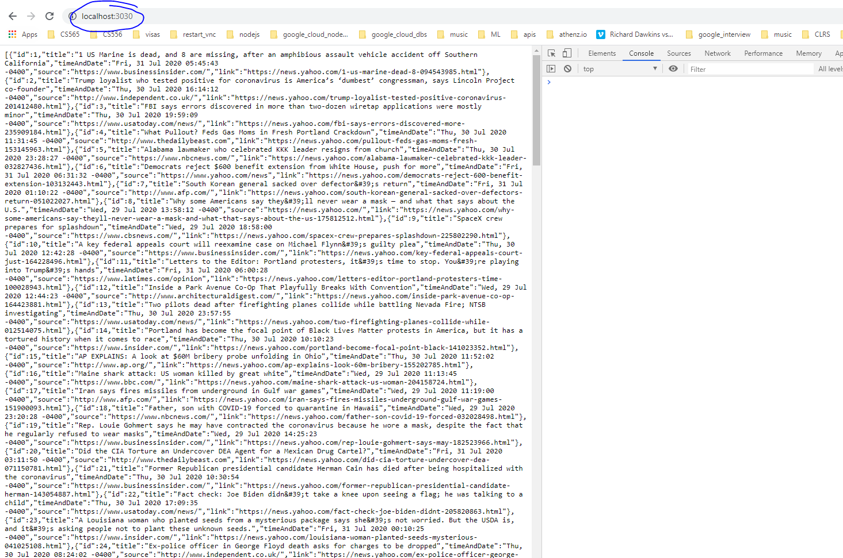



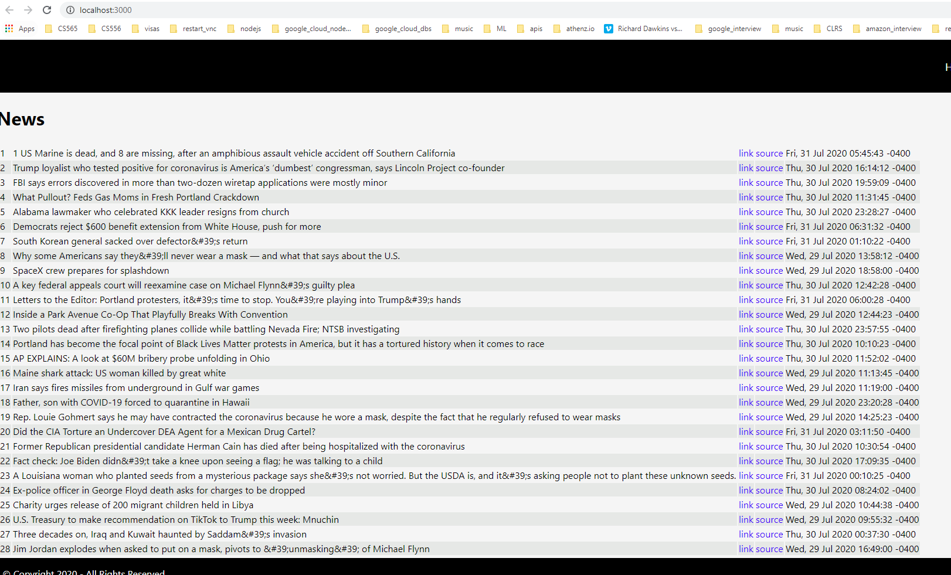
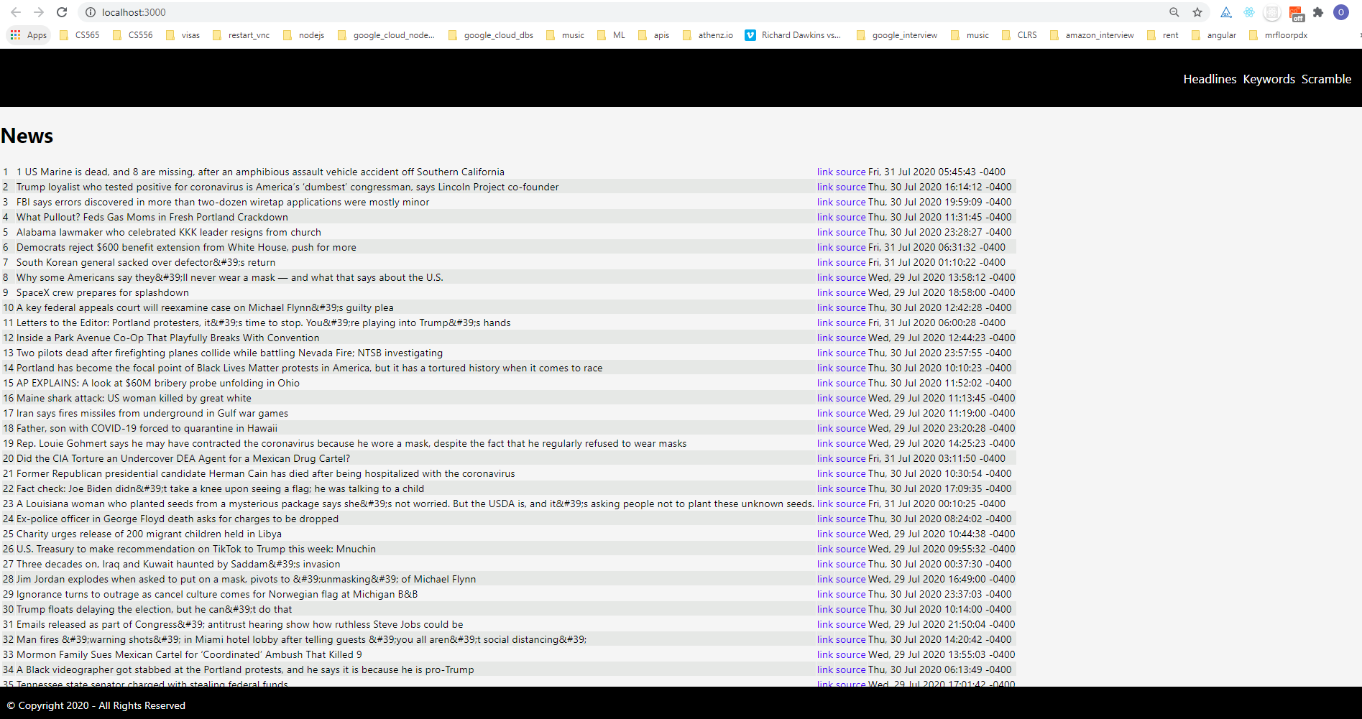
git repo: https://github.com/ovimura/pacteraedge-hackathon



2.

Query 2:

For each type of the stores, find 5 stores with highest average weekly sales.

Solution:

select tp, avg_w from
(select st.Type tp,st.Store sto, avg(sa.Weekly_Sales) avg_w from stores_data st join sales_data sa on (st.Store = sa.Store)
group by st.Type, st.Store
having avg_w > (select Weekly_Sales from stores_data))
group by avg_w order by 2 limit 5

Query 3:

Find stores with increased total sales in December from 2010 to 2011.

SELECT st.Store a, sum(sd.Weekly_Sales) b
from stores_data st join sales_data sd on st.Store = sd.Store
where SUBSTR(sd.date, 7, 4) IS '2010' and SUBSTR(sd.date, 4, 2) IS '12'
group by a;

and b > 1000;
(
SELECT sum(sd1.Weekly_Sales) from stores_data st1 join sales_data sd1 on st1.Store = sd1.Store
where SUBSTR(sd1.date, 7, 4) = '2011' and SUBSTR(sd1.date, 4, 2) = '12'
and a = st1.Store
);

3.




import pandas as pd
class Employee(object):
def __init__(self, fn, ln, g, tl, stat, yrs, sal, lb):
self.first_name = fn
self.last_name = ln
self.gender = g
self.title = tl
self.status = stat
self.yrs_of_experience = yrs
self.salary = sal
self.last_bonus = lb
def calc_aprox_sal(self) -> float:
def_sal = 30000
if self.last_name is not None:
if self.title in ["Software Engineer", "Full Stack Developer", "Software Developer Engineer"]:
def_sal *= 2
if self.yrs_of_experience < 2:
def_sal *= 1.1
elif self.yrs_of_experience == 2:
def_sal *= 1.3
elif self.yrs_of_experience > 2:
def_sal *= 1.6
elif self.yrs_of_experience > 6:
def_sal *= 2
return def_sal
def main():
es = []
for i in range(25):
es.append(Employee("John", "Smith", "Male", "Software Engineer", "Single", 2, 30000, 1000))
df = pd.DataFrame(es)
print(df.count())
if __name__ == "__main__":
main()

