Installing Ruby

1. Install some dependencies for Ruby:

> sudo apt-get update

> sudo apt-get install git-core curl zlib1g-dev build-essential libssl-dev libreadline-dev libyaml-dev libsqlite3-dev sqlite3 libxml2-dev libxslt1-dev libcurl4-openssl-dev python-software-properties libffi-dev

2. Install RVM and Ruby

> curl -L https://get.rvm.io | bash -s stable

> source ~/.rvm/scripts/rvm

> rvm install 2.2.3

> rvm use 2.2.3 --default

3. Tell Rubygems not to install the documentation for each package locally and then install Bundler

> echo "gem: --no-ri --no-rdoc" > ~/.gemrc

> gem install bundler

4. Configuring Git and generating SSH key

> git config --global color.ui true
> git config --global user.name "YOUR NAME"
> git config --global user.email "YOUR@EMAIL.com"
> git config --global push.default matching

> ssh-keygen -t rsa -C "YOUR@EMAIL.com"

Copy newly generated SSH key and add it to your Github account:

> cat ~/.ssh/id_rsa.pub

https://github.com/settings/ssh

Once you've done this, you can check and see if it worked:

> ssh -T git@github.com

You should get a message like this:

Hi excid3! You've successfully authenticated, but GitHub does not provide shell access.

5. Installing NodeJS (Coffeescript + Asset Pipeline) and Rails

> sudo apt-get install nodejs

> gem install rails -v 4.2.4

6. Setting Up PostgreSQL

> sudo apt-get install postgresql postgresql-contrib libpq-dev

> sudo -u postgres createuser -s volodymyr

> heroku version

> postgres=# \password volodymyr
> postgres=# \q

7. Running Rails

> rails new myapp -d postgresql

> cd myapp

# If you setup MySQL or Postgres with a username/password, modify the
# config/database.yml file to contain the username/password that you specified

# Create the database
> rake db:create

> rails s

8. Installing Heroku (optional)

> wget -O- https://toolbelt.heroku.com/install-ubuntu.sh | sh

> heroku login

> cd ~/myapp

> heroku create

9. Final

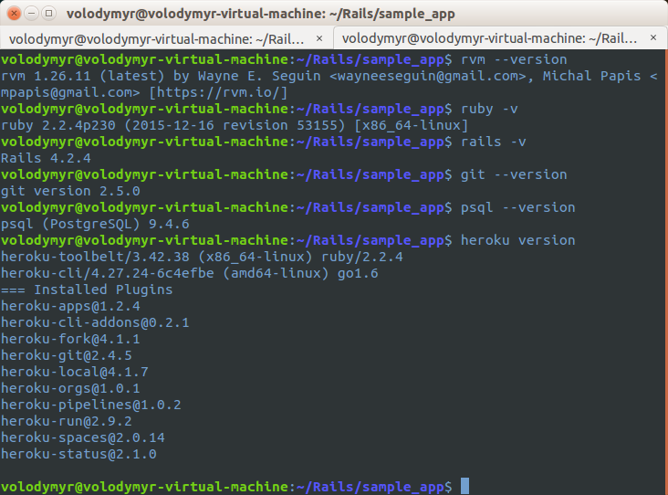

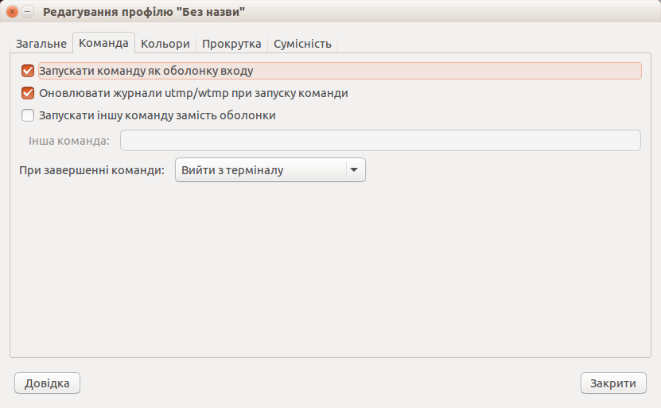
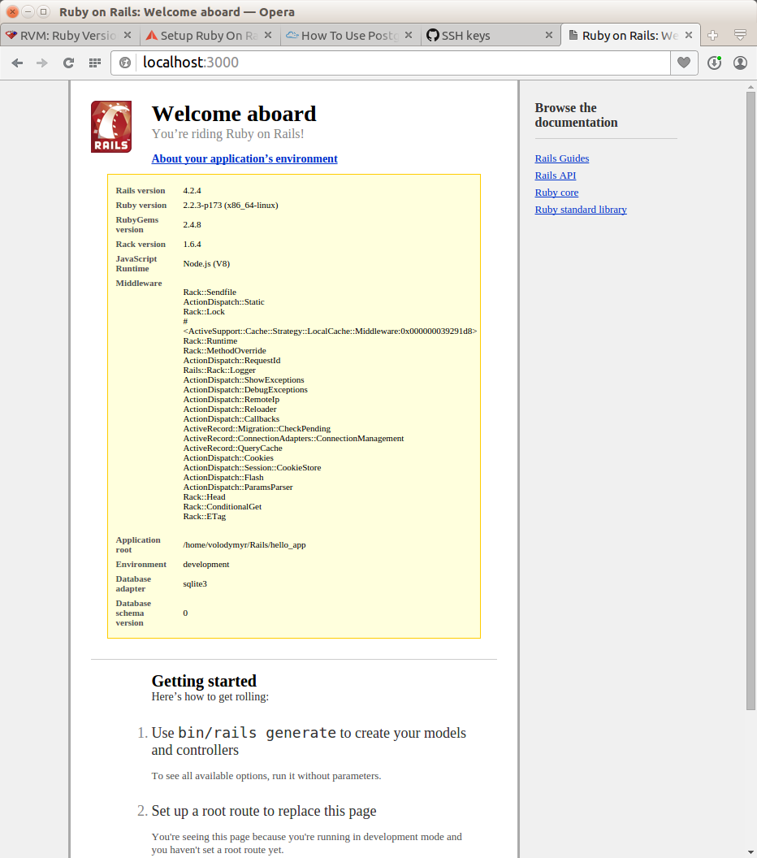
Setting Up Sublime Text 3

1. Installing ST3

https://www.sublimetext.com/3

2. Installing Package Control

https://packagecontrol.io/installation

3. Installing packages

Preferances — Package Control — Install Package

- Sass
- SublimeERB
- Theme - Spacegray
- Railcasts Extended

4. Other settings

/home/volodymyr/.config/sublime-text-3/Installed Packages

Copy this from
Theme — Spacegray.sublime-package/base16-ocean.dark.tmTheme
to
Railscasts Extended.sublime-package/Railscasts Extended.tmTheme

<key>gutterSettings</key>
<dict>
<key>background</key>
<string>#343d46</string>
<key>divider</key>
<string>#343d46</string>
<key>foreground</key>
<string>#65737e</string>
<key>selectionBackground</key>
<string>#4f5b66</string>
<key>selectionForeground</key>
<string>#a7adba</string>
</dict>
...
<key>settings</key>
<array>
<dict>
<key>settings</key>
<dict>
...
<key>background</key>
<string>#2b303b</string>
...
<key>lineHighlight</key>
<string>#343d46</string>
Preferences — Settings — User

"theme": "Spacegray.sublime-theme",
"highlight_line": true,
"bold_folder_labels": true

