**Temperature-Dependent Kinetics of Unsaturated Fatty Acid Methyl Esters: Modeling Autoxidation Mechanisms**

Maxime Touffeta, Olivier Vitracb[1]*

a Global Core R&D, Cargill R&D Centre Europe, Havenstraat 84, 1800, Vilvoorde, Belgium

b UMR 0782 SayFood Paris-Saclay Food and Bioproducts Engineering Research Unit, INRAE, AgroParisTech, Université Paris-Saclay, 91120 Palaiseau, France

Abstract

Understanding the oxidative stability of unsaturated fatty acid methyl esters (FAMEs) is critical for food preservation and industrial applications. This study extends our first-principles kinetic model (Food Res Int 2023, 173, 113289) by integrating mechanistic insights into the temperature-dependent shift from bimolecular to monomolecular hydroperoxide decomposition. Our approach, based on experimental evidence of a critical temperature and the parameterization of the equilibrium between free and hydrogen‐bonded hydroperoxides, was validated against data spanning 7°C to 200°C (391 measurements). Without further fitting, the model achieves R² values between 0.613 and 0.896. On curated datasets, the Concordance Correlation Coefficient exceeds 0.78, the Prediction Interval Coverage Probability is over 50%, and relative deviation errors below 30%. Below 80°C, bimolecular pathways dominate, whereas monomolecular processes prevail at higher temperatures, influencing induction times and oxidation rates. These findings lay the groundwork for predictive models that optimize shelf life by integrating FAME composition and temperature history.

# Introduction

Predicting the stability of fatty acids exposed to oxygen and temperature is of broad interest across various applications involving edible oil, meat, milk, and chocolate (Chow, 2007), as well as in cosmetics, biodiesel, lubricants, and paintings, whether these fatty acids are free or esterified with methanol, ethanol, or glycerol. Autoxidation begins when dioxygen, a di-radical essential for aerobic life, dissolves into fat or oil, forming hydroperoxides. These hydroperoxides then degrade into more stable, often volatile or polymerized, breakdown products. Hydroperoxides play a key role in this mechanism, acting as organic oxygen carriers capable of propagating reactions far from the exposed surfaces, as observed during deep-frying (M. Touffet, Allouche, Ariane, & Vitrac, 2021; M. Touffet, Patsioura, Ziaiifar, Eveleigh, & Vitrac, 2018). While oxygen is present, the mechanism proceeds through homolytic decomposition, producing free radicals centered on oxygen, which can abstract labile hydrogen atoms from neighboring molecules. This reaction sequence is amplified by mineral oxygen, leading to the regeneration of hydroperoxides and an increase of oxygenated by-products, ultimately causing a loss of nutritional, sensory, and functional values. Despite over a century of research, starting with the seminal works of Rogers (1909) , predicting the autoxidation rates and pathways of a given mixture of fatty acids and antioxidants under external strains (temperature, oxygen accessibility) remains challenging (Aladedunye, 2015). Waste oils and fats have a significant environmental impact, contributing to food waste (Okino-Delgado, Prado, Facanali, Marques, Nascimento, Fernandes, et al., 2017), and can be harmful to the environment due to their cytotoxicity. A better understanding of oxidation mechanisms could provide mutual benefits, such as reducing waste, simplifying the formulation of oil blends, and promoting the valorization of various oil and fat sources.

In food systems, the effective kinetics of lipid degradation are complicated by several factors: i) oxygen mass transfer from the atmosphere to the oil at free surfaces (Patsioura, Ziaiifar, Smith, Menzel, & Vitrac, 2017) or through packaging during bottled oil storage (Del Nobile, Bove, La Notte, & Sacchi, 2003), ii) heat transfer (M. Touffet, Allouche, Ariane, & Vitrac, 2021), iii) the diffusion of lipids into container packaging (Riquet, Wolff, Laoubi, Vergnaud, & Feigenbaum, 1998), and iv) the non-uniform distribution of antioxidants in structured foods such as emulsions (Costa, Losada-Barreiro, Paiva-Martins, Bravo-Díaz, & Romsted, 2015). The combinatory nature of propagation and termination reactions, once deemed intractable due to the vast possible combinations and complex progression, has been recently addressed. Maxime Touffet, Smith, and Vitrac (2023) recently addressed this challenge for liquid mixtures of unsaturated fatty methyl esters (FAMEs) by proposing a two-scale cross-reaction model. This model separates chemical functions' reactivity from function holders' local mobility, both activated by temperature. The model provides remarkable predictions at high temperatures, similar to frying or cooking conditions, but becomes less accurate at temperatures close to 80°C or below. Similar deviations have been observed at 80°C during the oxidation of polypropylene (Achimsky, Audouin, Verdu, Rychly, & Matisova-Rychla, 1997; Gijsman, Hennekens, & Vincent, 1993), polybutadiene (Coquillat, Verdu, Colin, Audouin, & Nevière, 2007) and polyethylene (Khelidj, Colin, Audouin, Verdu, Monchy-Leroy, & Prunier, 2006). This temperature range is associated with the higher stability of hydrogen bonds between hydroperoxides at lower temperatures, where the homolytic bimolecular decomposition of hydroperoxides via a cage mechanism was first hypothesized by the group of Bolland (Bolland, 1949; Bolland & Rideal, 1946), dominates. According to this hypothesis, decomposition evolves from a monomolecular mechanism at high temperatures to a bimolecular mechanism dominating at ambient conditions, as Bateman, Hughes, and Morris (1953) suggested. The shelf life and service life of systems incorporating fatty acids are primarily determined by the initiation stage, when hydroperoxides accumulate faster than they decompose (FAO/WHO, 1996). Since the accumulation rate is controlled by the oxygen transfer and dissolution kinetics, improving the predictions of propagation and termination radical reactions over a broad temperature range is crucial, covering both cooking and chilled conditions. Indeed, oils and fats are typically not processed, used, or stored at a single temperature.

This study aims to identify a critical temperature that controls the hydroperoxide decomposition mechanisms and to parameterize the intrinsic decomposition rates of unsaturated fatty acid methyl esters (FAMEs) below this critical temperature. Ultimately, a unified combinatory model should be capable of describing oil degradation kinetics above their melting points and across the full range of temperatures encountered in food processing, including storage temperatures (10°C - 40°C), low cooking temperatures (60°C - 80°C), and frying/baking temperatures (150°C - 190°C). The article is organized as follows: Section 2 summarizes the most recent kinetic theory of lipid oxidation and outlines an approach to identifying hydroperoxide decomposition mechanisms. Section 3 briefly introduces the materials and characterization techniques used in this work. Section 4 presents the results on FAMEs. The conclusions and perspectives for developing a general model of lipid oxidation are summarized in the final section.

# General Oxidation Mechanisms of FAMEs

The chemical pathways of unsaturated methyl esters were already discussed by Maxime Touffet, Smith, and Vitrac (2023) and are only summarized hereafter with specific attention to the hydroperoxide decomposition mechanism and the effect of temperature.

## Pathways and Oxidizability of FAMEs

### The High-Temperature Reaction Scheme

Under conditions of non-limiting oxygen transfer at atmospheric pressure, the classical oxidation scheme at high temperatures is initiated by the monomolecular decomposition of hydroperoxide,  This scheme was originally proposed by Tobolsky, Metz, and Mesrobian (1950) to develop a general oxidation model for thermoplastic polymers based on the oxidation kinetics of ethyl linoleate in the range 50°C-150°C. Although they referred to it as a "low-temperature" scheme due to the relatively low temperatures compared to polymer melting points, we consider this a "high-temperature" reaction scheme in the context of food applications. This scheme has been well-validated for pure methyl esters and their mixtures (Maxime Touffet, Smith, & Vitrac, 2023) and it is represented as:



In this reaction,  with  represents oleate, linoleate, and linolenate FAMEs, respectively. The monomolecular decomposition of hydroperoxide produces two reactive oxygen-centered radicals: alkoxyl ) and hydroxyl ) radicals. The superscript “free” in R1 indicates that hydroperoxides are not involved in cooperative hydrogen bonding when the homolytic scission of the peroxide function occurs.

The hydroxyl radical is the most reactive radical (Mitroka, Zimmeck, Troya, & Tanko, 2010), abstracting hydrogen at a diffusion-controlled rate (Okada, Kaneko, & Okajima, 1996). The alkoxyl radical can either abstract labile hydrogen or generate small volatile compounds such as aldehydes, alkanes, and oxo-esters via its β-scission (Chan, Prescott, & Swoboda, 1976).

Hydrogen abstraction by peroxyl radical () is governed by the bond dissociation energy of the carbon-hydrogen bond adjacent to the double bond in unsaturated FAMEs (Korcek, Chenier, Howard, & Ingold, 1972). The addition of oxygen () to alkyl radicals is a fast, diffusion-controlled reaction (Ingold, 1969). When oxygen transfer is not limiting at atmospheric pressure, termination reactions between peroxyl radicals dominate, while alkyl-alkyl and alkyl-peroxyl terminations are negligible. (Labuza & Dugan Jr, 1971).

### The Assumption of Bimolecular Decomposition of Hydroperoxides at Low Temperatures

Building on the pioneering work of Bolland and Rideal (1946), Tobolsky, Metz, and Mesrobian (1950) proposed a bimolecular mechanism for hydroperoxide decomposition alongside the monomolecular mechanism presented in R1:



In this reaction, the superscript “cage” indicates that hydroperoxides involved in the bimolecular decomposition are engaged in cooperative hydrogen bonding:  as justified in the Supplementary Material S1.

. Determining the exact decomposition mechanism from oxidation kinetics can be challenging. For instance, Patsioura, Ziaiifar, Smith, Menzel, and Vitrac (2017) and Roman, Courtois, Maillard, and Riquet (2012) analyzed the same data from 5-doxyl stearic free radical spin trapping experiments. Yet, they identified different initiation mechanisms – bimolecular and monomolecular, respectively.

## Hydroperoxide Decomposition Reaction Rate Models and Induction Times for the Unimolecular Model

The rate of hydroperoxide decomposition typically follows an Arrhenius-type behavior:



where  is the temperature (in °C),  is the rate at the reference temperature  ,  the activation energy and  the gas constant.

The constant rate of oxidation is closely related to the induction time – the initial period during which the oxidation rate remains relatively slow or negligible. This phase precedes the rapid increase in oxidation rate, typically associated with the accumulation and subsequent decomposition of hydroperoxides. Experimentally, the induction time is determined by identifying when the first significant deviation from the baseline is observed, signaling the onset of rapid oxidation. It is mathematically defined from the intercept of the tangent at the inflection point with the baseline (Achimsky, Audouin, & Verdu, 1997). For free hydroperoxides involved in a monomolecular decomposition, the experimental induction time reads:



where  is the time at the inflection point and  is the maximum rate of accumulation of hydroperoxides. Practical relationships between experimental induction times and  are shown in the Supplementary Material S2.

## Rate of Termination Reactions over the Whole Temperature Range

As justified by Denisov (1974), termination reactions involve reactions between two free radicals. Termination reactions via peroxyl radicals are rapid, often several orders of magnitude faster than other reactions. Richaud, Audouin, Fayolle, Verdu, and Matisova-Rychla (2012) reported that for unsaturated FAMEs at temperatures above 130°C, these termination reactions occur at rates close to the diffusion-controlled limit, which is typically around 106 m3·mol-1·s-1 (Ingold, 1969; Okamba-Diogo, Richaud, Verdu, Fernagut, Guilment, & Fayolle, 2015).

This diffusion-controlled rate can be calculated using the Smoluchowski limit defined by Smoluchowski (1918), as:



where is the gyration radius of the peroxyl radical, the Avogadro’s number and  the diffusion coefficient of peroxyl radical that can be estimated by the Stoke-Einstein equation,



where  is the hydrodynamic radius and  is the dynamic viscosity of the considered FAME (Miller & Walker, 1924).

At lower temperatures, termination reactions might shift from being diffusion-controlled to chemically-controlled. The overall reaction rate across the full range of temperature ,, is calculated as the harmonic mean of the chemical rate,  and the Smoluchowski limit, as described by Berg and Hippel (1985) :



The chemical rate constant, , follows an Arrhenius relationship:



where  is the rate at the reference temperature  and  is the activation energy.

# Materials and Methods

## Fatty Acid Methyl Esters (FAMEs)

Methyl oleate (96% purity), methyl linoleate (99% purity), and methyl linolenate (99% purity) were purchased from Alfa Aesar, Acros Organics, and Sigma Aldrich, respectively.

## Oxidation Conditions

Oxidation reactions were conducted in a bubbling reactor, as detailed in previous studies (M. Touffet, Allouche, Ariane, & Vitrac, 2021; Maxime Touffet, Smith, & Vitrac, 2023). Approximately four grams of pure FAMEs were placed in the reactor and subjected to oxidation at temperatures ranging from 20°C to 65°C.

## Determination of Hydroperoxide Content by Differential Scanning Calorimetry

The total hydroperoxide content, denoted , was determined by differential scanning calorimetry DSC following the method already outlined by Mallégol, Gonon, Commereuc, and Verney (2001). A small oil aliquot (10-20 mg) was heated from 25°C to 250°C at a rate of 3°C·min-1 under nitrogen flow. The decomposition of the hydroperoxides in the DSC pan and the exothermic combination of produced radicals allowed for the direct quantification of hydroperoxides, assuming an apparent enthalpy of 320 kJ·mol-1.

## Determination of Residual Methyl Oleate by Fourier Transform Infrared Spectroscopy

The residual amount of methyl oleate during oxidation was estimated by deconvolving the absorption band around 3008 cm-1 band associated with the cis unsaturation of the methyl esters in the mid-infrared spectrum as described by M. Touffet, Patsioura, Ziaiifar, Eveleigh, and Vitrac (2018). The decrease of absorbance observed during oxidation is associated to the isomerization cis-trans during the allylic hydrogen abstraction (Frankel, Garwood, Khambay, Moss, & Weedon, 1984).

## Kinetic Oxidation Model

The oxidation kinetics were modeled using the reaction scheme and the reaction rates described by Maxime Touffet, Smith, and Vitrac (2023). Eq. was either substituted into or added to Eq. to simulate a bimolecular decomposition of hydroperoxides or a combination of monomolecular and bimolecular mechanisms.

In all cases, as justified by Maxime Touffet, Smith, and Vitrac (2023), the dissolution kinetics of oxygen obeys to the mass balance equation:



where the first term describes the transport of oxygen, with  as the interfacial mass transfer coefficient of oxygen,  as the surface area of the FAME sample in contact with air,  as the volume of FAME sample, as the partial pressure of oxygen in the air, as the solubility oxygen in the FAME sample. The second term accounts for the addition of oxygen to alkyl radicals.

## Model validation

For each dataset considered in this study, including 391 experimental hydroperoxide concentration determinations, the likelihood of the whole oxidation scheme and the proposed parameters was tested. The whole procedure involving the estimation of Concordance Correlation Coefficients (CCC) and Prediction Interval Coverage Probabilities (PICP) is detailed in Supplementary Material S3.

# Results and Discussion

## Justification of the switch of the hydroperoxide decomposition mechanism between low and high temperatures

### Temperature-Dependent Equilibrium between Monomolecular and Bimolecular Decomposition Pathways of Hydroperoxides

During the induction period under non-limiting oxygen dissolution kinetics, FAMEs undergo oxidation, leading to the accumulation of hydroperoxides. The subsequent decomposition of these hydroperoxides, dictated by their half-life, is crucial in determining the effective rate of FAME degradation. Starting with zero hydroperoxides, a bimolecular hydroperoxide decomposition mechanism will extend the induction period, followed by a sharp increase in oxidation rates once the hydroperoxides accumulate sufficiently. Conversely, monomolecular hydroperoxide decomposition will lead more rapidly to an exponential decay of FAMEs from the outset.

These two mechanisms are compared with the experimental decomposition of methyl oleate () at 36°C, 80°C, and 140°C in Figure 1. The rate constants  for monomolecular decomposition and  for bimolecular decomposition were fitted using a non-linear least squares method, integrating the prediction errors for the concentrations of  and their corresponding hydroperoxide . The other constants were obtained from the literature and are summarized in Table 1.

At 36°C, the degradation profile exhibits a delayed onset with a sigmoidal shape (Figure 1a). This behavior can only be accurately reproduced by the bimolecular decomposition mechanism. The maximum accumulation of hydroperoxides occurs after approximately 50 days. Although incorporating a monomolecular mechanism, either fully or partially, can also lead to a delayed accumulation of hydroperoxides, it results in a faster decay of , which is inconsistent with the experimental observations.

At 140°C, the degradation behavior is reversed, with  decreasing without noticeable lag. Only the monomolecular decomposition mechanism can adequately describe the observed effects in this scenario.

At an intermediate temperature of 80°C, monomolecular and bimolecular mechanisms must be considered equally to match the experimental data. The competition between these mechanisms is evident at moderate temperatures, indicating that one mechanism's preference is not solely based on kinetic factors. Instead, it points to the existence of two distinct populations of hydroperoxides: one population is free, denoted as , which undergoes monomolecular decomposition, while the other population is involved in a cage structure, denoted as , which decomposes bimolecularly. The equilibrium between these two populations is strongly temperature-dependent and occurs faster than their decomposition:



Assuming that the equilibrium constant  follows the van ’t Hoff equation governed by the enthalpy of the cage formation  and its reference value and its reference value at the critical temperature  , the populations of “cage” and “free” evolve with temperature,  (in °C), as:



At the critical temperature , the “free” and “cage” concentrations are assumed to be equal, leading to  from the mass balance equation. Based on the literature (see section 2.1.2), it is reasonable to consider the exothermic formation of the cage with  ranging between 40 and 65 kJ⋅mol-1. By definition, the temperature , ranging from 70 to 90°C, represents the point where oxygen addition following monomolecular or bimolecular hydroperoxide decompositions becomes equally probable.

Combining the mass balance with Eq. allows for the calculation of the cage and free concentrations at any given time and temperature:





At low temperatures, where  values is large  and , indicating that hydroperoxides predominantly exist in the cage form. Conversely, at high temperatures, where is small,  and, meaning hydroperoxides are mostly in the free form. In addition, it is straightforward to demonstrate that both forms of hydroperoxides verify the mass action law and are proportional to .

Eqs. - extend the decomposition mechanism across the entire temperature range by accounting for the temperature-dependent equilibrium between the “cage” and “free” hydroperoxides. Thermodynamically, the critical temperature  reflects a specific balance between the thermodynamic driving forces (enthalpy and entropy changes) that orients the decomposition mechanism:



 is likely to be independent of the  when it is defined from induction times evaluated at the inflection points, that is, when is about half its maximum concentration at steady state.

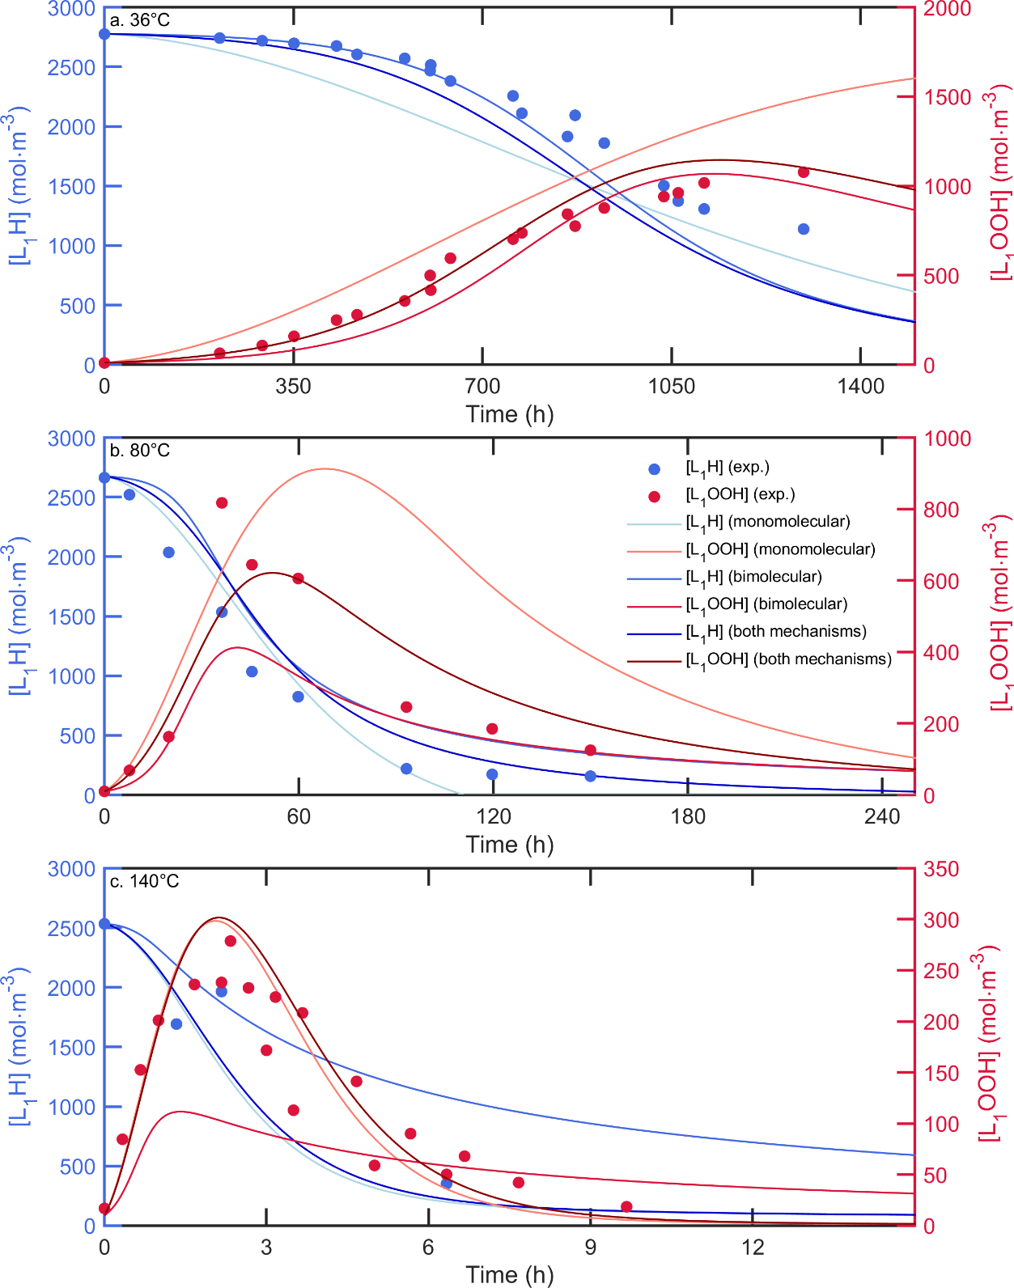

Figure 1: Comparison between the predictions of the models at (a) 36°C (b) 70°C and (c) 140°C considering exclusively the monomolecular decomposition of peroxide or the bimolecular decomposition or both mechanisms with experimental data from (Ikeda & Fukuzumi, 1978b) at 36°C, (Hamilton & Olcott, 1937)at 80°C and Maxime Touffet, Smith, and Vitrac (2023) at 140°C.

Table 1: Pre-exponential factor (s-1 or m3·mol-1·s-1) at Tref=140°C (except Tref=40°C for the bimolecular decomposition of hydroperoxides) and activation energies (kJ·mol-1) used in this study.

|  |  |  |  |  |  |
| --- | --- | --- | --- | --- | --- |
| Reaction | Parameter | Oleate (i=1) | Linoleate (i=2) | Linolenate (i=3) | Comments |
|  |  | 3.00·10-4 | 7.00·10-4 | 9.00·10-4 | From Maxime Touffet, Smith, and Vitrac (2023) |
|  | 89 | 79 | 67 | From Maxime Touffet, Smith, and Vitrac (2023) |
|  |  | 4.00·10-10 | 4.50·10-9 | 14.00·10-9 | Close from values reported by for methyl linoleate hydroperoxide at 40°C (~1.23·10-8) by Cash, George, and Bartley (1987) |
|  | 100 | 110 | 110 | Close from values reported by for methyl linoleate hydroperoxide (104±11) by Cash, George, and Bartley (1987) |
|  |  | 3.80·103 | 8.80·103 | 13.0·103 | From Small Jr., Scaiano, and Patterson (1979) |
|  | 14.0 | 14.0 | 14.0 | Guessed from the median range of values obtained for ter-butoxyl radical (Gray & Williams, 1959) |
|  |  | 2·106 | 107 | 107 | From Q.-D. Wang and Ni (2016) and Tavadyan, Khachoyan, Martoyan, and Kamal-Eldin (2007) for oleate and linoleate, respectively. |
|  | 0 | 0 | 0 | From Tavadyan, Khachoyan, Martoyan, and Kamal-Eldin (2007) |
|  |  | 18.0·10-2 | 42.0·10-2 | 84.0·10-2 | From Korcek, Chenier, Howard, and Ingold (1972) considering two mono-allylic sites for oleate, one bi-allylic site for linoleate and two bi-allylic sites for linolenate. |
|  | 47 | 28 | 24 | Close to values described by Korcek, Chenier, Howard, and Ingold (1972) |
|  |  | 106 | 106 | 106 | From Ingold (1969) |
|  | 0 | 0 | 0 | From Ingold (1969) |
|  |  | 2.28·106 | 2.28·106 | 2.28·106 | Close from values described by Pfaendtner and Broadbelt (2008) and Oakley, Casadio, Shull, and Broadbelt (2018) |
|  | 47 | 47 | 47 | Close from values described by Pfaendtner and Broadbelt (2008) and Oakley, Casadio, Shull, and Broadbelt (2018) |
|  |  | 4.00·105 | 1.50·106 | 1.50·107 | Close from values described by Maxime Touffet, Smith, and Vitrac (2023) |
|  | 55..0 | 45.0 | 56.0 | Close from values described by Maxime Touffet, Smith, and Vitrac (2023) |
|  | 8.29·106 | 9.31·106 | 9.74·106 | From Eq. |
|  | 4.27·105 | 1.41·106 | 6.32·106 | From Eq. , close from values described by Richaud, Audouin, Fayolle, Verdu, and Matisova-Rychla (2012), Howard and Ingold (1967), Katušin-Ražem and Ražem (2000), Tavadyan, Khachoyan, Martoyan, and Kamal-Eldin (2007). |

### Transition in Induction Time Kinetics: Evidence of Non-Arrhenius Behavior in the Oxidation of Unsaturated FAMEs across a Critical Temperature

Induction times for the oxidation of methyl oleate, linoleate, and linolenate were collected from the literature and supplemented with values determined in this study, covering a broad range of temperatures between 7°C and 150°C. Induction times derived from oxygen uptake were rescaled to be comparable with those obtained for hydroperoxide measurements, considering , as justified in the Supplementary Material S2.

Figure 2 presents the induction times plotted against the reciprocal absolute temperature. A linear relationship is observed between the logarithmic values of induction times and the reciprocal temperature in the range of 150°C to 80°C for all studied unsaturated FAMEs. However, a distinct change in slope occurs around 80°C, which is more pronounced for methyl oleate and linoleate, and less so for methyl linolenate. The reduced slope change for methyl linoleate is likely due to the greater difficulty in controlling initial hydroperoxide concentrations in polyunsaturated FAMEs, making these experimental induction times more susceptible to errors and biases. This critical value of ≈80°C seems universal. It was already noticed previously for edible oils (M. Touffet, Allouche, Ariane, & Vitrac, 2021), polypropylene (Achimsky, Audouin, Verdu, Rychly, & Matisova-Rychla, 1997; Gijsman, Hennekens, & Vincent, 1993), polybutadiene (Coquillat, Verdu, Colin, Audouin, & Nevière, 2007) and polyethylene (Khelidj, Colin, Audouin, Verdu, Monchy-Leroy, & Prunier, 2006).

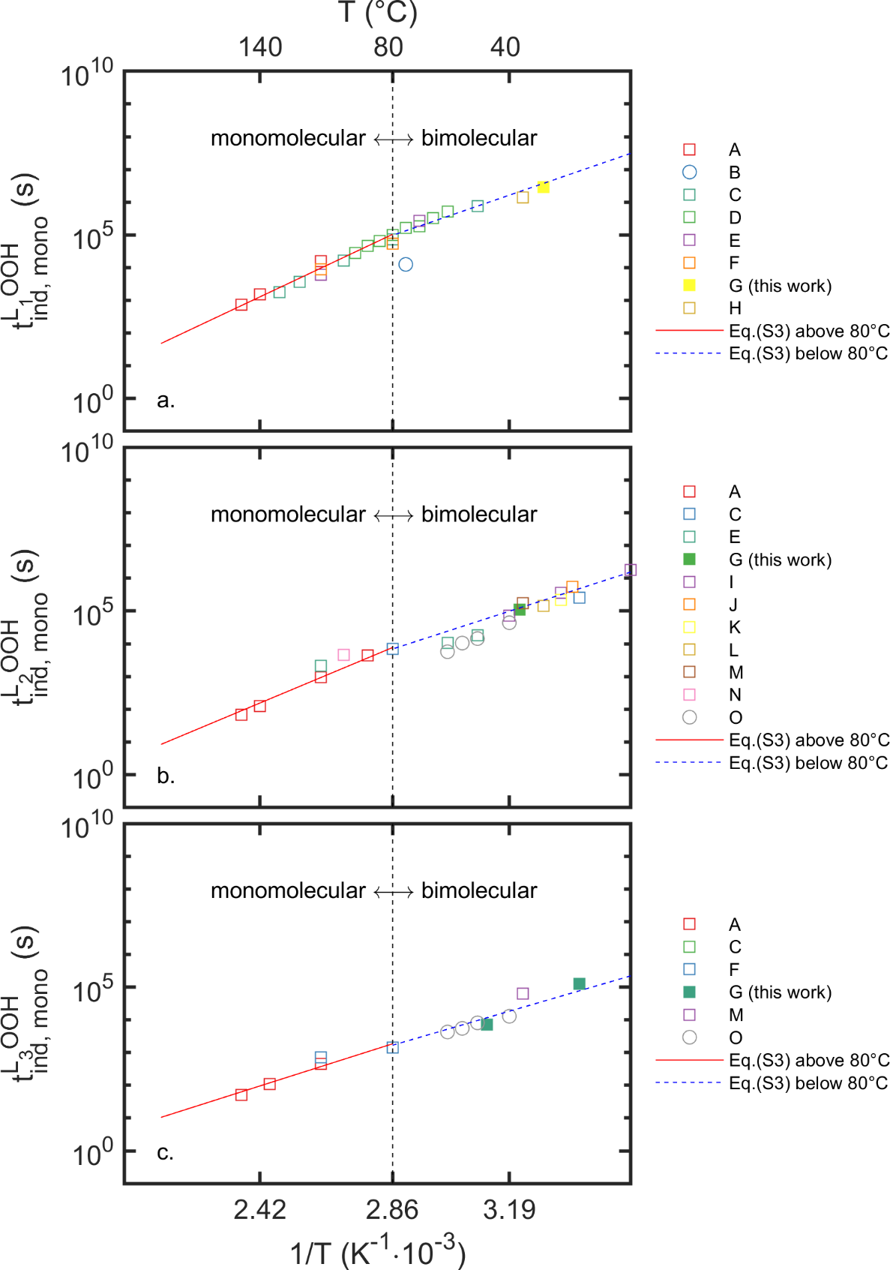

Figure 2: Arrhenius plots of induction times measured during the oxidation of (a) methyl oleate (23 values), (b) methyl linoleate (21 values) and (c) methyl linolenate (12 values) at different temperatures. Experimental data sources: A: Richaud, Audouin, Fayolle, Verdu, and Matisova-Rychla (2012), B: Khan, Brown, and Deatherage (1951), C: Gunstone and Hilditch (1945), D: Dunn (2008), E: T. Wang, Lee, da Silva, Hammond, and Yao (2015), F:, Moser (2009), G: this work, H: Ikeda and Fukuzumi (1978a), I: Tekin and Hammond (2004), J: Franks, Gent, and Roberts (1965), K: Koprucuoglu, Calikoglu, Tekin, and Hammond (2011), L: Allen, Jackson, and Kummerow (1949), M: Ikeda and Fukuzumi (1978b), N: Lomanno and Nawar (1982), O: Pizzimenti, Bernazzani, Duce, Tinè, and Bonaduce (2023). Squares represent induction times determined from hydroperoxide and circles are induction times determined oxygen uptake.

According to Eq. , the equilibrium between “cage” and “free” hydroperoxide forms impacts the determination of induction times, especially near  where the two mechanisms coexist. Given that the equilibrium between the two forms imposes , the corresponding induction times, , and , are ranked as:



A similar ranking of induction times is consistent with the trends of Figure 1b at 70°C. As indicated by these inequalities, induction times continue to increase with temperature decrease, though not as sharply once the temperature crosses the critical threshold where bimolecular decomposition begins to dominate. This shift in slope is likely due to the dimerization of hydroperoxides at lower temperatures, as confirmed by redshifts in infrared spectroscopy (Danoczy, Holly, Jalsovszky, & Gal, 1984; Richardson & Steed, 1967; Walling & Heaton, 1965). Khelidj, Colin, Audouin, Verdu, Monchy-Leroy, and Prunier (2006). Assuming a critical temperature =80°C and an enthalpy of cage formation =60 kJ⋅mol-1, the calculated “cage” fraction is approximately of 97% at 5°C, 83% at 40°C, 31% at 100°C, 9% at 140°C and 2.1% at 180°C. Reducing  to 40 kJ⋅mol-1 reduces the temperature dependence, resulting in cage fractions of 89% at 5°C, 75% at 40°C, 38% at 100°C, 18% at 140°C and 8.3% at 180°C. Despite the uncertainty in the exact value of the cage formation enthalpy, a significant shift of the cage-to-free population is anticipated with increasing temperature. The coexistence of the two populations was first suggested by Bateman, Hughes, and Morris (1953).

Induction times measured at 140°C were used to estimate the monomolecular decomposition rate constant  via Eq.(S3). The estimated values are compared with those reported in the literature in Table 2. Apparent activation energies above and below 80°C are also reported. Notably, the induction time of methyl oleate, 1057 s at 140°C, is one order of magnitude longer than that for polyunsaturated FAMEs. The calculated rates of hydroperoxide decomposition are in good agreement with previous reports for methyl oleate but are higher than those reported for methyl linoleate. These discrepancies might be due to differences in initial hydroperoxide concentrations, as Eq.(S3) assumes low initial hydroperoxide levels. This could explain the variation in decomposition rates calculated from induction time versus those determined by directly measuring hydroperoxide disappearance in anoxic conditions (Hatate, Kawano, & Sone, 1989; M. Touffet, Allouche, Ariane, & Vitrac, 2021; Yanishlieva, 1973).

Table 2: Induction times, activation energies, and associated monomolecular hydroperoxide decomposition rate constants, compared with literature data. Sources: A: Richaud, Audouin, Fayolle, Verdu, and Matisova-Rychla (2012), B: M. Touffet, Allouche, Ariane, and Vitrac (2021), C: Maxime Touffet, Smith, and Vitrac (2023) D: Yanishlieva (1973), E: Hatate, Kawano, and Sone (1989). * Determined from induction times.

|  |  |  |  |
| --- | --- | --- | --- |
| FAME | Methyl oleate | Methyl linoleate | Methyl linolenate |
| (s) | 1057 | 140 | 85 |
| from Eq.(S3) (s-1) | 3.65·10-4 | 2.8·10-3 | 4.5·10-3 |
| from literature (s-1) | 2.59·10-4 A*  (2.11±1.86)·10-4 B  3.00·10-4 C | 0.73·10-3 D:  3.1·10-3 A*  (0.59±0.52)·10-3 B  0.70·10-3 C | 4.6·10-3 A*  (0.61±0.56)·10-3 B  0.90·10-3 C |
| (kJ·mol-1) | 89 | 79 | 60 |
| from literature (kJ·mol-1) | 73.6 E  104.1 A  74.8±5.58 B  90 C | 88.7 A  64.7±4.26 B  79C | 73.6 A  51.2±8.23 B  67C |
| (kJ·mol-1) | 65 | 61 | 55 |

In the remainder of this study, Eq. will be combined with Eq. through Eqs. - using a critical temperature =80°C and an enthalpy of cage formation =60 kJ⋅mol-1. This approach accounts for all possible initiation mechanisms at any given temperature, thereby providing a comprehensive framework for understanding the oxidation kinetics of unsaturated FAMEs.

### Confirming the Bimolecular Decomposition Mechanism of Hydroperoxides at Low Temperatures in Diluted Mixtures

The model’s capability predict the kinetics of polyunsaturated FAMEs, specifically methyl linoleate, when diluted in various saturated FAMEs (such as methyl palmitate or methyl laurate), was rigorously tested. It was assumed that saturated FAMEs act purely as diluents and do not participate in the oxidation reactions, in line with the relative oxidizability 114:1 between linoleic and stearic acids at 100°C, as reported by Brodnitz (1968). The comparison between model predictions and experimental values for residual methyl linoleate oxidized at 65°C under a non-limiting oxygen dissolution regime in either methyl laurate or methyl palmitate is shown in Figure 3a and Figure 3b, respectively. The initial hydroperoxide concentration in the diluted sample was set to 10 mol·m3.

In both scenarios, the model successfully captures the primary trends observed experimentally, such as an extended lag phase and a reduced maximum oxidation rate with increasing dilution levels. A noticeable induction time was present in each kinetic, increasing with the level of dilution. The dependence of induction time on the initial hydroperoxide concentration is characteristic of bimolecular hydroperoxide decomposition, where the induction time, , decreases with the logarithm of the initial hydroperoxide concentration, , as described by Colin and Verdu (2012).



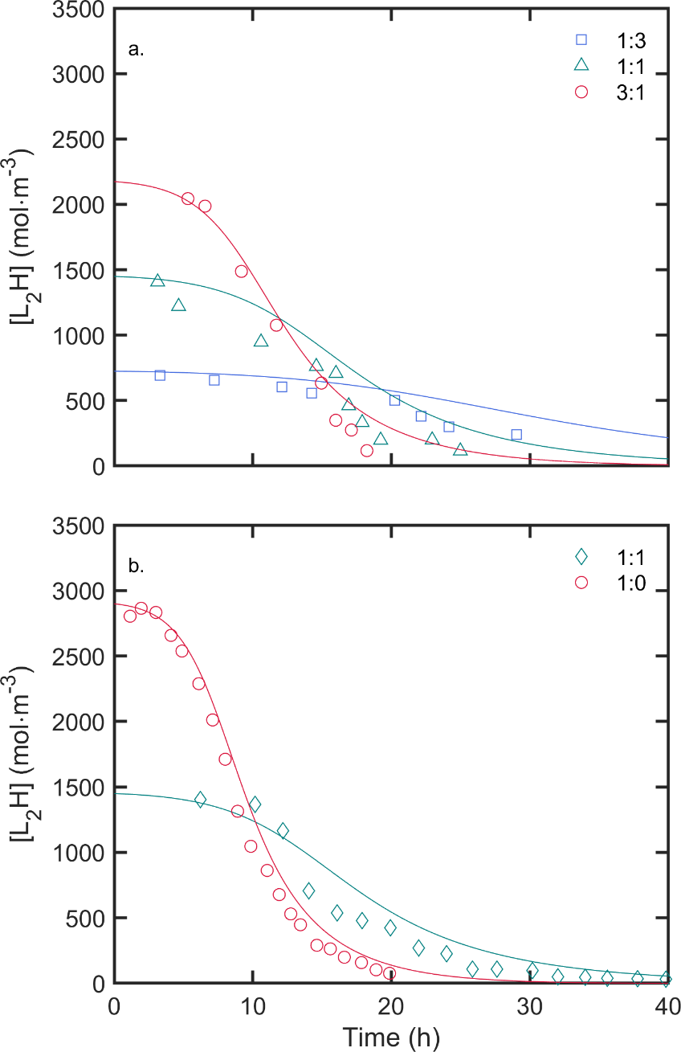

Figure 3: Kinetics of residual methyl linoleate diluted in (a) methyl laurate (experimental data from Ishido, Minemoto, Adachi, and Matsuno (2001)) and (b) methyl palmitate. Experimental data are from Ma, Takahashi, Kobayashi, and Adachi (2012)) during autoxidation at 65°C in a non-limiting oxygen dissolution regime.

## Predicting Oxidation Kinetics of Pure FAMEs from 7°C to 200°C under Non-limiting Oxygen Dissolution Conditions

The kinetics of FAMEs consumption and hydroperoxide accumulation during autoxidation at various temperatures (between 7°C to 200°C) under non-limiting oxygen dissolution conditions at atmospheric pressure are presented in Figure 4 for oleate (a, d), linoleate (b, e) and linolenate (c, f) FAMEs. Predictions were obtained using the model presented by Maxime Touffet, Smith, and Vitrac (2023) modified to integrate the equilibrium between free and cage forms of hydroperoxides (see Eq. ). Free forms decompose according to R1, whereas cage forms decompose bimolecularly via Eq. . The corresponding pre-exponential factors and activation energies are reported in Table 1. . The model predictions are plotted alongside experimental values from this study and collected from the literature.

Across all studied FAMEs, increasing the temperature accelerates substrate consumption and reduces the lag time observed before significant degradation occurs. At the same temperature, methyl oleate is consumed approximately ten times slower than methyl linoleate and about twenty times slower than methyl linolenate, which is in good agreement with the values reported in the review by (Brodnitz, 1968). The model captures these trends well, naturally combining all hydroperoxide decomposition modes without additional fitting. The predictions start to deviate significantly from measurements above 200°C. The global accuracy of the model in predicting hydroperoxide concentrations is reflected in the  values of 0.893 (), 0.613 (), and 0.804 (), as shown in Figure S1 of the Supplementary Material. These predictions are derived from first principles, meaning the model is based on fundamental physical and chemical laws rather than empirical fitting to the experimental data. This approach ensures that the model is predictive rather than descriptive, providing a robust framework for extrapolation to untested conditions.

Hydroperoxides begin to accumulate after the lag phase, with the lag time decreasing at higher temperatures. Hydroperoxides accumulate when the production rate exceeds the decomposition rate, reaching a steady state when the hydroperoxide concentration reaches its maximum. This maximum concentration decreases with increasing temperature, likely due to the higher activation energy associated with the decomposition step than propagation. After the steady state is reached, the concentration of hydroperoxides declines as the high concentration of peroxyl radicals and the diminishing availability of unoxidized methyl esters lead to increased decomposition.

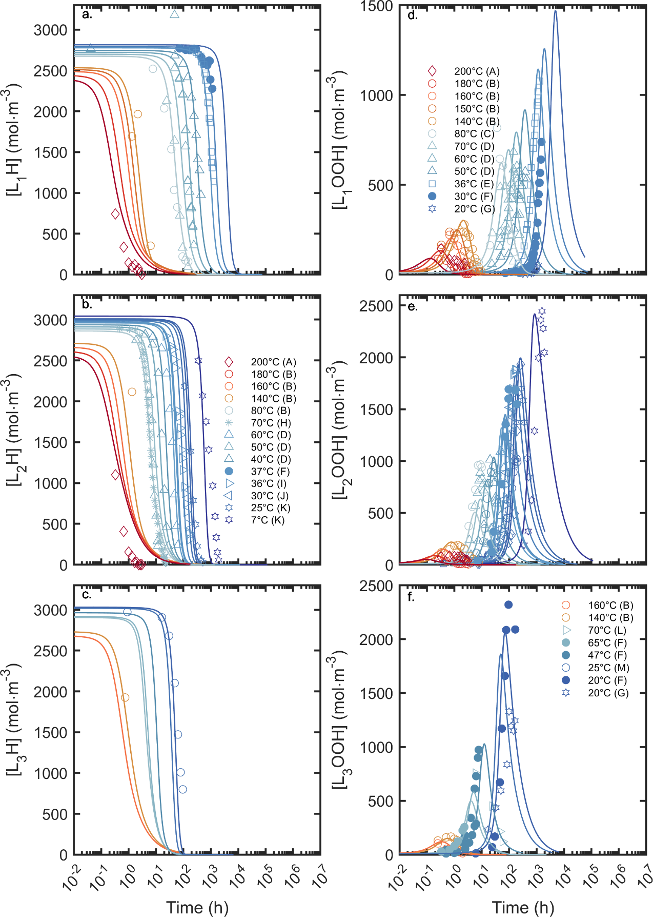

Figure 4: Comparison of predicted (continuous curves) and experimental oxidation kinetics. Experimental data sources: A: (Chen, Tai, Chen, & Chen, 2001); B: Maxime Touffet, Smith, and Vitrac (2023); C: Hamilton and Olcott (1937); D: T. Wang, Lee, da Silva, Hammond, and Yao (2015), E: [Ikeda and Fukuzumi (1978a)](#_ENREF_33" \o "Ikeda, 1978 #41), F: this work, G: Gunstone and Hilditch (1945); H: van't Hoff, Harmon, Orlova, Hermans, Gambardella, and Iedema (2024); I: Ikeda and Fukuzumi (1978b); J: Allen, Jackson, and Kummerow (1949); K: [Tekin and Hammond (2004)](#_ENREF_65" \o "Tekin, 2004 #57); L: Lomanno and Nawar (1982); , M: [Ahn, Kwon, Cho, Kim, and Oh (1989)](#_ENREF_3" \o "Ahn, 1989 #61)

## Model validation

The performance of the oxidation model was rigorously evaluated using multiple statistical metrics to ensure a comprehensive assessment of its predictive accuracy and reliability. While traditional metrics such as the coefficient of determination () indicates the proportion of variance in the experimental data explained by the model, they alone are insufficient to fully characterize the model's performance. Therefore,  was interpreted alongside complementary metrics, notably the Concordance Correlation Coefficient (CCC) and the Prediction Interval Coverage Probability (PICP), which are described in detail in Supplementary Material S3. These metrics provide critical insights into the model's precision, accuracy, and uncertainty quantification.

The likelihood of the model and its predictions were analyzed individually for each of the 31 experimental datasets, which collectively encompass 391 measured hydroperoxide concentrations. Although the model is built from first principles—with parameters derived independently of the experimental data—the initial concentrations of reactive species (including hydroperoxides) were experiment-dependent. This distinction ensures that the model's predictions are evaluated under realistic, varied conditions, thereby demonstrating its robustness and generalizability. The complete analysis is documented in Supporting Material S4 and summarized in Table 3, where results are organized into three temperature ranges: (i) chilled and ambient temperatures, (ii) intermediate temperatures near the critical temperature, and (iii) high temperatures. Four outlier datasets were identified based on discrepancies with other datasets and their CCC values lower than 0.5 (see Table 1 of the Supplementary Material).

Direct comparisons between model predictions and experimental measurements revealed high concordance, with CCC values exceeding 0.78 and PICP values typically close to or above 50%, despite the non-linear model not being tuned to the data. Deviations in predictions ranged between a factor of 0.5 to 1.8. No systematic bias was observed across the three temperature ranges. The poorest predictions (CCC≤0.11) were obtained at 200°C, likely because additional mechanisms not captured by the current scheme may occur at this temperature. Dataset L (70°C) yielded intermediate predictions (CCC≈0.45) due to detection limit issues. On average, prediction errors—quantified in terms of the median relative deviation—range from ±20% to ±30%, which is consistent with the overall experimental uncertainty, including variations due to sample handling and differences in oxygenation conditions before, during, and after the experiments. Notably, most experiments did not strictly adhere to isothermal oxidation kinetics, further contributing to the observed variability.

Moreover, because the model is derived solely from first principles without data fitting, the observed error levels are anticipated to remain consistent when extrapolating to longer reaction times, variable temperature conditions, and different FAME compositions. This extrapolative capability underscores the robustness of the underlying mechanistic framework. These non-linear extrapolation features are illustrated in Figure 3 and Figure 4.

Table 3. Performance of the oxidation model across the temperature spectrum.

|  |  |  |  |
| --- | --- | --- | --- |
| Temperature Range →  ↓Hydroperoxide | **Chilled and ambient Temperatures**  **(7-40°C)** | **Intermediate Temperatures**  **(45-80°C)** | **High Temperatures  (140-200°C)** |
| **L1OOH**  *a*CCC range  *b*PICP range (%)  *c*RD range  Outliers‡:  *a*CCC range  *b*PICP range (%)  *c*RD range | *references†: E,F,G*   * 0.92 – 0.96 * 44.0 – 72.7 * 0.66 – 1.28   *references†: N/A* | *references†: C*   * 0.79 – 0.92 * 30.0 – 42.9 * 0.76 – 1.56   *references†: D (70°C)*   * 0.43 * 23.3 – 83.25 * 1 - 7.82 | *references†: B*   * 0.81 – 0.88 * 33.3 – 60.0 * 0.53 – 0.79   *references†: A (200°C)*   * 0.11 * 2.52 – 55.61 * 0.029 – 0.39 |
| **L2OOH**  *a*CCC range  *b*PICP range (%)  *c*RD range  Outliers‡:  *a*CCC range  *b*PICP range (%)  *c*RD range | *references†: D,F,I,J,K*   * 0.79 – 0 .99 * 45.2 – 76.9 * 0.69 – 1.2   *references†: N/A* | *references†: B,D*   * 0.86 – 0.97 * 45.5 – 63.3 * 0.49 – 1   *references†: N/A* | *references†: B*   * 0.78 – 0.90 * 60.0 – 77.8 * 0.82 – 1.0   *references†: A (200°C)*   * 0.02 * 2.52 – 55.61 * 0.027 – 0.19 |
| **L3OOH**  *a*CCC range  *b*PICP range (%)  *c*RD range  Outliers‡:  *a*CCC range  *b*PICP range (%)  *c*RD range | *references†: F,G*   * 0.96 * 33.5 – 79.7 * 0.98 – 1.7   *references†: N/A* | *references†: F*   * 0.92 * 14.3 – 82.7 * 0.54 – 1.11   *references†: L (70°C)*   * 0.45 * 5.3 – 85.3 * 0.01 – 1 | *references†: B*   * 0.91 – 0.92 * 37.5 – 96.3 * 0.81 – 1.12   *references†: N/A* |

†References used in Figure 4.

‡ Datasets were considered outliers when their CCC was lower than 0.5.

*a* Concordance Correlation Coefficient defined in Eq. (S5) of the Supplementary Material: Measures the agreement between predicted and experimental values, accounting for both precision and bias. Values range from −1 (perfect disagreement) to 1 (perfect agreement).

*b* Prediction Interval Coverage Probability defined in Eq. (S8) of the Supplementary Material: Estimates the fraction of experimental data points within the model's prediction intervals, reflecting the reliability of uncertainty quantification. For multiple datasets, the range of values represents the minimum and maximum of the likeliest PICP value observed across the datasets. For a single dataset, the 95% confidence interval is provided, as calculated in Eqs. (S9)-(S10) of the Supplementary Material.

*c* Relative Deviation characterizes the systematic under- or over-estimation of predictions relative to experimental values. For multiple datasets, the range of values represents the minimum and maximum of the likeliest deviation ratio. For a single dataset, the 95% confidence interval is provided instead.

## Discussion about Termination Reactions between Peroxyl Radicals

Termination reactions between peroxyl radicals are crucial in halting oxidation, mainly when the oxygen partial pressure is over 13 kPa. However, some reported reaction rates at high temperatures (above 130°C) occasionally surpass the theoretical limit of 106 m3·mol-1·s-1. The Smoluchowski limits for all FAMEs were calculated with Eq. and the Stoke-Einstein equation using the dynamic viscosity values taken from Maxime Touffet, Smith, and Vitrac (2023) and with a ratio  (Tande, Wagner, Mackay, Hawker, & Jeong, 2001). These limits are consistent across different FAMEs, ranging from 8·105 at 7°C and 2·107 at 200°C.

For methyl oleate, the termination reactions involving methyl oleate peroxyl radicals are not diffusion-controlled over most of the temperature range studied (7°C to 180°C): . Only above 180°C does the contribution of diffusion become slightly noticeable. In contrast, for polyunsaturated FAMEs such as methyl linoleate and methyl linolenate, diffusion effects become significant at lower temperatures—above 100°C for methyl linoleate and above 60°C for methyl linolenate, with .

However, the model likely underestimates the impact of diffusion because the dynamic viscosity of FAMEs increases during autoxidation, as observed by Canakci, Monyem, and Van Gerpen (1999). This increase in viscosity would lower the Smoluchowski limit, thereby affecting the predicted termination rates.

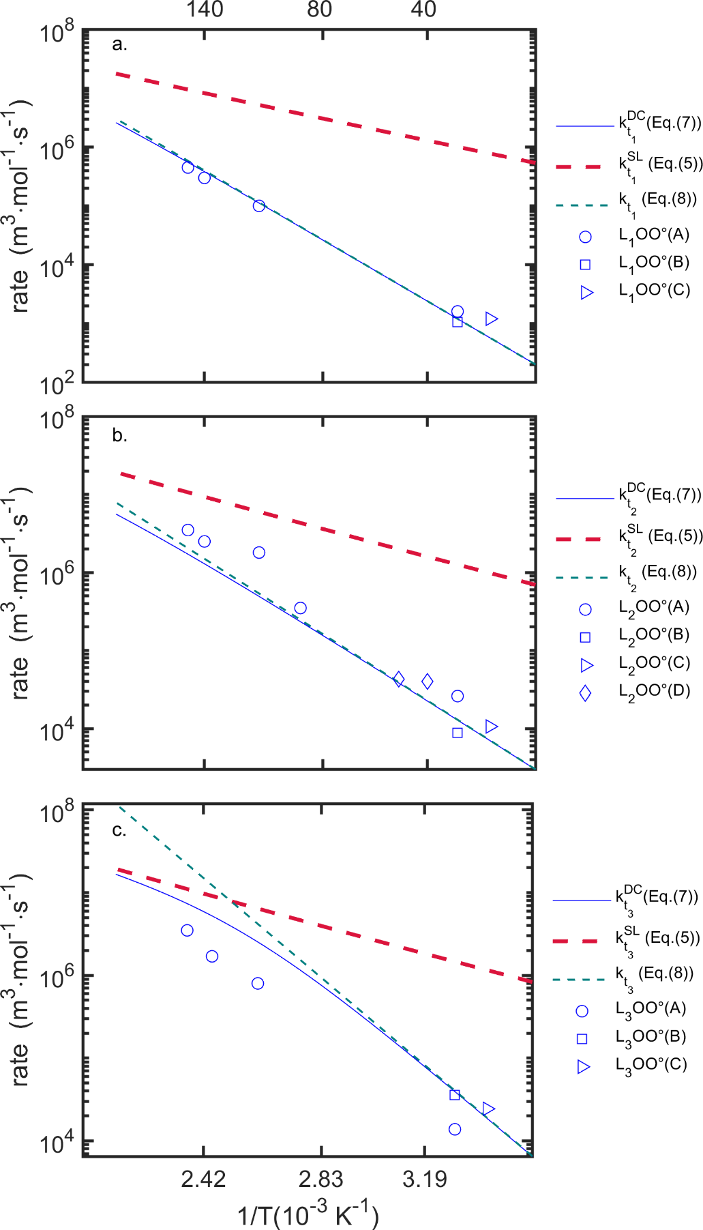

Figure 5: Comparison between predicted termination rates using Eq. and data from the literature. Experimental data sources: A: Richaud, Audouin, Fayolle, Verdu, and Matisova-Rychla (2012), B: Howard and Ingold (1967), , C: Katušin-Ražem and Ražem (2000), D: Tavadyan, Khachoyan, Martoyan, and Kamal-Eldin (2007).

# Conclusions

The oxidation model previously described by Maxime Touffet, Smith, and Vitrac (2023) was extended to lower temperatures by evaluating the critical temperature where hydroperoxides decompose by a monomolecular or bimolecular mechanism. This critical temperature was identified using the methodology proposed by Audouin, Gueguen, Tcharkhtchi, and Verdu (1995) and based on the dependence of induction times on temperature. A deviation from a pure monomolecular mechanism was revealed for temperatures below 80°C, as previously suspected by M. Touffet, Allouche, Ariane, and Vitrac (2021). The updated model captures this transition effectively, allowing it to accurately predict the consumption of FAMEs and the production and decomposition of hydroperoxides across a wide temperature range (7°C to 200°C).

A key aspect of this model is the recognition of a temperature-dependent equilibrium between two distinct populations of hydroperoxides: those that are free and undergo monomolecular decomposition and those involved in hydrogen-bonded cage structures, leading to bimolecular decomposition. The displacement of this equilibrium with temperature is crucial for accurately modeling the oxidation kinetics. Cage-structured hydroperoxides predominate at temperatures below the critical threshold of 80°C, driving the bimolecular decomposition mechanism. As the temperature increases, the equilibrium shifts, favoring the free hydroperoxides and the monomolecular pathway. This seamless integration of the two mechanisms within a unified framework enhances the model’s robustness and applicability.

Despite the model's high accuracy in predicting the oxidation kinetics of FAMEs, the model – built entirely from first principles – requires further refinements to extend its applicability to more complex food systems, such as edible oils. Its extrapolative capacity is a key strength; however, additional work is needed to incorporate factors that influence oxidation under real‐world conditions. For instance, future efforts should directly determine the enthalpy of cage formation for different hydroperoxide types, enabling detailed concentration/temperature diagrams for each FAME. Furthermore, to adapt the model for edible oils, the effects of glycerol esterification—impacting both oxidation rates and tocopherol antioxidant mechanisms—must be considered. In addition, a thorough investigation of oxidation kinetics under limited oxygen transfer conditions is necessary to refine the evaluation of radical termination and oxygen addition rates, which is especially relevant for packaged foods and emulsions.

In summary, while the current model significantly advances our understanding of FAME oxidation over a wide temperature range, these enhancements will pave the way for a more comprehensive and versatile tool for predicting oxidative stability and optimizing product shelf life in complex food matrices.

# Declaration of interest

The authors declare no conflict of interest.

# References

Achimsky, L., Audouin, L., & Verdu, J. (1997). Kinetic study of the thermal oxidation of polypropylene. *Polymer Degradation and Stability, 57*(3), 231-240.

Achimsky, L., Audouin, L., Verdu, J., Rychly, J., & Matisova-Rychla, L. (1997). On a transition at 80 °C in polypropylene oxidation kinetics. *Polymer Degradation and Stability, 58*(3), 283-289.

Ahn, J. K., Kwon, T. B., Cho, M. Z., Kim, S. I., & Oh, S. K. (1989). Kinetic Study on the Autoxidation of Methyl Linolenate by NMR Spectrometer. *The Korean Society for Applied Biological Chemistry, 32*(1), 8-13.

Aladedunye, F. A. (2015). Curbing thermo-oxidative degradation of frying oils: Current knowledge and challenges. *European Journal of Lipid Science and Technology, 117*(11), 1867-1881.

Allen, R. R., Jackson, A., & Kummerow, F. A. (1949). Factors which affect the stability of highly unsaturated fatty acids. I. Differences in the oxidation of conjugated and nonconjugated linoleic acid. *Journal of the American Oil Chemists’ Society, 26*(8), 395-399.

Audouin, L., Gueguen, V., Tcharkhtchi, A., & Verdu, J. (1995). “Close loop” mechanistic schemes for hydrocarbon polymer oxidation. *Journal of Polymer Science Part A: Polymer Chemistry, 33*(6), 921-927.

Bateman, L., Hughes, H., & Morris, A. L. (1953). Hydroperoxide decomposition in relation to the initiation of radical chain reactions. *Discussions of the Faraday Society, 14*(0), 190-199.

Berg, O. G., & Hippel, P. H. v. (1985). Diffusion-Controlled Macromolecular Interactions. *Annual Review of Biophysics and Biophysical Chemistry, 14*(1), 131-158.

Bolland, J. L. (1949). Kinetics of olefin oxidation. *Quarterly Reviews, Chemical Society, 3*(1), 1-21.

Bolland, J. L., & Rideal, E. K. (1946). Kinetic studies in the chemistry of rubber and related materials. I. The thermal oxidation of ethyl linoleate. *Proceedings of the Royal Society of London. Series A. Mathematical and Physical Sciences, 186*(1005), 218-236.

Brodnitz, M. H. (1968). Autoxidation of saturated fatty acids. A review. *Journal of Agricultural and Food Chemistry, 16*(6), 994-999.

Canakci, M., Monyem, A., & Van Gerpen, J. (1999). Accelerated oxidation processes in biodiesel. *Transactions of the ASAE, 42*(6), 1565-1572.

Cash, G. A., George, G. A., & Bartley, J. P. (1987). A chemiluminescence study of the decomposition of methyl linoleate hydroperoxides on active substrates. *Chemistry and Physics of Lipids, 43*(4), 265-282.

Chan, H. W. S., Prescott, F. A. A., & Swoboda, P. A. T. (1976). Thermal decomposition of individual positional isomers of methyl linoleate hydroperoxide: Evidence of carbon-oxygen bond scission. *Journal of the American Oil Chemists’ Society, 53*(9), 572-576.

Chen, J. F., Tai, C. Y., Chen, Y. C., & Chen, B. H. (2001). Effects of conjugated linoleic acid on the degradation and oxidation stability of model lipids during heating and illumination. *Food Chemistry, 72*(2), 199-206.

Chow, C. K. (2007). *Fatty Acids in Foods and their Health Implications*. Boca Raton: CRC Press.

Colin, X., & Verdu, J. (2012). Mechanisms and Kinetics of Organic Matrix Thermal Oxidation. In K. V. Pochiraju, G. P. Tandon & G. A. Schoeppner (Eds.), *Long-Term Durability of Polymeric Matrix Composites*, (pp. 311-344). Boston, MA: Springer US.

Coquillat, M., Verdu, J., Colin, X., Audouin, L., & Nevière, R. (2007). Thermal oxidation of polybutadiene. Part 1: Effect of temperature, oxygen pressure and sample thickness on the thermal oxidation of hydroxyl-terminated polybutadiene. *Polymer Degradation and Stability, 92*(7), 1326-1333.

Costa, M., Losada-Barreiro, S., Paiva-Martins, F., Bravo-Díaz, C., & Romsted, L. S. (2015). A direct correlation between the antioxidant efficiencies of caffeic acid and its alkyl esters and their concentrations in the interfacial region of olive oil emulsions. The pseudophase model interpretation of the “cut-off” effect. *Food Chemistry, 175*, 233-242.

Danoczy, E., Holly, S., Jalsovszky, G., & Gal, D. (1984). Hydrogen bonding in .alpha.-phenylethyl hydroperoxide. *The Journal of Physical Chemistry, 88*(6), 1190-1194.

Del Nobile, M. A., Bove, S., La Notte, E., & Sacchi, R. (2003). Influence of packaging geometry and material properties on the oxidation kinetic of bottled virgin olive oil. *Journal of Food Engineering, 57*(2), 189-197.

Denisov, E. T. (1974). Methods for Measuring Rate Constants of Radical Reactions. In E. T. Denisov (Ed.), *Liquid-Phase Reaction Rate Constants*, (pp. 157-172). Boston, MA: Springer US.

Dunn, R. O. (2008). Effect of Temperature on the Oil Stability Index (OSI) of Biodiesel. *Energy & Fuels, 22*(1), 657-662.

FAO/WHO, J. (1996). Report Of The Fifteenth Session Of The Codex Committee On Fats And Oils. *Codex Alimentarius Commission, 17*.

Frankel, E. N., Garwood, R. F., Khambay, B. P. S., Moss, G. P., & Weedon, B. C. L. (1984). Stereochemistry of olefin and fatty acid oxidation. Part 3. The allylic hydroperoxides from the autoxidation of methyl oleate. *Journal of the Chemical Society, Perkin Transactions 1*(0), 2233-2240.

Franks, F., Gent, M., & Roberts, B. (1965). Quantitative study of the oxidative discoloration of ethyl linoleate. III. Some kinetic aspects of the early stages of the hydroperoxidation reaction. *Journal of Applied Chemistry, 15*(6), 243-249.

Gijsman, P., Hennekens, J., & Vincent, J. (1993). The influence of temperature and catalyst residues on the degradation of unstabilized polypropylene. *Polymer Degradation and Stability, 39*(3), 271-277.

Gray, P., & Williams, A. (1959). The Thermochemistry And Reactivity Of Alkoxyl Radicals. *Chemical Reviews, 59*(2), 239-328.

Gunstone, F. D., & Hilditch, T. P. (1945). 220. The union of gaseous oxygen with methyl oleate, linoleate, and linolenate. *Journal of the Chemical Society (Resumed)*(0), 836-841.

Hamilton, L. A., & Olcott, H. S. (1937). VIII. Autoxidation of Oleic Acid, Methyl Oleate, and Oleyl Alcohol. *Industrial & Engineering Chemistry, 29*(2), 217-223.

Hatate, Y., Kawano, Y., & Sone, H. (1989). Autoxidation Rates of Oleic Acid and Oleates. *JOURNAL OF CHEMICAL ENGINEERING OF JAPAN, 22*(4), 407-412.

Howard, J. A., & Ingold, K. U. (1967). Absolute rate constants for hydrocarbon autoxidation. VI. Alkyl aromatic and olefinic hydrocarbons. *Canadian Journal of Chemistry, 45*(8), 793-802.

Ikeda, N., & Fukuzumi, K. (1978a). Autoxidation of Unsaturated Fatty Acid Methyl Esters. I

Monoene Compounds. *Journal of Japan Oil Chemists' Society, 27*(1), 21-25.

Ikeda, N., & Fukuzumi, K. (1978b). Autoxidation of Unsaturated Fatty Acid Methyl Esters. II. Nonconjugated Compounds. *Journal of Japan Oil Chemists' Society, 27*(1), 26-32.

Ingold, K. U. (1969). Peroxy radicals. *Accounts of Chemical Research, 2*(1), 1-9.

Ishido, E., Minemoto, Y., Adachi, S., & Matsuno, R. (2001). Oxidation of Linoleic Acid and Methyl Linoleate Mixed with Saturated Fatty Acid or its Methyl Ester. *LWT - Food Science and Technology, 34*(4), 234-238.

Katušin-Ražem, B., & Ražem, D. (2000). Absolute Rate Constants of Elementary Reaction Steps in Radiation-Induced Peroxidation of Unsaturated Fatty Acids. *The Journal of Physical Chemistry A, 104*(7), 1482-1494.

Khan, N. A., Brown, J. B., & Deatherage, F. E. (1951). Autoxidation of methyl oleate, methyl stearolate, and methyl 9,10-dieuteroöleate. *Journal of the American Oil Chemists' Society, 28*(3), 105-109.

Khelidj, N., Colin, X., Audouin, L., Verdu, J., Monchy-Leroy, C., & Prunier, V. (2006). Oxidation of polyethylene under irradiation at low temperature and low dose rate. Part II. Low temperature thermal oxidation. *Polymer Degradation and Stability, 91*(7), 1598-1605.

Koprucuoglu, Y., Calikoglu, E., Tekin, A., & Hammond, E. G. (2011). Effect of Some Transition Metals on the Monolayer Oxidation of Methyl Linoleate. *Journal of the American Oil Chemists' Society, 88*(11), 1845-1848.

Korcek, S., Chenier, J. H. B., Howard, J. A., & Ingold, K. U. (1972). Absolute Rate Constants for Hydrocarbon Autoxidation. XXI. Activation Energies for Propagation and the Correlation of Propagation Rate Constants with Carbon-Hydrogen Bond Strengths1. *Canadian Journal of Chemistry, 50*, 2285-2297.

Labuza, T. P., & Dugan Jr, L. R. (1971). Kinetics of lipid oxidation in foods. *C R C Critical Reviews in Food Technology, 2*(3), 355-405.

Lomanno, S. S., & Nawar, W. W. (1982). Effect of Heating Temperature and Time on the Volatile Oxidative Decomposition of Linolenate. *Journal of Food Science, 47*(3), 744-746.

Ma, T., Takahashi, T., Kobayashi, T., & Adachi, S. (2012). Oxidation of Methyl Linoleate Mixed with Methyl Octanoate, Laurate or Palmitate. *Japan Journal of Food Engineering, 13*(2), 25-29.

Mallégol, J., Gonon, L., Commereuc, S., & Verney, V. (2001). Thermal (DSC) and chemical (iodometric titration) methods for peroxides measurements in order to monitor drying extent of alkyd resins. *Progress in Organic Coatings, 41*(1), 171-176.

Miller, C. C., & Walker, J. (1924). The Stokes-Einstein law for diffusion in solution. *Proceedings of the Royal Society of London. Series A, Containing Papers of a Mathematical and Physical Character, 106*(740), 724-749.

Mitroka, S., Zimmeck, S., Troya, D., & Tanko, J. M. (2010). How Solvent Modulates Hydroxyl Radical Reactivity in Hydrogen Atom Abstractions. *Journal of the American Chemical Society, 132*(9), 2907-2913.

Moser, B. R. (2009). Comparative Oxidative Stability of Fatty Acid Alkyl Esters by Accelerated Methods. *Journal of the American Oil Chemists' Society, 86*(7), 699-706.

Oakley, L. H., Casadio, F., Shull, K. R., & Broadbelt, L. J. (2018). Examination of Mechanisms for Formation of Volatile Aldehydes from Oxidation of Oil-Based Systems. *Industrial & Engineering Chemistry Research, 57*(1), 139-149.

Okada, Y., Kaneko, M., & Okajima, H. (1996). Hydroxyl Radical Scavenging Activity of Naturally Occurring Furan Fatty Acids. *Biological & Pharmaceutical Bulletin, 19*(12), 1607-1610.

Okamba-Diogo, O., Richaud, E., Verdu, J., Fernagut, F., Guilment, J., & Fayolle, B. (2015). Molecular and macromolecular structure changes in polyamide 11 during thermal oxidation – Kinetic modeling. *Polymer Degradation and Stability, 120*, 76-87.

Okino-Delgado, C. H., Prado, D. Z. d., Facanali, R., Marques, M. M. O., Nascimento, A. S., Fernandes, C. J. d. C., Zambuzzi, W. F., & Fleuri, L. F. (2017). Bioremediation of cooking oil waste using lipases from wastes. *PLOS ONE, 12*(10), e0186246.

Patsioura, A., Ziaiifar, A. M., Smith, P., Menzel, A., & Vitrac, O. (2017). Effects of oxygenation and process conditions on thermo-oxidation of oil during deep-frying. *Food and Bioproducts Processing, 101*, 84-99.

Pfaendtner, J., & Broadbelt, L. J. (2008). Mechanistic Modeling of Lubricant Degradation. 1. Structure−Reactivity Relationships for Free-Radical Oxidation. *Industrial & Engineering Chemistry Research, 47*(9), 2886-2896.

Pizzimenti, S., Bernazzani, L., Duce, C., Tinè, M. R., & Bonaduce, I. (2023). A versatile method to fingerprint and compare the oxidative behaviour of lipids beyond their oxidative stability. *Scientific Reports, 13*(1), 8094.

Richardson, W. H., & Steed, R. F. (1967). Structure of .alpha.-oxo hydroperoxides. *The Journal of Organic Chemistry, 32*(3), 771-774.

Richaud, E., Audouin, L., Fayolle, B., Verdu, J., & Matisova-Rychla, L. (2012). Rate constants of oxidation of unsaturated fatty esters studied by chemiluminescence. *Chemistry and Physics of Lipids, 165*, 753-759.

Riquet, A. M., Wolff, N., Laoubi, S., Vergnaud, J. M., & Feigenbaum, A. (1998). Food and packaging interactions: Determination of the kinetic parameters of olive oil diffusion in polypropylene using concentration profiles. *Food Additives & Contaminants, 15*(6), 690-700.

Rogers, L. A. (1909). *Fishy flavor in butter*. Washington: G.P.O.

Roman, O., Courtois, F., Maillard, M.-N., & Riquet, A.-M. (2012). Kinetic Study of Hydroperoxide Degradation in Edible Oils Using Electron Spin Resonance Spectroscopy. *Journal of the American Oil Chemists' Society, 89*(8), 1409-1417.

Small Jr., R. D., Scaiano, J. C., & Patterson, L. K. (1979). Radical Processes In Lipids. A Laser Photolysis Study Of T-Butoxy Radical Reactivity Toward Fatty Acids. *Photochemistry and Photobiology, 29*(1), 49-51.

Smoluchowski, M. v. (1918). Versuch einer mathematischen Theorie der Koagulationskinetik kolloider Lösungen. *Zeitschrift für Physikalische Chemie, 92U*(1), 129-168.

Tande, B. M., Wagner, N. J., Mackay, M. E., Hawker, C. J., & Jeong, M. (2001). Viscosimetric, Hydrodynamic, and Conformational Properties of Dendrimers and Dendrons. *Macromolecules, 34*(24), 8580-8585.

Tavadyan, L., Khachoyan, A., Martoyan, G., & Kamal-Eldin, A. (2007). Numerical revelation of the kinetic significance of individual steps in the reaction mechanism of methyl linoleate peroxidation inhibited by -tocopherol. *Chemistry and Physics of Lipids, 147*, 30-45.

Tekin, A., & Hammond, E. G. (2004). Products of the surface oxidation of methyl linoleate. *Journal of the American Oil Chemists' Society, 81*(5), 481-485.

Tobolsky, A. V., Metz, D. J., & Mesrobian, R. B. (1950). Low Temperature Autoxidation of Hydrocarbons: the Phenomenon of Maximum Rates1,2. *Journal of the American Chemical Society, 72*(5), 1942-1952.

Touffet, M., Allouche, M. H., Ariane, M., & Vitrac, O. (2021). Coupling between oxidation kinetics and anisothermal oil flow during deep-fat frying. *Physics of Fluids, 33*(085105), 1-16.

Touffet, M., Patsioura, A., Ziaiifar, A. M., Eveleigh, L., & Vitrac, O. (2018). Online reconstruction of oil oxidation kinetics and reaction schemes during deep-frying by deconvolution of ATR-FTIR spectra. *Journal of Food Engineering, 224*, 1-16.

Touffet, M., Smith, P., & Vitrac, O. (2023). A comprehensive two-scale model for predicting the oxidizability of fatty acid methyl ester mixtures. *Food Research International, 173*, 113289.

van't Hoff, T. E., Harmon, R. E., Orlova, Y., Hermans, J. J., Gambardella, A., & Iedema, P. D. (2024). Experimental validation of a reaction network model for autoxidation of linoleate esters. *Progress in Organic Coatings, 189*, 108363.

Walling, C., & Heaton, L. (1965). Hydrogen Bonding and Complex Formation in Solutions of t-Butyl Hydroperoxide1. *Journal of the American Chemical Society, 87*(1), 48-51.

Wang, Q.-D., & Ni, Z.-H. (2016). Theoretical and kinetic study of the hydrogen atom abstraction reactions of unsaturated C6 methyl esters with hydroxyl radical. *Chemical Physics Letters, 650*, 119-125.

Wang, T., Lee, S.-l., da Silva, J. A. C., Hammond, E., & Yao, L. (2015). Determination of Oxidation of Methyl Ricinoleates. *Journal of the American Oil Chemists' Society, 92*(6), 871-880.

Yanishlieva, N. (1973). Über einige eigent€umlichkeiten in der kinetik zu beginn der autoxydation von estern ungesättigter fettsäuren 5. Mitt. Über den mechanismus des hydroperoxidabbaus. *Nahrung, 17*(3), 313-322.

1. * Corresponding author. Tel : +33189101185 ; *E-mail Address*: [olivier.vitrac@agroparistech.fr](mailto:olivier.vitrac@agroparistech.fr) (O. Vitrac).