Edge Intelligence Laboratory
Oviya R
25MML0007

TASK-1
The Data Jar
- The MNIST dataset is taken and loaded. It contains 70000 images out of which 60000 are used for training and 10000 are for testing
- The shape of the training and testing data are printed.
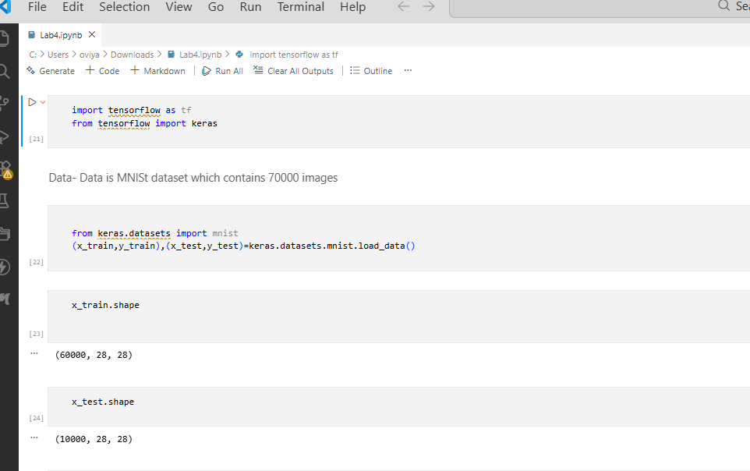

- The Normalisation is done to ensure the range between 0 to 1
- Then data type is also checked.
- The reshaping is done and again the shape of the training and testing data is printed

The Tast Jar:
- The task is to classify the digits in the MNIST dataset.
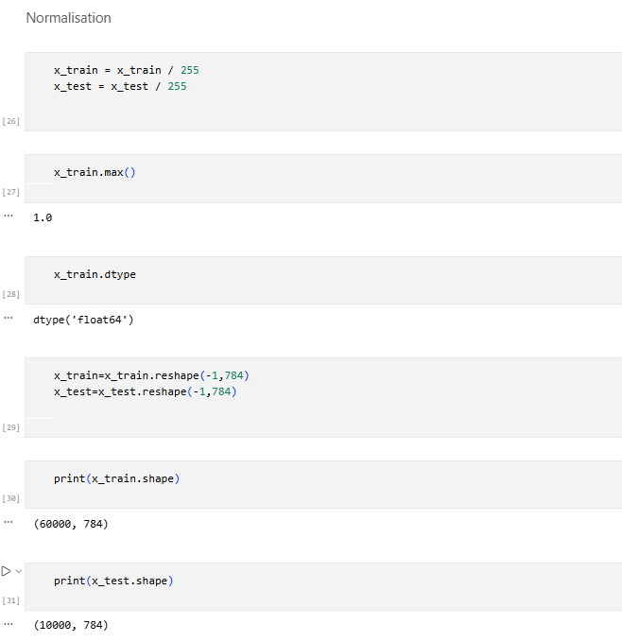
The Model Jar:
- The ANN is used here. Two layers are only used. 128 neurons for input layers and 10 for output layers
- The ReLu activation function is used for input and Softmax is used for output
- Then the model summary is printed

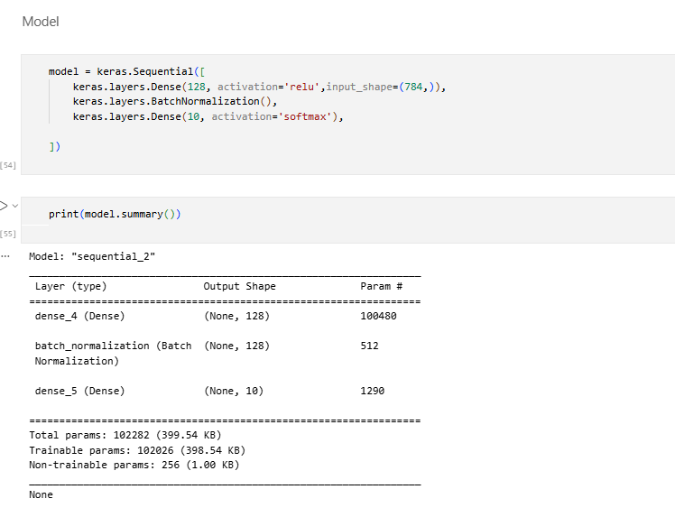

The Loss Jar:
- Here categorical_crossentropy is used for calculating the loss.
- The loss is reduced from 38% to 7.39%

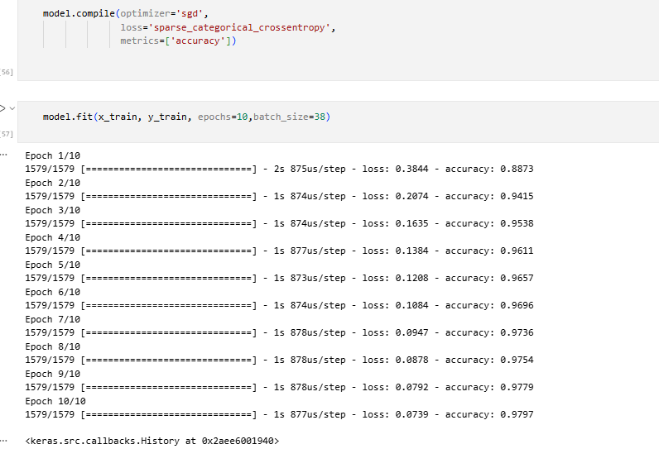

The Accuracy Jar:
- The accuracy of 97.4% is achieved by training the model until 10 epochs with batch size of 38

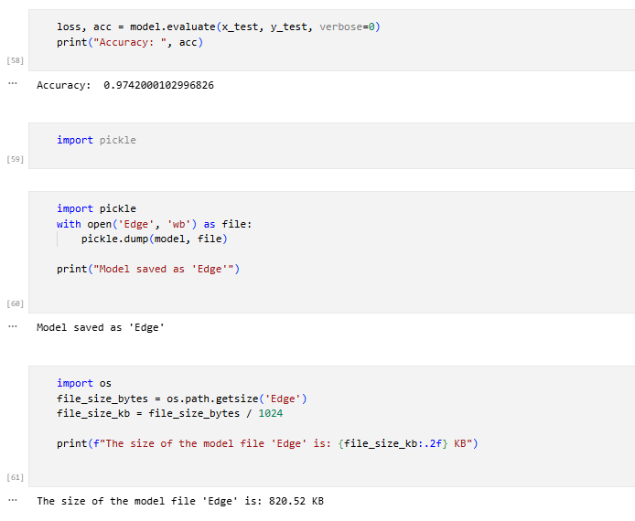

TASK-2

- In Edge Impulse framework, I created an account with username and password
- Then I created a new project.
- In the data acquisition tab, I choose collect data which connects my edge device like smart phone to gather the data
- Then I captured some images of the objects like Fan, Monitor, Mouse, Note and Keyboard.
- I gave the label name and then captured the images of the respective objects.
- I captured total of 20 images among that 16 images are for training and 4 images are for testing.
