1. Convert the Temperature

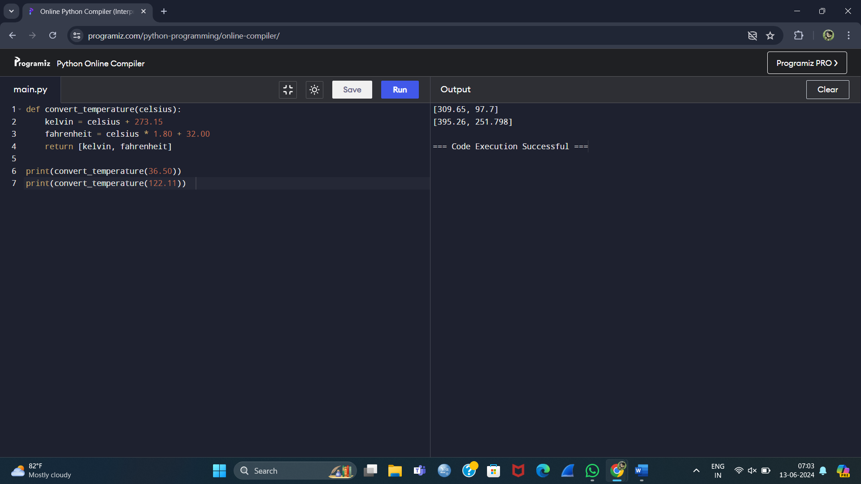

1. Number of Subarrays With LCM Equal to K

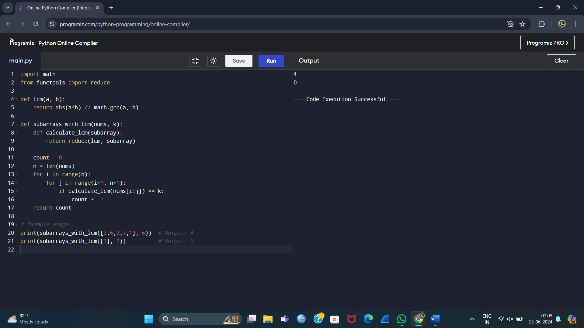

1. Minimum Number of Operations to Sort a Binary Tree by Level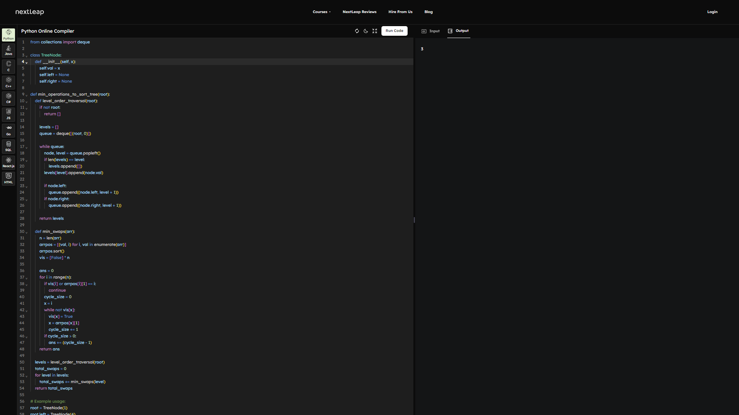
2. Maximum Number of Non-overlapping Palindrome Substrings

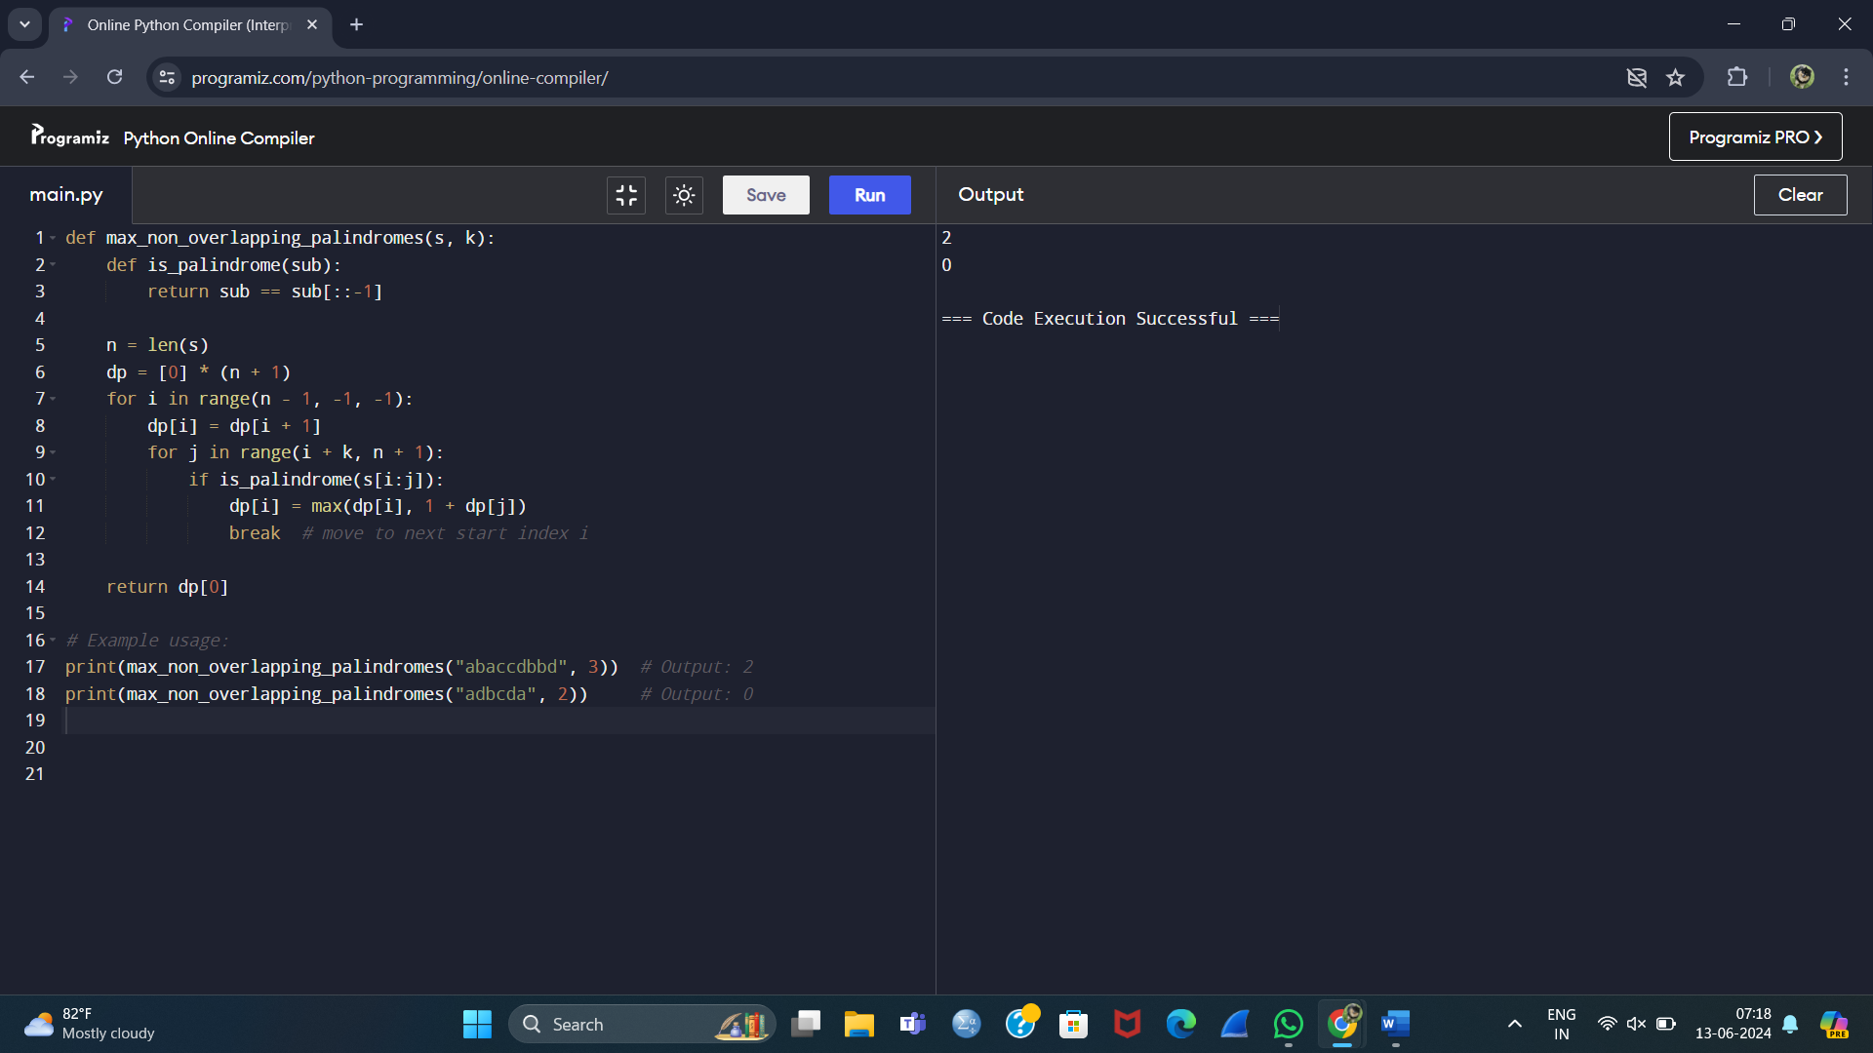

1. Minimum Cost to Buy Apples

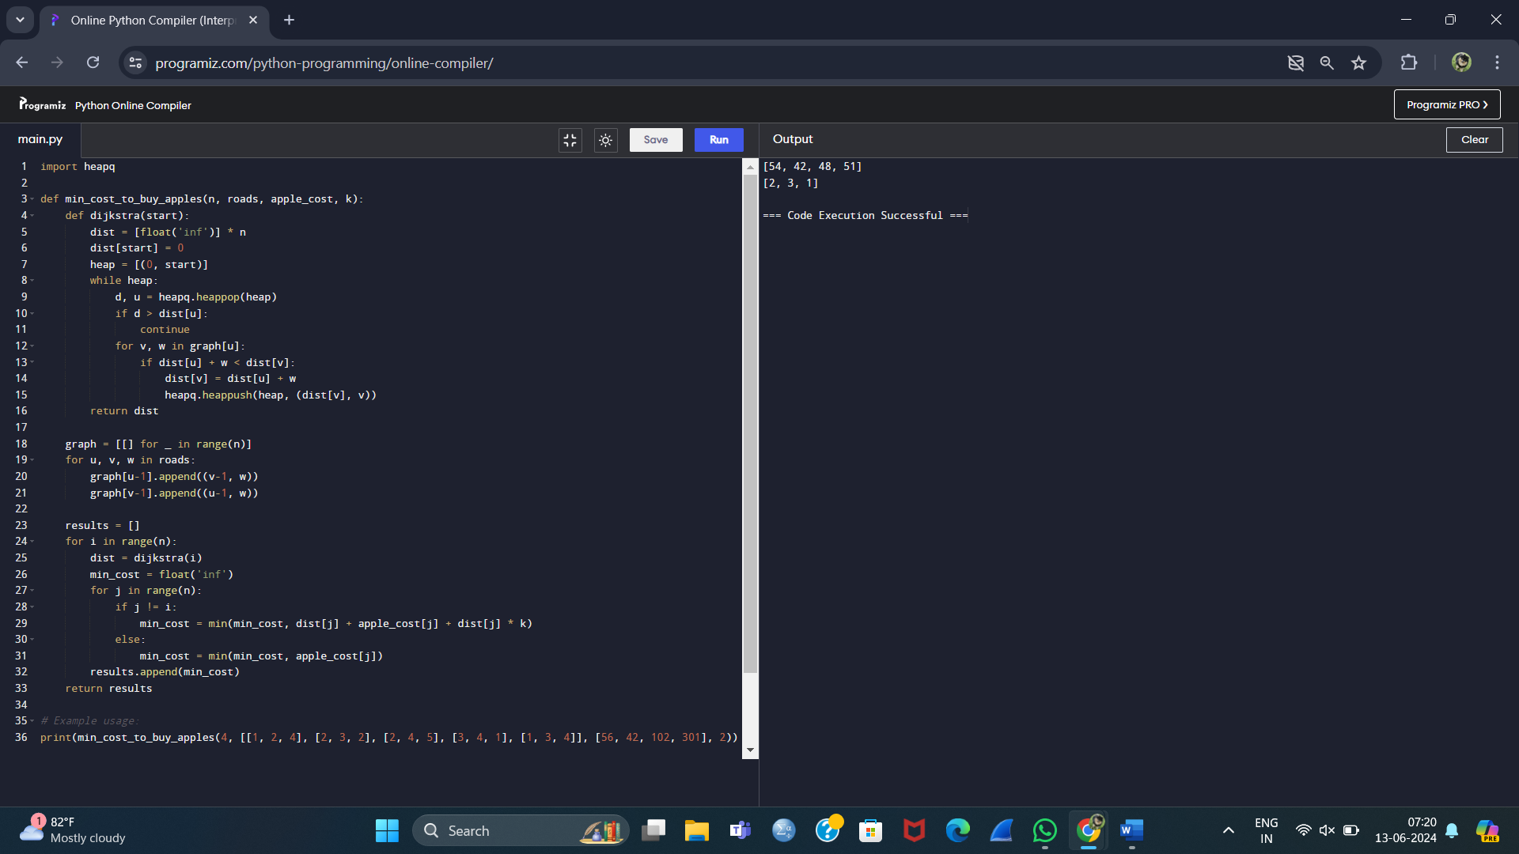

6.SQL

7. Number of Unequal Triplets in Array

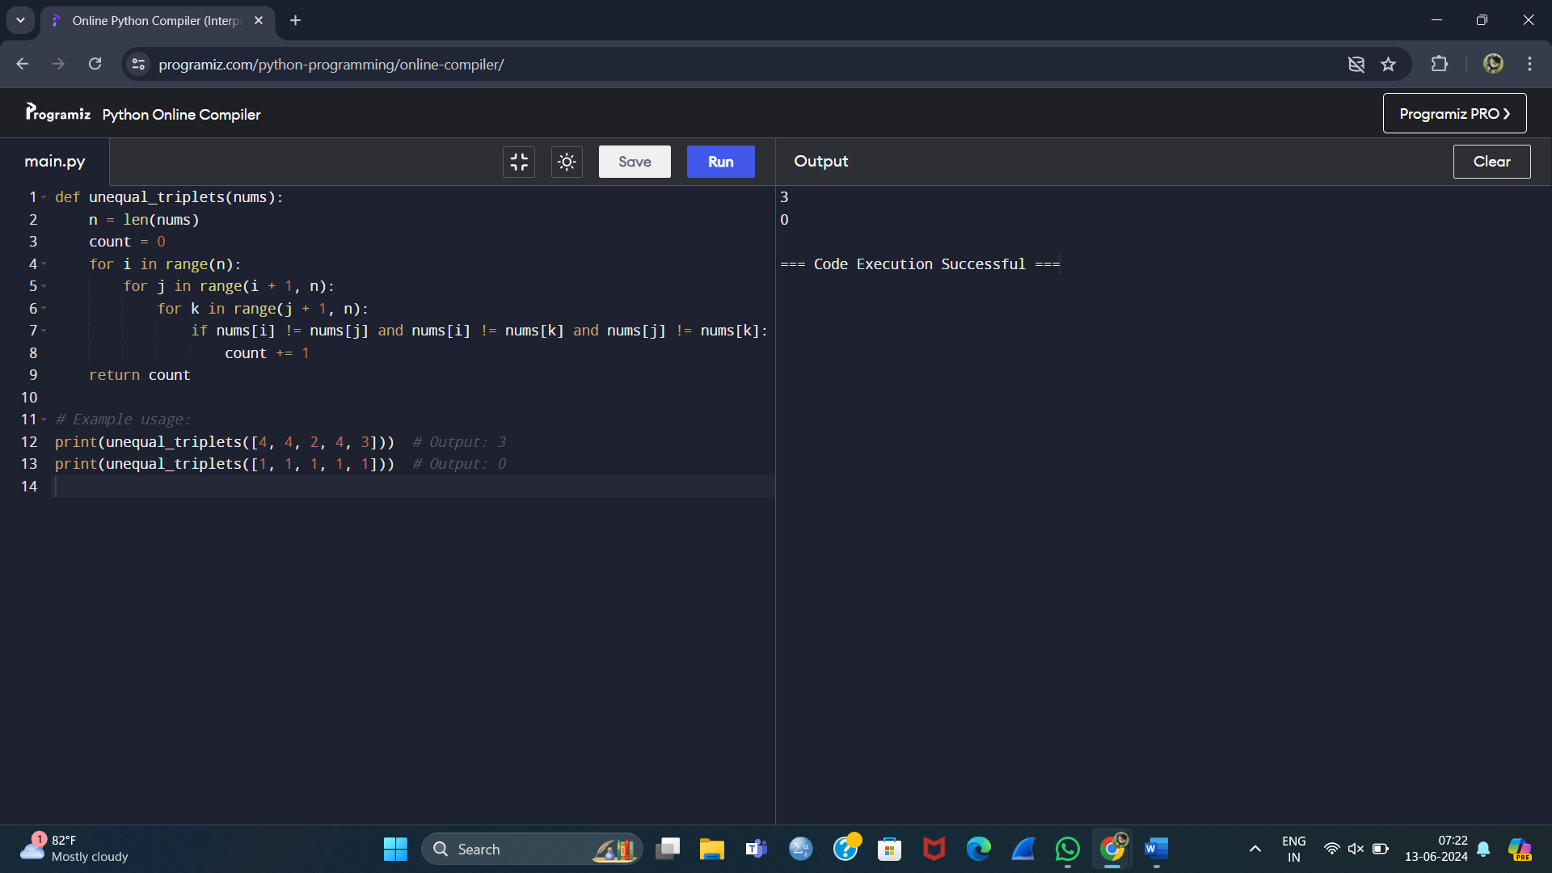

8. Closest Nodes Queries in a Binary Search Tree

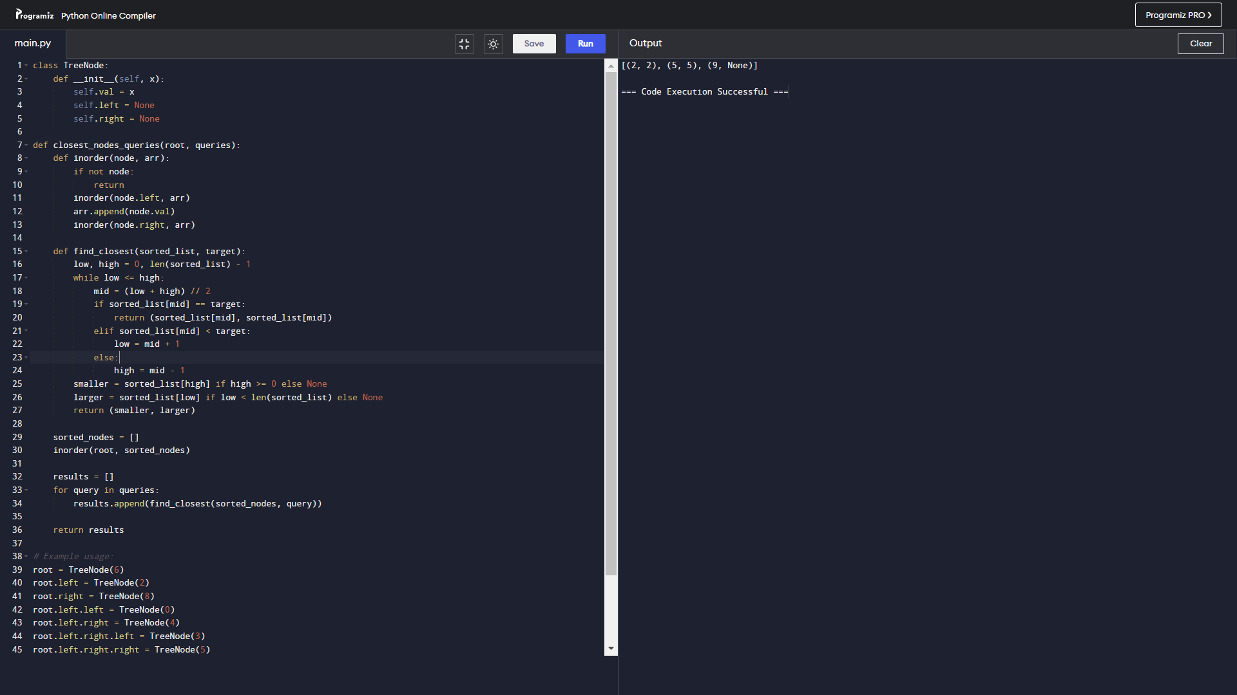

9. Add Edges to Make Degrees of All Nodes Even 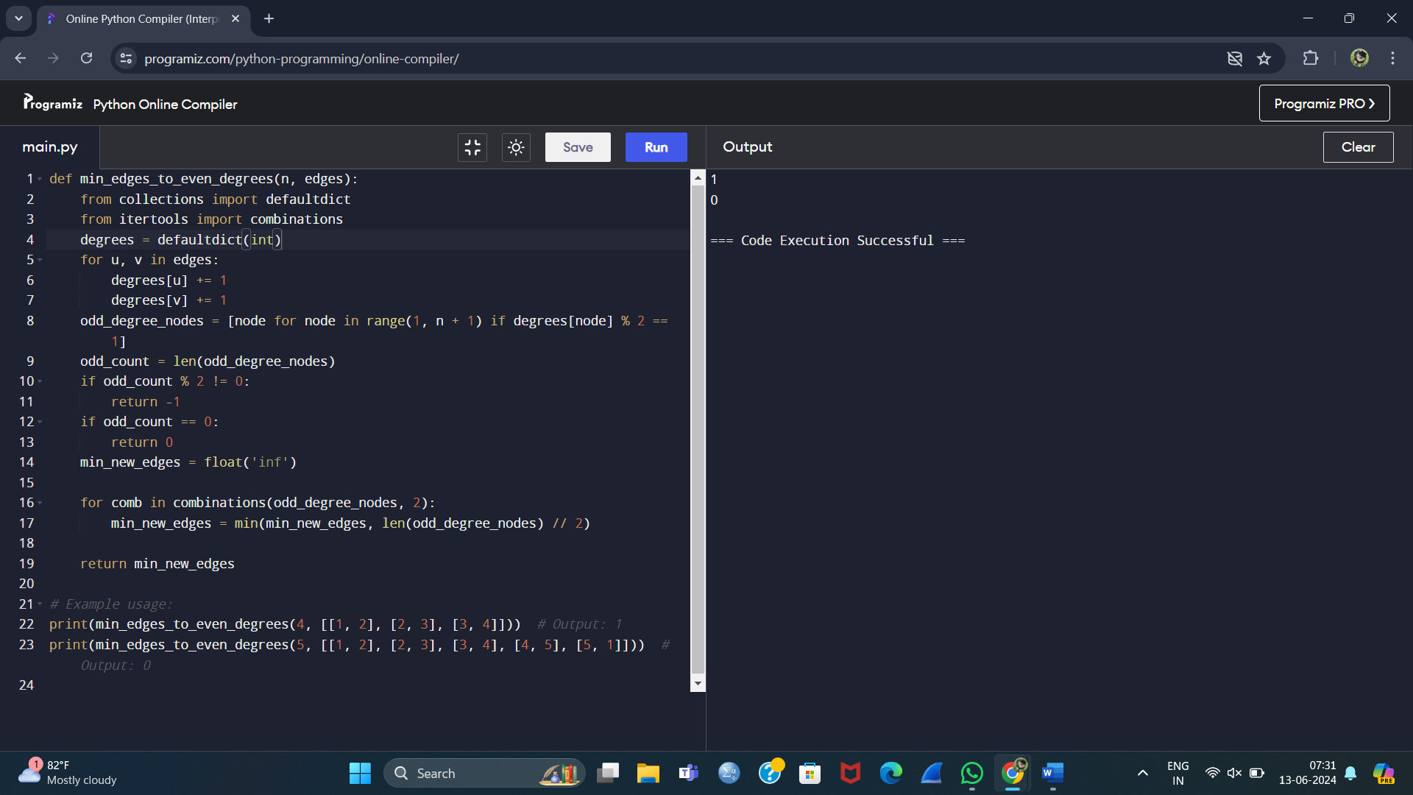

10.SQL