ComicCraft - AI Comic Story Creator using Gemini Models

Milestone 2. Core Functionalities Development

Activity 2.1: Develop the Core Functionalities

Generate Structured Comic Panel Outline
Function: generate_outline()
File: gemini_flash.py
- This function uses the Gemini Flash AI model to generate a structured 5-panel comic outline based on the user's story prompt.
- Each panel contains a panel number, title, scene description, and an image generation prompt.
- The output is a list of dictionaries, one for each comic panel.
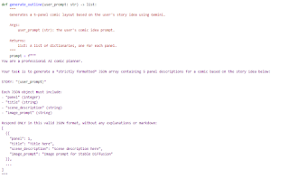
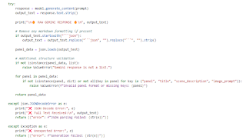

Generate Comic Story Narration and Dialogue
Function: generate_story()
File: gemini_pro.py
- This function uses the Gemini Pro AI model to expand the panel outlines into a full comic-style story.
- It creates engaging narration and character dialogues for each panel.
- The output is a single formatted text containing all the panels' stories.
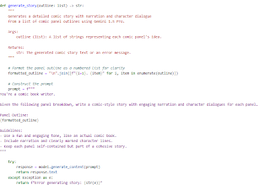

Generate Comic Illustrations from Prompts
Function: generate_image()
File: image_generator.py
- This function uses the Stable Diffusion model to create a comic-style image based on the provided image prompt.
- It sanitizes the prompt for safe filenames and saves the generated image to the static/panels directory.
- Returns the file path to the saved image.
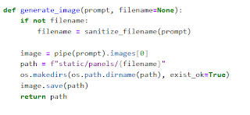

Organize Comic Panels into Layout Structure
Function: build_comic_layout()
File: layout_builder.py
- This function organizes the generated images and full comic story into a structured layout.
- It matches each image with its corresponding panel story.
- The output is a list of dictionaries containing the panel number, image path, and text.
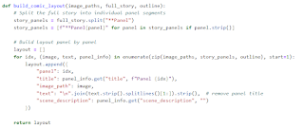

Export Comic Panel and Story into PDF
Function: save_pdf()
File: exporters.py
- This function compiles the full comic into a multi-page PDF file using the FPDF library.
- Each panel's image and narration are placed neatly on separate pages.
- The final PDF file is saved into the static/exports folder, and the path is returned.
