ComicCraft
AI Comic Story Creator using Gemini Models
Project Design Phase
Data Flow Diagrams | Solution & Technical Architecture | User Stories
Prepared by: Oviya
September 2026

1. Introduction
ComicCraft is an AI-powered web application that turns a short story idea into a fully illustrated, five-panel comic. A user submits a story prompt along with a main character name, a setting, a tone, and an art style through a simple web form. The system then uses Google's Gemini models to plan the comic panel-by-panel and write engaging narration and dialogue, and uses a Stable Diffusion image model to illustrate each panel. The finished comic is shown as an in-browser preview and can be downloaded as a formatted PDF.
This document covers the Project Design Phase: the Data Flow Diagrams (Level 0 and Level 1) that describe how information moves through the system, the Solution & Technical Architecture that describes how the frontend, backend, and AI services fit together, and the User Stories that break the build into epics and tasks.

2. Data Flow Diagrams
The Data Flow Diagrams below describe how story data moves through ComicCraft, from the user's initial prompt to the final downloadable comic.

2.1 DFD Level 0 - Context Diagram
The context diagram treats ComicCraft as a single process and shows its three external entities: the User, the Google Gemini API, and the Stable Diffusion model.
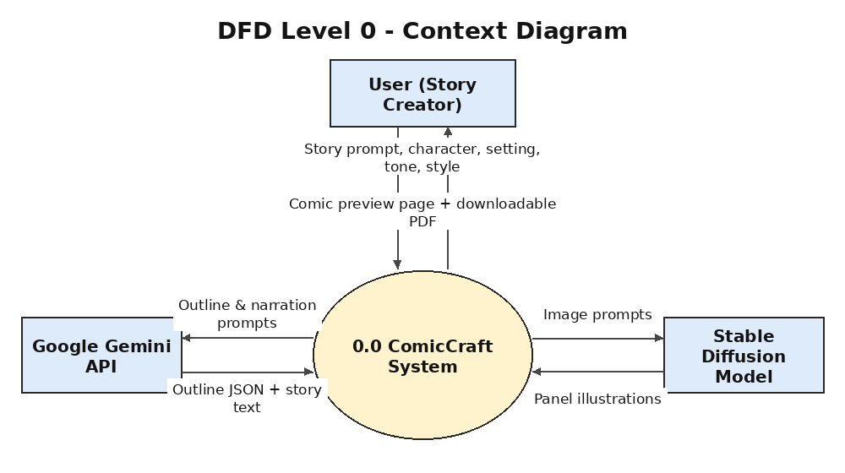
Figure 1: DFD Level 0 - Context Diagram

2.2 DFD Level 1 - Detailed Process Diagram
The Level 1 diagram expands the single process into the six processing steps that run for every comic generation request, along with the intermediate data stores used to pass results between steps.
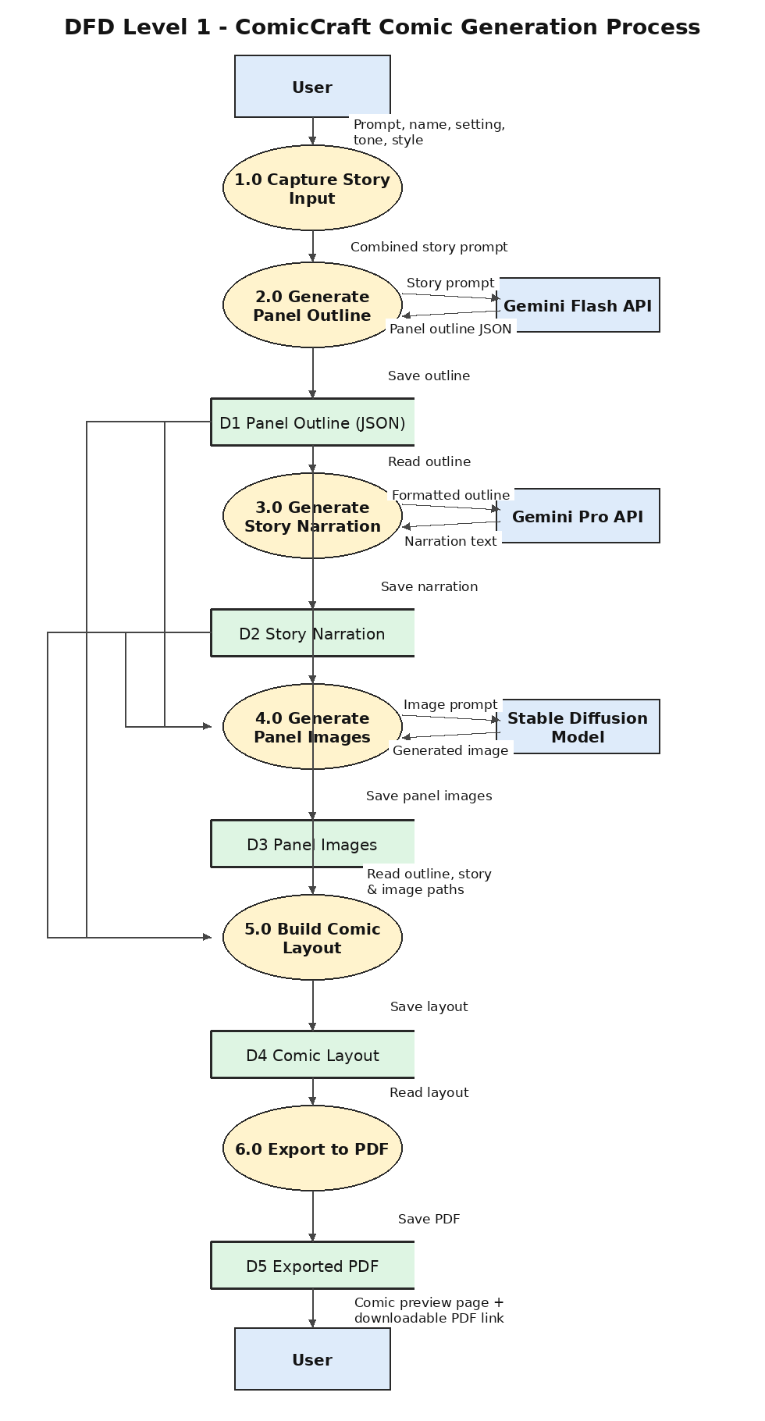
Figure 2: DFD Level 1 - ComicCraft Comic Generation Process

2.3 Process Descriptions
Process No. | Process Name | Description
1.0 | Capture Story Input | Collects the story prompt, character name, setting, tone, and art style from the web form and combines them into a single prompt.
2.0 | Generate Panel Outline | Sends the combined prompt to Gemini Flash and receives a strictly-formatted JSON outline of 5 panels (title, scene description, image prompt).
3.0 | Generate Story Narration | Sends the panel outline to Gemini Pro and receives full comic-style narration and character dialogue for every panel.
4.0 | Generate Panel Images | Sends each panel's image prompt to the Stable Diffusion model and receives a generated illustration, saved under static/panels/.
5.0 | Build Comic Layout | Combines the outline, the narration text, and the generated images into one ordered layout structure, one entry per panel.
6.0 | Export to PDF | Renders the layout into a multi-page PDF (one panel per page, image plus story text) and saves it under static/exports/.

3. Solution & Technical Architecture
ComicCraft follows a simple layered architecture: a browser-based frontend, a FastAPI backend, and a set of AI integration modules that call external generative models. The diagram below shows how a request flows from the user through each layer to produce the final comic.
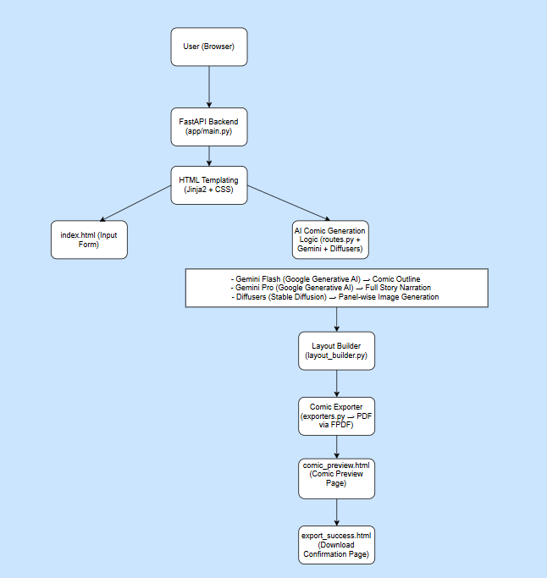
Figure 3: Solution & Technical Architecture

3.1 Component Responsibilities
Component | Technology | Responsibility
Frontend | HTML, CSS, Jinja2 templates | Collects user input (index.html), renders the generated comic preview (comic_preview.html), and shows the export confirmation (export_success.html).
Backend | FastAPI (Python), Uvicorn | Handles routing (routes.py) for both form submissions and a JSON API, coordinates calls to the AI services, and returns rendered pages.
Outline Generation | Gemini Flash (gemini_flash.py) | Converts the user's story idea into a structured 5-panel JSON outline with titles, scene descriptions, and image prompts.
Story Generation | Gemini Pro (gemini_pro.py) | Expands the outline into full comic narration with character dialogue for each panel.
Image Generation | Stable Diffusion via Hugging Face Diffusers (image_generator.py) | Renders a comic-style illustration for every panel's image prompt and saves it to static/panels/.
Layout Builder | layout_builder.py | Merges the outline, narration text, and generated images into one ordered layout used by both the preview page and the PDF exporter.
Comic Exporter | FPDF2 (exporters.py) | Compiles the final layout into a downloadable, multi-page PDF saved to static/exports/.

4. User Stories
The work was broken down into five epics, each covering a stage of the build: choosing and architecting around the right AI models, building the core generation functions, wiring up FastAPI routing, building the frontend, and preparing the app for deployment.
Epic | Story No. | User Story / Task | Acceptance Criteria | Priority
Epic 1: Model Selection  and Architecture | US-1 | Research and select the appropriate generative AI models. | Gemini Flash, Gemini Pro, and a Stable Diffusion model are evaluated and selected based on output quality, speed, and documentation support. | High
 | US-2 | Define the architecture of the application. | A layered architecture (frontend, backend, AI integration) is documented, covering how data flows between components. | High
 | US-3 | Set up the development environment. | Python virtual environment, dependencies, and API keys (Gemini, Hugging Face) are configured and the server starts without errors. | High
Epic 2: Core  Functionalities Development | US-4 | Develop the core functionalities. | generate_outline(), generate_story(), generate_image(), and build_comic_layout() each run correctly and return the expected data structure. | High
 | US-5 | Implement the FastAPI backend to manage routing and user input processing. | Form and JSON requests are validated, routed, and errors are returned with clear HTTP status codes. | High
Epic 3: routes.py  Development | US-6 | Write the main application logic in routes.py. | The /, /generate, /generate-comic/json, /export-success, and /test-image routes all function end-to-end. | High
Epic 4: Frontend  Development | US-7 | Design and develop the user interface. | index.html collects all required fields (prompt, character, setting, tone, style) in a clear, usable form. | Medium
 | US-8 | Create dynamic templates with FastAPI's Jinja2 engine. | comic_preview.html renders all 5 panels with images and text; export_success.html confirms the PDF was created. | Medium
Epic 5: Deployment | US-9 | Prepare the application for local deployment. | requirements.txt, .env configuration, and folder structure are finalized so the app can be installed from scratch. | Medium
 | US-10 | Test and verify local deployment. | The full pipeline (outline -> story -> images -> layout -> PDF) is tested via the browser and /docs, producing a valid PDF. | High

