Basic Concepts of Number Theory and Finite Fields

Divisibility and the Divisibility Algorithm

Divisibility
We say that a nonzero b divides a if a = mb for some m, where a, b, and m are integers. That is, b divides a if there is no remainder on division. The notation b│a is commonly used to mean b divides a. Also, if b│a, we say that b is a divisor of a.
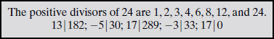
Subsequently, we will need some simple properties of divisibility for integers, which are as follows:
- If a│1, then a =±1.
- If a│b and b│ a, then a =± b.
- Any b ≠0 divides 0.
- If a│b and b│ c, then a│ c:


If b│g and b│h, then b│(mg + nh) for arbitrary integers m and n.

■ If b│g, then g is of the form g = b * g1 for some integer g1.

■ If b│h, then h is of the form h = b * h1 for some integer h1.

So

mg + nh = mbg1 + nbh1 = b * (mg1 + nh1)

and therefore b divides mg + nh.

The Division Algorithm
Given any positive integer n and any nonnegative integer a, if we divide a by n, we get an integer quotient q and an integer remainder r that obey the following relationship:
a = qn + r 0 ≤ r < n; q = [a/n]; The remainder r is often referred to as a residue.
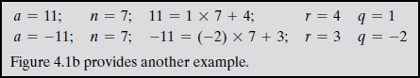

The Euclidean Algorithm
One of the basic techniques of number theory is the Euclidean algorithm, which is a simple procedure for determining the greatest common divisor of two positive integers. First, we need a simple definition: Two integers are relatively prime if their only common positive integer factor is 1.

Greatest Common Divisor
We will use the notation gcd(a, b) to mean the greatest common divisor of a and b. The greatest common divisor of a and b is the largest integer that divides both a and b. We also define gcd(0, 0) = 0.
More formally, the positive integer c is said to be the greatest common divisorof a and b if
- c is a divisor of a and of b.
- Any divisor of a and b is a divisor of c. An equivalent definition is the following:
gcd(a, b) = max[k, such that k│ a and k│ b]
Because we require that the greatest common divisor be positive, gcd(a, b) = gcd(a, -b) = gcd(-a, b) = gcd(-a,-b). In general, gcd(a, b) = gcd( │a│ ,│b│).
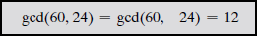

Also, because all nonzero integers divide 0, we have gcd(a, 0) = │a│ . We stated that two integers a and b are relatively prime if their only common positive integer factor is 1. This is equivalent to saying that a and b are relatively prime if gcd(a, b) = 1.

Finding the Greatest Common Divisor
Suppose we have integers a, b such that d = gcd(a, b). Because gcd( │a│ ,│b│) = gcd(a, b), there is no harm in assuming a ≥ b > 0. Now dividing a by b and applying the division algorithm, we can state:
𝑎 = 𝑞₁ + 𝑟₁ 0 ≤ 𝑟₁ < 𝑏
If it happens that 𝑟₁ = 0, then b│a and d = gcd(a, b) = b. But if 𝑟₁ ≠ 0, we can state that d│𝑟₁. Let us assume that 𝑟₁ ≠ 0. Because b > 𝑟₁, we can divide b by 𝑟₁and apply the division algorithm to obtain:
𝑏 = 𝑞₂𝑟₁ + 𝑟₂ 0 ≤ 𝑟₂ < 𝑟₁

As before, if 𝑟₂ = 0, then 𝑑 = 𝑟₁ and if 𝑟₂ ≠ 0, then d = gcd(r1, r2). The division process continues until some zero remainder appears, say, at the (n + 1)th stage where 𝑟_{𝑛−1} is divided by 𝑟_{𝑛}. The result is the following system of equations:
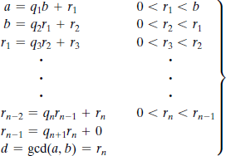
At each iteration, we have d = gcd(𝑟_{𝑖}, 𝑟_{𝑖+1}) until finally d = gcd(𝑟_{𝑛}, 0) = 𝑟_{𝑛}. Thus, we can find the greatest common divisor of two integers by repetitive application of the division algorithm. This scheme is known as the Euclidean algorithm.
Let us now look at an example with relatively large numbers to see the power of this algorithm:
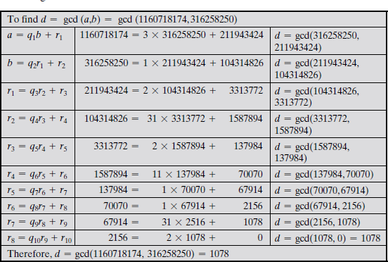
In this example, we begin by dividing 1160718174 by 316258250, which gives 3 with a remainder of 211943424. Next we take 316258250 and divide it by 211943424. The process continues until we get a remainder of 0, yielding a result of 1078. It will be helpful in what follows to recast the above computation in tabular form. For every step of the iteration, we

have 𝑟_{𝑖−2} = 𝑞_{𝑖}𝑟_{𝑖−1} + 𝑟_{𝑖}, where 𝑟_{𝑖−2} is the dividend, 𝑟_{𝑖−1} is the divisor, 𝑞_{𝑖} is the quotient, and 𝑟_{𝑖} is the remainder. Table 4.1 summarizes the results.
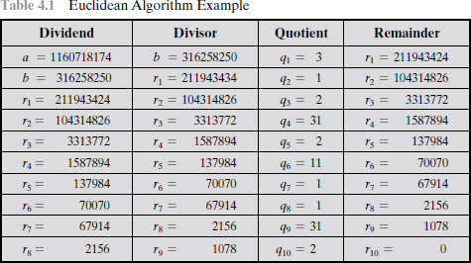

MODULAR ARITHMETIC
The Modulus
If a is an integer and n is a positive integer, we define a mod n to be the remainder when a is divided by n. The integer n is called the modulus.
𝑎 = 𝑞𝑛 + 𝑟 0 ≤ 𝑟 < 𝑛; 𝑞 = [𝑎/𝑛]
𝑎 = [𝑎/𝑛] × 𝑛 + (𝑎 𝑚𝑜𝑑 𝑛)
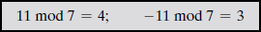
-a mod n={0, if a mod n=0
n-(a mod n),​ otherwise​
Example 1: $-1 mod 5$
Find $q,r$: $-1=(-1)×5+4$, Check: $0≤4<5 ✓$ , $\boxed{-1 mod 5=4}$
Example 2: $-6 mod 5$ $-6=\left(-2\right)×5+4$ , $\boxed{-6 mod 5=4}$
Example 3 : $-8 mod 7$ $-8=\left(-2\right)×7+6$, $\boxed{-8 mod 7=6}$
Example 4: $-13 mod 4$ $-13=(-4)×4+3$, $\boxed{-13 mod 4=3}$
Example 5: $-15 mod 6-15=(-3)×6+3$, $\boxed{-15 mod 6=3}$
Example 6: (using shortcut) $-19 mod 8$
First: $19 mod 8=3$, Then: $-19 mod 8=8-3=5 \boxed{-19 mod 8=5}$
Two integers a and b are said to be congruent modulo n, if (a mod n) = (b mod n). This is written as 𝑎 ≡ 𝑏(𝑚𝑜𝑑 𝑛).
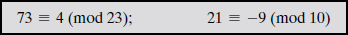

Note that if a ≡ 0 (mod n), then n│ a. Properties of Congruences Congruences have the following properties.
- 𝑎 ≡ 𝑏 (𝑚𝑜𝑑 𝑛) if n│(𝑎 − 𝑏).
- 𝑎 ≡ 𝑏 (𝑚𝑜𝑑 𝑛) implies 𝑏 ≡ 𝑎 (𝑚𝑜𝑑 𝑛).
- 𝑎 ≡ 𝑏 (𝑚𝑜𝑑 𝑛) and 𝑏 ≡ 𝑐 (𝑚𝑜𝑑 𝑛) implies 𝑎 ≡ 𝑐 (𝑚𝑜𝑑 𝑛).

To demonstrate the first point, if n_ (a - b), then (a - b) = kn for some k.
So we can write a = b + kn. Therefore, (a mod n) = (remainder when b +
kn is divided by n) = (remainder when b is divided by n) = (b mod n).

Modular Arithmetic Operations.
Properties
- [(𝑎 𝑚𝑜𝑑 𝑛) + (𝑏 𝑚𝑜𝑑 𝑛)]𝑚𝑜𝑑 𝑛 = (𝑎 + 𝑏) 𝑚𝑜𝑑 𝑛.
- [(𝑎 𝑚𝑜𝑑 𝑛) − (𝑏 𝑚𝑜𝑑 𝑛)]𝑚𝑜𝑑 𝑛 = (𝑎 − 𝑏) 𝑚𝑜𝑑 𝑛.
- [(𝑎 𝑚𝑜𝑑 𝑛) × (𝑏 𝑚𝑜𝑑 𝑛)]𝑚𝑜𝑑 𝑛 = (𝑎 × 𝑏) 𝑚𝑜𝑑 𝑛.
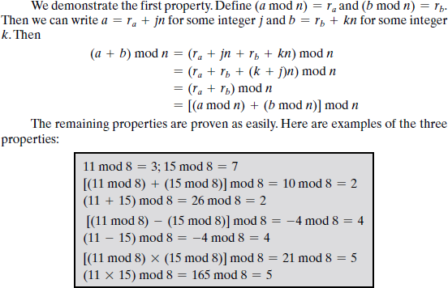

Exponentiation is performed by repeated multiplication, as in ordinary arithmetic.
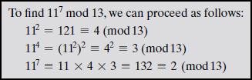

Table 4.2 provides an illustration of modular addition and multiplication modulo 8. Looking at addition, the results are straightforward, and there is a regular pattern to the matrix. Both matrices are symmetric about the main diagonal in conformance to the commutative property of addition and multiplication. As in ordinary addition, there is an additive inverse, or negative, to each integer in modular arithmetic. In this case, the negative of an integer x is the integer y such that (x + y) mod 8 = 0. To find the additive inverse of an integer in the left- hand column, scan across the corresponding row of the matrix to find the value 0; the integer at the top of that column is the additive inverse; thus, (2 + 6) mod 8 = 0. Similarly, the entries

in the multiplication table are straightforward. In ordinary arithmetic, there is a multiplicative inverse, or reciprocal, to each integer. In modular arithmetic mod 8, the multiplicative inverse of x is the integer y such that (x * y) mod 8 = 1 mod 8. Now, to find the multiplicative inverse of an integer from the multiplication table, scan across the matrix in the row for that integer to find the value 1; the integer at the top of that column is the multiplicative inverse; thus, (3
* 3) mod 8 = 1. Note that not all integers mod 8 have a multiplicative inverse.
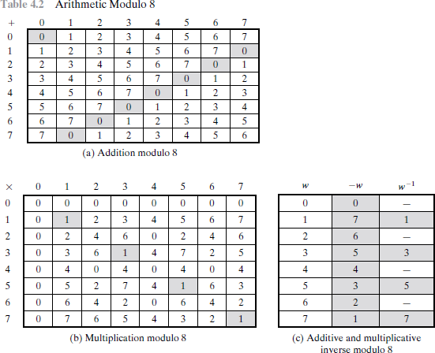

Properties of Modular Arithmetic
Define the set 𝑍_{𝑛} as the set of nonnegative integers less than n:
𝑍_{𝑛} = {0,1, (𝑛 − 1)}
This is referred to as the set of residues, or residue classes (mod n). To be more precise, each integer in 𝑍_{𝑛} represents a residue class. We can label the residue classes
(mod n) as [0], [1], [2], , [n - 1], where
[r] = {a: a is an integer, 𝑎 ≡ 𝑟(𝑚𝑜𝑑 𝑛)}

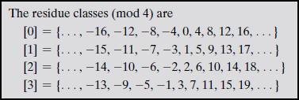

Of all the integers in a residue class, the smallest nonnegative integer is the one used to represent the residue class. Finding the smallest nonnegative integer to which k is congruent modulo n is called reducing k modulo n.
If we perform modular arithmetic within 𝑍_{𝑛}, the properties shown in Table 4.3 hold for integers in 𝑍_{𝑛}.
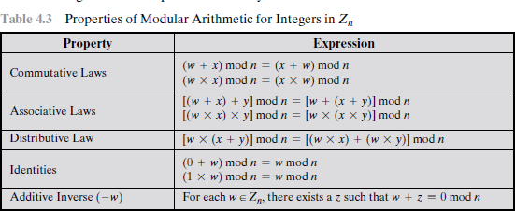

Quadratic Residue?
Let n be a positive integer. An integer a is called a quadratic residue modulo n if there exists an integer x such that:
$$x^{2}≡a ( mod n)$$
a is a quadratic residue mod n if it is the remainder of a perfect square modulo n.
If no such x exists, then a is called a quadratic non-residue modulo n.
x2=x×x
Quadratic residues modulo 7
Compute $x^{2} mod 7$for all possible $x$.
Since modulo 7, it’s enough to check:
$$x=0,1,2,3,4,5,6$$
x x² x²mod7
0 0 0
1 1 1
2 4 4
3 9 2
4 16 2
5 25 4
6 36 1

Quadratic residues mod 7: $\left\{0 , 1 , 2 , 4\right\}$
Quadratic non-residues mod 7: $\left\{3 , 5 , 6\right\}$
Property 1: If p is an odd prime, then:
- There are exactly $\frac{p-1}{2}$non-zero quadratic residues mod p

Property 2 (symmetry)
$$x^{2}≡(-x)^{2} ( mod n)$$

Is 6 a quadratic residue mod 11?
Check from the table:
$$6∉\{0,1,3,4,5,9\}$$
So:
$$\boxed{6\text{ is NOT a quadratic residue mod }11}$$a is a quadratic residue mod n if it is congruent to a square modulo n.

What is a Quadratic Non-Residue?
Let n be a positive integer.
An integer a is called a quadratic non-residue modulo n if:
$$x^{2}≢a ( mod n)\text{for all integers }x$$
In words: a is a quadratic non-residue mod n if it is NOT congruent to any perfect square modulo n.

(mod 11) Squares modulo 11 give: $\left\{0 , 1 , 3 , 4 , 5 , 9\right\}$
Quadratic non-residues mod 11: $\boxed{\left\{2 , 6 , 7 , 8 , 10\right\}}$

The Extended Euclidean Algorithm
For given integers a and b, the extended Euclidean algorithm not only calculate the greatest common divisor d but also two additional integers x and y that satisfy the following equation.
𝑎𝑥 + 𝑏𝑦 = 𝑑 = 𝑔𝑐𝑑(𝑎, 𝑏)
It should be clear that x and y will have opposite signs.
Now let us show how to extend the Euclidean algorithm to determine (x, y, d ) given a and b.
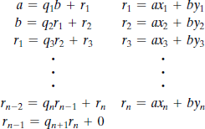

For each of the following equations, find an integer x that satisfies the equation.
- 4x≡2(mod3)
In modular arithmetic, we are allowed to reduce numbers modulo 3.
$$4≡1 ( mod 3)$$So replace 4 by 1 in the equation: 1⋅x≡2(mod3)
which simplifies to: x≡2(mod3), When $x$is divided by 3, the remainder is 2.
So possible values of $x$are: $x=2,5,8,11,…$
- Solve : 7x≡4(mod9)

- Find the modular inverse of: $9^{-1}(mod23)$
This means: Find $x$such that $9x≡1(mod23)$ (Multiply 9 by something → result leaves remainder 1 when divided by 23.)
Use Euclidean Algorithm (find gcd)

We divide repeatedly:
$$23=2(9)+5 \\ 9=1(5)+4 \\ 5=1(4)+1 \\ 4=4(1)+0$$
So: $gcd⁡(23,9)=1$, Inverse exists.

Find:
$$\left(\frac{4}{7}\right)$$
Squares mod 7:
$$1^{2}=1, 2^{2}=4, 3^{2}=2, 4^{2}=2, 5^{2}=4, 6^{2}=1$$
We see 4 appears.
So:
$$\left(\frac{4}{7}\right)=1$$
4 is a quadratic residue.

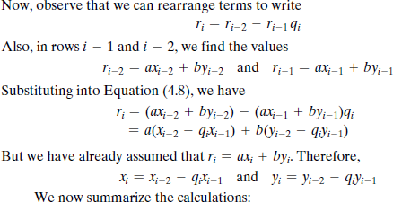
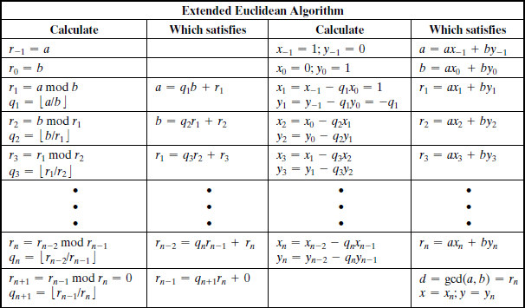

Find multiplicative inverse of 14 modulo 37
14x≡1(mod37).
Use the Extended Euclidean Algorithm
We solve: $14x+37y=1.$
Euclidean division
$$37=2(14)+9 \\ 14=1(9)+5 \\ 9=1(5)+4 \\ 5=1(4)+1$$
Back substitute
$$1=5-4 \\ =5-\left(9-5\right)=2\left(5\right)-9 \\ =2\left(14-9\right)-9=2\left(14\right)-3\left(9\right) \\ =2\left(14\right)-3\left(37-2\left(14\right)\right) \\ =8\left(14\right)-3\left(37\right)$$1=8(14)−3(37), So, $14⋅8≡1\left(mod37\right).$
$$\boxed{{14}^{-1}≡8(mod37)}$$

Solve for $x$:
$$\left\{\begin{aligned}x≡12(mod29) \\ x≡7(mod31) \\ x≡19(mod37)\end{aligned}\right.$$All moduli are pairwise coprime, so a unique solution exists modulo $29×31×37$.

Product of moduli
$$N=29×31×37=33263$$
Partial moduli
$$N_{1}=\frac{33263}{29}=1147 \\ N_{2}=\frac{33263}{31}=1073 \\ N_{3}=\frac{33263}{37}=899$$Find modular inverses
We solve:
$$N_{i}M_{i}≡1(modm_{i})$$

Inverse of $1147(mod29)$
$$1147≡16(mod29)$$
Inverse of 16 mod 29 is:
$$M_{1}=20$$Inverse of $1073(mod31)$
$$1073≡19(mod31)$$
Inverse of 19 mod 31 is:
$$M_{2}=18$$
Inverse of $899(mod37)$
$$899≡11(mod37)$$
Inverse of 11 mod 37 is:
$$M_{3}=27$$Construct CRT solution
$$x=12(1147)(20)+7(1073)(18)+19(899)(27)$$
Compute each term:
$$=275280+135198+461187 \\ x=871665$$Reduce modulo $N$
$$x≡871665(mod33263) \\ x≡6827(mod33263)$$Final Answer
$$\boxed{x≡6827(mod33263)}$$

Alphabet mapping:

$$A=0, B=1, …, Z=25$$

Encryption

$$C=(5P+3)(mod26)$$

Decryption

$$P=5^{-1}(C-3)(mod26)$$

Inverse of 5 mod 26:

$$5^{-1}=21$$

Plaintext → cryptography
Letter | P | $5P+3$mod 26 | Cipher
c | 2 | 13 | n
r | 17 | 10 | k
y | 24 | 19 | t
p | 15 | 0 | a
t | 19 | 20 | u
o | 14 | 21 | v
g | 6 | 7 | h
r | 17 | 10 | k
a | 0 | 3 | d
p | 15 | 0 | a
h | 7 | 12 | m
y | 24 | 19 | t

