**WEEK-3**

**Spring REST using Spring Boot**

**Superset ID: 6419740**

**Hands-on 1:Create a Spring Web Project using Maven**

**Code:**

**SpringLearnApplication.java:**

package com.cognizant.springlearn;

import org.slf4j.Logger;

import org.slf4j.LoggerFactory;

import org.springframework.boot.SpringApplication;

import org.springframework.boot.autoconfigure.SpringBootApplication;

@SpringBootApplication

public class SpringLearnApplication {

private static final Logger LOGGER = LoggerFactory.getLogger(SpringLearnApplication.class);

public static void main(String[] args) {

LOGGER.info("Application Started");

SpringApplication.run(SpringLearnApplication.class, args);

LOGGER.info("Application Ended");

}

}

**HelloController.java:**

package com.cognizant.springlearn.controller;

import org.springframework.web.bind.annotation.GetMapping;

import org.springframework.web.bind.annotation.RestController;

@RestController

public class HelloController {

@GetMapping("/")

public String sayHello() {

return "Welcome to Spring Boot from VS Code!";

}

}

**Output:**

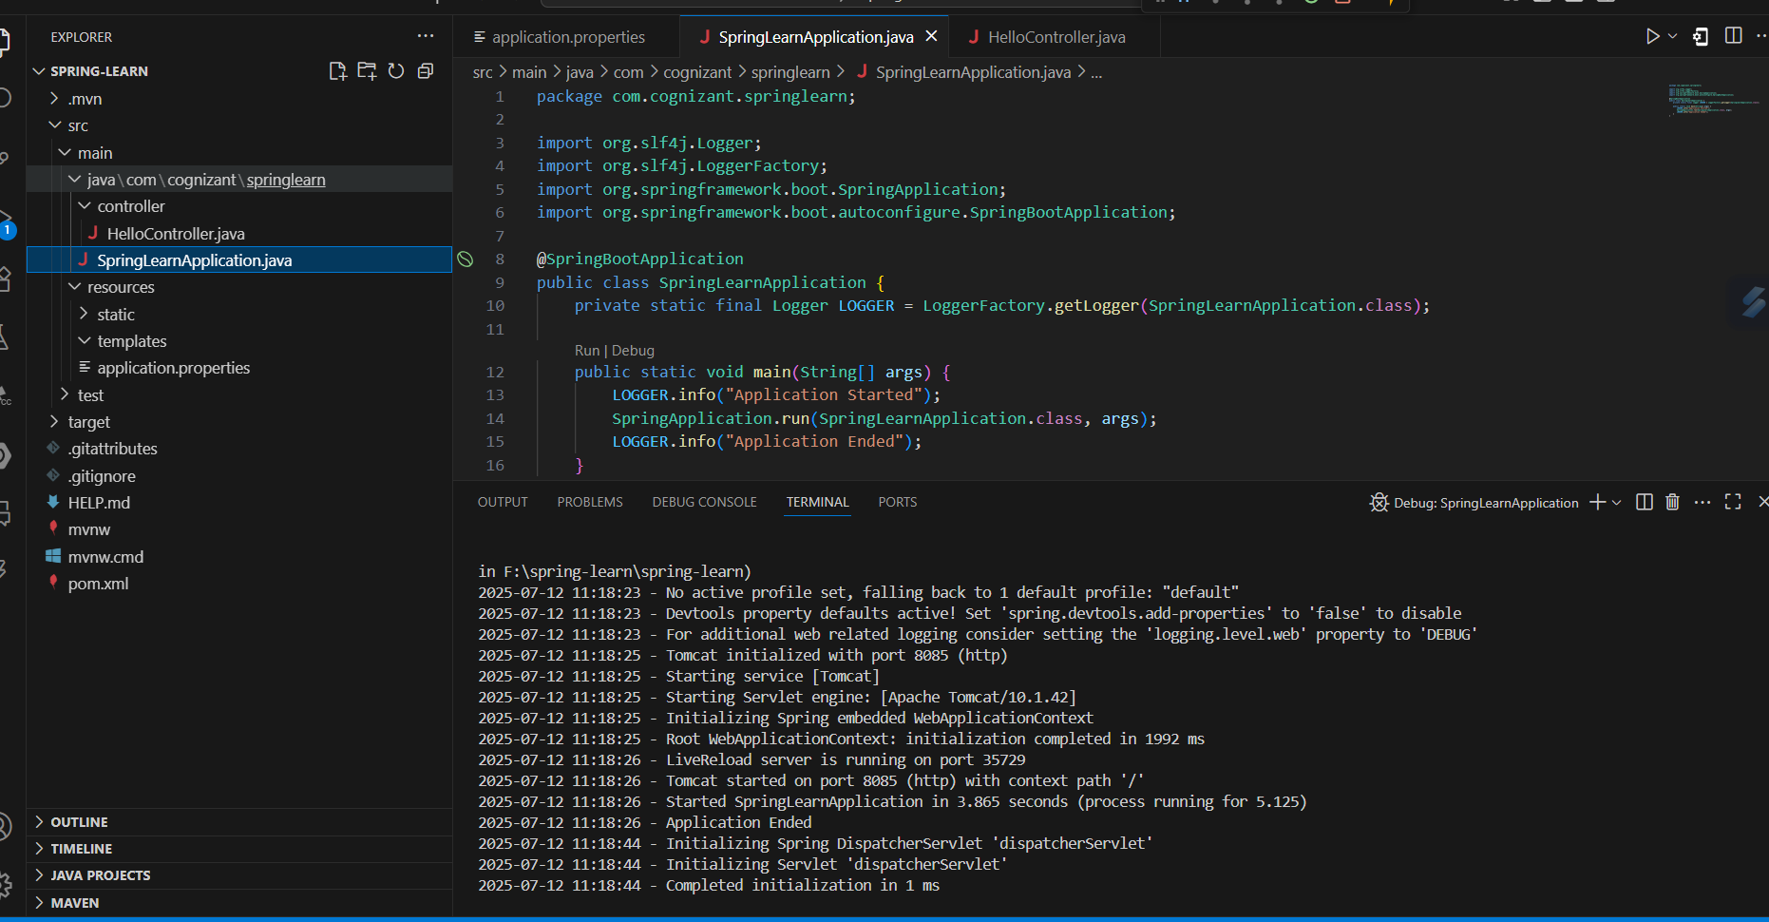

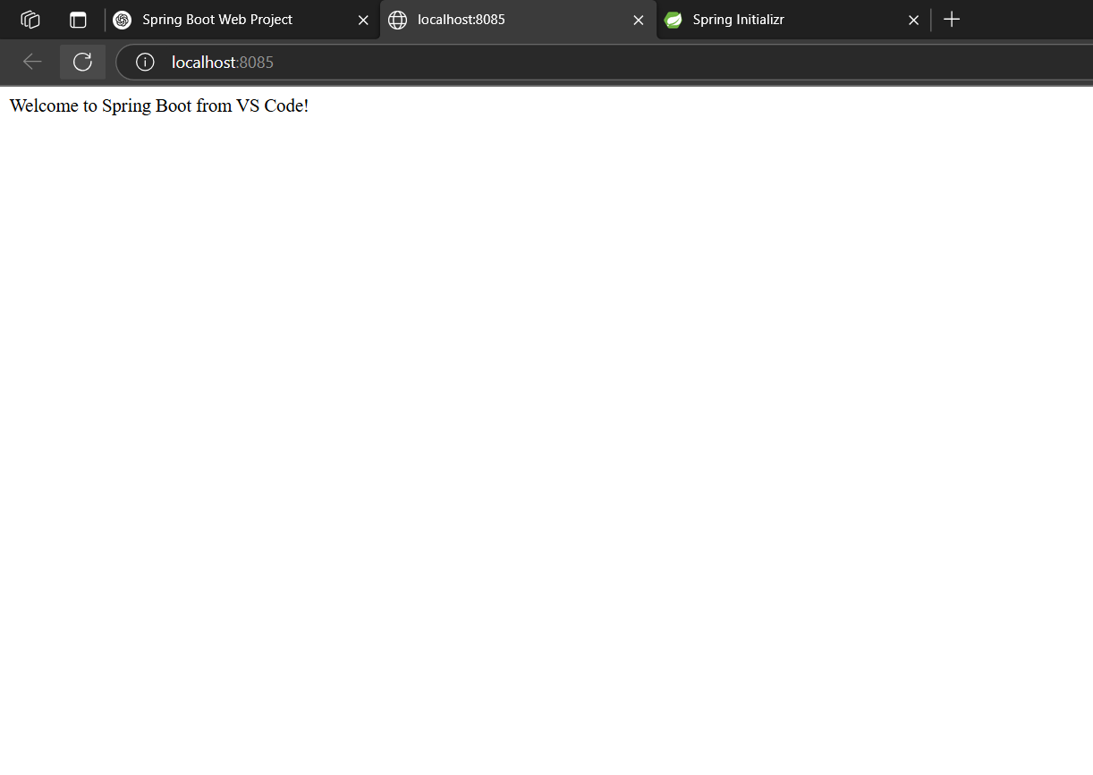

**Hands-on 2**

**Spring Core – Load SimpleDateFormat from Spring Configuration XML**

**Code:**

**SpringLearnApplication.java:**

package com.cognizant.springlearn;

import org.springframework.boot.SpringApplication;

import org.springframework.boot.autoconfigure.SpringBootApplication;

import org.slf4j.Logger;

import org.slf4j.LoggerFactory;

import org.springframework.context.ApplicationContext;

import org.springframework.context.support.ClassPathXmlApplicationContext;

import java.text.SimpleDateFormat;

import java.util.Date;

@SpringBootApplication

public class SpringLearnApplication {

private static final Logger LOGGER = LoggerFactory.getLogger(SpringLearnApplication.class);

public static void main(String[] args) {

LOGGER.info("START");

SpringApplication.run(SpringLearnApplication.class, args);

displayDate();

LOGGER.info("END");

}

public static void displayDate() {

ApplicationContext context = new ClassPathXmlApplicationContext("date-format.xml");

SimpleDateFormat format = context.getBean("dateFormat", SimpleDateFormat.class);

try {

Date date = format.parse("31/12/2018");

System.out.println("Parsed Date: " + date);

} catch (Exception e) {

e.printStackTrace();

}

}

}

**date-format.xml:**

<?xml version="1.0" encoding="UTF-8"?>

<beans xmlns="http://www.springframework.org/schema/beans"

xmlns:xsi="http://www.w3.org/2001/XMLSchema-instance"

xsi:schemaLocation="http://www.springframework.org/schema/beans

https://www.springframework.org/schema/beans/spring-beans.xsd">

<bean id="dateFormat" class="java.text.SimpleDateFormat">

<constructor-arg value="dd/MM/yyyy" />

</bean>

</beans>

**Output:**

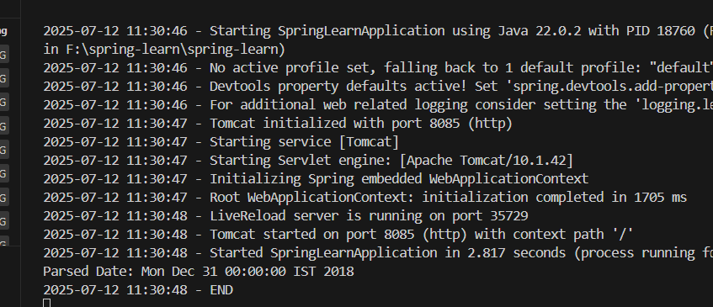

**Hands on 3**

**Spring Core - Incorporate Logging**   
**Code:**

**SpringLearnApplication.java:**

package com.cognizant.springlearn;

import org.springframework.boot.SpringApplication;

import org.springframework.boot.autoconfigure.SpringBootApplication;

import org.slf4j.Logger;

import org.slf4j.LoggerFactory;

import org.springframework.context.ApplicationContext;

import org.springframework.context.support.ClassPathXmlApplicationContext;

import java.text.SimpleDateFormat;

import java.util.Date;

@SpringBootApplication

public class SpringLearnApplication {

private static final Logger LOGGER = LoggerFactory.getLogger(SpringLearnApplication.class);

public static void main(String[] args) {

LOGGER.info("START");

SpringApplication.run(SpringLearnApplication.class, args);

displayDate();

LOGGER.info("END");

}

public static void displayDate() {

LOGGER.info("START");

ApplicationContext context = new ClassPathXmlApplicationContext("date-format.xml");

SimpleDateFormat format = context.getBean("dateFormat", SimpleDateFormat.class);

try {

Date date = format.parse("31/12/2018");

LOGGER.debug("Parsed Date: {}", date.toString());

} catch (Exception e) {

LOGGER.error("Error parsing date", e);

}

LOGGER.info("END");

}

}

**application.properties:**

logging.level.org.springframework=info

logging.level.com.cognizant.springlearn=debug

logging.pattern.console=%d{yyMMdd}|%d{HH:mm:ss.SSS}|%-20.20thread|%5p|%-25.25logger{25}|%25M|%m%n

**Output:**

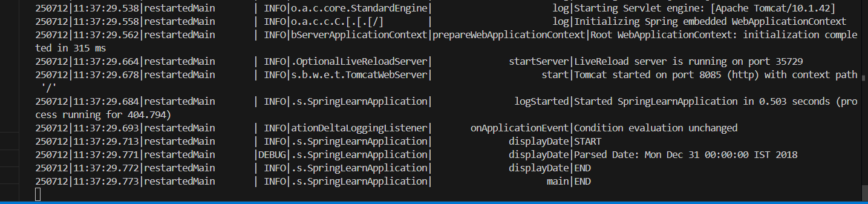

**Hands on 4**

**Spring Core – Load Country from Spring Configuration XML**

**Code:**

**Country.java:**

package com.cognizant.springlearn;

import org.slf4j.Logger;

import org.slf4j.LoggerFactory;

public class Country {

private static final Logger LOGGER = LoggerFactory.getLogger(Country.class);

private String code;

private String name;

public Country() {

LOGGER.debug("Inside Country Constructor.");

}

public String getCode() {

LOGGER.debug("Inside getCode()");

return code;

}

public void setCode(String code) {

LOGGER.debug("Inside setCode()");

this.code = code;

}

public String getName() {

LOGGER.debug("Inside getName()");

return name;

}

public void setName(String name) {

LOGGER.debug("Inside setName()");

this.name = name;

}

@Override

public String toString() {

return "Country [code=" + code + ", name=" + name + "]";

}

}

**SpringLearnApplication.java:**

package com.cognizant.springlearn;

import org.springframework.boot.SpringApplication;

import org.springframework.boot.autoconfigure.SpringBootApplication;

import org.slf4j.Logger;

import org.slf4j.LoggerFactory;

import org.springframework.context.ApplicationContext;

import org.springframework.context.support.ClassPathXmlApplicationContext;

@SpringBootApplication

public class SpringLearnApplication {

private static final Logger LOGGER = LoggerFactory.getLogger(SpringLearnApplication.class);

public static void main(String[] args) {

LOGGER.info("START");

SpringApplication.run(SpringLearnApplication.class, args);

displayCountry();

LOGGER.info("END");

}

public static void displayCountry() {

LOGGER.info("START");

ApplicationContext context = new ClassPathXmlApplicationContext("country.xml");

Country country = context.getBean("country", Country.class);

LOGGER.debug("Country : {}", country.toString());

LOGGER.info("END");

}

}

**Output:**

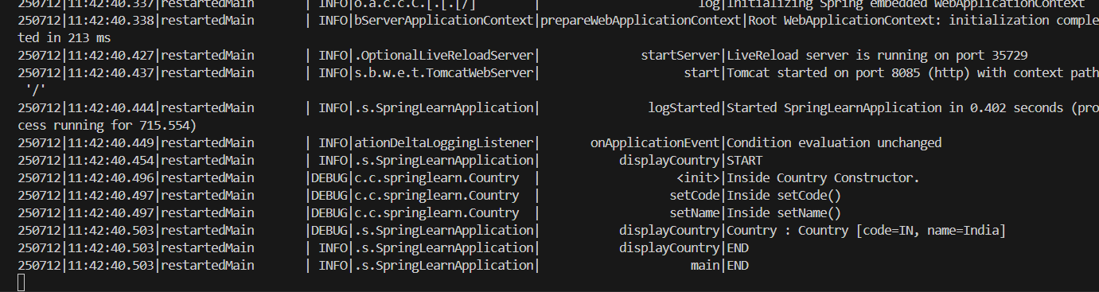

**Hands on 5**

**Spring Core – Demonstration of Singleton Scope and Prototype Scope   
Code:**

**Country.java:**

package com.cognizant.springlearn;

import org.slf4j.Logger;

import org.slf4j.LoggerFactory;

public class Country {

private static final Logger LOGGER = LoggerFactory.getLogger(Country.class);

private String code;

private String name;

public Country() {

LOGGER.debug("Inside Country Constructor.");

}

public String getCode() {

LOGGER.debug("Inside getCode()");

return code;

}

public void setCode(String code) {

LOGGER.debug("Inside setCode()");

this.code = code;

}

public String getName() {

LOGGER.debug("Inside getName()");

return name;

}

public void setName(String name) {

LOGGER.debug("Inside setName()");

this.name = name;

}

@Override

public String toString() {

return "Country [code=" + code + ", name=" + name + "]";

}

}

**SpringLearnApplication.java:**

package com.cognizant.springlearn;

import org.springframework.boot.SpringApplication;

import org.springframework.boot.autoconfigure.SpringBootApplication;

import org.slf4j.Logger;

import org.slf4j.LoggerFactory;

import org.springframework.context.ApplicationContext;

import org.springframework.context.support.ClassPathXmlApplicationContext;

@SpringBootApplication

public class SpringLearnApplication {

private static final Logger LOGGER = LoggerFactory.getLogger(SpringLearnApplication.class);

public static void main(String[] args) {

LOGGER.info("START");

SpringApplication.run(SpringLearnApplication.class, args);

displayCountry();

LOGGER.info("END");

}

public static void displayCountry() {

LOGGER.info("START");

ApplicationContext context = new ClassPathXmlApplicationContext("country.xml");

Country country = context.getBean("country", Country.class);

Country anotherCountry = context.getBean("country", Country.class);

LOGGER.debug("Country : {}", country.toString());

LOGGER.debug("AnotherCountry: {}", anotherCountry.toString());

LOGGER.info("END");

}

}

**Output:**

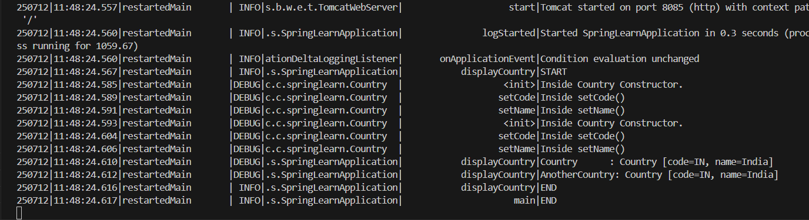

**Hands on 6**

**Spring Core – Load list of countries from Spring Configuration XML**

**Code:**

**Country.xml:**

<?xml version="1.0" encoding="UTF-8"?>

<beans xmlns="http://www.springframework.org/schema/beans"

       xmlns:xsi="http://www.w3.org/2001/XMLSchema-instance"

       xsi:schemaLocation="http://www.springframework.org/schema/beans

       https://www.springframework.org/schema/beans/spring-beans.xsd">

    <!-- Bean for Hands-on 4 & 5 -->

    <bean id="country" class="com.cognizant.springlearn.Country">

        <property name="code" value="IN" />

        <property name="name" value="India" />

    </bean>

    <!-- Beans for individual countries -->

    <bean id="in" class="com.cognizant.springlearn.Country">

        <property name="code" value="IN" />

        <property name="name" value="India" />

    </bean>

    <bean id="us" class="com.cognizant.springlearn.Country">

        <property name="code" value="US" />

        <property name="name" value="United States" />

    </bean>

    <bean id="de" class="com.cognizant.springlearn.Country">

        <property name="code" value="DE" />

        <property name="name" value="Germany" />

    </bean>

    <bean id="jp" class="com.cognizant.springlearn.Country">

        <property name="code" value="JP" />

        <property name="name" value="Japan" />

    </bean>

    <!-- Bean for List of Countries (Hands-on 6) -->

    <bean id="countryList" class="java.util.ArrayList">

        <constructor-arg>

            <list>

                <ref bean="in" />

                <ref bean="us" />

                <ref bean="de" />

                <ref bean="jp" />

            </list>

        </constructor-arg>

    </bean>

</beans>

**SpringLearnApplication.java:**

package com.cognizant.springlearn;

import org.springframework.boot.SpringApplication;

import org.springframework.boot.autoconfigure.SpringBootApplication;

import java.util.ArrayList;

import java.util.List;

import org.slf4j.Logger;

import org.slf4j.LoggerFactory;

import org.springframework.context.ApplicationContext;

import org.springframework.context.support.ClassPathXmlApplicationContext;

@SpringBootApplication

public class SpringLearnApplication {

    private static final Logger LOGGER = LoggerFactory.getLogger(SpringLearnApplication.class);

public static void main(String[] args) {

        LOGGER.info("START");

  SpringApplication.run(SpringLearnApplication.class, args);

        displayCountry();

        displayCountries(); // Calling the list display method

        LOGGER.info("END");

    }

    public static void displayCountry() {

        LOGGER.info("START");

        ApplicationContext context = new ClassPathXmlApplicationContext("country.xml");

        Country country = context.getBean("country", Country.class);

        Country anotherCountry = context.getBean("country", Country.class);

        LOGGER.debug("Country : {}", country.toString());

        LOGGER.debug("Another Country : {}", anotherCountry.toString());

        LOGGER.info("END");

    }

    public static void displayCountries() {

        LOGGER.info("START");

        ApplicationContext context = new ClassPathXmlApplicationContext("country.xml");

        List<Country> countryList = context.getBean("countryList", ArrayList.class);

        LOGGER.debug("Country List : {}", countryList);

        LOGGER.info("END");

    }

}

**Output:**

