**WEEK 4**

**SPRING REST HANDS ON**

**Superset ID: 6419740**

**1.Problem Statement - Display Employee List and Edit Employee form using RESTful Web Service**

**CODE:**

**Employee.java:**  
package com.example.employeeapi.model;

public class Employee {

private int id;

private String name;

private String department;

public int getId() { return id; }

public void setId(int id) { this.id = id; }

public String getName() { return name; }

public void setName(String name) { this.name = name; }

public String getDepartment() { return department; }

public void setDepartment(String department) { this.department = department; }

}

**employees.xml:**

<beans xmlns="http://www.springframework.org/schema/beans"

xmlns:xsi="http://www.w3.org/2001/XMLSchema-instance"

xsi:schemaLocation="http://www.springframework.org/schema/beans

http://www.springframework.org/schema/beans/spring-beans.xsd">

<bean id="employeeList" class="java.util.ArrayList">

<constructor-arg>

<list>

<bean class="com.example.employeeapi.model.Employee">

<property name="id" value="101"/>

<property name="name" value="Oviya"/>

<property name="department" value="IT"/>

</bean>

<bean class="com.example.employeeapi.model.Employee">

<property name="id" value="102"/>

<property name="name" value="Valli"/>

<property name="department" value="HR"/>

</bean>

<bean class="com.example.employeeapi.model.Employee">

<property name="id" value="103"/>

<property name="name" value="Ravi"/>

<property name="department" value="Finance"/>

</bean>

</list>

</constructor-arg>

</bean>

</beans>

**EmployeeService.java:**

package com.example.employeeapi.service;

import com.example.employeeapi.model.Employee;

import org.springframework.stereotype.Service;

import org.springframework.context.support.ClassPathXmlApplicationContext;

import java.util.List;

@Service

public class EmployeeService {

public List<Employee> getAllEmployees() {

ClassPathXmlApplicationContext context = new ClassPathXmlApplicationContext("employees.xml");

return (List<Employee>) context.getBean("employeeList");

}

public Employee getEmployeeById(int id) {

return getAllEmployees()

.stream()

.filter(e -> e.getId() == id)

.findFirst()

.orElse(null);

}

}

**EmployeeController.java:**

package com.example.employeeapi.controller;

import com.example.employeeapi.model.Employee;

import com.example.employeeapi.service.EmployeeService;

import org.springframework.web.bind.annotation.*;

import org.springframework.beans.factory.annotation.Autowired;

import java.util.List;

@RestController

@RequestMapping("/api/employees")

@CrossOrigin(origins = "*") // Optional: allow access from frontend

public class EmployeeController {

@Autowired

private EmployeeService employeeService;

@GetMapping

public List<Employee> getAll() {

return employeeService.getAllEmployees();

}

@GetMapping("/{id}")

public Employee getById(@PathVariable int id) {

return employeeService.getEmployeeById(id);

}

}

**OUTPUT:**

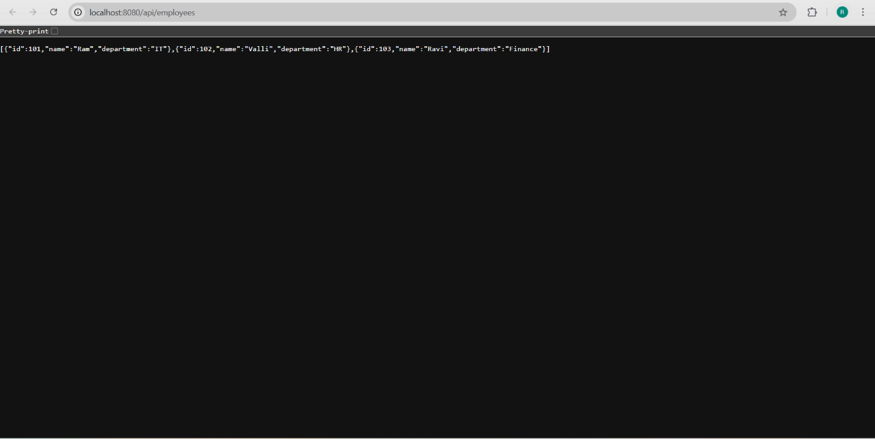

**2.Create static employee list data using spring xml configuration**

**CODE:**

**EmployeeController.java:**

package com.example.employee_api.controller;

import com.example.employee_api.model.Employee;

import com.example.employee_api.service.EmployeeService;

import org.springframework.web.bind.annotation.*;

import org.springframework.beans.factory.annotation.Autowired;

import java.util.List;

@RestController

@RequestMapping("/api/employees")

@CrossOrigin(origins = "*")  // Optional: allow access from frontend

public class EmployeeController {

    @Autowired

    private EmployeeService employeeService;

    @GetMapping

    public List<Employee> getAll() {

        return employeeService.getAllEmployees();

    }

    @GetMapping("/{id}")

    public Employee getById(@PathVariable int id) {

        return employeeService.getEmployeeById(id);

    }

}

**EmployeeDao.java:**package com.example.employee_api.dao;

import com.example.employee_api.model.Employee;

import org.springframework.context.support.ClassPathXmlApplicationContext;

import org.springframework.stereotype.Repository;

import java.util.ArrayList;

import java.util.List;

@Repository

public class EmployeeDao {

    public static List<Employee> EMPLOYEE_LIST = new ArrayList<>();

    public EmployeeDao() {

        try {

            ClassPathXmlApplicationContext context =

                    new ClassPathXmlApplicationContext("employee.xml");

            EMPLOYEE_LIST = (List<Employee>) context.getBean("employeeList");

            System.out.println(">>> Loaded employees from XML: " + EMPLOYEE_LIST.size());

        } catch (Exception e) {

            e.printStackTrace();

        }

    }

    public List<Employee> getAllEmployees() {

        return EMPLOYEE_LIST;

    }

}

**Employee.java:**

package com.example.employee_api.model;

import java.util.List;

public class Employee {

    private int id;

    private String name;

    private String department;

    private List<String> skills;

    public Employee() {}

    public int getId() { return id; }

    public void setId(int id) { this.id = id; }

    public String getName() { return name; }

    public void setName(String name) { this.name = name; }

    public String getDepartment() { return department; }

    public void setDepartment(String department) { this.department = department; }

    public List<String> getSkills() { return skills; }

    public void setSkills(List<String> skills) { this.skills = skills; }

}

**OUTPUT:**

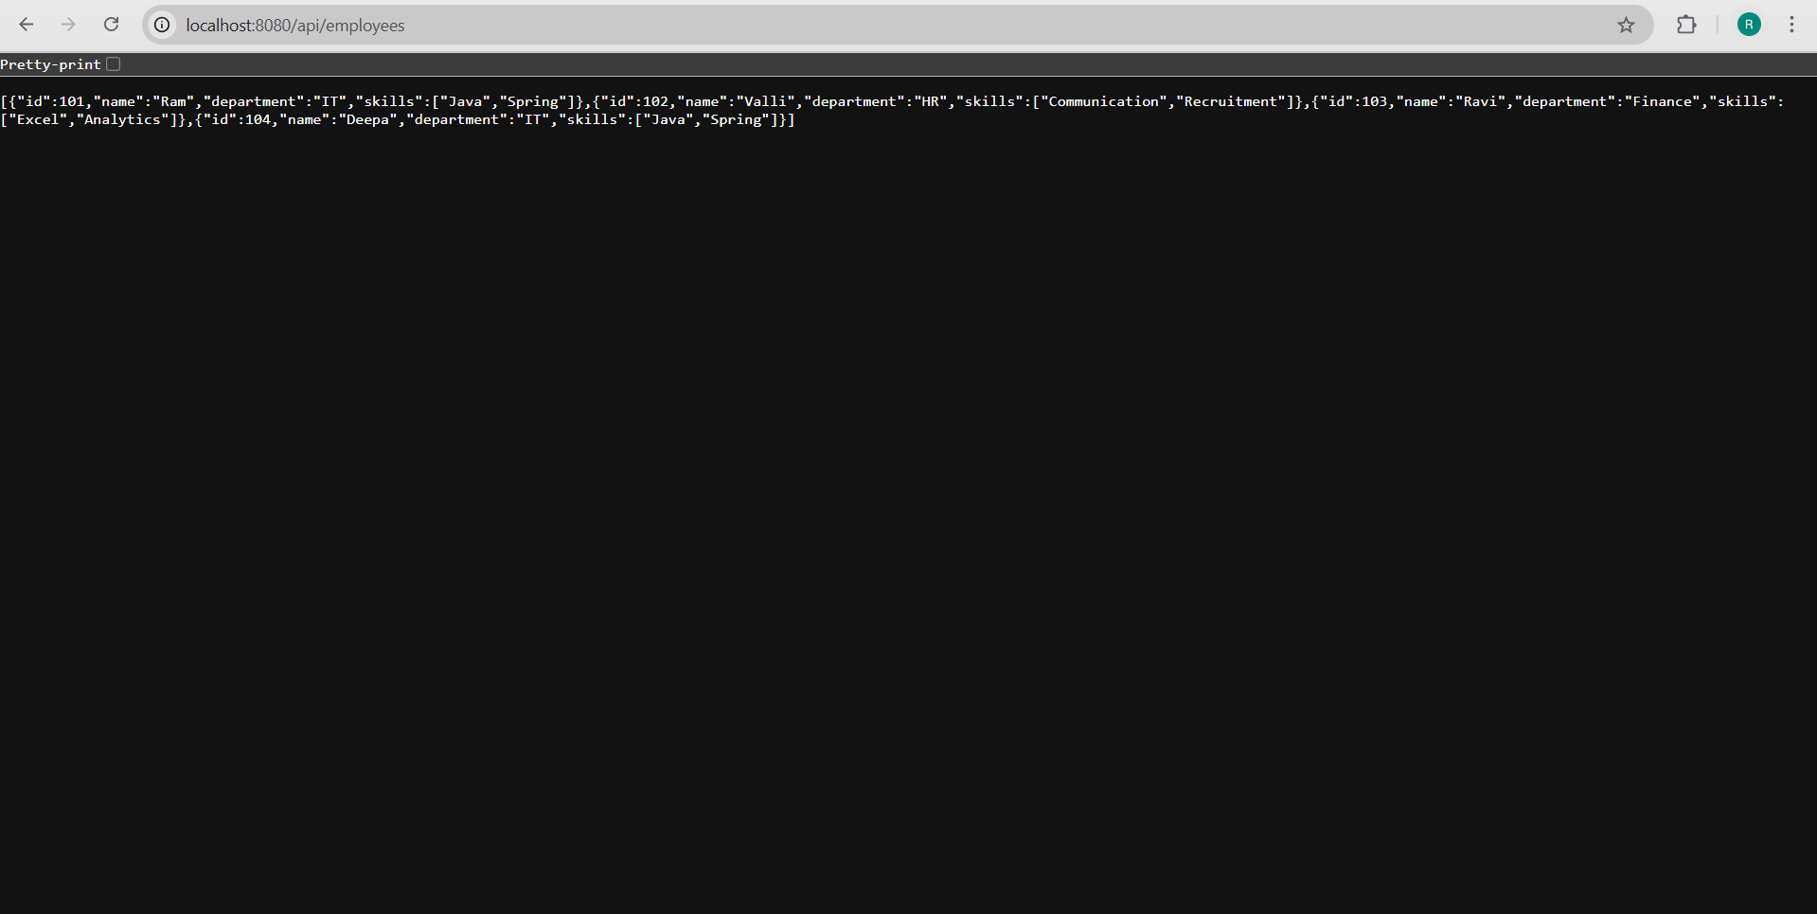

**3. Create REST service to gets all employees**

**CODE:**

**EmployeeController.java:**

package com.example.employee_api.controller;

import com.example.employee_api.model.Employee;

import com.example.employee_api.service.EmployeeService;

import org.springframework.beans.factory.annotation.Autowired;

import org.springframework.web.bind.annotation.*;

import java.util.List;

@RestController

@RequestMapping("/api")

public class EmployeeController {

    @Autowired

    private EmployeeService employeeService;

    @GetMapping("/employees")

    public List<Employee> getAllEmployees() {

        return employeeService.getAllEmployees();

    }

}

**EmployeeDao.java:**

package com.example.employee_api.dao;

import com.example.employee_api.model.Employee;

import org.springframework.context.support.ClassPathXmlApplicationContext;

import org.springframework.stereotype.Repository;

import java.util.ArrayList;

import java.util.List;

@Repository

public class EmployeeDao {

    public static List<Employee> EMPLOYEE_LIST = new ArrayList<>();

   public static void main(String[] args) {

    try {

        ClassPathXmlApplicationContext context =

                new ClassPathXmlApplicationContext("employee.xml");

        List<Employee> list = (List<Employee>) context.getBean("employeeList");

        System.out.println("TEST: Loaded " + list.size() + " employees");

        for (Employee emp : list) {

            System.out.println(emp.getId() + " - " + emp.getName());

        }

    } catch (Exception e) {

        System.out.println("Failed to load employee.xml");

        e.printStackTrace();

    }

}

    public List<Employee> getAllEmployees() {

        return EMPLOYEE_LIST;

    }

}

**Employee.java:**

package com.example.employee_api.model;

import java.util.List;

public class Employee {

    private int id;

    private String name;

    private String department;

    private List<String> skills;

    public int getId() { return id; }

    public void setId(int id) { this.id = id; }

    public String getName() { return name; }

    public void setName(String name) { this.name = name; }

    public String getDepartment() { return department; }

    public void setDepartment(String department) { this.department = department; }

    public List<String> getSkills() { return skills; }

    public void setSkills(List<String> skills) { this.skills = skills; }

}

**EmployeeService.java:**

package com.example.employee_api.service;

import com.example.employee_api.dao.EmployeeDao;

import com.example.employee_api.model.Employee;

import org.springframework.beans.factory.annotation.Autowired;

import org.springframework.stereotype.Service;

import org.springframework.transaction.annotation.Transactional;

import java.util.List;

@Service

public class EmployeeService {

    @Autowired

    private EmployeeDao employeeDao;

    @Transactional

    public List<Employee> getAllEmployees() {

        return employeeDao.getAllEmployees();

    }

}

**OUTPUT:**

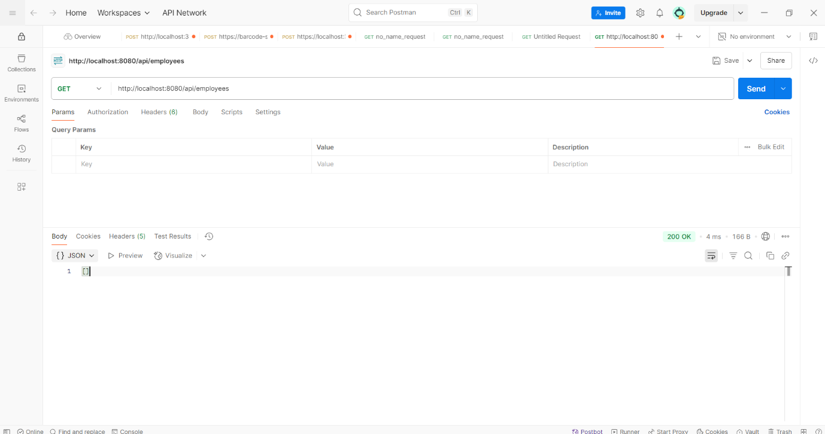

**4. Create REST service for department**

**CODE:**

**DepartmentController.java:**

package com.example.employee_api.controller;

import com.example.employee_api.service.DepartmentService;

import org.springframework.beans.factory.annotation.Autowired;

import org.springframework.web.bind.annotation.*;

import java.util.List;

@RestController

@RequestMapping("/api")

public class DepartmentController {

    @Autowired

    private DepartmentService departmentService;

    @GetMapping("/departments")

    public List<String> getAllDepartments() {

        System.out.println("/departments endpoint called");

        return departmentService.getAllDepartments();

    }

}

**DepartmentDao.java:**

package com.example.employee_api.dao;

import org.springframework.context.support.ClassPathXmlApplicationContext;

import org.springframework.stereotype.Repository;

import java.util.ArrayList;

import java.util.List;

@Repository

public class DepartmentDao {

    private static List<String> DEPARTMENT_LIST = new ArrayList<>();

    public DepartmentDao() {

        try {

            ClassPathXmlApplicationContext context =

                    new ClassPathXmlApplicationContext("employee.xml");

            DEPARTMENT_LIST = (List<String>) context.getBean("departmentList");

            System.out.println("Loaded Departments: " + DEPARTMENT_LIST);

        } catch (Exception e) {

            System.out.println("Failed to load departmentList from XML");

            e.printStackTrace();

        }

    }

    public List<String> getAllDepartments() {

        return DEPARTMENT_LIST;

    }

}

**DepartmentService.java:**

package com.example.employee_api.service;

import com.example.employee_api.dao.DepartmentDao;

import org.springframework.beans.factory.annotation.Autowired;

import org.springframework.stereotype.Service;

import java.util.List;

@Service

public class DepartmentService {

    @Autowired

    private DepartmentDao departmentDao;

    public List<String> getAllDepartments() {

        return departmentDao.getAllDepartments();

    }

}

**OUTPUT:**

