**BUILD A EMPLOYEE TRAVEL APPROVAL APPLICATION FOR CORPORATES**

1 INTRODUCTION

 1.1 OVERVIEW

     Welcome to Salesforce! Salesforce is game-changing technology, with a host of productivity-boosting features, that will help you sell smarter and faster.

 1.2 PURPOSE

     Travel Approval Application allows us to arrange and monitor travel plans and expense reports for our organizations using Salesforce Platform.

2 PROBLEM DEFINITION & DESIGN THINKING

 2.1 EMPATHY MAP

     An empathy map is a template that organizes a user’s behaviors and feelings to create a sense of empathy between the user and your team.  The empathy map represents a principal user and helps teams better understand their motivations, concerns, and user experience.

     An empathy map is a simple & easy visual that captures knowledge about a user’s behaviors and attitudes.  It is a useful tool to help teams better understand their users.  Creating an effective solution requires understanding the true problem and that person who is experiencing it.  The exercise of creating the map helps participants consider things from the user’s perspective along with his or her goals and challenges.

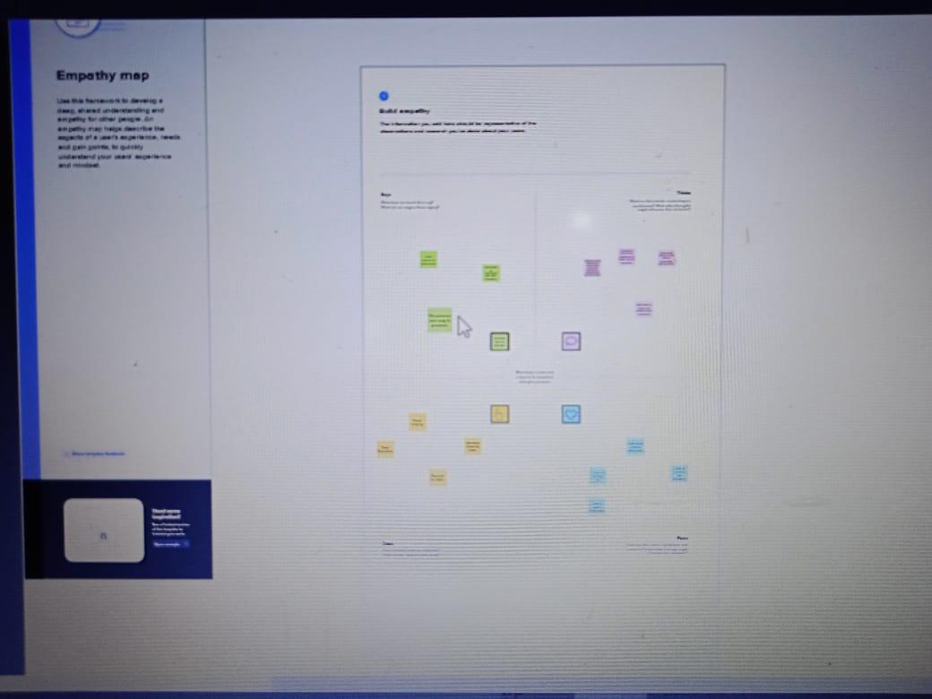

 2.2 IDEATION & BRAINSTORMING MAP

     Ideation is often closely related to the practice of brainstorming, a specific technique that is utilized to generate new ideas.  A principal difference between ideation and brainstorming is that ideation is commonly more thought of as being an individual pursuit, while brainstorming is almost always a group activity.  Brainstorming is usually conducted by getting a group of people together to come up with either general new ideas for solving a specific problem or dealing with a specific situation.

     Brainstorming provides a free and open environment that encourages everyone within a team to participate in the creative thinking process that leads to problem solving.    Prioritizing volume over value, out-of-the-box ideas are welcome and built upon, and all participants are encouraged to collaborate, helping each other develop a rich amount of creative solutions.

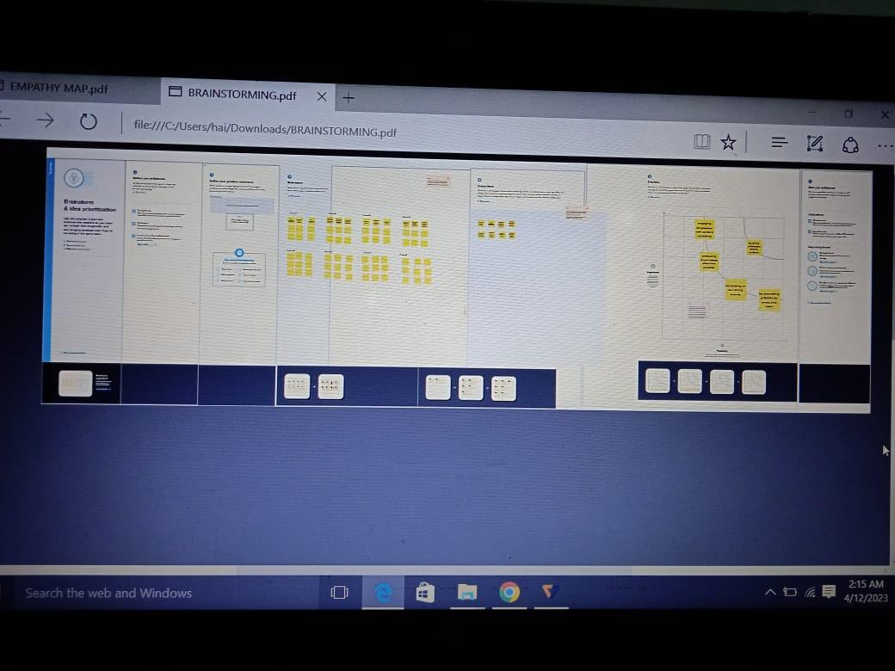

3 RESULT

 3.1 DATA MODEL:

|  |  |  |
| --- | --- | --- |
| OBJECT NAME | FIELD LABEL | DATA TYPE |
| obj1 | Department | Currency |
| obj2 | Travel Approval | Pick list |
| obj3 | Expense Item | Master-Detail Relationship |

 3.2 ACTIVITY & SCREENSHOT

      Milestone 1 is about creating Salesforce Org.

      Milestone 2  Creating the Application:

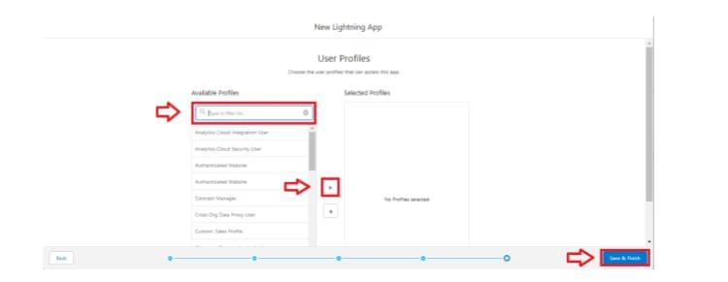

      Milestone 3  What is an object?

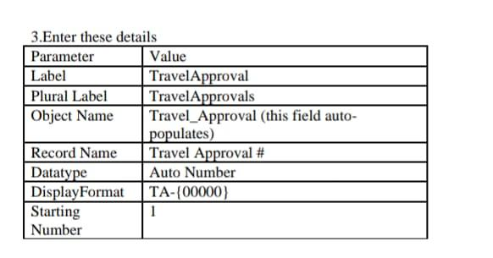

      Milestone 4  What is a Tab?

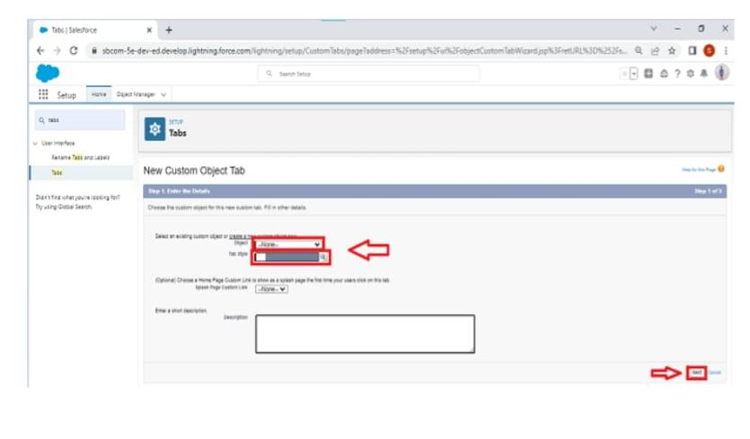

      Milestone 5  Create - Fields & Relationships :

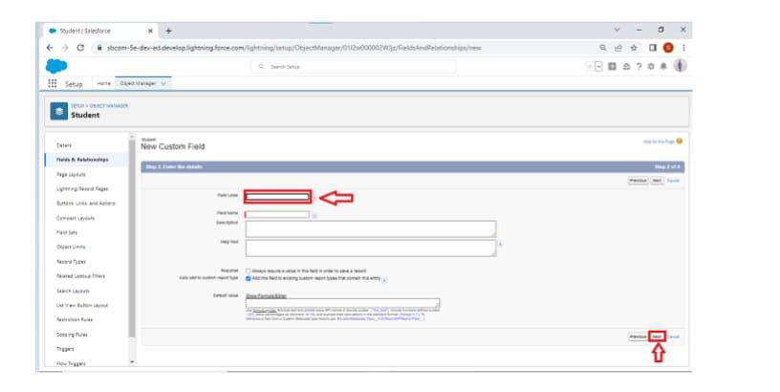

      Milestone 6  Import Departments:

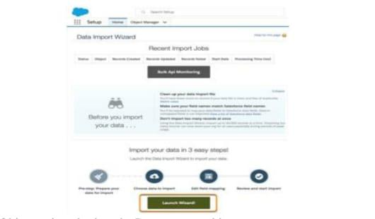

      Milestone 7  Customize User Interface:

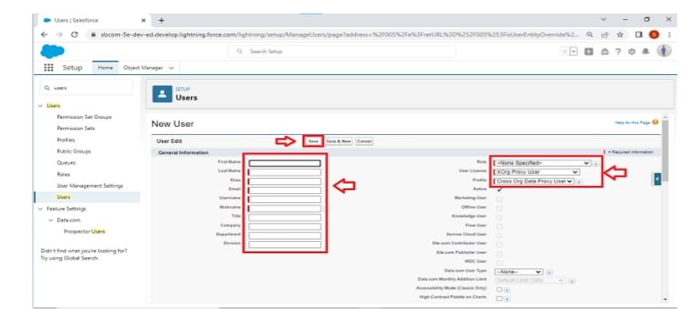

      Milestone 8  Use customization:

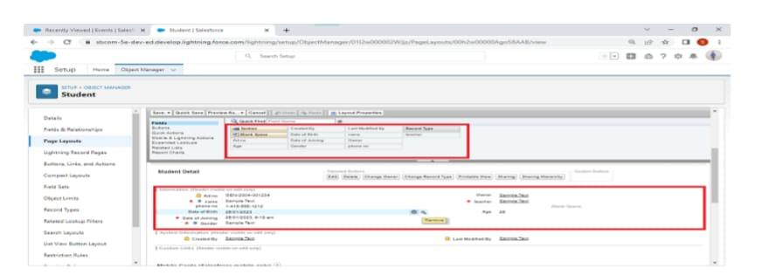

      Milestone 9  Add Business Logic to Travel App:

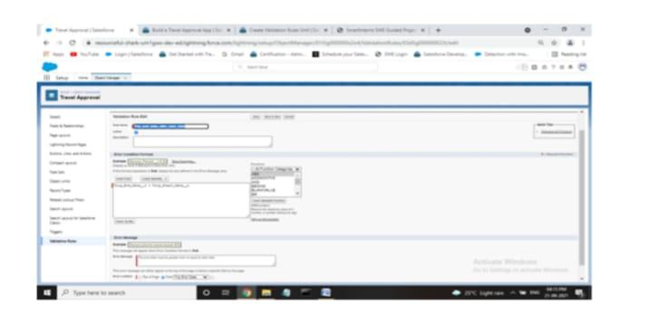

      Milestone 10 What are Reports?

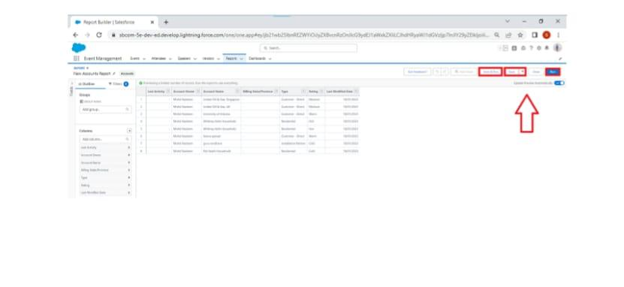

      Milestone 11 Dashboards:

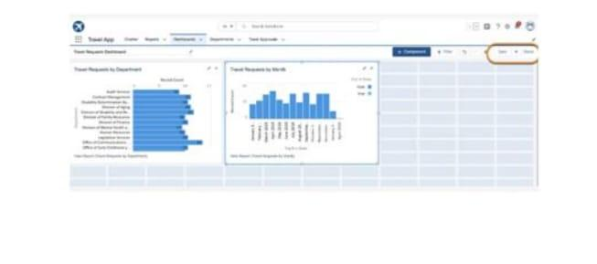

4 TRAILHEAD PROFILE PUBLIC URL

TEAM LEADER- <https://trailblazer.me/id/oviya31>

TEAM MEMBER 1- [https://trailblazer.me/id/helenjas01](http://trailblazer.me/id/helenjas01)

TEAM MEMBER 2-[- https://trailblazer.me/id/archana71](https://trailblazer.me/id/geetb8)

   TEAM MEMBER 3 - <https://trailblazer.me/id/priyadharshini08>

5 ADVANTAGES & DISADVANTAGES

  ADVANTAGES:

     As an Employee you are guaranteed payment for your services either weekly or monthly depending on your agreement, but definitely on the due date of your agreement you will be paid whether or not the company is making profit.  So therefore whether the Employer is running on a Loss or not, you will be guaranteed of your pay.

DISADVANTAGES:

     One major disadvantage of being an employee is that there is usually no equality between your Pay and Work, meaning that the pay of an Employee is usually not commensurate with their work.  As an Employee you could work as an Elephant and eat like an Ant.

6 APPLICATIONS

     Build and customize a Lightning app for travel approvals using clicks, not code.  Set up a Lightning app to streamline the travel approval process.  Use list views and page layouts to streamline an app user's experience.  Add business logic to improve the user experience.  Use reports and dashboards to analyze your travel approvals.

     Salesforce is the world’s #1 customer relationship management (CRM) platform.  We help your marketing, sales, commence, service and IT teams work as one from anywhere- so you can keep your customers happy everywhere.

7 CONCLUSION

     Customer Relationship Management enables a company to align its strategy with the needs of the customer in order to best meet those needs and thus ensure long-term customer loyalty.  However, in order to be successful in these aims, the different company departments have to work together and use measures in a coordinated fashion.  This purpose is achieved via a customer database which is analyzed and updated using CRM software.  This approach will be of particular interest to companies operating in highly competitive markets; it is difficult to attract new customers.

8 FUTURE SCOPE

     The best CRM technology today uses cloud-based, mobile-friendly, and AI-optimized software.  These features are increasingly the norm, not the future.  CRM already gives companies the ability to provide key personalized customer experience.  The future of customer relationship management can be seen in a number of ways, including increased adoption of CRM technology across enterprises, deeper insights fueled by expanding artificial intelligence, and more robust customer data integration.  Companies that invest in CRM will benefit from having a single source of customer truth, as well as a way to uniformly support the entirety of the customer life cycle.