# Analysis Report for All Inputs

## General Analysis Report for All Inputs:  
### Lecture-26-Cicero-and-Caesar-Reading.docx:  
Lecture-26-Cicero-and-Caesar-Reading.docx Analysis Report:  
---------------------  
Affective: 100.00  
Animate: 0.70  
Commonality: 10.05  
Cognitive: 0.13  
Directness: 0.00  
Dynamic: 0.00  
Formality: 0.00  
Generic: 0.00  
Inanimate: 29.17  
Individual: 50.00  
Informality: 0.00  
Intentionality: 0.00  
LongTerm: 0.00  
Negative: 100.00  
Novelty: 0.03  
Objectivity: 0.00  
Place: 20.83  
Politeness: 5.00  
Positive: 30.14  
Qualitative: 0.00  
Quantitative: 0.58  
ShortTerm: 30.06  
Social: 0.07  
Specific: 100.00  
Static: 0.09  
Time: 25.27  
  
## Synergy Analysis:  
No significant synergies detected.  
  
Overall Interpretation:  
The text shows strong indications in the following dimensions:  
- Affective (Score: 100.00)  
- Negative (Score: 100.00)  
- Specific (Score: 100.00)  
  
No dimensions show particularly weak indications.  
  
  
**Analysis Method Used:** Advanced  
Interpretations are based on the dimension scores calculated using the selected method.  
  
## Zero Scores Interpretation:  
The following dimensions have a score of 0.00:  
- **Directness**: Score is 0.00 due to an error during analysis.  
- **Dynamic**: Score is 0.00 due to an error during analysis.  
- **Formality**: Score is 0.00 due to an error during analysis.  
- **Generic**: Score is 0.00 due to an error during analysis.  
- **Informality**: Score is 0.00 due to an error during analysis.  
- **Intentionality**: Score is 0.00 due to an error during analysis.  
- **LongTerm**: Score is 0.00 due to an error during analysis.  
- **Objectivity**: Score is 0.00 due to an error during analysis.  
- **Qualitative**: Score is 0.00 due to an error during analysis.

## Radar Chart for This Input

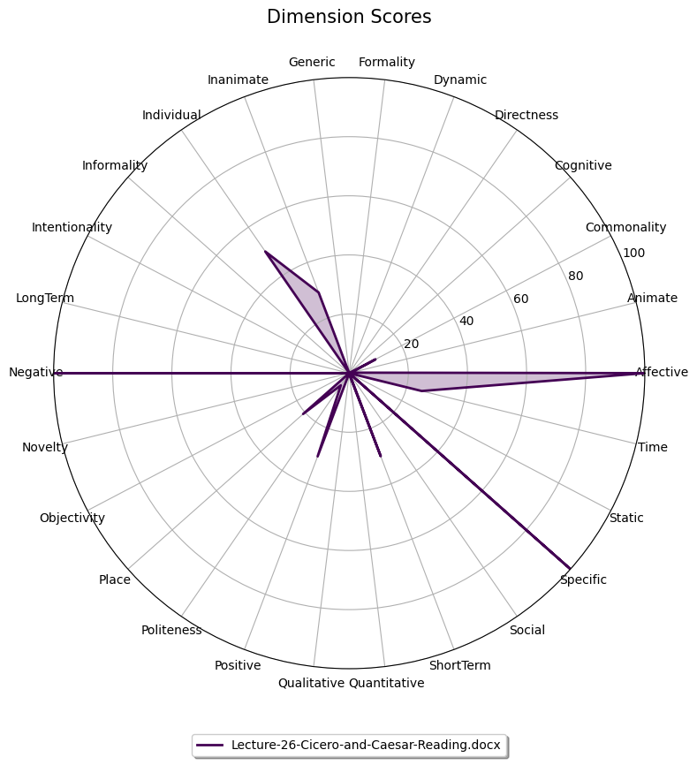

## Combined Radar Chart for All Inputs

