# Analysis Report for All Inputs

## General Analysis Report for All Inputs:  
### Test_drive.docx:  
Test_drive.docx Analysis Report:  
---------------------  
Affective: 20.00  
Animate: 0.00  
Commonality: 33.50  
Cognitive: 70.09  
Directness: 0.00  
Dynamic: 0.00  
Formality: 50.00  
Generic: 0.00  
Inanimate: 0.00  
Individual: 0.00  
Informality: 50.00  
Intentionality: 50.00  
LongTerm: 50.00  
Negative: 0.09  
Novelty: 70.10  
Objectivity: 50.00  
Place: 0.00  
Politeness: 100.00  
Positive: 0.64  
Qualitative: 0.00  
Quantitative: 0.98  
ShortTerm: 85.11  
Social: 70.04  
Specific: 76.08  
Static: 70.06  
Time: 70.38  
  
## Synergy Analysis:  
High Social and Cognitive scores highlight the interaction between social structures and logical thinking. This synergy often emerges in sociolinguistics or discourse analysis, where social contexts shape cognitive understanding. Texts in education, leadership, or organizational behavior often reflect this interaction. (Oxford Academic: https://academic.oup.com).  
  
Overall Interpretation:  
The text shows strong indications in the following dimensions:  
- Politeness (Score: 100.00)  
- ShortTerm (Score: 85.11)  
- Specific (Score: 76.08)  
  
The text shows weaker indications in the following dimensions:  
- Individual (Score: 0.00)  
- Place (Score: 0.00)  
- Qualitative (Score: 0.00)  
  
  
**Analysis Method Used:** Advanced  
Interpretations are based on the dimension scores calculated using the selected method.  
  
## Zero Scores Interpretation:  
The following dimensions have a score of 0.00:  
- **Animate**: Score is 0.00 indicating the text lacks characteristics related to this dimension.  
- **Directness**: Score is 0.00 indicating the text lacks characteristics related to this dimension.  
- **Dynamic**: Score is 0.00 due to an error during analysis.  
- **Generic**: Score is 0.00 due to an error during analysis.  
- **Inanimate**: Score is 0.00 indicating the text lacks characteristics related to this dimension.  
- **Individual**: Score is 0.00 indicating the text lacks characteristics related to this dimension.  
- **Place**: Score is 0.00 indicating the text lacks characteristics related to this dimension.  
- **Qualitative**: Score is 0.00 indicating the text lacks characteristics related to this dimension.

## Radar Chart for This Input

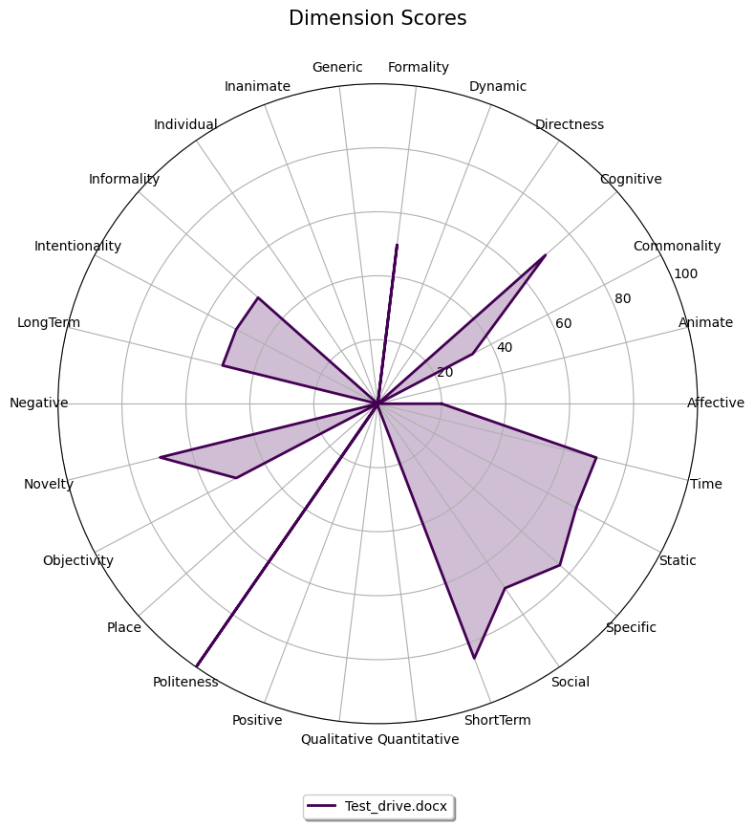

## Combined Radar Chart for All Inputs

