# Analysis Report for https://www.gutenberg.org/cache/epub/1513/pg1513-images.html

https://www.gutenberg.org/cache/epub/1513/pg1513-images.html Analysis Report:  
---------------------  
Affective: 20.00  
Animate: 0.00  
Commonality: 31.58  
Cognitive: 0.05  
Directness: 0.00  
Dynamic: 0.00  
Formality: 0.00  
Generic: 0.00  
Inanimate: 70.27  
Individual: 12.16  
Informality: 0.00  
Intentionality: 0.00  
LongTerm: 0.00  
Negative: 30.47  
Novelty: 0.03  
Objectivity: 0.00  
Place: 36.49  
Politeness: 5.00  
Positive: 30.16  
Qualitative: 0.00  
Quantitative: 0.39  
ShortTerm: 50.06  
Social: 30.14  
Specific: 100.00  
Static: 0.10  
Time: 50.42  
  
## Synergy Analysis:  
No significant synergies detected.  
  
Overall Interpretation:  
The text shows strong indications in the following dimensions:  
- Specific (Score: 100.00)  
- Inanimate (Score: 70.27)  
- Time (Score: 50.42)  
  
The text shows weaker indications in the following dimensions:  
- LongTerm (Score: 0.00)  
- Objectivity (Score: 0.00)  
- Qualitative (Score: 0.00)  
  
  
**Analysis Method Used:** Advanced  
Interpretations are based on the dimension scores calculated using the selected method.  
  
## Zero Scores Interpretation:  
The following dimensions have a score of 0.00:  
- **Animate**: Score is 0.00 indicating the text lacks characteristics related to this dimension.  
- **Directness**: Score is 0.00 indicating the text lacks characteristics related to this dimension.  
- **Dynamic**: Score is 0.00 indicating the text lacks characteristics related to this dimension.  
- **Formality**: Score is 0.00 indicating the text lacks characteristics related to this dimension.  
- **Generic**: Score is 0.00 indicating the text lacks characteristics related to this dimension.  
- **Informality**: Score is 0.00 indicating the text lacks characteristics related to this dimension.  
- **Intentionality**: Score is 0.00 indicating the text lacks characteristics related to this dimension.  
- **LongTerm**: Score is 0.00 indicating the text lacks characteristics related to this dimension.  
- **Objectivity**: Score is 0.00 indicating the text lacks characteristics related to this dimension.  
- **Qualitative**: Score is 0.00 indicating the text lacks characteristics related to this dimension.

## Radar Chart for This Input

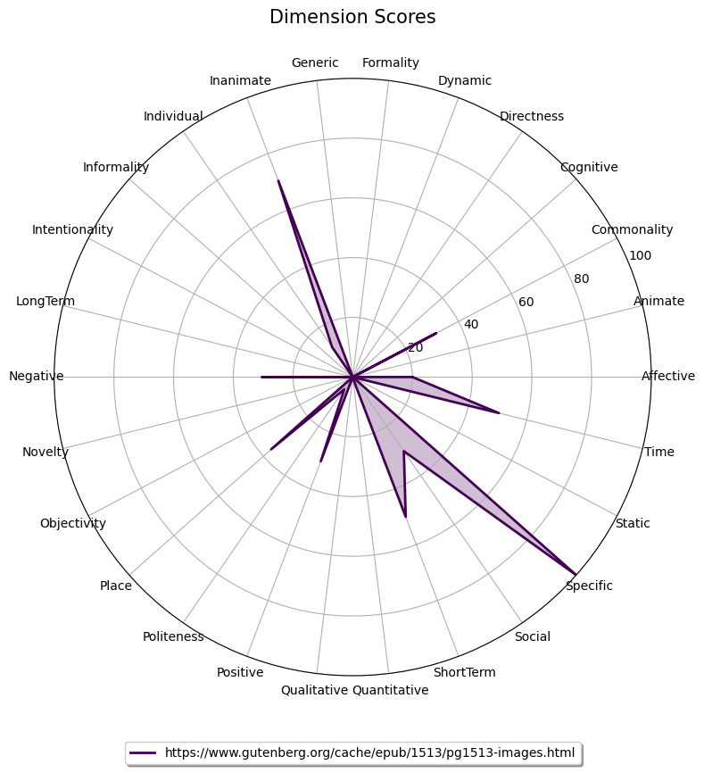

## Combined Radar Chart for All Inputs

