# Analysis Report for All Inputs

## General Analysis Report for All Inputs:  
### Article 2: Positive, Long-Term, and Social.docx:  
Article 2: Positive, Long-Term, and Social.docx Analysis Report:  
---------------------  
Affective: 100.00  
Animate: 0.00  
Commonality: 0.00  
Cognitive: 70.02  
Directness: 0.00  
Dynamic: 0.00  
Formality: 0.00  
Generic: 0.00  
Inanimate: 0.00  
Individual: 0.00  
Informality: 0.00  
Intentionality: 0.00  
LongTerm: 0.00  
Negative: 0.14  
Novelty: 70.08  
Objectivity: 0.00  
Place: 0.00  
Politeness: 100.00  
Positive: 0.18  
Qualitative: 0.00  
Quantitative: 0.33  
ShortTerm: 70.07  
Social: 70.49  
Specific: 76.10  
Static: 70.05  
Time: 70.14  
  
## Synergy Analysis:  
The high Affective and Cognitive scores suggest that emotional engagement is influencing logical reasoning in this text. This synergy is critical in persuasive writing, where emotional appeal is balanced with well-structured argumentation. Academic studies have shown that emotional elements can enhance cognitive processing, especially in contexts like advertising, political speeches, and motivational talks. (Oxford Academic: https://academic.oup.com) (SpringerLink: https://link.springer.com).  
  
High Social and Cognitive scores highlight the interaction between social structures and logical thinking. This synergy often emerges in sociolinguistics or discourse analysis, where social contexts shape cognitive understanding. Texts in education, leadership, or organizational behavior often reflect this interaction. (Oxford Academic: https://academic.oup.com).  
  
Overall Interpretation:  
The text shows strong indications in the following dimensions:  
- Affective (Score: 100.00)  
- Politeness (Score: 100.00)  
- Specific (Score: 76.10)  
  
The text shows weaker indications in the following dimensions:  
- Objectivity (Score: 0.00)  
- Place (Score: 0.00)  
- Qualitative (Score: 0.00)  
  
  
**Analysis Method Used:** Advanced  
Interpretations are based on the dimension scores calculated using the selected method.  
  
## Zero Scores Interpretation:  
The following dimensions have a score of 0.00:  
- **Animate**: Score is 0.00 indicating the text lacks characteristics related to this dimension.  
- **Commonality**: Score is 0.00 indicating the text lacks characteristics related to this dimension.  
- **Directness**: Score is 0.00 indicating the text lacks characteristics related to this dimension.  
- **Dynamic**: Score is 0.00 indicating the text lacks characteristics related to this dimension.  
- **Formality**: Score is 0.00 indicating the text lacks characteristics related to this dimension.  
- **Generic**: Score is 0.00 indicating the text lacks characteristics related to this dimension.  
- **Inanimate**: Score is 0.00 indicating the text lacks characteristics related to this dimension.  
- **Individual**: Score is 0.00 indicating the text lacks characteristics related to this dimension.  
- **Informality**: Score is 0.00 indicating the text lacks characteristics related to this dimension.  
- **Intentionality**: Score is 0.00 indicating the text lacks characteristics related to this dimension.  
- **LongTerm**: Score is 0.00 indicating the text lacks characteristics related to this dimension.  
- **Objectivity**: Score is 0.00 indicating the text lacks characteristics related to this dimension.  
- **Place**: Score is 0.00 indicating the text lacks characteristics related to this dimension.  
- **Qualitative**: Score is 0.00 indicating the text lacks characteristics related to this dimension.  
  
  
### https://www.gutenberg.org/cache/epub/1513/pg1513-images.html:  
https://www.gutenberg.org/cache/epub/1513/pg1513-images.html Analysis Report:  
---------------------  
Affective: 20.00  
Animate: 0.00  
Commonality: 31.58  
Cognitive: 0.05  
Directness: 0.00  
Dynamic: 0.00  
Formality: 0.00  
Generic: 0.00  
Inanimate: 70.27  
Individual: 12.16  
Informality: 0.00  
Intentionality: 0.00  
LongTerm: 0.00  
Negative: 30.47  
Novelty: 0.03  
Objectivity: 0.00  
Place: 36.49  
Politeness: 5.00  
Positive: 30.16  
Qualitative: 0.00  
Quantitative: 0.39  
ShortTerm: 50.06  
Social: 30.14  
Specific: 100.00  
Static: 0.10  
Time: 50.42  
  
## Synergy Analysis:  
No significant synergies detected.  
  
Overall Interpretation:  
The text shows strong indications in the following dimensions:  
- Specific (Score: 100.00)  
- Inanimate (Score: 70.27)  
- Time (Score: 50.42)  
  
The text shows weaker indications in the following dimensions:  
- LongTerm (Score: 0.00)  
- Objectivity (Score: 0.00)  
- Qualitative (Score: 0.00)  
  
  
**Analysis Method Used:** Advanced  
Interpretations are based on the dimension scores calculated using the selected method.  
  
## Zero Scores Interpretation:  
The following dimensions have a score of 0.00:  
- **Animate**: Score is 0.00 indicating the text lacks characteristics related to this dimension.  
- **Directness**: Score is 0.00 indicating the text lacks characteristics related to this dimension.  
- **Dynamic**: Score is 0.00 indicating the text lacks characteristics related to this dimension.  
- **Formality**: Score is 0.00 indicating the text lacks characteristics related to this dimension.  
- **Generic**: Score is 0.00 indicating the text lacks characteristics related to this dimension.  
- **Informality**: Score is 0.00 indicating the text lacks characteristics related to this dimension.  
- **Intentionality**: Score is 0.00 indicating the text lacks characteristics related to this dimension.  
- **LongTerm**: Score is 0.00 indicating the text lacks characteristics related to this dimension.  
- **Objectivity**: Score is 0.00 indicating the text lacks characteristics related to this dimension.  
- **Qualitative**: Score is 0.00 indicating the text lacks characteristics related to this dimension.  
  
  
### https://www.gutenberg.org/cache/epub/20165/pg20165-images.html:  
https://www.gutenberg.org/cache/epub/20165/pg20165-images.html Analysis Report:  
---------------------  
Affective: 100.00  
Animate: 0.00  
Commonality: 37.24  
Cognitive: 0.29  
Directness: 0.00  
Dynamic: 0.00  
Formality: 0.00  
Generic: 0.00  
Inanimate: 50.00  
Individual: 19.23  
Informality: 0.00  
Intentionality: 0.00  
LongTerm: 0.00  
Negative: 30.12  
Novelty: 0.09  
Objectivity: 0.00  
Place: 7.69  
Politeness: 5.00  
Positive: 0.06  
Qualitative: 0.00  
Quantitative: 1.83  
ShortTerm: 50.03  
Social: 0.04  
Specific: 100.00  
Static: 25.43  
Time: 0.12  
  
## Synergy Analysis:  
No significant synergies detected.  
  
Overall Interpretation:  
The text shows strong indications in the following dimensions:  
- Affective (Score: 100.00)  
- Specific (Score: 100.00)  
- ShortTerm (Score: 50.03)  
  
The text shows weaker indications in the following dimensions:  
- LongTerm (Score: 0.00)  
- Objectivity (Score: 0.00)  
- Qualitative (Score: 0.00)  
  
  
**Analysis Method Used:** Advanced  
Interpretations are based on the dimension scores calculated using the selected method.  
  
## Zero Scores Interpretation:  
The following dimensions have a score of 0.00:  
- **Animate**: Score is 0.00 indicating the text lacks characteristics related to this dimension.  
- **Directness**: Score is 0.00 indicating the text lacks characteristics related to this dimension.  
- **Dynamic**: Score is 0.00 indicating the text lacks characteristics related to this dimension.  
- **Formality**: Score is 0.00 indicating the text lacks characteristics related to this dimension.  
- **Generic**: Score is 0.00 indicating the text lacks characteristics related to this dimension.  
- **Informality**: Score is 0.00 indicating the text lacks characteristics related to this dimension.  
- **Intentionality**: Score is 0.00 indicating the text lacks characteristics related to this dimension.  
- **LongTerm**: Score is 0.00 indicating the text lacks characteristics related to this dimension.  
- **Objectivity**: Score is 0.00 indicating the text lacks characteristics related to this dimension.  
- **Qualitative**: Score is 0.00 indicating the text lacks characteristics related to this dimension.  
  
  
### https://www.gutenberg.org/cache/epub/56796/pg56796-images.html:  
https://www.gutenberg.org/cache/epub/56796/pg56796-images.html Analysis Report:  
---------------------  
Affective: 20.00  
Animate: 0.00  
Commonality: 27.53  
Cognitive: 0.02  
Directness: 0.00  
Dynamic: 0.00  
Formality: 0.00  
Generic: 0.00  
Inanimate: 59.46  
Individual: 10.81  
Informality: 0.00  
Intentionality: 0.00  
LongTerm: 0.00  
Negative: 100.00  
Novelty: 0.11  
Objectivity: 0.00  
Place: 16.22  
Politeness: 5.00  
Positive: 60.08  
Qualitative: 0.00  
Quantitative: 4.50  
ShortTerm: 50.11  
Social: 0.08  
Specific: 100.00  
Static: 0.25  
Time: 75.25  
  
## Synergy Analysis:  
No significant synergies detected.  
  
Overall Interpretation:  
The text shows strong indications in the following dimensions:  
- Negative (Score: 100.00)  
- Specific (Score: 100.00)  
- Time (Score: 75.25)  
  
The text shows weaker indications in the following dimensions:  
- LongTerm (Score: 0.00)  
- Objectivity (Score: 0.00)  
- Qualitative (Score: 0.00)  
  
  
**Analysis Method Used:** Advanced  
Interpretations are based on the dimension scores calculated using the selected method.  
  
## Zero Scores Interpretation:  
The following dimensions have a score of 0.00:  
- **Animate**: Score is 0.00 indicating the text lacks characteristics related to this dimension.  
- **Directness**: Score is 0.00 indicating the text lacks characteristics related to this dimension.  
- **Dynamic**: Score is 0.00 indicating the text lacks characteristics related to this dimension.  
- **Formality**: Score is 0.00 indicating the text lacks characteristics related to this dimension.  
- **Generic**: Score is 0.00 indicating the text lacks characteristics related to this dimension.  
- **Informality**: Score is 0.00 indicating the text lacks characteristics related to this dimension.  
- **Intentionality**: Score is 0.00 indicating the text lacks characteristics related to this dimension.  
- **LongTerm**: Score is 0.00 indicating the text lacks characteristics related to this dimension.  
- **Objectivity**: Score is 0.00 indicating the text lacks characteristics related to this dimension.  
- **Qualitative**: Score is 0.00 indicating the text lacks characteristics related to this dimension.  
  
  
### https://www.gutenberg.org/cache/epub/6130/pg6130-images.html:  
https://www.gutenberg.org/cache/epub/6130/pg6130-images.html Analysis Report:  
---------------------  
Affective: 60.00  
Animate: 0.00  
Commonality: 24.55  
Cognitive: 0.08  
Directness: 0.00  
Dynamic: 0.00  
Formality: 0.00  
Generic: 0.00  
Inanimate: 33.21  
Individual: 21.44  
Informality: 0.00  
Intentionality: 0.00  
LongTerm: 0.00  
Negative: 65.16  
Novelty: 0.05  
Objectivity: 0.00  
Place: 19.40  
Politeness: 5.00  
Positive: 50.05  
Qualitative: 0.00  
Quantitative: 0.89  
ShortTerm: 100.00  
Social: 30.12  
Specific: 100.00  
Static: 0.15  
Time: 25.24  
  
## Synergy Analysis:  
No significant synergies detected.  
  
Overall Interpretation:  
The text shows strong indications in the following dimensions:  
- ShortTerm (Score: 100.00)  
- Specific (Score: 100.00)  
- Negative (Score: 65.16)  
  
The text shows weaker indications in the following dimensions:  
- LongTerm (Score: 0.00)  
- Objectivity (Score: 0.00)  
- Qualitative (Score: 0.00)  
  
  
**Analysis Method Used:** Advanced  
Interpretations are based on the dimension scores calculated using the selected method.  
  
## Zero Scores Interpretation:  
The following dimensions have a score of 0.00:  
- **Animate**: Score is 0.00 indicating the text lacks characteristics related to this dimension.  
- **Directness**: Score is 0.00 indicating the text lacks characteristics related to this dimension.  
- **Dynamic**: Score is 0.00 indicating the text lacks characteristics related to this dimension.  
- **Formality**: Score is 0.00 indicating the text lacks characteristics related to this dimension.  
- **Generic**: Score is 0.00 indicating the text lacks characteristics related to this dimension.  
- **Informality**: Score is 0.00 indicating the text lacks characteristics related to this dimension.  
- **Intentionality**: Score is 0.00 indicating the text lacks characteristics related to this dimension.  
- **LongTerm**: Score is 0.00 indicating the text lacks characteristics related to this dimension.  
- **Objectivity**: Score is 0.00 indicating the text lacks characteristics related to this dimension.  
- **Qualitative**: Score is 0.00 indicating the text lacks characteristics related to this dimension.

## Radar Chart for This Input

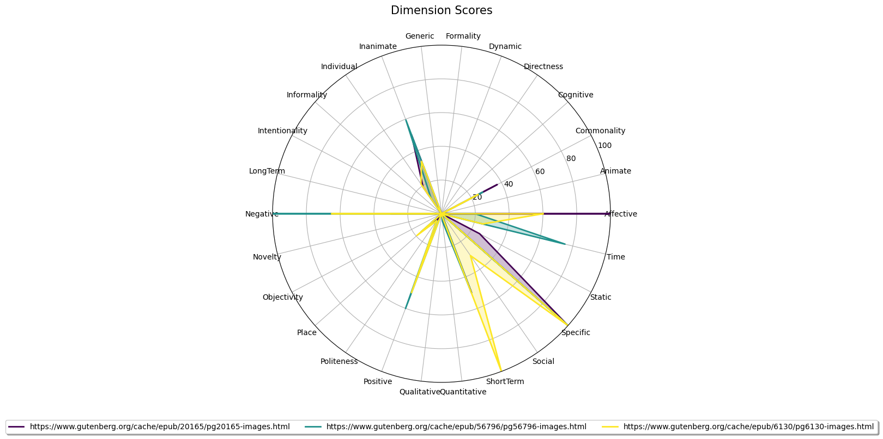

## Combined Radar Chart for All Inputs

