

PostgreSQL Warm-Standby Replication with 2warm

Gregory Smith
Principal Consultant, 2ndQuadrant

3 February 2010

Introduction

Terminology

The standard introduction to the technology behind the PostgreSQL warm standby system is the official documentation. The version of warm standby that ships with 8.4 has the most complete such documentation: http://www.postgresql.org/docs/8.4/static/backup.html

This is a good place to start even if you are targeting an earlier version, because the documentation has been updated to be more readable and complete. You just need to note which features are not available in the version you're using, which is covered below.

Some common terms used in this area, some of which are specific to this 2warm package, are:

- Write-ahead log (WAL): PostgreSQL writes information to a series of write-ahead log files, in segments 16MB in size, before making corresponding changes to the database itself. If you start with an identical pair of databases, and apply the same WAL files to them, the resulting pair will also be identical—since the WAL contains all changed data.
- Base backup: A backup made of the database in a way that includes everything needed for the copy to go through crash recovery and be intact, even if files were changed during the time the backup was being made. This requires using the pg_start_backup and pg_stop_backup commands, as well as making backup copies of both the entire database and the WAL files archived during the period between when those commands executed.
- Point-in-time recovery (PITR): If you have a base database and a series of WAL files, you can apply only some of them and then stop recovering information from those WAL files. This allows the point in time recovery feature. This even allows complicated recovery situations like alternate timelines, where a rebuilt database diverges from its original history—perhaps multiple times in search of the best place to recover to—before the server is started.
- File-based log shipping: If you make a base backup of a server, and then “ship” all of the new WAL files it archives to another server, that new server can be kept in sync with the original.
- Standby: A system with a complete base backup and a stream of file-based logs shipped to it can be a standby: a server with exactly the same data as the original. A standby is kept up to date as enough new transactions appear (or time passes) and WAL files are shipped to it. A warm standby continuously applies new WAL files as they appear.
- Fail-over: Taking the standby out of recovery mode and turning it into an active server, using what's called a “trigger” file. In intentional failover situations, you can stop the primary first and make sure all its data has been flushed. In a true failure of the primary situation, this will not be possible, and some recent transactions (the ones not yet shipped to the standby) committed on the primary may not be available on the standby that's not promoted to being a primary.
- Disaster Recovery Relay: It is also possible to “relay” the files the standby receives to a third system (or potentially even more, although this is not directly supported by the standard 2warm scripts). Those systems then also become useful disaster recovery candidates if both primary and secondary systems are lost.

History of Built-in PostgreSQL Replication Features

8.1

PostgreSQL 8.1 introduced Point-in-time recovery (PITR) to the database. This allows rebuilding a database using a “base backup” of its current state, along with a series of write-ahead log (WAL) files that contain all of the changes to the data since then. “Replay” of the information in those WAL files can take as long or even longer than the original data did to accumulate however. By saving those files to another system, this allowed simple replication of a database to a standby node.
But while many clients can make changes to the database at once, there's only one client doing the replay recovery. Since that recovery didn't start until there was a fail-over to the standby system that made it the new primary, a failover of a standby that had been up for hours could correspondingly take hours to finish—during which the database server is down.

8.2

PostgreSQL 8.2 improved this situation by introducing the concept of a warm standby. Rather than wait until the database was being activated, warm standbys continuously poll for new incoming WAL segments, and immediately apply them as they appear. That makes the replication closer to real-time, and vastly decreases the expected fail-over time in the case of a failure on the primary.

The warm standby is far from being ready to go after a basic PostgreSQL install though. One of the key parts of making this system work well is having a program to fetch the new segments and apply them to the secondary. No such program is provided with PostgreSQL 8.2. 2ndQuadrant developed a reference implementation named pg_standby that handles this particular task.

8.3

PostgreSQL 8.3 ships with pg_standby as one of its contrib modules you can optionally use. It also adds a useful new feature to the archive_command allowing better pruning of old WAL files from the system. In 8.2, you had to guess how many still needed, which inevitably resulted in wasted disk space from the overestimation required for safety.

8.4

Few changes were made in the area of PITR in this release. There are some bug fixes to pg_standby.

9.0

The upcoming PostgreSQL 9.0 integrates real-time streaming replication, rather than just copying a full WAL file at a time, into an easier to setup form than was ever available before. And the Hot Standby feature, primarily developed by 2ndQuadrant, allows executing queries against standby nodes.

There is still some scripting required in order to manage these new features in 9.0. Currently, the 2warm package does not support 9.0, but the expectation is that it will be upgraded to do so before 9.0 is released. This should result in a fairly smooth transition path if you are already using the 2warm package but eventually upgrade to a version with better replication features.

Configuration files

These are all relative locations from the 2warm directory, which will typically be in $PGDATA/../2warm ; several scripts will need to be customized if this is not where the scripts are located at.

- global/recovery.conf: restore_command file needed by pg_standby. This is expected to be the same on every server in the cluster. It is not used on the primary however.
- global/pg_hba.conf: This is expected to be the same on every server in the cluster.
- local/postgresql.conf: This particular node's postgresql.conf file. There need not be any difference between the settings used on any particular node. This setup does allow customizations for situations like when the disaster recovery node runs on a smaller hardware configuration than the primary/standby pair.
- local/replication/othernode: Text file containing the hostname of the partner node in a master/standby pair.
- local/replication/drnode: Text file containing the hostname of the disaster recovery relay node logs are shipped to. Can be empty. Only used on the secondary, to relay data over to the disaster recovery node.
- local/replication/archiving_active: If this file exists, the server will archive WAL files. Only used on the current primary.

Available Scripts and Commands

The scrripts used generally follows one of the paths outlined on this internal diagram:

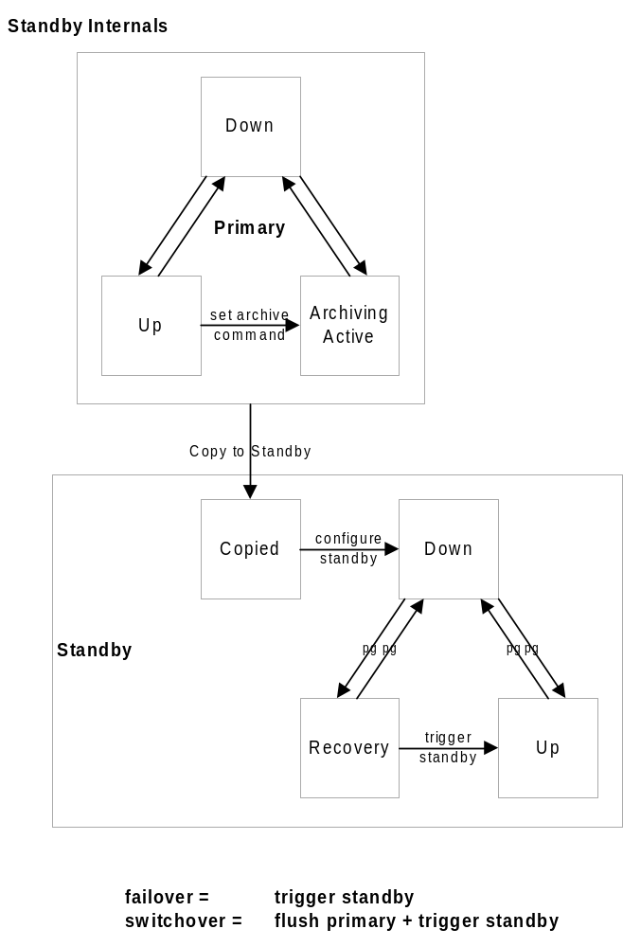

These scripts are all in the 2warm/global/replication directory.

Initial setup

- archiveWALFile
: Called by archive_command on primary. If archiving_active is set, save any WAL files the server hands over.
- rsync_global
: Runs on the primary. Copies the 2warm script environment over to the standby and, if available the disaster recovery node.
- configStandby
: Copies postgresql.conf and recovery.conf needed to setup a standby and makes sure it's not triggered. Erases all the pg_xlog files on the system. WARNING: This will destroy a primary if it's accidentally executed there, instead of on its intended target of a fresh standby, and if the primary server is down at the time. The script will abort itself if it discovers there's an active database running as a safety feature.
- copyToStandby
: Runs on the primary. Copies the main database over its standby “othernode”
- copyToDR
: Runs on the primary. Copies the main database over to a disaster recovery node. Optional—only needed if there is a disaster recovery node.

State changes

- flushPrimary
: First step for Switchover event. Flush out all recent activity to the standby. Non-superuser connections should be disabled before this script is run, and the primary database server stopped afterwards.
- triggerStandby: Final step for Switchover and Failover events. Promotes a standby or disaster recovery node to a primary.

Utility and Background Scripts

- restoreWALFile
: Called by restore_command, uses pg_standby to apply a new WAL segment.
- rsyncDR
: Runs via cron on the standby once installed. Copies all of the WAL archives the standby has received to the disaster recovery node.
- configSetup
: Subroutine library for rest of the commands. If run with the parameter “debug” this script will, like all the other standalone scripts in this directory, just print the environment information the scripts here are working with and then exit.

Architecture Diagrams

In the simple two-node case, the transitions possible are fairly straightforward:

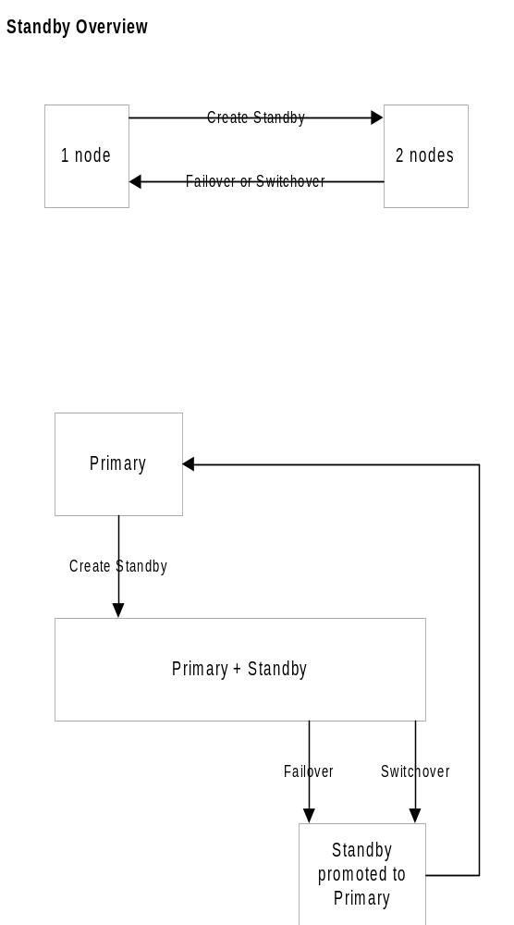

If a third disaster recovery node is added, there are several more possible paths involved:

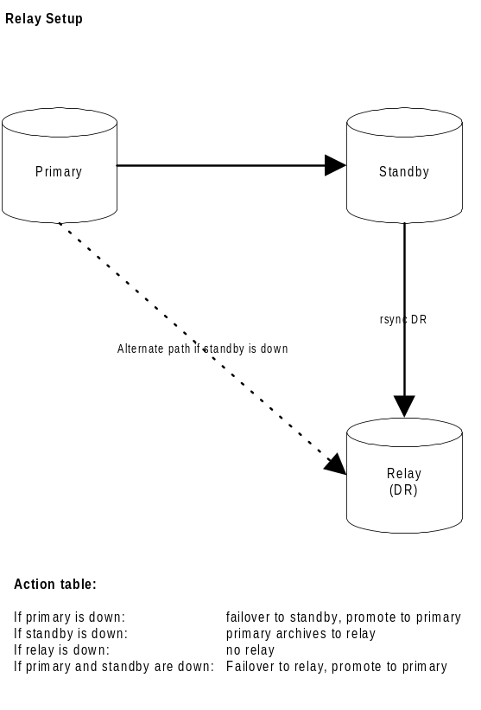

Initial Configuration of 2warm

Setup trusted copy between postgres accounts

Compile pg_standby

Synchronize 2warm scripts across all nodes

Update local postgresql.conf with any customizations required on individual systems

Install archive_command on master

Configure standby for recovery

Base backup onto secondary

Confirm new log file segments appear on standby

Setup optional disaster recovery node and relay system

Changing Node States

Failover: Trigger standby

Switchover: Flush primary + trigger standby

Testing of a new installation

Switchover

Switchback

Failover

Disaster Recovery

