PERSONAL INFORMATION | Olga Vovnenciuc
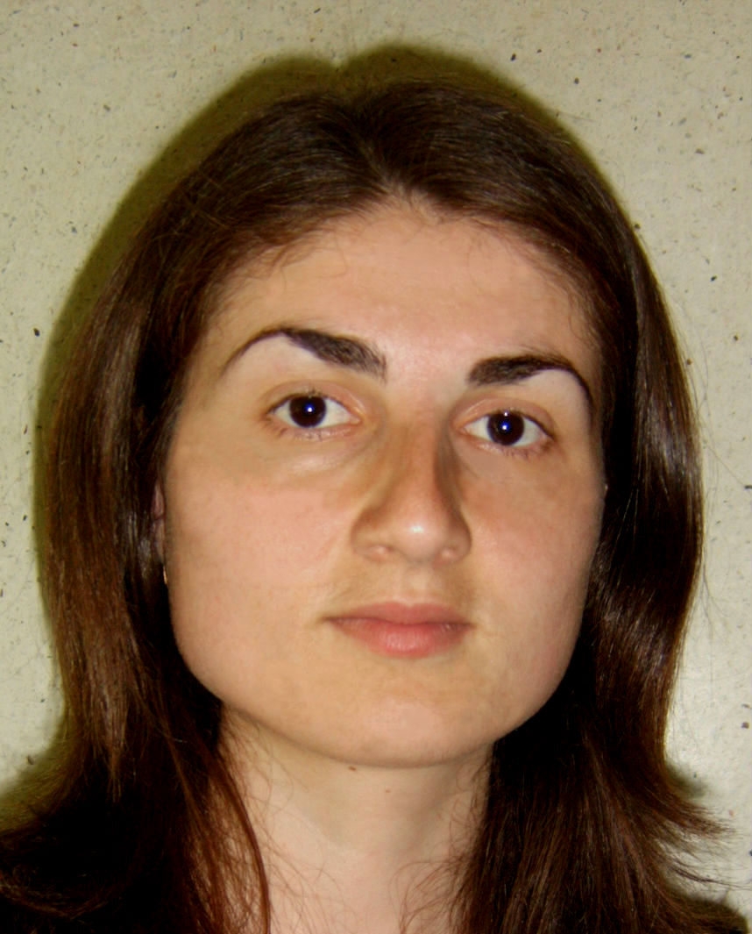
 |   69, street Păcii, village Corlateni, district Rîșcani, MD – 5616, Republic of Moldova

+373 25657085  +373 79802943

olga.vovnenciuc@gmail.com

Skype gisca.olga
 | Sex Female | Date of birth 17/06/1983 | Nationality Republic of Moldova

WORK EXPERIENCE

November 2015 - present | Developer
November 2015 - present | AM-SoftGroup LLC, Republic of Moldova, Balti  - Java Developer  - Hybris Developer
October 2013 - 2015 | Consultant in informatics systems
October 2013 - 2015 | AM-SoftGroup LLC, Republic of Moldova, Balti  - Data Loading
September 2014 - present | Lecturer
September 2014 - present | Balti Alecu Russo State University, Republic of Moldova  Faculty for Exact, Economic and Natural Sciences
September 2007 - 2014 | Assistant Lecturer
September 2007 - 2014 | Balti Alecu Russo State University, Republic of Moldova  Faculty for Exact, Economic and Natural Sciences
September 2006 - 2007 | Teacher of Computer Science
September 2006 - 2007 | Regional High School „Ion Creanga”, Balti, Republic of Moldova

EDUCATION AND TRAINING

November 2009 – November 2012 | Doctor of Philosophy in Pedagogic | Doctor in Pedagogy
November 2009 – November 2012 | PhD in Pedagogy Tiraspol State University, Republic of Moldova
November 2009 – November 2012 | - Philosophy, Pedagogy, Didactic of Computer Science
September 2007 – May 2008 | Master in Informatics | Master in Informatics
September 2007 – May 2008 | Balti Alecu Russo State University, Republic of Moldova
September 2007 – May 2008 | - ICT, Computer Science & Informatics
September 2002 – June 2008 | Licentiate in Mathematics | Licentiate in mathematics
September 2002 – June 2008 | Balti Alecu Russo State University, Republic of Moldova
September 2002 – June 2008 | - Mathematics, Complex Analysis
September 2002 – June 2007 | Licentiate in Informatics | Licentiate in Informatics
September 2002 – June 2007 | Balti Alecu Russo State University, Republic of Moldova
September 2002 – June 2007 | - ICT, Computer Science & Informatics, Information Processing Management

PERSONAL SKILLS

Mother tongue(s) | Romanian, Russian
Other language(s) | UNDERSTANDING |  | SPEAKING |  | WRITING
Other language(s) | Listening | Reading | Spoken interaction | Spoken production
English | C1 | C2 | B1 | B1 | B1
French | B1 | B2 | A2 | A2 | A2
Levels: A1/2: Basic user - B1/2: Independent user - C1/2 Proficient user
Common European Framework of Reference for Languages

Computer skills | - OS: Windows, Linux  - Programming languages: Java, PHP  - Java technologies: Hibernate  - J2EE Servers/ Servlet Container: Apache Tomcat, Jetty  - RDBMS: MS SQL Server, PostgreSQL  - IDE Tools: Intellij IDEA  - Version Control: Git

