**Manual of Toxicity Estimator**

**open-source software**

**Step 1.** *Draw molecule or select input molecular files.*

If you want to draw the structure of a chemical compound, you can use the capabilities of the built-in chemical editor Ketcher (<https://github.com/epam/ketcher>). After creating the structure of a chemical compound, it can be controlled using two buttons: 1)"reset" - deleting the structure to create a new one 2) "Apply" - transferring the structure of the compound for further analysis, forecasting to step 2.

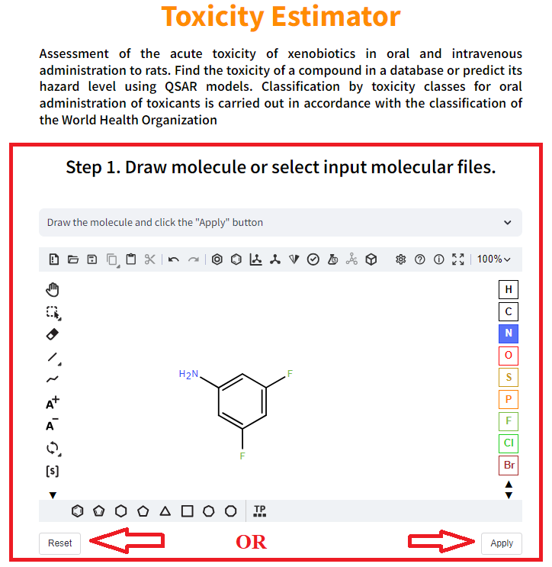

After clicking on the 'Apply' button, make sure that the structure has been created. If the structure is successfully created, its smiles will be displayed under the chemical editor window

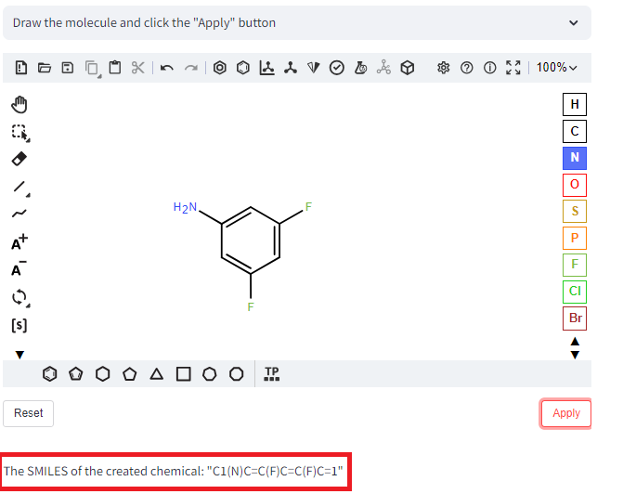

If you choose smiles, please, directly paste the SMILES representation of the desired chemical structure and press Ctrl+Enter. If the entered chemical structure is correct, the application will generate a 2D image of the studied compound.

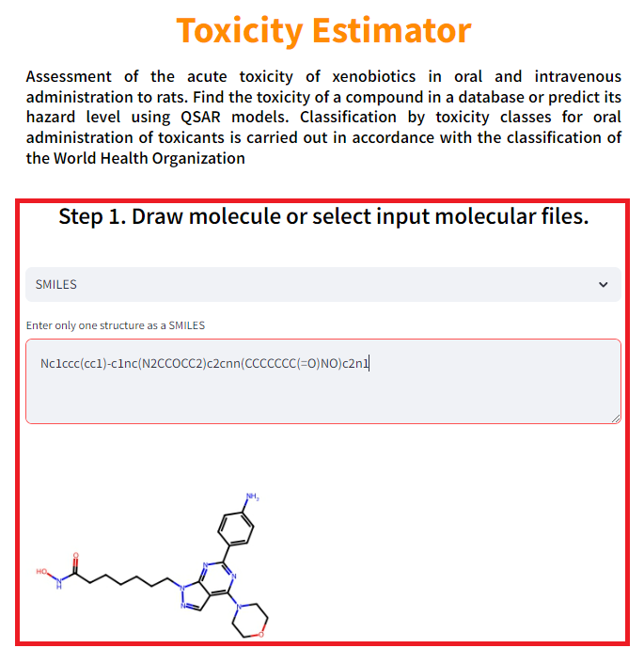

If the entered structure is incorrect, the application reports an error.

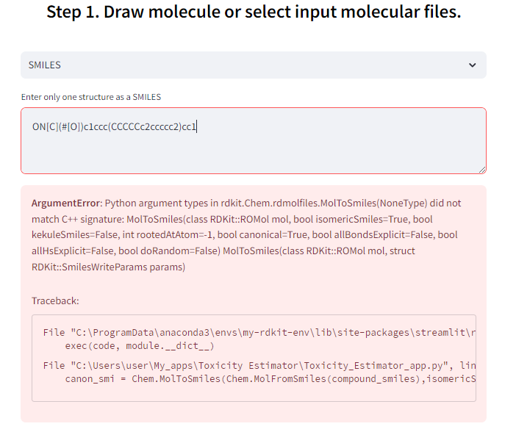

If you choose a file *sdf or *csv, that may contain a different number of chemical structures, please specify the path to this file on your computer's hard drive. In this case, you need to click the "Browse files" button. It is important to note that if you choose a file with the *csv extension, the file should contain a column with the name "SMILES"

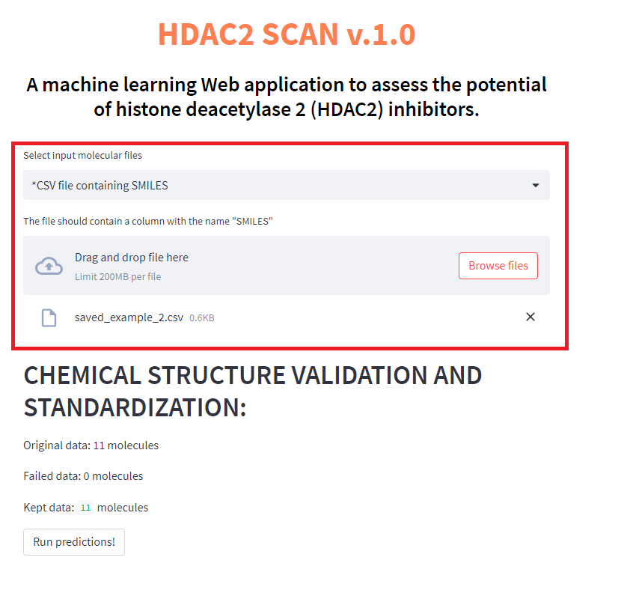

If incorrect structures are detected in the file *sdf or *csv, the corresponding information will appear in the section "CHEMICAL STRUCTURE VALIDATION AND STANDARDIZATION"

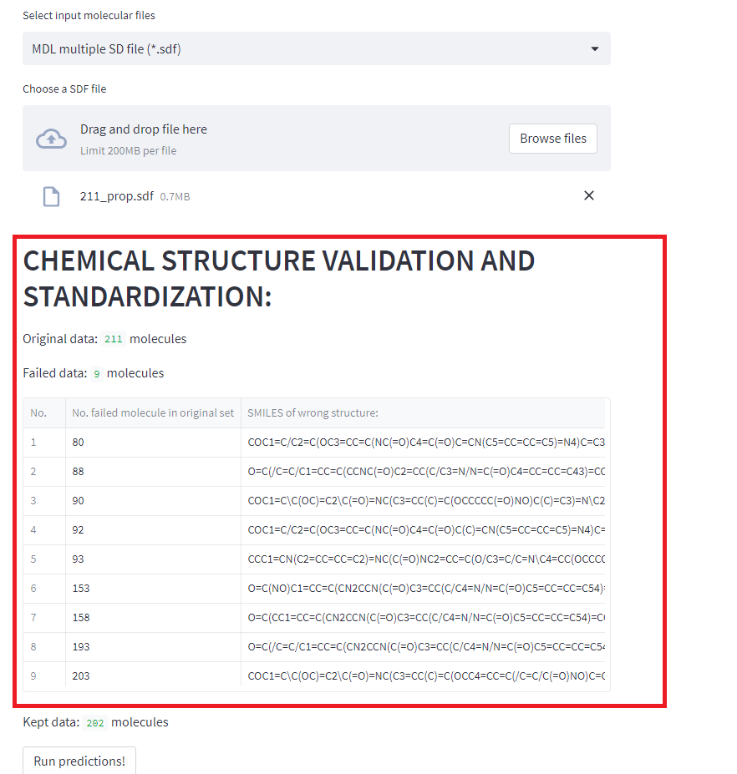

**Step 2.** *Select administration of substance.*

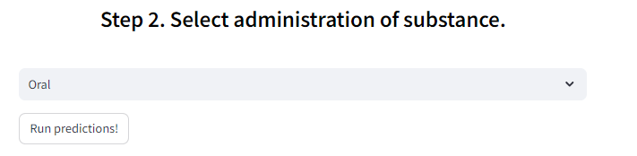

**Step 2**. Click on the “Run predictions!” button for prediction.

**Step 3**. *Prediction results*.

The form of presentation of the results depends on the type of descriptors selected, as well as the format of the input chemical data. For example, when selecting SMILES, the results will be displayed for a single molecule. When displaying the results on the screen, it is taken into account whether there are experimental values of activity and toxicity for the studied compound.

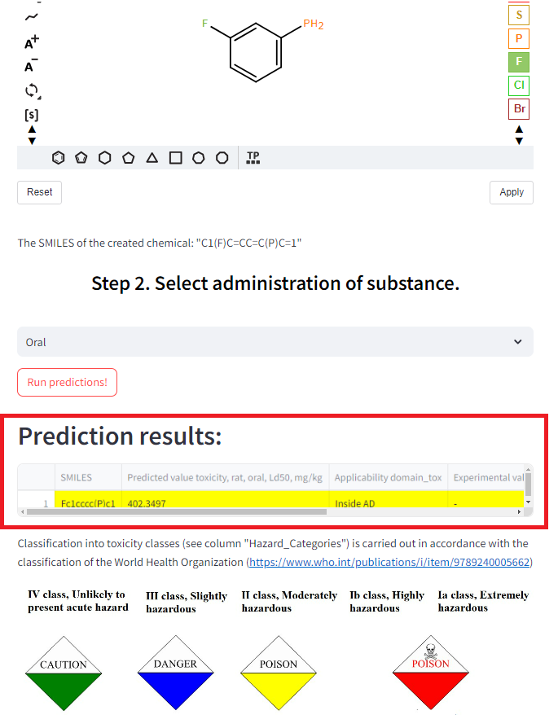

The rows in the final table are colored depending on the toxicity class. The correspondence of the colors to the toxicity classes is shown in the figure below the final table.

The final table contains the following columns:

1) ***SMILES*** - the chemical structure is displayed in the SMILES notation

2) ***Predicted value toxicity, Ld50, mg/kg*** - predicted value of acute toxicity when administered intravenous or orally to rat. If experimental data is available in the PubChem database, the label "see experimental value" is displayed in this cell.

3) ***Applicability domain_tox*** - compliance of the chemical compound with Applicability domain. If experimental data is available in the PubChem database, the label "-" is displayed in this cell.

4) ***Experimental value toxicity, Ld50*** - experimental data presented in the PubChem database. Toxicity was measured by a dose of LD50 when administered intravenous or orally to rat to rats

5) ***CAS number*** - a unique identification number assigned by the Chemical Abstracts Service (CAS)

6) Hazard_Categories - classification of a chemical into a toxicity class in accordance with an experimental or predicted level of toxicity

If you choose a file *sdf or *csv, the prediction results for correct chemical structures are displayed in a table that can be downloaded.

