all about vikings

Vikings in general were Norse seafarers who conducted commerce and raids across wide areas of the European continent from the late 8th to late 11th centuries.

**Introduction and Thesis.**

Comparison between the human trafficking operations of the Cilician pirates in the eastern Mediterranean and the Viking pirates in the North Sea, with the bases of comparison including scale, scope, and the sustainability of the operations given the regional/political/economic contexts.

**Thesis**: The successes of the Cilician pirates in the eastern Mediterranean and the Viking pirates in the North Sea demonstrate the same something

compare the operations of human traffickers (scope: people who capture for the purpose of reselling, operating outside the legal framework of the regions in which they are operating)

**why cilicia?**

specific strain of piracy and approach to human trafficking with its own specific cultural history [need proof!]

**why viking piracy?**

generalizable [need proof!]

**Definitions and scope.**

Maritime crime

Non-state violence

Kidnapping

focusing on human trafficking operations and not ransom operations.

with ransoming, " what the man-hunter exploited here was not the old vocation of slave-traffickingbut the perhaps older habit of extortion " (Gabrielson 393)

*SSD: what is kidnapping?*

115

"distinguish so-called warfare from kidnapping raids by small "war parties" on neighboring groups."

"We have separated kidnapping from warfare on the grounds that it was not usually a communal affair and might be directed either at a neighborhood group with whom there was no overt state of warfare or at members of the kidnappers' own group. Kidnapping was also conducted with the sole aim of acquiring captives, whereas this was often only a by-product of warfare."

"Kidnapping, especially piracy... ranked close to captivity in warfare as an original and current means of enslavement among all the ancient and medieval slaveholding societies of the mediterranean. The area was ideally suited to this form of enslavement, as Ormerod and others have shown.

piracy goes down when a supreme leader (e.g. athenian empire, roman republic) rises

**Piracy**

de Souza in the encyclopdia of ancient history (oct 26 2012, https://onlinelibrary.wiley.com/doi/pdf/10.1002/9781444338386.wbeah09199 )

1

"ancient piracy is distinct from banditry, not merely because of its maritime aspect, but also because of the greater range which ships give to piratical activities."

>> ancient piracy =/= banditry

"In the fifth and fourth centuries BCE, when narrower political objectives were given precedence over the socioeconomic aims of raiding and plundering, war and piracy began to be differentiated more clearly"

>> ancient piracy =/= warfare

"Labeling opponents as pirates was a way of delegitimizing their activities, similar to the modern practice of describing political violence as terrorism."

>> ancient piracy was sometimes conflated with warfare, politically advantageous label

"In the Hellenistic and Roman republican periods, piracy was endemic in the Mediterranean, particularly on the fringes of wars. Raiders attached to one side or another attacked islands and coastal cities in search of both plunder and prisoners, the latter to be ransomed or sold as slaves"

>> pirates skulked around fringes of wars as opportunity for kidnapping and other plunder

"The numerous coastal settlements of the Aegean and eastern Mediterranean were especially vulnerable to the sudden appearance of pirate ships, whose crews could easily bypass or overwhelm local defenses and plunder at will (e.g., IG XII.7 386; IG XII.8 53)."

>> pirates have many reliable sources of kidnapping victims

The ancient sources refer to the Illyrians, Cretans, Pamphylians, and Cilicians as habitual pirates.

>> four different main groups of pirates

"the heavily politicized concept of pirates as the common enemies of all peoples, implicit in the law of 100 BCE and fully articulated by Cicero, gave way to the equation of pirates with common bandits (Cic. Off. 3.107; de Souza 2008; Tarwacka 2009)."

>> political equation of pirates with common bandits:

Roman Empire began breaking up in the fifth century CE, piracy again became commonplace in the politically unstable Mediterranean region, particularly after the Vandal seizure of Carthage in 439

>> piracy decreases with Leviathan and increases with its dissolution

**Cilician Pirates**

until suppressed by Pompey 67-66 BC, had held a stranglehold on Mediterranean commerce and threatened Rome with famine.

With the decline of the Hellenistic powers (kingdoms of the Diadochi) in the late 2nd, early 1st centuries BC, Rome is the only major Mediterranean power. Not a strong naval power (hired ships as necessary) and only protected the nearby Tyrrhenian and Adriatic seas, addressing only the nearby pirate bases on the coasts of Liguria and Illyria and the Balearic Isles.

So pirates were able to consolidate and organize and established havens in regions not under the tight control of any Mediterranean empires.

Crete

- devastated by civil wars, lots of people turned to piracy

- strategic position in the midst of the Mediterranean

- independent Greek territory; not under the control of any Mediterranean empires

Cilicia, likewise

- excellent natural harbors, easily defensible

- Seleucids were too weak to suppress them

de souza PGRW

97

"By the 70s BC the region of Southern Anatolia known as Rough Cilicia and the neighbouring district of Pamphylia were notorious as the homeland of pirates whose exploits terrorized the inhabitants of the Mediterranean."

Data scarcity for origins of Cilician pirates:

1. "lack of contemporary sources for the second half of the 2nd century BC,

particularly for events in the eastern Mediterranean"

2. "tendency of later sources to portray the growth of piracy in this region in moralistic

terms which oversimplify the phenomenon and distort its development."

since many describe piracy as a problem which was 'solved' by Pompey in 67 BC.

"The most important source is Strabo, who had scant regard for the Pamphylians

and Cilicians."

Geographic setting:

Strabo 14.3.2 via De Souza (97)

"At Side, a city of Pamphylia, the docks were set up for the benefit of the Cilicians: they used to sell their captives there by auction, admitting that they were free men."

>> Strabo confirms that the Cilicians engaged in the selling of free citizens, and implies that this was known to be illegal.

>> Strabo addresses the network of pirate docks even in territories that are not Cilician but economically subject to Cilician commerce.

97

"While it is impossible to reconstruct a full, detailed narrative of events relating to the Cilician pirates, there is enough evidence to enable the modern historian to discern the broad outlines."

98

political chaos in the wake of Tryphon's rebellion with rival Syrian kings fighting amongst each other makes it easy for pirates to take control in Cilicia and maintain presence

99

some leaders of pirate groups became "notorious (and powerful) enough to enter the historical record."

organization of pirates:

"'fiefdoms' of varying sizes along the southern coast of Anatolia, from Rough Cilicia to Pamphylia, in which individual leaders exercise autocratic power and from which (it is implied) they direct piratical forces against their neighbors and more distant targets. Rulers of small fiefdoms which lay further inland were less of a threat as they could not easily project their power across long distances. They remained small-scale 'bandit' leaders, acknowledging neither the authority" of the Seleukids, Rome, or any of Rome's enemies (unless it suited them)

"strabo speaks of the Cilicians 'passing themselves off as slavers' (str 14.5.2)." de souza has "drawn attention to this comment and [suggests] that the lack of decisive roman intervention against the cilician pirates was a result of their selfish desire to preserve the cilicians as an important source of their slaves." However... "there is no firm evidence that the Cilicians were vital to Rome's slave-supply."

>> not sure how important was cilician piracy to roman slave supply

100

>>indiv attempts from various govts to eradicate piracy not super constructive toward wiping it out

113

>> The lex de provinciis praetoriis found at Delphi and Knidos "is the earliest clear statement of the position of Rome concerning pirates. They are effectively being declared enemies of the Roman people, and their friends and allies."

114

"Also worthy of emphasis is the method by which piracy is to be combated, according to this law. The most importantant thing is to deny bases to the pirates, wherever they may be."

"... the Romans were well aware at this time that the most effective way to deal with pirates was to tackle them *on land*."

125

>> De Souza suggests that pirates gained profit from the misfortunes of others, skulking around the fringes of major conflicts during the Hellenistic period, e.g. pirates who accompanied Demetrios Poliorketes to the siege of Rhodes and those who rescued Mithridates when his flagship was holed (Ap. Mith. 78)

>> would be opportunity to collect human chattel

Strabo Geographica (written several generations later) 14.5.1, transl via http://penelope.uchicago.edu/Thayer/E/Roman/Texts/Strabo/14E*.html#ref1

"As for Cilicia outside the Taurus, one part of it is called Tracheia [Rough/Rugged] and the other Pedias [Smooth]. As for Tracheia, its coast is narrow and has no level ground, or scarcely any; and, besides that, it lies at the foot of the Taurus, which affords a poor livelihood... Celicia Pedias... consists for the most part of plains and fertile land."

**Strabo Geographica**

14.5.2

Cilicia is protected by the stronghold of "Coracesium, situated on an abrupt rock, which was used by Diodotus, called Tryphon, as a base of operations at the time when he caused Syria to revolt from the kings and was fighting it out with them."

**origin of Cilician piracy**

"...it was Tryphon, together with the worthlessness of the kings who by succession were then reigning over Syria and at the same time over Cilicia, who caused the Cilicians to organize their gangs of pirates; for on account of his revolutionary attempts others made like attempts at the same time..."

**Cilician pirates and slave trading**

The exportation of slaves induced them most of all to engage in their evil business, since it proved most profitable; for not only were they easily captured, but the market, which was large and rich in property, was not extremely far away, I mean Delos, which could both admit and send away ten thousand slaves on the same day; whence arose the proverb, "Merchant, sail in, unload your ship, everything has been sold." The cause of this was the fact that the Romans, having become rich after the destruction of Carthage and Corinth, used many slaves; and the pirates, seeing the easy profit therein, bloomed forth in great numbers, 669themselves not only going in quest of booty but also trafficking in slaves. 

>> slave trading hugely profitable for Cilician pirates, nearby markets (Delos) and consumers (Romans used a lot of slaves)

>> e.g. the huge Roman latisfundia (plantations) of Sicily

The kings both of Cyprus and of Egypt co‑operated with them in this, being enemies to the Syrians. Neither were the Rhodians friendly to the Syrians, and they therefore afforded them no assistance. 

>> enabled by cooperation of the Cypriot, Egyptian, and Rhodian governments (all enemies to the Syrians)

And at the same time the pirates, pretending to be slave-dealers, carried on their evil business unchecked. 

>> Cilician pirates pretended to be legitimate slave dealers

Neither were the Romans concerning themselves as yet so much about the peoples outside the Taurus; but they sent Scipio Aemilianus, and again certain others, to inspect the tribes and the cities; and they decided that the above mentioned piracy was due to the incompetence of the rulers, although they were ashamed, since they themselves had ratified the hereditary succession from Seleucus Nicator, to deprive them of it... the sea... they gave over to the Cilicians. Then, after these people had grown in power, the Romans were forced to destroy them by war and with an army, although they had not hindered their growing power.

>> The Romans sent out Scipio Aemilianus to survey the pirate situation; Romans conclude that they have more pressing concerns and essentially "cede the sea to the Cilicians" to the extent that by the 70s BC the Cilicians are the only substantial power on the Mediterranean. Then Rome has to address them.

14.5.6

Cilicia Tracheia "was naturally well adapted to the business of piracy both by land and by sea — by land, because of the height of the mountains and the large tribes that live beyond them, tribes which have plains and farm-lands that are large and very easily overrun, and by sea, because of the good   supply, not only of shipbuilding timber, but also of harbours and fortresses and secret recesses"

>> Rough Cilicia: great for piracy on land (nearby tribes easy to overrun) and at sea (geography and timber)

**Appian Mithridates**

App. Mith 14.92

"Having lost both livelihood and country by reason of the war and fallen into extreme destitution, they [the pirates] harvested the sea instead of the land... sailing in squadrons under pirate chiefs, who were like generals of an army."

>> origin of pirates, led by chiefs

They fell upon unfortified towns. They undermined or battered down the walls of others, or captured them by regular siege and plundered them. They carried off the wealthier citizens to their haven of refuge and held them for ransom. They scorned the name of robbers and called their takings the prize of warfare. They had artisans chained to their tasks

>> attacks on land, considered themselves legitimate prizewinners

>> suggests that they actually used some slaves, too!

thought that if they should all come together in the same place they would be invincible. They built ships and made all kinds of arms... They had castles and towers and desert islands and retreats everywhere.

>> they got really big

They chose for their principal rendezvous the coast of Cilicia where it was rough and harborless and rose in high mountain peaks, for which reason they were all called by the common name of Cilicians. Perhaps this evil had its beginning among the men of the Crags of Cilicia, but thither also men of Syrian, Cyprian, Pamphylian, and Pontic origin and those of almost all the Eastern nations had congregated, who, on account of the long continuance of the Mithridatic war, preferred to do wrong rather than to suffer it, and for this purpose chose the sea instead of the land.

>> these pirates came from all over the eastern Mediterranean and gathered on the Cilician coast.

App. Mith 14.93

Thus, in a very short time, they increased in number to tens of thousands. They dominated now not only the Eastern waters, but the whole Mediterranean to the Pillars of Hercules. They vanquished some of the Roman prætors in naval engagements, and among others the prætor of Sicily on the Sicilian coast itself. No sea could be navigated in safety, and land remained untilled for want of commercial intercourse.

>> explosive spread of piracy across the Mediterranean

The city of Rome felt this evil most keenly, her subjects being distressed and herself suffering grievously from hunger by reason of her very greatness. It appeared to them to be a great and difficult task to destroy so large a force of seafaring men scattered everywhither on land and sea, and so nimble of flight, sallying out from no particular country or any known places, having no habitation or anything of their own, but only what they might chance to light upon. Thus both the greatness and the unexampled nature of this war, which was subject to no laws and had nothing tangible or visible about it, caused perplexity and fear on all sides. Murena had attacked them, but accomplished nothing worth mention, nor had Servilius Isauricus, who succeeded him. And now the pirates contemptuously assailed the coasts of Italy, around Brundusium and Etruria, and seized and carried off some women of noble families who were travelling, and also two prætors with their very insignia of office.

>> super problematic and daunting problem for Rome

>> this war has no precedent (This quote suggests that fighting cilician piracy is like counter-terrorism today, because just war theory often considers terrorists to be stateless? This person argues that piracy is terrorism: https://www.nytimes.com/2008/12/05/opinion/05burgess.html)

App. Mith 14.94

When the Romans could no longer endure the damage

|  |
| --- |
| B.C. 67 |

and disgrace they made Gnæus Pompey, who was then their man of greatest reputation, commander by law for three years, with absolute power over the whole sea within the Pillars of Hercules, and of the land for a distance of 400 stades from the coast. They sent letters to all kings, rulers, peoples, and cities, that they should aid Pompey in all ways. They gave him power to raise troops and to collect money from the provinces, and they furnished a large army from their own enrolment, and all the ships they had, and money to the amount of 6000 Attic talents, -- so great and difficult did they consider the task of overcoming such great forces, dispersed over so wide a sea, hiding easily in so many nooks, retreating quickly and darting out again unexpectedly. Never did any man before Pompey set forth with so great authority conferred upon him by the Romans. Presently he had an army of 120,000 foot and 4000 horse, and 270 ships, including hemiolii. He had twenty-five assistants of senatorial rank, whom they call lieutenant-generals, among whom he divided the sea, giving ships, cavalry, and infantry to each, and investing them with the insignia of prætors, in order that each one might have absolute authority over the part intrusted to him, while he, Pompey, like a king of kings, should course among them to see that they remained where they were stationed, lest, while he was pursuing the pirates in one place, he should be drawn to something else before his work was finished, and so that there might be forces to encounter them everywhere and to prevent them from forming junctions with each other.

>> the Romans outfit Pompey to do a total spread over the Mediterranean

>> this shows how great a task the Romans thought pirate eradication was

App. Mith 14.96 (Perseus)

Pompey himself hastened to Cilicia with forces of various kinds and many engines, as he expected that there would be need of every kind of fighting and every kind of siege against the rock-bound citadels; but he needed nothing. The terror of his name and the greatness of his preparations had produced a panic among the robbers. They hoped that if they did not resist they might receive lenient treatment.

>> cilicia gets his attention and he thinks it's super important (tho he actually doesn't even need to fight anyway)

among what the pirates surrendered to Pompey, "a multitude of captives either held for ransom or chained to their tasks"

>> they were holding lots of slaves!

Roman History, Cassius Dio transl. Earnest Cary (via lexundria)

36.20

1. Pirates always used to harass those who sailed the sea, even as brigands did those who dwelt on land. There was never a time when these practices were unknown, nor will they ever cease probably so long as human nature remains the same. **2**But formerly freebooting was limited to certain localities and small bands operating only during the summer on sea and on land; whereas at this time, ever since war had been carried on continuously in many different places at once, and many cities had been overthrown, while sentences hung over the heads of all the fugitives, and there was no freedom from fear for anyone anywhere, large numbers had turned to plundering. **3**Now the operations of the bandits on land, being in better view of the towns, which could thus perceive the injury close at hand and capture the perpetrators with no great difficulty, would be broken up with a fair degree of ease; but those on the sea had grown to the greatest proportions. **4**For while the Romans were busy with their antagonists, the pirates had gained great headway, sailing about to many quarters, and adding to their band all of like condition, to such an extent that some of them, after the manner of allies, assisted many others.

>> explosion of piracy in aftermath of mithridatic wars, sea is easier to get away with piracy than land, rome was busy, pirates started to organize.

36.21.1

Indeed, I have already related how much they accomplished in connection with others. When those wars had been ended, the pirates, instead of desisting, did much serious injury alone by themselves both to the Romans and to their allies. They no longer sailed in small force, but in great fleets; and they had generals, so that they had acquired a great reputation.

>> pirate alliances super important, super strong

36.21.2

**2**First and foremost they robbed and pillaged those sailing the sea, no longer permitting them any safety even during the winter season, since as the result of their daring, practice, and success they made voyages in security even then; and next they despoiled even those in the harbours.

>> pirates everywhere and year round

36.21.3

even if he conquered, he would be unable to capture any of the enemy by reason of the speed of their ships.

>> pirates super speedy, hard to catch even when they don't slaughter you

Accordingly, they would return after a little, as if victors, and would ravage and set in flames not only farms and fields, but also whole cities; some places, however, they conciliated, so as to gain naval stations and winter quarters in a friendly land as it were.

>> pirates quasi conquered land

36.32.1

As these operations of theirs met with success it became customary for them to go into the interior, and they inflicted many injuries on those even who had nothing to do with the sea. This is the way they treated not only the distant allies of Rome, but even Italy itself.

36.32.2

**2**For, believing that they would obtain greater gains in that quarter and also that they would terrify all the others still more if they did not even keep their hands off that country, they sailed into the very harbour of Ostia as well as other cities in Italy, burning the ships and pillaging everything. **3**Finally, as no attention was paid to them, they took up their abode on the land, disposing fearlessly of whatever men they did not kill, and of whatever spoils they took, just as if they were in their own land.

>> pushing into the interior of land

36.32.4-5

And though some plundered here and some there, since of course it was not possible for the same persons to do harm throughout the whole length of the sea at once, they nevertheless showed such friendship one for another as to send money and assistance even to those entirely unknown, as if to their nearest of kin. **5**In fact, this was one of the chief sources of their strength, that those who paid court to any of them were honoured by all, and those who came into collision with any of them were despoiled by all.

>> pirate alliances !! v tight!

36.23.1-3

To such an extent did the power of the pirates grow that their hostility became a grave and constant menace, admitting of no precaution and knowing no truce. The Romans, of course, heard of these deeds from time to time, and even saw a little of what was going on, inasmuch as imports in general ceased coming in and the corn supply was shut off entirely; **2**but they paid no serious attention to it at the proper time. Instead, they would send out fleets and generals only as they were stirred by individual reports, but accomplished nothing; on the contrary, they caused their allies all the greater distress by these very means, until they were finally reduced to the last extremity. Then at length they came together and deliberated for many days as to what really should be done. **3**Wearied by the continued dangers and perceiving that the war against the pirates would be a great and extensive one, and believing, too, that it was impossible to assail them all at once or yet individually, inasmuch as they helped one another and there was no way of driving them back everywhere at once, the people fell into great perplexity and despair of making any successful move.

>> Rome is affected along with the rest of the mediterranean and is like gah what can we do, they all help each other

Plut. Pomp. 24

1-2

The power of the pirates had its seat in Cilicia at first, and at the outset it was venturesome and elusive; but it took on confidence and boldness during the Mithridatic war,[1](http://www.perseus.tufts.edu/hopper/text?doc=Plut.%20Pomp.%2024&lang=original#note1) because it lent itself to the king's service. [2] Then, while the Romans were embroiled in civil wars at the gates of Rome, the sea was left unguarded, and gradually drew and enticed them on until they no longer attacked navigators only, but also laid waste islands and maritime cities. And presently men whose wealth gave them power, and those whose lineage was illustrious, and those who laid claim to superior intelligence, began to embark on piratical craft and share their enterprises, feeling that the occupation brought them a certain reputation and distinction.

>> explosive growth of cilician piracy

3

There were also fortified roadsteads and signal-stations for piratical craft in many places, and fleets put in here which were not merely furnished for their peculiar work with sturdy crews, skilful pilots, and light and speedy ships

>> piracy infrastructure

4

their seizures of persons in high command, and their ransomings of captured cities, were a disgrace to the Roman supremacy. For, you see, the ships of the pirates numbered more than a thousand, and the cities captured by them four hundred.

>> power of pirates

5

Besides, they attacked and plundered places of refuge and sanctuaries hitherto inviolate, such as those of Claros, Didyma, and Samothrace; the temple of Chthonian Earth at Hermione; that of Asclepius in Epidaurus; those of Poseidon at the Isthmus, at Taenarum, and at Calauria; those of Apollo at Actium and Leucas; and those of Hera at Samos, at Argos, and at Lacinium.

>> attacked sacred places

6

But they heaped most insults upon the Romans, even going up from the sea along their roads and plundering there, and sacking the neighbouring villas. Once, too, they seized two praetors, Sextilius and Bellinus, in their purple-edged robes, and carried them away, together with their attendants and lictors. They also captured a daughter of Antonius, a man who had celebrated a triumph, as she was going into the country, and exacted a large ransom for her.

>> plundered rome, took romans as ransom

Plut. Pomp. 25

1

This power extended its operations over the whole of our Mediterranean Sea, making it unnavigable and closed to all commerce. This was what most of all inclined the Romans, who were hard put to it to get provisions and expected a great scarcity, to send out Pompey with a commission to take the sea away from the pirates.

>> pirates shut down commerce across the Mediterranean, bad for Rome which relies on trade for survival

2

>> the law which Gabinius drew up for Pompey gave him totalitarian power over the sea.

For the law gave him dominion over the sea this side of the pillars of Hercules, and over all the mainland to the distance of four hundred furlongs from the sea. These limits included almost all places in the Roman world, and the greatest nations and most powerful kings were comprised within them. [3] Besides this, he was empowered to choose fifteen legates from the senate for the several principalities, and to take from the public treasuries and the tax-collectors as much money as he wished, and to have two hundred ships, with full power over the number and levying of soldiers and oarsmen.

>> they think the problem is massive, that pompey's job is really important

Gabrielson in Piracy and the Slave-Trade in A Companion to the Hellenistic World

389

"The pervasiveness of chattel slavery as an institution ensured that every free individual, high or low, had to live with the fear of losing his or her personal liberty and thus become another person’s property."

>> Kidnapping in the ancient Mediterranean world is a constant danger to free people.

like any other commodity that of human captives was part and parcel (and a very large one at that) of the wider economic life, with an established supply/demand system, points of distribution and sale, a host of purveyors, shippers, dealers and buyers and price- setting routines - all in all, a market in humans

>> human trafficking was a part of life in the ancient mediterranean

390

>> no one ever felt any compunctions about human trafficking in the ancient mediterranean from the classical period to the Hellenistic period.

(Xen. Cy.**7.5.73)** - "... persons and their property appropriated in war belong to those who had seized them. "- Gabrielson

As historical phenomena, piracy and brigandage are by far the most complex of the ‘sources of peril’ mentioned above. [as compared with war captivity and the "customary right of reprisal (*syle, rhysia*)" (389)]

>> piracy hella complex

391

"in volume his activity surpassed that of the brigand: His chosen element enabled him to prey over an area that was both much larger and far richer in catch, that is, the high seas as well as the Mediterranean and Black Sea littorals; in addition, his unequally greater ease of movement, besides minimizing the risk of capture, afforded him the advantage of hitting, within a given time, many more targets than his landward counterpart could hope for; moreover, even though he plied the seas by ship, his operations were often amphibious. It seems therefore defensible to regard the maritime ***leistes*** as historically and economically the more significant of the two, a fact also accentuated by the substantial investment of precisely that agent in the technological improvement of his ‘hunting equipment’, the light, fast-sailing galley"

>> can focus on pirates because activity more significant than brigands

"Indeed, a slave market was to be found in practically every port. Some of them, notably Side, Phaselis, Alexandria, Rhodes and Delos, as well as the ports of Crete and the Black Sea, at various periods, dwarfed the rest in scale." Also some "inland counterparts, such as, for instance, Karian Mylasa (Men. Sik. **3-7)**"

>> a bunch of examples of slave markets

Delos, of course, is a well-known exception. And yet, it is only by chance that we are informed of the island’s function as a market in the late third century ***(SEG* 3.666)** - and as a pirate base in the early second century (***S1G3* 582).** More importantly, Strabo offers a vivid description of the momentous boost experienced by Delos after **145** (Maroti **1969-70;** Rauh **1993: 41-68),** an expansion of the island’s in- and outgoing traffic in slaves that might have prompted the construction of facilities related to that trade (Coarelli **1982:** the Delian ‘Agora of the Italians’ was essentially a slave market).

>> Delos! Proof that it's a market and pirate base and slave market.

It is "incontestable" that "all these slave markets, small and great, were also fed by the pirates themselves, often directly"

395

King **Minos,** archaic Corinth and classical Athens number among the early representatives; the task was taken over by Alexander, then by successors such as Antigonos and Demetrios and the Ptolemies; in the mid third century it was the turn of the Rhodians, and from **102** it was taken up in earnest by the Romans, who effectively finished the job off when Pompey in **67** annihilated the claimed plague of those times, the so-called Cilician pirates, right at their very base in Korakesion.

>> anti-piracy with varying degrees of zeal and success until Pompey annihilates in 67

idea that strength of maritime hegemon is directly negatively proportional to fluorishing of piracy is overly simplistic. we know that in general on the mediterranean, groups of pirates often allied with kings as mercenaries

"The archpirate who put his flotilla and brilliant tactical **skills** at the service of the kings is a common figure in Hellenistic naval operations(Launey**1949:34-35,180-95;** Ducrey**1968:178)** Ample historiographic coverage is received by a few celebrities: the Phokian Ameinias (hired by Antigonos Gonatas),the Illyrians Agron and Demetrios of Pharos (employedbyDemetrios**I1**and Antigonos Doson respectively), their compatriot Skerdilaidas (in the service of Philip V), and the Aitolian Dikaiarchos, who having served Philip V shifted his allegiance to Egypt, where Ptolemaic favour materialized in the grant of a lucrative concession placing him in a key-post within the Egyptian slave market (Westermann **1929: 1-3, 22-5;** cf. Launey **1949: 192).** But these should not get all of our attention at the expense of their far more numerous, though less well-known, colleagues: for instance, the archpirate Nikandros, who in **190** operated in Antiochos **111’s** fleet, or one Timokles, who served under Demetrios Poliorketes during the siege of Rhodes (Livy **37.11.16;**App..’S **24;**Diod.**20.97)**

>> a bunch of examples of pirates who worked with state powers

as a consequence the proceeds from piracy, humans and other valuables, went piggyback on, and therefore were indistinguishable from, those of warfare

>> piracy connected with warfare

399

>> use of terms "pirate" and "piracy" very political, flag as "inhuman" and "illegitimate" behavior; dominant power, with help of history writers, can "construct a specific image of its political opponents"

403

So too did the three major components of a long-term trend observable from Thucydides(1.5)to Plutarch ***(Ant.*29).**The trend itself is quite simplyt hat predatory activity increasingly attains ethnic specificity, and to such a degree as to create a widely-used classificatory system that proved as resilient to change as it was overly simplistic. The first and most conspicuous of its components is reflected in the fact that the ‘succession list’ of maritime protectors mentioned in section **4** above is matched by a similar list of ‘rogue states’ or ‘rogue peoples’, all of which had won renown for their addiction to predatory activity:most notably (and in crude chrono- logical order), the Karians, Ozolian Lokrians, Akarnanians, Tyrrhenians, Illyrians, Aitolians, Cretans, Pamphylians and Cilicians. The second component consists of the virtual correspondence which our sources claim existed between these ‘rogue states’ and the inhabitants of areas commonly branded with the stigma of cultural and political backwardness.

>> long-term trends: (1) increasing ethnic specificity. (2) connection with regions considered culturally and politically backward.

"political communities in two diametrically opposed camps... In certain states, organized violence had become the absolute monopoly of the central political authority, which accordingly had taken all such activity under its purview, legally restricted its usage to the pursuit of ‘national’ objectives and claimed for itself the exclusive right to any material proceeds ***(lapbyon, leia)*** that might accrue therefrom: for these there was only one legitimate ‘booty- seizurer’ - the state - and one field furnishing a justifiable cause for performing that role - that of the political ... In the Mediterranean, these states were the naval protectors and the major Hellenistic monarchies."

>> camp 1: central authorities monopolize organized violence.

Meanwhile, the central political authority in regions such as Cilicia " was wilting to share the right to exercise violence with the private entrepreneur, whether a native citizen or a foreigner in need of an operational base in which his trade remained legally undisputed. "

>> camp 2: central authorities allowed (sometimes purposely, sometimes de facto) entrepreneurs to exercise organized violence

review of de souza by casson:

>> it's important not to forget how effective pompey's pirate campaign was instead of branding it as not historical fact but the politics of our sources

Ancient Piracy oxford reference

 Rhodes had a crack fleet built along Athenian lines that was skilled at maneuver-and-ram warfare with smaller units. But when the Rhodian state offended Rome during the Third Macedonian War (171–168), the Romans enacted a series of measures that cut Rhodian revenues, removed their independence, and degraded their ability to maintain a navy. The unintended result was an increase in piracy that progressively impacted Italian shipping during the second and first centuries until Pompey (Gnaeus Pompeius Magnus, 106–48 b.c.e.) was given a set of extraordinary powers to deal with the threat in 67 b.c.e.

>> Econonomic warfare of Rome vs. Delos leads to decline of delian navy and rish of pirates

**[] Viking Pirates**

oxford reference norse navigation

http://www.oxfordreference.com/view/10.1093/acref/9780195130751.001.0001/acref-9780195130751-e-0887?rskey=cedSRS&result=2

By convention, the Viking era of northern European history begins in 793 AD with the raid on Lindisfarne, a monastery island in Northumbria.

Over the century following, emigration and expansion from the present-day Scandinavian countries of Norway, Denmark, and Sweden westward, southward, and eastward settling in Shetland, the Orkneys, England, Scotland, the Faroes and Iceland. Expeditions westward reached as far as North America.

To the east, "the Old Norse sphere of influence" extended as far as Sicily, the banks of the Caspian and Black seas (including Constantinople).

Extensive navigational knowledge and skills both to the east and to the west.

Peak power in the first half of the eleventh century, violent Viking raids based in the Orkney Islands continued into the 12th century, the cultural activity of saga writing continued in Iceland until the fourteenth century

oxford encyclopedia of maritime history

vikings

The Iceland cycle was completed by an exploratory visit to the South Alptafjord in the Eastfjords by Ingolf Arnarson and Hiaor-Leif Hrodmarsson out of Dalsfjord around 872, a swift Viking raid into Ireland in the following year to support their future plans with loot and Irish slaves, and a two-ship colonizing voyage in 874 that culminated with Ingolf’s settlement at Reykjavík in 877.

>> Vikings raided slaves in preparation for establishing settlements, either to sell to raise funds or to bring along when establishing settlements

10-11

intro in cambr hist of scand

knut helle

"That the commercial expansion in north-west Europe in the preceding century was an important condition for the outburst of Viking piracy from the end of the eighth century seems clear, but it is at present a matter of debate whether the first recorded incursions on the coasts of the British Isles and the Continent were more than sporadic plundering raids. In contrast to the long-standing conflict between Danes and Franks there is so far no clear evidence of close interaction between the Germanic and Christian kingdoms of the British Isles and Scandinavia prior to the first known Viking raids. Conse- quently, it has not been possible to substantiate the argument that the raids were organised by Scandinavian rulers in order to counteract what was believed to be threats from those kingdoms. At any rate, the raids were soon followed by territorial conquests and colonisation which made a lasting impact on both western and eastern Europe. "

>> outburst from end of 8th century

>> As of right now, hard to substantiate the argument that the Viking raids began with political motivation.

11

"Society was predominantly agricultural and clearly stratified, with slaves as the lowest stratum and a warlike aristocracy at its head. "

conclusion

776

slavery/thraldom - extent and economic significance clearlyy in decline during the early Middle Ages. Iceland, ceased before 1100 and Norway during 12th cent, denmark until early 13th cent and sweden until early 14th cent.

777

recent research: due to landowners finding it cheaper to let freed slaves cultivate tenanted plots rather than use slave labor for agriculture on their own account.

In Denmark and the central farming regions of Sweden there developed a manorial system with large-scale farming of demesnes by slaves

152

Vikings dominated the routes of the European slave trade from the early ninth to middle of twelfth centuries (1) in north sea and across english channel and (2) sea, river, overland transport. "Anglo-Saxons and Vikings were raiding and trading peoples from all over Western Europe. The Celtic peoples of the British Isles and the Scandinavians themselves were the main victims. large numbers of Welsh and Irish were raided and sold to Iceland in order to augment the labor force during the period of settlement; at the same time they, along with Scandinavian slaves, were bought in quantity by Norwegian masters to restore the losses in manpower created by the emigration to Iceland."

154

The Welsh "raided and traded in the interior for slaves, then sold them to the Viking seaborne merchant pirates. The port cities of Cardiff and Swansea may have begun as slave-trading marts. But the two major centers were Dublin and Bristol. From these depots and from their own home bases, especially Hedeby, the Scandinavian merchants spread out all over Western Europe, and frequently as far as the mediterranean, selling their human caroges."

>> scandinavian peoples, loosely affiliated entities, no problems selling each others

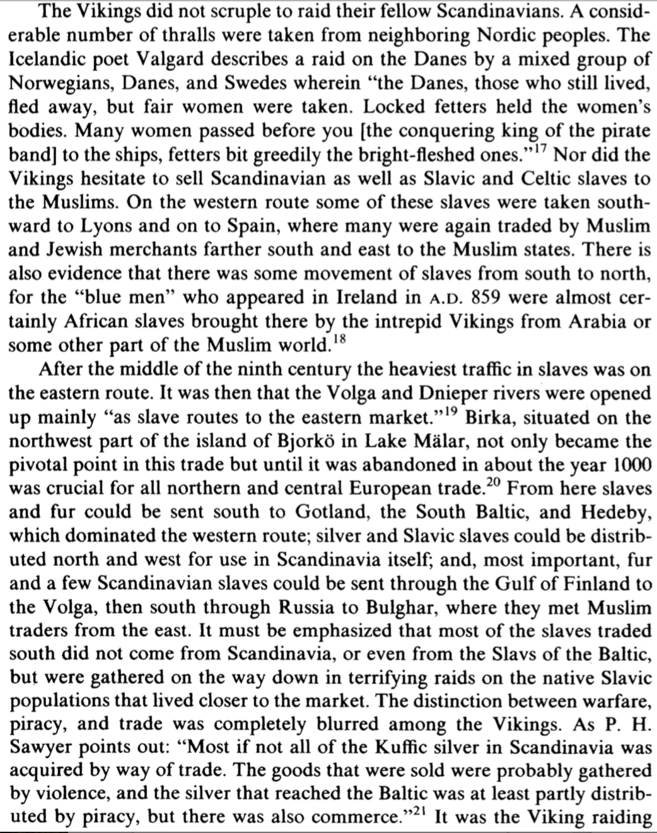

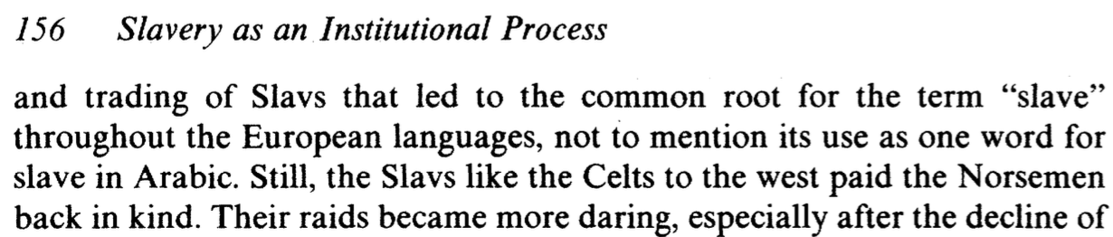

viking voyages were not super destructive:

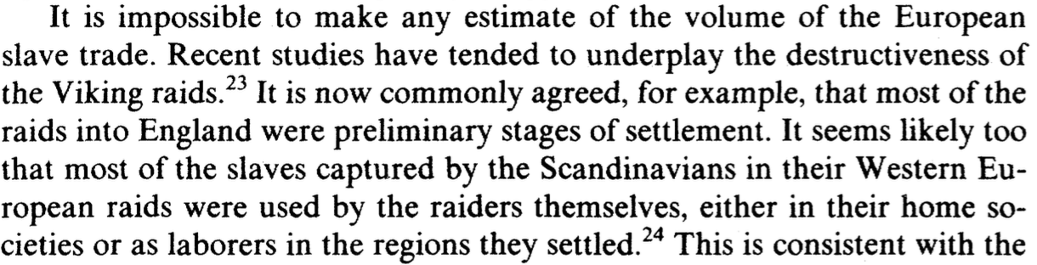

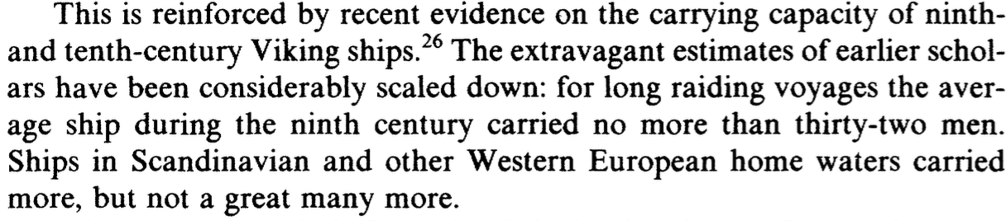

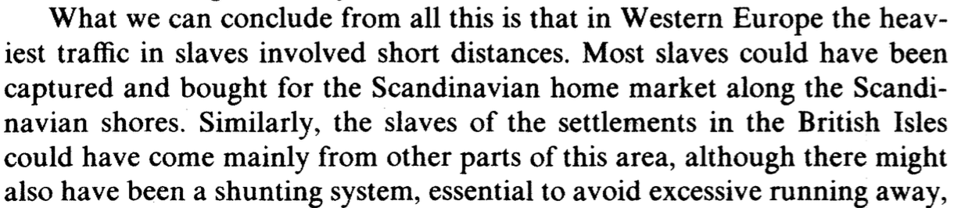

**MAGNITUDE AND DEMAND**

"It is, as noted earlier, impossible to offer any sound estimate of the volume of the European slave trade during this period."

JC Russel: Western Europe around 950 was 22.6 million.

Patterson estimates at least 15% of total pop was enslaved. "this is highly conservative")

157

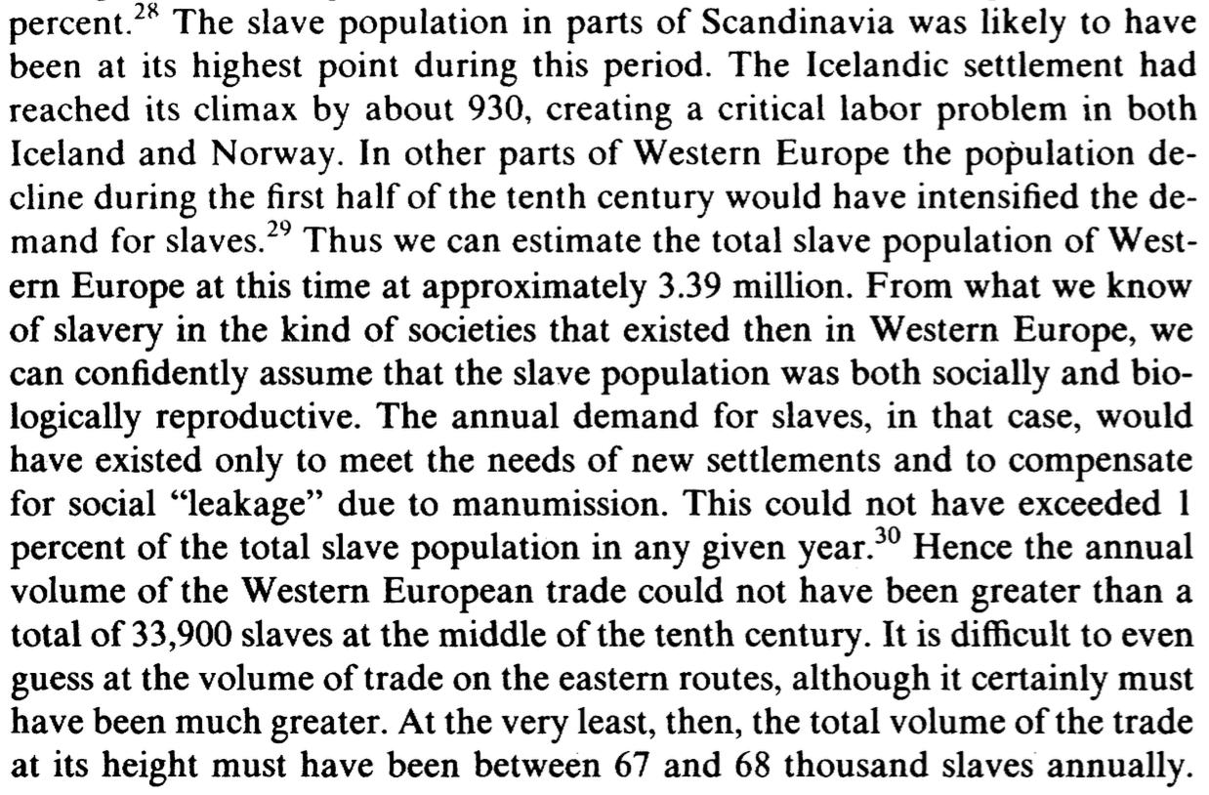

richards

2

"in different contexts Vikings have been marauders, merchants, manufacturers, poets, explorers, democrats, statesmen, or warriors."

>> "viking" vs "viking pirate"

4

*víkingar* used "on 11th-century rune stones to describe respectable sons raiding overseas as well as local nuisances. "

>> range of viking pirates

4-5

This paper will define

Vikings - cultural entity, sometimes settlements, assuming members of "viking" subset who settled and gave rise to generations in viking settlements, therefore include domestic constituents; this is how the term seams to often be used

Viking pirates - the raiders (vis a vis definition of piracy)

5

a not-insignificant proportion of authors refer to Viking identity as that of a full-fledged civilization

>> more defining of viking identity

although 793 has long been commonly accepted date for beginning of Viking Age with raid on Lindisfarne, Richards contests, says we should take into account earlier North Sea crossings - evidence of earlier contact in the form of Irish and English artefacts in 8th cent. norwegian graves.

>> time period

"The dispute is really between those who see raiding as the key characteristic of Viking activity, and are reluctant to place that earlier than the 790s, and those who see outward-looking expansion, state formation, and other positive features taking place from the 710s."

>> more defining of viking identity. this is why this essay will specify "viking pirates".

"Raiding activity intensified in Western Europe from the 830s "

6

"aggressive military activity had stopped by the second half of the 11th century."

>> more defining of viking identity: increasing settlement complexity, both rural and urban, and growth of nation states.

39

>> vikings as a collective had legitimate traders and manufacturers

45-46

"the cosmopolitan bustle of merchants and craftsmen ... familiar throughout Northern Europe. Nonetheless, they facilitated overseas trade and expansionism, and provided the economic basis for the centralization of power and the growth of a mercantile class. "

49

>> slave trading was a regular activity in Ireland, England, and Wales

53-54

"...slaves acquired through raiding in Ireland might have been sold in York, for example. Scandinavians played a decisive role in trade in many of the areas where they took political control. They traded not only in luxury goods, but also increasingly in ordinary bulk commodities. They also acted as middlemen between the East and the West, and after Muslim incursions in the Mediterranean closed the traditional trade routes, they opened new ones through the Baltic and Russia. Economic expansion was fueled by population increase, manufacturing growth, and new wealth – which was itself often derived from plunder and tribute. It was facilitated by Scandinavian political domination, with the fact that exchange was easy within an area under the same language and culture.

>> LIKE CILICIAN PIRATES  
 trade in luxury and common goods  
 middlemen between east and west, opened new trade routes  
>> UNLIKE CILICIAN PIRATES  
 econ expansion fueled by expansion population, political dom, manufacturing

VIKING PIRATES sustainable success of human trafficking operations due to political bases, things that come with having settlement, etc.

even if both vikings and cilicians lack particular central authority

54

>>early viking raids motivated by hoarding, amassing wealth, trading to gain luxury items for gift exchange, to win friends, influence the powerful, purchase allies

later viking raids, by this time ownership of land was more important than portable wealth. "Land and estates became the main source of power, not territories and followers, and the later Viking raids were directed to the acquisition of new places to settle."

55

**>> how raids are patterned, and examples**

"The first recorded raids on Western Europe date from the close of the 8th century. Whether in continental Europe or the North or Irish Seas, raiding followed a similar pattern. Unprotected coastal and riverine sites, including monasteries and markets, were the first targets, normally for small bands of Vikings in two or three ships who returned home as the winter storms began. In the 790s they attacked the Northumbrian monasteries and in 799 raided the Carolingian Empire. The first Viking raid on the Irish coast took place in 795, and movement inland is first recorded *c*.830. From the 830s larger forces raided along the Frisian coast (the modern Netherlands) and devastated the south coast of England. The wealthy trading town of Dorestad was plundered for four successive years in 834–8. "

**LIKE CILICIAN PIRATES**

>> exploit divisions. also force fortifications.

"The Viking armies were quick to exploit local rivalries and weakness. After the death of Louis the Pious in 840 the Carolingian Empire was divided amongst his sons. With civil war and independent warlords intent upon carving out their own territory, Viking commanders hastened further fragmentation. In 841 Vikings ravaged Rouen and in 845 an attack on Paris was only prevented by the payment of 7,000 pounds of silver. In 852 a Viking fleet wintered on the Seine and in 853 on the Loire. The fleet continued to exploit these river systems until Charles the Bald built fortified bridges and protected the towns and abbeys, forcing the Viking armies to focus their attention on England."

**viking and cilician pirates are both wealth extractors**

57

"While Scandinavians from Denmark and Norway looked predominately westwards, those from Sweden looked eastwards "

58

"In 860 there was a famous Viking raid on Byzantium "

**viking base at Dublin**

in 917 the [viking] base at Dublin was re-established; by the mid-10th century it ruled over a substantial hinterland and written sources describe Dublin as the centre of the slave trade

**>> viking raiders as opposed to settlers**

Wyatt - in Celtic-Norse Relationships

97

"Slavery, then, was not simply an institution concerned with the manipulation of labour and financial gain; it also had powerfully symbolic psychological and cultural facets. Indeed, slavery was a significant social institution in the medieval period which was intimately related to con- structions of prestige, honour and gender identity." (Patterson SSD 86-94.)

**Concluding thoughts.**

We're still working on eradicating piracy. EU's Operation Atalanta is closer to eradication of Cilician pirates because deterrent with military power (guards on cargo ships) and trying to keep them trapped on coast of Somalia before they go too far out to sea; military action wasn't so influential in North Sea as the rise of Christianity.

(The distinct reasons that the operations eventually declined – economic, with the decline of chattel slavery due to the advent of Christianity in Scandinavia, versus military, with Pompey's anti-piracy campaigns – are also interesting, but I find the similarities between the two models of human trafficking more interesting than their differences.)

* EU's Operation Atalanta
  + somali pirates (armed gangs didn't have to worry about coast guards or police because of Somalia's lawlessness)

Cilician pirates were eradicated militarily and quickly by Pompey

Viking pirates were eradicated economically by Jesus (decline of chattel slavery due to Christianity)

Working Bib

Tröster, Manuel. “Roman Hegemony and Non-State Violence: A Fresh Look at Pompey's Campaign against the Pirates.” *Greece & Rome*, vol. 56, no. 1, 2009, pp. 14–33. *JSTOR*, JSTOR, www.jstor.org/stable/40388852.

Smith, R. E. “Pompey's Conduct in 80 and 77 B. C.” *Phoenix*, vol. 14, no. 1, 1960, pp. 1–13. *JSTOR*, JSTOR, www.jstor.org/stable/1086879.

Braund, D. C., and G. R. Tsetskhladze. “The Export of Slaves from Colchis.” *The Classical Quarterly*, vol. 39, no. 1, 1989, pp. 114–125. *JSTOR*, JSTOR, www.jstor.org/stable/639245.

https://news.nationalgeographic.com/2015/12/151228-vikings-slaves-thralls-norse-scandinavia-archaeology/

>> slavery was essential to the viking way of life

*Scandinavian slavery still echoes in the English language today. The expression “to be held in thrall,” meaning to be under someone’s power, traces back to the Old Norse term for a slave: thrall.*

http://allthatsinteresting.com/iceland-founded-viking-slaves

https://en.natmus.dk/historical-knowledge/denmark/prehistoric-period-until-1050-ad/the-viking-age/power-and-aristocracy/slaves-and-thralls/

http://www.sciencemag.org/news/2016/04/vikings-may-have-first-taken-seas-find-women-slaves

http://www.sciencemag.org/news/2016/04/vikings-may-have-first-taken-seas-find-women-slaves

Gabrielsen, V. (2003) “Piracy and the slave-trade.” In A. Erskine, ed., A companion to the Hellenistic world: 389–404. Oxford.