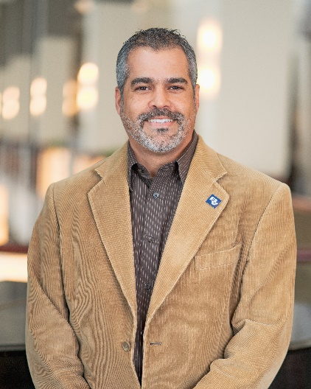

RAFAEL E. FRIAS III, pe

Rafael Frias is an Associate Vice President and Regional Manager with the global water business of Black & Veatch Corporation, responsible for its commercial operations in Florida and the Caribbean. In this role, he specializes in the management of water resources projects in the United States and internationally. With over 20 years of experience, Rafael established Black & Veatch’s South Florida operations in 2010 and is currently delivering multiple infrastructure projects in Miami-Dade, Broward, Palm Beach and Monroe Counties, as well as in Puerto Rico. He is the Past- President of the American Water Resources Association (AWRA), a 2,000-member national association that focuses on the comprehensive management of our water resources.