The largest circuit motif identity consists of 11 nodes, with neurons that are both GABAergic and serotonergic and that span the hemispheres of the fly brain (Figure 1). These local neurons lack the traditional separation of dendritic and axonal arborizations and contain only dendritic arborizations. These neurons can be visualized in Figure 2.
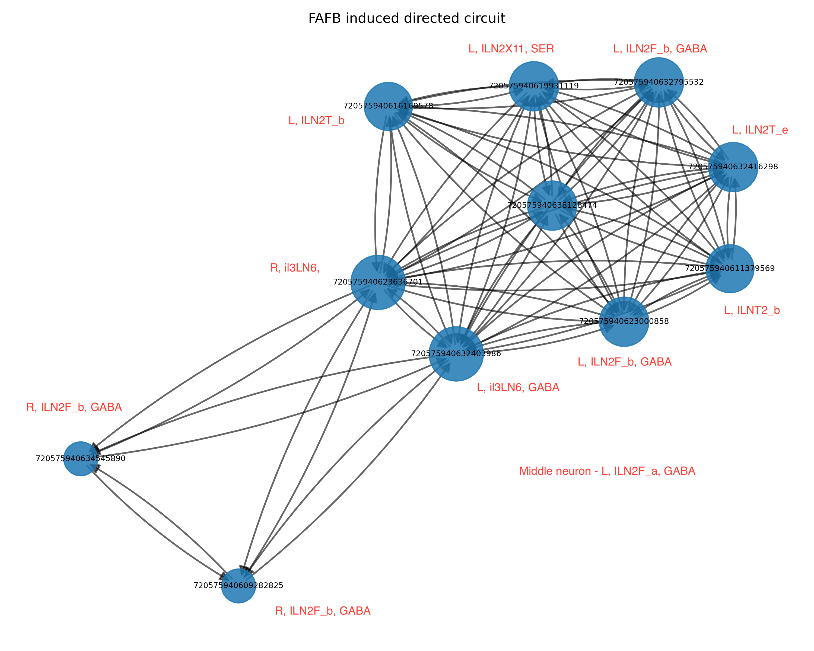
Figure 1. Largest directed induced subgraph identified in the FAFB dataset. The neurons are labeled with their Codex IDs and, in red, with identifiers such as <side>, <Cell Type>, and <NT Type>.
- GABAergic local neurons shape odor tuning and contrast. GABAergic inhibition in the Drosophila antennal lobe shapes odor-evoked spatiotemporal activity patterns and can regulate projection neuron responses, helping transform glomerular input into more selective output patterns¹.
- Dense LN–LN connectivity suggests recurrent normalization/gain control. The graph shows many reciprocal or near-reciprocal connections among LNs, which is consistent with antennal-lobe circuits acting as recurrent inhibitory networks rather than simple feedforward filters. Prior work shows that Drosophila antennal-lobe LNs are diverse in morphology, neurotransmitter identity, wiring, and physiology, supporting specialized roles in odor processing².
- This circuit may coordinate interglomerular inhibition. LNs in the antennal lobe connect across glomeruli and can mediate lateral inhibition, which helps decorrelate odor representations, suppress broadly activated channels, and improve odor discrimination^{1,3}.
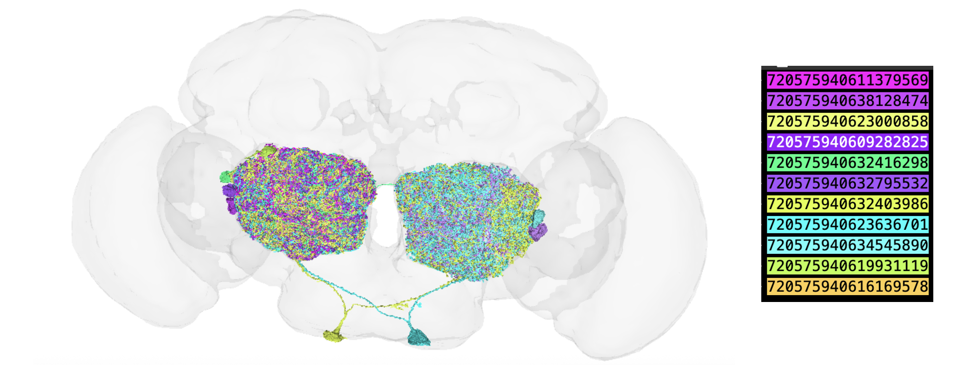
Figure 2. Visualization of the 3D codex meshes of all the neurons in the circuit. The color code of the neurons visualized on the left is given on the right.
- The serotonergic node may provide state-dependent modulation. The node labeled "serotonergic" is interesting because serotonin has been shown to modulate Drosophila antennal lobe processing in an odor-specific manner, enhancing projection neuron sensitivity and influencing inhibitory local interneuron activity⁴.
- The bilateral elements may coordinate odor processing across hemispheres. The circuit includes left and right local neurons, suggesting possible cross-hemisphere coupling⁵. Biologically, this could help compare bilateral olfactory input, stabilize odor representations, or coordinate antennal lobe gain across sides, although that specific function would need to be tested.

References
1. Wilson, R. I. & Laurent, G. Role of GABAergic Inhibition in Shaping Odor-Evoked Spatiotemporal Patterns in the Drosophila Antennal Lobe. J. Neurosci. 25, 9069–9079 (2005).
2. Chou, Y.-H. et al. Diversity and wiring variability of olfactory local interneurons in the Drosophila antennal lobe. Nat. Neurosci. 13, 439–449 (2010).
3. Galizia, C. G. & Sachse, S. Odor Coding in Insects. in The Neurobiology of Olfaction (ed. Menini, A.) (CRC Press/Taylor & Francis, Boca Raton (FL), 2010).
4. Dacks, A. M., Green, D. S., Root, C. M., Nighorn, A. J. & Wang, J. W. Serotonin Modulates Olfactory Processing in the Antennal Lobe of Drosophila. J. Neurogenet. 23, 366–377 (2009).
5. Taisz, I. et al. Generating parallel representations of position and identity in the olfactory system. Cell 186, 2556-2573.e22 (2023).

