Picture | Name and size | Location | Function | Features
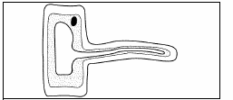 | Hair root cell | Below surface of hair | Absorb water and minerals | Large surface area
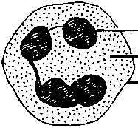 | I googled this and still couldn’t find this after 20 minutes research, idk if I’m blind or just don’t see it, I think its either a bone cell or muscle cell but im unsure
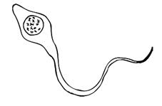 | Sperm cell | Human testis | Fertilises an egg cell | It has a tail to propel itself
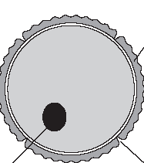 | Egg cell | Human ovaries | Carries mothers DNA | Contains source of food that acts for the developing babies food
 | Red blood cell | Blood/Bone marrow | Can carry oxygen to the cells | Membrane can let oxygen easily
Picture | Name and size | Plant / Animal | Function | Features
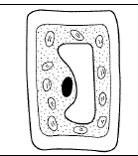 | Leaf Cell | plant | Absorbs sunlight photosynthesis | Contains a lot of chloroplasts
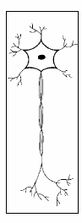 | Nerve Cell | animal | Commanding point for other cells to order and communicate. | What makes you feel pain?
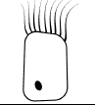 | Epithelial cell | plant | Protects underlying stricture/acts as a barrier | Looks very fluffy
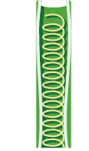 | Xylem Cell

