**Management System**

**Baby Shop Hub**

**PROJECT:** EBOOK

|  |  |
| --- | --- |
|  |  |
|  |  |
|  |  |

Baby Shop Hub

|  |  |
| --- | --- |
| GROUP MEMBERS | **ENROLMENT NUMBERS** |
| MUHAMMAD SAAD KARIM | Student1420981 |
| MUHAMMAD UMER SIDDIQUI | Student1397533 |
| TAYYABA | Student1421220 |
| MUHAMMAD DANIYAL SALEEM | Student1393920 |
| MUHAMMAD SAIF UDDIN | Student1364872 |
| MUHAMMAD YOUSUF . | Student1365810 |

**FACULTY**: Sir Tahir

**SEMESTER:** ADSE1

**BATCHCODE**:2207F2

**Table of contents**

`

Table of Contents

Introduction ……………………………………………………………………………...02

Background ………………………………………………………………………..02

Objectives ……………………………………………………………………….02

Non-Functional Requirements ….…………………………………………………………..03

Functional Requirements .………………………………………………………………..04

Objectives of the project………………………………………………………………..04

**Problem Statement**

**Introduction:**

The thirst for learning, upgrading technical skills and applying the concepts in real life environment at a fast pace is what the industry demands from IT professionals today. However busy work schedules, far-flung locations, unavailability of convenient time-slots pose as major barriers when it comes to applying the concepts into realism. And hence the need to look out for alternative means of implementation in the form of laddered approach.

The above truly pose as constraints especially for our students too! With their busy schedules, it is indeed difficult for our students to keep up with the genuine and constant need for integrated application which can be seen live especially so in the field of IT education where technology can change on the spur of a moment. Well, technology does come to our rescue at such times!!

Keeping the above in mind and in tune with our constant endeavor to use Technology in our training model, we at Aptech have thought of revolutionizing the way our students learn and implement the concepts using tools themselves by providing a live and synchronous eProject learning environment!

**Background:**

The idea for the "**BabyShopHub**" app originated from the increasing demand for a user-friendly and convenient platform for parents and caregivers to shop for infant products. With the ever-growing market of baby products, the need for a dedicated, reliable, and secure mobile app became evident. The app aims to provide a comprehensive solution for parents, offering a wide range of infant products and features to simplify their shopping experience.

The app, named "**BabyShopHub**" is designed to help parents and caregivers find and purchase a wide range of infant products, from diapers and baby food to clothing and toys.

**Objectives:**

* Practice step by step i.e., laddered approach.
* Build a larger more robust application.
* Usage of certain utilities in applications designed by user.
* Single program to unified code leading to a complete application.
* Learn implementation of concepts in a phased manner.
* Enhance skills and add value.
* Work on real life projects.
* Give a real-life scenario and help to create applications more complicated and useful.
* Mentoring through email support.

**Non-Functional Requirements-**

**Responsiveness:** The app should respond to user interactions within 1-2 seconds, ensuring a smooth and lag-free experience.

**Loading Time:** The app's initial loading time should be minimized to ensure users can access it quickly.

**User Interface:** The app's user interface should be intuitive, following best design practices for mobile apps to ensure ease of use.

**Accessible:** The application should have clear and legible fonts, user-interface elements, and navigation elements.

**User-friendly:** The application should be easy to navigate with clear menus and other elements and easy to understand.

**Operability**: The application should operate in a reliably efficient manner.

**Error Handling:** Implement robust error handling to provide clear error messages to users and gracefully handle unexpected situations.

**Scalability:** The application architecture and infrastructure should be designed to handle increasing user traffic, data storage, and feature expansions.

**Security:** The application should implement adequate security measures such as authentication. For example, only registered users can access certain features.

**User Documentation:** Provide user guides, FAQs, and tutorials to help users understand and navigate the application.

**Developer Documentation:** Maintain developer documentation to assist in further development and maintenance.

Video: Provide video displaying complete working of the application.

**►Functional Requirements:**

**User Registration and Authentication:**

**User Registration:** Users should be able to create an account with their personal information, including name, email, and password.

**User Authentication:** Secure login and authentication mechanisms to ensure that only registered users can access their accounts.

**User Profile:** Users should have a profile section where they can manage their personal information, delivery addresses, and payment methods.

**Product Browsing and Search:**

**Product Categories:** Display a variety of product categories relevant to infants, such as diapers, baby food, clothing, toys, and more.

**Product Search:** Implement a search feature to enable users to find specific products by name, brand, or category.

**Product Details:** Display detailed product information, including images, descriptions, prices, and customer reviews.

**Shopping Cart and Checkout:**

**Add to Cart:** Allow users to add products to their shopping cart for future purchase.

**Cart Management:** Users should be able to view and manage the contents of their shopping cart, including updating quantities and removing items.

**Checkout Process:** Implement a smooth and secure checkout process, including order review, payment processing (dummy), and order confirmation.

**Order History and Tracking:**

**Order History:** Display a history of previous orders, including order status, items purchased, and order details.

**Order Tracking:** Enable users to track the delivery status of their orders in real-time

**Reviews and Ratings:**

**Product Reviews:** Allow users to submit and read product reviews and ratings, providing valuable feedback to other users.

**Seller Ratings:** Provide a rating system for sellers to build trust and credibility among users.

**Admin Panel:**

**Product Management:** An admin panel to manage product listings, prices, and inventory.

**User Management:** Ability to manage user accounts, monitor user activity, and address user inquiries.

**Order Management:** Monitor and manage orders, including tracking and order status updates.

**Feedback and Support:**

**User Support:** A support system for users to contact for assistance, report issues, and provide feedback.

**Objectives of the project**

1. The Objective of this program is to give a sample project to work on real life projects. These applications help you build a larger more robust application.
2. The objective is not to teach you the concepts but to provide you with a real-life scenario and help you create applications using the tools.
3. You can revise them before you start with the project.
4. It is very essential that a student has a clear understanding of the subject.
5. Kindly get back to eProjects Team, in case of any doubts regarding the application or its objectives.

**Hardware/ Software Requirements**

**Hardware:**

* A minimum computer system that will help you access all the tools in the courses is a Pentium 166 or better
* 128 Megabytes of RAM or better
* Windows 2000 Server (or higher if possible)
* Windows OS/JAVA/Android SDK/Notepad/SQL/Dart/Flutter

**Software:**

**Operating System:**

* Windows 2000 Server (or higher if possible)

**Status Notifications:**

Stay informed! Receive automatic email notifications after every status change in your deliveries for a transparent and updated experience

**Secure Online Payment Gateway:**

Experience seamless transactions with our robust online payment gateway, ensuring secure and efficient financial interactions

**Diverse Service Options:**

Choose convenience with our walk-in, online, and rider services, catering to your preferences for a seamless experience.

**Email Verification for Secure Sign-Up:**

Ensure account security by receiving a verification code on your email. Only after verification, you can log in to your account.

**Effortless Password Recovery:**

Experience hassle-free password recovery! Receive a code via email to reset your password and regain access to your account.

**New Features Additions**

Project Duration

**Project Making & Background**

|  |  |  |  |  |  |
| --- | --- | --- | --- | --- | --- |
| **NO.** | **TASK** | **ACTUAL START DAYS** | **ACTUAL DAYS**   1. Analysis --- 1Days 2. Design ----5Days 3. Development ----20Days 4. Testing ------2Days 5. Documentation -----2Days | **NAMES** | **STATUS** |
| 1 | CASE STUDY | 03-feb-2024 | 1 | MUHAMMAD DANIYAL SALEEM, MUHAMMAD UMER SIDDIQUI, MUHAMMAD SAIF UDDIN, MUHAMMAD YOUSUF ., MUHAMMAD SAAD KARIM, TAYYABA .­­­ | Completed |
| 2 | UI DESIGNING | 07-feb-2024 | 2 | MUHAMMAD DANIYAL SALEEM, MUHAMMAD UMER SIDDIQUI, MUHAMMAD SAIF UDDIN, MUHAMMAD YOUSUF ., MUHAMMAD SAAD KARIM, TAYYABA .­­­ | Completed |
| 3 | SCENARIO MAKING | 10-feb-2024 | 3 | MUHAMMAD DANIYAL SALEEM, MUHAMMAD UMER SIDDIQUI, MUHAMMAD SAIF UDDIN, MUHAMMAD YOUSUF ., MUHAMMAD SAAD KARIM, TAYYABA .­­­ | Completed |
| 4 | MATERIAL SEARCHING | 14-feb-2024 | 4 | MUHAMMAD DANIYAL SALEEM, MUHAMMAD UMER SIDDIQUI, MUHAMMAD SAIF UDDIN, MUHAMMAD YOUSUF ., MUHAMMAD SAAD KARIM, TAYYABA .­­­ | Completed |
| 5 | DATABASE CONNECTIVITY | 20-feb-2023 | 6 | MUHAMMAD DANIYAL SALEEM, MUHAMMAD UMER SIDDIQUI, MUHAMMAD SAIF UDDIN, MUHAMMAD YOUSUF ., MUHAMMAD SAAD KARIM, TAYYABA .­­­ | Completed |
| 6 | Backend work | 25-feb-2023 | 5 | MUHAMMAD DANIYAL SALEEM, MUHAMMAD UMER SIDDIQUI, MUHAMMAD SAIF UDDIN, MUHAMMAD YOUSUF ., MUHAMMAD SAAD KARIM, TAYYABA .­­­ | Completed |
| 7 | DOCUMENTATION | 27-feb-2023 | 2 | MUHAMMAD DANIYAL SALEEM, MUHAMMAD UMER SIDDIQUI, MUHAMMAD SAIF UDDIN, MUHAMMAD YOUSUF ., MUHAMMAD SAAD KARIM, TAYYABA .­­­ | Completed |

**Work flow submission checklist**

|  |  |  |  |
| --- | --- | --- | --- |
| **S.NO** | **LIST OF ITEMS** | **Remarks** | **COMMENTS** |
| 1. | ARE ALL PAGES LINKED TOGATHER? | **YES** | THROUGH THE URL. |
| 2. | IS THE DATABASE CONNECTED? | **YES** | USING MySQL. |
| 3. | ARE THE PAGE COLOURS ACCORDING TO THE GUIDELINES? | **YES** | USED PROFESSIONAL COLOR COMBINATIONS. |
| 4. | ARE THE TABLES WORKING? | **YES** | CRUD OPERATIONS – IN OPERATION. |
| 5. | IS THE DOCUMENTATION INCLUDED? | **YES** | ALL DOCUMENTS-USER GUIDEDEVELOPER GUIDE & DOCUMENTATIO. |
| 6. | IS THE PROJECT COMPRESSED? | **YES** | CREATED USING WIN ZIP-RAR. |

Our User Side

**Order Tracking**

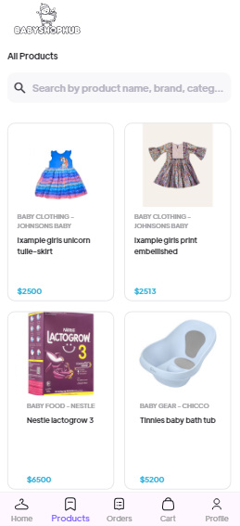

**Products Reviews**

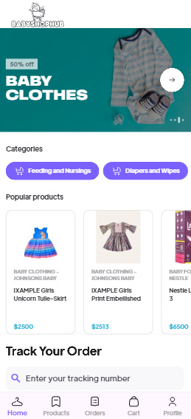

**Products**

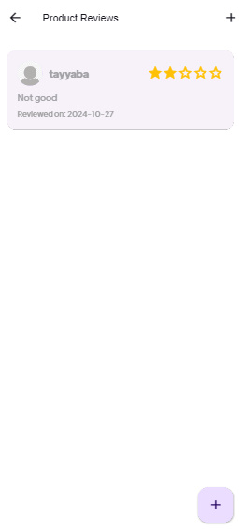

Our Admin Panel

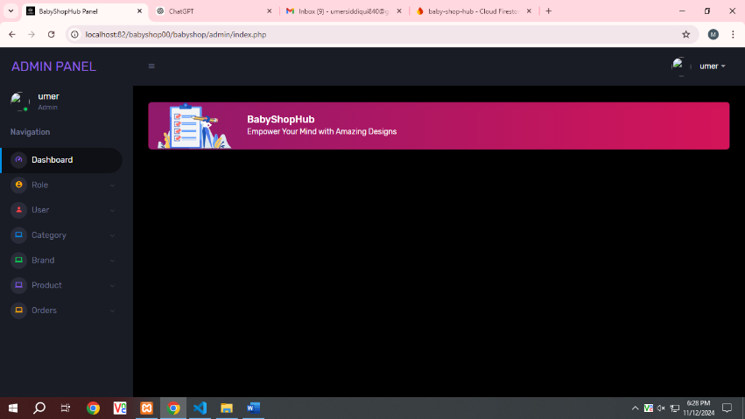

**Users Show Page**

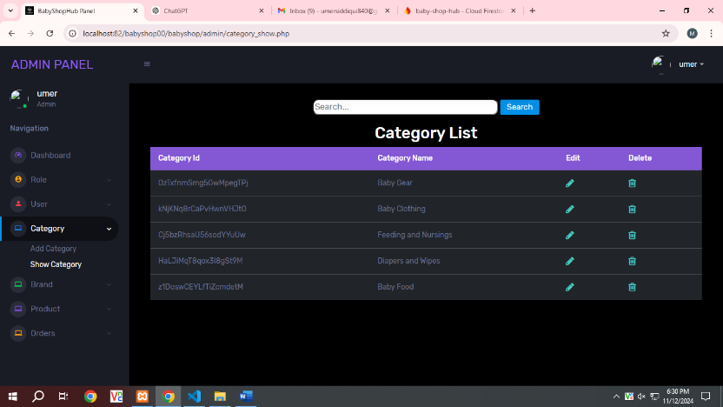

**Admin Panel**

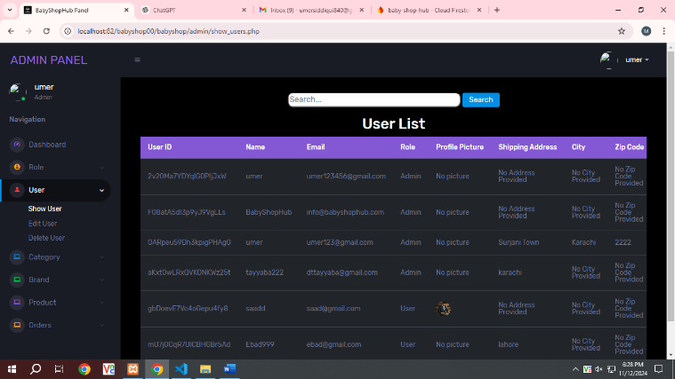

**Category Show Page**

**Brands Show Page**

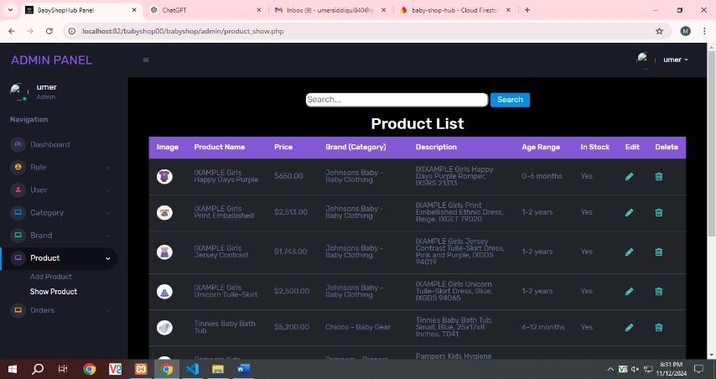

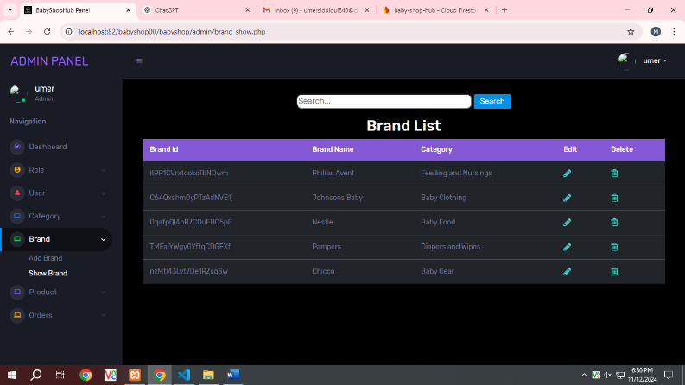

**Product Show Page**