**Supercenters**

**1.Add column for Daytime**

SELECT

time, (CASE

WHEN time BETWEEN '00:00:00' AND '12:00:00' THEN 'Morning'

WHEN time BETWEEN '12:01:00' AND '16:00:00' THEN 'Afternoon'

ELSE 'Evening'

END) AS time_of_day

FROM

walmartdb.walmart;

alter table walmartdb.walmart add column time_of_day varchar (20);

update walmartdb.walmart

set time_of_day = (

CASE

WHEN time BETWEEN '00:00:00' AND '12:00:00' THEN 'Morning'

WHEN time BETWEEN '12:01:00' AND '16:00:00' THEN 'Afternoon'

ELSE 'Evening'

END);

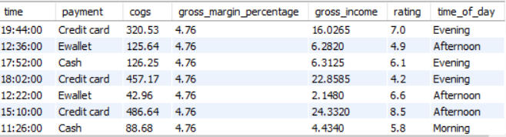

**2.Add column for Day name**

SELECT

date, DAYNAME(date) AS day_name

FROM

walmartdb.walmart;

alter table walmartdb.walmart add column day_name varchar(10);

update walmartdb.walmart

set day_name = DAYNAME(date);

3. A**dd column for month name**

SELECT

date, MONTHNAME(date)

FROM

walmartdb.walmart;

alter table walmartdb.walmart add column month_name varchar(15);

UPDATE walmartdb.walmart

SET

month_name = MONTHNAME(date);

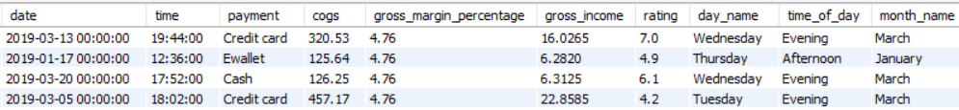

4. How many unique cities does in the data have?

select distinct city from walmartdb.walmart

5.Which branch is located in each city?

select distinct city, branch from walmartdb.walmart

6. How many unique product lines are in the data set?

select count(distinct product_line) from walmartdb.walmart

7. What is the most common payment method?

SELECT

payment, COUNT(payment) AS count_of_payment_method

FROM

walmartdb.walmart

GROUP BY payment

ORDER BY count_of_payment_method DESC;

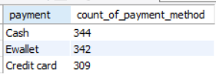

8.what is the most selling product line?

SELECT

product_line, COUNT(product_line) AS pl_cnt

FROM

walmartdb.walmart

GROUP BY product_line

ORDER BY pl_cnt DESC;

9. what is the total revenue by month?

SELECT DISTINCT

month_name as month, ROUND(SUM(total), 2) as total_sales

FROM

walmartdb.walmart

GROUP BY month

order by total_sales desc;

10. Which month had the highest COGS?

SELECT

month_name AS month, SUM(cogs) AS cogs

FROM

walmartdb.walmart

GROUP BY month;

11. Which product line generated the largest revenue?

SELECT

product_line AS product_line,

ROUND(SUM(total), 2) AS total_revenue

FROM

walmartdb.walmart

GROUP BY product_line

order by total_revenue desc;

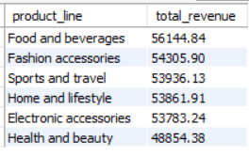

12. which city is with the largest revenue?

SELECT

city, sum(total) AS total_revenue

FROM

walmartdb.walmart

GROUP BY city

ORDER BY total_revenue DESC;

13. Which product line is associated with the highest tax?

SELECT

product_line, ROUND(SUM(tax), 2) AS tax

FROM

walmartdb.walmart

GROUP BY product_line

ORDER BY tax DESC;

13. How much is the average tax associated with the product line?

SELECT

product_line, ROUND(AVG(tax), 2) AS avg_tax

FROM

walmartdb.walmart

GROUP BY product_line

ORDER BY avg_tax DESC;

14. Which branch sold more products than average product sold?

SELECT

branch, SUM(quantity) AS qty

FROM

walmartdb.walmart

GROUP BY branch

HAVING SUM(quantity) > (SELECT

AVG(quantity)

FROM

walmartdb.walmart);

15. Which types of product lines are preferred by different genders?

SELECT

gender, product_line, COUNT(gender) AS total_nos

FROM

walmartdb.walmart

GROUP BY gender , product_line

ORDER BY total_nos;

16. What is the average rating of each product line?

SELECT

product_line, ROUND(AVG(rating), 2) AS avg_rating

FROM

walmartdb.walmart

GROUP BY product_line;

17. What is the number of sales made at different times of the day for each weekday?

SELECT

time_of_day, COUNT(*) as cnt

FROM

walmartdb.walmart

where day_name = "sunday"

GROUP BY time_of_day, day_name

order by cnt desc;

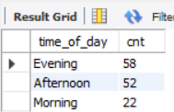

18 . Which customer type has the greater purchasing power?

SELECT

customer_type, ROUND(SUM(total), 2) AS purchasing_p

FROM

walmartdb.walmart

GROUP BY customer_type

19. Which city has the highest percentage of tax payments?

SELECT

city,

CONCAT(ROUND(SUM(tax) / (SELECT

SUM(tax)

FROM

walmartdb.walmart) * 100,

2),

'%') AS percent

FROM

walmartdb.walmart

GROUP BY city

20. Which type of customer pays the highest amount of tax?

SELECT

customer_type, SUM(tax)

FROM

walmartdb.walmart

GROUP BY customer_type SELECT

customer_type, SUM(tax)

FROM

walmartdb.walmart

GROUP BY customer_type

21. Find out most customer purchasing power?

SELECT

gender, ROUND(SUM(total), 2) AS total_revenue

FROM

walmartdb.walmart

GROUP BY gender

22. Which city has purchasing power also counting separate by gender?

1. SELECT

city,

CONCAT('$', FORMAT(SUM(CASE

WHEN gender = 'female' THEN total

ELSE 0

END), 2)) AS female,

CONCAT('$', FORMAT(SUM(CASE

WHEN gender = 'male' THEN total

ELSE 0

END), 2)) AS male,

CONCAT('$', FORMAT(SUM(total), 2)) AS grand_total

FROM

walmartdb.walmart

GROUP BY city WITH ROLLUP;

1. SELECT

city,

SUM(CASE

WHEN gender = 'female' THEN 1

ELSE 0

END) AS female,

SUM(CASE

WHEN gender = 'male' THEN 1

ELSE 0

END) AS male,

COUNT(*) AS grand_total

FROM

walmartdb.walmart

GROUP BY city WITH ROLLUP;

23. At what times do customers provide average ratings, and how do these ratings vary by gender?

SELECT

time_of_day, AVG(rating)

FROM

walmartdb.walmart

GROUP BY time_of_day

SELECT

time_of_day,

SUM(CASE

WHEN gender = 'female' THEN 1

ELSE 0

END) AS female,

SUM(CASE

WHEN gender = 'male' THEN 1

ELSE 0

END) AS male,

COUNT(*) AS total_no

FROM

walmartdb.walmart

GROUP BY time_of_day WITH ROLLUP

