PROGREE CYBERSECURITY INTERNSHIP

Internship Task Report
Task 1 — Professional LinkedIn Announcement
Task 2 — Host & Network Vulnerability Assessment Lab
Task 3 — Low-Level Network Packet Inspection & Protocol Analysis

Prepared by: Owais Ahmed (ASH)
Cybersecurity Intern — Progree
September 2026

Lab environment: Kali Linux (attacker) and Metasploitable 3 — Ubuntu (target), isolated host-only network

Table of Contents
Task 1: Professional LinkedIn Announcement 3
Task 2: Host & Network Vulnerability Assessment Lab 4
Task 3: Low-Level Network Packet Inspection & Protocol Analysis 15
Overall Conclusion / Learning Summary 24
Note: page numbers are approximate; right-click and choose "Update Field" in Word if a linked table of contents is preferred.

TASK 1: PROFESSIONAL LINKEDIN ANNOUNCEMENT



TASK 2: HOST & NETWORK VULNERABILITY ASSESSMENT LAB
Metasploitable 3 (Ubuntu) — Vulnerability Scan Results & Risk Assessment

A. Executive Summary
A vulnerability assessment was carried out against a Metasploitable 3 (Ubuntu) target machine to identify exposed network services, outdated software versions, and configuration weaknesses. The assessment was performed entirely inside an isolated virtual lab, so no production systems or external networks were involved at any point.
The scan identified eight open ports hosting a range of services, including SSH, HTTP, SMB, IPP/CUPS, MySQL, a second HTTP service running on WEBrick, IRC, and a Jetty-based HTTP service. Several of these services are running old, unpatched versions, and the version numbers correspond to publicly documented CVEs covering Remote Code Execution (RCE), Denial of Service (DoS), request smuggling, and unauthorized access.
The most significant finding is a backdoor in the UnrealIRCd service on TCP port 6697 (CVE-2010-2075), which was validated using the Metasploit Framework and confirmed to allow remote code execution. Additional high- and medium-priority findings affect Apache, Samba, WEBrick, and CUPS. None of these findings are exaggerated beyond what the scans and validation steps actually showed — they are presented below together with the supporting evidence and are ranked by urgency of remediation.

B. Lab Setup and Environment
The assessment used a two-machine isolated lab:
- Attacker machine: Kali Linux, running Nmap, Nikto, and the Metasploit Framework.
- Target machine: Metasploitable 3 (Ubuntu), a deliberately vulnerable virtual machine.
- Both machines were hosted on Oracle VirtualBox and connected through a host-only network (192.168.56.0/24), which is isolated from the internet and from any production network.
- Target IP address: 192.168.56.103 (confirmed via ip a on the target, Figure 1).
- Attacker IP address: 192.168.56.102 (confirmed via ifconfig on Kali, Figure 2).
- Network connectivity between the two machines was verified with ping before scanning began (Figure 3).

C. Methodology
The following tools were used, in the order shown, to move from basic reconnaissance to a validated exploit:

1. ifconfig / ip a — network verification
Used to confirm the IP address, subnet, and interface state of both the attacker and target machines before any scanning began. This step confirmed both machines were reachable on the same isolated 192.168.56.0/24 network.

2. ping — connectivity check
Used to confirm basic reachability and measure round-trip latency to the target prior to running any scans. The result showed 0% packet loss.

3. Nmap quick scan (-T4 -F)
A fast scan of the most common ports, used to get an initial picture of which services were reachable before committing to a slower full scan.

4. Nmap full-port, version-detection scan (-A -T4 -p-)
A scan of all 65,535 TCP ports with service and version detection enabled, used to build the complete list of open ports and identify the exact software version running behind each one — this is the evidence base for the CVE matching later in the report.

5. Nmap vulnerability scripts (nmap --script=vuln)
Used to run Nmap's built-in NSE vulnerability-detection scripts against the target, which flagged specific misconfigurations (such as exposed directories and CSRF-vulnerable forms on the Apache web service) and known CVE-mapped weaknesses.

6. Nikto
Run against the Apache web service on port 80 to check specifically for missing security headers, directory indexing, and other common web-server misconfigurations that Nmap's scripts do not focus on.

7. CVE / NVD cross-reference
Each detected service version was looked up against the NVD (National Vulnerability Database) to confirm that the version numbers actually correspond to a published CVE, rather than assuming a vulnerability from the version number alone.

8. Metasploit validation of the UnrealIRCd finding
Because the UnrealIRCd backdoor was the highest-severity finding, it was the only vulnerability actually exploited in the lab, using Metasploit's unreal_ircd_3281_backdoor module, to confirm the finding was real and not a false positive from the scanners.
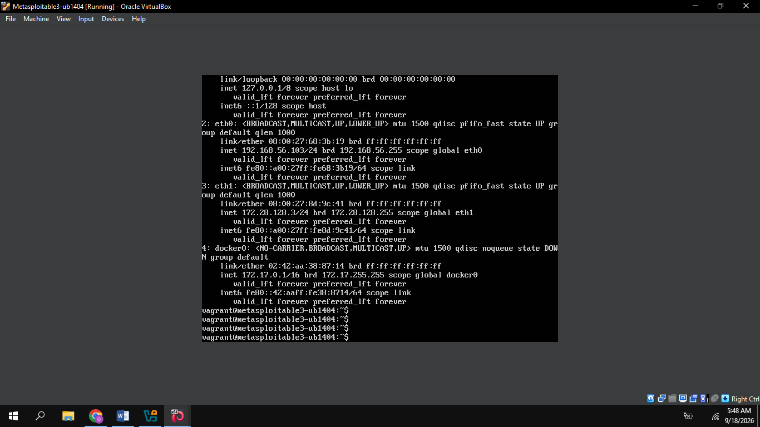
Figure 1: Network interface configuration (ip a) on the Metasploitable 3 Ubuntu target, confirming the assigned address 192.168.56.103/24 on eth0.
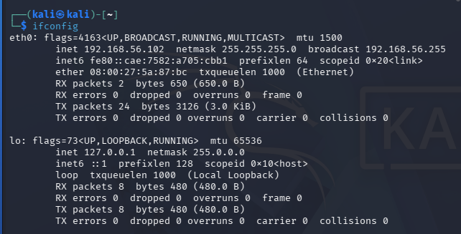
Figure 2: Network interface configuration (ifconfig) on the Kali Linux attacker machine, showing address 192.168.56.102 on eth0 within the same host-only network.
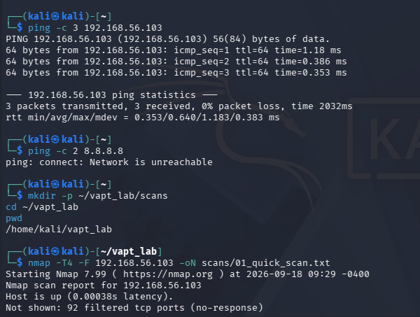
Figure 3: Connectivity check to the target (ping -c 3 192.168.56.103, 0% packet loss), creation of the working scan directory, and the start of the initial Nmap quick scan.
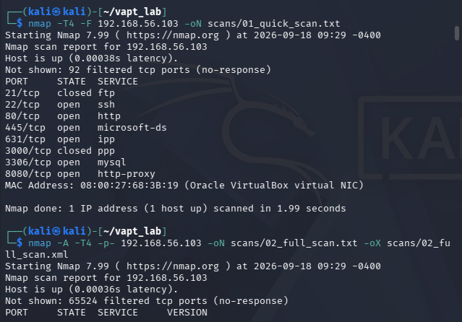
Figure 4: Results of the Nmap quick scan (-T4 -F) showing seven open ports, followed by the start of the full-port, version-detection scan (-A -T4 -p-).

D. Open Ports and Services
The full-port version-detection scan identified the following services. Each of these increases the target's attack surface — every open port is a potential entry point, and the risk grows further when the service behind it is an old, unpatched version, as several of these are:
Port | Service | Version / Observation
22/tcp | SSH | OpenSSH 6.6.1p1 Ubuntu
80/tcp | HTTP | Apache HTTP Server 2.4.7 (Ubuntu)
445/tcp | SMB | Samba 4.3.11-Ubuntu
631/tcp | IPP | CUPS 1.7.x
3306/tcp | MySQL | MySQL service detected; authentication required
3500/tcp | HTTP | WEBrick 1.3.1 / Ruby 2.3.8
6697/tcp | IRC | UnrealIRCd 3.2.8.1
8080/tcp | HTTP | Jetty 8.1.7.v20120910

- SSH (22/tcp): a fairly current OpenSSH build; the main risk here is brute-force login attempts against exposed credentials rather than a version-specific exploit.
- HTTP (80/tcp): an old Apache 2.4.7 build; outdated web servers are a common route to DoS and, in some configurations, to unauthorized code execution.
- SMB (445/tcp): an outdated Samba build; SMB is a classic target for both DoS and, in older Samba branches, remote code execution.
- IPP/CUPS (631/tcp): an unnecessary exposure for a general-purpose target — printing services are rarely needed and add attack surface for little benefit.
- MySQL (3306/tcp): authentication was required, but an exposed database port is still a target for credential attacks and should not be reachable outside the database tier.
- HTTP / WEBrick (3500/tcp): a very old Ruby/WEBrick combination with multiple known CVEs, covering everything from information disclosure to request smuggling.
- IRC / UnrealIRCd (6697/tcp): the highest-risk service on the host — this version contains a known backdoor, detailed in section E.1.
- HTTP / Jetty (8080/tcp): an old Jetty build; a second web service on a non-standard port that increases the number of components requiring patching.
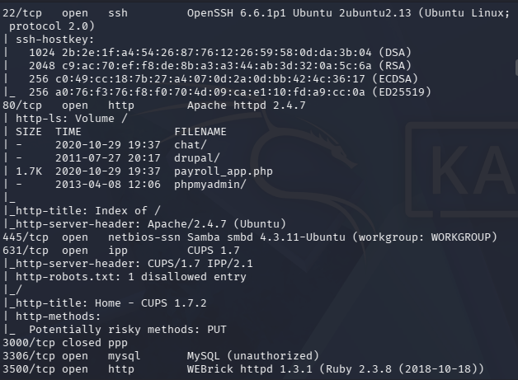
Figure 5: Detailed service and version enumeration from the full Nmap scan, showing OpenSSH 6.6.1p1, Apache 2.4.7, Samba 4.3.11-Ubuntu, CUPS 1.7, MySQL, and WEBrick 1.3.1/Ruby 2.3.8.
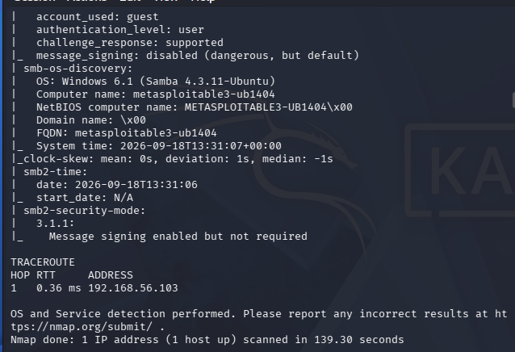
Figure 6: SMB host information disclosure from the Nmap scan, confirming the Samba workgroup configuration and that SMB message signing was enabled but not required.
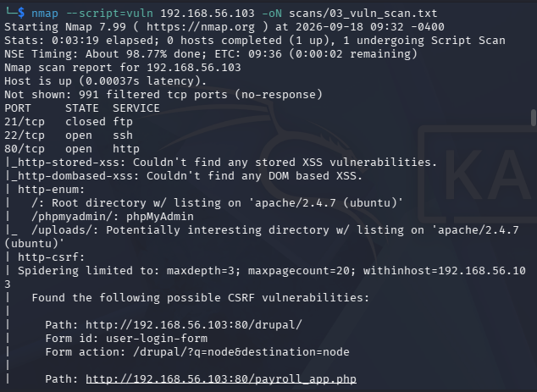
Figure 7: Nmap vulnerability script scan (--script=vuln) output showing HTTP enumeration and CSRF findings on the Apache web service, including exposed directories such as /phpmyadmin/ and /uploads/.
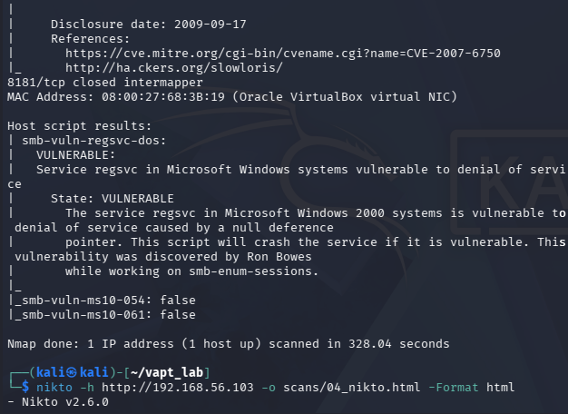
Figure 8: Slowloris CVE reference (CVE-2007-6750) returned by the Nmap vulnerability scripts, followed by the start of the Nikto web server scan.
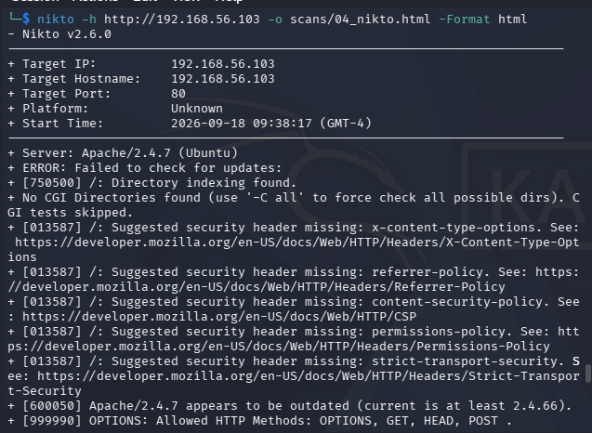
Figure 9: Nikto scan results showing the Apache/2.4.7 (Ubuntu) banner, directory indexing, and multiple missing HTTP security headers.
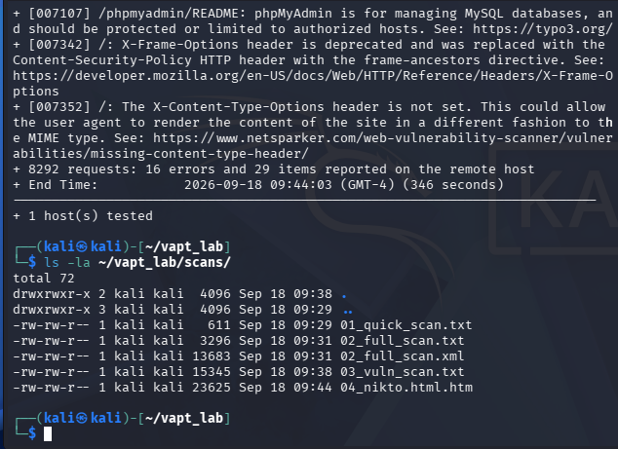
Figure 10: Continued Nikto findings, including the outdated Apache version and an allowed-methods listing, followed by a listing of the saved scan output files.

E. Vulnerability Findings

E.1 UnrealIRCd Backdoor — CRITICAL
Affected Port | 6697/tcp
Service | IRC
Affected Software | UnrealIRCd 3.2.8.1
CVE | CVE-2010-2075
Risk | Critical
Potential Impact | Remote Code Execution (RCE)

The UnrealIRCd service on TCP port 6697 was flagged as the most serious finding of the assessment. Version 3.2.8.1 is affected by a known backdoor: a Trojan-horse modification introduced into some distributed copies of the source code that lets an attacker execute arbitrary commands on the host, without needing to authenticate first.

Security Impact
- Execute unauthorized commands remotely.
- Compromise the affected system.
- Access or modify system resources.
- Use the compromised host as a starting point for further attacks.

Exploitation Verification
This finding was validated (not just flagged by a scanner) using the Metasploit Framework's unreal_ircd_3281_backdoor module. The module was configured with the target host and port 6697 and a reverse TCP payload. On execution, Metasploit confirmed the target was vulnerable and successfully established the backdoor command channel, as shown in Figures 11–13.
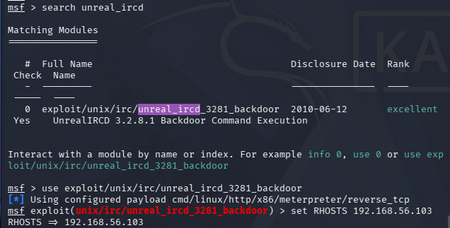
Figure 11: Metasploit module search for unreal_ircd, showing the unix/irc/unreal_ircd_3281_backdoor exploit module being selected and configured against the target.
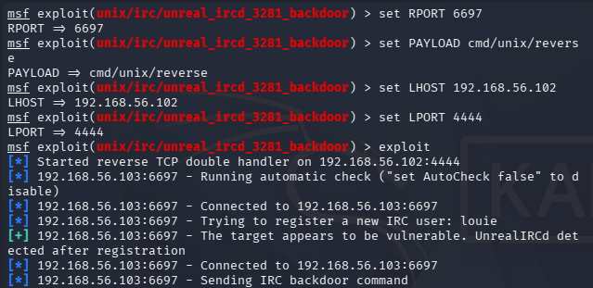
Figure 12: Metasploit exploitation of the UnrealIRCd backdoor, confirming the target was vulnerable and that a backdoor command channel was established.
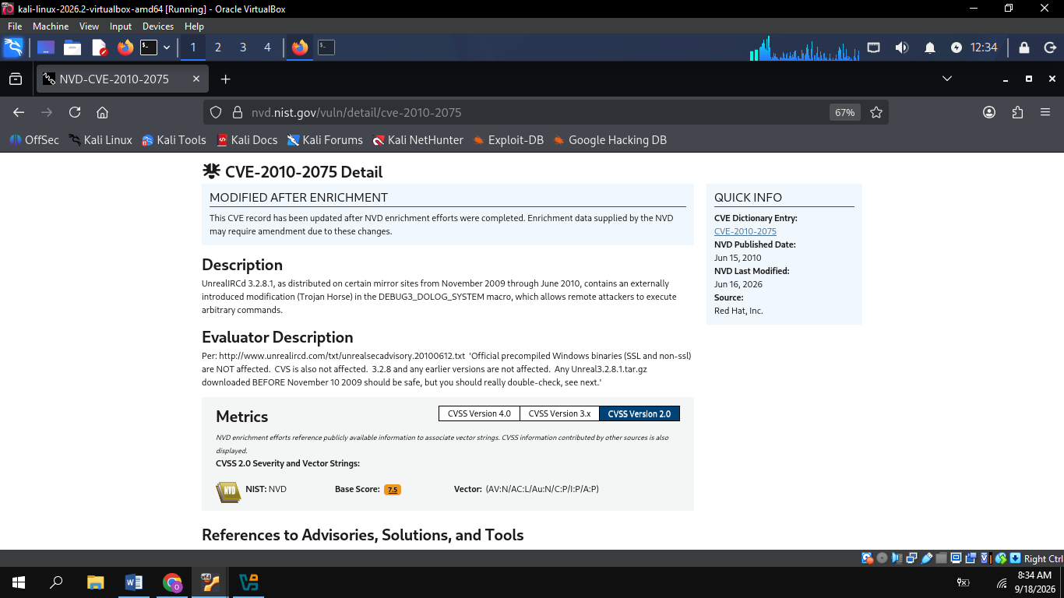
Figure 13: NVD record for CVE-2010-2075, confirming the UnrealIRCd 3.2.8.1 Trojan-horse backdoor vulnerability (CVSS 2.0 base score 7.5).

Remediation
- Upgrade UnrealIRCd to a secure and supported version.
- If IRC functionality is not required, disable and remove the service.
- Restrict access to TCP port 6697 using firewall rules.
- Review system logs for suspicious IRC activity or unexpected command execution.
- Reassess the system after remediation to verify the vulnerable service is no longer exposed.
Priority: Immediate

E.2 Apache HTTP Server Vulnerabilities — HIGH / MEDIUM
Affected Service | HTTP (80/tcp)
Detected Version | Apache HTTP Server 2.4.7 (Ubuntu)
Findings | Slowloris DoS (CVE-2007-6750); mod_userdir+suexec bypass (CVE-2025-66200)
Risk | High / Medium

The Nmap vulnerability scripts flagged the web service as "LIKELY VULNERABLE" to the Slowloris Denial-of-Service attack, which works by opening many incomplete HTTP connections and holding them open, eventually exhausting the server's available connections and denying service to legitimate users.
Separately, the detected Apache version (2.4.7) falls inside the affected range for CVE-2025-66200, a mod_userdir+suexec bypass via AllowOverride FileInfo that can let CGI scripts run under an unexpected user ID (CVSS 3.x base score 5.4, Medium). The fixed release is Apache 2.4.66.

Security Impact
- Reduced web server availability and exhaustion of connection resources.
- Denial of service for legitimate users.
- Potential unauthorized CGI execution under an unexpected user context.
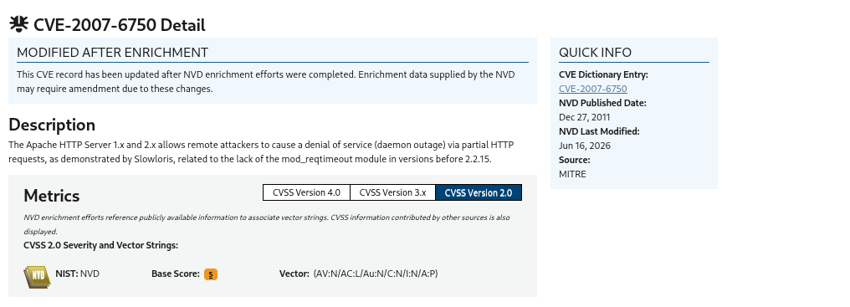
Figure 14: NVD record for CVE-2007-6750 (Slowloris denial-of-service) affecting the Apache HTTP Server versions identified on the target.
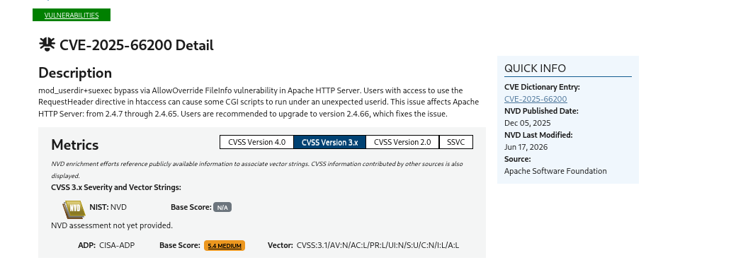
Figure 15: NVD record for CVE-2025-66200, the Apache mod_userdir+suexec bypass affecting versions through 2.4.65 (CVSS 3.x base score 5.4).

Remediation
- Update Apache HTTP Server to version 2.4.66 or later.
- Configure appropriate connection and request timeouts.
- Implement rate limiting and/or a reverse proxy or WAF where suitable.
- Verify the vulnerable version is no longer installed and re-scan to confirm remediation.
Priority: High

E.3 Samba Security Vulnerabilities — HIGH
Affected Port | 445/tcp
Service | SMB
Detected Version | Samba 4.3.11-Ubuntu
Risk | High
Potential Impact | Denial of Service / Service Disruption

Samba 4.3.11 is outdated and is associated with multiple publicly documented vulnerabilities, including CVE-2020-10704 (stack overflow / potential DoS) and CVE-2020-10745 (resource/CPU exhaustion / potential DoS). The host information disclosure scan (Figure 6) also confirmed that SMB message signing was enabled but not required, which is a further hardening gap on top of the version issue.

Remediation
- Upgrade Samba to a currently supported and secure release.
- Disable SMB functionality if it is not required.
- Restrict TCP port 445 to trusted networks and enforce SMB signing.
- Conduct a follow-up vulnerability scan after patching.
Priority: High

E.4 WEBrick / Ruby Vulnerabilities — HIGH
Affected Port | 3500/tcp
Service | HTTP / WEBrick
Detected Version | WEBrick 1.3.1 / Ruby 2.3.8
Risk | High

This port runs an outdated WEBrick web server on an old Ruby runtime. Publicly documented issues affecting this combination include CVE-2017-10784 (terminal escape-sequence injection), CVE-2020-25613 (HTTP request smuggling), and CVE-2019-16201 (Regular Expression Denial of Service).
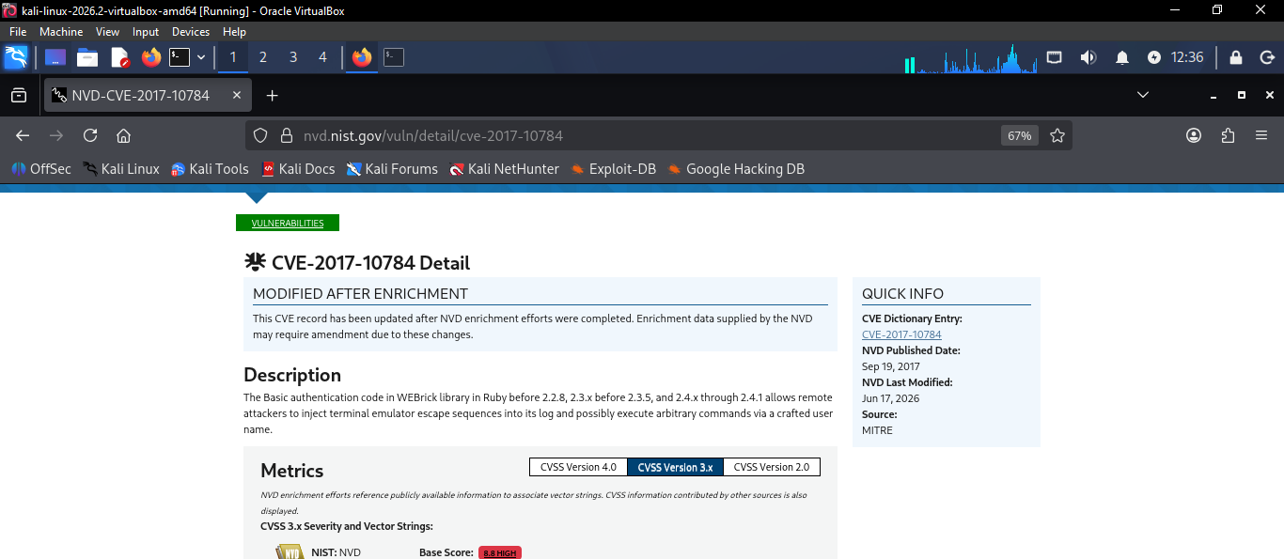
Figure 16: NVD record for CVE-2017-10784, a terminal escape-sequence injection vulnerability in the WEBrick library (CVSS 3.x base score 8.8).

Remediation
- Upgrade Ruby and WEBrick to supported versions.
- Remove or disable the service if not required.
- Restrict access to TCP port 3500 and re-test after upgrading dependencies.
Priority: High

E.5 CUPS Security Vulnerabilities — MEDIUM
Affected Port | 631/tcp
Service | IPP / CUPS
Detected Version | CUPS 1.7.x
Risk | Medium

The CUPS printing service on TCP port 631 is outdated and may be affected by CVE-2018-4700, a Cross-Site Request Forgery (CSRF) vulnerability. A printing service is rarely needed on a general-purpose host, so exposing it unnecessarily increases the attack surface without a corresponding benefit.

Remediation
- Upgrade CUPS to a supported version, or disable it if not required.
- Restrict access to TCP port 631 and review CUPS permissions.
- Re-scan the system after remediation.
Priority: Medium

E.6 Additional Related Findings
Cross-referencing the enumerated service versions against the NVD surfaced two further historical vulnerabilities worth tracking during remediation, alongside the primary findings above:
- CVE-2017-7494 — Samba versions 3.5.0 through 4.4.14 (before patched releases) allow a malicious client to upload a shared library and cause the server to load and execute it. Rated Critical (CVSS 3.x base score 9.8).
- CVE-2015-2080 (JetLeak) — Exception handling in the WEBrick library in Ruby before 2.2.9.v20150224 allows remote attackers to obtain sensitive information from process memory via illegal characters in an HTTP header. Rated High (CVSS 3.x base score 7.5).
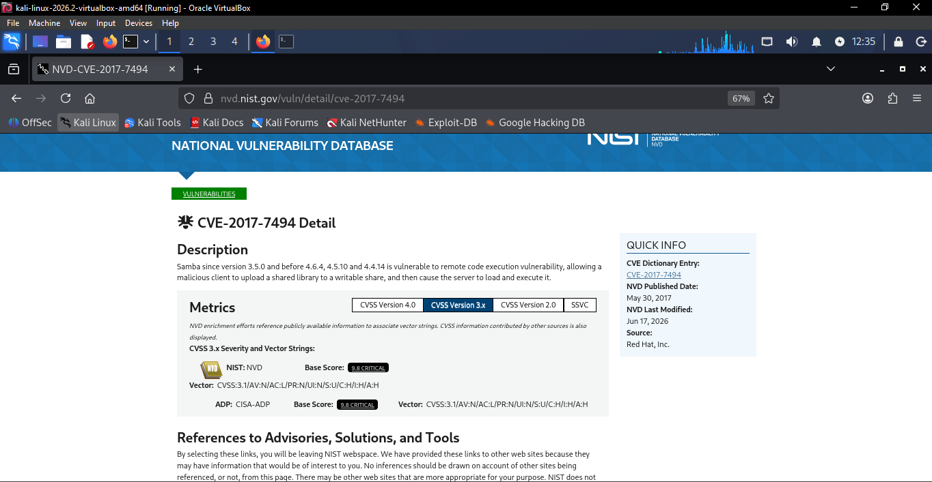
Figure 17: NVD record for CVE-2017-7494, a critical remote code execution vulnerability affecting the Samba versions in the detected range (CVSS 3.x base score 9.8).
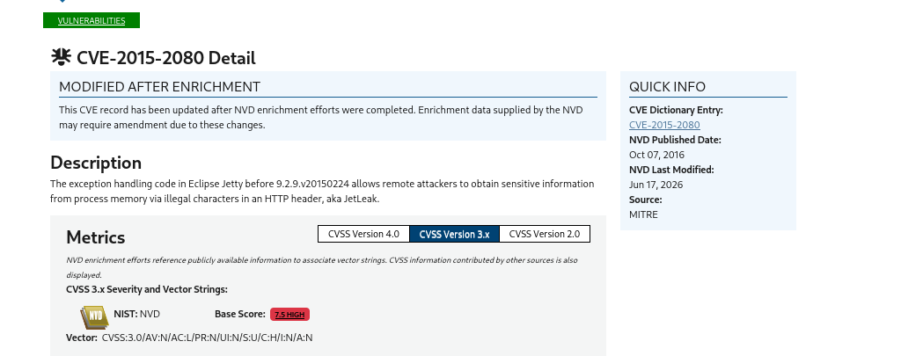
Figure 18: NVD record for CVE-2015-2080 (JetLeak), an information-disclosure vulnerability in the WEBrick library used by the detected Ruby/WEBrick service.

F. Risk Prioritization
The findings above are ranked below by urgency of remediation, following the prioritization already established in the source assessment:
Priority | Finding | Port | Risk | Primary Impact
1 | UnrealIRCd Backdoor | 6697 | Critical | Remote Code Execution
2 | Apache Slowloris | 80 | High | Denial of Service
3 | Samba Vulnerabilities | 445 | High | DoS / Service Disruption
4 | WEBrick Vulnerabilities | 3500 | High | RCE / DoS / Request Smuggling
5 | CUPS Vulnerabilities | 631 | Medium | CSRF / Unauthorized Requests

G. Remediation Strategy

Immediate Actions
- Address the UnrealIRCd backdoor vulnerability immediately.
- Disable unnecessary network-facing services.
- Restrict access to exposed ports using firewall rules.

Short-Term Actions
- Upgrade outdated versions of Apache, Samba, Ruby/WEBrick, and CUPS.
- Review service configurations and authentication controls.
- Limit SMB, IRC, printing, and development services to trusted networks where required.

Long-Term Actions
- Establish a regular vulnerability scanning and patch-management process.
- Maintain an inventory of installed software and exposed services.
- Remove unsupported software versions and perform periodic configuration reviews.
- Conduct a follow-up vulnerability assessment after remediation.

I. Task 2 Conclusion
This assessment shows that the Metasploitable 3 Ubuntu target has a large attack surface, driven mainly by the number of exposed, outdated services rather than any single misconfiguration. The most severe issue — the UnrealIRCd backdoor — was not just theoretical; it was confirmed exploitable in the lab and represents a genuine remote code execution risk. The remaining findings on Apache, Samba, WEBrick, and CUPS are lower severity individually, but together they reinforce the same underlying problem of unpatched software sitting on an internet-facing (or in this case, network-facing) host.
Patching and hardening these services would remove most of the risk identified here, but patching alone is not the end of the process. A follow-up vulnerability scan after remediation is necessary to confirm that each fix actually closed the gap it was meant to close, and that no new issues were introduced in the process.

TASK 3: LOW-LEVEL NETWORK PACKET INSPECTION & PROTOCOL ANALYSIS

A. Objective
The official task objective was to monitor data packet streams in order to catch network security anomalies or clear-text authentication exposure. In practice, this meant capturing live traffic between the Kali Linux attacker machine and the Metasploitable 3 target, generating a mix of reconnaissance and login traffic, and then examining the capture to see what the TCP handshake looks like at the packet level and whether any protocol in use was transmitting data — especially authentication data — without encryption.

B. Lab Setup
- Target machine: Metasploitable 3 (Ubuntu), IP address 192.168.56.103 (confirmed via ip a, Figure 19).
- Attacker machine: Kali Linux, IP address 192.168.56.10 (confirmed via ip a, Figure 20).
- Both machines sit on the same isolated 192.168.56.0/24 host-only network used for the rest of the internship labs.
- Packets were captured to a file at /tmp/task3.pcap. The exact capture command is partially cut off at the top of Figure 22, so the full syntax used to start the capture (interface, filter, and tool) could not be confirmed from the screenshot.
VERIFY AGAINST SCREENSHOT/SOURCE: the exact command used to start the packet capture and write /tmp/task3.pcap is partially obscured in Figure 22 — please confirm the full command (interface used, any capture filter applied) so it can be added here.
- Connectivity to the target was confirmed with sudo ip neigh flush all followed by ping -c 4 192.168.56.103, which returned 0% packet loss (Figure 21).
- Traffic/threat simulation: the sample traffic analyzed in this task came from an Nmap SYN scan of ports 21, 22, 80, and 445; a curl HTTP POST request to /login.php with test login data; and FTP login activity against the target (Figures 22–23).

C. Packet Capture and Analysis Methodology
The task brief names Wireshark as the packet capture tool. The evidence provided for this task, however, shows the capture file /tmp/task3.pcap being read and filtered from the command line using tcpdump — the same underlying capture format that Wireshark reads, but analyzed here without the graphical interface.
VERIFY AGAINST SCREENSHOT/SOURCE: the task brief specifies Wireshark; the screenshots provided show command-line tcpdump analysis of the same .pcap file rather than the Wireshark GUI. Confirm whether separate Wireshark GUI screenshots exist and should be added, or whether tcpdump is an acceptable substitute to note here.
The following filters were applied against the capture file to isolate specific traffic of interest:
- tcpdump -r /tmp/task3.pcap -A 'tcp port 21' | grep -E "USER|PASS" — isolates the FTP control-channel commands carrying the login username and password (Figures 24–25).
- tcpdump -r /tmp/task3.pcap -A 'tcp port 80' | grep -E "POST|username|password|pma_user|pass" — isolates HTTP POST requests and any credential-shaped form fields (Figures 25–26).
- tcpdump -r /tmp/task3.pcap 'tcp[tcpflags] & tcp-syn != 0' | head -20 — isolates only the packets with the SYN flag set, i.e. the first two steps of any TCP handshake (Figures 26–27).
- tcpdump -r /tmp/task3.pcap -A 'tcp port 22' | head -30 — reads the first packets of the SSH (port 22) conversation without a SYN-only filter, showing the full early exchange for that connection (Figure 27).
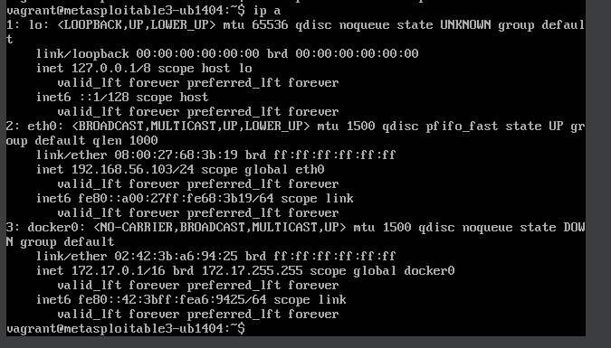
Figure 19: Network interface configuration (ip a) on the Metasploitable 3 Ubuntu target, confirming address 192.168.56.103/24 on eth0.
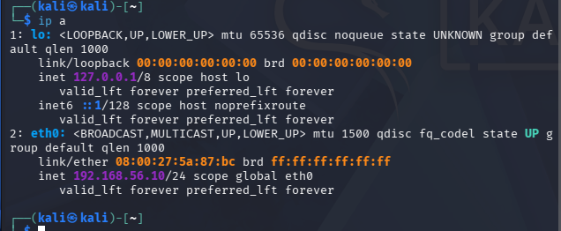
Figure 20: Network interface configuration (ip a) on the Kali Linux attacker machine, confirming address 192.168.56.10/24 on eth0.
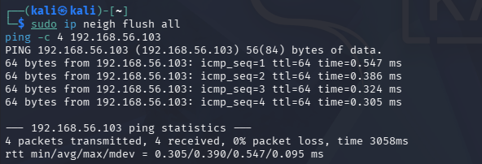
Figure 21: ARP cache flush and connectivity check (ping -c 4 192.168.56.103) confirming reachability with 0% packet loss before capture.
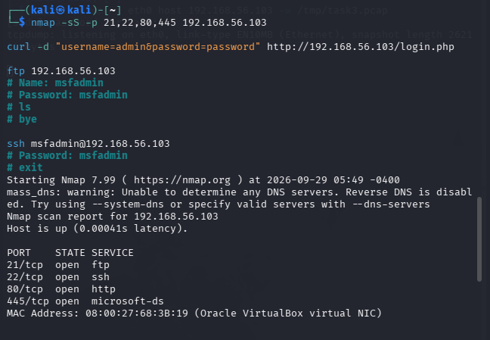
Figure 22: Nmap SYN scan of ports 21, 22, 80 and 445 on the target, shown alongside the commands used to generate sample traffic for the capture (an HTTP POST login attempt and FTP/SSH login activity).
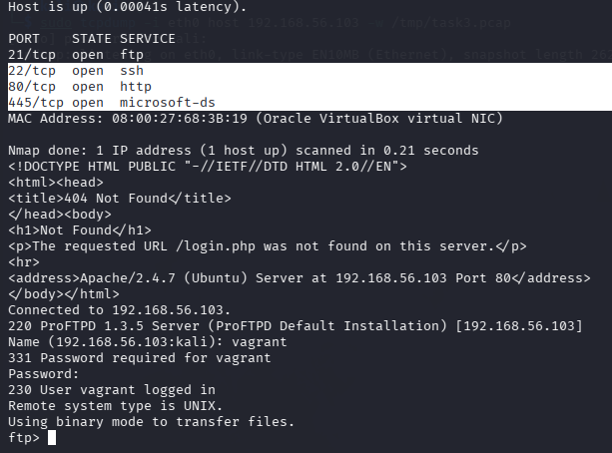
Figure 23: Continuation of the Nmap results and an interactive FTP session against the target, showing the ProFTPD 1.3.5 banner and a successful login.

D. TCP Three-Way Handshake
A standard TCP handshake has three steps: the client sends a SYN packet to request a connection, the server replies with a SYN-ACK to acknowledge the request and signal it is willing to connect, and the client completes the exchange with an ACK. The capture evidence here shows the first two of these steps clearly; the SYN-only filter used in Figures 26–27 deliberately captures packets with the SYN flag set, which by definition covers steps 1 and 2 but not the plain ACK of step 3.
For the FTP connection (port 21), the following exchange was captured:
- SYN: 192.168.56.10:53982 → 192.168.56.103:21, seq 1373143133, win 64240 — the attacker requests a connection to the FTP service.
- SYN-ACK: 192.168.56.103:21 → 192.168.56.10:53982, seq 3897414052, ack 1373143134, win 28960 — the target acknowledges the request and offers its own sequence number.
For an SSH connection attempt (port 22), the capture in Figure 27 shows a different outcome — the handshake was not completed normally:
- SYN: 192.168.56.10:53815 → 192.168.56.103:22, seq 3472282983, win 1024 — the attacker requests a connection to SSH.
- SYN-ACK: 192.168.56.103:22 → 192.168.56.10:53815, seq 3378975159, ack 3472282984, win 29200 — the target replies normally.
- RST: 192.168.56.10:53815 → 192.168.56.103:22, seq 3472282984, win 0 — the attacker resets the connection instead of sending the expected ACK. A second SYN from a new source port (35276) follows shortly after (05:48:20), but its outcome is not shown in the captured excerpt.
This reset does not by itself indicate an attack — it is simply an incomplete connection — but it is the kind of pattern worth noting during packet inspection, since a burst of SYN packets followed by resets can also be a sign of scanning activity, which is consistent with the Nmap SYN scan run earlier in this task (Figure 22).

E. Packet / Data Layer Analysis
- Ethernet layer: the capture header confirms link-type EN10MB (Ethernet) for /tmp/task3.pcap, i.e. standard Ethernet framing (visible in the tcpdump headers in Figures 24 and 26).
- IP layer: every packet in the capture shows the attacker (192.168.56.10) and target (192.168.56.103) IP addresses, consistent with the interface configuration confirmed in Figures 19–20.
- TCP layer: source/destination ports, flags (SYN, SYN-ACK, ACK-bearing data packets, RST), sequence and acknowledgment numbers, window size, and TCP options (MSS, SACK-permitted, timestamps, window scaling) are all visible directly in the -A output shown in Figures 24–27.
- Application layer: for FTP, the USER and PASS commands are visible as plain ASCII text inside the TCP payload (Figures 24–25). For HTTP, the POST request line, headers, and the urlencoded form body (username=...&password=...) are visible in the same way (Figures 25–26).
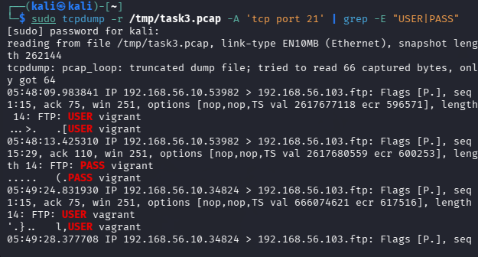
Figure 24: tcpdump read of the capture file filtered on tcp port 21, piped through grep -E "USER|PASS" to isolate the FTP authentication commands.
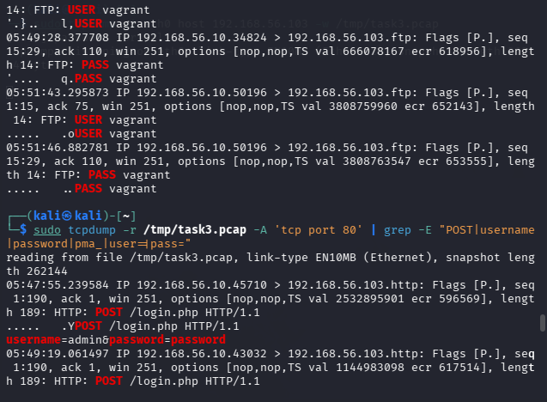
Figure 25: Continued FTP credential capture, followed by a tcpdump read filtered on tcp port 80 and piped through grep to isolate the HTTP POST request containing login-form data.

F. Clear-Text / Unencrypted Traffic
Two unencrypted protocols were observed carrying authentication data in this capture:

FTP (port 21)
The tcpdump filter on tcp port 21 captured the FTP USER and PASS commands directly as plaintext: USER vagrant and PASS vagrant, repeated across several connection attempts from different ephemeral source ports (Figures 24–25). Because FTP sends its control channel — including the login sequence — entirely unencrypted, anyone with visibility into this traffic (for example, on a shared network segment, a hub, a mirrored switch port, or a compromised intermediate host) could read this username and password without needing to break any encryption at all.
VERIFY AGAINST SCREENSHOT/SOURCE: the lab notes visible at the top of Figure 22 reference planned FTP and SSH test credentials of msfadmin/msfadmin, but the actual packet capture (Figures 24–25) and the interactive FTP session (Figure 23) both show the username vagrant was the one actually used and captured on the wire. Please confirm which credentials were intended for this task write-up.

HTTP (port 80)
The tcpdump filter on tcp port 80 captured two separate cleartext POST requests: one to /login.php containing username=admin&password=password, and one to /drupal containing name=admin&pass=password (Figures 25–26). In both cases the login form data is sent as plain urlencoded text inside the HTTP request body, with no transport encryption, so the same passive-interception risk applies as with FTP.

SSH (port 22), for contrast
No login credentials were visible at the application layer for the SSH connection attempts in this capture. This is expected — SSH encrypts its session data, including authentication, so even though the TCP handshake itself is visible (Figure 27), the content of any login exchange is not readable in the same way the FTP and HTTP traffic was.
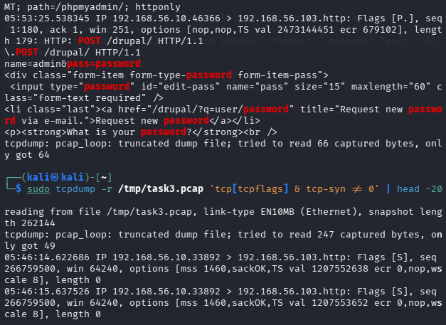
Figure 26: Continued HTTP POST capture showing a second cleartext form submission, followed by the start of a tcpdump read filtered on the TCP SYN flag to isolate handshake packets.
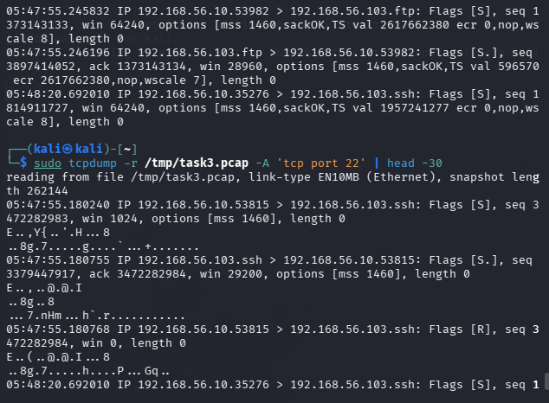
Figure 27: Continuation of the SYN-flag filtered capture, followed by a tcpdump read filtered on tcp port 22 showing the TCP handshake behaviour for an SSH connection attempt.

G. Network Security Anomaly / Data Exfiltration Analysis
The traffic captured in this task consisted of reconnaissance (an Nmap SYN scan), a web login form submission, and FTP login activity. No large outbound transfer, no unusual destination beyond the isolated lab target, and no other indicator of data being moved out of the environment appears anywhere in the provided evidence.
No confirmed data exfiltration was established from the provided packet evidence.

H. Security Findings
Finding | Evidence | Security Impact | Recommended Mitigation
FTP transmits login credentials in cleartext | Figs. 24–25 | Anyone able to observe network traffic (e.g. on a shared segment or via a compromised host) can read the username and password directly. | Replace FTP with SFTP/FTPS, or disable the FTP service if it is not required.
HTTP login form submits credentials in cleartext | Figs. 25–26 | Login credentials submitted to /login.php and /drupal are exposed to passive interception; no encryption protects the POST body. | Enforce HTTPS/TLS on all pages that accept authentication data.
SSH connection attempt reset before completion | Fig. 27 | An observed TCP handshake to port 22 ended in a reset (RST) rather than a completed connection; on its own this is inconclusive but is the kind of pattern worth correlating with logs. | Monitor and log repeated failed/reset connection attempts to authentication services as part of routine detection.

I. Recommendations
- Replace FTP with SFTP or FTPS so that authentication and file transfer happen over an encrypted channel.
- Serve login forms over HTTPS instead of HTTP so that credentials are encrypted in transit, closing the exposure seen on both /login.php and /drupal.
- Apply encryption in transit as a default requirement for any service that handles authentication data, not just the two flagged here.
- Use network segmentation to limit which hosts can even reach management or authentication endpoints in the first place.
- Continue using packet-level monitoring (Wireshark/tcpdump or an IDS) to catch clear-text credential exposure and connection patterns like the reset SSH handshake observed in this capture.
- Apply firewall/access controls to restrict FTP and administrative HTTP endpoints to trusted source addresses.

J. Task 3 Conclusion
This exercise confirmed, at the packet level, that both FTP and the HTTP login forms tested against the Metasploitable 3 target transmit authentication data in cleartext — the usernames and passwords were readable directly from the capture with no decryption required. The TCP handshake analysis also showed the practical difference between a normal SYN/SYN-ACK exchange (FTP) and an aborted one ending in a reset (SSH), which is a useful pattern to recognize when reviewing capture data. No confirmed data exfiltration was found in the traffic reviewed here.
The main security lesson is a simple one: unencrypted protocols expose exactly what they carry to anyone positioned to observe the traffic, which is why moving authentication traffic to encrypted equivalents (SFTP/FTPS, HTTPS) is not just a best practice but a direct fix for a vulnerability that was actually demonstrated here.

OVERALL CONCLUSION / LEARNING SUMMARY
Across Task 2 and Task 3, this internship work covered two complementary sides of vulnerability and network assessment: identifying what is exposed and outdated on a host, and observing what is actually visible on the wire once traffic starts flowing.
Task 2 showed that a single target can accumulate a large attack surface simply by running old, unpatched services — eight open ports were identified, and every one of them mapped to either a documented CVE or a clear hardening gap. The UnrealIRCd backdoor stood out because it was not just a version-based guess: it was validated end-to-end with Metasploit and confirmed exploitable, which is a different level of confidence than a scanner flag alone.
Task 3 showed the other half of the picture: even when a host's services are reachable, the real exposure often comes down to whether the protocol in use encrypts what it carries. FTP and an HTTP login form both handed over usernames and passwords in plain, readable text the moment the traffic was captured and filtered — no exploitation was needed, just visibility into the network.
Taken together, the two tasks point to the same underlying remediation priorities: patch and remove outdated or unnecessary services, and move any remaining authentication traffic onto encrypted protocols. Both labs also reinforced the value of validating findings with real evidence — screenshots, scan output, and packet captures — rather than relying on a scanner's word alone, which is the same standard this report has tried to hold to throughout.

