# DEPARTMENT OF COMPUTER SCIENCE

**ALIGARH MUSLIM UNIVERSITY**

**ALIGARH**



**SOFTWARE REQUIREMENT SPECIFICATION DOCUMENT**

**OF**

1. **Healthcare System**

**Submitted To:**

**Mr. Md Naved Iqbal**

**Submitted By:**

**Mohammad Owais**

**20MCA052**

**GJ7490**

**Table of Content**

ABSTRACT 3

**Chapter - 1: INTRODUCTION**

1.1 PROPOSED SYSTEM 4

1.2 OBJECTIVES OF PROPOSED SYSTEM 4

1.3 REFERENCES 5

1.4 EXISTING SYSTEM 6

**Chapter - 2: MODULES** 8

**Chapter - 3: SYSTEM ANALYSIS AND DESIGN**

3.1 SYSTEM DEVELOPMENT TOOLS 10

3.2 CHOICE OF LANGUAGE 11

3.3 NON-FUNATIONAL REQUIREMENTS 11

**Chapter - 4: SYSTEM IMPLEMENTATION**

4.1 SOFTWARE DEVELOPMENT MODELS 13

4.2 HARDWARE REQUIREMENTS 14

4.3 SOFTWARE REQUIREMENTS 14

**Chapter - 5: FUCTIONAL REQUIREMENTS SPECIFICATIONS**

5.1 ER-DIAGRAM 15

5.2 DATABASE TABLES 16

5.3 DATA FLOW DIAGRAM 20

5.4 USE CASE DIAGRAM 23

5.5 CLASS DIAGRAM 25

**Abstract**

Most of the reasons for implementing the EHS (Electronic Healthcare System) focus on improving medical care as a whole for Patient, Physicians and Doctors. However, achieving an excellent quality of best medical care through EMR (Electronic Medical Record) is neither low cost nor easy. Based on our qualitative study on physician practices we have found that quality improvement depends heavily on doctors’ use of the EMRs, not use of papers for their daily tasks. I also identified Key barriers to physician’s use of EMRs and also observed that EMR software becomes useless for doctors due to its complex interface. E-Health System for Outdoor patient is the complete comprehensive solution for hospitals and clinics. This solution caters the full life cycle of modern hospitals and clinics, using this system patients can take appointment form their homes and confirm the availability of particular doctors. A consultant can access the medical record of their patient, and prescribe to their patient using this system.

**Chapter - 1: INTRODUCTION**

The rapid growth in Information & Communication Technology (ICT), and the power of Internet has strongly impacted the business and service delivery models of today‘s global environment. Health Management Systems provide the benefits of streamlined operations, enhanced administration & control, superior patient care, strict cost control and improved profitability. Hospital Management Systems are in high demand to handle increasing population needs and also aids the practicing doctors and hospital service and support staff with timely service and precision. There are varied metrics available to assess the performance of services like hospital industry, and the successful implementation and usage of Hospital information system forms a crucial role. My Cloud based web application of E-Healthcare system will provide comprehensive, effective and efficient solution for carrying out management of hospitals and clinics fulfilling the needs and requirements of all stakeholders such as doctors, patients and staffs.

**Proposed system:**

After extensive research had been carried out on hospital management process, I proposed cloud based web application for E-Health Management System which will provide comprehensive, effective and efficient solution for carrying out management of hospitals fulfilling the needs and requirements of all stakeholders such as doctors, patients and staffs by providing following features. • 

* Patient Appointment Management. 
* Doctors appointment scheduling.
* Identify and maintain patient records. 
* Manage patient medical history such as reports, prescriptions, laboratory tests, etc. 
* Electronic Prescriptions for a doctor. 
* Patient medical records Security and privacy. 
* Physician Profile Management. 
* Appointments reminder management. 
* SMS Dose reminder for patients. 
* Patient Billing management.

**Objective:-**

The E-Health Management System has following goals:

* Authorize doctors and assisting staffs to access the medical history of patient efficiently 
* Appointment and reminder system for Patients 
* To build a built-in medical solutions repository on the basis of historical and statistical data 
* To let the doctors and surgeons build their profile and personal repository in which they may store their routine medicines names, precautions instructions and can take required help from this repository later when needed.

**References:**

1. <https://www.skoolbeep.com/>
2. <https://www.tutorialspoint.com/uml/uml_standard_diagrams.htm>
3. <https://www.w3schools.com/>
4. <https://www.javatpoint.com/>

**Existing System:**

There are couple of Hospital Management Software are currently present, I will discuss two of them as follows: 

* Hospital Management Software (Tirupati International) I
* NSTA HMS Hospital Management System (ACG Infotech)

**Common Features:**

All these systems have the following common functionalities

* Appointment Management • 
* Billing & Invoicing • 
* Claims Management • 
* Patient Management • 
* Patient Records Management • 
* Physician Management • 
* Policy Management

**Comparison (Pros and Cons)**

Hospital Management Software (Tirupati International)

**Pros:**

This system provide functionalities of appointment system, patient record facility, doctor’s management, billing and policy management system.

**Cons:**

This system is offline system and run locally. We need local area network to use this software. It's not user friendly. Users’ needs training to get understanding of use of this software which increase cost. User needs to be in hospital to check any information. There is no remote access to this system. Patient have to contact hospital to take appointments. There is no online appointment systems which is very inconvenient for patients.

**INSTA HMS**

Insta HMS is a cloud/web-based application for hospital management.

**Pros:**

Insta HMS is a cloud/web-based application which covers all financial, clinical and operational requirements of a hospitals. This system provide functionalities of appointment system, patient record facility, doctor’s management, billing and policy management system. Its user friendly and mobile app contains all the modules required. It provides everything under one platform, doctor visits, appointments everything is managed periodically. It can be accessed anywhere with internet connection.

**Cons:**

Doctors scheduling is very poor. Individual doctors has to type dates and time which is not user friendly. It requires typing inputs for most of its process such as assigning medicines. It does not has appointment reminder system for patients. Users’ needs training to get understanding of use of this software which increase cost. There is no document or guideline videos for using this software.

**Chapter - 2: MODULES**

**System Description:**

The system comprises of 3 major modules with their sub-modules as follows:

**Admin:-**

1. Login: Admin can login with his personal id and password.
2. 2.Manage Doctors:
3. View Current Doctors
4. b)Delete Doctor
5. Manage Patients Records.
6. Manage Patients Medical History.
7. Add lab tests and reports.
8. Verify Doctor
9. Generate payment bill.

**Patient:-**

1. Register: Patient can register with their details.
2. Login: Patient can login with his email id and password.
3. Book An Appointment With Doctor.
4. Check Doctor Availability Online.
5. See Your Medical Reports, Doctor Prescriptions and Laboratory Tests.
6. Patient will receive a reminder regarding his appointment.
7. Patient can check his payment status and history.
8. Patient can ask any query from doctor.

**Doctor:-**

1. Register:- Doctor can registration with their details.
2. Login:- Doctor with his email id and password.
3. View his own profile
4. Edit his own profile.
5. See Patient Medical Reports
6. Doctor can accept or reject patient’s appointments.
7. Doctor can check his payment history.
8. Reply patient query.

**Chapter - 3: SYSTEM ANALYSIS AND DESIGN**

It is a process of collecting and interpreting facts, identifying the problems, and decomposition of a system into its components. System analysis is conducted for the purpose of studying a system or its parts in order to identify its objectives. It is a problem solving technique that improves the system and ensures that all the components of the system work efficiently to accomplish their purpose. It is a process of planning a new business system or replacing an existing system by defining its components or modules to satisfy the specific requirements. Before planning, you need to understand the old system thoroughly and determine how computers can best be used in order to operate efficiently.

**3.1 SYSTEM DEVELOPMENT TOOLS**

As mentioned earlier that one of the most important tasks is to understand users' requirements. There are two aspects in this understanding:

1. Understanding the flow of documents in an organization. (Documents incorporate the basic data available in the organization and hence it is essential to know where they originate and how they flow).
2. Understanding the rules to process data (very often the rules are complex and orally stated,leading to misunderstanding).

Two important System Development tools are used to assist the above tasks:

1. Data flow diagrams that specify the origin of data and how they flow through a system and where they are processed.
2. Decision tables that are used to specify complex processing rules in a concise and easily understood form.

Besides these tools used in specifying users’ requirements, there are also other tools used in a system design. These are database management system and associated languages which allow rapid prototyping of systems. Quickly obtaining a prototype is very useful to get user feed-back. Tools such as spreadsheets are very useful in answering any questions.Further, report generators and graphics systems are used in visualizing information. A system analyst would be conversant with all these tools and know-how to effectively use them.

**3.2 CHOICE OF LANGUAGE**

Front End : HTML, CSS, javascript.

Back End : Java(Spring Boot), MySQL.

**3.3NON-FUNATIONAL REQUIREMENTS**

1. **Performance Requirement:**

The system shall minimize errors and a clear error message should be displayed that guides the user to handle it. The product shall be based on the web and has to be run from a web server. The product shall take initial load time depending on internet connection strength which also depends on the media from which the product is run. The performance shall depend upon hardware components of the client/customer

1. **Security Requirement:**

The system provides a username and password to prevent the system from unauthorized access. Password will be saved in encrypted form in a database for security purposes. The system must automatically log out all customers after a period of inactivity. The system should not leave any cookies on the customer’s computer containing the user’s password. The system should provide a high level of security and integrity of the data held by the system, only the admin has the right to delete the driver's account from the system if found something suspicious about him.

1. **Availability:**

The system should be available at all times (i.e. 24 X 7 availability), meaning the user can access it using a web browser, only restricted by the downtime of the server on which the system runs.

1. **Portability:**

The application is HTML and scripting language-based. So the end-user part is fully portable and any system using any web browser should be able to use the features of the system, including any hardware platform that is available or will be available in the future. An end-user is using this system on any OS; either it is Windows or Linux. The system shall run on PC, Laptops, etc.

1. **Usability:**

The system should satisfy the maximum number of user's needs. The system provides a help and support menu in all interfaces for the user to interact with the system. The user can use the system by reading help and support.

**Chapter - 4: SYSTEM IMPLEMENTATION**

**4.1SOFTWARE DEVELOPMENT MODELS**

There are many software development models which are used but we used waterfall model, such as:

**Waterfall model:**

In this project, I am using the Waterfall model, as my project is small and all the requirements are known in advance. The waterfall approach was the first SDLC Model to be used widely in Software Engineering to ensure the success of the project. In "The Waterfall" approach, the whole process of software development is divided into separate phases. In the Waterfall model, typically, the outcome of one phase acts as the input for the next phase sequentially. The sequential phases in the Waterfall model are:

1. **Requirement Gathering and analysis:** All possible requirements of the system to be developed are captured in this phase and documented in a requirement specification doc.
2. **System Design:** The requirement specifications from the first phase are studied in this phase and system design is prepared. System Design helps in specifying hardware and system requirements and also helps in defining overall system architecture.
3. **Implementation:** With inputs from system design, the system is first developed in small programs called units, which are integrated into the next phase. Each unit is developed and tested for its functionality which is referred to as Unit Testing.
4. **Integration and Testing:** All the units developed in the implementation phase are integrated into a system after testing each unit. Post integration the entire system is tested for any faults and failures.
5. **Deployment of the system:** Once the functional and non-functional testing is done, the product is deployed in the customer environment or released into the market.
6. **Maintenance:** Some issues come up in the client environment. To fix those issues patches are released. Also to enhance the product some better versions are released. Maintenance is done to deliver these changes in the customer environment.

**4.2HARDWARE REQUIREMENTS**

Processor : Intel Pentium 3 or above

RAM : Minimum 2 GB

ROM : Minimum 128 GB

**4.3SOFTWARE REQUIREMENTS**

Operating System : windows 7 and above

Internet Browser : Google chrome or any other compatible browser

**Chapter - 5: FUCTIONAL REQUIREMENTS SPECIFICATIONS**

**5.1 ER-DIAGRAM**

An Entity-Relationship Model is a popular high-level Conceptual data model and its diagrammatic notation is known as ER Diagram. An entity-relationship diagram is a detailed logical representation of data for an organization. It has three main components:

1. Data Entities
2. Relationships
3. Attributes

Entities are the elementary thing of an organization. About which data is to be maintained. Every entity has a unique identity. Entities are connected by relationship. It indicates how two entities are associated. Attributes are a property or characteristic of an entity that is of interest to the organization.

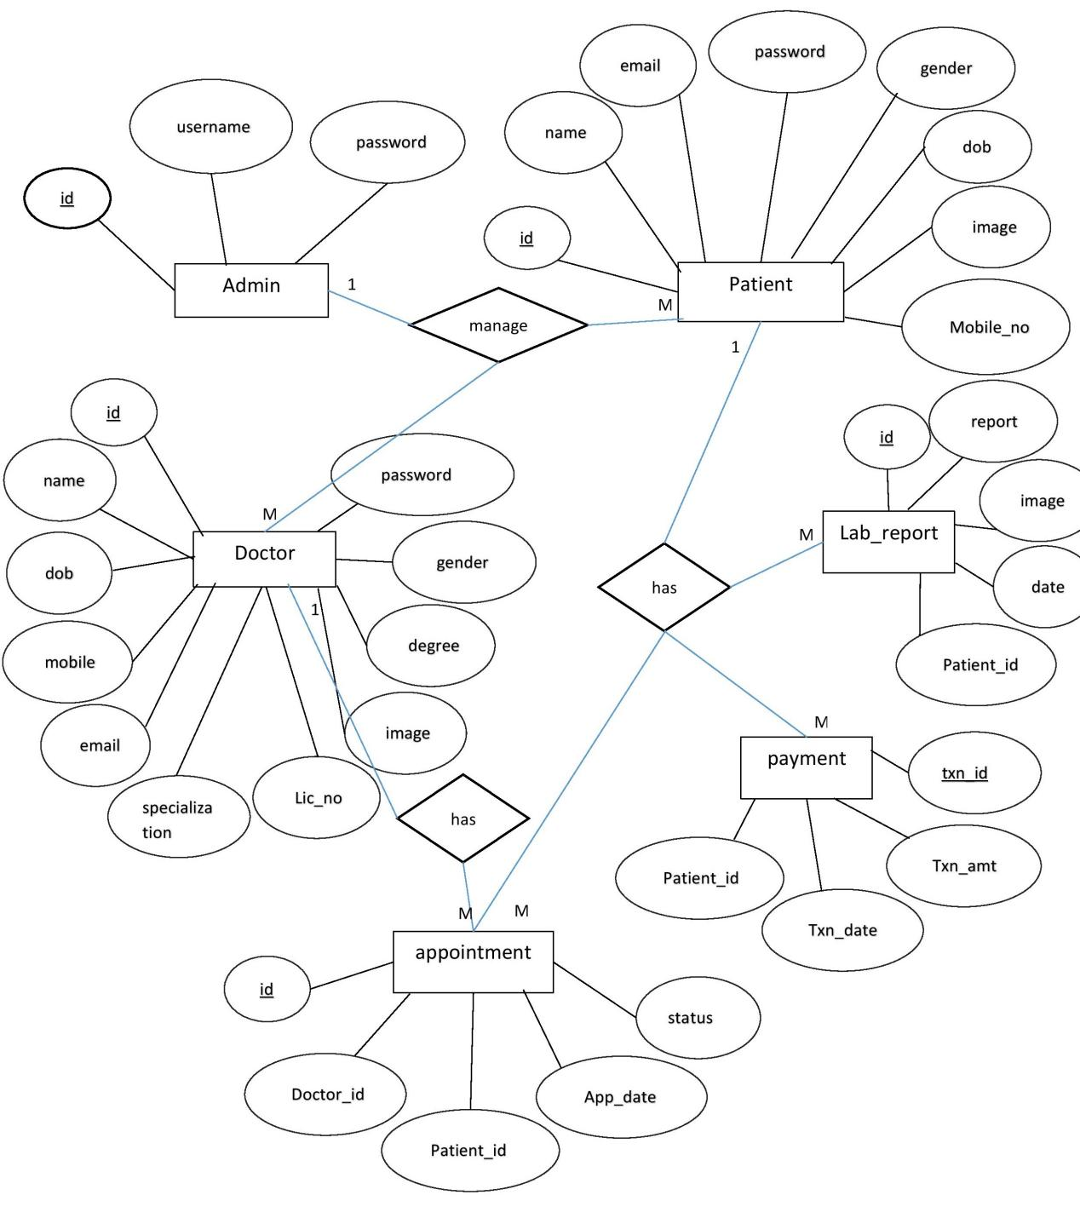

**5.2 DATABASE TABLES**

|  |  |  |
| --- | --- | --- |
| **Column** | **Type** | **Null** |
| id (Primary) | Int (10) | No |
| username | varchar(25) | No |
| password | varchar(25) | No |

**ADMIN**

**DOCTOR**

|  |  |  |
| --- | --- | --- |
| **Column** | **Type** | **Null** |
| id (Primary) | int (10) | No |
| name | varchar (50) | No |
| email | varchar (50) | No |
| mobile_no | varchar (15) | No |
| gender | varchar (50) | No |
| password | varchar (255) | No |
| dob | varchar (255) | No |
| Lic_no | varchar (50) | No |
| image | varchar (30) | Yes |
| degree | Varchar(30) | No |
| specialization | varchar(30) | No |

**PATIENT**

|  |  |  |
| --- | --- | --- |
| **Column** | **Type** | **Null** |
| id (Primary) | int (10) | No |
| name | varchar (50) | No |
| email | varchar (50) | No |
| mobile_no | varchar (15) | No |
| gender | varchar (15) | No |
| password | varchar (255) | No |
| dob | varchar (255) | No |
| image | varchar (50) | Yes |

**LAB_REPORT**

|  |  |  |
| --- | --- | --- |
| **Column** | **Type** | **Null** |
| id (Primary) | int (10) | No |
| Report_name | varchar (50) | No |
| image | varchar (50) | No |
| date | varchar (15) | No |
| Patient_is | int (10) | No |

**APPOINTMENT**

|  |  |  |
| --- | --- | --- |
| **Column** | **Type** | **Null** |
| id (Primary) | int (10) | No |
| Patient_id | Int(10) | No |
| Doctor_id | Int(10) | No |
| App_date | varchar (15) | No |
| status | varchar (15) | No |

**PAYMENT**

|  |  |  |
| --- | --- | --- |
| **Column** | **Type** | **Null** |
| Txn_id (Primary) | int (10) | No |
| Txn_amt | float | No |
| Txn_date | varchar (15) | No |
| Patient_id | Int(10) | No |

**5.3 DATA FLOW DIAGRAM**

Data Flow Diagram is a graphical representation of the flow of data in an information system. It is capable of depicting (drawing/showing) incoming data flow, outgoing data flow, and data stored. I have used Yourdon and Coad notations for making these DFDs.

In the Data Flow Diagrams, there are four symbols

Symbol Name

Database

Process

Data Flow

Entity

Two types of DFD are made for this system:

### CONTEXT DIAGRAM

1. The context diagram is the most abstract data flow representation of a system.
2. It represents the entire system as a single bubble.
3. It depicts the entire information system as one diagram concealing all underlined details.
4. It is also called 0 level (zero level).

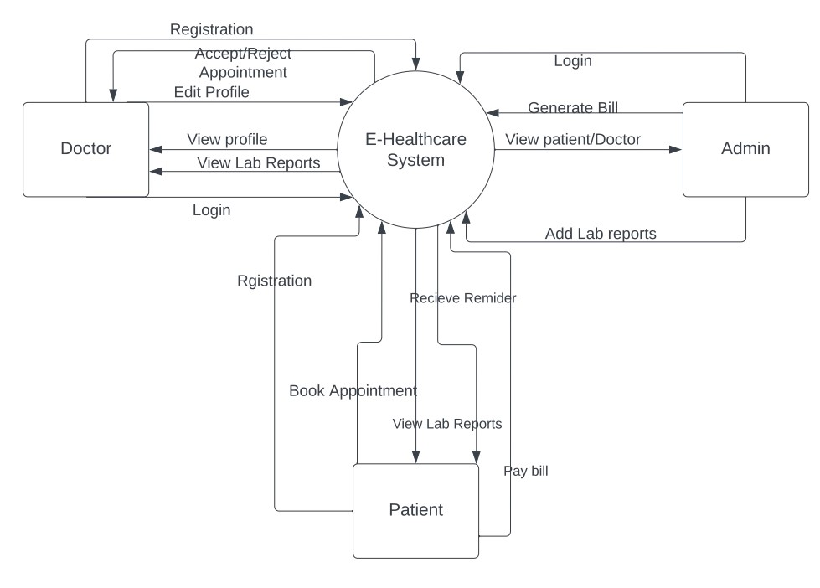

### LEVEL DIAGRAM

I. In level 1, the level 0 DFD is broken into a more specific level.

II. Level 1 DFD depicts basic modules in the system and the flow of data among variousmodules.

III. It also mentions basic process and source of information.

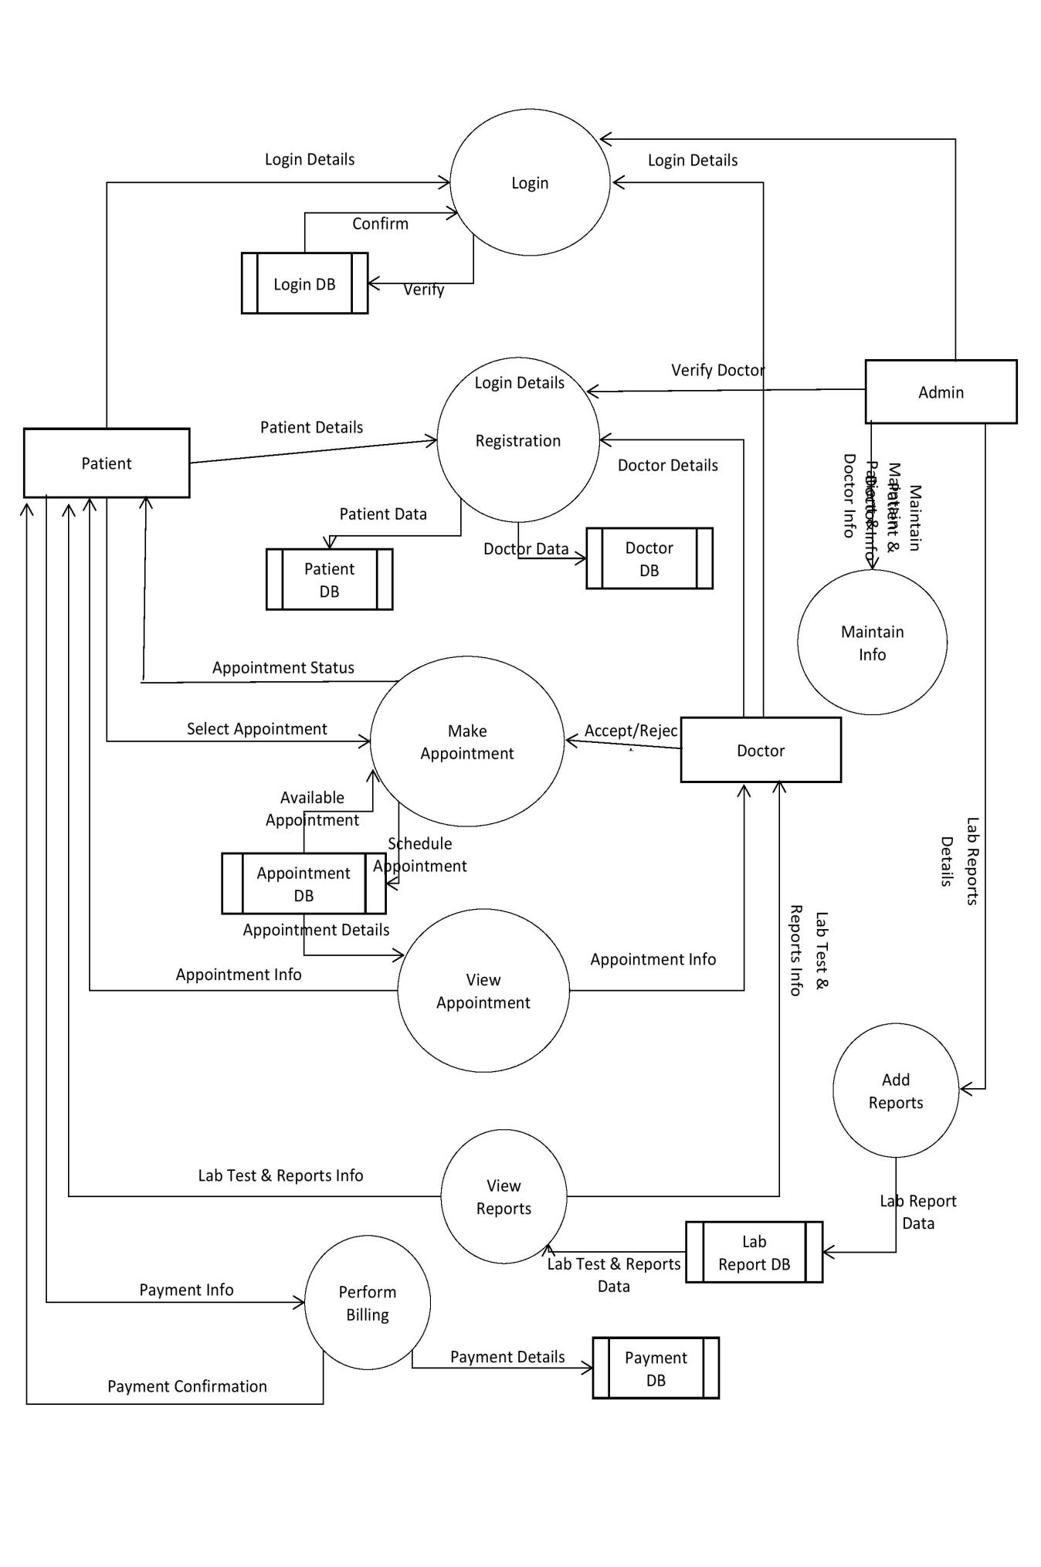

**5.4 USE CASE DIAGRAM**

**ADMIN USE CASE**

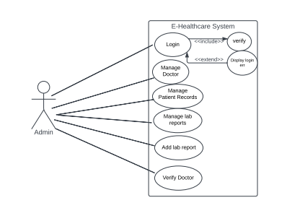

**DOCTOR USE CASE**

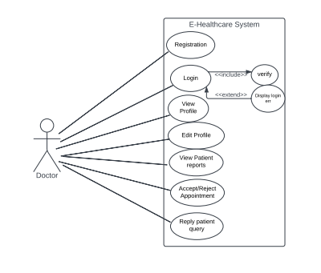

**PATIENT USE CASE**

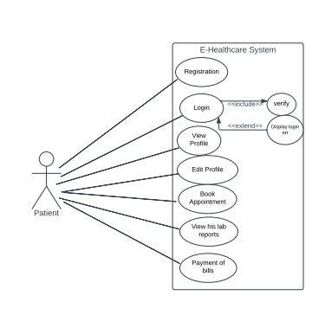

**5.5 CLASS DIAGRAM**

|  |
| --- |
| **User** |
|  |
| +register()  +login()  +logout() |

|  |
| --- |
| **Doctor** |
| -id : int  -name : string  -email : string  -password : string  -gender : string  -dob : string  -lic_no : string  -degree :string  -specialization : string  -image : string  -mobile_no : string |
| +viewProfile()  +editProfile()  +replyQuery() |

|  |
| --- |
| **Admin** |
| -id : int  -username : string  -password : string |
| +verifyDoctor()  +viewDoctor()  +removeDoctor()  +viewPatient() |

|  |
| --- |
| **Patient** |
| -id : int  -name : string  -email : string  -password : string  -gender : string  -dob : string  -image : string  -mobile_no : string |
| +viewProfile()  +editProfile()  +askQuery() |

|  |
| --- |
| **LabReport** |
| -id : int  -reportName : string  -image : string  -date : string  -patient_id : int |
| +addReport()  +viewReport() |

|  |
| --- |
| **Appointment** |
| -id : int  -doctor_id : int  -patient_id : int  -date : string  -status : string |
| +bookAppointment()  +viewAppointment() |

|  |
| --- |
| **Payment** |
| -txn_id : int  -txn_amt : float  -txn_date : string  -patient_id : int |
| +payBill();  +viewPreviousBill() |