Part 01:

Steps taken to create an AWS Account (Since I already have an AWS Account setup previously, I will just mention the steps which are required to be taken to create an AWS Account)

1. Specify a username and email address.
2. Define the purpose you will be using the AWS account for (i.e. Personal or Business).
3. Configure the Type of Support you will need (in our case it is the basic AWS Support).
4. Provide Payment Card Confirmation.
5. Verify your contact information with an OTP send on the provided number.
6. Account Creation Successful.

Figure 1: Enter the AWS SQS Queue Service from AWS Management Console and Click on Create Queue

Figure 2: Set the name of Queue as MuhammadOwais_Imran and leave the rest of configuration as Default and Click on “Create Queue” Button

Figure 3: From available queue list, select your queue and Click on "Send and Receive Messages"

Figure 4: Fill in the Message Body field and click on “Send Message” button

Figure 5: To receive the message sent, Click on "Poll for Messages" button.

Figure 6: Message Received

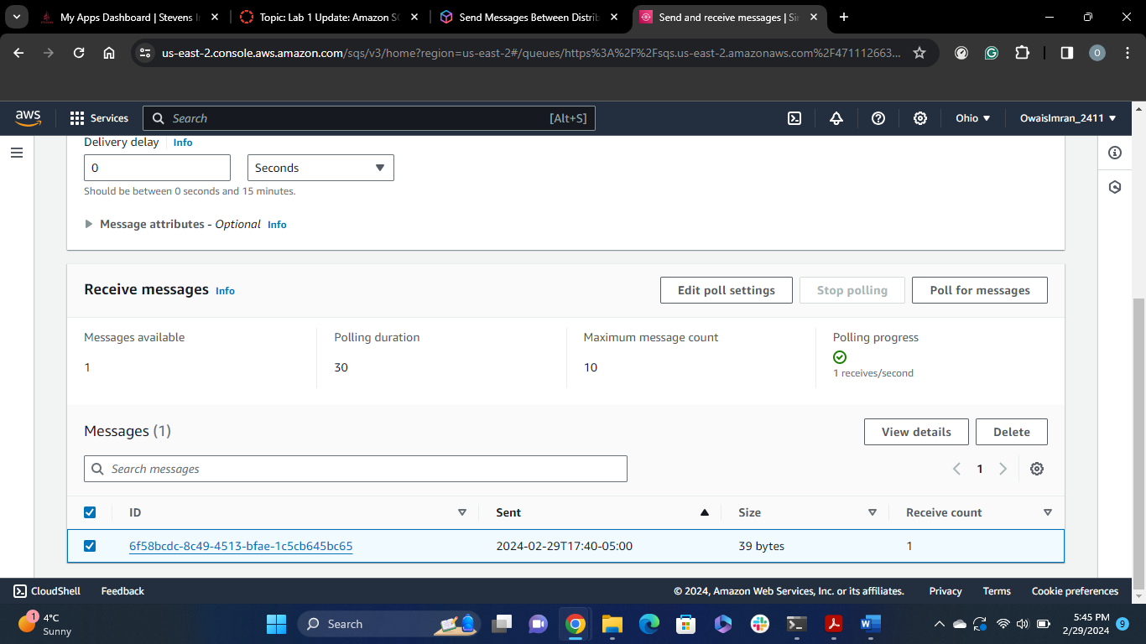

Figure 7: Select the Message and Click on Delete button to delete the message from the Queue.

Part 02:

After launching an EC2 instance with the following config:

* Instance type: t2.micro
* Volume: 8GB gp2
* RSA Based Keypair
* Default Security Group
* Amazon AMI

The following commands were executed on the ec2 instance:

1. ```uname -a``` - the command shows the entire system information, which includes the instance type and architecture, OS, Timestamp of system launch, public ipv4 address, and other kernel and system information;  
   Output:  
   
2. ```whoami``` - the command shows the associated user profile with the system.  
   Output:   
   
3. ```df -h``` - the command shows the file system disk usage information, -h flag is used to present the information in human readable format.  
   Output:  
   A table with numbers and letters

   Description automatically generated with medium confidence
4. ```ifconfig -a```- the command is used to configure/display all available network interfaces on the system, with all information like loop back address, ipv4 network address, ipv6 network address, and all necessary network level information.  
   Output:  
   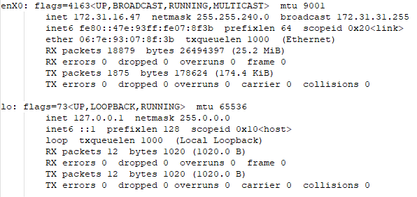
5. ```netstat``` - the command shows all the network connection, route tables, interface statistics, masquerade connections, and multicast addresses.  
   Output (it is truncated)