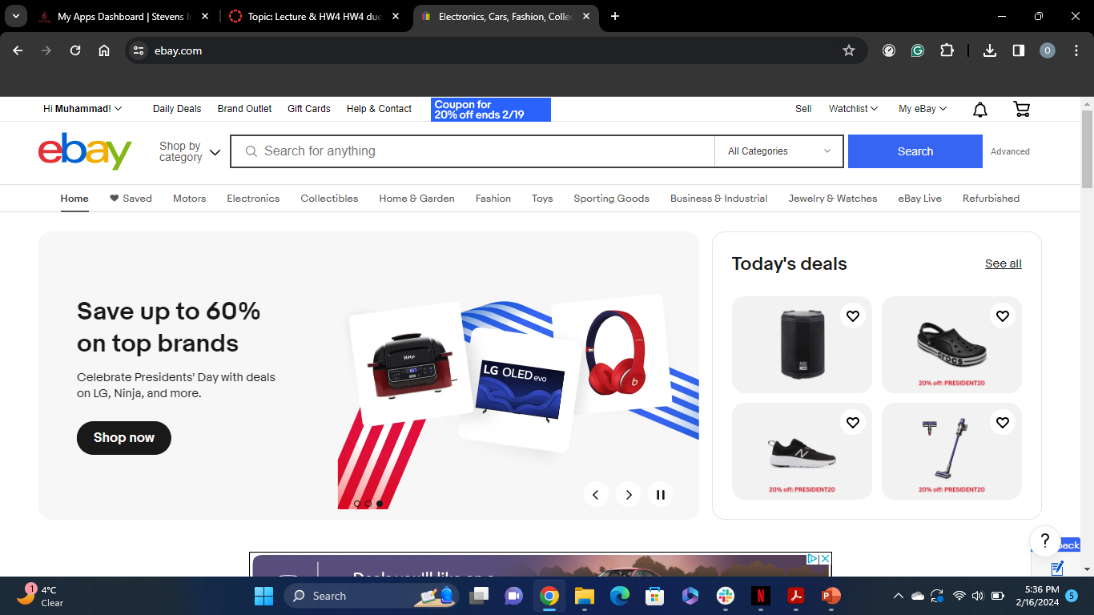

Figure 1: Ebay Home Screen after login

Figure 2: First Search Keywords Result

Figure 3: Second Search with advanced filters

Figure 4: Screenshot of email alert with advanced search filter

Figure 5: Screenshot of email with basic search result