E-Project
Zurich INSURANCE
WEBSITE

Muhammad Owais
Student id: 1699626

Content
Abstract 1
Acknowledgement 2
Requirement 3
ScreenShot 4
Task Sheet 8

Abstract
This insurance website, Safe Craze, has been developed to help users easily explore and compare different insurance plans for vehicles such as cars and bikes. It is designed for customers who want quick access to information about various insurance companies, plan types, pricing, and features without visiting physical offices. The website is especially useful for individuals looking to make informed decisions about insurance policies in a convenient and user-friendly way. In the development of this website, I used HTML to structure the content, CSS to design and style the layout, Bootstrap to create a responsive and modern interface, and JavaScript to add interactivity and enhance the overall user experience.

Acknowledgement:

I would like to express my sincere gratitude to Ms. Anumta Fareed for her continuous support, guidance, and encouragement throughout the development of my project. Her valuable insights and feedback played a crucial role in the successful completion of my Insurence Website.
I am also thankful to my institute, Aptech Metro Star Gate, for providing me with the opportunity and platform to work on this project titled “Safecraz Insurence Website”. This project not only enhanced my frontend and backend development skills in HTML, CSS, JavaScript, but also gave me a better understanding of UI/UX design.
The completion of this project would not have been possible without the support and motivation provided by my mentor and institute.

Requirements
The website will have three users/roles:
- Administrator
- Insurance Agent
- Customer

The Administrator should be able to do the following:

1) Home Page should contain logo of the site with proper sections and details of
various Insurance plans available.
2) The site should display a menu which will contain the options for brief
introduction about the various categories and plans available, location of the
shop and any other information if required.
3) The information should be categorized according to the company names of
the Insurance plans like if a User wants to see only “Zurich Insurance” plans
or any other company’s insurance plans then he/she can click on a
Link/button/menu etc and can see only that Companies plans .
4) Another category option for plans of different type of vehicles, like ‘Four
Wheelers’, ‘Two Wheelers’ etc. should be created and accordingly.
5) When a user selects any particular brand, a list of various plans for that brand
will be displayed
6) A brief summary about individual plans should be displayed on the Web Page
along with the base price.
7) There should be a “Contact Us” page which will have the Address of the Store
which is as follows and the mail address which when clicked will invoke the
local mail client from where they can send an email.

Note: Name, Address, Phone Numbers, Email-ids should be mandatory to be provided.
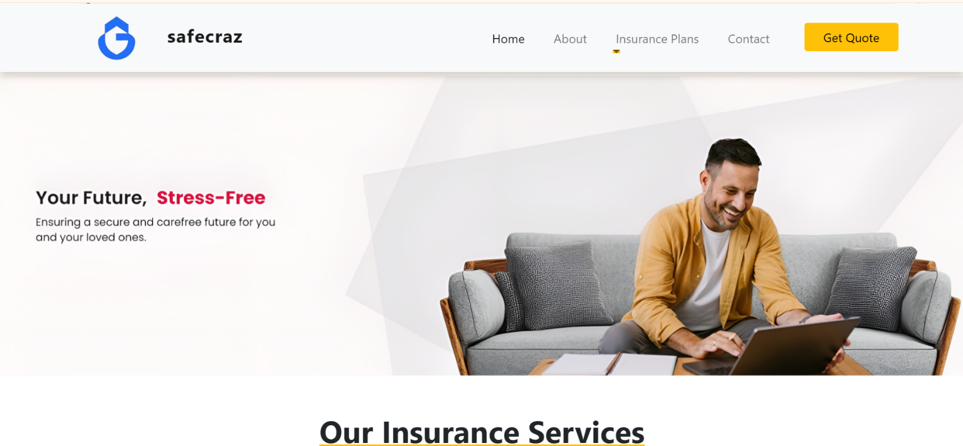
Screenshots:

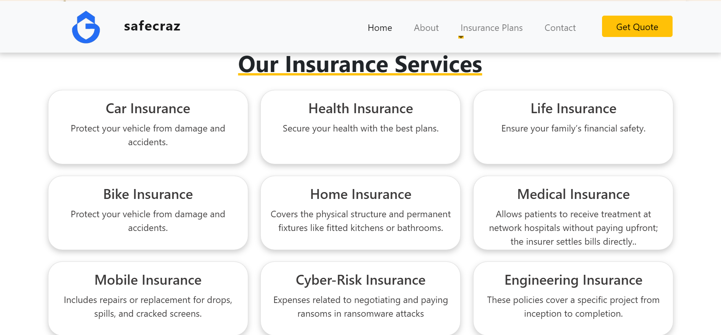

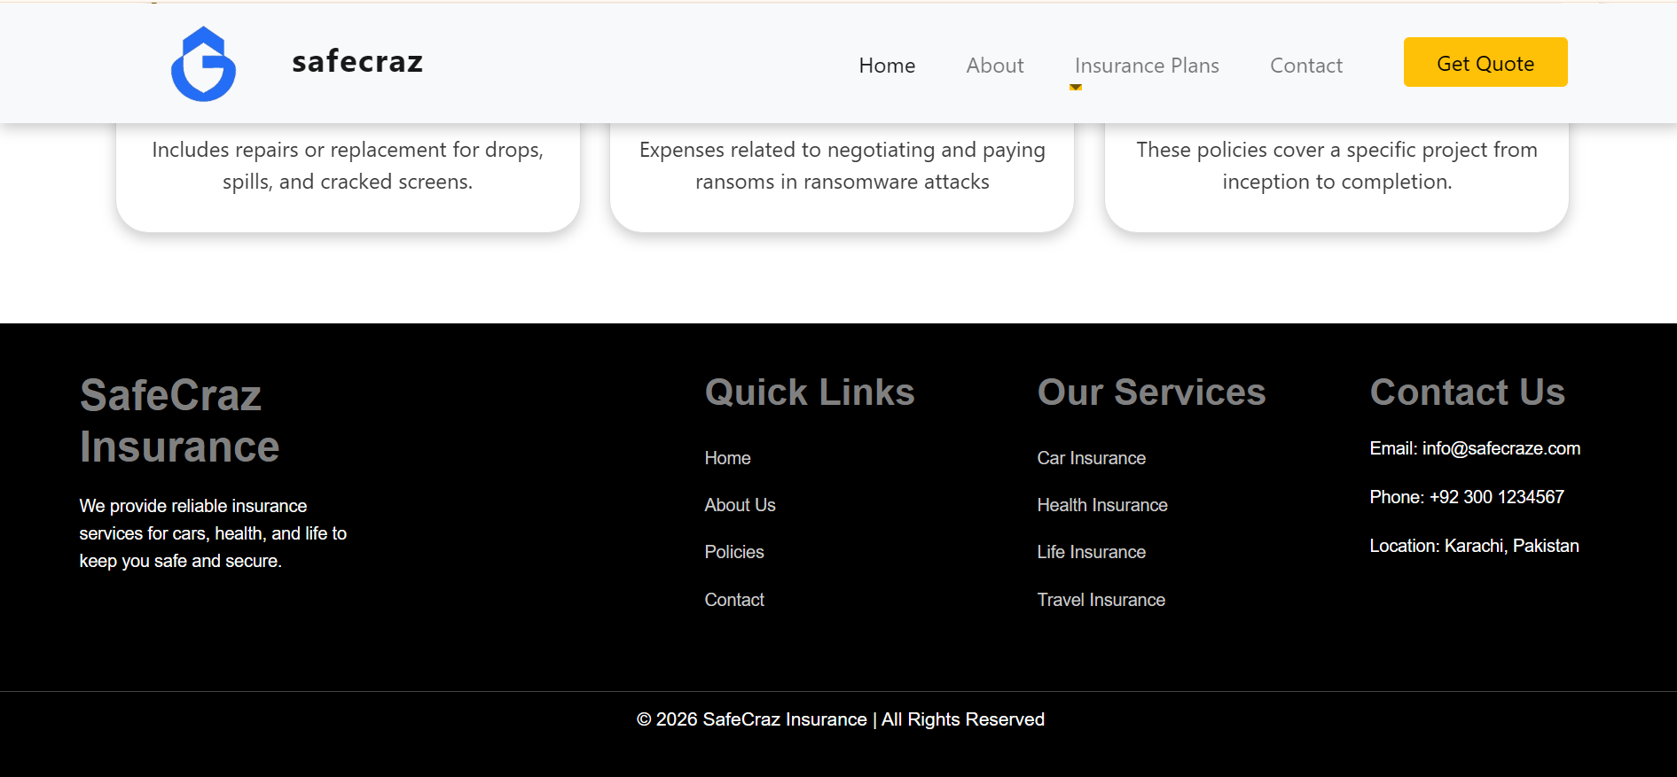

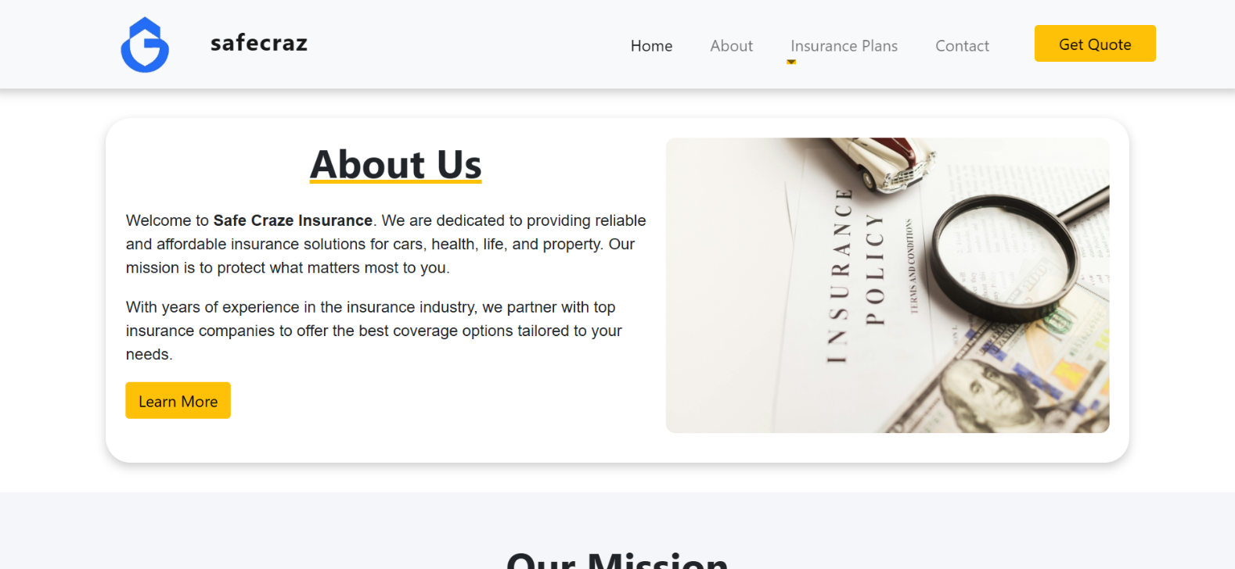

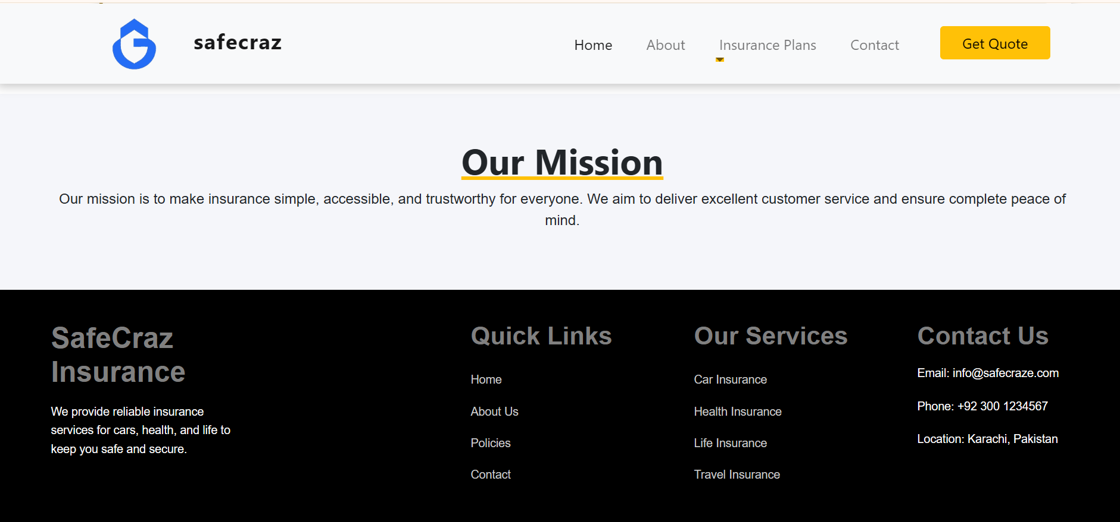

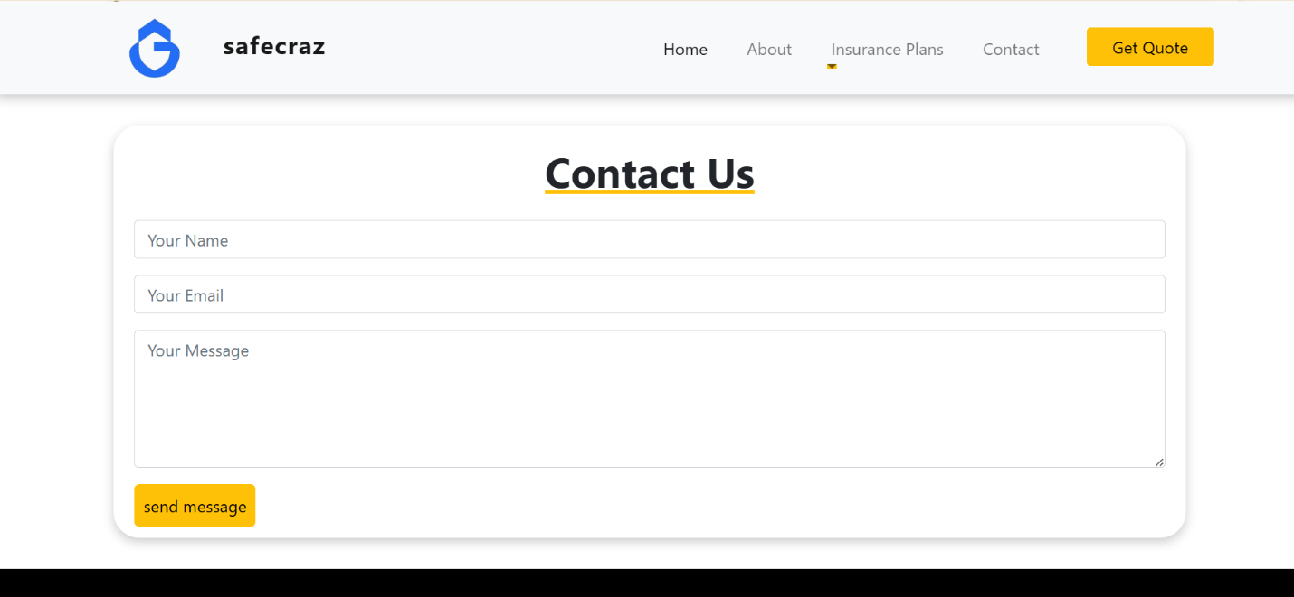

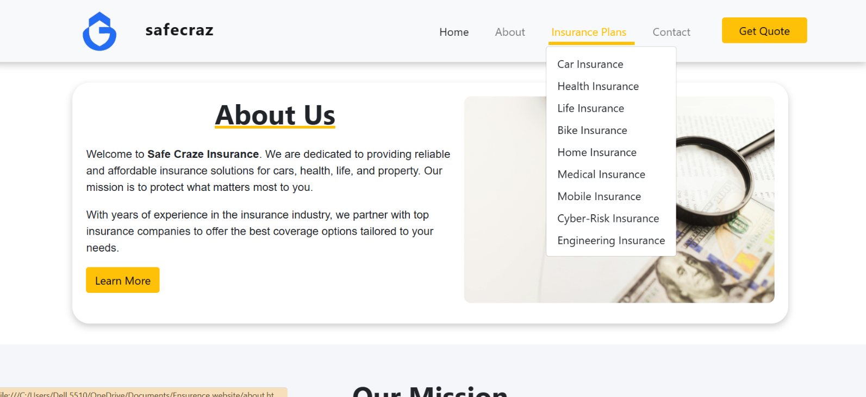

Task Sheet:

Task | Name | Days
Frontend | Muhammad Owais | 15
JS | Muhammad Owais | 05
CSS | Muhammad Owais | 05
Connection | Muhammad Owais | 01

Thank You

