**MOHAMMAD ALI JINNAH UNIVERSITY**

**NAME: MUHAMMAD OWAIS**

**ID: SP18-MSCS-0033**

**COURSE: DESIGN PATTERN**

**ASSIGNMENT 2**

**DATE: 19/03/2018**

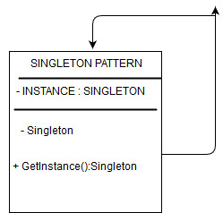

**SINGLETON PATTERN DIAGRAM**

