**Q1**

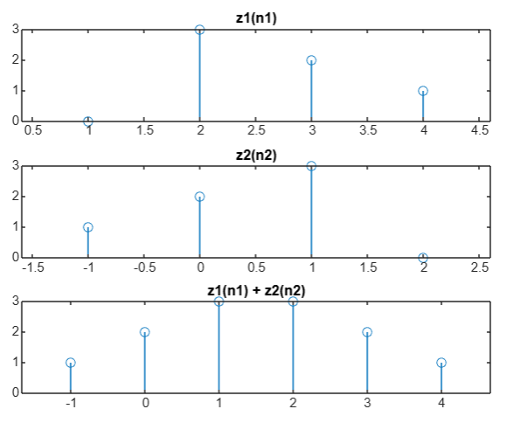z1 = [0, 3, 2, 1];

n1 = [1, 2, 3, 4];

z2 = [1, 2, 3, 0];

n2 = [-1, 0, 1, 2];

[y, n] = sigadd(z1, n1, z2, n2);

subplot(3, 1, 1)

stem(n1, z1)

title('z1(n1)');

subplot(3, 1, 2)

stem(n2, z2)

title('z2(n2)');

subplot(3, 1, 3);

stem(n, y);

title('z1(n1) + z2(n2)');

function [y, n] = sigadd(x1, n1, x2, n2)

n = min(min(n1), min(n2)):max(max(n1), max(n2));

y1 = zeros(1, length(n));

y2 = zeros(1, length(n));

idx1 = (n >= min(n1)) & (n <= max(n1));

idx2 = (n >= min(n2)) & (n <= max(n2));

y1(idx1) = x1;

y2(idx2) = x2;

y = y1 + y2;

end

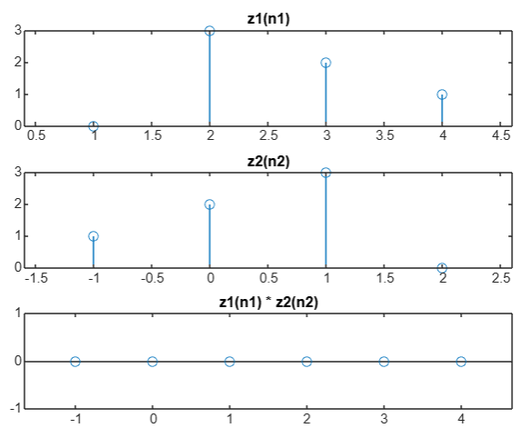

**Q2**

**Q3**

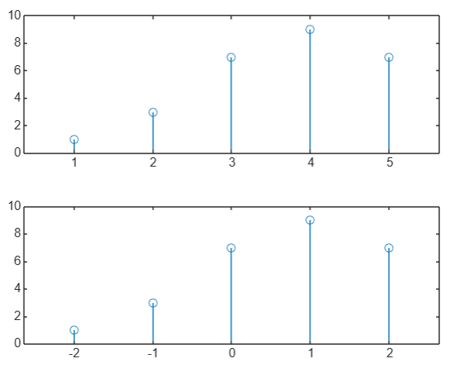

x=[1,3,7,9,7];

n=[1:1:5];

subplot(211)

stem(n,x)

subplot(212)

stem(n-3,x)

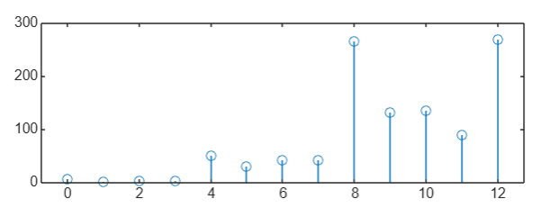**Q4 Q5**

x=[1,2,5,8,3,2];

n=0:length(x)-1;

subplot(211)

stem(n,x)

x=fliplr(x)

subplot(212)

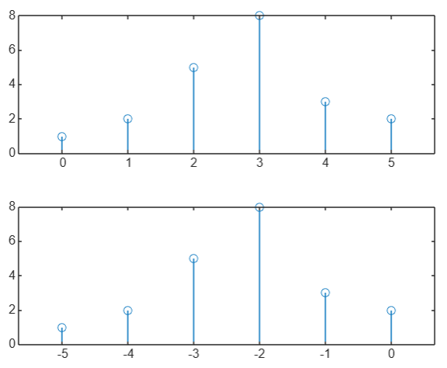stem(-n,x)

a=[1,2,3,4,5,6,7,6,5,4,3,2,1];

n=0:length(a)-1;

a(1)=7;

for i=5:length(a)

a(i)=3*a(i)+a(i-4)*a(i);

end

stem(n,a)

**Q6**

x = [0, 7, 5, 4, 8, 2, 6, 3, 8, 9, 10];

sum_x = sum (x) ;

disp ( ['Sum of the samples of x (n) : ', num2str (sum_x) ]) ;