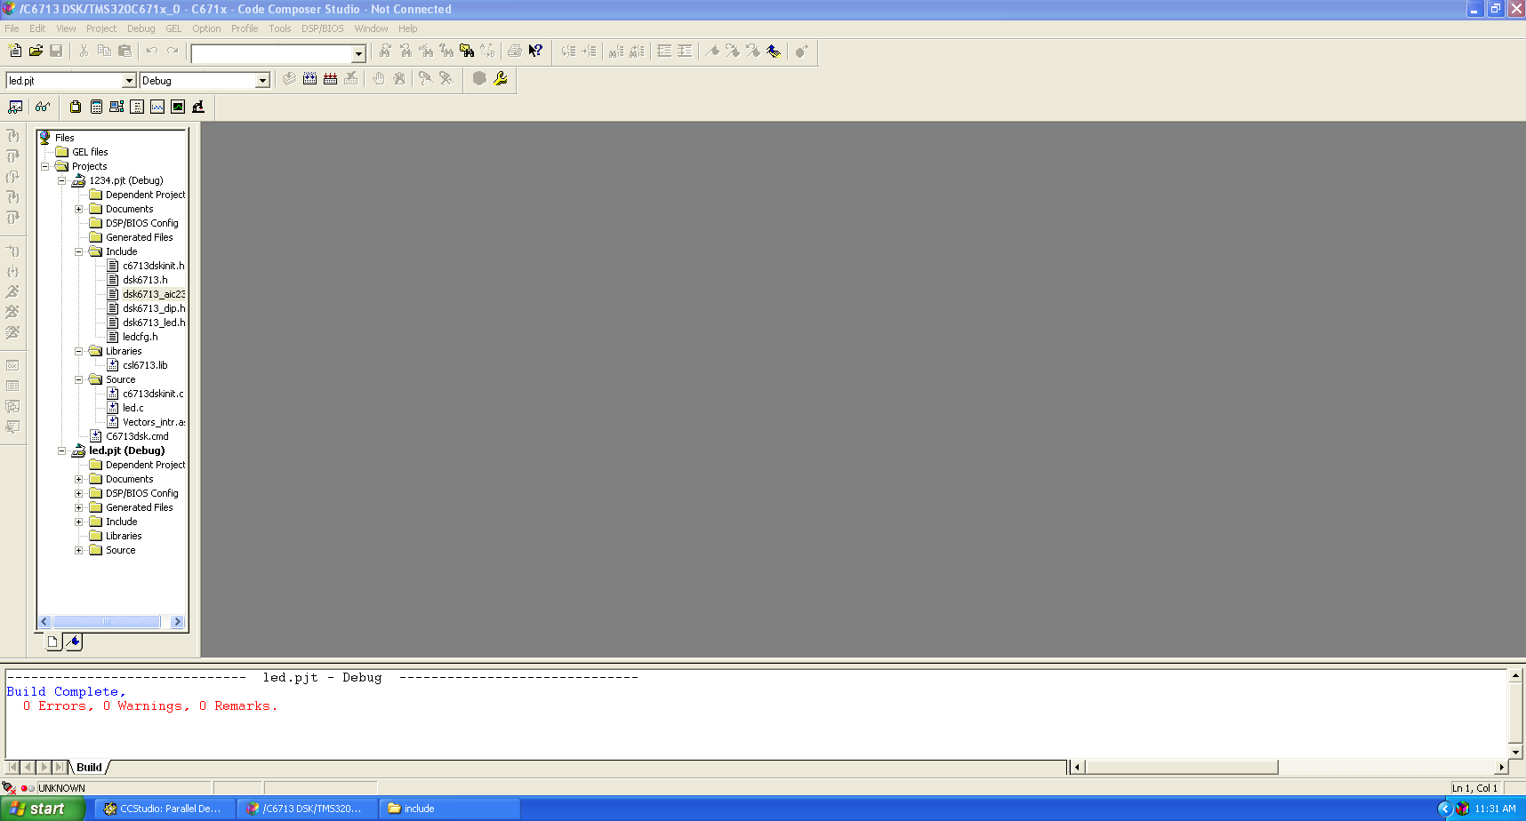

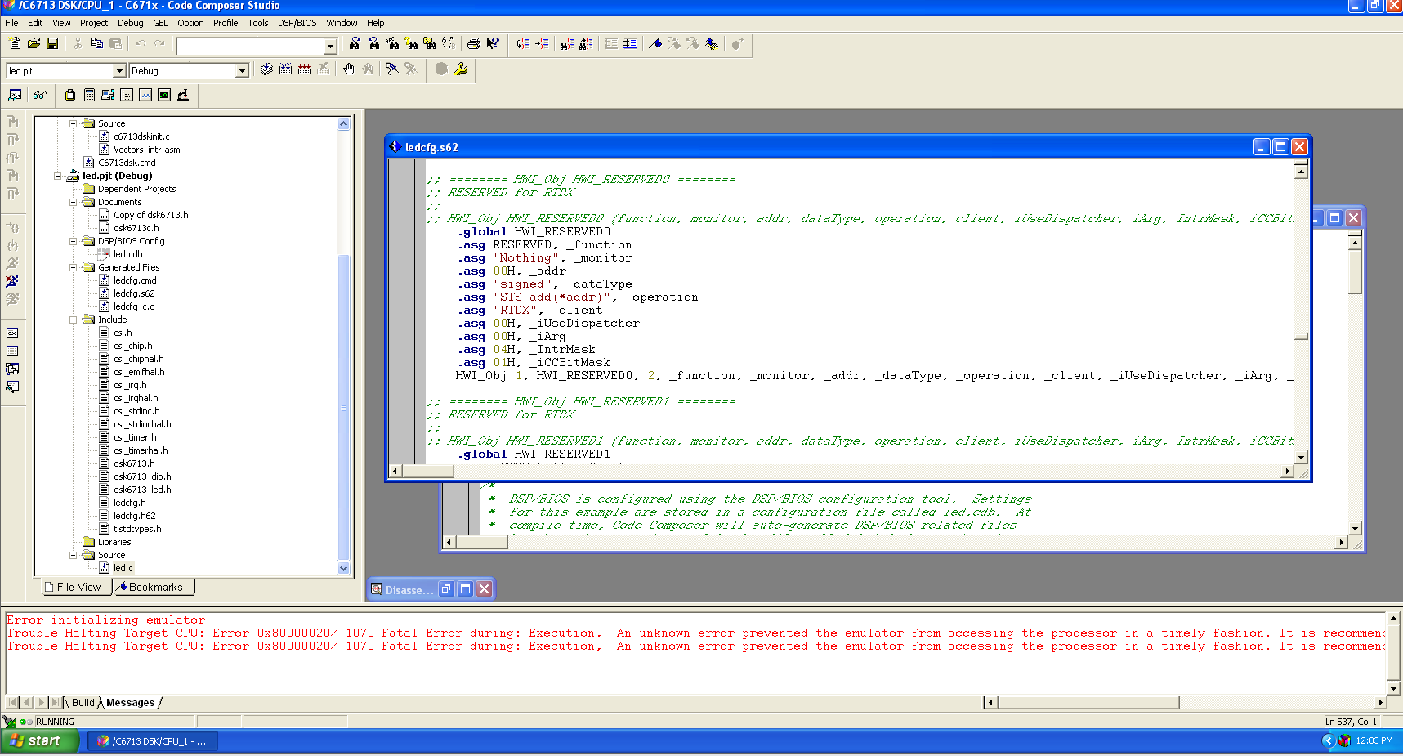

**Library**

C:\CCStudio_v3.1\C6000\csl\lib\csl6713.lib

**Source Files**

C:\CCStudio_v3.1\C6000\c6713dskinit.c

C:\Documents and Settings\Administrator\Desktop\led\led.c

C:\CCStudio_v3.1\C6000\Vectors_intr.asm

**Command File**

C:\CCStudio_v3.1\C6000\C6713dsk.cmd

