**Exercise 1**

function [y, n] = conv_seq(x1, x2, n1, n2)

y = conv(x1, x2);

n_start = n1(1) + n2(1);

n_end = n1(end) + n2(end);

n = n_start:n_end;

stem(n, y);

title('Linear Convolution Result');

end

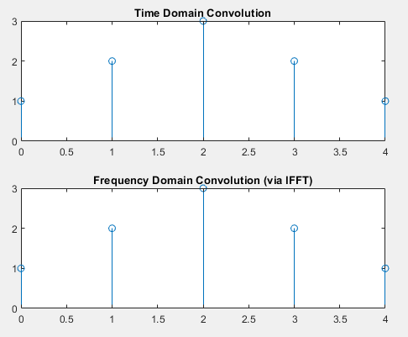**Exercise 2**

x = [1 1 1];

n = 0:2;

y = conv(x, x);

N = length(y);

X = fft(x, N);

H = fft(x, N);

Y_freq = X .* H;

y_ifft = ifft(Y_freq);

subplot(2,1,1);

stem(0:N-1, y);

title('Time Domain Convolution');

subplot(2,1,2);

stem(0:N-1, real(y_ifft));

title('Frequency Domain Convolution (via IFFT)');

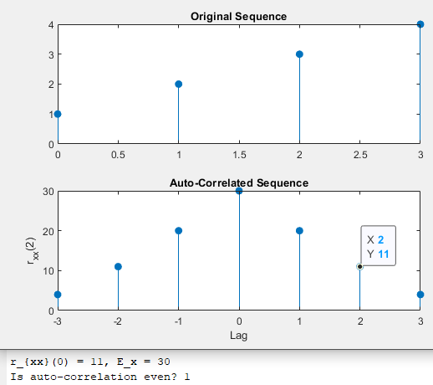

**Exercise 3**

x = [1 2 3 4];

rxx = xcorr(x);

lags = -length(x)+1:length(x)-1;

subplot(2,1,1);

stem(0:length(x)-1, x, 'filled');

title('Original Sequence');

subplot(2,1,2);

stem(lags, rxx, 'filled');

title('Auto-Correlated Sequence');

xlabel('Lag');

ylabel('r_{xx}(2)');

rxx_zero = rxx(lags == 2);

E_x = sum(x.^2);

fprintf('r_{xx}(0) = %d, E_x = %d\n', rxx_zero, E_x);

fprintf('Is auto-correlation even? %d\n', isequal(rxx, fliplr(rxx)));

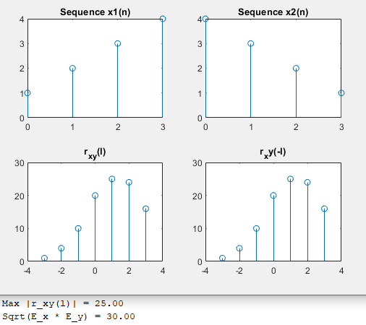**Exercise 4**

x1 = [1 2 3 4];

x2 = [4 3 2 1];

rxy = xcorr(x1, x2);

lags = -(length(x1)-1):(length(x1)-1);

subplot(2,2,1);

stem(0:length(x1)-1, x1);

title('Sequence x1(n)');

subplot(2,2,2);

stem(0:length(x2)-1, x2);

title('Sequence x2(n)');

subplot(2,2,3);

stem(lags, rxy);

title('r_{xy}(l)');

ryx = xcorr(x2, x1);

subplot(2,2,4);

stem(lags,fliplr(ryx));

title('r_xy(-l)');

Ex = sum(x1.^2);

Ey = sum(x2.^2);

rxx0 = sum(x1.^2);

ryy0 = sum(x2.^2);

max_rxy = max(abs(rxy));

bound = sqrt(rxx0 * ryy0);

fprintf('Max |r_xy(l)| = %.2f\n', max_rxy);

fprintf('Sqrt(E_x * E_y) = %.2f\n', bound);

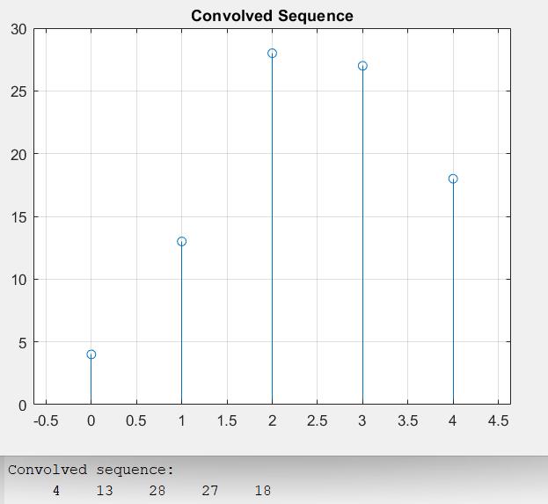

**Post Lab**

x = [1 2 3];

h = [4 5 6];

Lx = length(x);

Lh = length(h);

Ly = Lx + Lh - 1;

x_pad = [x, zeros(1, Ly - Lx)];

h_pad = [h, zeros(1, Ly - Lh)];

y = zeros(1, Ly);

for n = 1:Ly

for k = 1:n

y(n) = y(n) + x_pad(k) * h_pad(n - k + 1);

end

end

disp('Convolved sequence:');

disp(y);

stem(0:Ly-1, y);

title('Convolved Sequence');

grid on;