**Exercise 1**

fs = 44100;

N = 8;

f = [0 3000 4000 8000 12000 fs/2];

a = [0 0 1 1 0 0];

W = [1 1 1];

f_norm = f / (fs/2);

b = firls(N, f_norm, a, W);

fvtool(b, 1);

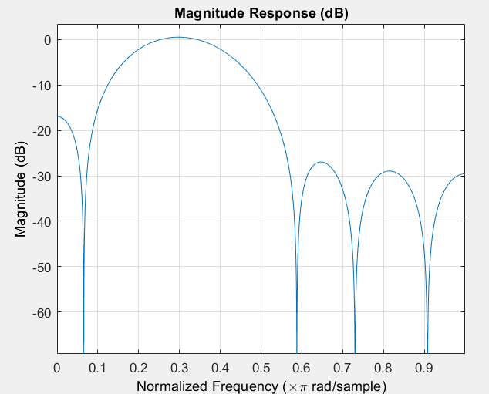title('FIR Bandpass Filter - Least Squares Design');

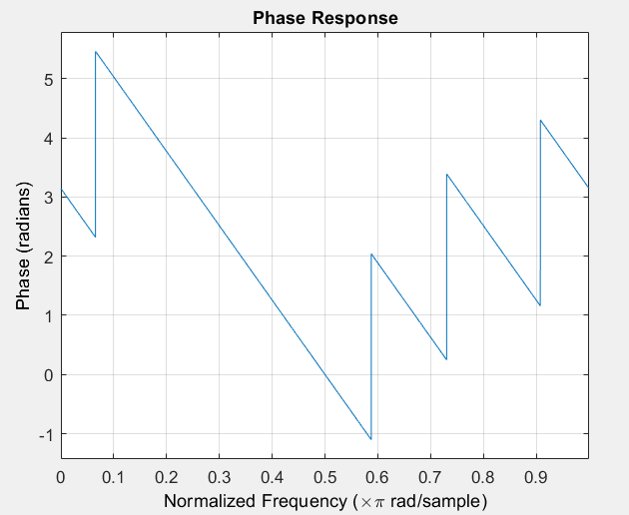

**Exercise 2(a)**

**Rectangular Window**

Fs = 32000;

Fc = 4000;

wc = 2*pi*Fc/Fs;

n = -20:20;

h = wc/pi * sinc(wc * n / pi);

x = cos(wc * n);

y = conv(x, h, 'same');

[H, w] = freqz(h, 1, 1024);

X = fftshift(fft(x, 1024));

Y = fftshift(fft(y, 1024));

w1=linspace(-pi, pi, 1024);

subplot(3,3,1); stem(n, h); title('Impulse Response h(n)');

subplot(3,3,2); plot(w/pi, abs(H)); title('|H(ω)|');

subplot(3,3,3); plot(w/pi, angle(H)); title('∠H(ω)');

subplot(3,3,4); stem(n, x); title('Input x(n)');

subplot(3,3,5); plot(w1, abs(X)); title('|X(ω)|');

subplot(3,3,6); plot(w1, angle(X)); title('∠X(ω)');

subplot(3,3,7); stem(n, y); title('Output y(n)');

subplot(3,3,8); plot(w1, abs(Y)); title('|Y(ω)|');

subplot(3,3,9); plot(w1, angle(Y)); title('∠Y(ω)');

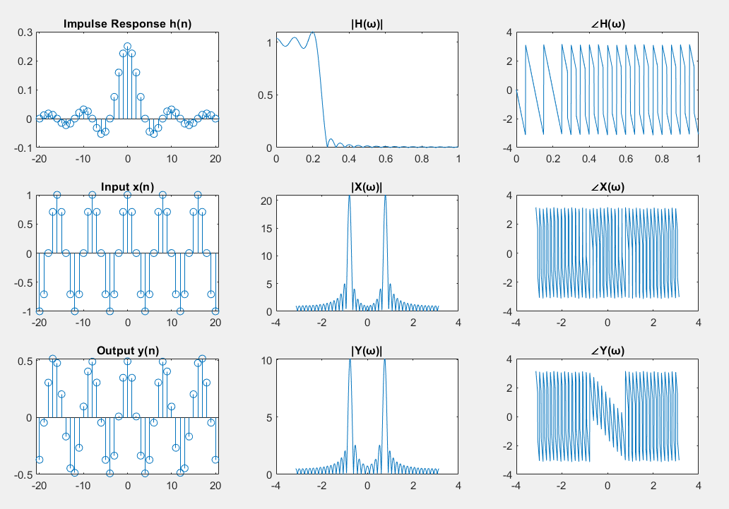

**Hanning Window**

Fs = 32000;

Fc = 4000;

wc = 2*pi*Fc/Fs;

n = -20:20;

L = length(n);

h_ideal = wc/pi * sinc(wc * n / pi);

w_hann = hann(L)';

h = h_ideal .* w_hann;

x = cos(wc * n);

y = conv(x, h, 'same');

[H, w] = freqz(h, 1, 1024);

X = fftshift(fft(x, 1024));

Y = fftshift(fft(y, 1024));

w1 = linspace(-pi, pi, 1024);

subplot(3,3,1); stem(n, h); title('Impulse Response h(n) with Hanning');

subplot(3,3,2); plot(w/pi, abs(H)); title('|H(ω)| with Hanning');

subplot(3,3,3); plot(w/pi, angle(H)); title('∠H(ω)');

subplot(3,3,4); stem(n, x); title('Input x(n)');

subplot(3,3,5); plot(w1, abs(X)); title('|X(ω)|');

subplot(3,3,6); plot(w1, angle(X)); title('∠X(ω)');

subplot(3,3,7); stem(n, y); title('Output y(n)');

subplot(3,3,8); plot(w1, abs(Y)); title('|Y(ω)|');

subplot(3,3,9); plot(w1, angle(Y)); title('∠Y(ω)');

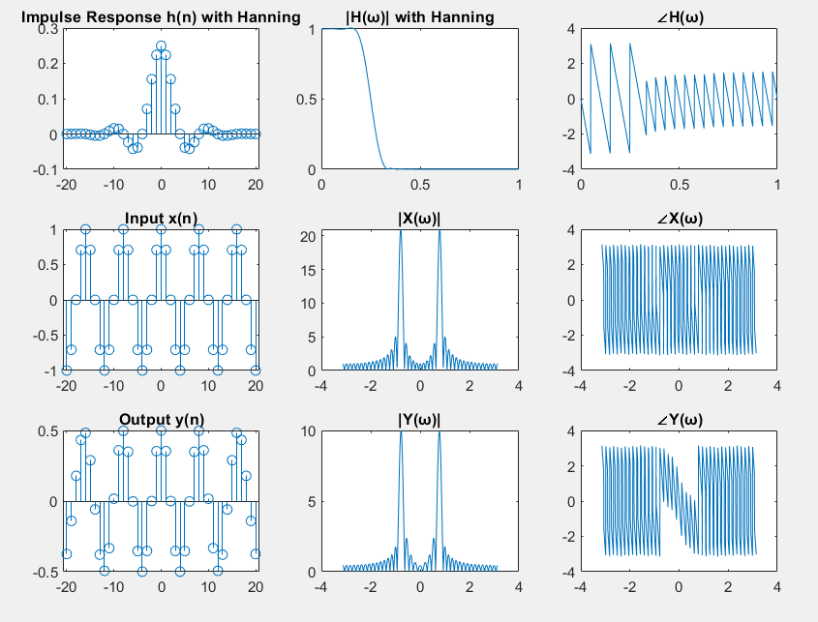

**Hamming Window**

Fs = 32000;

Fc = 4000;

wc = 2*pi*Fc/Fs;

n = -20:20;

L = length(n);

h_ideal = wc/pi * sinc(wc * n / pi);

w_hamming = hamming(L)';

h = h_ideal .* w_hamming;

x = cos(wc * n);

y = conv(x, h, 'same');

[H, w] = freqz(h, 1, 1024);

X = fftshift(fft(x, 1024));

Y = fftshift(fft(y, 1024));

w1 = linspace(-pi, pi, 1024);

subplot(3,3,1); stem(n, h); title('Impulse Response h(n) with Hamming');

subplot(3,3,2); plot(w/pi, abs(H)); title('|H(ω)| with Hamming');

subplot(3,3,3); plot(w/pi, angle(H)); title('∠H(ω)');

subplot(3,3,4); stem(n, x); title('Input x(n)');

subplot(3,3,5); plot(w1, abs(X)); title('|X(ω)|');

subplot(3,3,6); plot(w1, angle(X)); title('∠X(ω)');

subplot(3,3,7); stem(n, y); title('Output y(n)');

subplot(3,3,8); plot(w1, abs(Y)); title('|Y(ω)|');

subplot(3,3,9); plot(w1, angle(Y)); title('∠Y(ω)');

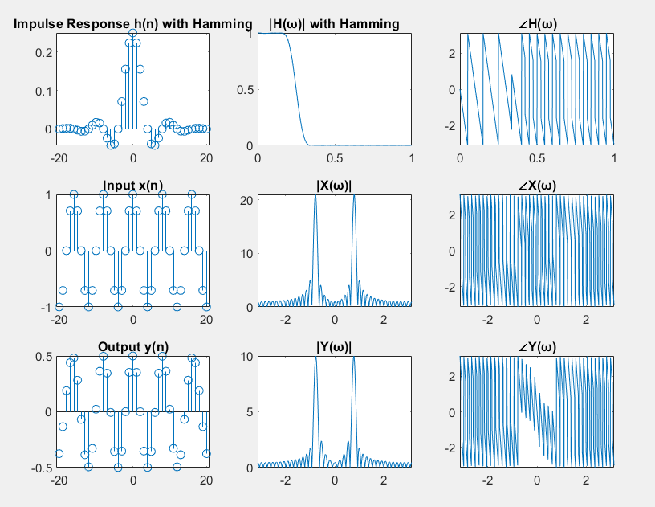

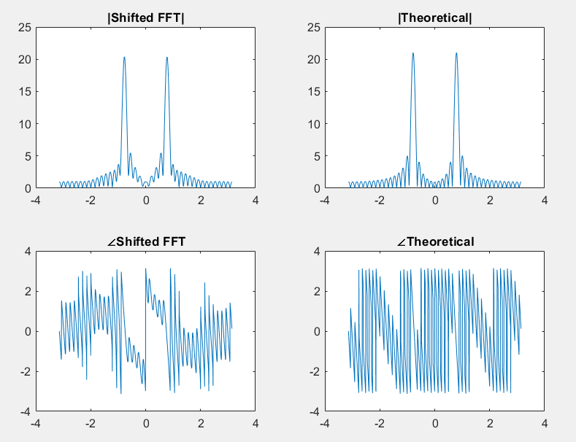**Exercise 2(b)**

d = 5;

x_shifted = circshift(x, [0, d]);

X_shifted = fftshift(fft(x_shifted, 1024));

w = linspace(-pi, pi, 1024);

X_theory = exp(-1j * w * d) .* fftshift(fft(x, 1024));

subplot(2,2,1);plot(w, abs(X_shifted));

title('|Shifted FFT|');

subplot(2,2,2);plot(w, abs(X_theory));

title('|Theoretical|');

subplot(2,2,3);plot(w, angle(X_shifted));

title('∠Shifted FFT');

subplot(2,2,4);plot(w, angle(X_theory));

title('∠Theoretical');

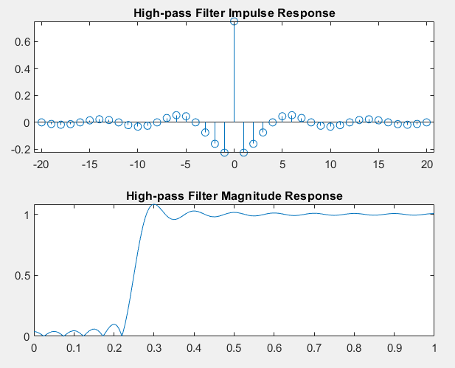**Exercise 2(c)**

h = wc/pi * sinc(wc * n / pi);

h_lp = h;

h_hp = -h_lp;

center_index = find(n==0);

h_hp(center_index) = 1 + h_hp(center_index);

[H_hp, w_hp] = freqz(h_hp, 1, 1024);

subplot(2,1,1); stem(n, h_hp);

title('High-pass Filter Impulse Response');

subplot(2,1,2); plot(w_hp/pi, abs(H_hp));

title('High-pass Filter Magnitude Response');