**Q1a**

Fs = 12000;

t = 0:1/Fs:0.01;

x1 = 3 * cos(2000 * pi * t);

x2 = 5 * sin(6000 * pi * t);

x3 = 10 * cos(12000 * pi * t);

x = x1 + x2 + x3;

subplot(4,2,1);

plot(t, x1)

title('x1(t) = 3cos(2000?t)');

subplot(4,2,2);

plot(t, x2);

title('x2(t) = 5sin(6000?t)');

subplot(4,2,3);

plot(t, x3);

title('x3(t) = 10cos(12000?t)');

subplot(4,2,4);

plot(t, x);

title('x(t) = x1(t) + x2(t) + x3(t)');

**Q1b**

Ts = 1/Fs;

n = 0:1:12;

t_n = n * Ts;

x1_n = 3 * cos(2000 * pi * t_n);

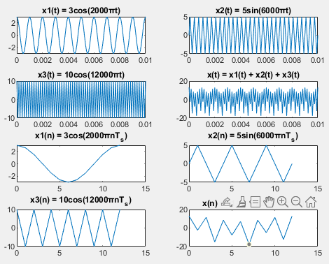x2_n = 5 * sin(6000 * pi * t_n);

x3_n = 10 * cos(12000 * pi * t_n);

x_n = x1_n + x2_n + x3_n;

subplot(4,2,5);

plot(n, x1_n);

title('x1(n) = 3cos(2000?nT_s)');

subplot(4,2,6);

plot(n, x2_n)

title('x2(n) = 5sin(6000?nT_s)');

subplot(4,2,7);

plot(n, x3_n)

title('x3(n) = 10cos(12000?nT_s)');

subplot(4,2,8);

plot(n, x_n)

title('x(n) = x1(n) + x2(n) + x3(n)');

**Q2a**

Dt = 0.01;

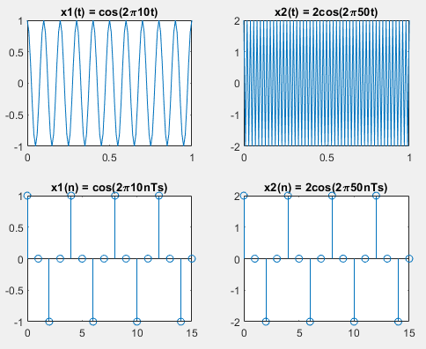t = 0:Dt:1;

x1t = cos(2*pi*10*t);

x2t = 2*cos(2*pi*50*t);

subplot(2,2,1);

plot(t,x1t);

title('x1(t) = cos(2\pi10t)');

subplot(2,2,2);

plot(t,x2t);

title('x2(t) = 2cos(2\pi50t)');

**b)**

Fs = 40;

n = 0:15;

Ts = 1/Fs;

x1n = cos(2*pi*10*n*Ts);

x2n = 2*cos(2*pi*50*n*Ts);

subplot(2,2,3);

stem(n,x1n);

title('x1(n) = cos(2\pi10nTs)');

subplot(2,2,4);

stem(n,x2n);

title('x2(n) = 2cos(2\pi50nTs)');

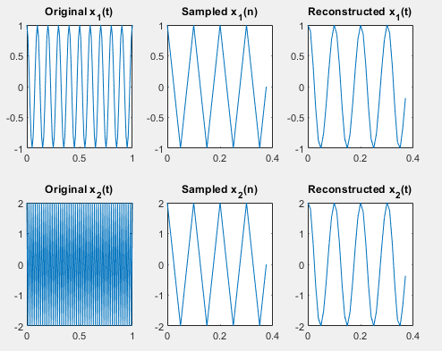**c)**

Dt = 0.01;

t = 0:Dt:1;

Fs = 40;

Ts = 1/Fs;

n = 0:15;

x1_t = cos(2*pi*10*t);

x2_t = 2*cos(2*pi*50*t);

x1_n = cos(2*pi*10*n*Ts);

x2_n = 2*cos(2*pi*50*n*Ts);

[t_recon, x1_recon] = reconst(x1_n, n, Fs, Dt);

[t_recon, x2_recon] = reconst(x2_n, n, Fs, Dt);

subplot(2,3,1);

plot(t, x1_t);

title('Original x_1(t)');

subplot(2,3,2);

plot (n*Ts, x1_n);

title('Sampled x_1(n)');

subplot(2,3,3);

plot(t_recon, x1_recon);

title('Reconstructed x_1(t)');

subplot(2,3,4);

plot(t, x2_t);

title('Original x_2(t)');

subplot(2,3,5);

plot (n*Ts, x2_n);

title('Sampled x_2(n)');

subplot(2,3,6);

plot(t_recon, x2_recon);

title('Reconstructed x_2(t)');

function [t, x] = reconst(xn, n, Fs, Dt)

Ts = 1 / Fs;

t = min(n) * Ts : Dt : max(n) * Ts;

nTs = n * Ts;

x = xn * sinc(Fs * (ones(length(n), 1) * t - nTs' * ones(1, length(t))));

end