**Exercise 1**

function y = DTFT(x, n, w)

y=zeros(1,length(w));

for k=1:length(w)

y(k)=sum(x.*exp(-1j*w(k)*n));

end

end

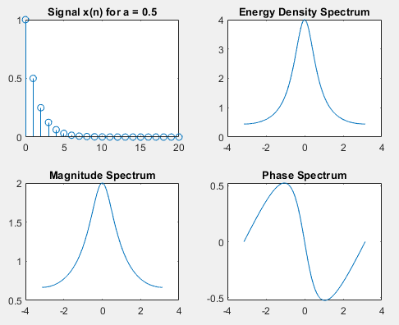**Exercise 2**

n = 0:20;

w = -pi:0.001*pi:pi;

a = 0.5;

x = a.^n;

X_w = DTFT(x, n, w);

Sxx = abs(X_w).^2;

figure;

subplot(2,2,1);

stem(n, x);title(['Signal x(n) for a = 0.5']);

subplot(2,2,2);

plot(w, Sxx);title('Energy Density Spectrum');

subplot(2,2,3);

plot(w, abs(X_w));title('Magnitude Spectrum');

subplot(2,2,4);

plot(w, angle(X_w));title('Phase Spectrum');

a = -0.5;

w = -pi:0.001:pi;

x = a.^n;

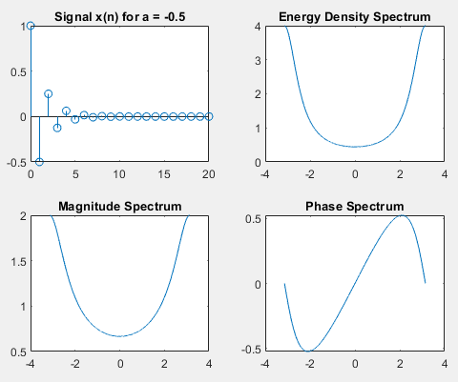X_w = DTFT(x, n, w);

Sxx = abs(X_w).^2;

figure;

subplot(2,2,1);

stem(n, x);title(['Signal x(n) for a = -0.5']);

subplot(2,2,2);

plot(w, Sxx);title('Energy Density Spectrum');

subplot(2,2,3);

plot(w, abs(X_w));title('Magnitude Spectrum');

subplot(2,2,4);

plot(w, angle(X_w));title('Phase Spectrum');

function y = DTFT(x, n, w)

y=zeros(1,length(w));

for k=1:length(w)

y(k)=sum(x.*exp(-1j*w(k)*n));

end

end

**Exercise 3**

f = 1/8;

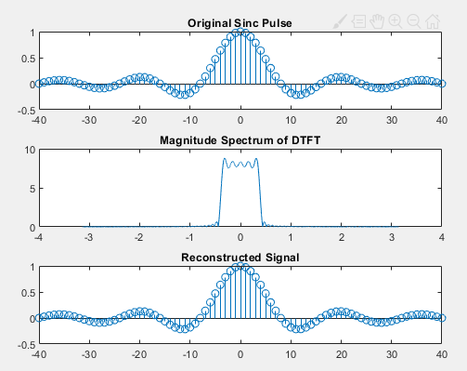n = -40:40;

x = sinc(f * n);

w = -pi:0.001/pi:pi;

X_w = DTFT(x, n, w);

dw = 0.001 / pi;

x_recon=zeros(size(n));

for i=1:length(n)

x_recon(i)=(1/(2*pi))*sum(X_w.*exp(1j*w*n(i))*dw);

end

figure;

subplot(3,1,1);

stem(n, x);title('Original Sinc Pulse');

subplot(3,1,2);

plot(w, abs(X_w));title('Magnitude Spectrum of DTFT');

subplot(3,1,3);

stem(n, x_recon);title('Reconstructed Signal');

function y = DTFT(x, n, w)

y=zeros(1,length(w));

for k=1:length(w)

y(k)=sum(x.*exp(-1j*w(k)*n));

end

end

**Exercise 4**

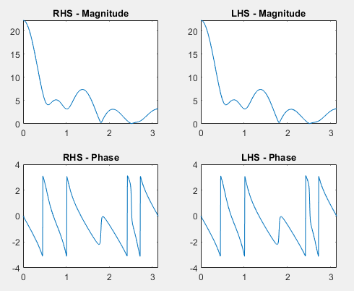

n = 0:10;

w = (0:500) * pi / 500;

a = 3;

b = 2;

x1 = rand(1, length(n));

x2 = rand(1, length(n));

X1_w = DTFT(x1, n, w);

X2_w = DTFT(x2, n, w);

X_sum_w = a * X1_w + b * X2_w;

x_sum = a * x1 + b * x2;

X_combined_w = DTFT(x_sum, n, w);

figure;

subplot(2,2,1);

plot(w, abs(X_sum_w));

title('RHS - Magnitude');

subplot(2,2,2);

plot(w, abs(X_combined_w));

title('LHS - Magnitude');

subplot(2,2,3);

plot(w, angle(X_sum_w));

title('RHS - Phase');

subplot(2,2,4);

plot(w, angle(X_combined_w));

title('LHS - Phase');

function y = DTFT(x, n, w)

y=zeros(1,length(w));

for k=1:length(w)

y(k)=sum(x.*exp(-1j*w(k)*n));

end

end

**Exercise 5**

n = -1:1;

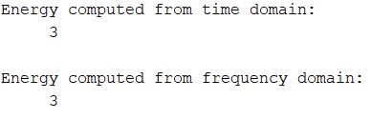x = [1 1 1];

w = 0:pi/100:2*pi;

E_time = sum(abs(x).^2);

X_w = DTFT(x, n, w);

X_w_mag2 = abs(X_w).^2;

E_freq = (1 / (2 * pi)) * trapz(w, X_w_mag2);

disp('Energy computed from time domain: ');

disp(E_time);

disp('Energy computed from frequency domain:');

disp(E_freq);

function y = DTFT(x, n, w)

y=zeros(1,length(w));

for k=1:length(w)

y(k)=sum(x.*exp(-1j*w(k)*n));

end

end

**Exercise 6**

n = -3:3;

x = [0 0 1 1 0 0 0];

n_shifted = n + 4;

x_shifted = x;

w = -pi:0.001/pi:pi;

X_w = DTFT(x, n, w);

X_shifted_w = X_w .* exp(-1j * w * 4);

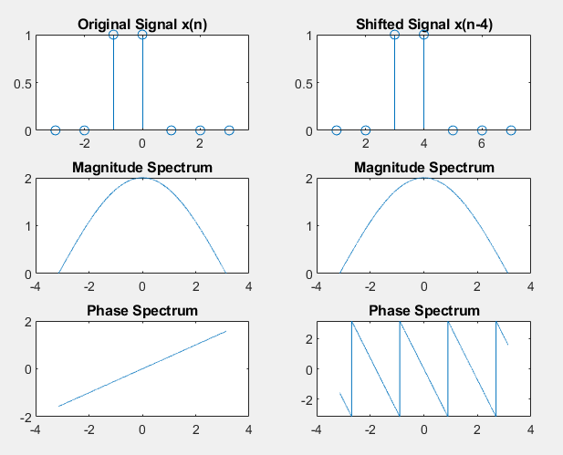

figure;

subplot(3,2,1);

stem(n, x);

title('Original Signal x(n)');

subplot(3,2,2);

stem(n_shifted, x_shifted);

title('Shifted Signal x(n-4)');

subplot(3,2,3);

plot(w, abs(X_w));

title('Magnitude Spectrum');

subplot(3,2,4);

plot(w, abs(X_shifted_w));

title('Magnitude Spectrum');

subplot(3,2,5);

plot(w, angle(X_w));

title('Phase Spectrum');

subplot(3,2,6);

plot(w, angle(X_shifted_w));

title('Phase Spectrum');

function y = DTFT(x, n, w)

y=zeros(1,length(w));

for k=1:length(w)

y(k)=sum(x.*exp(-1j*w(k)*n));

end

end

**Post Lab**

x = [1/3, 1/3, 1/3];

n = [0 1 2];

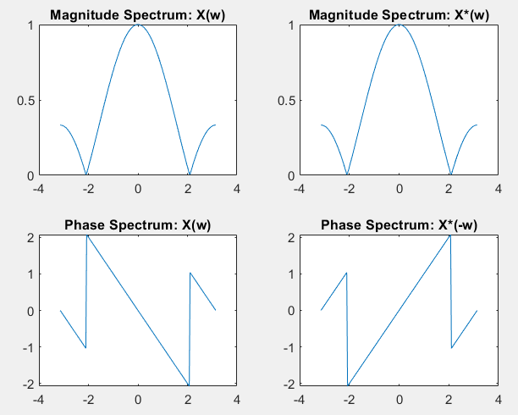w = -pi:pi/100:pi;

X_w = DTFT(x, n, w);

x_conjugate = conj(x);

X_w_conjugate = DTFT(x_conjugate, n, w);

X_w_neg = conj(X_w);

figure;

subplot(2,2,1);

plot(w, abs(X_w));

title('Magnitude Spectrum: X(w)');

subplot(2,2,2);

plot(-w, abs(X_w_conjugate));

title('Magnitude Spectrum: X*(w)');

subplot(2,2,3);

plot(w, angle(X_w));

title('Phase Spectrum: X(w)');

subplot(2,2,4);

plot(-w, angle(X_w_conjugate));

title('Phase Spectrum: X*(-w)');

function y = DTFT(x, n, w)

y=zeros(1,length(w));

for k=1:length(w)

y(k)=sum(x.*exp(-1j*w(k)*n));

end

end