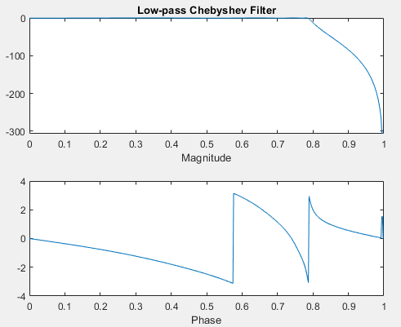**Q1(A)**

% Low-pass Chebyshev Filter

wp = 0.125*2*pi;

ws = 0.1375*2*pi;

Rp = 0.5;

As = 20;

n = 8;

[b, a] = cheby1(n, Rp, wp, 'low');

[H, w] = freqz(b, a);

subplot(2,1,1);

plot(w/pi, 20*log10(abs(H)));

title('Low-pass Chebyshev Filter');

xlabel('Magnitude');

subplot(2,1,2);

plot(w/pi, angle(H));

xlabel('Phase');

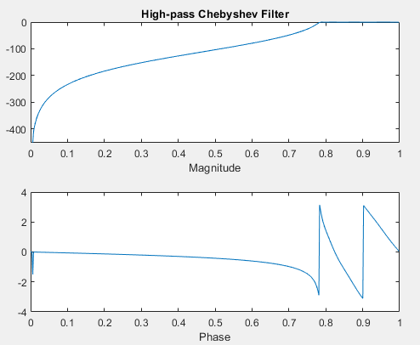**Q1(B)**

% High-pass Chebyshev Filter

wp = 0.125*2*pi;

ws = 0.1375*2*pi;

Rp = 0.5;

As = 20;

n = 8;

[b, a] = cheby1(n, Rp, wp, 'high');

[H, w] = freqz(b, a);

subplot(2,1,1);

plot(w/pi, 20*log10(abs(H)));

title('High-pass Chebyshev Filter');

xlabel('Magnitude');

subplot(2,1,2);

plot(w/pi, angle(H));

xlabel('Phase');

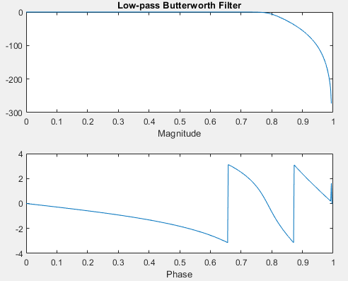**Q2(A)**

% Low-pass Butterworth Filter

wp = 0.125*2*pi;

ws = 0.1375*2*pi;

Rp = 0.5;

As = 20;

n = 8;

[b, a] = butter(n, wp, 'low');

[H, w] = freqz(b, a);

subplot(2,1,1);

plot(w/pi, 20*log10(abs(H)));

title('Low-pass Butterworth Filter');

xlabel('Magnitude');

subplot(2,1,2);

plot(w/pi, angle(H));

xlabel('Phase');

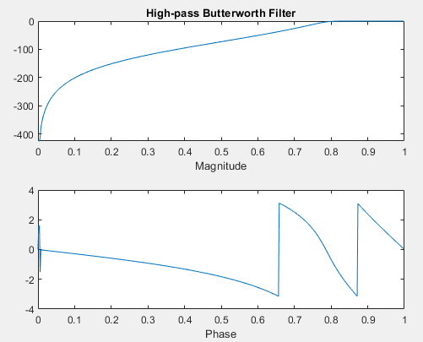**Q2(B)**

% High-pass Butterworth Filter

wp = 0.125*2*pi;

ws = 0.1375*2*pi;

Rp = 0.5;

As = 20;

n = 8;

[b, a] = butter(n, wp, 'high');

[H, w] = freqz(b, a);

subplot(2,1,1);

plot(w/pi, 20*log10(abs(H)));

title('High-pass Butterworth Filter');

xlabel('Magnitude');

subplot(2,1,2);

plot(w/pi, angle(H));

xlabel('Phase');

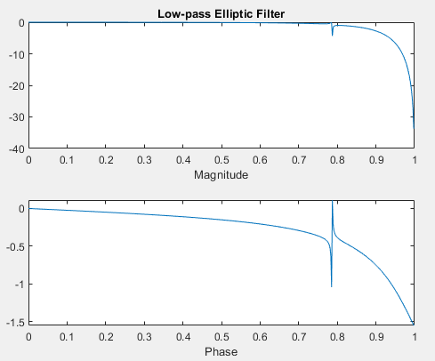**Q3(A)**

% Low-pass Elliptic Filter

wp = 0.125*2*pi;

ws = 0.1375*2*pi;

Rp = 0.5;

As = 20;

n = 5;

[b, a] = ellip(n, Rp,1.0, wp, 'low');

[H, w] = freqz(b, a);

subplot(2,1,1);

plot(w/pi, 20*log10(abs(H)));

title('Low-pass Elliptic Filter');

xlabel('Magnitude');

subplot(2,1,2);

plot(w/pi, angle(H));

xlabel('Phase');

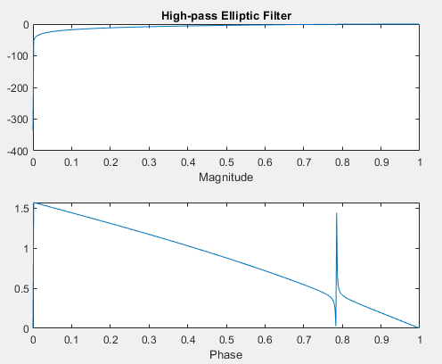**Q3(B)**

% High-pass Elliptic Filter

wp = 0.125*2*pi;

ws = 0.1375*2*pi;

Rp = 0.5;

As = 20;

n = 5;

[b, a] = ellip(n, Rp,1.0, wp, 'high');

[H, w] = freqz(b, a);

subplot(2,1,1);

plot(w/pi, 20*log10(abs(H)));

title('High-pass Elliptic Filter');

xlabel('Magnitude');

subplot(2,1,2);

plot(w/pi, angle(H));

xlabel('Phase');

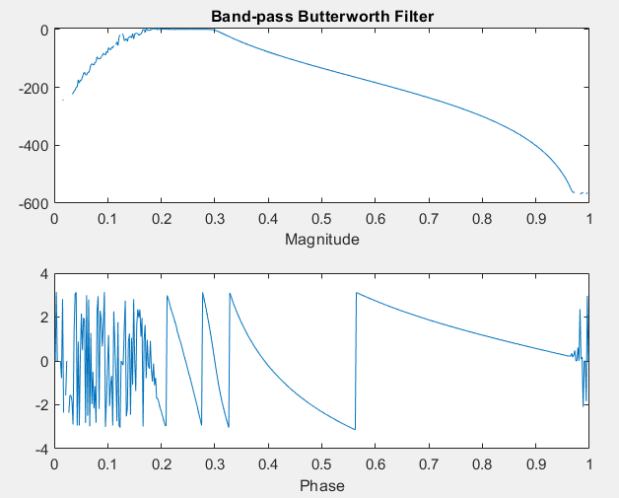**Post Lab**

% Band-pass Butterworth Filter

ws = 2000;

w1 = 100;

w2 = 300;

order = 32;

wn = [w1 w2] / (ws / 2);

[b, a] = butter(order/2, wn, 'bandpass');

[H, w] = freqz(b, a);

subplot(2,1,1);

plot(w/pi, 20*log10(abs(H)));

title('Band-pass Butterworth Filter');

xlabel('Magnitude');

subplot(2,1,2);

plot(w/pi, angle(H));

xlabel('Phase');