JKSSB COMPETITIVE EXAMINATION
Syllabus Section

ANATOMY & PHYSIOLOGY
COMPLETE EXAM NOTES

Cell • Tissues • Bones • Joints • Muscles
Blood • Heart • Circulation • Lymphatics
Respiration • Digestion • Liver • Nutrition
Endocrine • Urinary • Nervous System
Ear • Eye • Skin • Reproductive System

Complete, Topic-wise, Fact-dense Notes for Objective (MCQ) Papers
Based on the prescribed syllabus: Anatomy and Physiology

BEFORE YOU BEGIN
How to Use These Notes

These notes have been written for objective / MCQ based examinations. Every chapter of the prescribed syllabus section Anatomy and Physiology is covered in the same order as the syllabus, and each chapter is self-contained so that it can be revised independently.
The Structure of Every Chapter
▪ A coloured chapter banner with the chapter number, followed by a Chapter Outline strip that lists every section of that chapter — use it as a quick self-test checklist.
▪ Teal headings mark major sections, maroon headings mark topics, and blue italic headings mark sub-topics.
▪ Facts are written as short bullets, because examiners frame questions from single facts, not from long paragraphs.
▪ Tables are used for every classification, comparison and list of numbers — these are the highest yielding areas in anatomy and physiology papers.
The Coloured Boxes
Box | What it contains | How to use it
KEY POINTS | The one-line facts most often asked from that topic | Revise these the night before the exam
NORMAL VALUES | Numbers, counts, capacities, pressures, lengths, weights | Learn the number and its unit
MNEMONIC | Memory aids for lists and sequences | Say them aloud until automatic
EXAM FOCUS | Points repeatedly asked in previous papers | Never skip these
NOTE | Clarifications and common confusions | Read once, avoids negative marking
APPLIED / CLINICAL | Disease / applied links to the structure just studied | Frequently used as one-liners

A Suggested Revision Plan
1. First reading — read the whole chapter slowly, including the tables.
2. Second reading — read only the headings, bullets in bold, and all coloured boxes.
3. Third reading (revision) — read only the tables, the Normal Values boxes and the Key Points boxes.
4. Recall — cover the page, look at the Chapter Outline strip and try to reproduce the facts from memory.
HOW QUESTIONS ARE FRAMED
▪ Numbers: "Number of bones in the vertebral column of an adult is ____" — every count in this book is exam material.
▪ Names: largest / smallest / longest / strongest structure of a system.
▪ Functions: which hormone does what; which nerve supplies what; which vessel drains what.
▪ Matching: gland → hormone, vitamin → deficiency disease, cranial nerve → number.
▪ Sequence: path of blood, path of air, path of food, path of urine, path of a nerve impulse.

Spellings and Terminology
▪ Both the older and the current anatomical terms are given where examiners still use the older ones, e.g. Fallopian tube (uterine tube), Eustachian tube (pharyngotympanic tube).
▪ Weights, lengths and volumes are given in metric units; average adult values are used throughout.
▪ Where authorities differ slightly (for example the weight of the liver), the range accepted in standard nursing and paramedical textbooks is given.

CONTENTS
Table of Contents

CH. | TOPIC | PAGE
1 | Elementary Physics and Chemistry | 1
2 | Characteristics of Living Matter | 11
3 | The Structure of Living Matter — The Cell | 16
4 | The Tissues | 21
5 | Systems and Various Parts of the Human Body | 26
6 | Development and Types of Bones | 32
7 | Bones of Head and Trunk | 37
8 | Bones of the Limbs | 44
9 | Joints and Articulations | 50
10 | Structure and Action of Muscles | 56
11 | The Chief Muscles of the Body | 62
12 | The Blood | 70
13 | The Heart and Blood Vessels | 77
14 | The Circulatory System | 84
15 | The Lymphatic System | 90
16 | The Respiratory System | 96
17 | The Digestive System | 103
18 | The Liver, Biliary System and Pancreas | 112
19 | Nutrition and Metabolism | 118
20 | Endocrine Glands and Exocrine Glands | 125
21 | The Urinary System | 132
22 | The Nervous System | 139
23 | The Ear | 150
24 | The Eye | 155
25 | The Skin | 161
26 | The Reproductive System | 166

CHAPTER 1
Elementary Physics and Chemistry

CHAPTER OUTLINE
Matter, Energy and the Units of Measurement | Mechanics — Force, Gravity and Levers | Density, Pressure and the Behaviour of Liquids | Diffusion, Osmosis, Dialysis and Filtration | Heat | Sound, Light and Electricity | Elements, Atoms, Molecules and Compounds | Physical and Chemical Change | Acids, Bases, Salts, pH and Buffers | Water and the Gases of Respiration | The Organic Compounds of the Body

Anatomy is the study of the structure of the body; physiology is the study of its function. Both rest on the laws of physics and chemistry, because the human body is a physico-chemical machine: it obeys the laws of levers when it moves, the laws of pressure when it breathes, the laws of osmosis when its cells exchange water, and the laws of chemistry in every metabolic reaction. This chapter collects the elementary physics and chemistry that is examined as a part of Anatomy and Physiology.
TERMS YOU MUST NOT CONFUSE
▪ Anatomy – study of structure (Greek ana = apart, tome = cutting).
▪ Physiology – study of function of the living body.
▪ Histology – microscopic study of tissues.
▪ Cytology – study of cells.
▪ Embryology – study of development from fertilisation to birth.
▪ Pathology – study of disease / diseased structures.
▪ Biochemistry – chemistry of living processes.

Matter, Energy and the Units of Measurement
Matter
▪ Matter is anything that occupies space and has mass. It exists in three physical states — solid, liquid and gas (a fourth state, plasma, is ionised gas).
▪ Mass is the quantity of matter in a body; it is constant everywhere. Weight is the force with which gravity attracts that mass; weight changes with gravity, mass does not.
▪ Volume is the space occupied. Density = mass ÷ volume.
▪ Matter can be neither created nor destroyed — the Law of Conservation of Matter.
Energy
▪ Energy is the capacity to do work. It also cannot be created or destroyed, only converted from one form into another (Law of Conservation of Energy).
▪ Forms of energy important in the body: chemical (food, ATP), mechanical (muscle contraction), thermal (body heat), electrical (nerve impulse), radiant (light falling on the retina).
▪ Potential energy is stored energy (energy of position, e.g. food, a stretched muscle); kinetic energy is the energy of motion.
▪ In the body, the chemical energy of food is converted to mechanical work and heat. About 60% of the energy of food appears as heat.
Units of measurement commonly used in physiology
Quantity | SI / metric unit | Useful equivalents
Length | metre (m) | 1 m = 100 cm = 1000 mm; 1 micron (µm) = 1/1000 mm; 1 nanometre = 1/1000 µm; 1 Ångström = 1/10 nm
Mass | kilogram (kg) | 1 kg = 1000 g; 1 g = 1000 mg; 1 mg = 1000 µg
Volume | litre (L) | 1 L = 1000 mL; 1 mL = 1 cubic centimetre (cc)
Amount of substance | mole (mol) | 1 mol = molecular weight in grams; 1 mmol = 1/1000 mol
Temperature | kelvin (K); Celsius used clinically | 0 °C = 273 K; 37 °C = 98.4 °F
Pressure | pascal (Pa); mmHg clinically | 1 mmHg = 1 torr = 133 Pa; 760 mmHg = 1 atmosphere
Energy | joule (J); kilocalorie (kcal) dietetically | 1 kcal = 4.2 kJ (4184 J)
Force | newton (N) | 1 N accelerates 1 kg by 1 m/s²
Time | second (s) | —

TEMPERATURE CONVERSION
▪ °F = (°C × 9/5) + 32 and °C = (°F − 32) × 5/9
▪ Normal body temperature 36.9 °C ≈ 98.4 °F (range 36.1–37.2 °C).
▪ Freezing point of water 0 °C = 32 °F; boiling point 100 °C = 212 °F.
▪ 40 °C = 104 °F is the classical point where the two scales are easy to remember for fever charting.

Mechanics — Force, Gravity and Levers
▪ A force is anything that changes or tends to change the state of rest or motion of a body.
▪ Gravity is the force of attraction of the earth. The centre of gravity is the point at which the whole weight of a body may be considered to act. In an erect adult it lies just in front of the second sacral vertebra.
▪ A body is in stable equilibrium when a line dropped from its centre of gravity falls within its base; a wide base and a low centre of gravity give greater stability — the reason a nurse is taught to stand with the feet apart when lifting a patient.
▪ Friction opposes movement between two surfaces in contact. In the body it is reduced by synovial fluid in joints, serous fluid in the pleural, pericardial and peritoneal cavities and by mucus in the hollow tubes.
Levers
▪ A lever is a rigid bar that turns about a fixed point (the fulcrum) when a force (effort) is applied to move a weight (load). Bones act as levers, joints as fulcra and muscles supply the effort.
The three orders of lever with body examples
Order | Arrangement | Body example | Mechanical advantage
First order | Fulcrum lies between effort and weight (F in middle) | Nodding the head — the atlanto-occipital joint is the fulcrum, the weight of the face is the load, posterior neck muscles the effort | Balances; may gain force or speed
Second order | Weight lies between fulcrum and effort (W in middle) | Standing on tip-toe — the ball of the foot is the fulcrum, the body weight the load, the calf muscles the effort | Always gains force
Third order | Effort lies between fulcrum and weight (E in middle) | Flexing the elbow with a weight in the hand — the elbow is the fulcrum, biceps the effort, the hand-held weight the load | Gains speed and range, loses force; the commonest type in the body

ORDER OF THE LEVERS
"F-W-E — 1-2-3": whatever is in the middle names the order — Fulcrum in the middle = 1st order, Weight in the middle = 2nd order, Effort in the middle = 3rd order.

Density, Pressure and the Behaviour of Liquids
▪ Specific gravity (relative density) is the weight of a substance compared with an equal volume of water at 4 °C (water = 1.000). It has no units.
▪ Pressure = force ÷ area. Therefore the same force over a smaller area produces greater pressure — the principle behind pressure sores over bony prominences.
▪ Atmospheric pressure at sea level = 760 mmHg (101.3 kPa, 1 bar approx). It falls with altitude. Breathing, drinking through a straw, suction apparatus and the working of a syringe all depend on differences between atmospheric pressure and the pressure inside a cavity.
▪ Hydrostatic pressure is the pressure exerted by a liquid because of its weight; it increases with depth and is exerted equally in all directions at a given depth. Blood pressure in the feet of a standing person is higher than in the head for this reason.
▪ Pascal's law — pressure applied to an enclosed fluid is transmitted equally in all directions.
▪ Archimedes' principle — a body immersed in fluid loses weight equal to the weight of fluid it displaces; the basis of buoyancy and of exercise in water (hydrotherapy).
▪ A siphon carries liquid from a higher to a lower level through an inverted U-tube, the flow being maintained by atmospheric pressure and gravity. Gastric lavage, bladder washout and under-water seal chest drainage use the siphon principle.
▪ Capillarity is the rise of liquid in a narrow tube because of surface tension and adhesion — used by absorbent dressings, wicks and blotting paper.
▪ Surface tension makes a liquid surface behave like a stretched membrane; in the lungs it tends to collapse the alveoli and is reduced by surfactant.
▪ Viscosity is the internal friction or "stickiness" of a fluid. The viscosity of blood (about 5 times that of water) is a factor in peripheral resistance.
SPECIFIC GRAVITY — VALUES ASKED IN EXAMINATIONS
Fluid | Specific gravity
Water | 1.000
Whole blood | 1.055 – 1.060
Plasma | 1.026 – 1.031
Red blood cells | 1.090 – 1.095
Urine | 1.010 – 1.030 (average 1.020)
Cerebrospinal fluid | 1.005 – 1.008
Milk (cow) | 1.028 – 1.032

Diffusion, Osmosis, Dialysis and Filtration
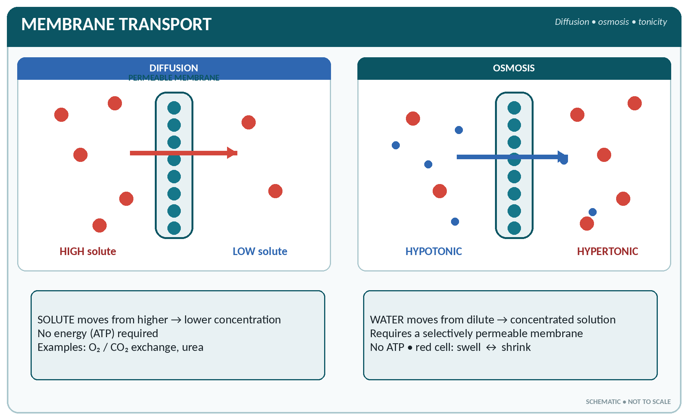
FIGURE • Diffusion moves solute down its concentration gradient; osmosis moves water across a selectively permeable membrane

These four processes move substances across the membranes of the body and are among the most frequently examined topics of elementary physics.
Comparison of the transport processes
Process | What moves | Direction | Requires | Body example
Diffusion | Molecules of solute or gas | From higher to lower concentration (down the gradient) | Concentration gradient only; no energy | O₂ and CO₂ exchange in the alveoli and tissues
Osmosis | Water (solvent) only | From weaker (hypotonic) to stronger (hypertonic) solution through a semi-permeable membrane | Semi-permeable membrane; no energy | Water movement between plasma, interstitial fluid and cells
Dialysis | Small crystalloid molecules, leaving colloids behind | Down the gradient through a selectively permeable membrane | Membrane permeable to crystalloids only | Haemodialysis; peritoneal dialysis
Filtration | Water plus small solutes | From higher to lower hydrostatic pressure | Pressure gradient | Formation of glomerular filtrate in the kidney
Active transport | Ions / molecules | Against the concentration gradient ("uphill") | Energy (ATP) and a carrier | Sodium–potassium pump; glucose and amino acid reabsorption in the renal tubule
Osmosis vs. filtration | Solvent vs. solution | Osmotic pressure vs. hydrostatic pressure | — | Both operate at the capillary wall (Starling forces)

▪ Osmotic pressure is the pressure that must be applied to prevent osmosis; it depends on the number of particles in solution, not on their size. Therefore crystalloids (sodium chloride, glucose) exert far more osmotic pressure than the larger but fewer protein molecules.
▪ Osmolarity = number of osmoles of solute per litre of solution. Plasma osmolarity is about 285–295 mOsm/L.
▪ Colloid osmotic (oncotic) pressure of plasma is about 25 mmHg and is due mainly to albumin — it holds water within the circulation. A fall in albumin causes oedema.
Types of solution in relation to body cells
Solution | Osmotic strength | Effect on a red cell | Example
Isotonic | Same as body fluid | No change — cell keeps its shape | 0.9% sodium chloride (normal saline); 5% dextrose; Ringer's lactate
Hypotonic | Weaker than body fluid | Water enters, cell swells and bursts (haemolysis) | 0.45% saline; distilled water
Hypertonic | Stronger than body fluid | Water leaves, cell shrinks (crenation) | 3% saline; 20% mannitol; 25% dextrose

CRYSTALLOIDS AND COLLOIDS
▪ Crystalloids — substances that crystallise, form true solutions, pass through a membrane and diffuse readily (salt, glucose, urea).
▪ Colloids — large particles that do not crystallise, do not pass through a membrane and diffuse poorly (proteins, gum, starch, gelatin). Protoplasm is a colloid. A colloid consists of a dispersed phase in a dispersion medium; a semi-solid colloid is a gel, a fluid colloid a sol.
▪ Brownian movement is the constant random dancing movement of colloidal particles.
▪ Adsorption is the holding of a substance on a surface — the principle of charcoal dressings.

Heat
▪ Heat is a form of energy; temperature is the degree of hotness measured on a scale.
▪ Heat travels in three ways:
– Conduction — through a substance, particle to particle, without movement of the substance (heat lost from the skin to clothing or to a cold bedpan).
– Convection — by actual movement of the heated fluid or air, the warm lighter part rising (circulating air in a ward; blood carrying heat from the core to the skin).
– Radiation — as invisible rays through space, needing no medium (heat lost from the naked skin to cold walls; an electric radiant heater).
▪ Evaporation absorbs heat and cools the surface — sweating and the insensible loss of water from skin and lungs. Evaporation of 1 litre of sweat removes about 580 kcal.
▪ Latent heat is the heat absorbed or given out when a substance changes state without a change in temperature (latent heat of fusion — ice to water; latent heat of vaporisation — water to steam). This is why moist heat (steam) sterilises better than dry heat and why steam scalds are severe.
▪ Specific heat is the heat needed to raise the temperature of 1 g of a substance by 1 °C. Water has a very high specific heat (1.0), so body water resists sudden temperature change.
▪ Humidity is the water vapour in air. Relative humidity is the amount present expressed as a percentage of the amount the air could hold at that temperature. High humidity prevents evaporation and so causes discomfort in hot weather.
HEAT LOSS FROM THE BODY
Approximate proportions of heat lost by a resting person: radiation ≈ 60%, evaporation ≈ 22%, conduction and convection ≈ 15%, and a small amount in expired air, urine and faeces (≈ 3%).

Sound, Light and Electricity
Sound
▪ Sound is produced by vibration and travels as longitudinal waves, requiring a material medium (it cannot travel through a vacuum).
▪ Speed of sound in air ≈ 330–340 m/s; it travels faster through liquids and solids.
▪ Frequency is measured in hertz (Hz); the audible range of the human ear is 20 Hz to 20 000 Hz. Above this is ultrasound (used for imaging and nebulisation).
▪ Pitch depends on frequency, loudness (intensity) on amplitude and is measured in decibels (dB). Normal conversation ≈ 60 dB; sounds above 85–90 dB on prolonged exposure damage hearing.
▪ Resonance amplifies sound — the basis of the chest resonating on percussion and of the stethoscope.
Light
▪ Light is a form of radiant energy travelling in straight lines as transverse waves at 3 × 10⁸ m/s (300 000 km/s); it needs no medium.
▪ Reflection — light bouncing off a surface. Refraction — bending of light when it passes obliquely from one medium into another of different density. The eye refracts light at the cornea, aqueous humour, lens and vitreous body.
▪ A convex (converging) lens brings rays together and corrects hypermetropia (long sight); a concave (diverging) lens spreads rays and corrects myopia (short sight); a cylindrical lens corrects astigmatism.
▪ The power of a lens is measured in dioptres (D) — the reciprocal of its focal length in metres.
▪ White light is split by a prism into the spectrum: red, orange, yellow, green, blue, indigo, violet (VIBGYOR in reverse). Beyond red lies infra-red (heat rays), beyond violet ultra-violet (produces vitamin D in skin, and is bactericidal — used in UV lamps).
▪ X-rays are very short electromagnetic rays that penetrate tissue and affect a photographic plate; they are produced in a vacuum tube and are used for diagnosis and therapy. They are ionising.
Electricity
▪ An electric current is a flow of electrons. Current is measured in amperes, potential difference (voltage) in volts, and resistance in ohms.
▪ Ohm's law: Current = Voltage ÷ Resistance (I = V/R).
▪ Substances that carry current are conductors (metals, salt solutions, body fluids); those that do not are insulators (rubber, glass, dry wood, porcelain).
▪ Earthing carries stray current safely to the ground and protects the patient and the nurse.
▪ Electrolytes conduct electricity because they dissociate into ions: positively charged cations travel to the cathode, negatively charged anions to the anode.
▪ Bio-electric currents produced by the body are recorded as the ECG (heart), EEG (brain) and EMG (muscle).
Elements, Atoms, Molecules and Compounds
▪ An element is a substance that cannot be split into anything simpler by chemical means; there are about 105–118 known elements, of which around 24–26 are found in the human body.
▪ An atom is the smallest particle of an element that can take part in a chemical reaction. It has a central nucleus containing protons (positive) and neutrons (neutral), with electrons (negative) revolving in shells around it.
▪ Atomic number = number of protons. Atomic weight (mass number) = protons + neutrons.
▪ Isotopes are atoms of the same element with the same atomic number but different atomic weights. Radioactive isotopes (radio-isotopes) emit rays and are used in diagnosis and treatment, e.g. iodine-131 for the thyroid.
▪ A molecule is the smallest particle of a substance (element or compound) that can exist independently.
▪ A compound is formed when two or more elements combine chemically in fixed proportions; its properties differ from those of its elements (water from hydrogen and oxygen).
▪ A mixture contains two or more substances merely mixed, in any proportion, each keeping its own properties and separable by physical means (air, blood plasma with its cells, a powder).
Elements of the human body
Group | Elements | Remarks
Major (about 96% of body weight) | Oxygen (65%), Carbon (18%), Hydrogen (10%), Nitrogen (3%) | Oxygen is the most abundant element in the body
Next in quantity | Calcium (1.5–2%), Phosphorus (1%), Potassium, Sulphur, Sodium, Chlorine, Magnesium | Calcium is the most abundant mineral — 99% of it in bone and teeth
Trace elements | Iron, Iodine, Copper, Zinc, Manganese, Cobalt, Fluorine, Chromium, Selenium, Molybdenum | Needed in minute amounts, mostly for enzymes and hormones

MOST ABUNDANT — QUICK RECALL
▪ Most abundant element in the body: oxygen.
▪ Most abundant compound / substance in the body: water (about 60–70% of body weight).
▪ Most abundant mineral: calcium. Most abundant intracellular cation: potassium.
▪ Most abundant extracellular cation: sodium; most abundant extracellular anion: chloride.
▪ Most abundant plasma protein: albumin. Most abundant protein in the body: collagen.
▪ Most abundant cell in blood: red blood cell. Most abundant gas in air: nitrogen (78%).

Chemical Bonds and Reactions
▪ Ionic (electrovalent) bond — formed by transfer of electrons, e.g. sodium chloride; such compounds dissociate into ions in water.
▪ Covalent bond — formed by sharing of electrons, e.g. water, methane; these are the bonds of most organic molecules.
▪ Hydrogen bond — a weak bond that holds water molecules together and maintains the shape of proteins and DNA.
▪ Types of reaction: synthesis (anabolism), decomposition (catabolism), exchange, and reversible reactions.
▪ A catalyst alters the speed of a reaction without itself being changed. The catalysts of the living body are the enzymes.
▪ Oxidation is the addition of oxygen or the loss of electrons/hydrogen; reduction is the reverse. Both occur together (redox reaction). Tissue oxidation liberates the energy of food.
▪ Hydrolysis is the splitting of a large molecule by the addition of water — the chemical basis of digestion. Condensation is the reverse, with the removal of water.
Physical and Chemical Change
Physical versus chemical change
Feature | Physical change | Chemical change
Nature of substance | Unchanged | A new substance is formed
Reversibility | Usually easily reversible | Usually not easily reversible
Composition | No change in molecular composition | Molecular composition changes
Energy | Little energy change | Marked absorption or release of energy
Examples | Melting of ice, boiling of water, dissolving salt, magnetising iron | Burning of coal, rusting of iron, digestion of food, tissue respiration, curdling of milk

Acids, Bases, Salts, pH and Buffers
▪ An acid is a substance that gives up hydrogen ions (H⁺), i.e. a proton donor; it turns blue litmus red and has a sour taste.
▪ A base (alkali) accepts hydrogen ions (or gives OH⁻); it turns red litmus blue, feels soapy and neutralises acids.
▪ A salt is formed when an acid reacts with a base — acid + base → salt + water (neutralisation).
▪ pH is the negative logarithm of the hydrogen ion concentration. The scale runs from 0 to 14:
– pH 7 = neutral; below 7 = acid; above 7 = alkaline.
– Each unit change means a tenfold change in H⁺ concentration.
▪ Buffers are substances that resist a change in pH. The chief buffers of the body are the bicarbonate system, phosphate system, plasma proteins and haemoglobin.
▪ The pH of blood is kept within extremely narrow limits by (1) the buffers, (2) the lungs (removing CO₂ — rapid) and (3) the kidneys (excreting H⁺ and conserving bicarbonate — slow but complete).
PH OF BODY FLUIDS
Fluid | pH
Arterial blood | 7.35 – 7.45 (average 7.4)
Venous blood | 7.32 – 7.38
Gastric juice | 1.0 – 3.5 (highly acid)
Saliva | 6.0 – 7.4
Bile | 7.6 – 8.6 (alkaline)
Pancreatic juice | 7.5 – 8.8 (most alkaline digestive juice)
Small intestinal contents | 7.5 – 8.0
Urine | 4.5 – 8.0 (average about 6.0, usually acid)
Cerebrospinal fluid | 7.3 – 7.4
Semen | 7.2 – 7.8
Vaginal secretion | 3.8 – 4.5 (acid — protective)
Sweat | 4.5 – 6.5
Tears | 7.4

ACID–BASE DISTURBANCES
▪ Acidosis — blood pH below 7.35. Respiratory (CO₂ retention, e.g. chronic lung disease); metabolic (diabetic ketosis, diarrhoea, renal failure).
▪ Alkalosis — blood pH above 7.45. Respiratory (hyperventilation, washing out CO₂); metabolic (persistent vomiting, excess alkali therapy).
▪ pH below 6.8 or above 7.8 is incompatible with life.

Water and the Gases of Respiration
▪ Water (H₂O) is the most abundant substance in the body — about 60% of adult body weight (higher, up to 75%, in the infant; lower in the aged and in the obese). It is the universal solvent, the medium of all reactions, the transport vehicle, and a regulator of temperature.
▪ Of total body water, roughly two-thirds is intracellular and one-third extracellular; the extracellular part is divided into interstitial fluid and plasma (plasma ≈ 5% of body weight).
▪ Hard water contains calcium and magnesium salts; it wastes soap. Water is purified by filtration, boiling and chlorination; distilled water contains no dissolved salts.
Composition of atmospheric, alveolar and expired air (approximate percentages)
Gas | Inspired (atmospheric) air | Alveolar air | Expired air
Oxygen | 20.9 – 21% | 13.5 – 14% | 16%
Carbon dioxide | 0.04% | 5.5 – 6% | 4%
Nitrogen (with inert gases) | 78 – 79% | 80% | 79%
Water vapour | Variable | Saturated | Saturated

▪ Oxygen — colourless, odourless, supports combustion, essential for tissue oxidation.
▪ Carbon dioxide — heavier than air, does not burn, turns lime water milky; it is the chief chemical stimulus to the respiratory centre.
▪ Nitrogen — inert; it neither enters nor leaves the blood in significant amount at normal pressure, but dissolves in body fluids at high pressure (the cause of caisson disease / decompression sickness).
▪ Carbon monoxide — a colourless, odourless, highly poisonous gas which combines with haemoglobin about 200–250 times more readily than oxygen to form carboxyhaemoglobin.
▪ Gas laws asked in examinations: Boyle's law (at constant temperature, volume varies inversely with pressure — the basis of the mechanics of breathing); Charles' law (volume varies directly with absolute temperature); Dalton's law of partial pressures (each gas in a mixture exerts its own pressure — the basis of gas exchange); Henry's law (the amount of a gas dissolving in a liquid is proportional to its partial pressure).
The Organic Compounds of the Body
▪ Inorganic compounds contain no carbon-hydrogen chains: water, salts, acids, bases, and the gases.
▪ Organic compounds are carbon compounds: carbohydrates, fats (lipids), proteins, and the nucleic acids, together with vitamins and hormones.
The three main classes of organic foodstuff
Class | Elements present | Building block (unit) | End products of digestion | Energy value
Carbohydrates | C, H, O (H : O = 2 : 1) | Monosaccharide | Glucose, fructose, galactose | 4 kcal/g (17 kJ)
Fats (lipids) | C, H, O (little O) | Fatty acid + glycerol | Fatty acids and glycerol | 9 kcal/g (37–38 kJ)
Proteins | C, H, O, N (± S, P) | Amino acid | Amino acids | 4 kcal/g (17 kJ)

▪ Carbohydrates are classified as monosaccharides (glucose, fructose, galactose), disaccharides (sucrose = glucose + fructose; lactose = glucose + galactose; maltose = glucose + glucose) and polysaccharides (starch, glycogen, cellulose, dextrin).
▪ Lipids include neutral fats (triglycerides), phospholipids (lecithin — in cell membranes and nervous tissue), and sterols (cholesterol, from which bile salts, vitamin D and the steroid hormones are made).
▪ Proteins are built of about 20 amino acids joined by peptide bonds; those that the body cannot make are the essential (indispensable) amino acids. Proteins are simple (albumin, globulin, keratin, collagen), conjugated (haemoglobin, mucin, nucleoprotein) or derived (peptones, peptides).
▪ Nucleic acids — DNA (deoxyribonucleic acid) carries the genetic code in the nucleus; RNA (ribonucleic acid) carries out protein synthesis in the cytoplasm.
▪ Adenosine triphosphate (ATP) is the immediate energy currency of the cell; energy is released when its terminal phosphate bond is split (ATP → ADP + Pi).
Enzymes
▪ Enzymes are biological catalysts, protein in nature, produced by living cells.
▪ Properties: highly specific for their substrate; act best at an optimum pH and temperature (about 37 °C); destroyed (denatured) by heat above about 56–60 °C; needed only in minute amounts; many are secreted as inactive pro-enzymes (zymogens), e.g. pepsinogen → pepsin, trypsinogen → trypsin; many need a co-enzyme (often a vitamin derivative) or a mineral activator.
▪ Naming: most end in -ase, and are named from the substrate — amylase acts on starch, lipase on fat, protease on protein, lactase on lactose, maltase on maltose.
▪ Older names ending in -in are retained for some digestive enzymes: pepsin, trypsin, rennin, ptyalin, chymotrypsin, erepsin.
HIGH-YIELD ONE-LINERS FROM THIS CHAPTER
▪ Anatomy = structure; physiology = function; histology = tissues; cytology = cells.
▪ Centre of gravity of the erect body — in front of the second sacral vertebra.
▪ Most levers in the body are of the third order; tip-toe standing is second order; nodding the head is first order.
▪ Osmosis moves water only; dialysis separates crystalloids from colloids; filtration needs a pressure gradient; active transport needs ATP.
▪ Normal saline = 0.9% NaCl and is isotonic; distilled water is hypotonic and causes haemolysis.
▪ Plasma oncotic pressure ≈ 25 mmHg, due mainly to albumin.
▪ Atmospheric pressure = 760 mmHg; blood pH = 7.35–7.45; plasma osmolarity ≈ 290 mOsm/L.
▪ Fat yields 9 kcal/g; carbohydrate and protein 4 kcal/g each.
▪ Enzymes are proteins, are destroyed by heat, and are substrate specific.
▪ Radiation accounts for the largest single share of heat loss from the body.

CHAPTER 2
Characteristics of Living Matter

CHAPTER OUTLINE
Protoplasm — the Physical Basis of Life | The Characteristics (Vital Properties) of Living Matter | Conditions Necessary for Life | Living Matter Compared with Non-Living Matter | Levels of Organisation of the Body

Living matter is called protoplasm. Everything that lives — from a single bacterium to the human body — is made of protoplasm and shows a group of properties which non-living matter does not. These properties are the "characteristics of living matter", and they are the foundation of physiology.
Protoplasm — the Physical Basis of Life
▪ The term protoplasm was introduced by Purkinje (1839) and popularised by Hugo von Mohl; Thomas Huxley called it "the physical basis of life".
▪ Protoplasm is a grey, translucent, semi-fluid, viscid, granular colloidal material which is slightly alkaline in reaction.
▪ It is an aqueous colloid — a sol when fluid, a gel when semi-solid — capable of changing from one state to the other. It shows Brownian movement and is selectively permeable.
▪ Protoplasm of a cell consists of:
– Cytoplasm — protoplasm outside the nucleus.
– Nucleoplasm (karyoplasm) — protoplasm within the nucleus.
▪ Living protoplasm is destroyed (its proteins coagulated / denatured) by heat above about 45–50 °C, by strong acids and alkalis, by heavy metals, by electric current and by lack of oxygen.
Chemical composition of protoplasm (approximate)
Constituent | Percentage | Remarks
Water | 70 – 90% | The most abundant constituent; the medium for all reactions
Proteins | 10 – 15% | Structural material and all enzymes
Lipids | 2 – 3% | Membranes; stored energy
Carbohydrates | 1 – 2% | Chief immediate fuel (glucose, glycogen)
Inorganic salts | about 1% | Na, K, Ca, Mg, Cl, phosphate, bicarbonate, sulphate
Nucleic acids and others | small | DNA, RNA, ATP, vitamins, pigments, hormones, waste products

REMEMBER
▪ Living matter = protoplasm; the smallest independent unit of living matter = the cell.
▪ Protoplasm is alkaline, colloidal and irritable (it responds to stimuli).
▪ Water is the largest constituent; protein is the largest solid constituent.

The Characteristics (Vital Properties) of Living Matter
There are nine classical characteristics. Every one of them may be asked separately, so learn the name, the definition and one body example of each.
The characteristics of living matter at a glance
Characteristic | Meaning | Example in the human body
1. Respiration | Taking in oxygen and giving out carbon dioxide to liberate energy from food | External respiration in the lungs; internal (tissue) respiration in every cell
2. Nutrition (ingestion & assimilation) | Taking in food, digesting it and building it into protoplasm | Digestion in the alimentary canal; assimilation of amino acids into tissue protein
3. Growth | Increase in size and in the amount of protoplasm | Growth of a child; hypertrophy of exercised muscle
4. Excretion | Removal of the waste products of metabolism | CO₂ by the lungs, urea by the kidney, sweat by the skin
5. Movement | Change of position of the whole or of a part | Movement of limbs; ciliary movement; amoeboid movement of leucocytes
6. Irritability (sensitivity) | The power to respond to a stimulus | Nerve impulse; contraction of muscle; pupil narrowing in light
7. Reproduction | Producing new individuals or new cells of the same kind | Cell division (mitosis); the reproductive system
8. Adaptability | Adjusting to a change in surroundings | Acclimatisation to altitude; tanning of skin in sunlight; increased RBC count at high altitude
9. Death | All living matter finally ceases to function | —

THE NINE VITAL CHARACTERISTICS
"MR NIGER D" — Movement, Respiration, Nutrition, Irritability, Growth, Excretion, Reproduction, Death (plus Adaptability).

Respiration
▪ External respiration — exchange of gases between the lungs and the blood.
▪ Internal (tissue / cellular) respiration — the oxidation of foodstuffs within the cell, liberating energy, water and carbon dioxide.
▪ Aerobic respiration takes place with oxygen and yields much energy; anaerobic respiration takes place without oxygen, yields little energy and produces lactic acid (as in vigorous muscle work).
Nutrition, Assimilation and Metabolism
▪ Ingestion → digestion → absorption → assimilation → metabolism.
▪ Metabolism is the sum total of all chemical changes in the body. It has two phases:
– Anabolism — the constructive, building-up phase; small molecules are built into larger ones; energy is used. Predominates in childhood, pregnancy and convalescence.
– Catabolism — the destructive, breaking-down phase; large molecules are broken to smaller ones; energy is liberated. Predominates in starvation, fever and old age.
▪ Basal metabolism is the energy used at complete rest, in a warm room, 12–18 hours after a meal.
▪ When anabolism and catabolism are equal, the body is in a state of equilibrium (balance); when anabolism exceeds catabolism the body grows; the reverse causes wasting.
Growth
▪ Growth may be by an increase in the number of cells (hyperplasia) or by an increase in the size of cells (hypertrophy).
▪ Growth needs food, oxygen, warmth, hormones (growth hormone, thyroxine, insulin, sex hormones) and the removal of waste.
▪ Growth is most rapid in intrauterine life and infancy, again rapid at puberty, and ceases when the epiphyseal cartilages of the long bones ossify (about 18–25 years).
▪ Repair (regeneration) is a form of growth. Highly specialised cells such as neurones and cardiac muscle cells cannot be replaced; epithelium, bone and blood cells regenerate freely.
Irritability and the Response to a Stimulus
▪ A stimulus is any change in the environment capable of exciting living matter. Stimuli may be mechanical, thermal, chemical, electrical, osmotic or light.
▪ The response may be contraction (muscle), conduction of an impulse (nerve), secretion (gland) or movement (cilia).
▪ Living tissue must reach a threshold (minimal) stimulus before it responds; below this, no response occurs. Immediately after a response there is a brief refractory period during which the tissue cannot respond again.
Movement
▪ Types of movement shown by living matter:
– Amoeboid — by the throwing out of pseudopodia, as by neutrophils and macrophages.
– Ciliary — by the lashing of cilia, as in the respiratory tract and uterine tube.
– Muscular (contractile) — skeletal, smooth and cardiac muscle.
– Intracellular streaming — movement of cytoplasm and of granules within the cell.
Reproduction
▪ Cells reproduce by division: mitosis (somatic cells; 2 identical daughter cells with the full 46 chromosomes) and meiosis (germ cells only; 4 cells with 23 chromosomes each).
▪ Asexual reproduction produces identical offspring from one parent cell; sexual reproduction requires the fusion of male and female gametes (fertilisation).
Adaptability and Homeostasis
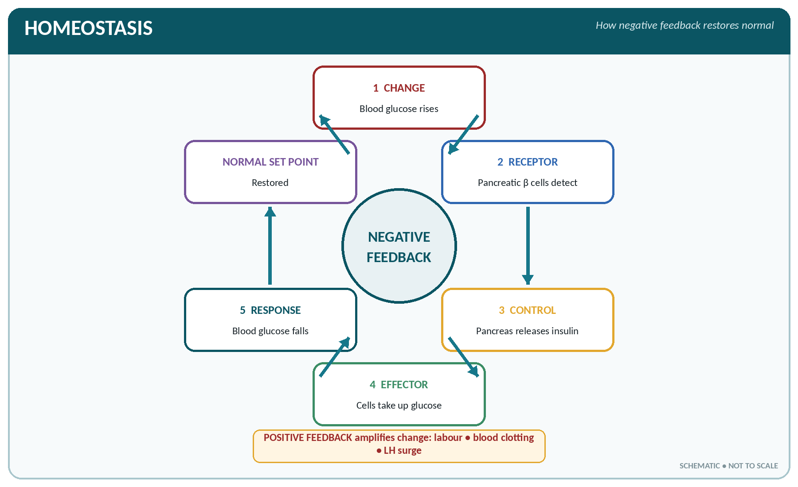
FIGURE • Negative feedback restores a variable to its normal set point; positive feedback amplifies the original change

▪ Homeostasis (term coined by Walter Cannon) is the maintenance of a constant internal environment in spite of changes outside the body. Claude Bernard described this internal environment as the milieu intérieur.
▪ The internal environment is essentially the extracellular (interstitial) fluid bathing the cells.
▪ Variables held constant include temperature, pH, osmotic pressure, blood glucose, blood gases, electrolytes, blood pressure and water content.
▪ Homeostasis works through feedback mechanisms:
– Negative feedback — the response reverses the original change; this is the usual and stabilising mechanism (a rise in blood glucose → insulin secretion → glucose falls; cooling of the body → shivering → temperature rises).
– Positive feedback — the response increases the original change; uncommon and self-amplifying (blood clotting; the action of oxytocin in labour; the LH surge before ovulation).
▪ The two great controlling systems of homeostasis are the nervous system (rapid, by impulses) and the endocrine system (slower, by hormones).
HOMEOSTASIS — FREQUENTLY ASKED
▪ Term "homeostasis" — Walter B. Cannon; "internal environment / milieu intérieur" — Claude Bernard.
▪ The commonest control mechanism in the body is negative feedback.
▪ Classic examples of positive feedback: blood coagulation, labour (oxytocin), the LH surge, and the depolarisation phase of the nerve action potential.
▪ Homeostatic organs most often named: lungs (CO₂, pH), kidney (water, electrolytes, pH), skin (temperature), liver (glucose, proteins), hypothalamus (thermostat, thirst, appetite).

Conditions Necessary for Life
For protoplasm to stay alive it requires:
1. Oxygen — for the oxidation of food; the brain cannot survive more than about 4–5 minutes without it.
2. Food (nutrients) — carbohydrate, fat, protein, mineral salts and vitamins.
3. Water — the medium of all reactions; loss of about 20% of body water is fatal.
4. A suitable temperature — about 37 °C; enzymes fail below 25 °C and are destroyed above 45 °C.
5. A suitable pressure — atmospheric pressure for gas exchange, blood pressure for perfusion.
6. Freedom from waste products and poisons — accumulation of CO₂, urea or drugs depresses protoplasm.
7. A suitable pH and osmotic pressure in the surrounding fluid.
Living Matter Compared with Non-Living Matter
Living versus non-living matter
Feature | Living matter | Non-living matter
Composition | Protoplasm — organised, contains protein and nucleic acid | Not organised into protoplasm
Metabolism | Present (anabolism and catabolism) | Absent
Growth | From within, by assimilation | From outside, by accretion (e.g. a crystal)
Respiration | Present | Absent
Irritability | Responds to stimuli | Does not respond in an organised way
Reproduction | Present | Absent
Repair | Can repair itself | Cannot
Movement | Spontaneous, self-initiated | Only when an external force acts
Life span | Definite; ends in death | Indefinite

Levels of Organisation of the Body
▪ The body is built up in an ascending series of levels; this sequence is a favourite examination question:
Chemical level (atoms → molecules) → Cell → Tissue → Organ → System → Organism
▪ Cell — the smallest living, functional and structural unit of the body (about 75 trillion cells in an adult; more than 200 different types).
▪ Tissue — a group of similar cells with a common function (epithelial, connective, muscular, nervous).
▪ Organ — two or more tissues acting together for a special function (heart, stomach, kidney).
▪ System — a group of organs performing a major function (digestive system, respiratory system).
▪ Organism — the complete individual.
CELL THEORY
▪ Proposed by Schleiden and Schwann (1838–39): all living things are made of cells and cell products.
▪ Rudolf Virchow (1855) added "omnis cellula e cellula" — every cell arises from a pre-existing cell. Robert Hooke (1665) first used the word "cell"; Leeuwenhoek first saw living cells.

CHAPTER 3
The Structure of Living Matter — The Cell

CHAPTER OUTLINE
Size, Shape and General Plan of the Cell | The Cell Membrane (Plasma Membrane) | The Cytoplasm and its Organelles | The Nucleus, Chromosomes and Genes | Cell Division | Fluids of the Body and the Cell's Environment

The cell is the smallest structural and functional unit of the body capable of independent existence. The human body contains about 75 trillion (7.5 × 10¹³) cells of more than 200 different types. All are built on the same plan: a cell membrane enclosing cytoplasm which contains organelles and a nucleus.
Size, Shape and General Plan of the Cell
▪ Size — most cells measure 10–30 micrometres (µm).
– Smallest cell in the body: the granule cell of the cerebellum / red cell (7.2 µm) is the commonest small cell quoted; the platelet (2–4 µm) is a cell fragment.
– Largest cell in the body: the ovum (about 120–150 µm, just visible to the naked eye).
– Longest cell in the body: a neurone (the axon of a motor nerve to the toe may exceed 1 metre).
– Largest cell in the animal kingdom: the ostrich egg.
▪ Shape is related to function — flat (squamous), cubical, columnar, spherical (ovum), biconcave (red cell), spindle (smooth muscle), star-shaped (neurone, osteocyte), cylindrical (skeletal muscle).
▪ Every cell has three main parts: cell (plasma) membrane, cytoplasm with organelles, and a nucleus (except the mature red blood cell and platelets, which have no nucleus).
The Cell Membrane (Plasma Membrane)
▪ Thickness about 7.5–10 nm; visible only with the electron microscope.
▪ Chemical composition: about 55–60% protein, 40% lipid (phospholipid and cholesterol) and 2–10% carbohydrate.
▪ Structure — the fluid mosaic model of Singer and Nicolson (1972): a bilayer of phospholipid (hydrophilic heads outward, hydrophobic tails inward) in which protein molecules float. Older description: the unit membrane / sandwich model of Danielli and Davson.
▪ Membrane proteins act as channels (pores), carriers (pumps), enzymes, receptors and identity markers (antigens).
▪ The membrane is selectively (differentially) permeable: freely permeable to water, O₂, CO₂ and fat-soluble substances; impermeable to large molecules such as protein.
▪ Surface modifications: microvilli (increase absorptive surface — intestine, renal tubule), cilia, flagellum (the tail of a spermatozoon), and junctions (tight junction, desmosome, gap junction).
Transport across the cell membrane
Mechanism | Energy needed | Against gradient? | Examples
Simple diffusion | No | No | O₂, CO₂, water, urea, fat-soluble vitamins, steroids
Facilitated diffusion | No (needs a carrier) | No | Glucose entry into most cells (with insulin), amino acids
Osmosis | No | No (water moves down its own gradient) | Water movement between plasma, interstitial fluid and cells
Filtration | No (uses hydrostatic pressure) | — | Glomerular filtration
Active transport | Yes (ATP) | Yes | Na⁺–K⁺ pump, Ca²⁺ pump, iodide trapping by thyroid, glucose and amino acid reabsorption in tubule
Endocytosis | Yes | — | Phagocytosis (cell eating — solid particles, by neutrophils and macrophages); pinocytosis (cell drinking — fluid droplets)
Exocytosis | Yes | — | Secretion of hormones, enzymes, neurotransmitters

THE SODIUM–POTASSIUM PUMP
▪ Pumps 3 Na⁺ out of the cell for every 2 K⁺ in, using ATP (enzyme Na⁺–K⁺ ATPase).
▪ Keeps Na⁺ high outside and K⁺ high inside the cell, maintains cell volume and creates the resting membrane potential (about −70 to −90 mV, inside negative).
▪ It accounts for a large part of the basal energy expenditure of the body and is inhibited by digoxin and by ouabain.

The Cytoplasm and its Organelles
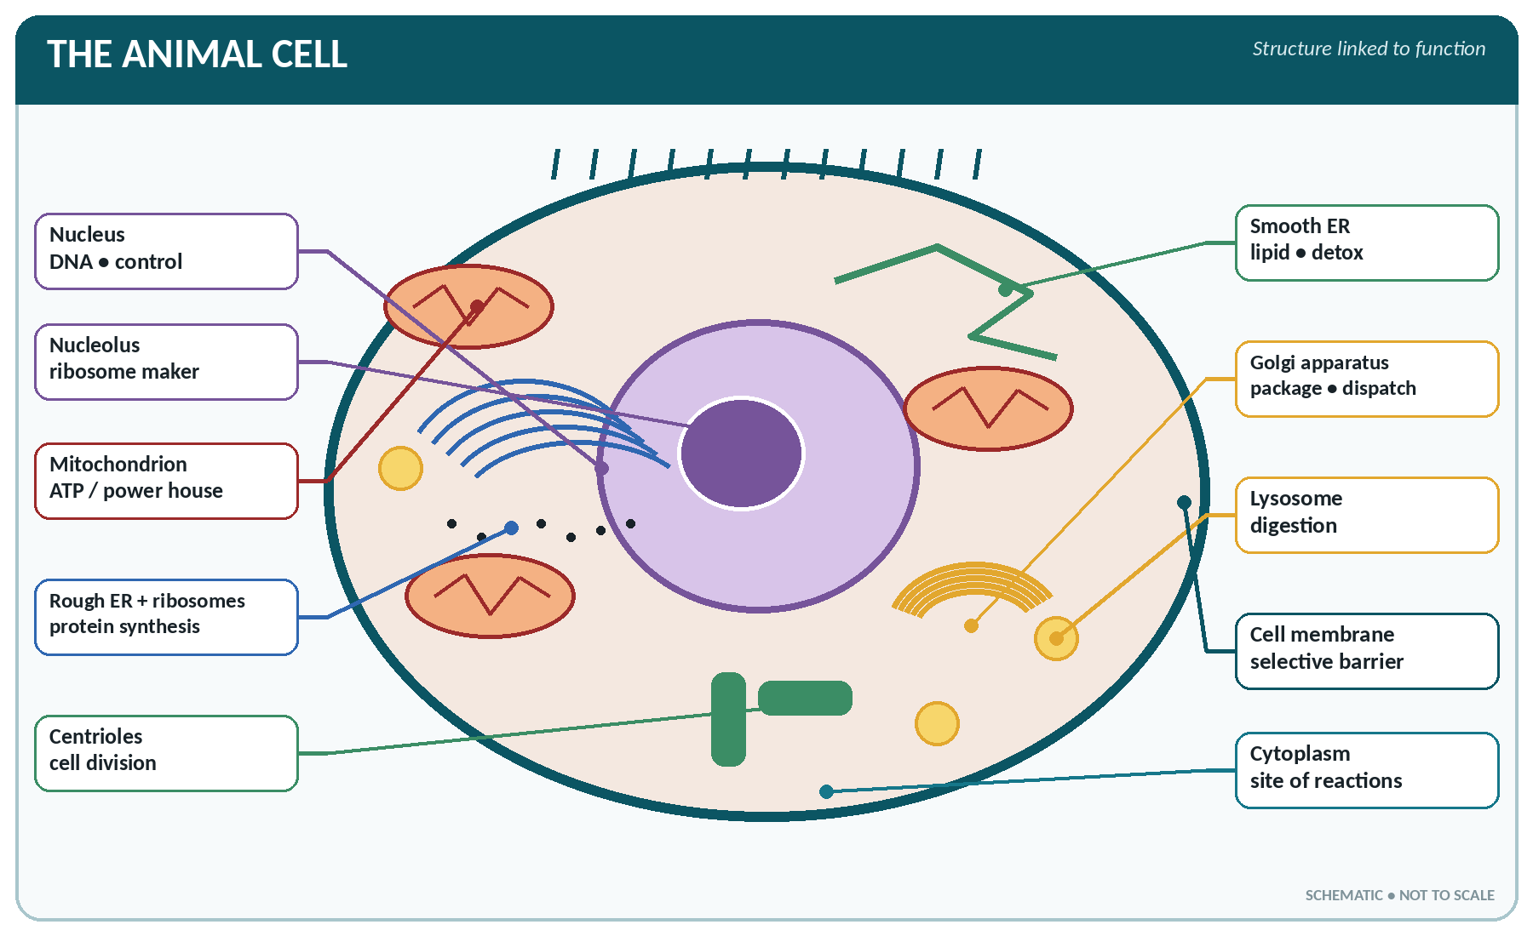
FIGURE • Labelled animal cell—learn every organelle together with its defining function

The cytoplasm consists of a fluid cytosol in which lie the organelles ("little organs") and inclusions.
The cell organelles — structure and function
Organelle | Structure | Function | Exam label
Nucleus | Largest organelle, bounded by a double nuclear membrane with nuclear pores; contains chromatin and one or more nucleoli | Controls all cell activity; contains DNA (the genetic material); nucleolus makes ribosomes / rRNA | "Control centre / brain of the cell"
Mitochondria | Rod-shaped, double-membraned; inner membrane folded into cristae; contain their own DNA and enzymes | Aerobic respiration — Krebs cycle, oxidative phosphorylation, ATP production | "Power house of the cell"
Ribosomes | Tiny granules of RNA + protein, free or on rough ER | Protein synthesis | "Protein factory"
Rough endoplasmic reticulum | Membranous channels studded with ribosomes | Synthesis and transport of protein; continuous with the nuclear membrane | —
Smooth endoplasmic reticulum | Membranous channels without ribosomes | Synthesis of lipid, cholesterol and steroids; detoxification; stores Ca²⁺ (as sarcoplasmic reticulum in muscle) | —
Golgi apparatus (Golgi body) | Stack of flattened membranous sacs near the nucleus | Packaging, modifying and storing secretions; forms secretory vesicles and lysosomes; adds carbohydrate to protein | "Packaging / despatching department"
Lysosomes | Membranous sacs of powerful hydrolytic (digestive) enzymes | Intracellular digestion; destruction of bacteria and worn-out organelles (autophagy); autolysis after death | "Suicide bags" (de Duve)
Peroxisomes | Small vesicles containing catalase and oxidases | Detoxification (alcohol), breakdown of hydrogen peroxide and fatty acids; abundant in liver and kidney | —
Centrosome / centrioles | Two rod-like centrioles at right angles | Form the spindle in cell division; form the basal body of cilia and flagella | Absent in mature neurones
Cytoskeleton | Microtubules, microfilaments (actin), intermediate filaments | Shape, support, intracellular transport, movement | —
Cilia and flagella | Hair-like projections with a 9 + 2 microtubule pattern | Cilia move mucus and ova; the single flagellum propels the sperm | —
Vacuoles / inclusions | Membrane-bound spaces; stored glycogen, fat, pigment | Storage | —

ORGANELLE ONE-LINERS
▪ Power house → mitochondrion. Suicide bag → lysosome. Packaging centre → Golgi.
▪ Protein factory → ribosome. Control centre → nucleus. Traffic / transport system → endoplasmic reticulum. Detoxifier → peroxisome and smooth ER.

The Nucleus, Chromosomes and Genes
▪ The nucleus contains chromatin — a complex of DNA + histone protein which condenses into chromosomes at cell division.
▪ Human somatic (body) cells contain 46 chromosomes = 23 pairs (the diploid number, 2n): 22 pairs of autosomes and 1 pair of sex chromosomes (XX in the female, XY in the male).
▪ Germ cells (ovum, spermatozoon) contain 23 chromosomes (the haploid number, n).
▪ A gene is the unit of inheritance — a segment of DNA that codes for one polypeptide. The human genome contains roughly 20 000–25 000 genes.
▪ DNA — a double helix (Watson and Crick, 1953) of two strands held by hydrogen bonds; the sugar is deoxyribose; the bases are adenine, guanine (purines) and thymine, cytosine (pyrimidines). Base pairing: A–T and G–C.
▪ RNA — usually single-stranded; sugar is ribose; uracil replaces thymine. Three types: mRNA (carries the code from nucleus to ribosome), tRNA (brings amino acids), rRNA (part of the ribosome).
▪ Protein synthesis: transcription (DNA → mRNA, in the nucleus) followed by translation (mRNA → protein, on the ribosome). A codon is a triplet of bases coding for one amino acid.
DNA compared with RNA
Feature | DNA | RNA
Strands | Double (helix) | Single (usually)
Sugar | Deoxyribose | Ribose
Bases | A, G, C, T | A, G, C, U
Site | Nucleus (also mitochondria) | Nucleus and cytoplasm
Function | Stores and transmits genetic information | Carries out protein synthesis

Cell Division
Mitosis
▪ Division of a somatic cell into two genetically identical daughter cells, each with 46 chromosomes.
▪ Interphase (not part of mitosis proper) has the phases G₁ → S (DNA replication) → G₂.
▪ The four stages of mitosis, in order:
1. Prophase — chromatin condenses into chromosomes, each with two chromatids; centrioles move apart; nuclear membrane and nucleolus disappear; spindle forms.
2. Metaphase — chromosomes line up at the equator of the cell, attached to the spindle by their centromeres.
3. Anaphase — centromeres split and the chromatids are pulled to opposite poles.
4. Telophase — chromosomes reach the poles, nuclear membrane re-forms, and the cytoplasm divides (cytokinesis).
▪ Mitosis takes about 1 hour; the whole cell cycle about 20–24 hours in a rapidly dividing tissue.
STAGES OF MITOSIS
"I P M A T" — Interphase, Prophase, Metaphase, Anaphase, Telophase. Chromosomes are best seen (and counted) in metaphase.

Meiosis (Reduction Division)
▪ Occurs only in the gonads, in the formation of gametes. There are two successive divisions (meiosis I and II) with only one replication of DNA, producing four haploid cells (23 chromosomes each).
▪ Crossing over of segments between homologous chromosomes occurs in prophase I, giving genetic variation.
▪ Spermatogenesis from one primary spermatocyte produces 4 spermatozoa; oogenesis from one primary oocyte produces 1 mature ovum + 3 polar bodies (which degenerate).
Mitosis versus meiosis
Feature | Mitosis | Meiosis
Site | All body (somatic) cells | Only germ cells in testis and ovary
Number of divisions | One | Two
Daughter cells | 2 | 4
Chromosome number | 46 (diploid) — unchanged | 23 (haploid) — halved
Genetic result | Identical to parent cell | Genetically different (crossing over)
Purpose | Growth and repair | Formation of gametes; maintains species number; variation

Fluids of the Body and the Cell's Environment
▪ Total body water ≈ 60% of body weight in an adult male (≈ 50–55% in the female, ≈ 70–75% in the newborn).
▪ Distribution: intracellular fluid ≈ 40% of body weight (two-thirds of body water) and extracellular fluid ≈ 20% (one-third), the latter made up of interstitial fluid (≈ 15%) and plasma (≈ 5%), with small transcellular volumes (CSF, synovial, pleural, aqueous humour).
Chief electrolytes inside and outside the cell
Electrolyte | Intracellular fluid | Extracellular fluid
Chief cation | Potassium (K⁺); also magnesium | Sodium (Na⁺)
Chief anion | Phosphate and protein | Chloride and bicarbonate
Protein content | High | Low (plasma more than interstitial fluid)

CELL — RAPID REVISION FACTS
▪ Cell theory — Schleiden and Schwann; "cell" first named by Robert Hooke.
▪ Fluid mosaic model — Singer and Nicolson; DNA double helix — Watson and Crick.
▪ Power house = mitochondrion; suicide bag = lysosome; packaging = Golgi.
▪ Cells without a nucleus: mature RBC and platelets. Cells that cannot divide: neurones, cardiac muscle, skeletal muscle fibres.
▪ Chromosome number 46 (23 pairs); female XX, male XY; sex of the child is determined by the father's sperm.
▪ Largest cell = ovum; longest cell = neurone; smallest blood cell = platelet.
▪ Resting membrane potential ≈ −70 mV; the Na⁺–K⁺ pump moves 3 Na⁺ out : 2 K⁺ in.
▪ ATP is produced mainly in the mitochondrion; each glucose molecule yields about 36–38 ATP aerobically but only 2 ATP anaerobically.

CHAPTER 4
The Tissues

CHAPTER OUTLINE
Epithelial Tissue | Connective Tissue | Muscular Tissue | Nervous Tissue | Membranes of the Body | Repair of Tissue and Wound Healing

A tissue is a group of cells of similar structure, together with their intercellular substance, which act together to perform a particular function. The study of tissues is histology. There are four primary (basic) tissues in the body:
1. Epithelial tissue — covers and lines; forms glands.
2. Connective tissue — connects, supports and transports (includes bone, cartilage, blood).
3. Muscular tissue — contracts and produces movement.
4. Nervous tissue — receives, conducts and transmits impulses.
THE FOUR TISSUES
"E-C-M-N" — Epithelial, Connective, Muscular, Nervous. Also remember: epithelium has no blood vessels of its own (avascular), whereas connective tissue is richly vascular; cartilage is the connective tissue exception — it too is avascular.

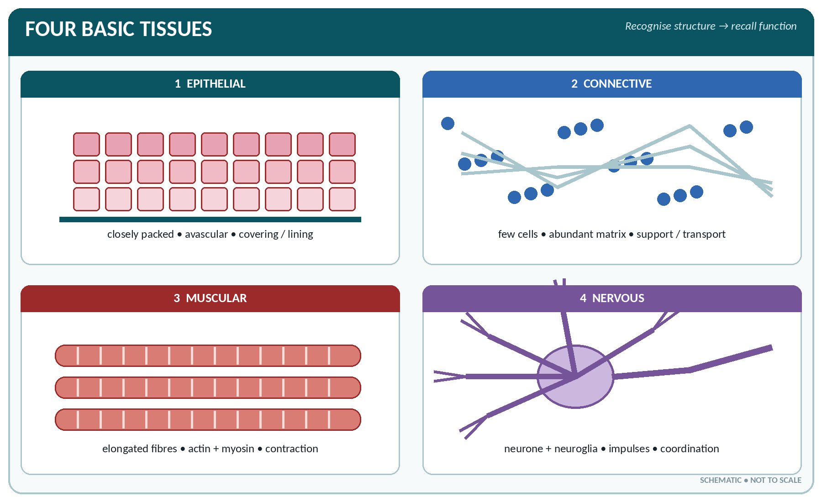
FIGURE • The four basic tissues—recognition pattern and principal function

Epithelial Tissue
General Features
▪ Consists of closely packed cells with very little intercellular substance.
▪ Rests on a basement membrane and is avascular (nourished by diffusion from underlying connective tissue) but is richly supplied with nerves.
▪ It has a free (apical) surface, high powers of regeneration, and undergoes rapid mitosis.
▪ Functions: protection, absorption, secretion, excretion, filtration, lubrication and sensation.
Classification of Epithelium
Simple epithelium (a single layer of cells)
Type | Description | Chief sites | Function
Simple squamous (pavement) | Single layer of thin flat cells with a flattened nucleus | Alveoli of lung, endothelium of blood and lymph vessels and heart, Bowman's capsule, mesothelium of pleura, pericardium and peritoneum | Diffusion, filtration, osmosis; smooth surface
Simple cuboidal | Cube-shaped cells | Kidney tubules, thyroid follicles, ducts of glands, germinal epithelium of ovary, choroid plexus | Secretion and absorption
Simple columnar | Tall narrow cells; may bear microvilli | Stomach, small and large intestine, gall bladder, some ducts | Absorption and secretion
Ciliated columnar | Columnar cells bearing cilia | Trachea and bronchi, uterine (Fallopian) tube, uterus, ventricles of the brain, part of nasal cavity | Propels mucus, ova and CSF
Pseudostratified columnar | Looks multi-layered but every cell touches the basement membrane | Trachea, large bronchi, male urethra, epididymis | Secretion of mucus; protection

Compound (stratified) epithelium — several layers of cells
Type | Description | Chief sites | Function
Stratified squamous — keratinised | Surface cells dead, flattened and filled with keratin | Epidermis of the skin, hair, nails | Protection against friction, drying and infection
Stratified squamous — non-keratinised | Surface cells alive and moist | Mouth, tongue, pharynx, oesophagus, anal canal, vagina, cornea | Protection of moist surfaces
Transitional epithelium (urothelium) | Pear-shaped cells able to slide over one another and stretch | Urinary bladder, ureter, renal pelvis and calyces, part of urethra | Allows distension; waterproof
Stratified cuboidal / columnar | Two or more layers | Large ducts of salivary and mammary glands, part of male urethra, conjunctiva | Protection and secretion

ENDOTHELIUM, MESOTHELIUM, EPITHELIUM
▪ Endothelium — the simple squamous lining of the blood vessels, heart and lymphatics.
▪ Mesothelium — the simple squamous lining of the serous cavities (pleura, pericardium, peritoneum).
▪ Epithelium — the covering of the skin and the lining of the mucous membranes.
▪ The only stratified epithelium able to stretch is transitional epithelium; the epithelium of the bladder is therefore never columnar.

Glandular Epithelium
▪ A gland is an epithelial structure specialised for secretion.
▪ Exocrine glands discharge their secretion through a duct onto a surface (sweat, salivary, gastric, pancreatic acini).
▪ Endocrine (ductless) glands discharge hormones directly into the blood (thyroid, adrenal, pituitary).
▪ Mixed glands have both functions — the pancreas (exocrine acini + islets of Langerhans), the testis and the ovary, the liver and the kidney.
Classification of exocrine glands
Basis | Types | Examples
Number of cells | Unicellular; multicellular | Goblet cell (unicellular); salivary gland
Shape of duct/gland | Simple tubular, coiled tubular, simple/compound acinar (alveolar), compound tubulo-acinar | Intestinal crypts; sweat gland (coiled tubular); sebaceous (simple branched acinar); salivary and pancreas (compound tubulo-acinar)
Nature of secretion | Serous (watery, enzyme-rich); mucous (thick); mixed; sebaceous (oily) | Parotid (serous); goblet cells (mucous); submandibular (mixed); sebaceous glands
Mode of secretion | Merocrine (by exocytosis, cell intact); apocrine (part of cell shed); holocrine (whole cell disintegrates) | Salivary/pancreas (merocrine); axillary sweat glands and mammary (apocrine); sebaceous gland (holocrine)

Connective Tissue
General Features
▪ Characterised by abundant intercellular substance (matrix) with relatively few, widely separated cells; most types are richly vascular (cartilage is avascular).
▪ Matrix = ground substance (water, proteoglycans, hyaluronic acid) + fibres.
▪ Functions: connection, support, protection, packing, transport (blood), storage of fat, defence and repair.
The fibres and cells of connective tissue
Component | Nature | Remarks
Collagen (white) fibres | Inelastic, very strong, protein collagen | The most abundant protein in the body; forms tendons, ligaments, bone matrix; requires vitamin C for its formation
Elastic (yellow) fibres | Stretchable, protein elastin | Ligamentum flavum, walls of arteries, lung, trachea, true vocal cords
Reticular fibres | Fine branching network | Framework of lymph node, spleen, bone marrow, liver
Fibroblast | Flat, branching cell | The chief cell; secretes fibres and matrix; essential for wound healing
Macrophage (histiocyte) | Large phagocyte | Part of the reticulo-endothelial system; ingests bacteria and debris
Mast cell | Granular cell near vessels | Releases heparin, histamine and serotonin; involved in allergy
Plasma cell | Derived from B lymphocyte | Produces antibodies
Adipocyte (fat cell) | Large, single fat droplet, nucleus pushed aside | Stores neutral fat; signet-ring appearance
Leucocytes | Wandering cells | Defence

Classification of Connective Tissue
Connective tissue proper
▪ Loose (areolar) connective tissue — the most widely distributed tissue in the body; a loose mesh of collagen and elastic fibres. Found in the superficial fascia, around vessels and nerves, and between organs. It is the "packing" of the body.
▪ Adipose tissue — areolar tissue loaded with fat cells. Sites: subcutaneous layer, around the kidney and eyeball, mesentery, omentum, bone marrow (yellow marrow), breast. Functions: energy store, insulation, support and protection. Brown adipose tissue in the newborn generates heat (non-shivering thermogenesis).
▪ Dense regular connective tissue — parallel bundles of collagen; forms tendons (muscle → bone), ligaments (bone → bone) and aponeuroses.
▪ Dense irregular connective tissue — interwoven collagen; forms dermis, periosteum, perichondrium, capsules of organs, dura mater and deep fascia.
▪ Elastic tissue — ligamentum flavum, suspensory ligament of the penis, walls of large arteries.
▪ Reticular (lymphoid) tissue — the framework of lymph nodes, spleen, tonsils and bone marrow.
▪ Mucoid (mucous) connective tissue — jelly-like; present in Wharton's jelly of the umbilical cord and in the vitreous body.
Cartilage
▪ A firm, resilient, avascular and non-nervous connective tissue whose cells (chondrocytes) lie in spaces called lacunae; covered by perichondrium (except articular cartilage).
▪ Nutrition is by diffusion from the perichondrium or synovial fluid — hence cartilage heals slowly.
The three types of cartilage
Type | Matrix | Sites | Function
Hyaline cartilage | Clear, bluish-white; fine collagen; the commonest type | Articular surfaces, costal cartilages, larynx (thyroid, cricoid, most of arytenoid), trachea and bronchi, nasal septum, epiphyseal plates, fetal skeleton | Smooth low-friction surface; flexible support
Fibrocartilage (white) | Dense bundles of collagen — strongest | Intervertebral discs, symphysis pubis, semilunar cartilages (menisci) of the knee, glenoid and acetabular labrum, some joint discs | Shock absorption; tensile strength
Elastic cartilage (yellow) | Elastic fibres in the matrix | Pinna (auricle) of the ear, epiglottis, external auditory meatus, Eustachian tube, apex of arytenoid, corniculate cartilage | Flexible support that regains its shape

Bone and blood
▪ Bone (osseous tissue) — connective tissue with a calcified matrix; the hardest tissue in the body after enamel. Cells: osteoblasts (form bone), osteocytes (mature, in lacunae), osteoclasts (resorb bone). Details in the chapters on bone.
▪ Blood — a fluid connective tissue in which the matrix is plasma and the cells are the erythrocytes, leucocytes and platelets.
▪ Lymph — a fluid connective tissue closely resembling plasma.
Muscular Tissue
The three types of muscular tissue compared
Feature | Skeletal (striated, voluntary) | Smooth (non-striated, involuntary) | Cardiac
Shape of fibre | Long cylindrical, unbranched | Spindle-shaped (fusiform) | Short, branched, joined end to end
Striations | Present | Absent | Present
Nucleus | Multinucleate, nuclei at the periphery | Single, central | Single (or two), central
Control | Voluntary (somatic nerves) | Involuntary (autonomic) | Involuntary (autonomic + intrinsic)
Special feature | Motor end plate; sarcomeres | Sheets and layers; spontaneous rhythm | Intercalated discs; syncytium; inherent rhythm; never tires
Speed / fatigue | Contracts rapidly, fatigues | Slow, sustained, does not fatigue easily | Rapid, rhythmical, does not fatigue
Sites | Muscles attached to the skeleton; tongue, diaphragm, pharynx, upper oesophagus, external sphincters | Walls of the gut, blood vessels, bronchi, bladder, uterus, ureter, iris, ciliary body, arrector pili | Myocardium only

MUSCLE TISSUE — EXAM POINTS
▪ The only muscle with intercalated discs and branched fibres is cardiac muscle.
▪ The only striated but involuntary muscle is cardiac muscle.
▪ Skeletal muscle is the only multinucleated muscle (a syncytium formed by fusion of myoblasts).
▪ Smooth muscle of the gut shows peristalsis; smooth muscle capable of great stretch lines the uterus and bladder.
▪ Muscle forms about 40–45% of the body weight and is the largest tissue mass of the body.

Nervous Tissue
▪ Made of two kinds of cell: the neurone (nerve cell — the structural and functional unit) and the neuroglia (supporting cells, about 5–10 times more numerous).
▪ Properties of nervous tissue: excitability (irritability) and conductivity.
▪ Neurones cannot divide after birth; once destroyed they are not replaced (a damaged axon in a peripheral nerve can, however, regenerate along its sheath).
▪ Neuroglia of the CNS: astrocytes (support, blood–brain barrier), oligodendrocytes (myelin in the CNS), microglia (phagocytic), ependymal cells (line ventricles, form CSF). In the peripheral nervous system, Schwann cells form the myelin sheath and satellite cells support ganglia. Full detail in the chapter on the nervous system.
Membranes of the Body
The membranes
Membrane | Lining epithelium | Secretion | Sites
Mucous membrane | Epithelium (columnar, ciliated, squamous) on connective tissue | Mucus from goblet cells | Lines cavities opening to the exterior — respiratory, digestive, urinary and genital tracts
Serous membrane | Mesothelium (simple squamous) | Serous fluid (watery) | Lines closed cavities — pleura, pericardium, peritoneum; has a parietal and a visceral layer
Synovial membrane | Modified connective tissue (no epithelium) | Synovial fluid | Lines the capsule of freely movable joints, bursae and tendon sheaths
Cutaneous membrane | Keratinised stratified squamous | Sebum and sweat | The skin
Meninges | Fibrous and vascular layers | CSF (from choroid plexus) | Coverings of brain and spinal cord (dura, arachnoid, pia)

Repair of Tissue and Wound Healing
▪ Regeneration — replacement by the same type of cell (epithelium, bone, liver).
▪ Repair by fibrosis — replacement by scar (fibrous) tissue where regeneration is impossible (heart muscle after infarction, brain after a stroke → gliosis).
▪ Healing by first intention (primary union) — clean, closely apposed wound edges; minimal scar. Healing by second intention — an open, infected or gaping wound; heals by granulation tissue with a large scar.
▪ Stages: haemostasis → inflammation → proliferation (granulation) → maturation (remodelling).
▪ Factors delaying healing: poor blood supply, infection, foreign body, movement, malnutrition (especially protein, vitamin C and zinc deficiency), diabetes, steroid therapy, old age, anaemia.
TISSUES — HIGHEST YIELD FACTS
▪ Four basic tissues: epithelial, connective, muscular, nervous.
▪ Epithelium is avascular; so is cartilage and the cornea and lens.
▪ Most widely distributed connective tissue — areolar; most abundant protein — collagen.
▪ Transitional epithelium → bladder; ciliated epithelium → trachea and uterine tube; stratified squamous keratinised → skin; simple squamous → alveoli and capillaries.
▪ Tendon joins muscle to bone; ligament joins bone to bone; aponeurosis is a flat tendon.
▪ Sebaceous glands are holocrine; sweat glands are coiled tubular; goblet cells are unicellular glands.
▪ Wharton's jelly (umbilical cord) is mucoid connective tissue.
▪ Vitamin C is essential for collagen formation — hence delayed healing in scurvy.

CHAPTER 5
Systems and Various Parts of the Human Body

CHAPTER OUTLINE
The Anatomical Position, Planes and Terms of Direction | The Regions and Parts of the Body | The Cavities of the Body | The Systems of the Body — An Overview | Basic Numbers of the Body

Before studying individual organs it is necessary to know the language of anatomy — the standard position of the body, the planes and terms of direction, the regions and cavities of the body, and an overview of each system with its organs and functions. Questions from this chapter are almost always straightforward one-liners.
The Anatomical Position, Planes and Terms of Direction
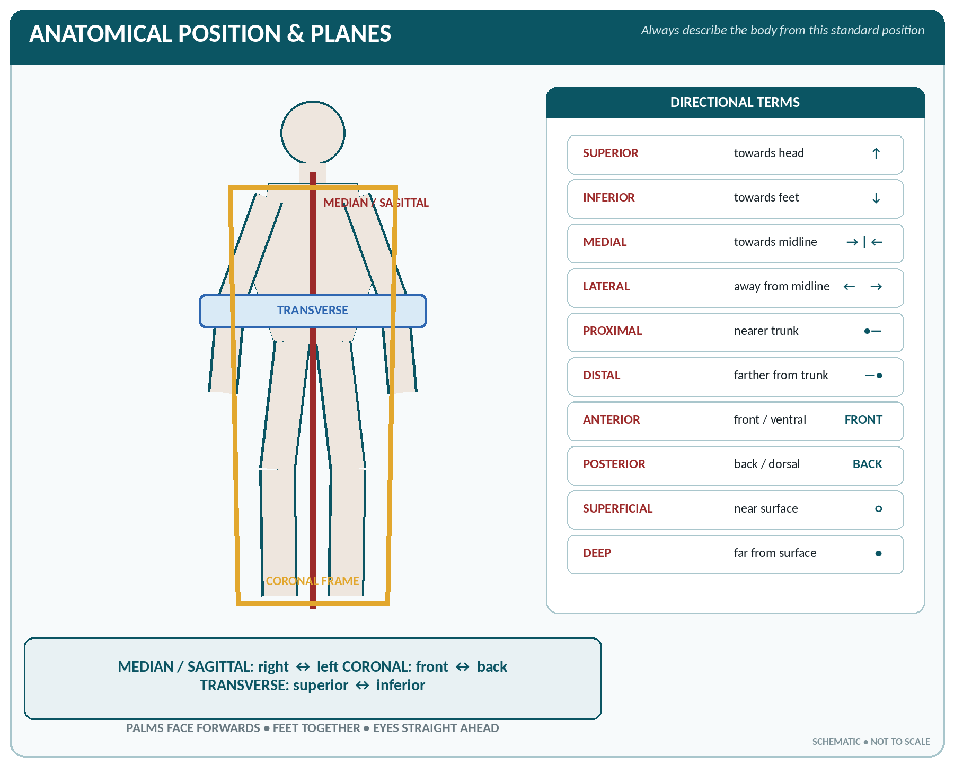
FIGURE • Anatomical position, the three principal body planes and directional terminology

The anatomical position
The body is erect, facing the observer, with the feet together and flat on the ground, the arms hanging at the sides and the palms facing forwards (supinated). All anatomical descriptions assume this position, whatever the actual posture of the patient.
Planes of the body
Plane | Direction | Divides the body into
Median (mid-sagittal) | Vertical, front to back, through the midline | Equal right and left halves
Sagittal (paramedian) | Vertical, front to back, parallel to the median plane | Unequal right and left parts
Coronal (frontal) | Vertical, from side to side, at right angles to the sagittal | Anterior (front) and posterior (back) parts
Transverse (horizontal / axial) | Horizontal | Upper (superior) and lower (inferior) parts
Oblique | Any slanting plane | Unequal oblique parts

Terms of position, direction and movement
Term | Meaning | Example
Anterior / ventral | Towards the front | The sternum is anterior to the heart
Posterior / dorsal | Towards the back | The vertebrae are posterior to the heart
Superior / cranial (cephalic) | Towards the head | The lungs are superior to the diaphragm
Inferior / caudal | Towards the feet | The stomach is inferior to the diaphragm
Medial | Nearer to the median plane | The ulna is medial to the radius
Lateral | Further from the median plane | The ears are lateral to the eyes
Proximal | Nearer to the trunk or to the origin | The elbow is proximal to the wrist
Distal | Further from the trunk or origin | The fingers are distal to the wrist
Superficial | Nearer the surface | The skin is superficial to the muscles
Deep | Further from the surface | The femur is deep to the thigh muscles
Internal / external | Inside / outside a cavity | Internal and external carotid arteries
Ipsilateral / contralateral | Same side / opposite side | Hemiplegia is contralateral to the brain lesion
Prone / supine | Lying face down / face up | —
Palmar / plantar | Front of the hand / sole of the foot | —
Parietal / visceral | Relating to the wall / to the organ | Parietal and visceral pleura

Terms of movement
Movement | Meaning
Flexion | Bending — decreasing the angle at a joint
Extension | Straightening — increasing the angle
Abduction | Movement away from the midline
Adduction | Movement towards the midline
Rotation | Turning about the long axis (medial / lateral)
Circumduction | A combination of flexion, abduction, extension and adduction — the limb describes a cone
Pronation / Supination | Turning the palm downwards / upwards (forearm only)
Inversion / Eversion | Turning the sole inwards (medially) / outwards (laterally)
Dorsiflexion / Plantar flexion | Raising the foot upwards / pointing the toes downwards
Elevation / Depression | Raising / lowering a part (shoulder, mandible)
Protraction / Retraction | Drawing forward / drawing backward (jaw, scapula)
Opposition | Touching the thumb to the tip of another digit (unique to the thumb)

The Regions and Parts of the Body
▪ The body is divided into the axial part (head, neck and trunk) and the appendicular part (the two upper and two lower limbs).
▪ The trunk consists of the thorax (chest), the abdomen and the pelvis.
▪ The head consists of the cranium (containing the brain) and the face.
The nine regions of the abdomen
Position | Right | Middle | Left
Upper (above the subcostal plane) | Right hypochondriac | Epigastric | Left hypochondriac
Middle (between subcostal and transtubercular planes) | Right lumbar | Umbilical | Left lumbar
Lower (below the transtubercular plane) | Right iliac (inguinal) | Hypogastric (suprapubic) | Left iliac (inguinal)

▪ The nine regions are marked out by two horizontal planes (subcostal and transtubercular) and two vertical (mid-clavicular / lateral) planes.
▪ Alternatively the abdomen is divided by a horizontal and a vertical line through the umbilicus into four quadrants — right and left upper, right and left lower.
Contents of the abdominal regions — commonly asked
Region | Chief contents
Right hypochondriac | Liver (right lobe), gall bladder, part of duodenum, right kidney upper pole, hepatic flexure
Epigastric | Stomach (pylorus), left lobe of liver, pancreas, duodenum, aorta, coeliac plexus, adrenals
Left hypochondriac | Spleen, fundus of stomach, tail of pancreas, splenic flexure, left kidney upper pole
Right lumbar | Ascending colon, right kidney, part of small intestine
Umbilical | Transverse colon, coils of jejunum and ileum, part of duodenum, pancreas head
Left lumbar | Descending colon, left kidney, part of small intestine
Right iliac | Caecum, appendix, end of ileum (McBurney's point lies here)
Hypogastric | Urinary bladder (when full), sigmoid colon, uterus in pregnancy, loops of ileum
Left iliac | Sigmoid colon, loops of small intestine

The Cavities of the Body
The body cavities and their contents
Cavity | Boundaries | Principal contents
Cranial cavity | Bones of the cranium | Brain, meninges, cranial vessels
Vertebral (spinal) canal | Vertebrae | Spinal cord, meninges, spinal nerve roots
Thoracic cavity | Sternum, ribs, thoracic vertebrae, diaphragm below | Heart in the pericardium, lungs in the pleurae, and the mediastinum
Abdominal cavity | Diaphragm above, abdominal muscles, vertebrae behind | Stomach, intestines, liver, gall bladder, pancreas, spleen, kidneys, adrenals, ureters
Pelvic cavity | Pelvic bones; continuous with abdominal cavity | Urinary bladder, rectum, sigmoid colon, uterus, uterine tubes, ovaries (female), prostate and seminal vesicles (male)

▪ The mediastinum is the space between the two pleural sacs. It contains the heart and pericardium, great vessels, trachea, oesophagus, thymus, thoracic duct, phrenic and vagus nerves and lymph nodes — everything in the thorax except the lungs.
▪ The diaphragm separates the thoracic from the abdominal cavity and is pierced by three large openings: aorta (T12), oesophagus (T10) and inferior vena cava (T8).
OPENINGS OF THE DIAPHRAGM
"I ate ten eggs at twelve" — Vena cava = T8, oEsophagus = T10, Aorta = T12.

▪ The dorsal (posterior) cavity comprises the cranial cavity and the vertebral canal; the ventral (anterior) cavity comprises the thoracic, abdominal and pelvic cavities.
▪ Serous membranes line the ventral cavities: pleura (lungs), pericardium (heart), peritoneum (abdominal organs). The peritoneum is the largest serous membrane of the body.
The Systems of the Body — An Overview
The eleven systems of the human body
System | Chief organs | Principal functions
1. Integumentary (skin) | Skin, hair, nails, sweat and sebaceous glands | Protection, temperature regulation, sensation, vitamin D synthesis, excretion
2. Skeletal | 206 bones, cartilage, ligaments, joints | Support, protection, movement (levers), mineral store (Ca, P), blood cell formation in red marrow
3. Muscular | Skeletal muscles (about 600), tendons | Movement, posture, heat production
4. Nervous | Brain, spinal cord, nerves, sense organs | Rapid control, coordination, sensation, intelligence, memory
5. Endocrine | Pituitary, thyroid, parathyroid, adrenal, pancreatic islets, gonads, pineal, thymus | Chemical (hormonal) control of metabolism, growth and reproduction
6. Cardiovascular (circulatory) | Heart, arteries, veins, capillaries, blood | Transport of O₂, CO₂, nutrients, hormones, heat and wastes; defence; clotting
7. Lymphatic and immune | Lymph, lymph vessels and nodes, spleen, thymus, tonsils | Drains tissue fluid, absorbs fat, filters lymph, immunity
8. Respiratory | Nose, pharynx, larynx, trachea, bronchi, lungs | Exchange of O₂ and CO₂, regulation of pH, voice production
9. Digestive | Mouth to anus, with liver, pancreas, gall bladder | Digestion, absorption of food, elimination of faeces
10. Urinary | Kidneys, ureters, bladder, urethra | Excretion of urea and water, regulation of fluid, electrolytes and pH, blood pressure, erythropoietin
11. Reproductive | Testes, penis / ovaries, uterine tubes, uterus, vagina | Production of gametes and hormones; continuation of the species

SUPERLATIVES OF THE HUMAN BODY
Feature | Structure
Largest organ | Skin (also the largest sense organ)
Largest internal organ / largest gland | Liver
Largest and longest bone | Femur
Smallest bone | Stapes (in the middle ear)
Largest bone of the face / only movable skull bone | Mandible
Hardest substance in the body | Enamel of the tooth
Longest nerve | Sciatic nerve
Largest nerve / thickest cranial nerve | Sciatic (peripheral) / trigeminal (cranial)
Longest cell | Neurone
Largest cell | Ovum
Smallest cell (blood) | Platelet (a cell fragment)
Largest artery | Aorta
Largest vein | Inferior vena cava
Longest vein | Great saphenous vein
Largest lymphatic vessel | Thoracic duct
Largest endocrine gland | Thyroid
Smallest endocrine gland | Pineal (and parathyroid)
Largest salivary gland | Parotid
Largest serous membrane | Peritoneum
Largest muscle | Gluteus maximus
Smallest muscle | Stapedius
Longest muscle | Sartorius
Strongest muscle | Masseter (jaw) / gluteus maximus
Widest / broadest muscle | Latissimus dorsi
Longest part of the small intestine | Ileum
Widest part of the alimentary canal | Stomach (caecum is the widest part of the large gut)
Longest and narrowest bone of the ear | — (stapes smallest, malleus largest ossicle)
Largest air sinus | Maxillary sinus (antrum of Highmore)
Largest lobe of the liver | Right lobe
Largest joint | Knee
Most movable joint | Shoulder
Least movable (fixed) joints | Sutures of the skull

Basic Numbers of the Body
Numbers most often asked
Structure | Number
Bones in the adult | 206 (newborn about 270–300)
Bones in the skull | 22 (8 cranial + 14 facial)
Vertebrae in the adult | 26 (7 + 12 + 5 + sacrum + coccyx); 33 in the child
Ribs | 24 (12 pairs) — 7 true, 3 false, 2 floating
Bones in each upper limb / both | 32 / 64
Bones in each lower limb / both | 31 / 62
Bones in the hand / foot | 27 / 26
Cranial nerves | 12 pairs
Spinal nerves | 31 pairs (8 cervical, 12 thoracic, 5 lumbar, 5 sacral, 1 coccygeal)
Teeth — deciduous / permanent | 20 / 32
Muscles (skeletal) | About 600–639
Chromosomes | 46 (23 pairs)
Lobes of the lung — right / left | 3 / 2
Chambers of the heart | 4
Valves of the heart | 4
Lobes of the liver (anatomical) | 4 (right, left, quadrate, caudate)
Kidneys / ureters / suprarenal glands | 2 / 2 / 2
Salivary glands (pairs) | 3 pairs (parotid, submandibular, sublingual)
Nasal air sinuses (pairs) | 4 pairs (maxillary, frontal, ethmoidal, sphenoidal)
Lumbar and sacral plexus components | —
Layers of the epidermis | 5 (in thick skin)
Coats of the eyeball | 3 (sclera/cornea, choroid/uveal, retina)
Ossicles in each middle ear | 3 (malleus, incus, stapes)

FROM THIS CHAPTER
▪ The median plane divides the body into equal halves; a sagittal plane into unequal halves.
▪ Prone = face downward, supine = face upward.
▪ The mediastinum contains everything in the thorax except the lungs.
▪ The abdomen has 9 regions (or 4 quadrants); the appendix lies in the right iliac region.
▪ Aorta pierces the diaphragm at T12, oesophagus at T10, IVC at T8.
▪ Opposition is a movement possible only at the thumb (first carpometacarpal joint).
▪ Number of bones: adult 206; newborn about 300 (they fuse with growth).

CHAPTER 6
Development and Types of Bones

CHAPTER OUTLINE
Functions of the Skeleton | Composition and Structure of Bone | Classification of Bones | Parts of a Young Long Bone | Ossification (Osteogenesis) | Blood Supply and Nerve Supply of Bone | Repair of a Fracture

Bone is the hardest and most rigid connective tissue of the body. The skeleton of the adult contains 206 bones, forms about 14–18% of body weight, and stores 99% of the body's calcium. The study of bones is osteology.
Functions of the Skeleton
1. Support — gives the body its shape and forms the framework.
2. Protection — the skull protects the brain, the vertebral column the spinal cord, the thorax the heart and lungs, the pelvis the pelvic viscera.
3. Movement — bones act as levers for the muscles; joints permit movement.
4. Haemopoiesis — red bone marrow forms red cells, granular leucocytes and platelets.
5. Mineral storage — calcium and phosphorus (also magnesium, sodium, fluoride); bone is the body's calcium bank.
6. Fat storage — yellow marrow stores triglyceride.
7. Sound conduction — the ear ossicles.
Composition and Structure of Bone
Chemical composition
▪ Water — about 25%; organic matter (mainly collagen, the "osteoid") — about 30–35%; inorganic mineral salts — about 45–70% of dry weight.
▪ The chief mineral is calcium phosphate (as crystals of hydroxyapatite), with calcium carbonate, calcium fluoride, magnesium phosphate and sodium chloride.
▪ The organic matrix gives toughness and resilience; the mineral gives hardness and rigidity. Remove the mineral (by acid) and the bone becomes rubbery; burn away the organic matter and the bone becomes brittle.
Cells of bone
The cells of bone
Cell | Origin / site | Function
Osteoprogenitor cell | Periosteum, endosteum | Stem cell — becomes an osteoblast
Osteoblast | Surfaces of growing bone | Forms bone — secretes collagen matrix and initiates calcification; rich in alkaline phosphatase
Osteocyte | Mature bone cell, lying in a lacuna | Maintains bone tissue; exchanges nutrients through canaliculi
Osteoclast | Large multinucleated cell in Howship's lacunae | Resorbs (destroys) bone; releases calcium into blood; stimulated by parathyroid hormone, inhibited by calcitonin

Microscopic structure
▪ Compact (cortical) bone — dense; arranged as cylindrical Haversian systems (osteons), each with a central Haversian canal carrying vessels and nerves, surrounded by concentric lamellae with osteocytes in lacunae joined by canaliculi. Volkmann's canals run transversely and connect Haversian canals with the surface.
▪ Cancellous (spongy, trabecular) bone — a meshwork of trabeculae with marrow in the spaces; no Haversian systems; arranged along lines of stress.
▪ Periosteum — a tough double-layered fibrous membrane covering the bone (absent over articular surfaces); its inner osteogenic layer forms new bone, so it is essential for growth in thickness and for repair. It carries the blood supply and nerves — it is the pain-sensitive part of bone.
▪ Endosteum — a thin layer lining the medullary cavity.
▪ Medullary cavity — contains marrow.
Red and yellow bone marrow
Feature | Red marrow | Yellow marrow
Nature | Haemopoietic tissue | Fatty tissue
Function | Forms RBC, granulocytes, monocytes, platelets (and lymphocytes) | Stores fat; can revert to red marrow in severe anaemia
Sites in the adult | Sternum, ribs, vertebrae, ilium (iliac crest), skull, clavicle, scapula and the proximal ends of the femur and humerus | Medullary cavities of the long bones of the limbs
In the child | Present in all bones | Appears progressively after about 5 years

SITE OF BONE MARROW ASPIRATION
In the adult, marrow is aspirated from the posterior superior iliac spine or the sternum; in children from the iliac crest or the upper end of the tibia.

Classification of Bones
According to shape
Types of bone by shape
Type | Description | Examples
Long bone | Has a shaft (diaphysis) and two ends (epiphyses); acts as a lever; contains a medullary cavity | Femur, tibia, fibula, humerus, radius, ulna; also the miniature long bones — metacarpals, metatarsals, phalanges, clavicle
Short bone | Roughly cube-shaped, mainly cancellous with a thin cortex | Carpals (8) and tarsals (7)
Flat bone | Two plates of compact bone with cancellous bone (diploë) between; protective and gives broad muscle attachment | Skull vault (frontal, parietal, occipital), sternum, ribs, scapula, hip bone
Irregular bone | Complex shape not fitting the other groups | Vertebrae, sacrum, sphenoid, ethmoid, maxilla, mandible, palatine, zygoma
Sesamoid bone | Develops within a tendon, where the tendon crosses a joint; no periosteum | Patella (the largest sesamoid), pisiform, sesamoids of the thumb and great toe
Pneumatic bone | Contains air sinuses | Maxilla, frontal, ethmoid, sphenoid, temporal (mastoid)
Accessory / supernumerary (sutural or Wormian) bone | Extra bone in a suture or tendon | Wormian bones of the skull

According to development (ossification)
▪ Membrane (mesenchymal) bones — formed by intramembranous ossification: the skull vault, facial bones, clavicle and mandible.
▪ Cartilage bones — formed by endochondral ossification in a cartilage model: all long bones, vertebrae, ribs, base of the skull.
▪ Membrano-cartilaginous bones — formed by both methods: clavicle, mandible, occipital, temporal, sphenoid.
THE CLAVICLE — A FAVOURITE QUESTION
▪ The first bone in the body to begin to ossify (5th–6th week of intrauterine life).
▪ The last bone to complete ossification (about 25 years).
▪ The only long bone that ossifies in membrane and lies horizontally.
▪ It has no medullary cavity and normally no epiphysis at its lateral end; it is the most commonly fractured bone in the body (usually at the junction of the middle and outer thirds).

Parts of a Young Long Bone
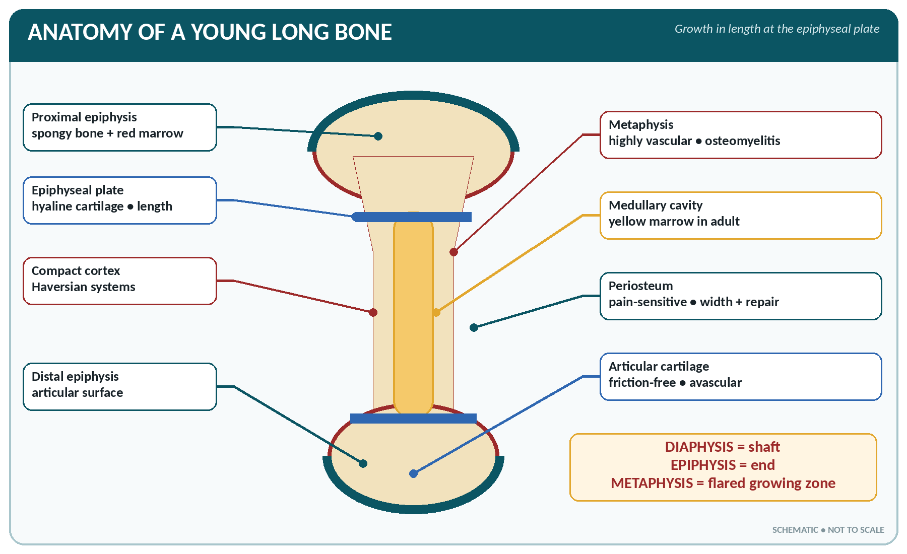
FIGURE • Parts of a young long bone—epiphysis, metaphysis, growth plate, diaphysis, marrow and periosteum

▪ Diaphysis — the shaft, ossified from the primary centre.
▪ Epiphysis — the end of the bone, ossified from a secondary centre.
▪ Epiphyseal plate (growth plate) — the plate of hyaline cartilage between diaphysis and epiphysis; it is responsible for growth in length. Its closure (fusion) ends growth.
▪ Metaphysis — the flared part of the shaft next to the epiphyseal plate; it is highly vascular and is the usual site of acute osteomyelitis in children.
▪ Articular cartilage — hyaline cartilage covering the joint surface of the epiphysis.
Types of epiphysis
Type | Character | Examples
Pressure epiphysis | Takes part in transmitting weight / pressure at a joint | Head of femur, head of humerus, lower end of radius
Traction epiphysis | Gives attachment to a muscle, does not transmit weight; ossifies later | Greater and lesser trochanters, tubercles of the humerus, mastoid process
Atavistic (autonomous) | Was an independent bone phylogenetically | Coracoid process of scapula, os trigonum
Aberrant | Not always present | Epiphysis at the head of the first metacarpal

Ossification (Osteogenesis)
Ossification is the formation of bone. It begins in the embryo at about the 6th–8th week and is not complete until about 25 years of age.
Intramembranous ossification
1. Mesenchymal cells in a fibrous membrane become osteoblasts at a centre of ossification.
2. Osteoblasts secrete osteoid, which calcifies; osteoblasts trapped in the matrix become osteocytes.
3. Spicules of woven bone radiate outward; the surface layers become compact bone and the periosteum forms.
4. Unossified areas persist at birth as the fontanelles of the skull.
Endochondral (intracartilaginous) ossification
1. A hyaline cartilage model of the bone is formed in the embryo.
2. A primary centre of ossification appears in the middle of the shaft; the periosteal collar forms.
3. Blood vessels invade; cartilage cells enlarge, the matrix calcifies and cartilage is replaced by bone.
4. Secondary centres appear in the epiphyses (mostly after birth).
5. The medullary cavity is hollowed out by osteoclasts.
6. Cartilage persists as the epiphyseal plate (for growth in length) and as articular cartilage.
Growth of bone
▪ Growth in length occurs at the epiphyseal plate by the multiplication of cartilage cells on the epiphyseal side and their replacement by bone on the diaphyseal side (interstitial growth of cartilage).
▪ Growth in thickness (diameter) occurs by appositional growth — new bone laid down beneath the periosteum, while osteoclasts enlarge the medullary cavity from within.
▪ Remodelling continues throughout life — bone is constantly formed by osteoblasts and removed by osteoclasts along lines of stress (Wolff's law: bone is laid down where needed and removed where not needed).
Factors influencing bone growth and health
Factor | Effect
Calcium and phosphorus | The raw materials of the mineral matrix
Vitamin D (calciferol) | Essential for absorption of calcium from the gut; deficiency causes rickets in children and osteomalacia in adults
Vitamin C | Needed for collagen formation; deficiency (scurvy) gives poor bone and delayed healing
Vitamin A | Controls the activity of osteoblasts and osteoclasts
Growth hormone (somatotropin) | Stimulates growth at the epiphyseal plates; excess before fusion → gigantism, after fusion → acromegaly; deficiency → dwarfism
Thyroid hormone (thyroxine) | Necessary for normal growth and maturation; deficiency in infancy → cretinism
Parathyroid hormone (PTH) | Raises blood calcium by activating osteoclasts (bone resorption)
Calcitonin (thyroid C cells) | Lowers blood calcium; inhibits osteoclasts
Sex hormones (oestrogen, testosterone) | Cause the adolescent growth spurt and then close the epiphyseal plates; oestrogen deficiency after the menopause → osteoporosis
Exercise and weight-bearing | Strengthen bone; immobilisation and weightlessness cause bone loss
Blood supply | Essential; its loss causes avascular necrosis

CALCIUM — NUMBERS TO REMEMBER
▪ Total body calcium 1–1.5 kg, of which 99% is in bone and teeth.
▪ Normal serum calcium 9–11 mg/dL (2.2–2.6 mmol/L); serum phosphate 3–4.5 mg/dL.
▪ Daily requirement: adult 800–1000 mg; pregnancy and lactation 1200–1500 mg.
▪ A low ionised calcium causes tetany; a high level causes muscle weakness and renal stones.

Blood Supply and Nerve Supply of Bone
▪ Nutrient (diaphysial) artery — enters the shaft through the nutrient foramen and supplies the marrow and inner two-thirds of the cortex.
▪ Periosteal arteries — supply the outer cortex through Volkmann's canals.
▪ Epiphyseal and metaphyseal arteries — supply the ends; before fusion of the epiphysis the two are separate, which is why avascular necrosis occurs in the head of the femur and the head of the humerus.
▪ Nerves accompany the vessels; the periosteum is richly supplied with sensory (pain) fibres, so fractures and periostitis are very painful.
Repair of a Fracture
Stages (each stage is a favourite one-liner):
1. Haematoma formation — bleeding between the fragments (immediate).
2. Inflammation and organisation — macrophages remove clot and dead bone; granulation tissue forms.
3. Soft callus (fibrocartilaginous callus) — fibroblasts and chondroblasts bridge the gap (about 2–3 weeks).
4. Hard (bony) callus — osteoblasts convert callus to woven bone (3 weeks to 3 months).
5. Remodelling (consolidation) — woven bone is replaced by lamellar bone and the medullary cavity is restored; may take months to years.
▪ Factors delaying union: movement at the site, infection, interposed soft tissue, poor blood supply, inadequate immobilisation, old age, malnutrition, diabetes, steroids.
COMMON BONE DISORDERS — ONE-LINERS
▪ Rickets — vitamin D deficiency in children: soft bones, bow legs, rickety rosary, craniotabes, delayed fontanelle closure.
▪ Osteomalacia — the adult form of vitamin D deficiency: bone pain and pseudofractures.
▪ Osteoporosis — reduced bone mass with normal composition; commonest in post-menopausal women; leads to fracture of the neck of the femur, wrist and vertebrae.
▪ Osteomyelitis — infection of bone (usually Staphylococcus aureus), typically in the metaphysis of a growing long bone.
▪ Osteogenesis imperfecta — "brittle bone disease", a defect of collagen type I.
▪ Paget's disease (osteitis deformans) — excessive disorganised remodelling; raised alkaline phosphatase.
▪ Achondroplasia — failure of endochondral ossification: short limbs with a normal trunk and head.
▪ Osteosarcoma — the commonest primary malignant bone tumour, usually near the knee in adolescents.

DEVELOPMENT OF BONE — RAPID FACTS
▪ Bone is a connective tissue; it is the second hardest structure after enamel.
▪ The cell that builds bone is the osteoblast; the cell that destroys it is the osteoclast; the mature cell is the osteocyte lying in a lacuna.
▪ Growth in length — at the epiphyseal plate; growth in thickness — beneath the periosteum.
▪ Haversian systems are found in compact bone only.
▪ First bone to ossify — clavicle; last to complete ossification — clavicle.
▪ Largest sesamoid bone — patella; the patella has no periosteum.
▪ Only bone in the body that does not articulate with any other bone — the hyoid.
▪ The sternum, iliac crest and vertebrae are the chief sites of red marrow in the adult.

CHAPTER 7
Bones of Head and Trunk

CHAPTER OUTLINE
The Skull | The Hyoid Bone | The Vertebral Column (Spine) | The Thoracic Cage (Bones of the Thorax) | The Pelvis (Bony Pelvis)

The skeleton is divided into the axial skeleton (80 bones — skull, vertebral column, ribs and sternum) and the appendicular skeleton (126 bones — the limbs and their girdles). This chapter deals with the axial skeleton.
The 206 bones of the adult skeleton
Region | Bones | Number
Skull | Cranium 8, face 14 | 22
Ear ossicles | Malleus, incus, stapes (×2) | 6
Hyoid | — | 1
Vertebral column | Cervical 7, thoracic 12, lumbar 5, sacrum 1, coccyx 1 | 26
Thorax | Sternum 1, ribs 24 | 25
Axial skeleton total |  | 80
Upper limbs | Each 32 (shoulder girdle 2, arm 1, forearm 2, hand 27) | 64
Lower limbs | Each 31 (hip 1, thigh 1, patella 1, leg 2, foot 26) | 62
Appendicular skeleton total |  | 126
GRAND TOTAL |  | 206

The Skull
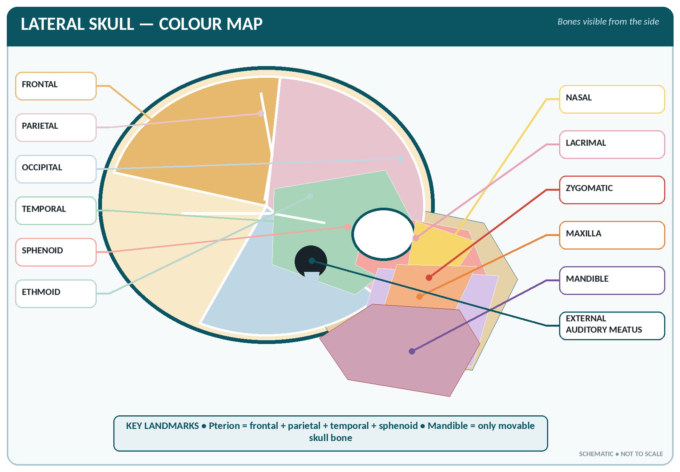
FIGURE • Colour-coded lateral skull—cranial and facial bones with exam-important landmarks

The skull has 22 bones: 8 cranial bones enclosing the brain and 14 facial bones. With the 6 ear ossicles and the hyoid, the "bones of the head" number 29.
The eight bones of the cranium
Bone | Number | Key features
Frontal | 1 | Forms the forehead and the roof of the orbit; contains the frontal air sinus; the supra-orbital notch/foramen transmits the supra-orbital nerve and vessels
Parietal | 2 | Form most of the roof and sides of the vault
Temporal | 2 | Contain the organ of hearing; bear the mastoid process, styloid process, zygomatic process, external acoustic meatus, petrous part (housing the inner ear) and the mandibular fossa
Occipital | 1 | Forms the back and base; pierced by the foramen magnum (transmits the medulla/spinal cord); bears the occipital condyles and the external occipital protuberance (inion)
Sphenoid | 1 | The "keystone", shaped like a bat; contains the sphenoidal sinus and the sella turcica (hypophyseal fossa) which holds the pituitary gland; has greater and lesser wings and pterygoid processes
Ethmoid | 1 | Light and spongy; forms part of the nasal cavity, orbit and cranial floor; bears the cribriform plate (transmits the olfactory nerves), the crista galli, the perpendicular plate (nasal septum) and the superior and middle turbinates

The fourteen bones of the face
Bone | Number | Key features
Maxilla | 2 | The chief bone of the upper jaw; carries the upper teeth; contains the maxillary sinus (antrum of Highmore) — the largest air sinus; forms the anterior part of the hard palate and the floor of the orbit
Zygomatic (malar) | 2 | The prominence of the cheek; forms the zygomatic arch with the temporal bone
Nasal | 2 | The bridge of the nose
Lacrimal | 2 | Smallest bones of the face; in the medial wall of the orbit; grooved for the lacrimal sac
Palatine | 2 | Form the posterior part of the hard palate and part of the lateral nasal wall
Inferior nasal concha (turbinate) | 2 | Scroll-like bones on the lateral nasal wall
Vomer | 1 | Forms the posterior/inferior part of the bony nasal septum
Mandible | 1 | The lower jaw — the largest and strongest facial bone and the only movable bone of the skull; has a body, two rami, condylar and coronoid processes, the mental foramen and the mandibular foramen

BONES OF THE SKULL
▪ Cranium (8): "PEST of 6" — Parietal (2), Ethmoid (1), Sphenoid (1), Temporal (2), plus Frontal (1) and Occipital (1).
▪ Face (14): 2 each of maxilla, zygomatic, nasal, lacrimal, palatine and inferior concha (= 12), plus 1 vomer + 1 mandible.

Sutures and fontanelles
▪ The bones of the vault are joined by immovable fibrous joints called sutures:
– Coronal suture — between frontal and parietal bones.
– Sagittal suture — between the two parietal bones.
– Lambdoid suture — between parietal and occipital bones.
– Squamous suture — between parietal and temporal.
– Metopic suture — between the two halves of the frontal bone (normally obliterated).
▪ Fontanelles are the membranous gaps at the angles of the parietal bones in the infant:
The fontanelles of the infant skull
Fontanelle | Position | Shape | Closes at
Anterior fontanelle (bregma) | Junction of sagittal, coronal and metopic sutures | Diamond / lozenge shaped; the largest | 18 months (12–18 months)
Posterior fontanelle (lambda) | Junction of sagittal and lambdoid sutures | Triangular | 6–8 weeks (2–3 months)
Sphenoidal (anterolateral) | Pterion region | Small | About 3 months
Mastoid (posterolateral) | Asterion region | Small | 12 months–2 years

▪ A bulging, tense fontanelle suggests raised intracranial pressure; a depressed fontanelle suggests dehydration.
▪ The pterion is the thin H-shaped meeting of frontal, parietal, temporal and sphenoid bones; it overlies the anterior division of the middle meningeal artery and is the weakest part of the skull — injury here causes extradural haemorrhage.
Foramina of the skull
Important foramina and their contents
Foramen | Bone | Chief contents
Foramen magnum | Occipital | Medulla oblongata, vertebral arteries, spinal roots of accessory nerve
Cribriform plate foramina | Ethmoid | Olfactory (I) nerves
Optic canal | Sphenoid | Optic (II) nerve and ophthalmic artery
Superior orbital fissure | Sphenoid | III, IV, VI and ophthalmic division of V; ophthalmic veins
Foramen rotundum | Sphenoid | Maxillary division of V (V₂)
Foramen ovale | Sphenoid | Mandibular division of V (V₃)
Foramen spinosum | Sphenoid | Middle meningeal artery
Internal acoustic meatus | Temporal (petrous) | Facial (VII) and vestibulocochlear (VIII) nerves
Jugular foramen | Between temporal and occipital | IX, X, XI and the internal jugular vein
Hypoglossal canal | Occipital | Hypoglossal (XII) nerve
Stylomastoid foramen | Temporal | Facial nerve leaves the skull
Carotid canal | Temporal | Internal carotid artery
Mental foramen | Mandible | Mental nerve and vessels
Infra-orbital foramen | Maxilla | Infra-orbital nerve and vessels

The air sinuses (paranasal sinuses)
▪ Four pairs of air-filled cavities that open into the nose, lined by ciliated mucous membrane: maxillary, frontal, ethmoidal and sphenoidal.
▪ Functions: lighten the skull, add resonance to the voice, warm and moisten inspired air.
▪ The maxillary sinus is the largest; it drains upwards, so it drains poorly and is the sinus most often infected. The sinuses are rudimentary at birth (only maxillary and ethmoidal are present) and enlarge at puberty.
The Hyoid Bone
▪ A small U-shaped bone in the front of the neck at the level of C3, between the mandible and the larynx.
▪ It is the only bone in the body that does not articulate with any other bone — it is slung from the styloid processes by the stylohyoid ligaments.
▪ It supports the tongue and gives attachment to the suprahyoid and infrahyoid muscles; it is a medico-legal landmark (fractured in strangulation).
The Vertebral Column (Spine)
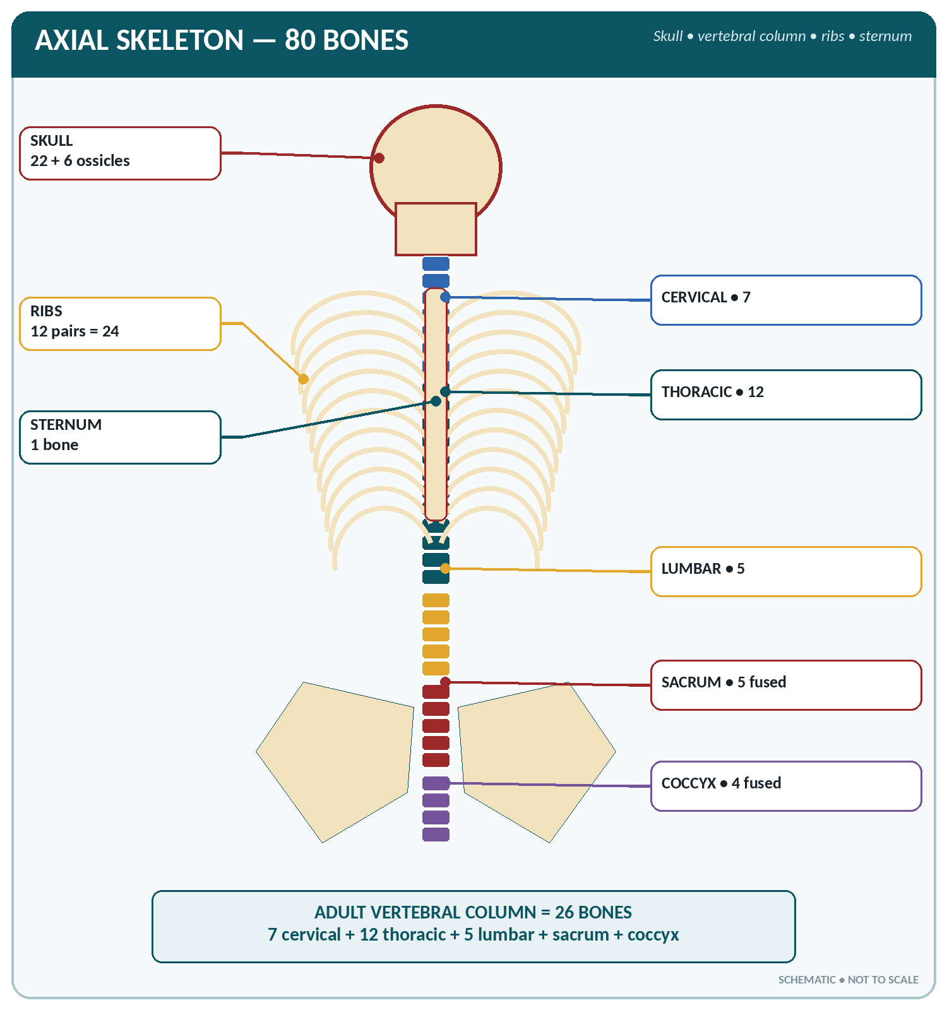
FIGURE • Axial skeleton—skull, vertebral regions, ribs, sternum and pelvis

▪ The adult column has 26 bones (the child has 33): 7 cervical, 12 thoracic, 5 lumbar, the sacrum (5 fused) and the coccyx (4 fused).
▪ Length about 70–72 cm in the male (about 60 cm in the female) — approximately 2/5 of the body height. The intervertebral discs make up about one-quarter of its length.
A typical vertebra
▪ Body (centrum) — anterior, weight-bearing.
▪ Vertebral (neural) arch — two pedicles and two laminae enclosing the vertebral foramen.
▪ Processes — one spinous (posterior), two transverse (lateral), and four articular (two superior, two inferior).
▪ Intervertebral foramina between adjacent vertebrae transmit the spinal nerves.
Regional characteristics of the vertebrae
Region | Number | Distinguishing features
Cervical | 7 | Foramen transversarium in each transverse process (transmits the vertebral artery, except in C7); small body; bifid spine (C3–C6); C1 = atlas (no body, no spine); C2 = axis (bears the odontoid process/dens); C7 = vertebra prominens (longest spine, palpable)
Thoracic | 12 | Costal facets on the body and transverse processes for the ribs; long, sharply downward-directed spine; heart-shaped body
Lumbar | 5 | Largest and heaviest bodies; short thick horizontal spine (hatchet-shaped); no costal facets, no foramen transversarium
Sacrum | 5 fused = 1 | Triangular; four pairs of sacral foramina; articulates with the ilium at the sacro-iliac joint and with L5 above; sacral hiatus at the lower end (site of caudal anaesthesia)
Coccyx | 4 fused = 1 | The vestigial "tail bone"; articulates with the sacrum

ATLAS AND AXIS
▪ Atlas (C1) — ring-shaped, has no body and no spine; carries the skull; the atlanto-occipital joint permits nodding ("yes").
▪ Axis (C2) — bears the dens (odontoid process) which projects into the ring of the atlas; the atlanto-axial joint permits rotation ("no").
▪ The spinal cord in the adult ends at the level of L1–L2 (lower border of L1); lumbar puncture is therefore performed between L3–L4 or L4–L5 (the level of the iliac crests).

Curves of the vertebral column
▪ Primary curves (present at birth, concave forwards / kyphotic): thoracic and sacral.
▪ Secondary curves (acquired, convex forwards / lordotic): cervical — appears when the baby holds up its head (about 3 months); lumbar — appears when the child sits and walks (about 9–18 months).
▪ Functions of the curves: they give strength and resilience (spring), absorb shock, help balance and increase the capacity of the thorax and pelvis.
▪ Abnormal curves: kyphosis (excessive backward thoracic curve — "hunchback"), lordosis (excessive forward lumbar curve — "hollow back"), scoliosis (lateral curvature).
Intervertebral discs
▪ Present between the bodies of adjacent vertebrae from C2 to the sacrum (there is no disc between the atlas and axis); 23 discs in all.
▪ Each disc has a tough outer annulus fibrosus (fibrocartilage) and a soft central nucleus pulposus (remnant of the notochord, 70–90% water).
▪ Functions: shock absorbers, allow movement and contribute to the length of the column.
▪ Prolapsed (herniated) disc most often occurs at L4–L5 or L5–S1 and presses on the nerve root, causing sciatica.
Movements and functions of the column
▪ Movements: flexion, extension, lateral flexion and rotation — greatest in the cervical region; rotation is greatest in the thoracic region; flexion and extension are free in the lumbar region; the thoracic region is the least mobile because of the ribs.
▪ Functions: protects the spinal cord, supports the skull, gives attachment to the ribs and muscles, transmits body weight to the pelvis, and permits movement while keeping the trunk erect.
The Thoracic Cage (Bones of the Thorax)
▪ Formed by the sternum in front, 12 pairs of ribs with their costal cartilages at the sides, and the 12 thoracic vertebrae behind.
▪ It protects the heart, lungs and great vessels, supports the shoulder girdle and takes part in respiration.
The sternum (breast bone)
▪ A flat, dagger-shaped bone in three parts:
– Manubrium — the upper part; articulates with the clavicles and the first rib; its upper border shows the suprasternal (jugular) notch.
– Body (gladiolus) — articulates with the cartilages of ribs 2–7.
– Xiphoid process — cartilaginous in youth, ossifies about 40 years.
▪ The sternal angle (angle of Louis) is the ridge at the manubriosternal joint, opposite the 2nd costal cartilage and the level of T4/T5 — an important surface landmark (bifurcation of the trachea, arch of the aorta).
▪ The sternum contains red marrow throughout life and is a site for marrow puncture; it is also the site of compression in cardiopulmonary resuscitation (lower half of the sternum).
The ribs
Classification of the ribs
Group | Ribs | Attachment in front
True (vertebro-sternal) | 1st – 7th | Attached to the sternum by their own costal cartilage
False (vertebro-chondral) | 8th, 9th, 10th | Attached indirectly, their cartilages joining the cartilage above
Floating (vertebral) | 11th and 12th | Free anteriorly — no attachment in front

▪ A typical rib (3rd–9th) has a head (two facets), a neck, a tubercle, a shaft with an angle, and a costal groove on its inner lower border carrying the intercostal nerve and vessels (order from above downward: vein, artery, nerve — "VAN").
▪ Atypical ribs: 1st (broadest, shortest, most curved; grooves for the subclavian vessels and the scalene tubercle), 2nd, 10th, 11th and 12th (single facet, no tubercle or angle).
▪ Cervical rib is an extra rib arising from C7; it may compress the subclavian artery and the brachial plexus (thoracic outlet syndrome).
▪ The ribs move at their vertebral joints in respiration, the upper ribs in a "pump-handle" and the lower in a "bucket-handle" fashion, increasing the antero-posterior and transverse diameters of the thorax.
CONTENTS OF THE COSTAL GROOVE
From above downwards — V-A-N: Vein, Artery, Nerve. (Remember this for the site of insertion of a chest drain — just above the upper border of the rib below, to avoid the vessels.)

The Pelvis (Bony Pelvis)
The pelvis is formed by the two hip bones, the sacrum and the coccyx. Each hip (innominate) bone is formed by the fusion of three bones — the ilium, ischium and pubis — which meet at the acetabulum (fusion complete by 20–25 years).
▪ The false (greater) pelvis lies above the pelvic brim and supports the abdominal viscera; the true (lesser) pelvis lies below it and contains the pelvic organs and forms the birth canal.
▪ The pelvic brim (inlet) is bounded by the sacral promontory, the iliopectineal lines and the upper border of the symphysis pubis.
▪ Joints of the pelvis: two sacro-iliac joints (synovial, very strong), the symphysis pubis (secondary cartilaginous) and the sacrococcygeal joint. In pregnancy the ligaments soften under the influence of relaxin and progesterone.
▪ The obturator foramen is the large opening in the hip bone, closed by the obturator membrane and transmitting the obturator nerve and vessels.
Male and female pelvis compared — a very common question
Feature | Male pelvis | Female pelvis
General build | Thick, heavy, strong | Light, thin, smooth
Pelvic inlet | Heart-shaped | Round / oval (transversely wider)
Pelvic cavity | Deep, funnel-shaped | Shallow, cylindrical, roomy
Pelvic outlet | Narrow | Wide
Sub-pubic (pubic) arch | Narrow, V-shaped (< 90°) | Wide, U-shaped (> 90°)
Greater sciatic notch | Narrow | Wide
Sacrum | Long, narrow, more curved | Short, wide, less curved
Ischial tuberosities and spines | Inturned, closer | Everted, further apart
Acetabulum | Large, faces laterally | Small, faces anteriorly
Obturator foramen | Round | Triangular / oval
Function | Support and locomotion | Adapted for child-bearing

DIAMETERS OF THE FEMALE PELVIS (OBSTETRIC AVERAGES)
Plane | Antero-posterior | Transverse | Oblique
Inlet (brim) | True conjugate 11 cm; obstetric (available) conjugate 10.5 cm; diagonal conjugate 12.5 cm | 13 cm | 12 cm
Cavity | 12 cm | 12 cm | 12 cm
Outlet | 13 cm | 11 cm | 12 cm

Note: at the inlet the transverse diameter is the longest; at the outlet the antero-posterior is the longest — this is why the fetal head rotates during labour.

HEAD AND TRUNK BONES — HIGH-YIELD FACTS
▪ Skull 22 bones (8 cranial + 14 facial); only movable skull bone = mandible; largest facial bone = mandible; smallest facial bones = lacrimal.
▪ Pituitary gland lies in the sella turcica of the sphenoid; olfactory nerves pierce the cribriform plate of the ethmoid; spinal cord passes through the foramen magnum of the occipital.
▪ Anterior fontanelle — diamond shaped, closes at 18 months; posterior fontanelle — triangular, closes at 6–8 weeks.
▪ Vertebrae 33 in the child, 26 in the adult; C7 = vertebra prominens; C1 = atlas, C2 = axis.
▪ Lumbar puncture is done at L3–L4/L4–L5 because the cord ends at L1–L2.
▪ Ribs: 7 true, 3 false, 2 floating; the 1st rib is the shortest, broadest and most curved.
▪ The sternal angle lies at the level of T4/T5 and the 2nd costal cartilage.
▪ The hip bone = ilium + ischium + pubis, fusing at the acetabulum.
▪ Female pelvic inlet is round/oval, male heart-shaped; pubic arch wide in the female.

CHAPTER 8
Bones of the Limbs

CHAPTER OUTLINE
The Shoulder (Pectoral) Girdle | The Bones of the Upper Limb | The Hip (Pelvic) Girdle | The Bones of the Lower Limb

The appendicular skeleton contains 126 bones — 64 in the two upper limbs (with the shoulder girdles) and 62 in the two lower limbs (with the hip bones).
Bones of one upper and one lower limb
Upper limb (32 bones) | Number | Lower limb (31 bones) | Number
Clavicle | 1 | Hip bone (innominate) | 1
Scapula | 1 | Femur | 1
Humerus | 1 | Patella | 1
Radius | 1 | Tibia | 1
Ulna | 1 | Fibula | 1
Carpals | 8 | Tarsals | 7
Metacarpals | 5 | Metatarsals | 5
Phalanges | 14 | Phalanges | 14
Total (one side) | 32 | Total (one side) | 31

The Shoulder (Pectoral) Girdle
Each shoulder girdle consists of a clavicle and a scapula. It attaches the upper limb to the axial skeleton — at only one bony joint, the sternoclavicular joint — which is why the upper limb is so mobile.
The clavicle (collar bone)
▪ A long bone lying horizontally, S-shaped (convex forwards medially, concave forwards laterally).
▪ Articulates medially with the sternum (sternoclavicular joint) and laterally with the acromion of the scapula (acromioclavicular joint).
▪ It acts as a strut holding the shoulder away from the trunk and transmits forces from the arm to the axial skeleton; it protects the vessels and nerves passing to the limb.
▪ Special features (frequently examined): the first bone to ossify and the last to complete ossification (25 years); ossifies in membrane; has no medullary cavity; is the most frequently fractured bone (commonly at the junction of the middle and lateral thirds).
The scapula (shoulder blade)
▪ A flat, triangular bone lying over the 2nd to 7th ribs on the back of the thorax.
▪ Borders: superior, medial (vertebral), lateral (axillary). Angles: superior, inferior, lateral.
▪ Important features:
– Glenoid cavity (fossa) — the shallow socket for the head of the humerus at the lateral angle.
– Spine of the scapula — the prominent ridge on the dorsal surface, ending laterally as the acromion process (the tip of the shoulder, the highest point).
– Coracoid process — a beak-like projection from the upper border ("crow's beak").
– Supraspinous and infraspinous fossae on the back, subscapular fossa in front.
– Suprascapular notch — transmits the suprascapular nerve.
The Bones of the Upper Limb
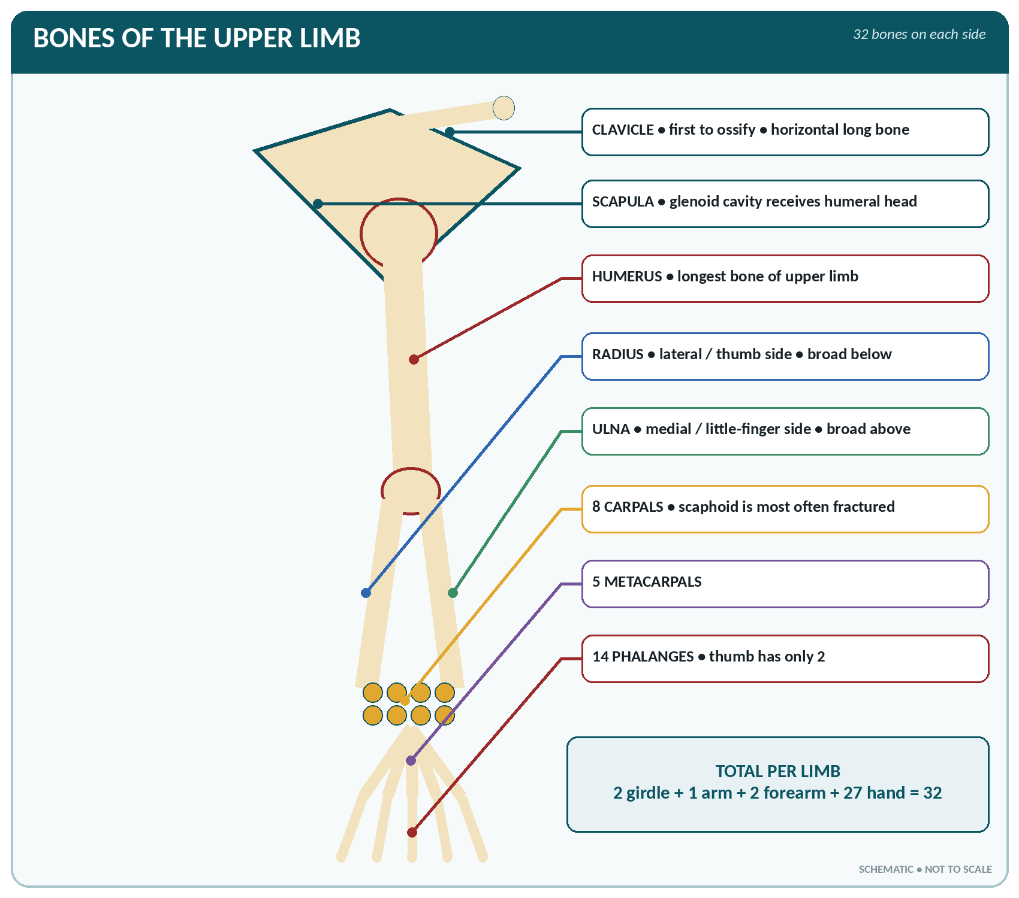
FIGURE • Bones of one upper limb—from shoulder girdle to the 27 bones of the hand

Humerus (bone of the arm)
▪ The longest and largest bone of the upper limb.
▪ Upper end: a hemispherical head (articulates with the glenoid cavity), an anatomical neck, a greater and a lesser tubercle separated by the intertubercular (bicipital) groove for the long head of biceps, and a surgical neck below the tubercles.
▪ Shaft: bears the deltoid tuberosity laterally and the spiral (radial) groove posteriorly for the radial nerve and profunda brachii vessels.
▪ Lower end: the trochlea (articulates with the ulna), the capitulum (articulates with the radius), the medial and lateral epicondyles, and the coronoid, radial and olecranon fossae.
▪ Nerve relations that are examination favourites:
– Surgical neck — axillary nerve and posterior circumflex humeral artery (injured in fracture of the surgical neck and in shoulder dislocation → deltoid paralysis, loss of sensation over the shoulder).
– Spiral groove of the shaft — radial nerve (injury → wrist drop).
– Behind the medial epicondyle — ulnar nerve (injury → claw hand).
– Supracondylar region — median nerve and brachial artery.
Radius and ulna (bones of the forearm)
Radius compared with ulna
Feature | Radius (lateral, thumb side) | Ulna (medial, little-finger side)
Upper end | Small disc-like head, neck, radial tuberosity for biceps | Large — olecranon process, coronoid process, trochlear notch, radial notch
Lower end | Large; articulates with the carpus (scaphoid and lunate) and with the ulna; bears the styloid process (lower than the ulnar styloid) | Small head with a styloid process; excluded from the wrist joint by the articular disc
Elbow joint | Articulates with the capitulum | Articulates with the trochlea — the chief bone of the elbow joint
Wrist joint | The chief bone of the wrist joint | Takes no direct part in the wrist joint
Movement | Rotates over the ulna in pronation and supination | Does not rotate
Classic fracture | Colles' fracture — lower end of radius, dorsal displacement ("dinner-fork deformity"), due to a fall on the outstretched hand; Smith's fracture is the reverse | Olecranon fracture; Monteggia fracture-dislocation

The hand (27 bones)
▪ Carpus — 8 short bones in two rows of four:
– Proximal row (lateral to medial): scaphoid, lunate, triquetral, pisiform.
– Distal row (lateral to medial): trapezium, trapezoid, capitate, hamate.
– The scaphoid is the most frequently fractured carpal bone and is liable to avascular necrosis; the capitate is the largest carpal bone; the pisiform is a sesamoid bone.
▪ Metacarpals — 5 miniature long bones, numbered from the thumb (1st) to the little finger (5th). The first metacarpal is the shortest and stoutest and its carpometacarpal joint is a saddle joint permitting opposition of the thumb.
▪ Phalanges — 14: two in the thumb (proximal and distal) and three in each of the other four fingers (proximal, middle, distal).
THE EIGHT CARPAL BONES
"She Looks Too Pretty, Try To Catch Her" — Scaphoid, Lunate, Triquetral, Pisiform (proximal row); Trapezium, Trapezoid, Capitate, Hamate (distal row). Remember: trapezium is in line with the thumb ("trapeziuM — thuMb").

The Hip (Pelvic) Girdle
▪ Each hip bone (innominate bone) is made of three parts fused at the acetabulum:
– Ilium — the large flared upper part; features: iliac crest (its highest point is at the level of L4), anterior and posterior superior iliac spines, anterior and posterior inferior iliac spines, iliac fossa and the auricular surface for the sacrum.
– Ischium — the lower and posterior part; features: ischial tuberosity (the bone we sit on), ischial spine (an obstetric landmark for the level of the fetal head and for pudendal nerve block), and the lesser and greater sciatic notches.
– Pubis — the anterior part; features: body, superior and inferior rami, pubic crest, pubic tubercle, and the symphysis pubis joining the two pubic bones.
▪ The acetabulum is the deep cup that receives the head of the femur; the obturator foramen lies below and in front of it.
The Bones of the Lower Limb
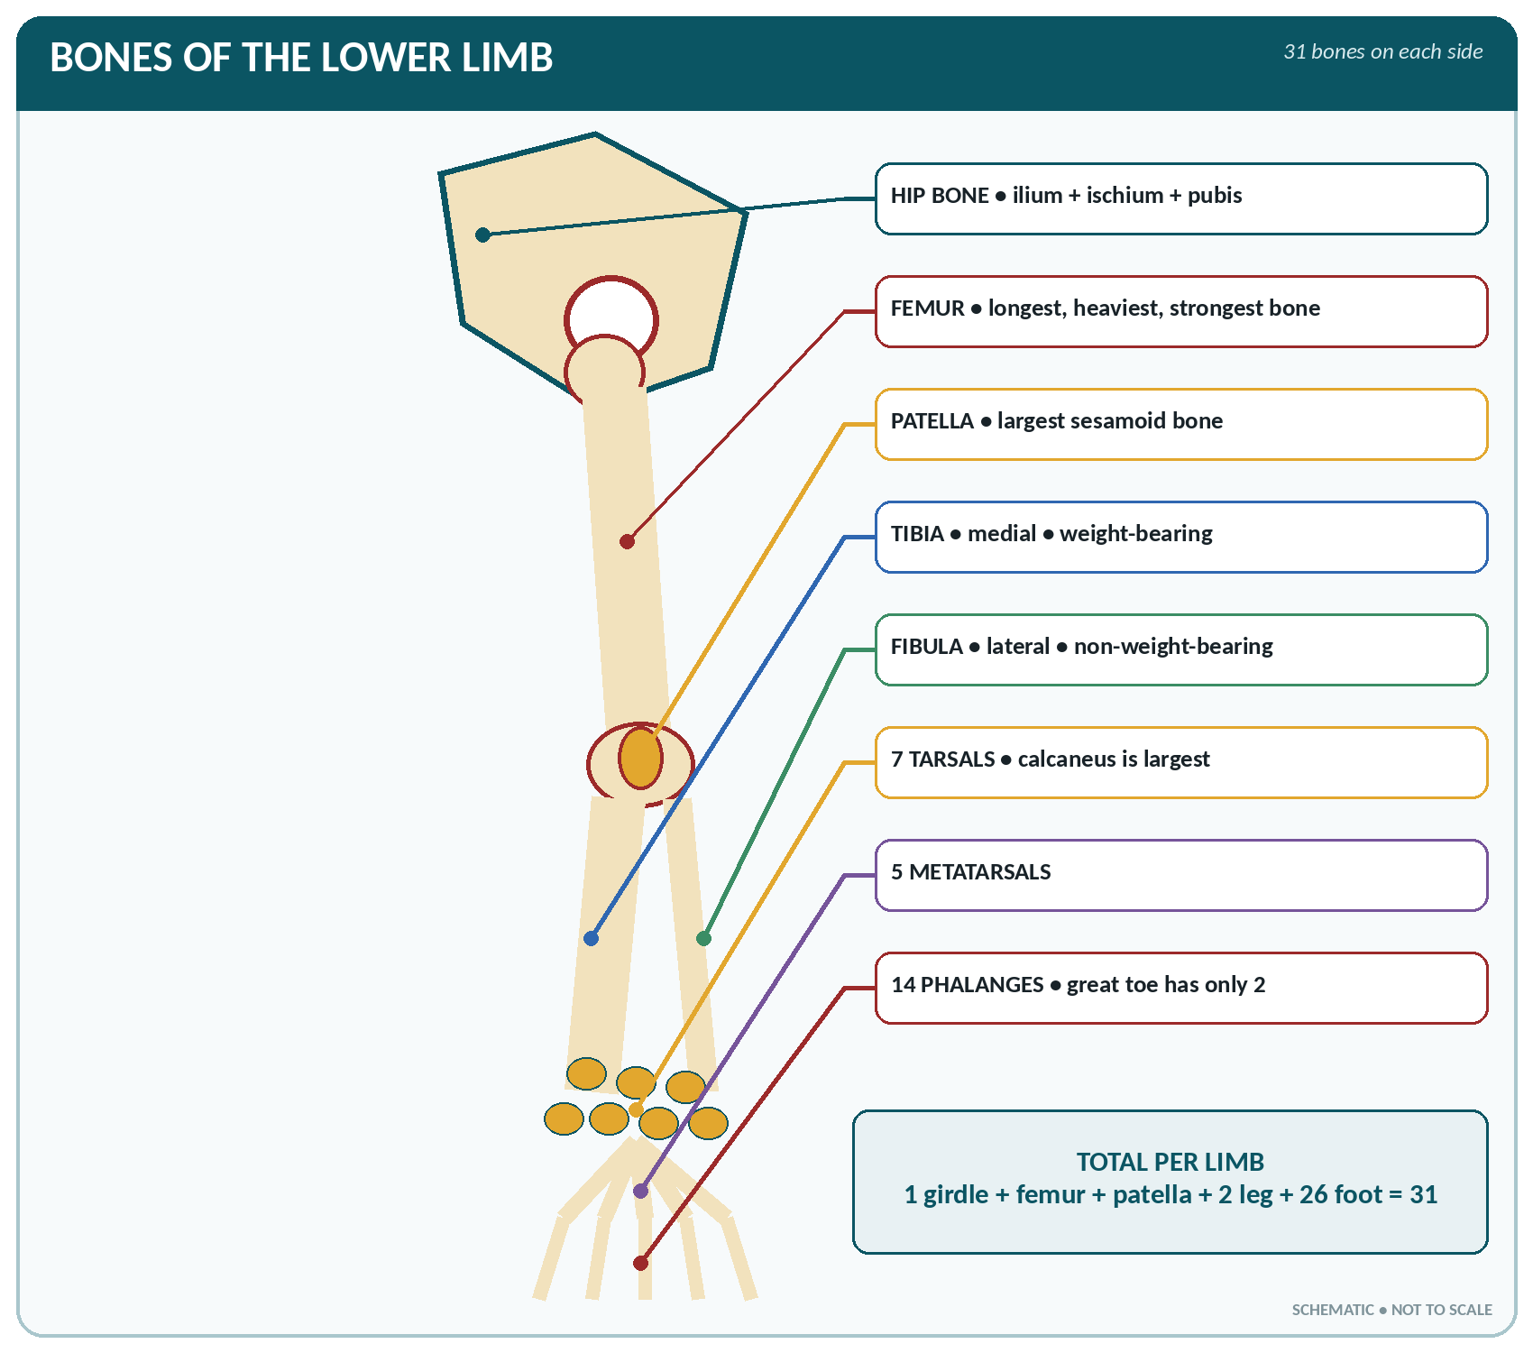
FIGURE • Bones of one lower limb—from hip bone to the 26 bones of the foot

Femur (thigh bone)
▪ The longest, heaviest and strongest bone in the body (about one-quarter of the body height).
▪ Upper end: the rounded head (with the fovea for the ligament of the head), a long neck (set at about 125° to the shaft — the angle of inclination), the greater and lesser trochanters, and the intertrochanteric line and crest.
▪ Shaft: slightly bowed forwards; bears the linea aspera posteriorly for muscle attachment.
▪ Lower end: two large condyles (medial and lateral) with the intercondylar fossa between, the patellar surface in front, and the medial and lateral epicondyles with the adductor tubercle.
▪ Blood supply and its importance: the head is supplied chiefly by the retinacular branches of the medial and lateral circumflex femoral arteries, with a small artery in the ligament of the head. A fracture of the neck of the femur (common in elderly osteoporotic women) tears these vessels and causes avascular necrosis of the head.
Patella (knee cap)
▪ The largest sesamoid bone in the body, lying in the tendon of the quadriceps femoris.
▪ Triangular with the apex downwards; its posterior surface articulates with the femoral condyles.
▪ It has no periosteum; it protects the front of the knee joint and increases the leverage of the quadriceps.
Tibia and fibula (bones of the leg)
Tibia compared with fibula
Feature | Tibia (shin bone — medial) | Fibula (lateral)
Size | The second longest bone of the body; weight-bearing | Slender; non-weight-bearing
Upper end | Medial and lateral condyles, intercondylar area, tibial tuberosity (for the patellar ligament) | Head — articulates with the lateral condyle of the tibia; the common peroneal nerve winds round its neck
Shaft | Triangular; the anterior border (shin) is subcutaneous | Gives attachment to muscles only
Lower end | Medial malleolus; forms the chief part of the ankle joint | Lateral malleolus — projects lower than the medial
Joints | Knee (above), ankle (below), and with the fibula | Does not take part in the knee joint; takes part in the ankle joint
Clinical | Common site of compound fracture (subcutaneous); site of intra-osseous infusion in children | May be removed for bone grafting without loss of weight-bearing

The foot (26 bones)
▪ Tarsus — 7 bones:
– Talus (astragalus) — the only bone of the foot articulating with the leg bones; forms the ankle joint; no muscle is attached to it; it transmits body weight to the foot and is liable to avascular necrosis.
– Calcaneus (heel bone) — the largest tarsal bone; bears the tendo calcaneus (Achilles tendon) and the sustentaculum tali.
– Navicular (medial), cuboid (lateral) and three cuneiforms (medial, intermediate, lateral).
▪ Metatarsals — 5, numbered from the great toe. The 1st is the shortest and thickest; the base of the 5th bears a prominent tuberosity (a common fracture site).
▪ Phalanges — 14: two in the great toe, three in each of the other toes.
THE SEVEN TARSAL BONES
"Tiger Cubs Need MILC" — Talus, Calcaneus, Navicular, Medial cuneiform, Intermediate cuneiform, Lateral cuneiform, Cuboid.

Arches of the foot
▪ The foot is arched so that weight is transmitted to the ground at three points: the heel (calcaneus), the head of the first metatarsal and the head of the fifth metatarsal.
▪ Medial longitudinal arch — calcaneus, talus, navicular, three cuneiforms, medial three metatarsals; higher and more important.
▪ Lateral longitudinal arch — calcaneus, cuboid, 4th and 5th metatarsals; low and flat.
▪ Transverse arch — cuboid, cuneiforms and the bases of the metatarsals.
▪ Arches are maintained by the shape of the bones, by ligaments (plantar calcaneonavicular or "spring" ligament, long and short plantar ligaments, plantar aponeurosis) and by muscles (tibialis posterior and anterior, peroneus longus, flexor hallucis longus, and the intrinsic muscles).
▪ Functions: distribute body weight, act as shock absorbers, give spring to the step, and protect the vessels and nerves of the sole.
▪ Loss of the medial arch produces flat foot (pes planus); an exaggerated arch is pes cavus.
LIMB BONES — RAPID REVISION
▪ Longest / strongest bone — femur; second longest — tibia; smallest bone — stapes.
▪ Clavicle: first to ossify, last to finish, commonest fracture, no medullary cavity.
▪ Largest sesamoid — patella; commonest fractured carpal — scaphoid; largest carpal — capitate; largest tarsal — calcaneus.
▪ Nerve at the surgical neck of humerus — axillary; in the spiral groove — radial (wrist drop); behind the medial epicondyle — ulnar; behind the neck of fibula — common peroneal (foot drop).
▪ Colles' fracture = lower end of the radius; Pott's fracture involves the ankle; fracture of the neck of femur → avascular necrosis of the head.
▪ Thumb and great toe have 2 phalanges each; every other digit has 3.
▪ The talus has no muscular attachment; the lateral malleolus (fibula) descends lower than the medial.
▪ The highest point of the iliac crest is at the level of L4 — the landmark for lumbar puncture.

CHAPTER 9
Joints and Articulations

CHAPTER OUTLINE
Fibrous Joints (Immovable) | Cartilaginous Joints (Slightly Movable) | Synovial Joints (Freely Movable) | The Chief Joints of the Body in Detail

A joint (articulation) is the site where two or more bones, or bone and cartilage, meet. The study of joints is arthrology. Joints are classified according to the material uniting the bones (structural classification) and according to the degree of movement they permit (functional classification).
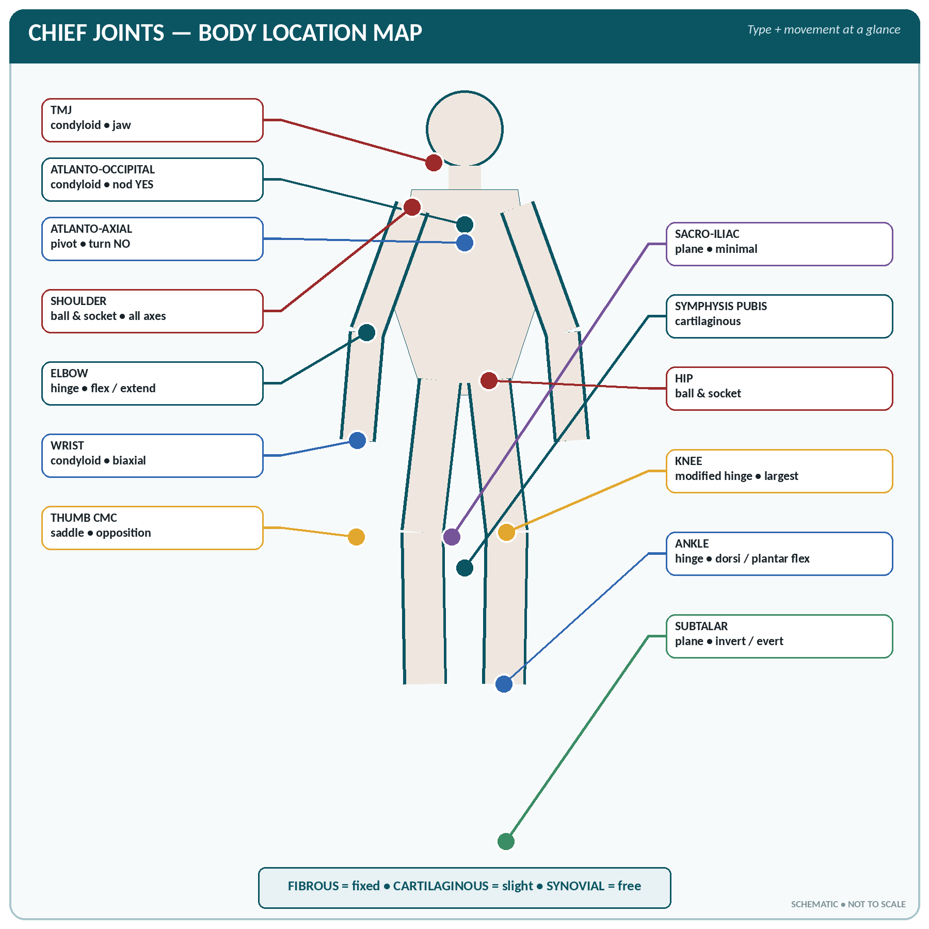
FIGURE • Body-location map of the chief joints, their structural type and characteristic movement

Functional (physiological) classification of joints
Class | Movement | Structural equivalent | Examples
Synarthrosis | Immovable (fixed) | Fibrous | Sutures of the skull, gomphosis (tooth in socket)
Amphiarthrosis | Slightly movable | Cartilaginous | Symphysis pubis, intervertebral discs, first sternocostal joint, sacro-iliac joint (partly)
Diarthrosis | Freely movable | Synovial | Shoulder, hip, knee, elbow, wrist, ankle — the great majority of the joints of the limbs

Fibrous Joints (Immovable)
▪ The bones are united by fibrous (collagenous) tissue; there is no joint cavity and virtually no movement.
▪ Types:
– Suture — thin fibrous layer between skull bones (serrate, squamous, plane sutures). In old age the fibrous tissue ossifies, forming a synostosis.
– Syndesmosis — bones joined by an interosseous ligament or membrane, permitting slight give: inferior tibiofibular joint, the interosseous membranes of the forearm and leg.
– Gomphosis (peg-and-socket) — the root of a tooth in its alveolus, held by the periodontal ligament.
Cartilaginous Joints (Slightly Movable)
▪ Primary cartilaginous joint (synchondrosis) — bones united by hyaline cartilage; usually temporary, disappearing when growth ends. Examples: the epiphyseal plate, the first sternocostal joint (permanent), the joint between the basi-occiput and basi-sphenoid.
▪ Secondary cartilaginous joint (symphysis) — the bone ends are covered with hyaline cartilage and joined by a disc of fibrocartilage; permanent and slightly movable, always in the median plane. Examples: symphysis pubis, the intervertebral joints (discs), the manubriosternal joint, the sacrococcygeal joint.
Synovial Joints (Freely Movable)
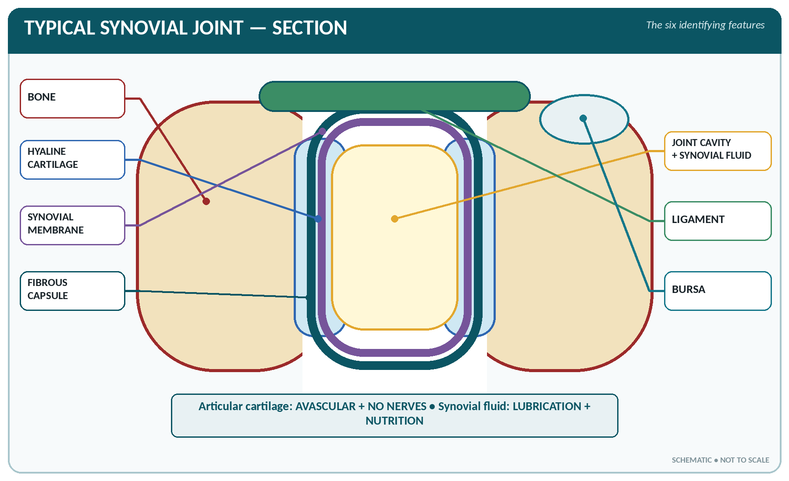
FIGURE • Section through a typical synovial joint—cartilage, cavity, membrane, capsule, ligament and bursa

Characteristic features
1. Articular (joint) cavity containing synovial fluid.
2. Articular cartilage — usually hyaline — covering the bone ends; it is avascular and has no nerve supply, so it is painless but heals poorly.
3. Articular capsule — an outer fibrous capsule lined by synovial membrane.
4. Synovial membrane — secretes synovial fluid; lines the capsule and all intra-articular surfaces except the articular cartilage and the articular discs.
5. Ligaments — capsular, extracapsular and intracapsular; they limit and guide movement.
6. Accessory structures in some joints: articular disc or meniscus (knee, temporomandibular, sternoclavicular, wrist), fat pads, bursae and tendon sheaths.
Synovial fluid
▪ A clear, pale-yellow, viscid fluid resembling egg-white (hence synovia), alkaline, containing hyaluronic acid, a little protein, salts and a few cells (macrophages and leucocytes).
▪ Functions: lubricates the joint and reduces friction; nourishes the articular cartilage (which is avascular); acts as a shock absorber; removes debris by the phagocytes it contains; maintains joint stability by surface tension.
▪ The amount is very small — for example only about 0.5 mL in the knee joint, the largest joint.
▪ Factors maintaining the stability of a synovial joint: shape of the articular surfaces, the ligaments and capsule, muscle tone (the most important factor), atmospheric pressure (important at the hip), and the intra-articular discs.
Classification of synovial joints
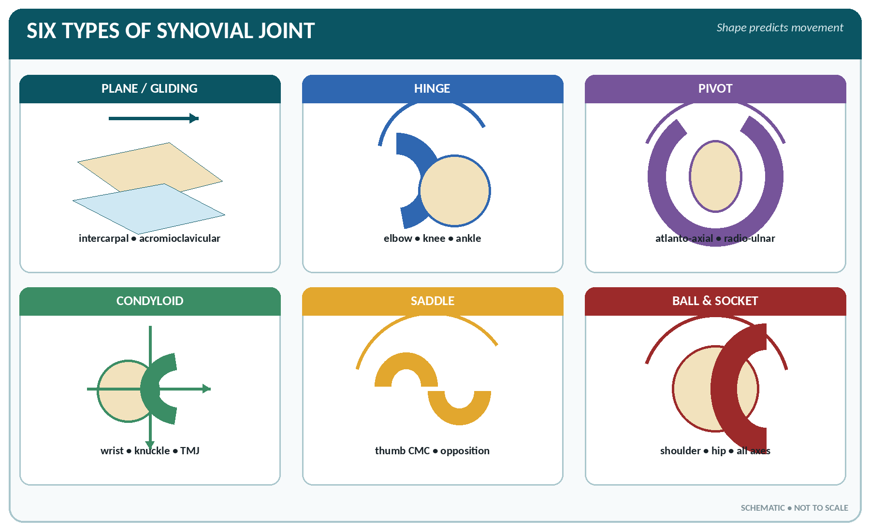
FIGURE • The six shapes of synovial joint—link each shape to its axes, movement and examples

The six types of synovial joint
Type | Shape / mechanism | Axes of movement | Movements | Examples
Plane (gliding) | Flat apposed surfaces | Non-axial | Gliding only | Intercarpal, intertarsal, acromioclavicular, joints between vertebral articular processes, sternoclavicular
Hinge | Convex on concave, like a door hinge | Uniaxial | Flexion and extension only | Elbow, knee (a modified hinge), ankle, interphalangeal joints
Pivot (trochoid) | A rounded process rotating in a ring | Uniaxial | Rotation | Atlanto-axial joint; superior and inferior radio-ulnar joints
Condyloid (ellipsoid) | Oval condyle in an elliptical socket | Biaxial | Flexion, extension, abduction, adduction, circumduction (no true rotation) | Wrist (radiocarpal), metacarpophalangeal (knuckle), temporomandibular, atlanto-occipital
Saddle (sellar) | Both surfaces concavo-convex, like a saddle | Biaxial | Flexion, extension, abduction, adduction, opposition | First carpometacarpal joint (thumb), sternoclavicular, calcaneocuboid
Ball and socket (spheroidal) | Globular head in a cup | Multiaxial (triaxial) | All movements — flexion, extension, abduction, adduction, rotation, circumduction | Shoulder, hip — the freest joints of the body

TYPES OF SYNOVIAL JOINT
"BACHPS" — Ball and socket, Angular/condyloid, Condyloid, Hinge, Pivot, Saddle and plane. Simpler: "Plane Hinges Pivot; Condyles Saddle the Ball."

The Chief Joints of the Body in Detail
Temporomandibular joint (TMJ)
▪ Condyloid (modified hinge) synovial joint between the mandibular condyle and the mandibular (glenoid) fossa of the temporal bone.
▪ Contains a complete fibrocartilaginous articular disc dividing it into two cavities; the articular surfaces are covered by fibrocartilage, not hyaline cartilage.
▪ Movements: depression and elevation (opening and closing the mouth), protraction and retraction, and side-to-side grinding. Muscles: masseter, temporalis and medial pterygoid close the mouth; the lateral pterygoid and the digastric/gravity open it.
▪ The only joint of the skull that moves; it may be dislocated anteriorly by wide yawning.
Shoulder joint (glenohumeral)
▪ Ball-and-socket joint between the head of the humerus and the shallow glenoid cavity of the scapula, deepened by the fibrocartilaginous glenoid labrum.
▪ The most freely movable joint in the body, and therefore the least stable and most frequently dislocated (usually antero-inferiorly, risking injury to the axillary nerve).
▪ Stability depends mainly on the rotator cuff muscles — supraspinatus, infraspinatus, teres minor and subscapularis (mnemonic SITS).
▪ Ligaments: glenohumeral, coracohumeral, transverse humeral; the coraco-acromial arch protects above.
▪ Movements: flexion, extension, abduction, adduction, medial and lateral rotation, circumduction. The first 15–20° of abduction is by supraspinatus, then the deltoid; beyond 90° the scapula rotates (trapezius and serratus anterior).
Elbow joint
▪ A hinge synovial joint: the trochlea of the humerus with the trochlear notch of the ulna, and the capitulum with the head of the radius.
▪ Movements: flexion and extension only. Flexors — biceps brachii, brachialis, brachioradialis; extensor — triceps.
▪ Strengthened by the medial and lateral collateral ligaments and the annular ligament (which holds the head of the radius). Pronation and supination occur at the radio-ulnar joints, not at the elbow.
▪ The ulnar nerve lies behind the medial epicondyle; the median nerve and brachial artery lie in front.
Wrist (radiocarpal) joint
▪ A condyloid (ellipsoid) joint between the lower end of the radius and the articular disc above and the scaphoid, lunate and triquetral below. The ulna does not take part.
▪ Movements: flexion, extension, abduction (radial deviation), adduction (ulnar deviation) and circumduction. No rotation.
Hip joint
▪ A ball-and-socket joint between the head of the femur and the deep acetabulum, which is deepened by the acetabular labrum and completed by the transverse acetabular ligament.
▪ Very strong and stable (weight-bearing) but less mobile than the shoulder.
▪ Ligaments: iliofemoral (the strongest ligament in the body, inverted-Y shaped), pubofemoral, ischiofemoral, and the intracapsular ligament of the head of the femur (ligamentum teres) which carries a small artery to the head.
▪ Movements: flexion, extension, abduction, adduction, medial and lateral rotation, circumduction.
▪ Clinical: congenital dislocation of the hip; fracture of the neck of the femur with avascular necrosis; the sciatic nerve lies behind the joint.
Knee joint
▪ The largest and most complicated joint in the body — a modified hinge (bicondylar) synovial joint between the condyles of the femur, the condyles of the tibia and the patella. The fibula takes no part.
▪ Intracapsular structures:
– Medial and lateral menisci (semilunar cartilages) of fibrocartilage — shock absorbers which deepen the surfaces. The medial meniscus is more often torn (it is more fixed).
– Anterior cruciate ligament (ACL) — prevents anterior displacement of the tibia on the femur and prevents hyperextension.
– Posterior cruciate ligament (PCL) — prevents posterior displacement of the tibia; the stronger of the two.
▪ Extracapsular structures: medial (tibial) and lateral (fibular) collateral ligaments, the patellar ligament, and the oblique and arcuate popliteal ligaments.
▪ Bursae — the suprapatellar, prepatellar ("housemaid's knee"), infrapatellar ("clergyman's knee") and popliteal bursae; the suprapatellar bursa communicates with the joint cavity.
▪ Movements: flexion and extension, with slight rotation when flexed. The knee is "locked" in full extension by medial rotation of the femur; it is "unlocked" by the popliteus muscle.
▪ The quadriceps femoris is the extensor; the hamstrings are the flexors.
Ankle (talocrural) joint
▪ A hinge joint between the lower end of the tibia and both malleoli above and the talus below ("the tibia and fibula grip the talus like a spanner").
▪ Movements: dorsiflexion (toes up) and plantar flexion (toes down) only. Inversion and eversion occur at the subtalar (talocalcanean) and talocalcaneonavicular joints, not at the ankle.
▪ Ligaments: deltoid (medial) ligament — strong; lateral ligament (anterior and posterior talofibular and calcaneofibular parts) — weaker, hence inversion sprains are the commonest ankle injury.
Summary of the chief joints — type and movement
Joint | Type | Movements permitted
Sutures of the skull | Fibrous (immovable) | None
Temporomandibular | Synovial — condyloid with disc | Opening, closing, protraction, retraction, side-to-side
Atlanto-occipital | Synovial — condyloid | Nodding — flexion and extension ("yes")
Atlanto-axial | Synovial — pivot | Rotation ("no")
Between vertebral bodies | Cartilaginous (symphysis) | Slight gliding; collectively large
Sternoclavicular | Synovial — saddle with disc | Gliding, elevation, depression, protraction, retraction
Acromioclavicular | Synovial — plane | Gliding
Shoulder | Synovial — ball and socket | All; the freest joint
Elbow | Synovial — hinge | Flexion, extension
Radio-ulnar (sup. and inf.) | Synovial — pivot | Pronation and supination
Wrist | Synovial — condyloid | Flexion, extension, abduction, adduction, circumduction
1st carpometacarpal (thumb) | Synovial — saddle | Flexion, extension, abduction, adduction, opposition
Metacarpophalangeal | Synovial — condyloid | Flexion, extension, abduction, adduction
Interphalangeal | Synovial — hinge | Flexion, extension
Sacro-iliac | Synovial (partly fibrous), very strong | Minimal gliding; slight in pregnancy
Symphysis pubis | Cartilaginous (secondary) | Slight; softens in pregnancy
Hip | Synovial — ball and socket | All movements; strong and stable
Knee | Synovial — modified hinge | Flexion, extension, slight rotation when flexed
Ankle | Synovial — hinge | Dorsiflexion, plantar flexion
Subtalar / talonavicular | Synovial — plane / ball and socket | Inversion and eversion
Tooth in its socket | Fibrous — gomphosis | None

JOINTS — SUPERLATIVES AND SPECIAL POINTS
▪ Largest and most complex joint — the knee. Most movable — the shoulder.
▪ Most commonly dislocated — the shoulder. Strongest ligament — the iliofemoral.
▪ Only joint of the skull with movement — the temporomandibular joint.
▪ Only saddle joints — the thumb (1st carpometacarpal) and sternoclavicular.
▪ Joints containing an articular disc/meniscus — knee, temporomandibular, sternoclavicular, acromioclavicular, inferior radio-ulnar (wrist).
▪ Articular cartilage is hyaline, avascular and has no nerve supply — hence pain in joint disease arises from the capsule, synovium and ligaments.
▪ Movement possible only in the thumb — opposition; movement at the atlanto-axial joint — rotation.

DISORDERS OF JOINTS
▪ Sprain — injury of a ligament; strain — injury of a muscle/tendon; dislocation (luxation) — complete displacement of the articular surfaces; subluxation — partial.
▪ Osteoarthritis — degenerative "wear and tear" disease of articular cartilage in weight-bearing joints (knee, hip, spine) in the elderly; no systemic features.
▪ Rheumatoid arthritis — a chronic autoimmune inflammation of the synovial membrane; symmetrical, affects small joints of hands and feet, with morning stiffness and deformity; rheumatoid factor positive.
▪ Gout — deposition of uric acid (sodium urate) crystals, classically in the first metatarsophalangeal joint of the great toe.
▪ Ankylosis — abnormal fusion of a joint; arthrodesis is surgical fusion; arthroplasty is joint replacement; arthroscopy is visual inspection of a joint; arthrocentesis is aspiration of joint fluid.
▪ Bursitis — inflammation of a bursa (prepatellar = housemaid's knee; olecranon = student's elbow).
▪ Frozen shoulder (adhesive capsulitis) — painful restriction of all shoulder movements.

CHAPTER 10
Structure and Action of Muscles

CHAPTER OUTLINE
Properties and Types of Muscle | Structure of a Skeletal Muscle | The Neuromuscular Junction and the Mechanism of Contraction | The Action of Muscles | Accessory Structures — Fascia, Bursae, Sheaths and Retinacula | Blood and Nerve Supply of Muscle

Muscle is the contractile tissue of the body. It forms about 40–45% of the body weight — the largest single tissue mass. There are about 600–640 skeletal muscles. The study of muscles is myology.
Properties and Types of Muscle
Fundamental properties of muscle tissue
1. Excitability (irritability) — ability to respond to a stimulus.
2. Contractility — ability to shorten and thicken; the unique property of muscle.
3. Extensibility — ability to be stretched.
4. Elasticity — ability to return to its original length after stretching.
5. Conductivity — ability to propagate an impulse along the fibre.
6. Tonicity (tone) — a state of partial, sustained contraction present at all times in a healthy muscle.
The three types of muscle — recapitulation
Comparison of the three muscle types
Feature | Skeletal | Smooth | Cardiac
Other names | Striated, voluntary | Non-striated, involuntary, visceral, plain | Myocardium
Fibre | Long, cylindrical, unbranched, up to 30 cm | Spindle-shaped, 20–200 µm | Short, branched
Nuclei | Many, peripheral | One, central | One or two, central
Striations | Present | Absent | Present
Intercalated discs | Absent | Absent | Present
Sarcoplasmic reticulum | Very well developed | Poorly developed | Moderate
Nerve supply | Somatic (voluntary) | Autonomic | Autonomic (modifies its own rhythm)
Speed of contraction | Fast (0.1 s) | Very slow (up to 30 s), sustained | Moderate (0.8 s cycle)
Fatigue | Fatigues readily | Does not fatigue readily | Never fatigues
Rhythmicity | Absent | Present (peristalsis) | Present — inherent (autorhythmicity)

Structure of a Skeletal Muscle
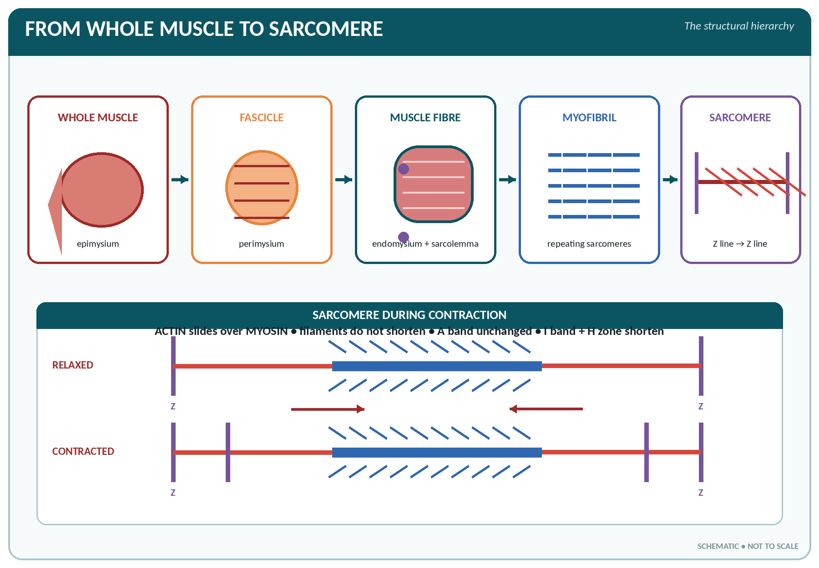
FIGURE • Structural hierarchy from whole skeletal muscle to sarcomere, followed by the sliding-filament mechanism

Gross structure and coverings
▪ A muscle consists of bundles (fasciculi) of muscle fibres. Each is invested in connective tissue:
– Endomysium — around each muscle fibre (cell).
– Perimysium — around each fasciculus (bundle).
– Epimysium — around the whole muscle; continuous with the deep fascia, and at the ends with the tendon, aponeurosis or periosteum.
▪ Attachments: the origin is the more fixed (proximal) attachment; the insertion is the more movable (distal) attachment. The fleshy part is the belly.
▪ Attachment structures: a tendon (a strong cord of dense white fibrous tissue, poorly vascular but very strong), an aponeurosis (a flattened sheet-like tendon) and fascia.
Microscopic structure of a muscle fibre
▪ Each muscle fibre is a multinucleated cell bounded by the sarcolemma, with cytoplasm called sarcoplasm containing many mitochondria, glycogen granules, myoglobin and hundreds of myofibrils.
▪ Sarcoplasmic reticulum (modified endoplasmic reticulum) stores calcium; the T (transverse) tubules carry the impulse into the depth of the fibre.
▪ Each myofibril is made of repeating units called sarcomeres — the functional contractile unit — lying between two Z lines (discs).
▪ Two chief contractile proteins:
– Actin — thin filaments, forming the light I band; associated with troponin and tropomyosin (the regulatory proteins).
– Myosin — thick filaments with heads, forming the dark A band.
▪ Bands of the sarcomere: the A band (dark, anisotropic) contains myosin; the I band (light, isotropic) contains only actin; the H zone is the centre of the A band (myosin only) and the M line its middle.
▪ During contraction the A band stays the same length while the I band and H zone shorten — the filaments slide, they do not shorten.
Red and white muscle fibres
Feature | Red (type I, slow) fibres | White (type II, fast) fibres
Myoglobin and mitochondria | Abundant | Few
Blood supply | Rich | Less
Metabolism | Aerobic (oxidative) | Anaerobic (glycolytic)
Speed and fatigue | Contract slowly, resist fatigue | Contract rapidly, fatigue quickly
Function / examples | Posture and endurance — back muscles, soleus, marathon running | Sudden powerful action — biceps, gastrocnemius, sprinting

The Neuromuscular Junction and the Mechanism of Contraction
Motor unit and motor end plate
▪ A motor unit is one motor neurone together with all the muscle fibres it supplies. The unit is small (a few fibres) where fine control is needed (extra-ocular muscles, 1 : 5–10) and large in powerful muscles (gastrocnemius, 1 : 1000–2000).
▪ The neuromuscular junction (motor end plate) is the specialised synapse between the axon terminal and the sarcolemma; the gap is the synaptic cleft. The transmitter is acetylcholine (ACh), which is destroyed by acetylcholinesterase (cholinesterase).
Sequence of events in contraction (excitation–contraction coupling)
1. A nerve impulse reaches the axon terminal and causes Ca²⁺ influx.
2. Acetylcholine is released into the synaptic cleft and binds to receptors on the sarcolemma.
3. The sarcolemma depolarises; an action potential sweeps over the fibre and along the T tubules.
4. Calcium is released from the sarcoplasmic reticulum into the sarcoplasm.
5. Ca²⁺ binds to troponin, moving tropomyosin and exposing the binding sites on actin.
6. Myosin heads attach to actin forming cross-bridges and swivel — the sliding filament mechanism (Huxley) — pulling the actin filaments toward the centre of the sarcomere. ATP is split for energy.
7. The sarcomeres shorten and the muscle contracts.
8. Acetylcholine is destroyed by cholinesterase; calcium is pumped back into the sarcoplasmic reticulum (needs ATP); tropomyosin re-covers the actin sites and the muscle relaxes.
CHEMISTRY OF MUSCLE CONTRACTION
▪ Immediate energy source: ATP. Reserve store: creatine phosphate (phosphocreatine).
▪ Longer-term fuel: glycogen → glucose, and fatty acids.
▪ Anaerobic work produces lactic acid, which causes fatigue and creates an oxygen debt that is repaid after exercise (rapid breathing continues, the liver converts lactate back to glycogen — the Cori cycle).
▪ Myoglobin stores oxygen in muscle and gives it the red colour.
▪ Rigor mortis — stiffening after death — is due to loss of ATP so that the cross-bridges cannot be released; it begins 2–4 hours after death and passes off in 24–48 hours.

Types of contraction
▪ Isotonic contraction — the muscle shortens and moves a load while the tension stays about the same (walking, lifting). It performs external work.
▪ Isometric contraction — the muscle develops tension without changing length (holding a weight steady, standing still, pushing a wall). It produces heat, not movement.
▪ Twitch — the response to a single stimulus, with a latent period, a contraction phase and a relaxation phase.
▪ Summation and tetanus — rapidly repeated stimuli fuse into a smooth sustained contraction (tetanus), which is how normal movement occurs.
▪ All-or-none law — a single muscle fibre contracts either maximally or not at all; a whole muscle grades its force by recruiting more motor units.
▪ Muscle tone — a continuous partial contraction maintained reflexly through the stretch reflex (muscle spindles → spinal cord → motor neurones). Tone keeps posture, maintains venous return and produces heat. Loss of nerve supply causes flaccidity; upper motor neurone lesions cause spasticity (hypertonia).
▪ Muscle fatigue — inability to contract after prolonged activity, due to depletion of glycogen and ATP, accumulation of lactic acid, and failure at the neuromuscular junction.
▪ Hypertrophy — increase in the size of fibres with exercise; atrophy — wasting from disuse or denervation. Muscle fibres do not increase in number after birth.
The Action of Muscles
How muscles work together
▪ Muscles can only pull, never push; they act across joints, using the bones as levers.
▪ Functional groups acting at a joint:
– Prime mover (agonist) — the muscle chiefly responsible for the movement.
– Antagonist — the muscle that produces the opposite movement; it relaxes (reciprocal inhibition) as the prime mover contracts.
– Synergist — assists the prime mover, or eliminates unwanted movement.
– Fixator — steadies the proximal part so that the prime mover has a firm base (e.g. the scapular muscles fixing the scapula during arm movement).
▪ Antigravity (postural) muscles — extensors of the back, hip and knee, and the calf muscles; they keep us erect.
▪ Muscle group actions at a joint: flexors and extensors, abductors and adductors, rotators, supinators and pronators, invertors and evertors, sphincters (circular muscles closing an orifice).
Shapes and arrangement of muscle fibres
Muscles classified by the direction of their fibres
Type | Arrangement | Example
Fusiform / spindle | Fibres parallel to the long axis | Biceps brachii, sartorius
Unipennate | Fibres oblique, on one side of a tendon (feather-like) | Flexor pollicis longus, extensor digitorum longus
Bipennate | Fibres oblique on both sides of a central tendon | Rectus femoris, dorsal interossei
Multipennate | Several tendons with oblique fibres | Deltoid, subscapularis
Quadrilateral / flat | Sheet-like, parallel fibres | Thyrohyoid, external oblique
Triangular / fan-shaped | Converging fibres | Temporalis, pectoralis major
Circular (sphincter) | Fibres encircle an opening | Orbicularis oris, orbicularis oculi, anal and pyloric sphincters
Cruciate | Fibres cross | Sternocleidomastoid (partly), masseter

▪ Pennate muscles have more fibres in the same volume, so they are stronger but have a smaller range of movement; parallel (fusiform) muscles have a greater range but are weaker.
Naming of muscles
Muscles are named according to:
▪ Shape — deltoid (triangular), trapezius (trapezoid), rhomboid, quadratus, gracilis.
▪ Size — maximus, medius, minimus, longus, brevis, major, minor, vastus, latissimus.
▪ Position — pectoralis (chest), brachii (arm), intercostal, supraspinatus, temporalis, tibialis.
▪ Number of heads/divisions — biceps (2), triceps (3), quadriceps (4), digastric (2 bellies).
▪ Direction of fibres — rectus (straight), oblique, transversus.
▪ Action — flexor, extensor, adductor, levator, depressor, supinator, pronator, sphincter, masseter (chewer), risorius (laughing).
▪ Attachments — sternocleidomastoid, sternohyoid, coracobrachialis, brachioradialis.
Accessory Structures — Fascia, Bursae, Sheaths and Retinacula
▪ Superficial fascia — subcutaneous areolar tissue with fat; carries superficial vessels, nerves and lymphatics; insulates and stores fat.
▪ Deep fascia — tough, inelastic fibrous sheet investing muscles; forms intermuscular septa, compartments, and specialised bands such as the fascia lata of the thigh with its iliotibial tract.
▪ Bursa — a small sac of synovial membrane containing a little fluid, lying where friction occurs (between tendon and bone, skin and bone).
▪ Synovial tendon sheath — a double-walled tube of synovial membrane around a tendon where it passes under a retinaculum or through a tunnel; inflammation is tenosynovitis.
▪ Retinaculum — a band of deep fascia holding tendons in place (flexor retinaculum at the wrist — the roof of the carpal tunnel through which the median nerve passes).
Blood and Nerve Supply of Muscle
▪ Muscle is very vascular; capillaries lie alongside every fibre. Blood flow rises enormously (up to 20 times) during exercise.
▪ Every muscle has a motor nerve supply (to the end plates), a sensory supply from the muscle spindles (stretch receptors) and Golgi tendon organs (tension receptors) — the basis of proprioception — and autonomic fibres to its vessels.
▪ Denervation produces flaccid paralysis, loss of tone and reflexes, and progressive atrophy with fibrous replacement.
DISORDERS OF MUSCLE AND NEUROMUSCULAR JUNCTION
▪ Myasthenia gravis — autoimmune destruction of acetylcholine receptors; fatigable weakness, ptosis and diplopia; improves with neostigmine/edrophonium.
▪ Muscular dystrophy — inherited degeneration of muscle fibres; Duchenne type is X-linked, affects boys, with pseudohypertrophy of the calves and a waddling gait.
▪ Tetanus — Clostridium tetani toxin blocks inhibitory transmitters → sustained spasm, trismus (lockjaw), risus sardonicus and opisthotonos.
▪ Cramp — painful involuntary spasm, often from salt and water loss or ischaemia.
▪ Myalgia — muscle pain; myositis — muscle inflammation; myopathy — muscle disease; fibrositis — inflammation of fibrous tissue.
▪ Curare and other neuromuscular blocking drugs compete with acetylcholine at the end plate and are used to relax muscles during anaesthesia. Organophosphate poisoning inhibits cholinesterase, so acetylcholine accumulates.

MUSCLE — RAPID REVISION
▪ Functional unit of a muscle fibre = sarcomere; contractile proteins = actin and myosin; regulatory proteins = troponin and tropomyosin.
▪ Neurotransmitter at the neuromuscular junction = acetylcholine; it is destroyed by cholinesterase.
▪ The ion that triggers contraction = calcium, stored in the sarcoplasmic reticulum.
▪ Energy for contraction = ATP; reserve = creatine phosphate; oxygen store = myoglobin.
▪ Isotonic = length changes (movement); isometric = tension changes (no movement, more heat).
▪ During contraction the A band is unchanged while the I band and H zone shorten.
▪ Muscle forms about 40–45% of body weight; there are about 600 skeletal muscles.
▪ Tendon joins muscle to bone; aponeurosis is a flat tendon; origin = fixed end, insertion = movable end.

CHAPTER 11
The Chief Muscles of the Body

CHAPTER OUTLINE
Muscles of the Face and Scalp (Muscles of Facial Expression) | Muscles of Mastication (Chewing) | Muscles of the Tongue, Palate and Pharynx | Muscles of the Neck | Muscles of the Trunk | Muscles of the Shoulder Girdle and Upper Limb | Muscles of the Lower Limb | Summary Tables for Rapid Revision

This chapter lists the muscles that are named in examinations, region by region, with their position, chief action and nerve supply. Learn them as groups: "which muscle does this movement?" and "which nerve supplies it?" are the two questions asked.
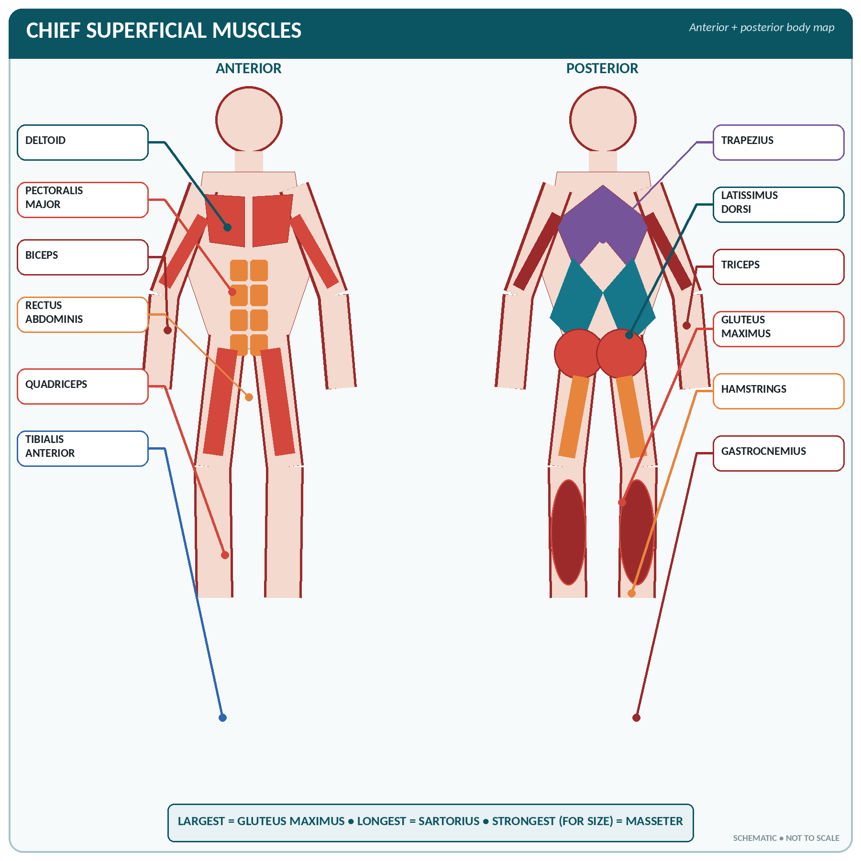
FIGURE • Major superficial muscles on anterior and posterior body maps

Muscles of the Face and Scalp (Muscles of Facial Expression)
▪ All the muscles of facial expression develop from the second branchial arch and are supplied by the facial nerve (VII). They are inserted into the skin.
Chief muscles of facial expression
Muscle | Position | Action
Occipitofrontalis (epicranius) | Scalp, with the intervening galea aponeurotica | Raises the eyebrows; wrinkles the forehead (look of surprise)
Orbicularis oculi | Encircles the eyelids | Closes the eye; blinking and winking; its paralysis causes drying of the cornea
Orbicularis oris | Encircles the mouth | Closes and purses the lips; whistling, sucking, kissing — "the sphincter of the mouth"
Buccinator | The muscle of the cheek | Blows out air, keeps food between the teeth ("trumpeter's muscle")
Zygomaticus major | Cheek bone to angle of mouth | Draws the angle of the mouth upward and outward — smiling and laughing
Levator labii superioris | Upper lip | Elevates the upper lip
Depressor anguli oris / triangularis | Angle of the mouth | Draws the angle down — sadness
Risorius | Cheek to angle of mouth | Retracts the angle — grinning
Mentalis | Chin | Protrudes the lower lip — pouting
Platysma | Superficial muscle of the neck | Draws the angle of the mouth down and wrinkles the neck
Corrugator supercilii | Between the eyebrows | Draws eyebrows together — frowning

FACIAL NERVE PALSY (BELL'S PALSY)
Paralysis of the facial nerve causes loss of expression on one side, inability to close the eye or whistle, drooping of the angle of the mouth with dribbling, loss of the nasolabial fold, and loss of taste on the anterior two-thirds of the tongue. All the muscles of expression are affected in a lower motor neurone lesion; only the lower half of the face in an upper motor neurone lesion.

Muscles of Mastication (Chewing)
▪ Four pairs, all supplied by the mandibular division of the trigeminal nerve (V₃) and all developed from the first branchial arch.
The four muscles of mastication
Muscle | Action
Masseter | Elevates the mandible (closes the jaw); the strongest muscle of the body for its size; easily felt when the teeth are clenched
Temporalis | Elevates and retracts the mandible
Medial (internal) pterygoid | Elevates and protracts; side-to-side grinding
Lateral (external) pterygoid | Opens the mouth (depresses the mandible) and protrudes it; grinding

▪ The mouth is also opened by gravity and the digastric, geniohyoid and mylohyoid muscles (suprahyoid group).
Muscles of the Tongue, Palate and Pharynx
▪ Tongue muscles are intrinsic (alter the shape) and extrinsic (alter the position — genioglossus, hyoglossus, styloglossus, palatoglossus). All are supplied by the hypoglossal nerve (XII) except palatoglossus (vagus). Genioglossus protrudes the tongue.
▪ Muscles of the soft palate — levator veli palatini, tensor veli palatini, palatoglossus, palatopharyngeus, musculus uvulae. They close the nasopharynx in swallowing.
▪ Pharyngeal muscles — three constrictors (superior, middle, inferior) with the stylopharyngeus, salpingopharyngeus and palatopharyngeus; they propel the bolus in swallowing (deglutition). Supplied by the pharyngeal plexus (IX and X); stylopharyngeus is supplied by the glossopharyngeal (IX) nerve — the only one.
Muscles of the Neck
Chief muscles of the neck
Muscle | Attachments | Action | Nerve
Sternocleidomastoid | Sternum and clavicle → mastoid process | One side: rotates the head to the opposite side and flexes it laterally. Both: flexes the neck and, when fixed, aids inspiration | Accessory (XI) + C2, C3
Trapezius (upper part) | Occiput and spines → clavicle, acromion, scapular spine | Elevates and braces the shoulder; extends the head | Accessory (XI) + C3, C4
Scalene muscles (anterior, middle, posterior) | Cervical vertebrae → 1st and 2nd ribs | Bend the neck; accessory muscles of inspiration (raise the upper ribs) | Cervical nerves
Platysma | Fascia of chest → mandible | Depresses the angle of the mouth; wrinkles the neck | Facial (VII)
Suprahyoid group (digastric, stylohyoid, mylohyoid, geniohyoid) | Mandible/skull → hyoid | Elevate the hyoid and larynx in swallowing; open the mouth | V₃, VII, C1
Infrahyoid (strap) group (sternohyoid, sternothyroid, thyrohyoid, omohyoid) | Sternum/scapula → hyoid, thyroid cartilage | Depress the hyoid and larynx after swallowing | Ansa cervicalis (C1–C3)
Longus colli / capitis, prevertebral group | In front of the vertebrae | Flex the neck | Cervical nerves
Splenius, semispinalis, erector spinae (cervical) | Behind | Extend the head and neck | Cervical nerves

▪ Torticollis (wry neck) is spasm or contracture of the sternocleidomastoid.
Muscles of the Trunk
Muscles of the thorax and respiration
Muscles of respiration
Muscle | Action | Nerve
Diaphragm | The chief (principal) muscle of inspiration; dome-shaped; on contraction it descends and flattens, increasing the vertical diameter of the thorax. Accounts for about two-thirds of the tidal volume | Phrenic nerve (C3, C4, C5) — "C3-4-5 keeps the diaphragm alive"
External intercostals (11 pairs) | Elevate the ribs — inspiration; increase the antero-posterior and transverse diameters | Intercostal nerves
Internal and innermost intercostals | Depress the ribs — forced expiration | Intercostal nerves
Accessory muscles of inspiration | Sternocleidomastoid, scalenes, pectoralis major and minor, serratus anterior, trapezius, erector spinae | —
Muscles of forced expiration | Anterior abdominal wall muscles (rectus abdominis, obliques, transversus), internal intercostals, latissimus dorsi | —

▪ Quiet expiration is passive — it depends on the elastic recoil of the lungs and chest wall.
Muscles of the anterior abdominal wall
The abdominal wall muscles (from superficial to deep, and their functions)
Muscle | Direction of fibres | Remarks
External oblique | Downwards and forwards ("hands in pockets") | The most superficial; its lower border forms the inguinal ligament
Internal oblique | Upwards and forwards (at right angles to the external) | Middle layer
Transversus abdominis | Transverse (horizontal) | The deepest layer
Rectus abdominis | Vertical, in the rectus sheath, crossed by 3 tendinous intersections | "Six-pack"; the two recti meet in the midline linea alba
Pyramidalis | Small triangular muscle in front of rectus | Tenses the linea alba
Quadratus lumborum & psoas (posterior wall) | — | Lateral flexion of the trunk; psoas is also a hip flexor

▪ Functions of the abdominal muscles: support and compress the viscera; flex and rotate the trunk; produce forced expiration, coughing, sneezing, vomiting, micturition, defaecation and parturition by raising intra-abdominal pressure (the Valsalva manoeuvre); maintain posture.
▪ Nerve supply: the lower six intercostal (T7–T11), subcostal (T12), iliohypogastric and ilio-inguinal (L1) nerves.
▪ Weak points: the inguinal canal (inguinal hernia — the commonest hernia, more frequent in males), the femoral ring (femoral hernia, commoner in females), and the umbilicus.
Muscles of the back and the pelvic floor
▪ Superficial back muscles — trapezius, latissimus dorsi, levator scapulae, rhomboids (they act on the shoulder girdle).
▪ Deep back muscles — the erector spinae (sacrospinalis) group — iliocostalis, longissimus, spinalis — with semispinalis, multifidus and the small rotators. They are the great extensors of the spine and the chief antigravity muscles of the trunk; supplied segmentally by the posterior rami of the spinal nerves.
▪ Pelvic floor (pelvic diaphragm) — the levator ani (with its pubococcygeus, iliococcygeus and puborectalis parts) and the coccygeus, supplied by S3, S4 and the pudendal nerve. They support the pelvic viscera, maintain continence and assist in defaecation and childbirth. Weakness causes prolapse and stress incontinence; the perineal body is the central fibromuscular mass torn in childbirth.
Muscles of the Shoulder Girdle and Upper Limb
Muscles moving the shoulder girdle and shoulder joint
Muscle | Chief action | Nerve supply
Trapezius | Elevates, retracts and rotates the scapula; braces the shoulder | Accessory (XI)
Latissimus dorsi | Adducts, extends and medially rotates the arm; the "climbing muscle"; the broadest muscle of the back | Thoracodorsal (C6–C8)
Levator scapulae / Rhomboids | Elevate and retract the scapula | Dorsal scapular nerve, C3–C5
Serratus anterior | Protracts the scapula (pushing, punching) and rotates it upward for abduction above 90°; holds the scapula to the chest wall | Long thoracic nerve (C5–C7) — injury causes winged scapula
Pectoralis major | Adducts and medially rotates the arm; flexes it | Medial and lateral pectoral nerves
Pectoralis minor | Depresses the shoulder; draws the scapula forward | Medial pectoral nerve
Deltoid | Abducts the arm (after the first 15–20°); its anterior fibres flex, posterior fibres extend | Axillary nerve (C5, C6) — the site of intramuscular injection
Supraspinatus | Initiates abduction (first 15–20°) | Suprascapular nerve
Infraspinatus, Teres minor | Lateral rotation of the arm | Suprascapular / axillary
Subscapularis | Medial rotation | Subscapular nerves
Teres major | Adduction and medial rotation | Lower subscapular
Coracobrachialis | Flexes and adducts the arm | Musculocutaneous

THE ROTATOR CUFF
"SITS" — Supraspinatus, Infraspinatus, Teres minor, Subscapularis. Three of them rotate laterally/medially; only subscapularis is a medial rotator, and supraspinatus starts abduction. The supraspinatus tendon is the one commonly torn or inflamed.

Muscles of the arm, forearm and hand
Group | Muscles | Action | Nerve
Front of the arm (flexors) | Biceps brachii (2 heads), brachialis, coracobrachialis | Flex the elbow; biceps is also the chief supinator | Musculocutaneous (C5–C7)
Back of the arm (extensor) | Triceps brachii (3 heads) | Extends the elbow | Radial (C6–C8)
Front of the forearm (flexor/pronator group) | Pronator teres, flexor carpi radialis, palmaris longus, flexor carpi ulnaris, flexor digitorum superficialis and profundus, flexor pollicis longus, pronator quadratus | Flex the wrist and fingers; pronate the forearm | Median (chiefly), with ulnar supplying flexor carpi ulnaris and half of flexor digitorum profundus
Back of the forearm (extensor/supinator group) | Brachioradialis, extensor carpi radialis longus and brevis, extensor digitorum, extensor carpi ulnaris, supinator, the three thumb extensors/abductor | Extend the wrist and fingers; supinate | Radial nerve and its posterior interosseous branch
Thenar muscles (thumb) | Abductor pollicis brevis, flexor pollicis brevis, opponens pollicis (+ adductor pollicis) | Movements of the thumb, especially opposition | Median (adductor pollicis by ulnar)
Hypothenar muscles (little finger) | Abductor, flexor and opponens digiti minimi | Movements of the little finger | Ulnar
Interossei (8) and lumbricals (4) | — | Abduct/adduct the fingers; flex the MCP and extend the IP joints (fine movements) | Ulnar (lumbricals 1 and 2 by median)

NERVE INJURIES OF THE UPPER LIMB
Nerve | Deformity / sign | Cause
Radial | Wrist drop; loss of extension of wrist and fingers | Fracture of the shaft of the humerus (spiral groove); crutch palsy; "Saturday-night palsy"
Ulnar | Claw hand; wasting of the hypothenar eminence; loss of adduction of the thumb | Injury behind the medial epicondyle; fracture of the medial epicondyle
Median | Ape thumb / pointing index; loss of opposition; wasting of the thenar eminence; carpal tunnel syndrome | Wrist laceration; supracondylar fracture; compression under the flexor retinaculum
Axillary | Loss of abduction (deltoid paralysis); loss of sensation over the shoulder | Fracture of the surgical neck of the humerus; shoulder dislocation
Long thoracic | Winged scapula | Surgery in the axilla; mastectomy
Erb's palsy (C5, C6) | "Waiter's tip" deformity — arm adducted, medially rotated, forearm pronated | Excessive traction on the head at birth
Klumpke's palsy (C8, T1) | Claw hand with Horner's syndrome | Excessive traction on the arm (breech delivery)

Muscles of the Lower Limb
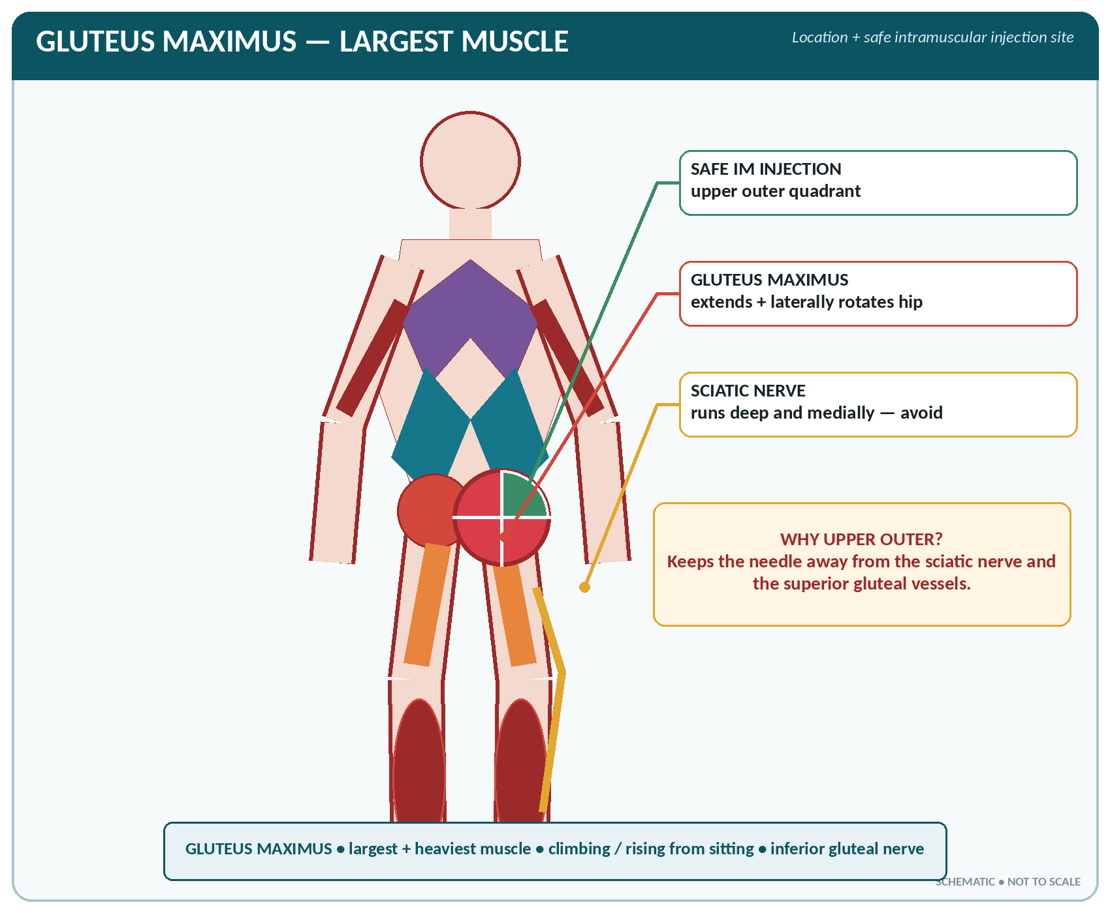
FIGURE • Gluteus maximus—the largest muscle, its location, action and safe intramuscular injection quadrant

Muscles of the gluteal region and hip
Muscle | Action | Nerve
Gluteus maximus | Extends and laterally rotates the thigh; the chief muscle of climbing and rising from sitting; the largest and heaviest muscle in the body | Inferior gluteal (L5, S1, S2)
Gluteus medius and minimus | Abduct and medially rotate the thigh; steady the pelvis during walking (their paralysis gives a waddling gait and a positive Trendelenburg sign) | Superior gluteal (L4, L5, S1)
Tensor fasciae latae | Tenses the fascia lata / iliotibial tract; abducts and medially rotates | Superior gluteal
Piriformis, obturators, gemelli, quadratus femoris | Lateral rotation of the thigh | Sacral plexus branches
Iliopsoas (iliacus + psoas major) | The chief flexor of the hip | Femoral nerve and L1–L3

▪ The gluteus maximus is the standard site for a deep intramuscular injection — given in the upper outer quadrant of the buttock to avoid the sciatic nerve.
Muscles of the thigh, leg and foot
Compartment | Muscles | Action | Nerve
Anterior thigh (extensors) | Quadriceps femoris = rectus femoris + vastus lateralis, medialis and intermedius; sartorius | Extend the knee (quadriceps is the most powerful extensor; inserted by the patellar ligament). Sartorius (the longest muscle in the body) flexes hip and knee — the "tailor's muscle" | Femoral (L2–L4)
Medial thigh (adductors) | Adductor longus, brevis and magnus, gracilis, pectineus | Adduct the thigh (used in horse-riding) | Obturator (L2–L4)
Posterior thigh (hamstrings) | Biceps femoris, semitendinosus, semimembranosus | Flex the knee and extend the hip | Sciatic (tibial part)
Anterior leg | Tibialis anterior, extensor hallucis longus, extensor digitorum longus, peroneus tertius | Dorsiflexion and inversion of the foot; extension of the toes | Deep peroneal (fibular) — injury gives foot drop
Lateral leg | Peroneus (fibularis) longus and brevis | Eversion of the foot | Superficial peroneal
Posterior leg (calf) | Gastrocnemius (2 heads) and soleus = triceps surae, inserted by the tendo calcaneus (Achilles tendon — the strongest tendon in the body); also popliteus, tibialis posterior, flexor hallucis and digitorum longus | Plantar flexion — walking, running, standing on tip-toe; the "peripheral heart" pumping venous blood upward | Tibial nerve
Muscles of the sole (4 layers) | Flexor digitorum brevis, abductor hallucis, interossei, lumbricals etc. | Support the arches and move the toes | Medial and lateral plantar nerves

ACTIONS TO REMEMBER
▪ Quadriceps extends the knee; hamstrings flex it. (Q for "quit bending" = extension.)
▪ Deltoid abducts, pectoralis major adducts the arm.
▪ Tibialis anterior dorsiflexes; gastrocnemius plantar flexes.
▪ Gluteus maximus extends, gluteus medius abducts the thigh.
▪ Peroneus everts (both start with the sound "ee"), tibialis inverts.

Summary Tables for Rapid Revision
"Which muscle performs this movement?"
Movement | Chief muscle(s)
Closing the eye | Orbicularis oculi
Closing the lips / whistling | Orbicularis oris
Smiling | Zygomaticus major
Chewing (closing the jaw) | Masseter, temporalis, medial pterygoid
Opening the jaw | Lateral pterygoid + digastric
Protruding the tongue | Genioglossus
Swallowing | Pharyngeal constrictors, suprahyoid muscles
Turning the head to the opposite side | Sternocleidomastoid
Inspiration (quiet) | Diaphragm + external intercostals
Forced expiration | Abdominal muscles + internal intercostals
Flexing the trunk | Rectus abdominis
Extending the spine | Erector spinae
Shrugging the shoulders | Trapezius
Starting abduction of the arm | Supraspinatus
Abducting the arm | Deltoid
Adducting the arm | Pectoralis major, latissimus dorsi
Flexing the elbow | Biceps brachii, brachialis
Extending the elbow | Triceps brachii
Supination | Biceps + supinator
Pronation | Pronator teres and quadratus
Opposition of the thumb | Opponens pollicis
Flexing the hip | Iliopsoas
Extending the hip | Gluteus maximus
Abducting the thigh | Gluteus medius and minimus
Adducting the thigh | Adductor group
Extending the knee | Quadriceps femoris
Flexing the knee | Hamstrings
Dorsiflexion of the foot | Tibialis anterior
Plantar flexion (tip-toe) | Gastrocnemius and soleus
Inversion of the foot | Tibialis anterior and posterior
Eversion of the foot | Peroneus longus and brevis

MUSCLES — MOST ASKED FACTS
▪ Largest muscle — gluteus maximus; smallest — stapedius; longest — sartorius; strongest (for size) — masseter; broadest — latissimus dorsi; strongest tendon — Achilles.
▪ Chief muscle of respiration — diaphragm, supplied by the phrenic nerve (C3, C4, C5).
▪ Muscles of facial expression — facial nerve (VII); muscles of mastication — trigeminal (V₃); muscles of the tongue — hypoglossal (XII); sternocleidomastoid and trapezius — accessory (XI).
▪ Site of intramuscular injection: deltoid (small volume), gluteus maximus — upper outer quadrant (large volume), vastus lateralis (infants).
▪ Winged scapula — serratus anterior (long thoracic nerve); wrist drop — radial; claw hand — ulnar; foot drop — common peroneal.
▪ The rotator cuff = SITS muscles; it stabilises the shoulder.

CHAPTER 12
The Blood

CHAPTER OUTLINE
General Characters, Composition and Functions | Plasma and the Plasma Proteins | The Red Blood Cells (Erythrocytes) | The White Blood Cells (Leucocytes) | The Platelets (Thrombocytes) | Haemostasis and Blood Coagulation | Blood Groups and Transfusion

Blood is a fluid connective tissue circulating in a closed system of vessels. It is the transport medium of the body — "the river of life".
General Characters, Composition and Functions
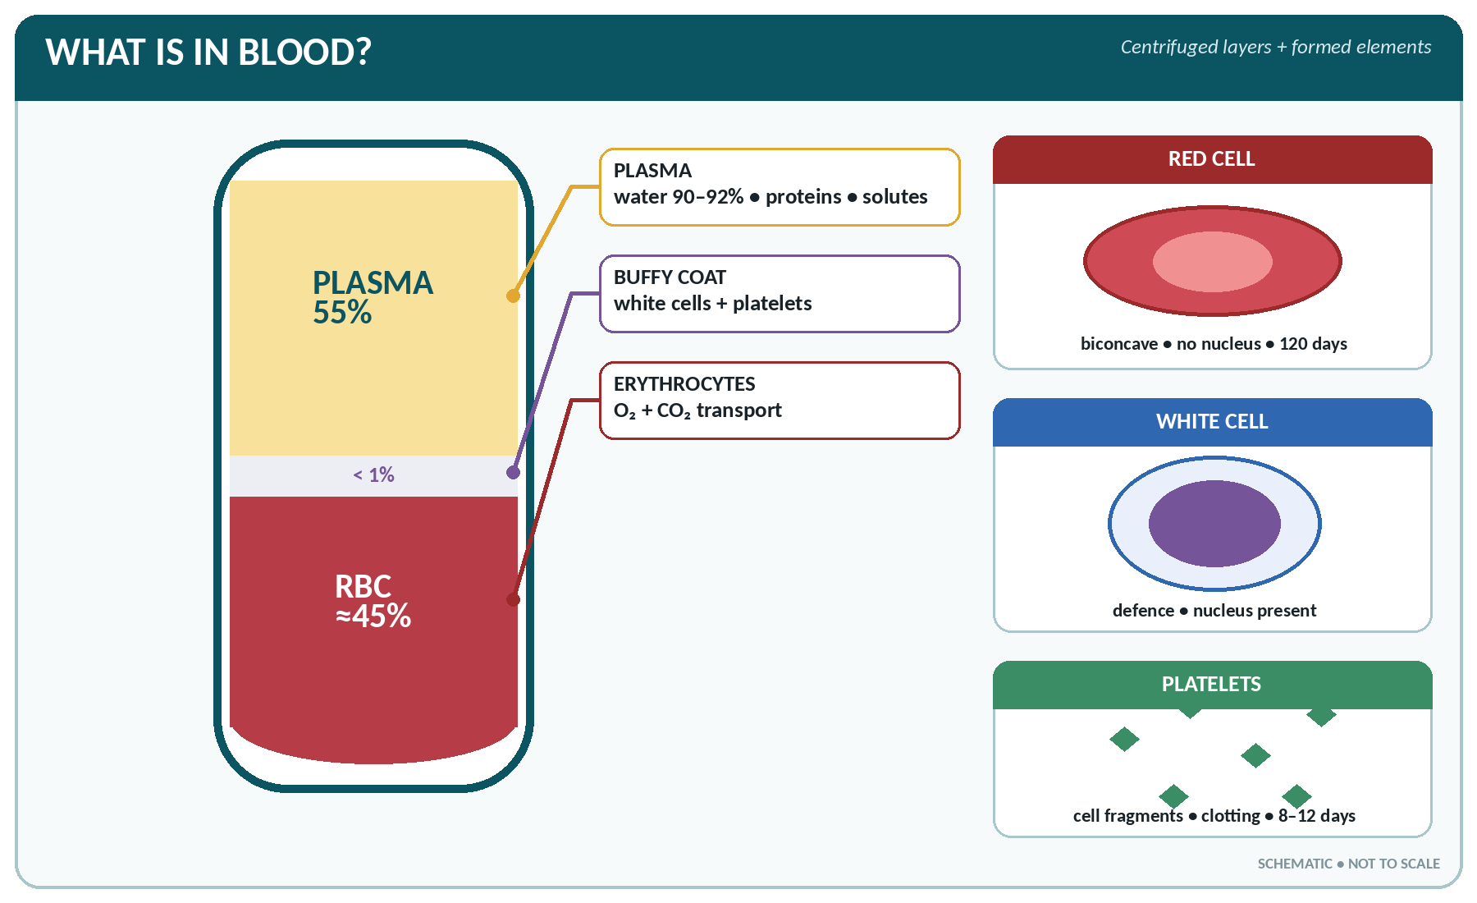
FIGURE • Centrifuged blood—plasma, buffy coat and red cells, with the three formed elements

BLOOD — BASIC VALUES
▪ Total volume: about 5–6 litres in an adult male, 4–5 litres in the female; roughly 8% of body weight (about 70–80 mL/kg; in the newborn about 85 mL/kg).
▪ Colour: scarlet red (arterial, oxygenated) or purplish/bluish red (venous, deoxygenated).
▪ Reaction: slightly alkaline, pH 7.35–7.45 (average 7.4).
▪ Specific gravity: whole blood 1.055–1.060; plasma 1.026; cells 1.090.
▪ Viscosity: about 5 times that of water.
▪ Temperature: about 38 °C (slightly higher than body surface temperature).
▪ Taste: saltish. Blood is opaque, not transparent.
▪ Composition by volume: plasma 55% and cells (formed elements) 45% — the cell volume is the haematocrit / packed cell volume (PCV).

Composition of blood
▪ Plasma (55%) — the fluid part: water 90–92%, plasma proteins 6–8%, and other solutes about 2% (inorganic salts, nutrients, waste products, hormones, enzymes, gases, antibodies).
▪ Formed elements (45%):
– Erythrocytes (red blood cells)
– Leucocytes (white blood cells)
– Thrombocytes (platelets)
▪ Serum = plasma minus fibrinogen (and the other clotting factors used up in clotting); serum does not clot.
Functions of blood
1. Transport of respiratory gases — O₂ from lungs to tissues, CO₂ from tissues to lungs.
2. Transport of nutrients — glucose, amino acids, fats, vitamins, minerals from the gut and liver.
3. Transport of waste — urea, uric acid, creatinine to the kidney; bilirubin to the liver.
4. Transport of hormones and enzymes from glands to target organs.
5. Regulation of water and electrolyte balance.
6. Regulation of acid–base balance (pH) by its buffers.
7. Regulation of body temperature — carries heat from the core to the skin.
8. Defence — leucocytes phagocytose; lymphocytes and antibodies give immunity.
9. Prevention of haemorrhage — clotting (platelets and clotting factors).
10. Maintenance of blood pressure and of osmotic pressure (plasma proteins).
Plasma and the Plasma Proteins
The plasma proteins
Protein | Normal value | Site of formation | Functions
Albumin | 3.5–5.5 g/dL (the most abundant) | Liver | Maintains colloid osmotic (oncotic) pressure — about 25 mmHg; transports bilirubin, hormones, drugs, calcium
Globulins (α, β, γ) | 2–3.5 g/dL | Liver (α, β) and lymphoid tissue/plasma cells (γ) | γ-globulins are the antibodies (immunoglobulins); α and β transport iron (transferrin), copper, lipids, hormones
Fibrinogen | 200–400 mg/dL | Liver | Converted to fibrin in clotting — essential for coagulation; its absence in serum
Prothrombin | — | Liver (needs vitamin K) | Clotting factor II

▪ Total plasma protein: 6–8 g/dL. Normal albumin : globulin (A : G) ratio = 2 : 1 (1.7–2.2 : 1).
▪ Functions of plasma proteins: osmotic pressure, buffering, viscosity (helps maintain BP), transport, immunity, clotting, and a reserve of protein.
▪ Low albumin (liver disease, nephrotic syndrome, malnutrition) causes oedema and ascites.
▪ Plasma expanders: dextran, human albumin, gelatin, hydroxyethyl starch.
The Red Blood Cells (Erythrocytes)
Structure and values
THE RED CELL
▪ Count: male 5–5.5 million/mm³ (4.5–6.5); female 4.5–5 million/mm³ (3.8–5.8); newborn 6–7 million/mm³.
▪ Shape: circular, biconcave disc without a nucleus (biconcavity gives a large surface area for gas exchange and flexibility to pass through capillaries).
▪ Diameter 7.2 µm (6.5–8.0); thickness 2.2 µm at the rim, 1 µm at the centre; volume ≈ 90 fL.
▪ Life span: 120 days (about 4 months); destroyed in the spleen, liver and bone marrow by macrophages — the spleen is the "graveyard of red cells".
▪ Haemoglobin: male 14–18 g/dL, female 12–16 g/dL, newborn 18–20 g/dL; child 11–14 g/dL.
▪ PCV (haematocrit): male 40–54%, female 36–47%.
▪ ESR (Westergren): male 0–9 mm/hour, female 0–20 mm/hour.
▪ Reticulocytes: 0.5–1.5% of red cells (raised when the marrow is active).
▪ MCV 78–98 fL; MCH 27–32 pg; MCHC 32–36%.
▪ Total red cell surface area ≈ 3000 m²; about 2.4 million red cells are formed and destroyed every second.

▪ The red cell has no nucleus, no mitochondria and no ribosomes in mammals; it therefore relies on anaerobic glycolysis for energy and cannot divide or repair itself.
▪ Haemoglobin (Hb) — a conjugated protein (chromoprotein): globin (4 polypeptide chains, normally 2 α and 2 β in HbA) + 4 haem groups, each containing ferrous iron (Fe²⁺).
– 1 gram of haemoglobin carries about 1.34 mL of oxygen; 100 mL of blood carries about 20 mL O₂.
– One haemoglobin molecule binds 4 molecules of oxygen to form oxyhaemoglobin.
– Molecular weight about 68 000. Types: HbA (adult, α₂β₂), HbA₂ (α₂δ₂), HbF (fetal, α₂γ₂ — has a greater affinity for oxygen), HbS (sickle cell).
– Abnormal compounds: carboxyhaemoglobin (with CO — cherry-red), methaemoglobin (iron in the ferric state — brown), sulphaemoglobin.
Erythropoiesis (formation of red cells)
▪ Sites: in the fetus — yolk sac (first 2 months) → liver and spleen (mid-trimester) → bone marrow (from the 5th month). After birth and in the adult — red bone marrow only (sternum, ribs, vertebrae, iliac crest, skull, ends of long bones).
▪ Stages: haemocytoblast (stem cell) → proerythroblast → early and late normoblast → reticulocyte (the only immature form normally found in blood) → mature erythrocyte. The nucleus is lost at the late normoblast stage. The whole process takes about 5–7 days.
▪ Requirements: iron, vitamin B₁₂ (cyanocobalamin) and folic acid (for DNA synthesis), protein, vitamin C, vitamin B₆, copper, cobalt, and the hormone erythropoietin.
▪ Erythropoietin is secreted mainly by the kidney (85–90%; the rest by the liver) in response to hypoxia, and stimulates the marrow. This is why anaemia is a feature of chronic renal failure and why the red cell count rises at high altitude.
▪ Intrinsic factor of the gastric parietal cells is needed for the absorption of vitamin B₁₂ in the terminal ileum; its absence causes pernicious anaemia.
Fate of red cells and the bile pigments
▪ Old cells are engulfed by macrophages of the reticulo-endothelial system (spleen, liver, marrow).
▪ Haemoglobin is split into globin (reused as amino acids), iron (stored as ferritin and haemosiderin and reused — the body conserves iron carefully) and haem, which becomes biliverdin → bilirubin.
▪ Bilirubin is carried to the liver bound to albumin (unconjugated), conjugated with glucuronic acid and excreted in bile; in the gut it becomes stercobilin (colour of faeces) and urobilinogen (partly reabsorbed and excreted in urine as urobilin).
▪ Excess bilirubin in blood causes jaundice (visible above about 2 mg/dL; normal total bilirubin 0.3–1.0 mg/dL).
ANAEMIA
Anaemia = a fall in haemoglobin, red cell count or PCV below normal for age and sex.
Type | Cause / features
Iron deficiency (microcytic hypochromic) | The commonest anaemia; blood loss, poor diet, hookworm, pregnancy; low MCV, MCH and serum ferritin; koilonychia, glossitis
Megaloblastic (macrocytic) | Vitamin B₁₂ or folic acid deficiency; large oval red cells; pernicious anaemia = B₁₂ deficiency from lack of intrinsic factor, with glossitis and neurological signs
Aplastic | Marrow failure — pancytopenia; drugs, radiation, benzene, idiopathic
Haemolytic | Increased destruction — thalassaemia, sickle cell disease, G6PD deficiency, hereditary spherocytosis, malaria, incompatible transfusion, Rh disease of the newborn; jaundice and splenomegaly
Haemorrhagic | Acute or chronic blood loss
Of chronic disease / renal failure | Lack of erythropoietin, chronic infection, malignancy

Related terms: polycythaemia (raised red cell count — at altitude, in polycythaemia vera); anisocytosis (unequal size), poikilocytosis (abnormal shapes), haemolysis (destruction of red cells), haemoglobinuria.

The White Blood Cells (Leucocytes)
LEUCOCYTES
▪ Total count (TLC): 4000–11 000 per mm³ (average 7000–8000); newborn 10 000–25 000.
▪ Leucocytosis = count above 11 000 (infection, leukaemia, exercise, pregnancy). Leucopenia = count below 4000 (typhoid, viral fever, aplastic anaemia, drugs, radiation).
▪ Differential count (DLC):
– Neutrophils (polymorphs) 40–75% (average 60–65%) — the most numerous
– Lymphocytes 20–45% (average 25–30%) — most numerous in children
– Monocytes 2–10% (average 5%) — the largest white cell
– Eosinophils 1–6%
– Basophils 0–1% — the least numerous white cell
▪ Life span: granulocytes hours to a few days (6 hours–5 days); monocytes months; lymphocytes days to years (memory cells for life).

The white blood cells — structure and function
Cell | Nucleus and granules | Chief functions | Increased in
Neutrophil (polymorph) | 3–5 lobed nucleus; fine lilac (neutral) granules | Phagocytosis of bacteria — the first line of cellular defence; forms pus; shows amoeboid movement and chemotaxis | Acute bacterial infection, appendicitis, abscess
Eosinophil | Bilobed ("spectacle") nucleus; coarse red/orange granules | Combats parasites (worms); controls allergic reactions; detoxifies histamine | Allergy, asthma, worm infestation, skin disease
Basophil | Indented nucleus; large blue/purple granules | Contains heparin, histamine and serotonin; involved in immediate hypersensitivity | Chronic myeloid leukaemia, hypersensitivity
Lymphocyte | Large round nucleus, scanty clear cytoplasm; non-granular | Immunity — T cells for cell-mediated immunity (killer, helper, suppressor), B cells become plasma cells producing antibodies | Chronic infection, tuberculosis, whooping cough, viral illness, lymphocytic leukaemia
Monocyte | Large kidney-shaped nucleus; the largest leucocyte | Becomes a macrophage in the tissues; phagocytosis, antigen presentation | Tuberculosis, typhoid, malaria, kala-azar, monocytic leukaemia

LEUCOCYTES IN ORDER OF FREQUENCY
"Never Let Monkeys Eat Bananas" — Neutrophils > Lymphocytes > Monocytes > Eosinophils > Basophils.

▪ Granulocytes (neutrophil, eosinophil, basophil) are formed in the red bone marrow; agranulocytes (lymphocyte, monocyte) in bone marrow and lymphoid tissue (thymus, lymph nodes, spleen, tonsils).
▪ Properties of leucocytes: amoeboid movement, chemotaxis (attraction to chemicals from bacteria), diapedesis (passing through the capillary wall) and phagocytosis.
▪ Pus is dead tissue, bacteria and dead neutrophils.
The Platelets (Thrombocytes)
▪ Small, non-nucleated, irregular fragments of the cytoplasm of megakaryocytes in the bone marrow.
▪ Count: 150 000–400 000 per mm³ (average 250 000); size 2–4 µm — the smallest formed element.
▪ Life span: 8–12 days; destroyed in the spleen. Formation is stimulated by thrombopoietin.
▪ Functions: haemostasis — they adhere to the injured vessel wall, aggregate to form the platelet plug, secrete serotonin (vasoconstriction) and platelet factor 3, release thromboxane A₂, and provide the surface for coagulation; they also help clot retraction and vessel repair (platelet-derived growth factor).
▪ Thrombocytopenia (low count) causes purpura, petechiae and bleeding; a count below 50 000 risks spontaneous bleeding, below 20 000 is dangerous. Thrombocytosis predisposes to thrombosis. Aspirin inhibits platelet function.
Haemostasis and Blood Coagulation
Stages of haemostasis
1. Vascular spasm — immediate reflex constriction of the injured vessel.
2. Platelet plug formation — adhesion, activation and aggregation of platelets (temporary plug).
3. Coagulation (clotting) — the plug is reinforced by a mesh of fibrin.
4. Clot retraction and fibrinolysis — the clot shrinks, squeezing out serum, and is finally dissolved by plasmin (fibrinolysin), activated from plasminogen.
The clotting factors
The coagulation factors
No. | Name | Note
I | Fibrinogen | Converted to fibrin
II | Prothrombin | Needs vitamin K; made in liver
III | Tissue factor (thromboplastin) | From damaged tissue
IV | Calcium ions | Essential at several steps
V | Labile factor (proaccelerin) | —
VII | Stable factor (proconvertin) | Vitamin K dependent
VIII | Antihaemophilic factor A | Deficient in haemophilia A (X-linked, males)
IX | Christmas factor | Deficient in haemophilia B; vitamin K dependent
X | Stuart–Prower factor | Vitamin K dependent
XI | Plasma thromboplastin antecedent | Haemophilia C
XII | Hageman factor | Starts the intrinsic pathway on contact
XIII | Fibrin-stabilising factor | Cross-links fibrin

There is no factor VI. Factors II, VII, IX and X require vitamin K — mnemonic "1972".
The mechanism of clotting
▪ Intrinsic pathway — triggered by contact of blood with a damaged surface (factor XII); slower; measured by the APTT / clotting time.
▪ Extrinsic pathway — triggered by tissue thromboplastin released from injured tissue; fast; measured by the prothrombin time (PT/INR).
▪ Both meet in the common pathway: Prothrombin activator + prothrombin (II) → thrombin, then thrombin + fibrinogen (I) → fibrin, which forms the mesh of the clot. Calcium is needed throughout.
HAEMOSTASIS — NORMAL TIMES
▪ Bleeding time: 1–6 minutes (Duke 1–3 min; Ivy 2–7 min) — tests platelets and vessels.
▪ Clotting (coagulation) time: 5–10 minutes — tests the clotting factors.
▪ Prothrombin time: 11–16 seconds (INR 0.9–1.2) — tests the extrinsic pathway.
▪ APTT: 30–40 seconds — tests the intrinsic pathway.
▪ Fibrinogen 200–400 mg/dL; platelet count 1.5–4 lakh/mm³.

▪ Anticoagulants: heparin (immediate, given by injection, acts via antithrombin III; antidote protamine sulphate); warfarin/dicoumarol (oral, blocks vitamin K; antidote vitamin K); sodium citrate, oxalate and EDTA (in vitro — they remove calcium). Aspirin is an anti-platelet, not an anticoagulant.
▪ Natural prevention of intravascular clotting: the smooth endothelium, the heparin of mast cells and basophils, antithrombin III, protein C, and rapid blood flow.
▪ Thrombus = a clot formed inside a vessel; embolus = any detached mass travelling in the blood. Virchow's triad of thrombosis: endothelial injury, stasis, hypercoagulability.
BLEEDING DISORDERS
▪ Haemophilia A — deficiency of factor VIII; X-linked recessive, affects males, carried by females; bleeding into joints (haemarthrosis) and muscles; normal bleeding time but prolonged clotting time/APTT.
▪ Von Willebrand's disease — the commonest inherited bleeding disorder; defective platelet adhesion.
▪ Purpura (ITP) — low platelets; petechiae; prolonged bleeding time.
▪ Vitamin K deficiency — obstructive jaundice, newborn (haemorrhagic disease of the newborn — prevented by vitamin K at birth); prolonged prothrombin time.
▪ DIC — widespread clotting with consumption of factors, then bleeding.
▪ Scurvy — vitamin C deficiency with capillary fragility and bleeding gums.

Blood Groups and Transfusion
The ABO system
▪ Discovered by Karl Landsteiner (1900–1901), who received the Nobel Prize; based on antigens (agglutinogens) A and B on the red cell and antibodies (agglutinins) anti-A and anti-B in the plasma.
The ABO blood groups
Group | Antigen on red cell | Antibody in plasma | Can donate to | Can receive from | Frequency (India, approx.)
A | A | anti-B | A, AB | A, O | 22%
B | B | anti-A | B, AB | B, O | 33% — commonest in India
AB | A and B | None | AB only | All (universal recipient) | 7%
O | None (H substance) | anti-A and anti-B | All (universal donor) | O only | 37%

▪ Group O negative is the universal donor; AB positive the universal recipient. Worldwide, O is the commonest group; in India B is very common.
▪ Blood group is inherited; A and B are dominant, O is recessive. Blood grouping is used in paternity disputes and in forensic work.
The Rhesus (Rh) system
▪ Named after the rhesus monkey; the important antigen is D. About 85% of people are Rh positive, 15% negative (in India about 93–95% positive).
▪ An Rh-negative person does not normally have anti-D antibodies but forms them if exposed to Rh-positive blood (by transfusion or by carrying an Rh-positive fetus) — this is sensitisation.
▪ Haemolytic disease of the newborn (erythroblastosis fetalis): an Rh-negative mother carrying an Rh-positive fetus; the first child usually escapes; later children may develop haemolysis, anaemia, jaundice (kernicterus) and hydrops. Prevented by giving anti-D immunoglobulin to the mother within 72 hours of delivery, abortion or amniocentesis.
Blood transfusion
▪ Before transfusion: grouping, Rh typing and cross-matching are essential; the unit is checked for name, number, group, expiry date and colour.
▪ Blood is stored at 2–6 °C with the anticoagulant CPD-A (citrate-phosphate-dextrose-adenine), which keeps it for 35 days (ACD for 21 days). Platelets are stored at 20–24 °C for 5 days; fresh-frozen plasma at −30 °C for 1 year.
▪ Hazards: haemolytic reaction from incompatibility (fever, loin pain, haemoglobinuria, shock), febrile and allergic reactions, circulatory overload, air embolism, transmission of infection (HIV, hepatitis B and C, malaria, syphilis), citrate toxicity and hypocalcaemia, hyperkalaemia, and hypothermia with massive transfusion.
BLOOD — RAPID REVISION
▪ Blood volume 5–6 L (8% of body weight); plasma 55%, cells 45%; pH 7.4.
▪ RBC life span 120 days; platelet 8–12 days; formed in red bone marrow.
▪ Hb male 14–18, female 12–16 g/dL; 1 g Hb carries 1.34 mL O₂; iron is in the ferrous state.
▪ Erythropoietin from the kidney; intrinsic factor from the stomach for vitamin B₁₂ absorbed in the ileum.
▪ Most numerous WBC — neutrophil; largest WBC — monocyte; least — basophil; WBC raised in allergy — eosinophil; cell of immunity — lymphocyte.
▪ Universal donor O negative; universal recipient AB positive; discovered by Landsteiner.
▪ Clotting factors needing vitamin K: II, VII, IX, X. Haemophilia A = factor VIII.
▪ Anticoagulant in the body = heparin; in the blood bank = CPD-A / citrate; the ion essential for clotting = calcium.
▪ Serum = plasma without fibrinogen. The spleen is the graveyard of red cells.

CHAPTER 13
The Heart and Blood Vessels

CHAPTER OUTLINE
The Heart — Position, Size and Coverings | The Chambers and Valves of the Heart | The Conducting System of the Heart | The Cardiac Cycle | Blood Supply and Nerve Supply of the Heart | The Blood Vessels | Exchange at the Capillary and the Formation of Tissue Fluid | Blood Pressure and Pulse

The Heart — Position, Size and Coverings
THE HEART — BASIC FACTS
▪ Shape: hollow, cone-shaped muscular pump, about the size of the person's closed fist.
▪ Size: about 12 cm long, 9 cm broad, 6 cm thick.
▪ Weight: 250–300 g in the male, 225–275 g in the female (about 0.5% of body weight).
▪ Position: in the middle mediastinum, behind the body of the sternum, between the lungs, above the diaphragm — two-thirds to the left of the median plane.
▪ Extends from the 2nd to the 5th intercostal space, and from the right border of the sternum to within 9 cm of the midline on the left.
▪ The apex is formed by the left ventricle and lies in the 5th left intercostal space about 9 cm from the midline, just medial to the mid-clavicular line (the site of the apex beat).
▪ The base is directed upwards, backwards and to the right, and is formed mainly by the left atrium.

The pericardium
▪ A double-walled sac with two parts:
– Fibrous pericardium — tough outer sac, attached to the diaphragm and great vessels; prevents over-distension.
– Serous pericardium — with a parietal layer lining the fibrous sac and a visceral layer (the epicardium) on the heart itself.
▪ Between the two serous layers is the pericardial cavity containing 10–20 mL (about 15–50 mL) of serous pericardial fluid, which prevents friction.
▪ Excess fluid (pericardial effusion) or blood (haemopericardium) compresses the heart — cardiac tamponade.
The walls of the heart — three layers
1. Epicardium — the visceral serous pericardium (mesothelium + fat, carrying the coronary vessels).
2. Myocardium — cardiac muscle; the thickest layer; thickest in the left ventricle (12–15 mm; right ventricle 3–5 mm; atria 2–3 mm) because it pumps against systemic resistance.
3. Endocardium — a smooth endothelial lining continuous with the endothelium of the vessels; it also covers the valves. Its inflammation is endocarditis.
The Chambers and Valves of the Heart
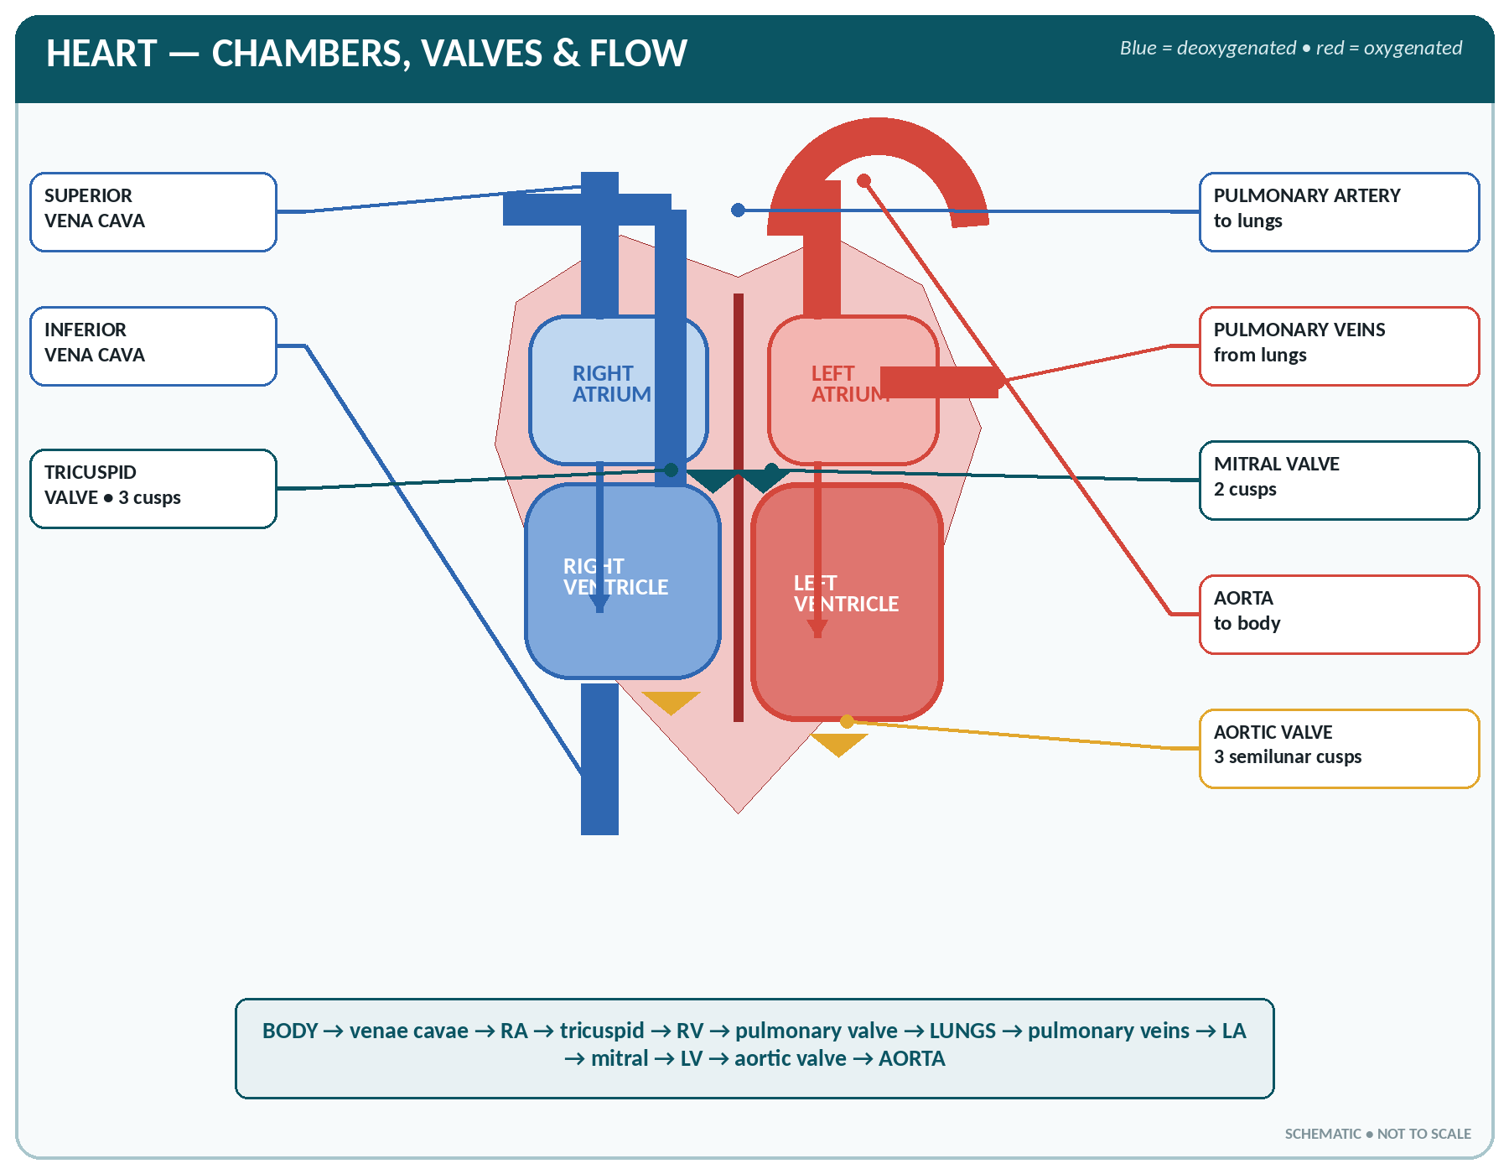
FIGURE • Heart chambers, valves, great vessels and the complete direction of blood flow

▪ The heart has four chambers — two upper atria (thin-walled receiving chambers) and two lower ventricles (thick-walled pumping chambers), separated by the interatrial and interventricular septa; the coronary (atrioventricular) sulcus and the interventricular grooves mark the divisions on the surface.
The chambers of the heart
Chamber | Receives blood from | Pumps blood into | Features
Right atrium | Superior and inferior vena cava and the coronary sinus | Right ventricle | Contains the SA node, the AV node, the fossa ovalis (remnant of foramen ovale), the opening of the coronary sinus
Right ventricle | Right atrium (through the tricuspid valve) | Pulmonary artery / trunk → lungs | Thin wall; trabeculae carneae; papillary muscles with chordae tendineae; crescentic on section
Left atrium | Four pulmonary veins (two from each lung) — oxygenated blood | Left ventricle | Smooth-walled; forms most of the base of the heart
Left ventricle | Left atrium (through the mitral / bicuspid valve) | Aorta → whole body | Thickest wall — 3 times that of the right; circular on section; forms the apex

The four valves of the heart
Valve | Position | Number of cusps | Opens / prevents
Tricuspid (right AV) | Between right atrium and right ventricle | 3 | Prevents backflow into the right atrium during ventricular systole
Mitral (bicuspid, left AV) | Between left atrium and left ventricle | 2 | Prevents backflow into the left atrium; the valve most often diseased in rheumatic fever
Pulmonary (semilunar) | At the opening of the pulmonary trunk | 3 | Prevents backflow from the pulmonary artery into the right ventricle
Aortic (semilunar) | At the opening of the aorta | 3 | Prevents backflow from the aorta into the left ventricle; the coronary arteries arise just above it

▪ The atrioventricular valves are anchored by chordae tendineae to the papillary muscles, which prevent the cusps from turning inside out during systole.
▪ The semilunar valves have no chordae; the pockets behind their cusps are the sinuses.
▪ Valves are formed of fibrous tissue covered with endothelium; they are avascular.
AUSCULTATION AREAS OF THE HEART VALVES
Valve | Where best heard
Mitral | Apex — 5th left intercostal space, mid-clavicular line
Tricuspid | Lower left sternal border, 4th–5th space
Aortic | 2nd right intercostal space, close to the sternum
Pulmonary | 2nd left intercostal space

Heart sounds: first sound "LUB" — closure of the mitral and tricuspid valves at the beginning of ventricular systole (long, dull, low-pitched); second sound "DUP" — closure of the aortic and pulmonary valves at the end of systole (short, sharp, high-pitched). A third and fourth sound may be heard in some normal and some abnormal states. A murmur is an abnormal sound caused by turbulent flow through a narrowed (stenosed) or leaking (incompetent) valve.

The Conducting System of the Heart
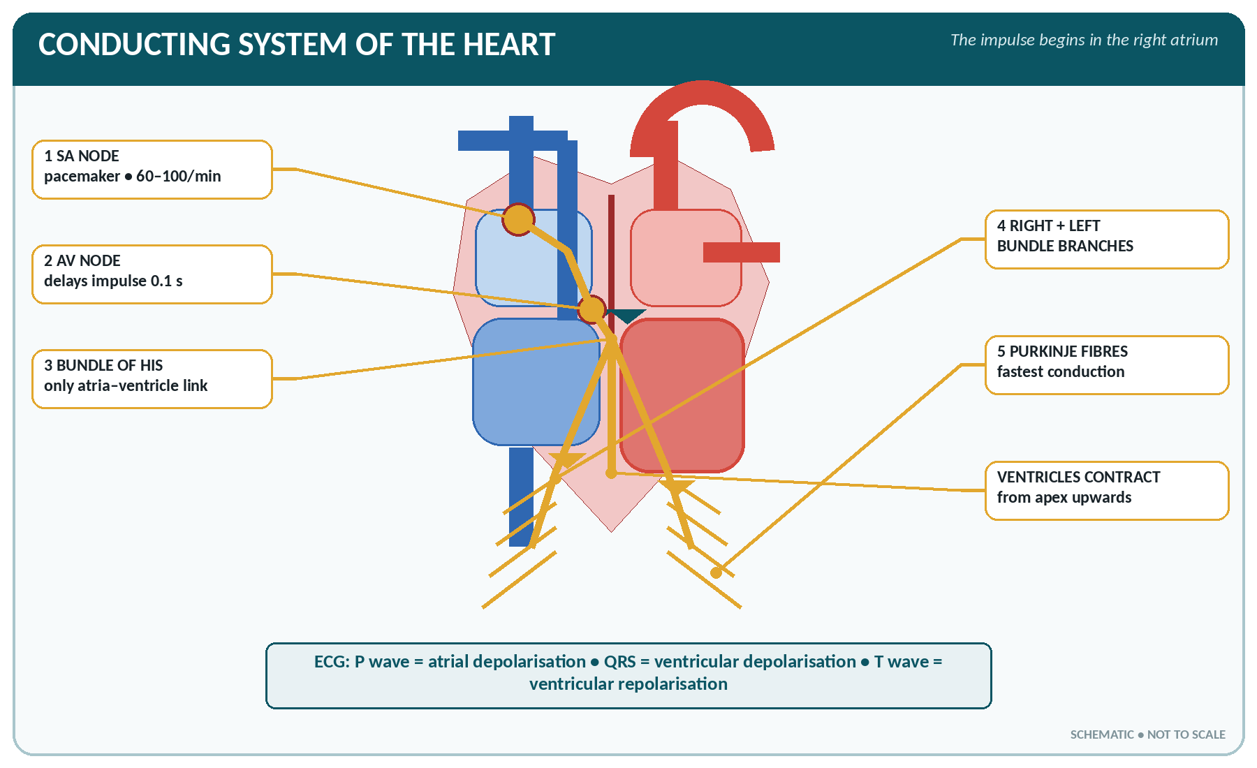
FIGURE • Cardiac impulse pathway—SA node to AV node, bundle of His, bundle branches and Purkinje fibres

▪ Cardiac muscle possesses autorhythmicity — it generates its own impulse. The specialised conducting tissue consists of:
Components of the conducting system
Structure | Position | Rate of impulse generation
Sino-atrial (SA) node — the pacemaker | In the wall of the right atrium, near the opening of the superior vena cava | 70–80 (60–100) per minute — the fastest, so it sets the rate
Atrioventricular (AV) node | Lower part of the interatrial septum, near the tricuspid valve | 40–60 per minute; it delays the impulse (0.1 s) to let the atria empty
Bundle of His (AV bundle) | In the interventricular septum | The only muscular connection between atria and ventricles
Right and left bundle branches | Down either side of the septum | —
Purkinje fibres | Spread through the ventricular myocardium | 20–40 per minute; conduct fastest (4 m/s)

▪ Sequence: SA node → atrial muscle (atria contract) → AV node → bundle of His → bundle branches → Purkinje fibres → ventricular muscle (ventricles contract from the apex upward).
▪ Nerve supply: the vagus (parasympathetic) slows the heart (cardio-inhibitory), the sympathetic (T1–T5, via the cardiac plexus) accelerates it and increases the force (cardio-accelerator). The heart beats even when denervated (as in a transplanted heart).
▪ The ECG (electrocardiogram) records this electrical activity:
– P wave — atrial depolarisation (contraction).
– QRS complex — ventricular depolarisation (contraction).
– T wave — ventricular repolarisation (relaxation).
– PR interval 0.12–0.20 s; QRS 0.08–0.10 s. The ECG was devised by Einthoven.
The Cardiac Cycle
▪ The cardiac cycle is one complete heart beat — the sequence of events from the beginning of one beat to the beginning of the next. At 75 beats/minute it lasts 0.8 second.
Phases of the cardiac cycle (at 75 beats per minute)
Phase | Duration | Events
Atrial systole | 0.1 s | Atria contract and complete the filling of the ventricles (they contribute only about 30%; 70% is passive filling); AV valves open, semilunar closed
Ventricular systole | 0.3 s | Ventricles contract; AV valves close (1st sound); pressure rises (isometric phase) until the semilunar valves open and blood is ejected
Complete cardiac diastole | 0.4 s | All chambers relax; semilunar valves close (2nd sound); AV valves open and the ventricles fill again

▪ Total systole 0.3 s; total diastole 0.5 s — the heart rests for a longer period than it works, and the coronary arteries are filled during diastole.
CARDIAC OUTPUT AND RELATED VALUES
▪ Stroke volume (SV): 60–80 mL (average 70 mL) per ventricle per beat.
▪ Cardiac output (CO) = stroke volume × heart rate = 70 × 72 ≈ 5 litres/minute (4.5–6 L/min).
▪ Cardiac index = cardiac output per square metre of body surface ≈ 3.2 L/min/m².
▪ Cardiac reserve — output can rise to 20–25 L/min in exercise (up to 35 L in athletes).
▪ Ejection fraction: 55–70% (SV ÷ end-diastolic volume).
▪ End-diastolic volume ≈ 120–130 mL; end-systolic volume ≈ 50 mL.
▪ Heart rate: adult 60–100/min (average 72); newborn 120–160; infant 100–120; child 80–100; athlete 50–60. Tachycardia > 100/min; bradycardia < 60/min.
▪ The heart beats about 100 000 times a day and pumps about 7000 litres in 24 hours.

▪ Factors affecting cardiac output: venous return (preload), the force of contraction (contractility), peripheral resistance (afterload), heart rate, blood volume, exercise, emotion, posture, temperature and hormones (adrenaline, thyroxine).
▪ Starling's law of the heart: within physiological limits, the force of contraction is directly proportional to the initial length of the muscle fibres — the more the heart is filled, the more forcibly it contracts.
Blood Supply and Nerve Supply of the Heart
▪ The heart is supplied by the right and left coronary arteries, the first branches of the aorta, arising from the aortic sinuses just above the aortic valve.
– Left coronary artery → anterior interventricular (left anterior descending, LAD) and circumflex branches; supplies most of the left ventricle, left atrium and the anterior part of the septum. The LAD is the "artery of sudden death".
– Right coronary artery → posterior interventricular and marginal branches; supplies the right atrium and ventricle, the SA node (in 60%) and the AV node (in 80–90%).
▪ Venous drainage: most of the blood returns through the coronary sinus into the right atrium; a few small veins open directly into the chambers.
▪ The coronary circulation receives about 250 mL/min (4–5% of the cardiac output) at rest; flow occurs mainly in diastole; the myocardium extracts 70–80% of the oxygen delivered to it.
▪ Ischaemic heart disease: narrowing (atheroma) causes angina pectoris on exertion; complete occlusion causes myocardial infarction, with severe crushing retrosternal pain radiating to the left arm and jaw, ECG changes and a rise in troponin, CK-MB and LDH.
The Blood Vessels
There are three main kinds of vessel — arteries, capillaries and veins — forming a closed circuit.
The three coats of an artery and a vein
Coat | Structure | Function
Tunica intima (interna) | A single layer of endothelium on a basement membrane, with subendothelial connective tissue and an internal elastic lamina | Provides a smooth, non-thrombogenic lining; secretes nitric oxide
Tunica media | Smooth muscle and elastic fibres — the thickest coat in arteries | Vasoconstriction and vasodilatation; withstands pressure; elastic recoil maintains diastolic flow
Tunica adventitia (externa) | Fibrous connective tissue, with the vasa vasorum and nerves; the thickest coat in veins | Support and protection

Arteries compared with veins
Feature | Arteries | Veins
Direction of flow | Away from the heart | Towards the heart
Blood carried | Oxygenated — except the pulmonary artery and the umbilical artery | Deoxygenated — except the pulmonary veins and the umbilical vein
Wall | Thick, strong, elastic; media thickest | Thin, less elastic; adventitia thickest
Lumen | Narrow, round, remains open when empty | Wide, oval/flattened, collapses when empty
Valves | Absent (except the aortic and pulmonary valves at their origin) | Present in veins over 2 mm, especially in the limbs — prevent backflow
Pressure and flow | High pressure (120/80 mmHg), pulsatile, rapid | Low pressure (5–10 mmHg), steady, slow
Blood volume held | About 15% of blood | About 60–70% of blood — the reservoir
Position | Usually deep | Deep and superficial
Special | Pulse is palpable | No pulse; varicose veins occur

▪ Arterioles — small arteries with a thick muscular coat; they are the chief site of peripheral resistance and therefore the main controllers of blood pressure ("stopcocks of the circulation").
▪ Capillaries — microscopic vessels, wall consisting of a single layer of endothelium only, diameter 5–10 µm (just wide enough for a red cell), length about 0.5–1 mm. About 10 billion capillaries with a total surface of 6000 m². They are the site of all exchange between blood and tissues. Blood flow through them is controlled by pre-capillary sphincters. Capillaries are absent in the epidermis, hair, nails, cornea, lens and cartilage.
▪ Sinusoids — wide, irregular capillary-like channels in the liver, spleen, bone marrow and endocrine glands.
▪ Venules — small veins collecting from capillaries.
▪ Anastomosis — a communication between vessels; end-arteries with no anastomosis are "anatomical end-arteries" (retina, kidney, spleen, brain) — their blockage causes infarction.
▪ Vasa vasorum — the small vessels supplying the walls of the large vessels themselves.
Exchange at the Capillary and the Formation of Tissue Fluid
▪ At the arterial end of a capillary the hydrostatic (blood) pressure (about 32–35 mmHg) exceeds the plasma colloid osmotic pressure (about 25 mmHg), so fluid filters out into the tissues.
▪ At the venous end the hydrostatic pressure has fallen (12–15 mmHg) below the osmotic pressure, so fluid is reabsorbed. These are the Starling forces.
▪ The small excess that remains in the tissues (about 2–4 litres a day) is drained away by the lymphatic capillaries.
▪ Oedema results from a rise in capillary pressure (heart failure, venous obstruction), a fall in plasma proteins (nephrotic syndrome, liver disease, malnutrition), increased capillary permeability (inflammation, burns, allergy) or lymphatic obstruction (filariasis — elephantiasis).
Blood Pressure and Pulse
BLOOD PRESSURE AND PULSE
▪ Normal adult BP: 120/80 mmHg (systolic 100–140, diastolic 60–90).
▪ Pulse pressure = systolic − diastolic = about 40 mmHg.
▪ Mean arterial pressure (MAP) = diastolic + 1/3 pulse pressure ≈ 93–100 mmHg.
▪ Hypertension — 140/90 mmHg or more on repeated readings; hypotension — below 90/60 mmHg.
▪ Pressures elsewhere: capillary 32 → 15 mmHg; venous 5–10 mmHg; right atrial (CVP) 0–8 mmHg (2–8 cm H₂O); pulmonary artery 25/10 mmHg.
▪ Pulse rate = heart rate: 60–100/min in the adult.

▪ Blood pressure is the lateral pressure exerted by the blood on the vessel wall. Systolic pressure is produced during ventricular contraction; diastolic pressure is maintained by the elastic recoil of the arteries during ventricular relaxation.
▪ BP = cardiac output × peripheral resistance. Factors determining it:
– Cardiac output (stroke volume and heart rate)
– Peripheral resistance — chiefly the calibre of the arterioles
– Blood volume and viscosity
– Elasticity of the arterial wall (loss of elasticity in old age raises systolic pressure)
– Venous return
▪ Regulation of blood pressure:
– Nervous (rapid) — the vasomotor centre in the medulla; the baroreceptors in the carotid sinus and aortic arch signal through the glossopharyngeal and vagus nerves and cause reflex slowing and vasodilatation when pressure rises; chemoreceptors in the carotid and aortic bodies respond to low O₂ and high CO₂.
– Chemical / hormonal (slower) — adrenaline and noradrenaline, the renin–angiotensin–aldosterone system (angiotensin II is the most powerful vasoconstrictor), ADH (vasopressin), atrial natriuretic peptide (lowers BP), and local factors such as nitric oxide (dilator), histamine and CO₂ (dilators).
– Renal (long-term) — control of water and sodium excretion.
▪ Physiological variations in BP: rises with age, exercise, emotion, meals, pain and cold; higher in the standing/sitting position than lying; higher in the leg than the arm; slightly higher in males; lowest during sleep.
▪ The pulse is the wave of distension passing along an artery with each heart beat. Sites where it is felt: radial (commonest), brachial, carotid, temporal, facial, femoral, popliteal, posterior tibial and dorsalis pedis. Characters noted: rate, rhythm, volume, force, tension and equality.
HEART AND VESSELS — RAPID REVISION
▪ The heart lies in the middle mediastinum; its apex is in the 5th left intercostal space; weight about 300 g; supplied by the coronary arteries (first branches of the aorta).
▪ Thickest myocardium — left ventricle; pacemaker — SA node in the right atrium; only muscular link between atria and ventricles — bundle of His.
▪ Tricuspid valve has 3 cusps, mitral 2; the mitral valve is most often affected by rheumatic heart disease.
▪ 1st heart sound = closure of AV valves; 2nd = closure of semilunar valves.
▪ Cardiac cycle 0.8 s — systole 0.3 s, diastole 0.5 s; stroke volume 70 mL; cardiac output 5 L/min; ejection fraction 55–70%.
▪ Starling's law relates force of contraction to initial fibre length (venous return).
▪ Vessels carrying deoxygenated blood despite being arteries — pulmonary and umbilical arteries.
▪ Capillaries have only one coat (endothelium); veins hold two-thirds of the blood volume; valves are present in veins, absent in arteries.
▪ Blood pressure = cardiac output × peripheral resistance; controlled by the vasomotor centre in the medulla and the baroreceptors of the carotid sinus.

CHAPTER 14
The Circulatory System

CHAPTER OUTLINE
The Two Circulations | The Aorta and its Branches | Arterial Supply, Region by Region | The Venous System | The Fetal Circulation | Special Features of Regional Circulations

The circulation is a closed double circuit: the pulmonary circulation carries blood from the heart to the lungs and back, and the systemic circulation carries blood from the heart to the rest of the body and back. William Harvey (1628) first described the circulation of the blood.
The Two Circulations
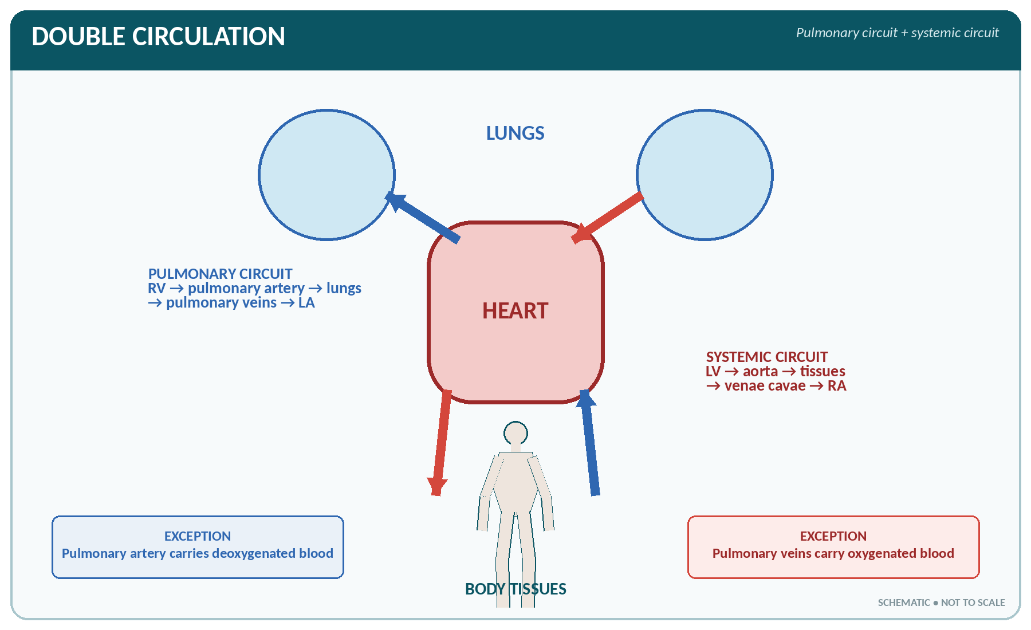
FIGURE • Pulmonary and systemic circuits—the human circulation is a closed double circuit

Pulmonary and systemic circulation compared
Feature | Pulmonary circulation | Systemic circulation
From → to | Right ventricle → lungs → left atrium | Left ventricle → body → right atrium
Vessel leaving the heart | Pulmonary artery (trunk) — carries deoxygenated blood | Aorta — carries oxygenated blood
Vessel returning | Four pulmonary veins — carry oxygenated blood | Superior and inferior venae cavae — carry deoxygenated blood
Pressure | Low — 25/10 mmHg, mean 15 mmHg | High — 120/80 mmHg, mean 93 mmHg
Resistance | Low | High
Length of circuit | Short | Long
Time for one circuit | About 4–8 seconds | About 20–25 seconds (complete circulation time about 25–30 s)
Purpose | Gas exchange (oxygenation) | Supply of oxygen and nutrients, removal of waste

The pulmonary circulation in detail
Right ventricle → pulmonary trunk → right and left pulmonary arteries → lobar and segmental arteries → arterioles → alveolar capillaries (gas exchange) → venules → two pulmonary veins from each lung → left atrium.
▪ The pulmonary trunk is about 5 cm long and divides under the arch of the aorta at the level of T5.
▪ The lungs also have a bronchial (nutritional) circulation from the thoracic aorta, whose blood returns partly by the bronchial veins to the azygos system — a small physiological shunt.
The Aorta and its Branches
The aorta is the largest artery of the body (diameter about 2.5 cm). It has four parts:
Parts and branches of the aorta
Part | Extent | Chief branches
Ascending aorta | From the left ventricle, 5 cm upward | Right and left coronary arteries
Arch of the aorta | Behind the manubrium, arching backward to the left at the level of T4 | 1. Brachiocephalic (innominate) artery (→ right common carotid + right subclavian); 2. Left common carotid; 3. Left subclavian
Thoracic (descending) aorta | T5 to T12 | Posterior intercostal, bronchial, oesophageal, mediastinal, superior phrenic arteries
Abdominal aorta | T12 (aortic opening of diaphragm) to L4, where it divides | Coeliac trunk (T12), superior mesenteric (L1), renal (L1–2), inferior mesenteric (L3), suprarenal, gonadal, lumbar, inferior phrenic, median sacral; ends by dividing into the two common iliac arteries

BRANCHES OF THE AORTIC ARCH
"ABC" from right to left — A: brachiocephalic Artery, B: left common carotid (B for "brain"), C: left subclavian. Remember there is no right brachiocephalic vein equivalent: the right common carotid and right subclavian arise from the brachiocephalic trunk, while on the left they arise directly from the arch.

Unpaired visceral branches of the abdominal aorta and their territories
Artery | Vertebral level | Supplies
Coeliac trunk (left gastric, splenic, common hepatic) | T12 | Stomach, lower oesophagus, liver, gall bladder, spleen, pancreas, duodenum (upper half) — the foregut
Superior mesenteric artery | L1 | Duodenum (lower half) to the right two-thirds of the transverse colon — the midgut; jejunum, ileum, caecum, appendix, ascending colon
Inferior mesenteric artery | L3 | Left third of the transverse colon, descending and sigmoid colon, upper rectum — the hindgut

Arterial Supply, Region by Region
Arteries of the head and neck
▪ The common carotid artery (right from the brachiocephalic, left from the arch) ascends in the neck and divides at the level of the upper border of the thyroid cartilage (C4) into:
– External carotid artery — supplies the face, scalp, neck and outside of the skull. Branches: superior thyroid, lingual, facial, occipital, posterior auricular, ascending pharyngeal, and its two terminal branches, the maxillary and superficial temporal arteries.
– Internal carotid artery — enters the skull through the carotid canal and supplies the brain (anterior circulation) and the eye. Branches: ophthalmic, anterior cerebral, middle cerebral and posterior communicating.
▪ The carotid sinus (a dilatation at the bifurcation) contains baroreceptors; the carotid body contains chemoreceptors.
▪ The vertebral artery (from the subclavian) ascends through the foramina transversaria of the cervical vertebrae, enters the skull through the foramen magnum, and the two join to form the basilar artery — the posterior circulation of the brain.
▪ The circle of Willis at the base of the brain is an arterial anastomosis formed by the two anterior cerebral arteries joined by the anterior communicating artery, the two internal carotids with their posterior communicating arteries, and the two posterior cerebral arteries from the basilar. It equalises pressure and provides a collateral supply.
Arteries of the upper limb
Subclavian → axillary (from the outer border of the 1st rib) → brachial (from the lower border of teres major) → divides at the elbow into the radial and ulnar arteries → deep and superficial palmar arches → digital arteries.
▪ Subclavian branches: vertebral, internal thoracic (mammary), thyrocervical and costocervical trunks.
▪ Brachial artery — the artery used for measuring blood pressure; lies medial to the biceps tendon in the cubital fossa, with the median nerve medial to it.
▪ Radial artery — the usual site for feeling the pulse, at the wrist lateral to the flexor carpi radialis tendon.
▪ The palmar arches are formed by both radial and ulnar arteries, giving a rich anastomosis (the reason Allen's test is done before radial artery puncture).
Arteries of the lower limb
Common iliac → external iliac → femoral (below the inguinal ligament) → popliteal (behind the knee, after passing through the adductor hiatus) → divides into anterior tibial and posterior tibial → dorsalis pedis (continuation of the anterior tibial) and the plantar arteries.
▪ The internal iliac artery supplies the pelvic organs, perineum, gluteal region and (in the female) the uterine artery.
▪ The femoral artery enters the thigh midway between the anterior superior iliac spine and the symphysis pubis (the mid-inguinal point) — the site for femoral puncture and for arresting bleeding.
▪ Pulses of the lower limb: femoral (groin), popliteal (behind the knee), posterior tibial (behind the medial malleolus) and dorsalis pedis (on the dorsum of the foot).
PRESSURE POINTS — WHERE TO COMPRESS AN ARTERY TO ARREST BLEEDING
Artery | Pressure point
Facial | Against the lower border of the mandible
Common carotid | Against the transverse process of C6 (carotid tubercle)
Subclavian | Downward and backward behind the middle of the clavicle against the 1st rib
Brachial | Against the shaft of the humerus on the medial side of the arm
Radial / ulnar | Against the lower end of the radius / ulna at the wrist
Femoral | At the mid-inguinal point against the head of the femur / pubic ramus
Popliteal | In the popliteal fossa against the lower end of the femur
Temporal | In front of the ear against the temporal bone

The Venous System
▪ Veins begin as venules from capillaries and end in the right atrium through the superior vena cava, inferior vena cava and the coronary sinus.
▪ There are two sets of veins in the limbs: deep veins (accompanying the arteries, usually two to each artery — venae comitantes) and superficial veins (in the superficial fascia), with perforating (communicating) veins between them.
Chief veins of the head, neck and upper limb
▪ Superficial veins of the scalp and face: facial, superficial temporal, retromandibular.
▪ Internal jugular vein — the largest vein of the head and neck; begins at the jugular foramen as a continuation of the sigmoid sinus, receives the facial, lingual and thyroid veins, and joins the subclavian vein to form the brachiocephalic vein.
▪ External jugular vein — superficial, drains the scalp and face, ends in the subclavian vein.
▪ The two brachiocephalic veins unite behind the right first costal cartilage to form the superior vena cava, which drains the head, neck, upper limbs and thorax into the right atrium.
▪ Upper limb: superficial — the cephalic (lateral) and basilic (medial) veins, joined in front of the elbow by the median cubital vein — the vein most used for venepuncture and intravenous infusion; deep — radial, ulnar, brachial and axillary veins.
Chief veins of the trunk and lower limb
▪ Inferior vena cava — formed by the union of the two common iliac veins at the level of L5; the largest vein in the body; ascends on the right of the aorta, pierces the diaphragm at T8, and enters the right atrium. It drains everything below the diaphragm.
– Tributaries: common iliac, lumbar, right gonadal, renal, right suprarenal, hepatic and inferior phrenic veins. (The left gonadal and left suprarenal veins drain into the left renal vein.)
▪ Azygos and hemiazygos veins — drain the posterior thoracic wall and form an important connection between the superior and inferior venae cavae.
▪ Lower limb: superficial — the great (long) saphenous vein, the longest vein in the body, which begins on the medial side of the dorsum of the foot, passes in front of the medial malleolus and ends in the femoral vein; and the small (short) saphenous vein, which passes behind the lateral malleolus and ends in the popliteal vein. Deep — anterior and posterior tibial, popliteal, femoral and external iliac veins.
The portal circulation
▪ A portal system is one in which blood passes through two sets of capillaries before returning to the heart.
▪ The hepatic portal vein carries blood from the abdominal part of the alimentary canal, spleen, pancreas and gall bladder to the liver. It is formed behind the neck of the pancreas by the union of the superior mesenteric vein and the splenic vein (which has received the inferior mesenteric vein). It is about 8 cm long and has no valves.
▪ It carries absorbed nutrients for storage and processing, and therefore contains a high concentration of glucose and amino acids after a meal, but is relatively deoxygenated. The liver also receives oxygenated blood from the hepatic artery; blood leaves the liver by the hepatic veins into the inferior vena cava.
▪ Other portal systems: the hypothalamo-hypophyseal portal system (hypothalamus → anterior pituitary) and the renal portal circulation (glomerular → peritubular capillaries).
▪ Porto-systemic anastomoses become important in portal hypertension (cirrhosis), producing oesophageal varices, caput medusae around the umbilicus and haemorrhoids.
Return of venous blood to the heart
Venous pressure is low, so venous return depends on:
1. The pumping action of the heart (vis a tergo) and the negative pressure in the right atrium.
2. The muscle pump — contraction of the limb muscles squeezes the deep veins; the valves ensure flow only towards the heart (the calf muscles are the "peripheral heart").
3. The respiratory pump — the negative intrathoracic pressure of inspiration draws blood upward.
4. Gravity — for structures above the heart.
5. Venous tone and the pulsation of neighbouring arteries.
6. The thoraco-abdominal pump and the pulsation of the diaphragm.
▪ Varicose veins result from incompetent valves and prolonged standing; they occur in the leg (saphenous), anal canal (haemorrhoids), scrotum (varicocele) and oesophagus (varices).
The Fetal Circulation
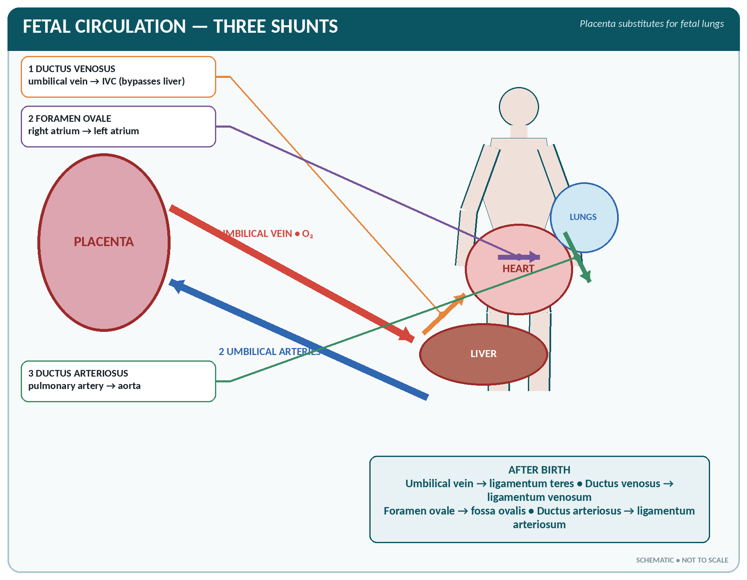
FIGURE • Fetal circulation—the placenta, umbilical vessels and the three shunts that bypass the liver and lungs

▪ In the fetus, the placenta performs respiration, nutrition and excretion; the lungs are collapsed and the liver is largely bypassed. Three shunts and two special vessels make this possible.
Special features of the fetal circulation and their fate after birth
Structure | Function before birth | Becomes after birth
Umbilical vein (1) | Carries oxygenated blood from the placenta to the fetus | Ligamentum teres of the liver
Umbilical arteries (2) | Carry deoxygenated blood from the fetus to the placenta | Lateral (obliterated) umbilical ligaments
Ductus venosus | Shunts blood from the umbilical vein to the inferior vena cava, bypassing the liver | Ligamentum venosum
Foramen ovale | Opening between the two atria — blood passes from right to left atrium, bypassing the lungs | Fossa ovalis
Ductus arteriosus | Connects the pulmonary artery to the aorta, bypassing the lungs | Ligamentum arteriosum

▪ The umbilical cord contains one vein and two arteries (mnemonic: AVA).
▪ At birth, the first breath expands the lungs, pulmonary resistance falls, the left atrial pressure rises and the foramen ovale closes (functionally at once, anatomically in about a year); the ductus arteriosus closes in 1–8 days (fibroses in 1–3 months); the umbilical vessels and ductus venosus close when the cord is tied.
▪ Persistence of these shunts causes congenital heart disease: patent ductus arteriosus, atrial septal defect. Other common defects: ventricular septal defect (the commonest), coarctation of the aorta, Fallot's tetralogy (pulmonary stenosis, VSD, overriding aorta, right ventricular hypertrophy — the commonest cyanotic congenital heart disease).
Special Features of Regional Circulations
Regional blood flow at rest (approximate share of a 5 L/min cardiac output)
Organ | Flow | Share
Liver (with the portal vein) | 1400 mL/min | 27%
Kidneys | 1100–1200 mL/min | 22–25% — the highest flow per 100 g of tissue
Brain | 750 mL/min | 15% (about 50 mL/100 g/min; needs 20% of the body's oxygen)
Skeletal muscle (rest) | 1000 mL/min | 15–20% (rises to 80% in exercise)
Heart (coronary) | 250 mL/min | 4–5%
Skin | 300–500 mL/min | 6–10% (very variable — temperature regulation)

▪ Cerebral circulation: kept remarkably constant by autoregulation; the strongest stimulus to cerebral vasodilatation is a rise in CO₂. The blood–brain barrier restricts the passage of substances from blood to brain tissue.
▪ Coronary circulation: flows mainly in diastole; dilated by hypoxia and adenosine.
▪ Cutaneous circulation: regulated by the sympathetic system for heat loss; blushing, pallor and flushing are its expressions.
THE CIRCULATION — RAPID REVISION
▪ Circulation of blood described by William Harvey; complete circulation time about 25–30 seconds.
▪ Branches of the arch of the aorta: brachiocephalic, left common carotid, left subclavian.
▪ Common carotid divides at C4 (upper border of thyroid cartilage); circle of Willis lies at the base of the brain.
▪ Largest artery — aorta; largest vein — inferior vena cava; longest vein — great saphenous.
▪ Vein used for intravenous injection — median cubital; pulse felt at the radial artery; BP measured at the brachial artery.
▪ Portal vein = superior mesenteric + splenic veins; carries blood from gut to liver; has no valves.
▪ Umbilical cord: 2 arteries + 1 vein; the umbilical vein carries oxygenated blood.
▪ Fetal shunts: ductus venosus, foramen ovale, ductus arteriosus → ligamentum venosum, fossa ovalis, ligamentum arteriosum.
▪ Organ receiving the greatest blood flow per gram — the kidney; the brain uses 20% of the body's oxygen.

CHAPTER 15
The Lymphatic System

CHAPTER OUTLINE
Lymph | Lymphatic Vessels | Lymph Nodes | The Lymphoid Organs | Immunity — An Outline

The lymphatic system is a one-way drainage system which returns tissue fluid to the blood. It consists of lymph, lymph capillaries and vessels, lymph nodes, and the lymphoid organs — spleen, thymus, tonsils, Peyer's patches and the appendix.
Lymph
▪ Lymph is the clear, colourless, slightly alkaline fluid found in the lymphatic vessels. It is essentially tissue (interstitial) fluid that has entered a lymphatic capillary.
▪ Composition: water, a little protein (2–3 g/dL — less than plasma but more than tissue fluid), salts, glucose, urea, lymphocytes, a few macrophages, fibrinogen (so it can clot slowly), and — from the intestine — fat.
▪ Chyle is the milky lymph from the intestinal lymphatics after a fatty meal; the fat is carried as chylomicrons. Intestinal lymphatics are therefore called lacteals.
▪ Quantity: about 2–4 litres are returned to the blood each day (lymph flow 100–120 mL/hour through the thoracic duct).
▪ Lymph differs from plasma chiefly in having much less protein and no platelets or red cells; it differs from tissue fluid in containing lymphocytes.
Functions of lymph and the lymphatic system
1. Drains excess tissue fluid and returns it with its protein to the blood — prevents oedema.
2. Absorption and transport of fat and fat-soluble vitamins (A, D, E, K) from the intestine.
3. Filtration of lymph by the nodes — removal of bacteria, cells and particles.
4. Immunity — production and circulation of lymphocytes and antibodies.
5. Returns plasma proteins that have escaped from capillaries.
6. Transport of some hormones and of large molecules.
Lymphatic Vessels
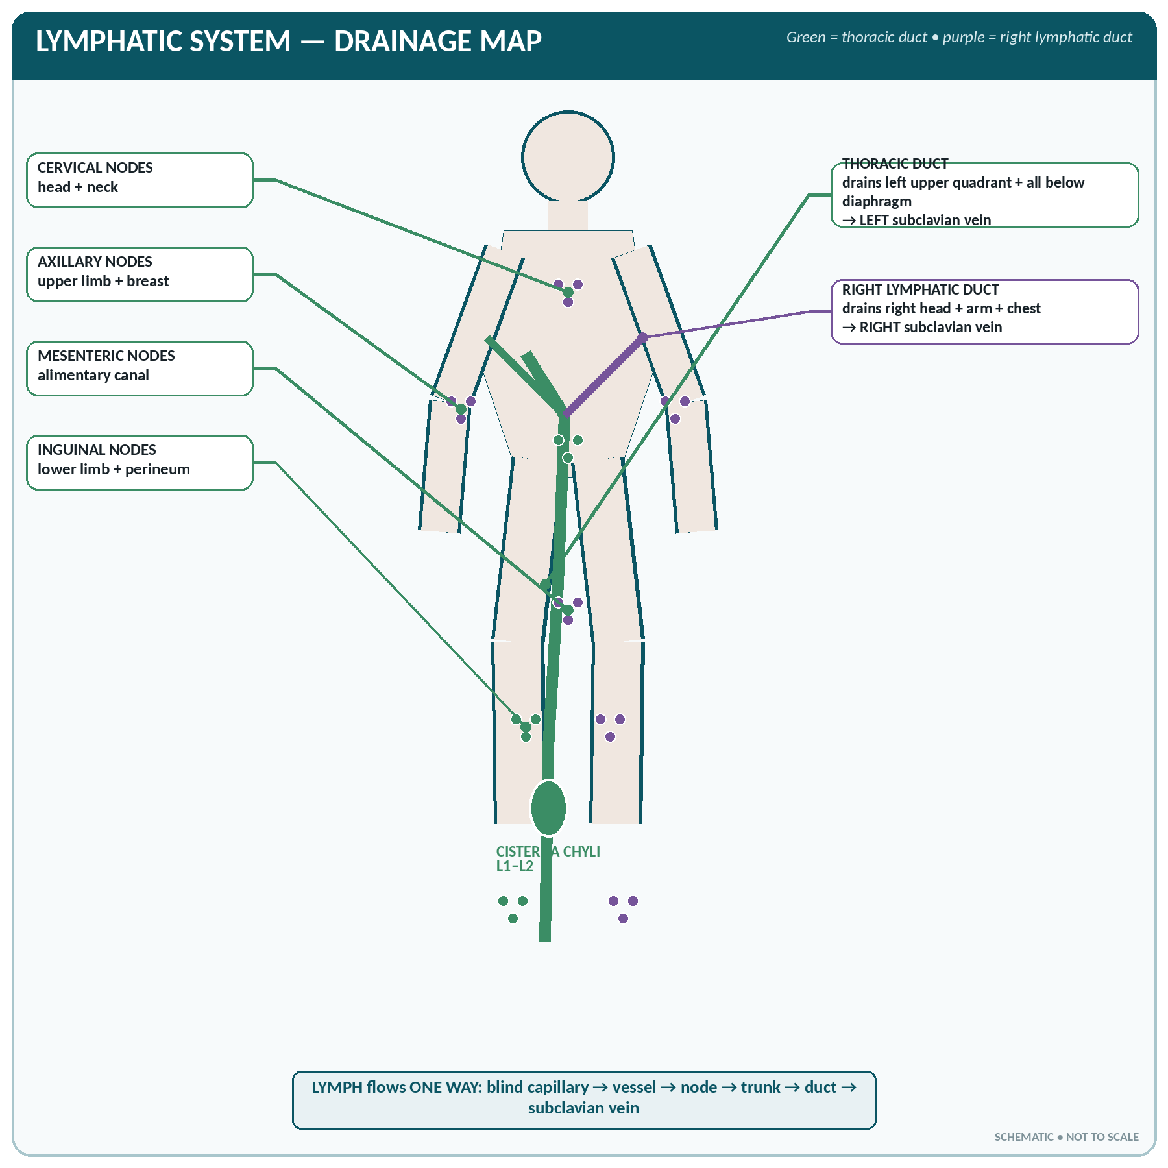
FIGURE • Major lymph-node groups and drainage through the thoracic and right lymphatic ducts

▪ Lymph capillaries begin blindly in the tissue spaces; their walls are a single layer of endothelium with wide overlapping junctions, so they are more permeable than blood capillaries.
▪ They join to form lymphatic vessels, which resemble veins but have thinner walls and many more valves, giving them a beaded appearance. They pass through at least one lymph node before reaching a duct.
▪ Lymphatics are absent in the central nervous system, bone marrow, cartilage, cornea, epidermis, hair, nails and the spleen pulp.
▪ Flow of lymph is slow and depends on: contraction of skeletal muscles, the valves, respiratory movements, the pulsation of adjacent arteries, the intrinsic contraction of the lymphatic wall (lymphangions) and negative intrathoracic pressure. It is not pumped by the heart.
The two great lymph ducts
Thoracic duct and right lymphatic duct
Feature | Thoracic duct | Right lymphatic duct
Size | The largest lymph vessel — 38–45 cm long | Small — about 1–1.25 cm
Begins as | The cisterna chyli (receptaculum chyli) in front of the L1–L2 vertebrae | Union of the right jugular, subclavian and bronchomediastinal trunks
Course | Ascends through the diaphragm (aortic opening, T12) in front of the vertebral column, crosses to the left at T5 | In the root of the neck
Ends in | Left subclavian vein (at its junction with the left internal jugular) | Right subclavian vein
Drains | Both lower limbs, the abdomen and pelvis, the left half of the thorax, the left upper limb, and the left side of the head and neck — about three-quarters of the body | Right upper limb, right half of the thorax, and the right side of the head and neck

WHICH DUCT DRAINS WHAT?
Everything drains into the thoracic duct except the right upper quadrant above the diaphragm (right head and neck, right arm, right chest), which drains into the right lymphatic duct.

Lymph Nodes
▪ Small oval or bean-shaped bodies, 1–25 mm across, placed along the course of the lymph vessels; there are about 400–700 lymph nodes in the body.
▪ Structure:
– A fibrous capsule sending trabeculae inward.
– Cortex — contains lymphatic follicles (nodules) with germinal centres where B lymphocytes multiply.
– Paracortex — T lymphocytes.
– Medulla — medullary cords of plasma cells and macrophages, with sinuses.
– Several afferent vessels enter the convex surface; one (or two) efferent vessel leaves at the concave hilum, along with the artery and vein. Lymph therefore flows slowly, allowing thorough filtration.
▪ Functions: filter lymph and phagocytose bacteria and foreign particles; produce lymphocytes, plasma cells and antibodies; act as a barrier to the spread of infection and of cancer cells (hence enlarged nodes in infection and in malignancy — lymphadenopathy).
The chief groups of lymph nodes and their drainage areas
Group | Position | Drains
Cervical (deep and superficial, submental, submandibular, occipital, pre- and post-auricular) | Neck | Scalp, face, mouth, tongue, teeth, pharynx, tonsils, thyroid
Axillary (anterior/pectoral, posterior, lateral, central, apical) | Axilla — 20–30 nodes | Upper limb, breast, chest wall — of great importance in carcinoma of the breast
Supratrochlear | Above the medial epicondyle | Medial side of the forearm and hand
Tracheobronchial, mediastinal | Thorax | Lungs, bronchi, heart, oesophagus
Coeliac, mesenteric, iliac, lumbar (para-aortic) | Abdomen and pelvis, along the vessels | Alimentary canal, liver, spleen, kidney, pelvic organs, testis and ovary (to para-aortic nodes)
Inguinal (superficial and deep) | Groin | Lower limb, external genitalia, perineum, anal canal below the pectinate line, lower abdominal wall, buttock
Popliteal | Behind the knee | Deep structures of the leg and foot

The Lymphoid Organs
The spleen
THE SPLEEN
▪ The largest lymphoid organ in the body; weight 150–200 g; measures about 12 × 7 × 3 cm (the "1, 3, 5, 7, 9, 11 rule": 1 × 3 × 5 inches, 7 oz, between the 9th and 11th ribs).
▪ Position: left hypochondrium, behind the stomach, against the diaphragm, in line with the 9th, 10th and 11th ribs, with its long axis along the 10th rib. It is not normally palpable.
▪ Blood supply: splenic artery (largest branch of the coeliac trunk); splenic vein joins the superior mesenteric vein to form the portal vein.
▪ Covered with peritoneum and enclosed in a fibro-elastic capsule; it has white pulp (lymphoid tissue) and red pulp (sinusoids full of blood).

▪ Functions:
1. Filtration of blood — removes worn-out red cells, platelets and bacteria; the "graveyard of red cells".
2. Immunity — produces lymphocytes, plasma cells, antibodies and opsonins.
3. Phagocytosis by the macrophages of the reticulo-endothelial system.
4. Reservoir of blood — stores blood (and platelets) and expels it on demand (a minor store in man).
5. Haemopoiesis — forms red cells in the fetus and again in severe anaemia (extramedullary haemopoiesis).
6. Iron metabolism — conserves the iron of destroyed haemoglobin.
▪ The spleen is not essential to life — after splenectomy its work is taken over by the liver, bone marrow and lymph nodes, but there is an increased risk of infection, especially by pneumococcus.
▪ Splenomegaly occurs in malaria, kala-azar, typhoid, infectious mononucleosis, leukaemia, lymphoma, thalassaemia, portal hypertension and endocarditis. The spleen is the most commonly injured abdominal organ in blunt trauma.
The thymus
▪ A bilobed lymphoid and endocrine gland in the superior mediastinum, behind the sternum, in front of the great vessels and the trachea.
▪ Largest and most active at birth and up to puberty (weight 10–15 g at birth, 30–40 g at puberty), after which it atrophies and is replaced by fat (involution).
▪ Functions: the site where T lymphocytes mature and are "educated" to distinguish self from non-self; secretes thymosin (thymopoietin); it is the primary lymphoid organ essential for cell-mediated immunity, and it is the master gland of immunity in early life.
▪ A thymic tumour (thymoma) is associated with myasthenia gravis.
The tonsils and other lymphoid tissue
▪ The Waldeyer's ring of lymphoid tissue guards the entrance of the pharynx:
– Palatine tonsils (2) — in the oropharynx between the palatoglossal and palatopharyngeal folds; their blood supply is from the tonsillar branch of the facial artery.
– Pharyngeal tonsil (adenoids) — in the nasopharynx; enlargement blocks the nose and the Eustachian tube in children.
– Lingual tonsil — at the back of the tongue.
– Tubal tonsils — around the openings of the auditory tubes.
▪ Gut-associated lymphoid tissue (GALT): Peyer's patches in the ileum (involved in typhoid, which may perforate here), the appendix ("abdominal tonsil"), and solitary follicles.
▪ MALT — mucosa-associated lymphoid tissue in the respiratory, genito-urinary and digestive tracts.
Primary and secondary lymphoid organs
Primary (where lymphocytes are formed and mature) | Secondary (where the immune response occurs)
Bone marrow (B cells) and thymus (T cells) | Lymph nodes, spleen, tonsils, Peyer's patches, appendix, MALT

Immunity — An Outline
Types of immunity
Type | Sub-type | Mechanism / examples
Innate (non-specific, natural) | First line | Skin and mucous membranes, mucus, cilia, tears and lysozyme, gastric acid, normal flora, inflammation, phagocytosis, complement, interferon, fever, natural killer cells
Acquired (specific, adaptive) — active | Natural active | Following an attack of the disease — long lasting
 | Artificial active | Vaccination (BCG, OPV, measles, tetanus toxoid) — slow onset, long duration
Acquired — passive | Natural passive | Antibodies from the mother across the placenta (IgG) and in breast milk/colostrum (IgA)
 | Artificial passive | Antisera / immunoglobulins (anti-tetanus serum, anti-D, anti-snake venom) — immediate onset, short duration

▪ Cell-mediated immunity — by T lymphocytes: helper (CD4), cytotoxic/killer (CD8), regulatory and memory cells; important against viruses, fungi, tuberculosis, tumours and transplants (graft rejection and the tuberculin test are T-cell reactions).
▪ Humoral (antibody-mediated) immunity — by B lymphocytes → plasma cells → antibodies (immunoglobulins).
The five classes of immunoglobulin
Class | Share | Features
IgG | 75–80% — the most abundant | Only antibody that crosses the placenta; gives long-term immunity; involved in secondary response
IgA | 10–15% | The antibody of secretions — saliva, tears, bile, colostrum and breast milk; mucosal defence
IgM | 5–10% | The largest antibody (macroglobulin); the first to appear in a new infection (primary response); includes the ABO isoagglutinins
IgE | Trace | Mediates allergy and hypersensitivity (asthma, hay fever); attached to mast cells
IgD | Trace | On the surface of B cells; receptor function

▪ Antigen — a substance that provokes an immune response; antibody — the immunoglobulin formed against it; antigen–antibody reaction neutralises, agglutinates, precipitates or lyses (with complement) the antigen.
▪ Hypersensitivity (allergy) — an exaggerated immune response; the immediate type (anaphylaxis) is mediated by IgE and histamine and is treated with adrenaline.
▪ Autoimmune disease — the body reacts against its own tissue (rheumatoid arthritis, rheumatic fever, Hashimoto's thyroiditis, myasthenia gravis, type 1 diabetes, systemic lupus erythematosus).
▪ Immunodeficiency — e.g. AIDS, in which HIV destroys CD4 helper T lymphocytes.
DISORDERS OF THE LYMPHATIC SYSTEM
▪ Lymphadenitis / lymphadenopathy — inflamed or enlarged nodes; lymphangitis — inflamed lymphatic vessels, seen as red streaks.
▪ Lymphoedema — swelling due to obstructed lymph drainage: after mastectomy with axillary node clearance (arm oedema), or in filariasis (Wuchereria bancrofti) causing elephantiasis.
▪ Hodgkin's lymphoma — painless rubbery cervical lymphadenopathy with Reed–Sternberg cells; non-Hodgkin's lymphoma; lymphatic leukaemia.
▪ Tuberculous lymphadenitis — matted cervical nodes with caseation and sinus formation.
▪ Chylothorax / chylous ascites — leakage of chyle after injury to the thoracic duct.
▪ Metastasis — carcinoma spreads chiefly by lymphatics; sarcoma chiefly by the blood stream. The first node draining a tumour is the sentinel node.

THE LYMPHATIC SYSTEM — RAPID REVISION
▪ Largest lymphatic vessel — thoracic duct (38–45 cm), begins as the cisterna chyli at L1–L2 and ends in the left subclavian vein.
▪ Largest lymphoid organ — spleen (150–200 g, left hypochondrium, ribs 9–11).
▪ Lymph moves by muscle contraction, valves and respiration — not by the heart.
▪ Lymphatics are absent in the CNS, cornea, cartilage, epidermis and bone marrow.
▪ Fat is absorbed by the lacteals of the villi as chyle.
▪ T cells mature in the thymus, B cells in the bone marrow.
▪ Most abundant immunoglobulin — IgG; only one crossing the placenta — IgG; largest and earliest — IgM; in secretions and breast milk — IgA; in allergy — IgE.
▪ Axillary nodes drain the breast — important in breast cancer; the testis drains to the para-aortic nodes.

CHAPTER 16
The Respiratory System

CHAPTER OUTLINE
The Nose and Nasal Cavity | The Pharynx | The Larynx (Voice Box) | The Trachea (Wind Pipe) | The Lungs | The Mechanism of Breathing | Exchange and Transport of Gases | The Regulation (Control) of Respiration

Respiration is the exchange of oxygen and carbon dioxide between the body and the atmosphere. The respiratory system consists of the nose, pharynx, larynx, trachea, bronchi, bronchioles and lungs, with the thoracic cage, diaphragm and respiratory muscles as the mechanical pump.
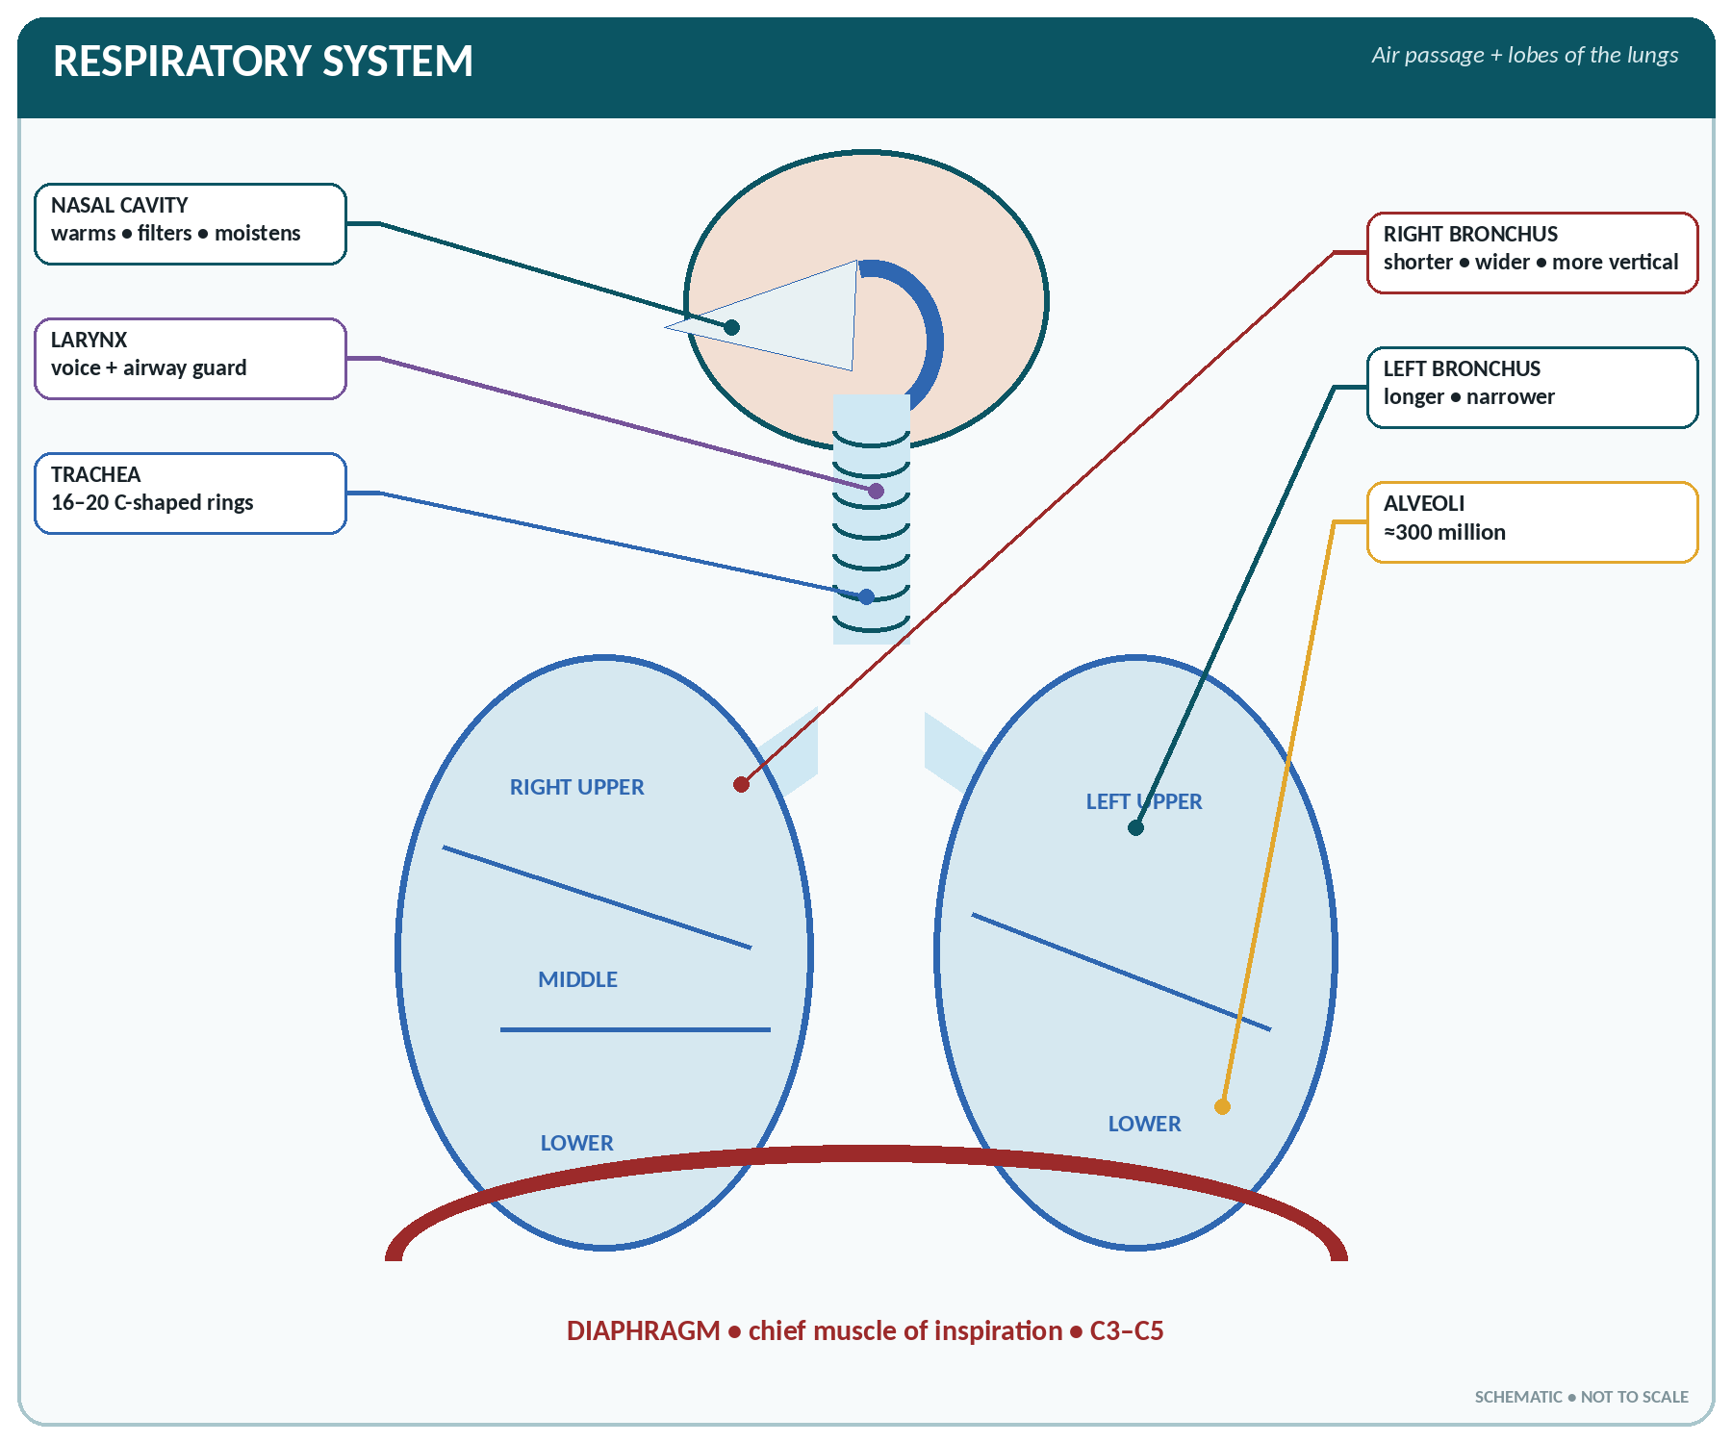
FIGURE • Respiratory tract from nasal cavity to alveoli, with the lobes of both lungs and the diaphragm

Divisions of the respiratory tract
Division | Parts | Function
Upper respiratory tract | Nose, nasal cavity, paranasal sinuses, pharynx, larynx | Conduction, filtration, warming and moistening of air; voice
Lower respiratory tract | Trachea, bronchi, bronchioles, alveoli, lungs | Conduction and gas exchange
Conducting zone (anatomical dead space, ≈ 150 mL) | Nose to terminal bronchioles | No gas exchange — air is conditioned
Respiratory zone | Respiratory bronchioles, alveolar ducts, alveolar sacs, alveoli | Gas exchange

The Nose and Nasal Cavity
▪ The external nose has a bony part (nasal bones, maxilla, frontal) and a cartilaginous part.
▪ The nasal cavity is divided by the nasal septum (formed by the perpendicular plate of the ethmoid, the vomer and the septal cartilage) into two halves; each has a roof, floor (hard palate), medial and lateral wall.
▪ The lateral wall carries three conchae (turbinates) — superior and middle (from the ethmoid) and the inferior concha (a separate bone). They create turbulence and increase the surface area.
▪ Openings into the nose: the nasolacrimal duct (into the inferior meatus), the maxillary, frontal, anterior and middle ethmoidal sinuses (into the middle meatus), the posterior ethmoidal (superior meatus) and the sphenoidal sinus (spheno-ethmoidal recess).
▪ Lining: the vestibule has skin with hairs; the upper part has olfactory epithelium (smell); the rest is ciliated columnar epithelium with goblet cells (respiratory mucosa), lying on a very vascular submucosa.
▪ Functions of the nose: warming, moistening (humidifying) and filtering inspired air; olfaction (smell); resonance of the voice; sneeze reflex; drainage of tears and sinuses.
▪ Blood supply: branches of the sphenopalatine (maxillary) and facial arteries; the rich anastomosis in the anterior septum is Little's area, the commonest site of epistaxis (nose bleed).
The Pharynx
▪ A muscular tube about 12–14 cm long, from the base of the skull to the level of C6, where it becomes the oesophagus. It is common to the respiratory and digestive tracts.
The three parts of the pharynx
Part | Extent | Openings and features | Lining
Nasopharynx | Base of skull to the soft palate | Two posterior nasal apertures, two openings of the auditory (Eustachian) tubes, the pharyngeal tonsil (adenoids) | Ciliated columnar
Oropharynx | Soft palate to the upper border of the epiglottis (C3) | Opening of the mouth, the palatine tonsils | Stratified squamous
Laryngopharynx (hypopharynx) | Epiglottis to C6 | Opening into the larynx in front and the oesophagus below | Stratified squamous

▪ The auditory tube equalises the pressure on the two sides of the tympanic membrane; infection spreads along it from the nasopharynx to cause otitis media, especially in children (in whom it is short, wide and horizontal).
The Larynx (Voice Box)
▪ Position: in the front of the neck, from C3 to C6, between the pharynx above and the trachea below; about 5 cm long. It is shorter in the female, which is why her voice is higher pitched.
▪ Cartilages (9 in all):
– Single: thyroid (the largest; forms the laryngeal prominence / Adam's apple), cricoid (the only complete ring, at C6 — the landmark for cricothyroidotomy and for cricoid pressure), and the epiglottis (leaf-shaped elastic cartilage).
– Paired: arytenoid (bear the vocal cords), corniculate and cuneiform.
– The thyroid, cricoid and most of the arytenoids are hyaline; the epiglottis, corniculate, cuneiform and the apex of the arytenoid are elastic cartilage.
▪ Vocal cords (folds): the true cords produce voice; the space between them is the rima glottidis (glottis) — the narrowest part of the airway in the adult. Above them lie the false (vestibular) cords.
▪ Muscles: the intrinsic muscles move the cords — all are supplied by the recurrent laryngeal nerve except the cricothyroid (external laryngeal nerve). The posterior cricoarytenoid is the only abductor ("the safety muscle of the larynx"); bilateral paralysis causes stridor and asphyxia.
▪ Nerve supply: sensory above the cords — internal laryngeal branch of the superior laryngeal; below the cords and all motor — the recurrent laryngeal nerve (a branch of the vagus). Injury during thyroid surgery causes hoarseness.
▪ Functions: production of voice (phonation); protection of the airway — the epiglottis and the cords close during swallowing; the cough reflex; conduction of air; it also takes part in the Valsalva manoeuvre.
▪ Voice production — expired air vibrates the cords; pitch depends on the length and tension of the cords, volume on the force of air, and resonance on the pharynx, mouth, nose and sinuses; articulation (speech) is by the tongue, lips, teeth and palate.
The Trachea (Wind Pipe)
▪ A tube about 10–12 cm long and 2–2.5 cm wide, extending from the larynx (C6) to its bifurcation at the level of T4/T5 (the sternal angle), where it divides into the two principal bronchi at the carina.
▪ Its wall contains 16–20 C-shaped (incomplete) rings of hyaline cartilage, deficient posteriorly where the trachealis muscle and fibrous tissue lie next to the oesophagus — this allows the oesophagus to expand, and keeps the trachea permanently open.
▪ Lining: ciliated pseudostratified columnar epithelium with goblet cells; the cilia beat upward (the mucociliary escalator) moving mucus and dust to the pharynx — smoking paralyses the cilia.
▪ Tracheostomy is performed through the 2nd to 4th tracheal rings.
Right and left principal (main) bronchi compared
Feature | Right bronchus | Left bronchus
Length | Shorter — about 2.5 cm | Longer — about 5 cm
Width | Wider | Narrower
Direction | More vertical (in line with the trachea) | More horizontal/oblique
Branches | 3 lobar bronchi | 2 lobar bronchi
Clinical | Inhaled foreign bodies and aspirated material go to the right bronchus; right lower lobe abscess is commoner | —

▪ Branching: principal bronchi → lobar (secondary) → segmental (tertiary, 10 on the right, 8–9 on the left) → smaller bronchi → bronchioles (no cartilage, mainly smooth muscle — the site of bronchospasm in asthma) → terminal bronchioles → respiratory bronchioles → alveolar ducts → alveolar sacs → alveoli. There are about 23 generations of branching.
The Lungs
THE LUNGS
▪ Number: two — right and left, in the thoracic cavity on either side of the mediastinum.
▪ Shape: cone-shaped, with an apex (rising 2.5–5 cm above the clavicle into the root of the neck), a base (resting on the diaphragm), costal and mediastinal surfaces.
▪ Weight: right lung about 625 g, left about 565 g (the right lung is larger and heavier).
▪ Lobes: right 3 (upper, middle, lower — separated by the oblique and horizontal fissures); left 2 (upper and lower — separated by the oblique fissure only). The left has a cardiac notch and the lingula.
▪ Bronchopulmonary segments: 10 in the right, 8–10 in the left — each with its own segmental bronchus, artery and vein, so it can be removed surgically.
▪ Alveoli: about 300 million, giving a total surface area of 70–100 m² (about the size of a tennis court). The respiratory membrane is only 0.5–1 µm thick.

▪ The hilum (root) of the lung transmits the principal bronchus, pulmonary artery, two pulmonary veins, bronchial vessels, lymphatics and nerves.
▪ Blood supply: a double supply — the pulmonary arteries (for gas exchange, carrying deoxygenated blood) and the bronchial arteries from the thoracic aorta (for nutrition).
▪ Nerve supply: from the pulmonary plexus — sympathetic fibres dilate the bronchi and vagal (parasympathetic) fibres constrict them and increase secretion.
The pleura
▪ A serous membrane with two layers: the parietal pleura lining the chest wall, diaphragm and mediastinum, and the visceral pleura covering the lung and dipping into the fissures.
▪ Between them is the pleural cavity, a capillary space containing only a few millilitres (about 5–15 mL) of serous fluid which lubricates the surfaces and holds them together by surface tension.
▪ The intrapleural pressure is negative — about −4 mmHg at the end of expiration and −8 mmHg at the end of inspiration — and this keeps the lungs expanded.
▪ Pleurisy — inflammation, with a "pleural rub" and pain on breathing; pleural effusion — fluid; empyema — pus; haemothorax — blood; pneumothorax — air, which collapses the lung.
▪ Surfactant, secreted by type II alveolar (septal) cells, is a phospholipid (dipalmitoyl lecithin) which lowers surface tension, prevents the alveoli from collapsing and reduces the work of breathing. Its deficiency in the premature infant causes respiratory distress syndrome (hyaline membrane disease). It appears from about the 24th week and is adequate by the 34th–36th week of gestation.
▪ The alveolar wall also contains type I cells (flat, for gas exchange) and alveolar macrophages (dust cells).
The Mechanism of Breathing
▪ Inspiration is an active process: the diaphragm (chief muscle, supplied by the phrenic nerve C3–C5) descends, and the external intercostals raise the ribs. The thorax enlarges in all three diameters, intrapulmonary pressure falls below atmospheric (−1 to −3 mmHg), and air flows in.
▪ Expiration is passive at rest — the muscles relax and the elastic recoil of the lungs and chest wall expels the air; pressure rises to +1 to +3 mmHg. Forced expiration uses the abdominal muscles and internal intercostals.
▪ The two together take about 5 seconds (inspiration 2 s, expiration 3 s) — an I : E ratio of 1 : 2.
▪ Compliance is the ease of expansion of the lungs (reduced in fibrosis and in surfactant deficiency); airway resistance is increased in asthma and bronchitis.
▪ Intrapleural pressure is always negative; a communication with the atmosphere abolishes it and the lung collapses.
LUNG VOLUMES AND CAPACITIES (AVERAGE ADULT MALE)
Volume / capacity | Value | Definition
Tidal volume (TV) | 500 mL (6–8 mL/kg) | Air moved in or out with each quiet breath
Inspiratory reserve volume (IRV) | 3000 mL | Extra air that can be inspired after a normal inspiration
Expiratory reserve volume (ERV) | 1100 mL | Extra air that can be expired after a normal expiration
Residual volume (RV) | 1200 mL | Air remaining in the lungs after the most forcible expiration — cannot be measured by spirometry
Inspiratory capacity (IC = TV + IRV) | 3500 mL | —
Functional residual capacity (FRC = ERV + RV) | 2300 mL | Air left after a normal expiration
Vital capacity (VC = IRV + TV + ERV) | 4500–4800 mL | The maximum air expired after a maximum inspiration; reduced in lung and heart disease, pregnancy and old age
Total lung capacity (TLC = VC + RV) | 5800–6000 mL | —
Anatomical dead space | 150 mL | Air in the conducting passages taking no part in exchange
Respiratory rate | 12–20/min in the adult (14–18 average); newborn 30–60; child 20–30 | —
Pulmonary ventilation (minute volume) | TV × rate = 500 × 15 = 6–8 L/min | —
Alveolar ventilation | (500 − 150) × 15 = 4.2–5 L/min | The effective ventilation
FEV₁ / FVC ratio | > 75–80% normally | Reduced in obstructive disease (asthma, COPD); normal or raised with reduced volumes in restrictive disease

Values are about 20–25% lower in the female.

Exchange and Transport of Gases
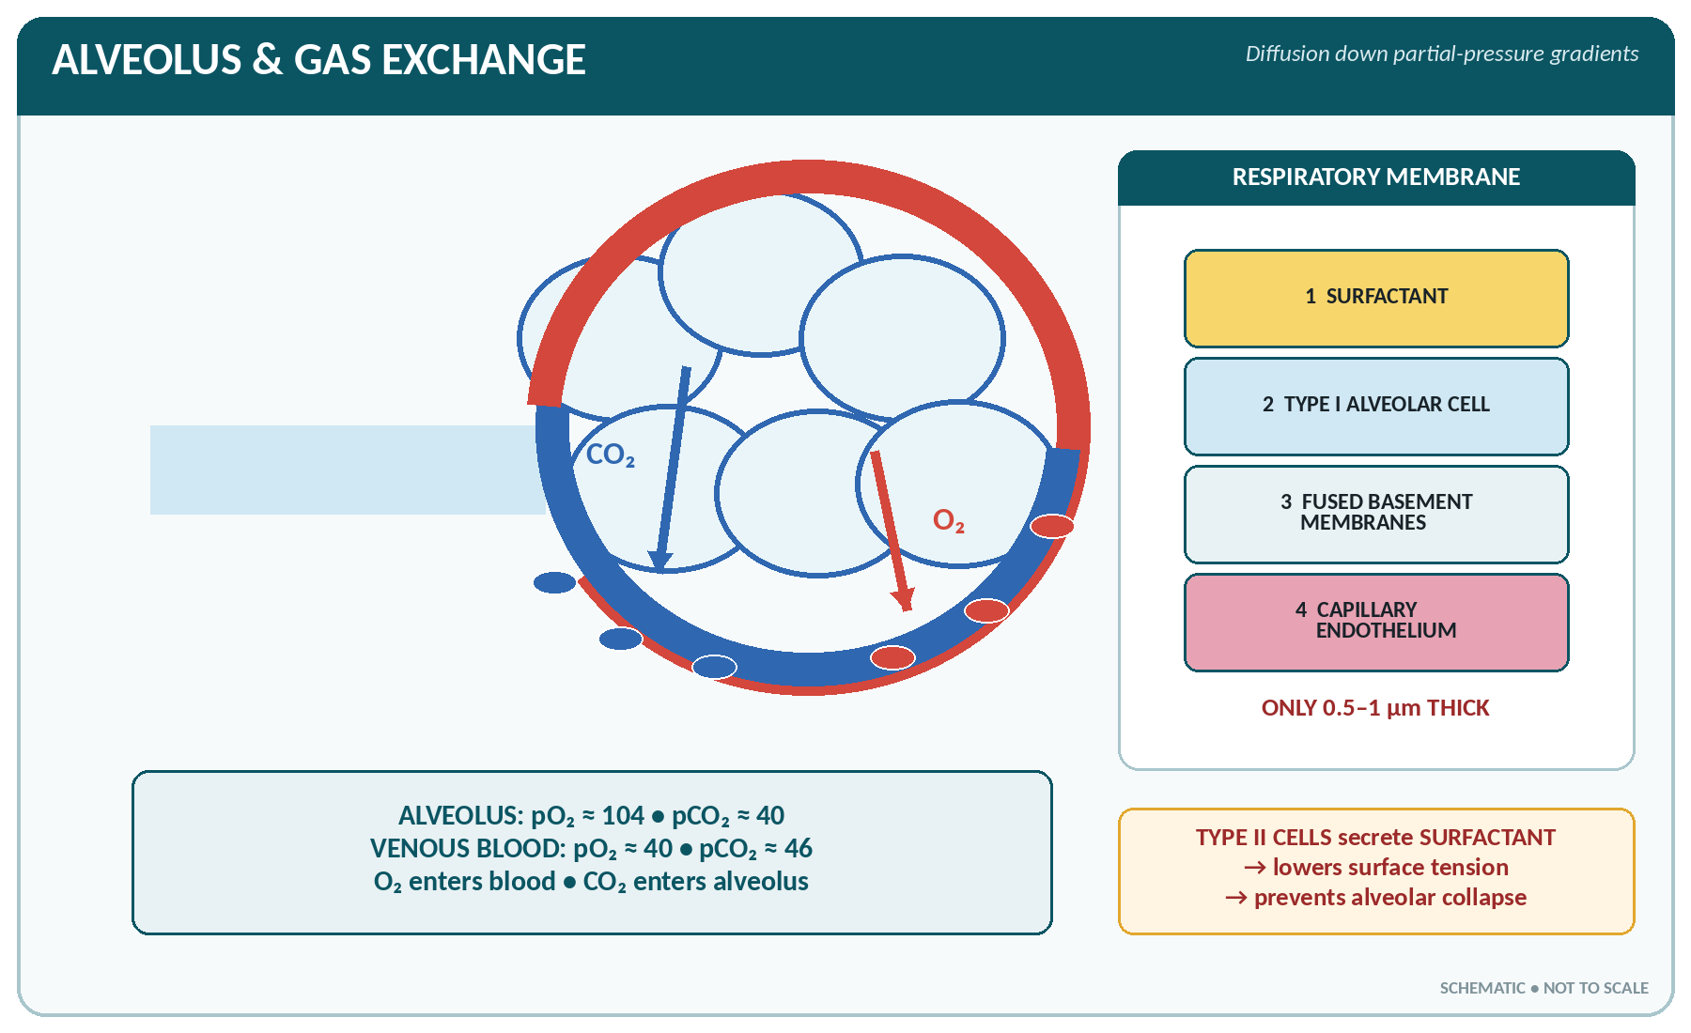
FIGURE • Alveolus, respiratory membrane and the opposite diffusion gradients of oxygen and carbon dioxide

Partial pressures
Partial pressures of oxygen and carbon dioxide (mmHg)
Site | pO₂ | pCO₂
Atmospheric (inspired) air | 159–160 | 0.3
Alveolar air | 100–104 | 40
Arterial blood | 95–100 | 40
Venous blood (mixed) | 40 | 46
Tissue (interstitial) | < 40 (about 30) | > 45 (about 50)

▪ External respiration — exchange between alveolar air and blood, by diffusion across the respiratory membrane, driven by the difference in partial pressure (Dalton's and Fick's laws). CO₂ diffuses about 20 times more readily than O₂ because it is far more soluble.
▪ Internal (tissue) respiration — exchange between blood and tissue cells, in the opposite direction.
Transport of oxygen
▪ 97–98% is carried as oxyhaemoglobin in the red cells; only 2–3% is dissolved in the plasma.
▪ 1 g of haemoglobin carries 1.34 mL O₂; 100 mL of arterial blood carries about 19–20 mL O₂ (oxygen capacity). Arterial saturation (SaO₂) is 95–100%; venous saturation about 75%.
▪ The oxygen–haemoglobin dissociation curve is S-shaped (sigmoid). A shift to the right means oxygen is released more readily to the tissues, and is caused by a rise in CO₂, a rise in H⁺ (fall in pH), a rise in temperature and a rise in 2,3-DPG — the Bohr effect. A shift to the left (alkalosis, cold, fetal haemoglobin, low CO₂) means oxygen is held more tightly.
Transport of carbon dioxide
▪ As bicarbonate in the plasma — about 70% (formed in the red cell by the enzyme carbonic anhydrase and exchanged for chloride — the chloride shift).
▪ As carbamino compounds with haemoglobin and plasma protein — about 23%.
▪ Dissolved in plasma — about 7%.
▪ The Haldane effect: deoxygenated blood carries carbon dioxide more readily.
The Regulation (Control) of Respiration
Nervous control
▪ The respiratory centre lies in the medulla oblongata and pons of the brain stem:
– Medullary centres — the inspiratory (dorsal) and expiratory (ventral) groups; the medulla sets the basic rhythm.
– Pontine centres — the pneumotaxic centre (inhibits inspiration, so it controls the rate) and the apneustic centre (prolongs inspiration).
▪ Voluntary control comes from the cerebral cortex (as in speaking, singing and breath-holding).
▪ Reflexes:
– Hering–Breuer (stretch) reflex — stretch receptors in the bronchi and bronchioles send impulses by the vagus to inhibit inspiration and prevent over-inflation.
– Reflexes from baroreceptors, pain, temperature, swallowing (apnoea), coughing and sneezing.
Chemical control — the more important
▪ Central chemoreceptors in the medulla are stimulated by a rise in the CO₂ (and H⁺) of the cerebrospinal fluid.
▪ Peripheral chemoreceptors in the carotid and aortic bodies respond mainly to a fall in oxygen (pO₂ below 60 mmHg), and also to raised CO₂ and H⁺.
▪ The most powerful normal stimulus to respiration is a rise in the carbon dioxide of the blood (hypercapnia) — a rise of even 0.3% in inspired CO₂ doubles the ventilation. Lack of oxygen is a weaker stimulus but becomes the chief one in chronic lung disease.
▪ Voluntary hyperventilation washes out CO₂ and produces a period of apnoea; breath-holding ends when CO₂ rises to the "breaking point".
Terms describing respiration
Term | Meaning
Eupnoea | Normal quiet breathing
Dyspnoea | Difficult or laboured breathing (breathlessness)
Orthopnoea | Dyspnoea on lying flat, relieved by sitting up (left heart failure)
Tachypnoea | Rapid breathing
Bradypnoea | Abnormally slow breathing
Apnoea | Temporary cessation of breathing
Hyperpnoea / hyperventilation | Increased depth (and rate) of breathing
Hypoventilation | Reduced ventilation, with CO₂ retention
Asphyxia | Lack of oxygen with retention of CO₂
Hypoxia / anoxia | Reduced / absent oxygen in the tissues
Cyanosis | Bluish discoloration from reduced haemoglobin — visible when there is about 5 g/dL of deoxygenated haemoglobin; central (tongue) and peripheral types
Cheyne–Stokes respiration | Cyclical waxing and waning with periods of apnoea (heart failure, raised intracranial pressure, terminal illness)
Kussmaul's respiration | Deep sighing rapid breathing of diabetic ketoacidosis/acidosis (air hunger)
Stridor | Harsh noisy breathing from upper airway obstruction
Wheeze | Musical sound of narrowed lower airways (asthma)
Haemoptysis | Coughing up blood
Stertorous breathing | Noisy snoring breathing (coma)

The protective reflexes of the respiratory tract
Reflex | Pathway / purpose
Sneezing | Irritation of the nasal mucosa → explosive expiration through the nose
Coughing | Irritation of the larynx, trachea or bronchi → deep inspiration, closure of the glottis, then explosive expiration through the mouth
Yawning | Deep inspiration through the wide-open mouth
Hiccup (singultus) | Spasmodic contraction of the diaphragm with sudden closure of the glottis
Sighing | Slow deep breath
Laryngeal (glottic) closure | Prevents aspiration during swallowing

COMMON RESPIRATORY DISORDERS
▪ Asthma — reversible bronchospasm with wheeze; obstructive.
▪ Chronic bronchitis and emphysema (COPD) — usually from smoking; barrel chest, prolonged expiration.
▪ Pneumonia — consolidation of the alveoli (commonest organism Streptococcus pneumoniae).
▪ Pulmonary tuberculosis — Mycobacterium tuberculosis; cough, evening rise of temperature, night sweats, weight loss, haemoptysis; diagnosed by sputum AFB and chest radiograph.
▪ Pleural effusion, pneumothorax, atelectasis (collapse), bronchiectasis, lung abscess.
▪ Pulmonary embolism — a clot from the leg veins impacting in the pulmonary artery.
▪ Respiratory distress syndrome of the newborn — surfactant deficiency.
▪ Carbon monoxide poisoning — cherry-red skin, treated with 100% oxygen.

RESPIRATORY SYSTEM — RAPID REVISION
▪ Trachea: 10–12 cm long, bifurcates at T4/T5 (sternal angle), has 16–20 C-shaped cartilages; the right bronchus is shorter, wider and more vertical.
▪ Right lung 3 lobes, left lung 2 lobes; about 300 million alveoli, surface area 70–100 m².
▪ Chief muscle of inspiration — diaphragm (phrenic nerve, C3–C5); quiet expiration is passive.
▪ Tidal volume 500 mL; vital capacity 4500–4800 mL; residual volume 1200 mL; dead space 150 mL; respiratory rate 12–20/min.
▪ Oxygen is carried as oxyhaemoglobin (97%); CO₂ chiefly as bicarbonate (70%); enzyme involved — carbonic anhydrase.
▪ The respiratory centre is in the medulla and pons; the chief chemical stimulus is CO₂.
▪ Surfactant is secreted by type II alveolar cells and lowers surface tension.
▪ Narrowest part of the adult airway — the glottis (rima glottidis); the only complete cartilage ring — the cricoid; the only abductor of the vocal cords — the posterior cricoarytenoid.
▪ Cyanosis appears when about 5 g/dL of haemoglobin is deoxygenated.

CHAPTER 17
The Digestive System

CHAPTER OUTLINE
The Structure of the Alimentary Canal — Four Coats | The Mouth (Oral Cavity) | Deglutition (Swallowing) | The Oesophagus | The Stomach | The Small Intestine | The Large Intestine | The Peritoneum

The digestive (alimentary) system consists of the alimentary canal — a tube about 9 metres (30 feet) long from mouth to anus — together with the accessory organs of digestion: the teeth, tongue, salivary glands, liver, gall bladder and pancreas.
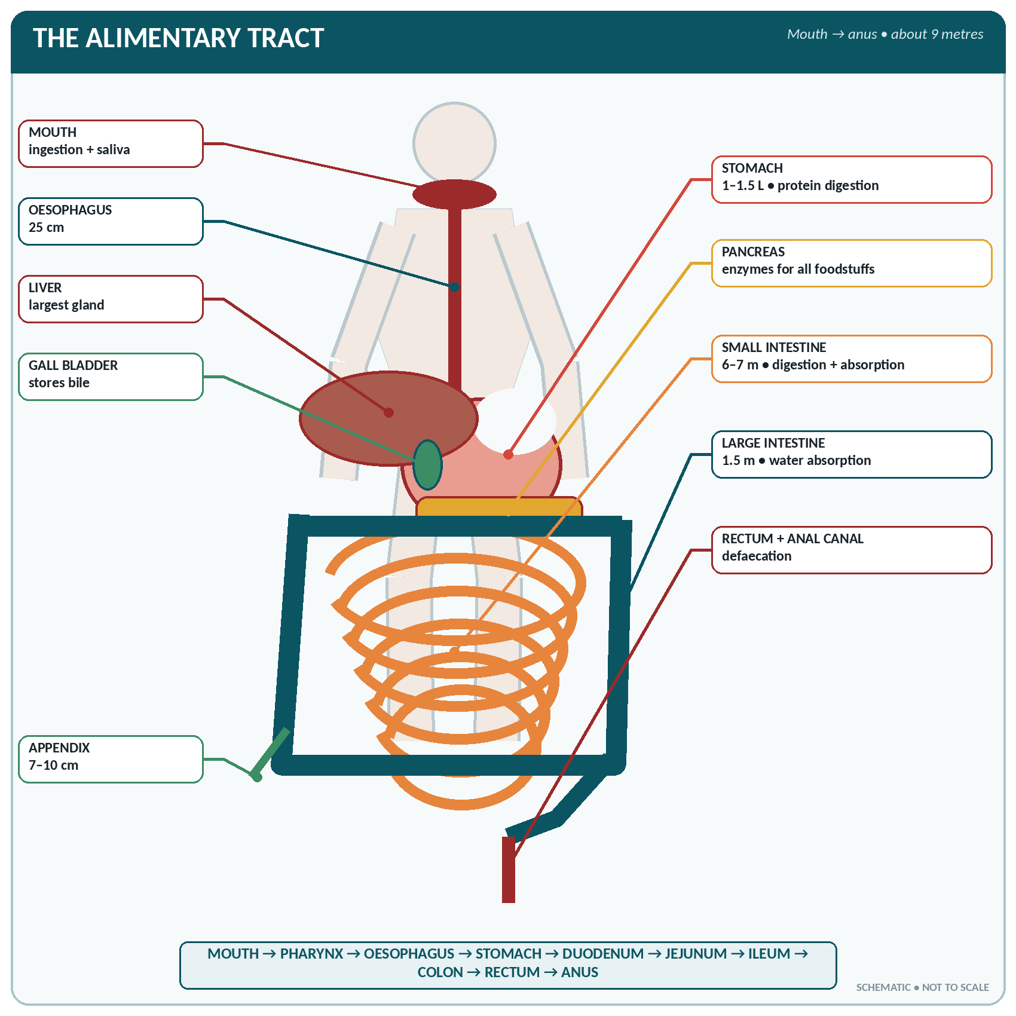
FIGURE • The alimentary tract and accessory digestive organs—from mouth to anus

Parts of the digestive system and their lengths
Part | Length / size
Mouth (oral cavity) | —
Pharynx | 12–14 cm
Oesophagus | 25 cm (10 inches)
Stomach | 25–30 cm long; capacity 1–1.5 litres (up to 4 L when greatly distended; 30 mL in the newborn)
Small intestine | 6–7 metres: duodenum 25 cm (12 inches), jejunum 2.5 m, ileum 3.5 m
Large intestine | 1.5 metres (5 feet)
Rectum and anal canal | Rectum 12–13 cm; anal canal 3.8–4 cm
Whole canal | About 9 metres

▪ The five basic processes of digestion: ingestion, digestion (mechanical and chemical), absorption, assimilation and elimination (defaecation), with secretion and motility throughout.
The Structure of the Alimentary Canal — Four Coats
The four layers of the gut wall (from inside out)
Layer | Structure | Function
Mucosa (mucous membrane) | Epithelium (stratified squamous in mouth, oesophagus and anal canal; columnar elsewhere), lamina propria, and a thin muscularis mucosae | Secretion of mucus, enzymes and hormones; absorption; protection; contains MALT
Submucosa | Loose connective tissue with blood vessels, lymphatics, glands and the submucous (Meissner's) plexus | Support; nutrition; controls secretion
Muscularis externa | Usually an inner circular and an outer longitudinal layer of smooth muscle, with the myenteric (Auerbach's) plexus between them | Peristalsis, segmentation, mixing; forms sphincters
Serosa / adventitia | Peritoneum (serosa) over the abdominal parts; fibrous adventitia where there is no peritoneum (oesophagus, rectum) | Smooth surface, support, attachment

▪ The stomach has three muscle layers (an additional inner oblique layer) and the oesophagus has striated muscle in its upper third.
▪ Peristalsis — a wave of contraction behind and relaxation in front of the bolus, moving contents onward. Segmentation mixes food; mass movement occurs in the colon 3–4 times a day.
▪ The enteric nervous system ("the gut brain", with more than 100 million neurones) can act independently; it is modulated by the vagus (parasympathetic — increases motility and secretion) and the sympathetic (inhibits).
The Mouth (Oral Cavity)
▪ Boundaries: lips in front, cheeks at the sides, hard and soft palate above, tongue and floor below, and the oropharyngeal isthmus behind.
▪ Lined by stratified squamous epithelium; the hard palate is formed by the palatine processes of the maxillae and the horizontal plates of the palatine bones. Failure of fusion causes cleft palate.
The tongue
▪ A mass of striated muscle covered with mucous membrane, attached to the hyoid bone, mandible and styloid process; it has a tip, body, root and a dorsum marked by the V-shaped sulcus terminalis.
▪ Papillae on the dorsum: filiform (most numerous, no taste buds), fungiform (tip and sides, with taste buds), circumvallate (8–12, in a V in front of the sulcus, many taste buds) and foliate. There are about 10 000 taste buds in all.
▪ Functions: taste, mastication, deglutition (swallowing), speech, cleansing the mouth, and it is an organ of touch and temperature.
▪ Nerve supply — a classic examination question:
Nerve supply of the tongue
Function | Anterior two-thirds | Posterior one-third
Taste (special sensation) | Facial nerve (VII) — via the chorda tympani | Glossopharyngeal (IX)
General sensation (touch, pain, temperature) | Trigeminal (V₃) — via the lingual nerve | Glossopharyngeal (IX)
Motor (muscles) | Hypoglossal (XII) — all muscles except palatoglossus | Hypoglossal (XII)

The posterior-most part (and the epiglottis) is supplied by the vagus (X).
▪ Primary tastes: sweet, sour (acid), salt, bitter and umami. Classical localisation: sweet at the tip, salt at the tip and sides, sour at the sides, bitter at the back.
The teeth
The deciduous (milk) and permanent teeth
Feature | Deciduous (temporary / milk) | Permanent
Number | 20 | 32
In each half jaw | 2 incisors, 1 canine, 2 molars = 5 | 2 incisors, 1 canine, 2 premolars, 3 molars = 8
Eruption begins | 6–8 months (lower central incisors first) | 6 years (first molar)
Complete by | 2–2.5 years | 17–25 years (third molar / wisdom tooth)
Premolars | Absent | Present (2 in each half jaw)

▪ Structure of a tooth: crown (above the gum), neck and root (in the socket).
– Enamel — covers the crown; the hardest substance in the body (96–97% mineral); non-living, cannot be repaired.
– Dentine — the bulk of the tooth; harder than bone, sensitive.
– Cement (cementum) — covers the root.
– Pulp cavity — contains the pulp with vessels and nerves.
– Periodontal membrane — fixes the tooth in its socket (a gomphosis).
▪ Nerve supply: upper teeth by the maxillary (V₂), lower teeth by the mandibular (V₃) nerve.
▪ Functions: incisors cut, canines tear, premolars and molars grind and crush.
▪ Dental caries needs bacteria (Streptococcus mutans), sugar and a susceptible tooth; fluoride protects (excess causes fluorosis and mottling).
The salivary glands
The three pairs of salivary glands
Gland | Position | Duct | Type of secretion | Nerve supply
Parotid | In front of and below the ear, over the masseter | Stensen's duct — opens opposite the 2nd upper molar | Serous (watery, enzyme-rich) | Glossopharyngeal (IX) via the otic ganglion
Submandibular | Below the angle of the jaw | Wharton's duct — opens at the side of the frenulum of the tongue | Mixed (mainly serous) — secretes the greatest amount (about 70%) | Facial (VII) via the chorda tympani and submandibular ganglion
Sublingual | Under the tongue, the smallest | Many small ducts (of Rivinus) | Mixed (mainly mucous) | Facial (VII)

▪ The parotid is the largest salivary gland; it is the gland affected in mumps and is traversed by the facial nerve.
SALIVA
▪ Quantity: 1–1.5 litres in 24 hours (about 1500 mL).
▪ pH 6.0–7.4 (slightly acid to neutral); specific gravity 1.002–1.008.
▪ Composition: water 99.5%; solids 0.5% — mucin, salivary amylase (ptyalin), lysozyme, lingual lipase, IgA, salts (bicarbonate, chloride, phosphate), urea and thiocyanate.
▪ Functions: (1) moistens food and helps form the bolus; (2) ptyalin digests cooked starch to maltose (it acts only in the mouth and is destroyed by gastric acid); (3) solvent for taste; (4) lubricates for swallowing and speech; (5) cleanses the mouth and teeth; (6) antibacterial — lysozyme, IgA, thiocyanate; (7) excretes some substances (urea, iodine, drugs, viruses); (8) keeps the mouth moist; (9) buffers acid.
▪ Control of secretion is entirely nervous (reflex) — unconditioned (food in the mouth) and conditioned (Pavlov's classic experiment — sight, smell or thought of food); the parasympathetic increases watery secretion, the sympathetic gives a scanty viscid secretion (dry mouth in fear).

Deglutition (Swallowing)
The three stages of swallowing
Stage | Control | Events
1. Oral (buccal) stage | Voluntary | The bolus is pushed by the tongue against the palate into the oropharynx
2. Pharyngeal stage | Involuntary (reflex) | The soft palate rises and closes the nasopharynx; the larynx rises and the epiglottis closes the glottis; respiration stops (deglutition apnoea); the pharyngeal constrictors propel the bolus into the oesophagus
3. Oesophageal stage | Involuntary | Peristalsis carries the bolus down in 4–8 seconds (liquids in about 1 second); the cardiac (lower oesophageal) sphincter relaxes

▪ The swallowing centre is in the medulla; the nerves involved are V, VII, IX, X and XII.
The Oesophagus
▪ A muscular tube about 25 cm long, from C6 (lower end of the pharynx) to the cardiac orifice of the stomach at T11, passing through the diaphragm at the level of T10.
▪ Lined with stratified squamous epithelium; the muscle coat is striated in the upper third, mixed in the middle and smooth in the lower third.
▪ Constrictions (important in swallowed foreign bodies and in oesophagoscopy): at its beginning (cricopharyngeal — the narrowest part), where the aortic arch and the left bronchus cross it, and at the diaphragm.
▪ The lower oesophageal (cardiac) sphincter is physiological; its incompetence causes gastro-oesophageal reflux and heartburn; achalasia is failure of it to relax.
The Stomach
▪ Position: in the epigastric, umbilical and left hypochondriac regions, below the diaphragm, between the oesophagus and the duodenum. Capacity 1–1.5 litres.
▪ Parts: cardia (around the oesophageal opening), fundus (the dome, above the level of the cardiac orifice — it contains swallowed air), body, and pyloric part (pyloric antrum and pyloric canal), ending at the pyloric sphincter.
▪ Curvatures: the short concave lesser curvature on the right (to which the lesser omentum is attached) and the long convex greater curvature on the left (to which the greater omentum is attached).
▪ Openings: the cardiac orifice (guarded by the physiological cardiac sphincter) and the pyloric orifice (guarded by the anatomical pyloric sphincter — a true thickening of circular muscle).
▪ Muscle coats — three: outer longitudinal, middle circular and inner oblique — allowing the churning movements. When empty, the mucosa is thrown into folds called rugae.
▪ Blood supply: from all three branches of the coeliac trunk — the left and right gastric arteries along the lesser curvature and the left and right gastro-epiploic arteries along the greater curvature, with the short gastric arteries to the fundus. Venous drainage is to the portal vein.
▪ Nerve supply: vagus (increases motility and secretion) and sympathetic from the coeliac plexus.
The gastric glands and gastric juice
The cells of the gastric mucosa
Cell | Secretion | Function
Parietal (oxyntic) cell | Hydrochloric acid and intrinsic factor | Acid digestion; intrinsic factor is essential for vitamin B₁₂ absorption
Chief (peptic / zymogen) cell | Pepsinogen (and a little gastric lipase) | Pepsinogen → pepsin in acid, digests protein
Mucous (goblet / surface) cell | Mucus and bicarbonate | Protects the mucosa from acid and pepsin
G cell (in the antrum) | Gastrin (a hormone) | Stimulates acid secretion and motility
Enterochromaffin-like cell | Histamine, serotonin | Stimulates acid secretion

GASTRIC JUICE
▪ Quantity: 2–3 litres in 24 hours (1500–3000 mL).
▪ pH 1.0–3.5 — the most acid fluid in the body; HCl concentration about 0.5% (160 mmol/L).
▪ Composition: water 99%, HCl, pepsinogen, gastric lipase, rennin (in infants — curdles milk), mucus, intrinsic factor, electrolytes.
▪ Functions of hydrochloric acid: (1) activates pepsinogen → pepsin and provides the acid medium for it; (2) kills bacteria (bactericidal); (3) denatures protein; (4) converts ferric to ferrous iron and helps absorb iron and calcium; (5) stops the action of salivary amylase; (6) stimulates the flow of bile and pancreatic juice (by releasing secretin).
▪ Functions of the stomach: temporary store of food (letting us eat meals, not continuously); churns food into chyme; begins protein digestion (pepsin); secretes intrinsic factor; produces gastrin; absorbs water, alcohol, glucose and some drugs (aspirin); kills bacteria; and controls the delivery of chyme to the duodenum. Emptying takes 2–6 hours (carbohydrate fastest, fat slowest).

Phases of gastric secretion
1. Cephalic (nervous) phase — about 20–30%: the sight, smell, taste or thought of food acts through the vagus.
2. Gastric phase — about 60–70%: distension of the stomach and the products of protein digestion release gastrin from the G cells.
3. Intestinal phase — about 10%: chyme in the duodenum first briefly stimulates, then inhibits gastric secretion and emptying through the entero-gastric reflex and the hormones secretin, cholecystokinin and gastric inhibitory peptide (GIP).
PEPTIC ULCER AND RELATED DISORDERS
▪ Peptic ulcer — a breach in the mucosa of the stomach or duodenum where acid and pepsin act; strongly associated with *Helicobacter pylori, NSAIDs, smoking and stress. Duodenal ulcer pain is relieved by food; gastric* ulcer pain is aggravated by food.
▪ Pyloric stenosis — in infants (projectile vomiting, visible peristalsis, olive-shaped mass) or from scarring of an ulcer.
▪ Haematemesis — vomiting blood; melaena — black tarry stools from digested blood.
▪ Gastritis, carcinoma of the stomach (commoner in pernicious anaemia and H. pylori infection).
▪ Vomiting is coordinated by the vomiting centre in the medulla; persistent vomiting causes loss of HCl → hypochloraemic metabolic alkalosis, dehydration and hypokalaemia.

The Small Intestine
▪ About 6–7 metres long and 2.5 cm wide, extending from the pylorus to the ileocaecal valve.
The three parts of the small intestine
Part | Length | Features
Duodenum | 25 cm (12 inches) — the shortest, widest and most fixed | C-shaped around the head of the pancreas; four parts; receives the bile duct and pancreatic duct at the ampulla of Vater, guarded by the sphincter of Oddi, opening on the major duodenal papilla of the second part; contains Brunner's glands (alkaline mucus) — the commonest site of peptic ulcer
Jejunum | 2.5 metres | Thicker wall, wider lumen, more vascular, prominent circular folds (plicae circulares / valves of Kerckring), few Peyer's patches; the chief site of absorption
Ileum | 3.5 metres — the longest part | Thinner wall, narrower, less vascular, abundant Peyer's patches (typhoid ulceration and perforation); absorbs vitamin B₁₂ and bile salts; ends at the ileocaecal valve

Adaptations for absorption
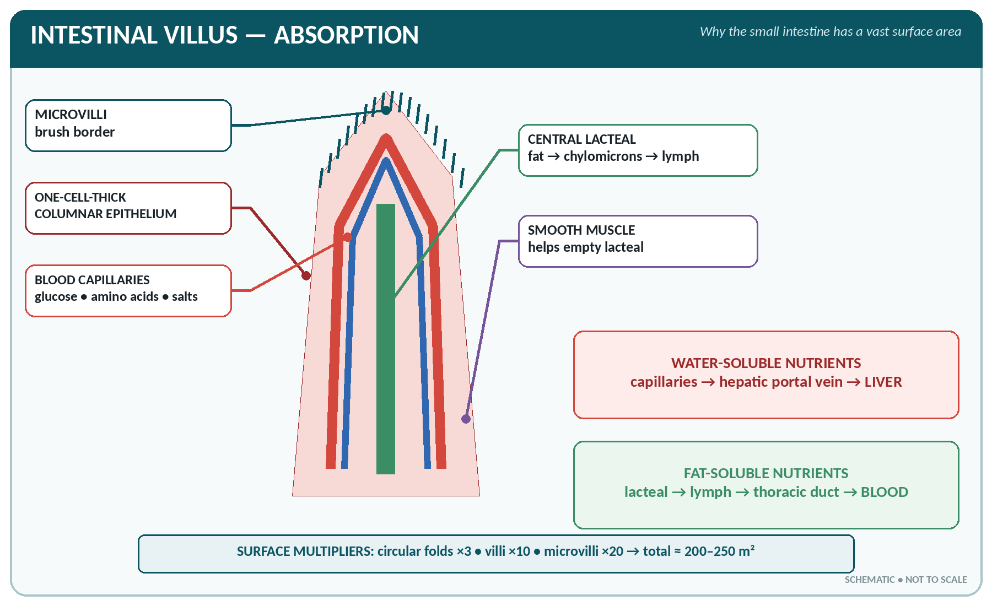
FIGURE • Intestinal villus—blood-capillary and lacteal routes for absorbed nutrients

▪ Plicae circulares (permanent circular folds) increase the surface 3-fold; villi — finger-like projections, 20–40 per mm², about 0.5–1 mm long — increase it 10-fold; microvilli (the brush border) increase it a further 20-fold. Total absorptive surface about 200–250 m².
▪ Each villus contains a network of capillaries, a central lacteal (lymph vessel), smooth muscle and nerve fibres, and is covered with columnar epithelium with goblet cells; between the villi are the crypts of Lieberkühn (intestinal glands), which also contain Paneth cells (lysozyme) and endocrine cells.
INTESTINAL (SUCCUS ENTERICUS) JUICE
▪ Quantity 1.5–2 litres/day; pH 7.5–8.0 (alkaline).
▪ Enzymes of the brush border/mucosal cells: enterokinase (enteropeptidase) — activates trypsinogen; peptidases (erepsin) — peptides to amino acids; maltase, sucrase (invertase), lactase — disaccharides to monosaccharides; intestinal lipase; nucleotidases.
▪ Also secreted: mucus, bicarbonate, water and the hormones secretin, cholecystokinin, GIP, motilin, VIP and somatostatin.

Digestion — summary of the whole process
Digestion of the three foodstuffs
Food | Mouth | Stomach | Small intestine | Final products
Carbohydrate | Salivary amylase (ptyalin): cooked starch → dextrin, maltose | Action stops in acid | Pancreatic amylase: starch → maltose; then maltase, sucrase, lactase on the brush border | Glucose, fructose, galactose
Protein | Nil | Pepsin (+ HCl): protein → peptones/polypeptides; rennin in infants | Trypsin, chymotrypsin, carboxypeptidase (pancreas) → peptides; peptidases → amino acids | Amino acids
Fat | Lingual lipase (slight) | Gastric lipase (slight) | Bile salts emulsify fat; pancreatic lipase (the chief fat enzyme) splits it | Fatty acids, monoglycerides and glycerol

Absorption
Sites of absorption
Substance | Chief site | Mechanism
Glucose, galactose | Duodenum and jejunum | Active transport with sodium (SGLT-1)
Fructose | Jejunum | Facilitated diffusion
Amino acids | Duodenum and jejunum | Active transport (with Na⁺)
Fatty acids, glycerol, monoglycerides | Jejunum | Diffusion into the cell, re-formed into triglyceride → chylomicrons → lacteals → thoracic duct (bypassing the liver)
Fat-soluble vitamins A, D, E, K | With fat, in the jejunum; need bile salts | Diffusion
Water-soluble vitamins | Jejunum | Diffusion / carrier
Vitamin B₁₂ | Terminal ileum | With intrinsic factor
Bile salts | Terminal ileum | Active — the enterohepatic circulation
Iron | Duodenum and upper jejunum | Active; helped by HCl and vitamin C (ferrous form)
Calcium | Duodenum and jejunum | Active; needs vitamin D and parathyroid hormone
Water (8–9 L/day presented) | Small intestine (most) and colon | Osmosis
Alcohol, some drugs, water | Stomach | Diffusion

The Large Intestine
▪ About 1.5 metres (5 feet) long and 6.5 cm wide, from the ileocaecal valve to the anus.
▪ Parts: caecum (with the appendix), ascending colon, hepatic flexure, transverse colon, splenic flexure, descending colon, sigmoid (pelvic) colon, rectum and anal canal.
▪ Special features: three bands of longitudinal muscle called taeniae coli, which gather the wall into sacculations or haustra; fat-filled tags of peritoneum called appendices epiploicae; and no villi in the mucosa, which is rich in goblet cells.
▪ The caecum is the widest part; the vermiform appendix is a blind tube 7–10 cm long arising from the caecum, containing lymphoid tissue; the base of the appendix lies at McBurney's point — one-third of the way along a line from the right anterior superior iliac spine to the umbilicus.
▪ The rectum (12–13 cm) has no taeniae or haustra; the anal canal (3.8 cm) has an internal sphincter of smooth muscle (involuntary) and an external sphincter of striated muscle (voluntary, pudendal nerve). The pectinate (dentate) line divides it into an upper (visceral, painless, portal drainage) and a lower (somatic, sensitive, systemic drainage) part.
Functions of the large intestine
1. Absorption of water (about 1–1.5 L a day) and of electrolytes (Na⁺, Cl⁻).
2. Absorption of some vitamins synthesised by bacteria — vitamin K and several B-complex vitamins (folic acid, B₁₂, thiamine, riboflavin).
3. Secretion of mucus for lubrication.
4. Temporary storage of faeces and their elimination (defaecation).
5. Bacterial action — the normal flora (Escherichia coli, bacteroides, lactobacilli) ferment residues, producing gas (flatus — CO₂, methane, hydrogen sulphide) and converting bilirubin to stercobilin.
FAECES
▪ Amount 100–200 g a day; water 60–75%, solids 25–40%.
▪ Solids: dead bacteria (about 30%), indigestible cellulose and fibre, fat, inorganic material, desquamated epithelium, mucus and stercobilin (which gives the brown colour).
▪ Faeces are normally slightly alkaline. Transit time through the whole canal about 24–72 hours.

▪ Defaecation: mass movement fills the rectum → stretch receptors initiate the defaecation reflex (S2, S3, S4 — the parasympathetic centre) → the internal sphincter relaxes; the external sphincter is under voluntary control. Straining uses the Valsalva manoeuvre with the abdominal muscles and diaphragm.
DISORDERS OF THE INTESTINE
▪ Appendicitis — pain beginning around the umbilicus and shifting to the right iliac fossa, with tenderness at McBurney's point, fever and leucocytosis.
▪ Constipation and diarrhoea; dysentery (blood and mucus); cholera (rice-water stools, severe dehydration).
▪ Malabsorption — coeliac disease (gluten), tropical sprue, lactose intolerance; steatorrhoea.
▪ Inflammatory bowel disease — ulcerative colitis (colon, continuous) and Crohn's disease (any part, skip lesions).
▪ Intestinal obstruction, intussusception, volvulus, hernia, peritonitis.
▪ Haemorrhoids (piles), anal fissure, fistula-in-ano, rectal prolapse.
▪ Worm infestations — roundworm, hookworm (anaemia), tapeworm, pinworm; amoebiasis.
▪ Carcinoma of the colon and rectum; typhoid ulcers in the ileum (Peyer's patches).

The Peritoneum
▪ The largest serous membrane in the body, with a parietal layer lining the abdominal wall and a visceral layer covering the organs; the peritoneal cavity between them contains a little serous fluid.
▪ Intraperitoneal organs (almost completely covered): stomach, jejunum, ileum, transverse and sigmoid colon, spleen, liver, appendix, caecum, uterus and ovaries.
▪ Retroperitoneal organs: kidneys, ureters, suprarenal glands, pancreas (except the tail), duodenum (2nd–4th parts), ascending and descending colon, aorta, IVC, and the rectum (lower part).
▪ Folds of the peritoneum:
– Greater omentum — hangs like an apron from the greater curvature of the stomach to the transverse colon; it is a store of fat and the "abdominal policeman", which walls off infection.
– Lesser omentum — from the lesser curvature to the liver; contains the portal vein, hepatic artery and bile duct in its free edge.
– Mesentery — suspends the jejunum and ileum from the posterior wall; 15 cm at its root, 6 m at its intestinal border.
– Mesocolon, mesoappendix, broad and round ligaments of the uterus, falciform ligament of the liver.
▪ Functions: secretes serous fluid to prevent friction; suspends and supports the viscera; carries vessels, nerves and lymphatics; stores fat; limits the spread of infection; and has great powers of absorption (used in peritoneal dialysis).
▪ Ascites — fluid in the peritoneal cavity; peritonitis — inflammation, causing a rigid "board-like" abdomen, absent bowel sounds and shock.
DIGESTIVE SYSTEM — RAPID REVISION
▪ Length of alimentary canal about 9 m; oesophagus 25 cm; small intestine 6–7 m; large intestine 1.5 m; duodenum 25 cm; appendix 7–10 cm.
▪ Saliva 1–1.5 L/day, enzyme ptyalin (salivary amylase) acting on cooked starch; largest salivary gland — parotid; gland secreting the most saliva — submandibular.
▪ Gastric juice 2–3 L/day, pH 1–3.5; HCl from parietal cells; pepsinogen from chief cells; intrinsic factor from parietal cells; gastrin from G cells of the antrum.
▪ Pepsin digests protein; amylase digests starch; lipase digests fat; bile emulsifies fat but contains no enzyme.
▪ Vitamin B₁₂ and bile salts are absorbed in the terminal ileum; iron and calcium in the duodenum; fat as chylomicrons into the lacteals.
▪ Only tooth structure harder than bone — enamel (hardest substance in the body); 20 milk teeth, 32 permanent teeth.
▪ Taste: anterior two-thirds — facial (chorda tympani); posterior third — glossopharyngeal; motor to the tongue — hypoglossal.
▪ Bile duct and pancreatic duct open at the ampulla of Vater guarded by the sphincter of Oddi.
▪ Taeniae coli, haustra and appendices epiploicae are features of the large intestine; the large intestine has no villi.
▪ The largest serous membrane is the peritoneum; the greater omentum is the abdominal policeman.

CHAPTER 18
The Liver, Biliary System and Pancreas

CHAPTER OUTLINE
The Liver | Bile and the Biliary System | The Pancreas | Summary of the Gastro-intestinal Hormones

The Liver
THE LIVER — BASIC FACTS
▪ The largest gland and the largest internal organ in the body; the largest solid organ.
▪ Weight: 1.2–1.5 kg (about 1500 g; roughly 1/40th of body weight in the adult and 1/20th in the newborn). Some texts give 1.4–1.8 kg in the male.
▪ Colour: reddish-brown; consistency soft and friable; it is highly vascular and receives 1400–1500 mL of blood per minute (about 27–28% of the cardiac output).
▪ Position: right hypochondrium and epigastrium, extending into the left hypochondrium; immediately below the diaphragm, filling the right dome. It is normally not palpable below the costal margin in the adult (but may be felt 1–2 cm below in children).
▪ Surfaces: a convex diaphragmatic (superior) surface and a visceral (inferior) surface bearing impressions of the stomach, duodenum, right kidney, colon and gall bladder.

Lobes, ligaments and the porta hepatis
▪ Anatomical lobes — four: the large right lobe, the smaller left lobe (separated on the front by the falciform ligament and on the back by the ligamentum venosum and fissure for the ligamentum teres), and, on the visceral surface, the quadrate and caudate lobes.
▪ Functional (surgical) lobes — two, divided by the plane of the gall bladder and inferior vena cava, each with its own arterial, portal and biliary supply; and eight segments.
▪ Ligaments: falciform (containing the ligamentum teres — the remains of the umbilical vein), coronary, right and left triangular, and the lesser omentum. The liver is also supported by the inferior vena cava and by intra-abdominal pressure.
▪ The porta hepatis (hilum) is the fissure on the visceral surface transmitting:
– Portal vein (entering — carries 70–75% of the blood, deoxygenated but nutrient-rich)
– Hepatic artery (entering — carries 25–30% of the blood, and most of the oxygen)
– Right and left hepatic ducts (leaving)
– Nerves and lymphatics
▪ Blood leaves the liver by the hepatic veins (usually three) directly into the inferior vena cava. The liver is the only organ that receives a double blood supply.
Microscopic structure
▪ The functional unit is the hepatic lobule — a hexagonal mass about 1 mm across, with about 50 000–100 000 lobules in the liver.
▪ Each lobule has a central vein (a tributary of the hepatic vein) with cords/plates of hepatocytes (liver cells) radiating from it, separated by sinusoids.
▪ At the angles of the hexagon are the portal triads (portal canals), each containing a branch of the portal vein, a branch of the hepatic artery and a bile ductule (plus a lymphatic).
▪ Direction of flow: blood flows from the periphery to the centre (portal vein and hepatic artery → sinusoids → central vein → hepatic vein → IVC); bile flows in the opposite direction, from the centre to the periphery, in the bile canaliculi between the hepatocytes.
▪ Kupffer cells are the star-shaped macrophages lining the sinusoids — part of the reticulo-endothelial system; they remove bacteria, worn-out red cells and debris.
▪ The liver has a remarkable power of regeneration: up to 70–80% can be removed and it will regrow.
Functions of the liver
The liver has been called the "chemical factory" and the "central metabolic laboratory" of the body. Its functions are conveniently grouped:
Functions of the liver
Group | Functions
Carbohydrate metabolism | Glycogenesis (glucose → glycogen, storing about 100 g); glycogenolysis (glycogen → glucose); gluconeogenesis (glucose from protein and fat); it is the chief regulator of blood glucose
Protein metabolism | Deamination of amino acids; transamination; formation of urea from ammonia (the only organ that does this); synthesis of plasma proteins — albumin, globulins (except gamma), fibrinogen, prothrombin and the other clotting factors; synthesis of non-essential amino acids
Fat metabolism | β-oxidation of fatty acids; formation of ketone bodies; synthesis of cholesterol, phospholipids and lipoproteins; conversion of excess carbohydrate and protein to fat; storage of fat
Secretion of bile | 500–1000 mL a day; bile salts for the emulsification and absorption of fat; excretion of bilirubin
Storage | Glycogen, vitamins A, D, E, K and B₁₂ (the liver is the chief store of vitamin A and B₁₂), iron (as ferritin), copper and some blood
Detoxification | Inactivation and conjugation of drugs, alcohol, toxins, hormones (oestrogen, aldosterone, insulin, thyroxine); conversion of ammonia to urea
Defence | Kupffer cells — phagocytosis of bacteria and debris
Haemopoiesis | Forms red cells in the fetus; destroys worn-out red cells and conserves their iron
Heat production | It is the most metabolically active organ — a major source of body heat
Vitamin activation | Hydroxylates vitamin D (25-hydroxycholecalciferol); synthesises vitamin A from carotene
Synthesis of other substances | Angiotensinogen, heparin, thrombopoietin, somatomedins, bile acids, urea, creatine, complement

THE LIVER — UNIQUE ROLES
▪ The only site of urea formation and of albumin synthesis.
▪ Stores glycogen, iron and vitamins A, D, B₁₂.
▪ The only organ with a double (dual) blood supply — portal vein and hepatic artery.
▪ Bile is the only digestive juice containing no enzyme; it acts physically on fat.
▪ Vitamin K is needed by the liver to make prothrombin and factors VII, IX, X.

Bile and the Biliary System
Bile
BILE
▪ Quantity: 500–1000 mL in 24 hours (about 600–800 mL).
▪ pH 7.6–8.6 (alkaline); specific gravity 1.010–1.040; colour golden-yellow or greenish (liver bile) becoming dark green in the gall bladder.
▪ Composition: water 97% in hepatic bile; bile salts (sodium glycocholate and taurocholate); bile pigments (bilirubin, biliverdin); cholesterol; lecithin; mucin; inorganic salts (chiefly bicarbonate); fatty acids; alkaline phosphatase.
▪ Gall bladder bile is 5–10 times more concentrated (water 89%).

▪ Functions of bile:
1. Bile salts emulsify fat (reduce surface tension, breaking fat into fine droplets) so that lipase can act.
2. Bile salts form micelles that carry fatty acids and the fat-soluble vitamins A, D, E and K to the mucosa for absorption.
3. Neutralises the acid chyme entering the duodenum (alkaline).
4. Excretes bilirubin, cholesterol, drugs, heavy metals and hormones.
5. Stimulates peristalsis (a mild laxative) and prevents putrefaction (mildly bactericidal).
6. Bile salts are largely reabsorbed in the terminal ileum and returned to the liver — the enterohepatic circulation (about 94% is recycled, 6–8 times a day).
▪ Bile contains no enzyme.
▪ Absence of bile (obstructive jaundice) causes pale, bulky, offensive, fatty stools (steatorrhoea), dark urine, failure to absorb fat-soluble vitamins, a bleeding tendency (vitamin K) and itching.
The biliary tract
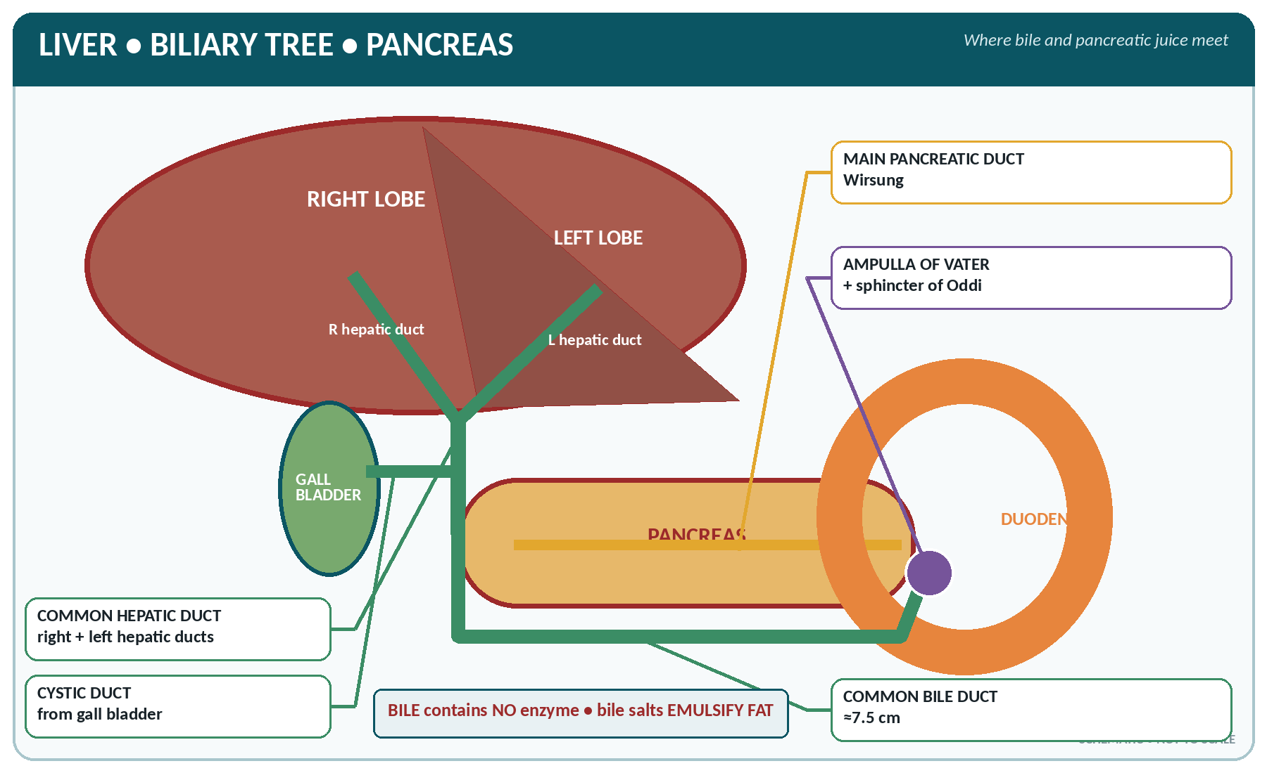
FIGURE • Biliary tree and pancreatic duct—both meet at the ampulla of Vater in the second part of the duodenum

▪ Right and left hepatic ducts → common hepatic duct (about 3 cm) → joined by the cystic duct (about 3–4 cm, from the gall bladder) → common bile duct (choledochus), about 7.5 cm long, which descends behind the head of the pancreas and joins the main pancreatic duct to form the ampulla of Vater (hepatopancreatic ampulla), opening into the second part of the duodenum at the major duodenal papilla, guarded by the sphincter of Oddi.
The gall bladder
▪ A pear-shaped sac on the visceral surface of the right lobe of the liver, about 7–10 cm long and 3 cm wide, with a capacity of 30–50 mL. It has a fundus, body and neck (the neck bearing the spiral valves of Heister).
▪ Its wall has mucosa with rugae (no villi), a smooth muscle coat and a serous covering; the lining epithelium is columnar.
▪ Functions: (1) stores bile between meals; (2) concentrates it 5–10 times by absorbing water and salts; (3) acidifies it slightly; (4) adds mucus; (5) expels bile into the duodenum when stimulated.
▪ Control: the hormone cholecystokinin (CCK), released from the duodenal mucosa by fat and protein in the chyme, makes the gall bladder contract and the sphincter of Oddi relax; the vagus also causes contraction.
▪ The fundus of the gall bladder lies at the tip of the 9th costal cartilage, where the right lateral border of the rectus abdominis crosses the costal margin — the surface marking used to elicit Murphy's sign.
DISORDERS OF THE LIVER AND BILIARY SYSTEM
▪ Jaundice (icterus) — yellow staining of skin, mucous membranes and sclera by bilirubin (evident above about 2 mg/dL):
– Pre-hepatic (haemolytic) — excess breakdown of red cells; unconjugated bilirubin; normal stools.
– Hepatic (hepatocellular) — liver cell damage, as in hepatitis and cirrhosis.
– Post-hepatic (obstructive) — stone or tumour blocking the ducts; conjugated bilirubin; pale stools and dark urine, itching.
– Physiological jaundice of the newborn — appears after 24 hours, due to immature liver enzymes; severe unconjugated hyperbilirubinaemia causes kernicterus.
▪ Hepatitis — viral (A and E by the faeco-oral route; B, C and D by blood and body fluids), alcoholic, drug-induced.
▪ Cirrhosis — irreversible fibrosis with nodules; causes portal hypertension with oesophageal varices, splenomegaly, ascites, caput medusae and haemorrhoids, plus jaundice, spider naevi, palmar erythema, gynaecomastia and finally hepatic encephalopathy (from ammonia).
▪ Cholelithiasis (gall stones) — classically in the "5 F" patient (female, fat, forty, fertile, fair); mostly cholesterol stones; may cause biliary colic, cholecystitis, obstructive jaundice or pancreatitis.
▪ Liver function tests: serum bilirubin, ALT (SGPT) and AST (SGOT), alkaline phosphatase (raised in obstruction), serum albumin, prothrombin time, and gamma-GT.

The Pancreas
▪ A soft, pale-grey, lobulated gland, 12–15 cm long and weighing 60–100 g, lying transversely across the posterior abdominal wall at the level of L1–L2, behind the stomach.
▪ It is retroperitoneal except for the tail. Parts: head (in the C of the duodenum, with the uncinate process), neck, body and tail (which touches the spleen).
▪ Ducts: the main pancreatic duct (duct of Wirsung) runs the whole length and joins the bile duct at the ampulla of Vater; an accessory duct (of Santorini) opens separately about 2 cm higher.
▪ Blood supply: splenic artery, and the superior and inferior pancreaticoduodenal arteries; venous drainage to the portal system.
▪ The pancreas is a mixed gland — it has both an exocrine and an endocrine part.
The exocrine pancreas
▪ Made of acini of serous cells (about 98–99% of the gland) draining into ducts, which secrete pancreatic juice.
PANCREATIC JUICE
▪ Quantity: 1–1.5 litres (1000–1500 mL) in 24 hours.
▪ pH 7.5–8.8 — the most alkaline of the digestive juices (rich in bicarbonate, which neutralises the acid chyme and provides the optimum pH for the intestinal enzymes).
▪ Enzymes (the most complete of all the digestive juices — it can digest all three foodstuffs):
– Proteolytic (secreted as inactive precursors): trypsinogen → trypsin (activated by enterokinase), chymotrypsinogen → chymotrypsin (activated by trypsin), procarboxypeptidase → carboxypeptidase, elastase.
– Amylolytic: pancreatic amylase (amylopsin) — starch and glycogen to maltose; it acts on both cooked and uncooked starch.
– Lipolytic: pancreatic lipase (steapsin) — the chief fat-digesting enzyme; also cholesterol esterase and phospholipase A₂.
– Nucleases: ribonuclease and deoxyribonuclease.
▪ The enzymes are secreted in an inactive form to prevent self-digestion; the duct cells also secrete a trypsin inhibitor. Failure of this protection leads to acute pancreatitis — the gland digests itself.

▪ Control of secretion:
– Secretin (from the duodenal mucosa, released by acid chyme) → a copious, watery, bicarbonate-rich juice.
– Cholecystokinin (CCK/pancreozymin) (released by fat and protein) → an enzyme-rich juice, and contraction of the gall bladder.
– The vagus (cephalic phase) → enzyme-rich secretion.
The endocrine pancreas — the islets of Langerhans
▪ About 1–2 million islets, most numerous in the tail, forming only 1–2% of the gland's mass.
Cells of the islets of Langerhans and their hormones
Cell | Share of islet | Hormone | Chief action
Beta (β) cell | 60–75% | Insulin | Lowers blood glucose — promotes uptake of glucose by cells, glycogenesis, lipogenesis and protein synthesis; the only hypoglycaemic hormone
Alpha (α) cell | 20–25% | Glucagon | Raises blood glucose — glycogenolysis and gluconeogenesis; lipolysis
Delta (δ) cell | 5–10% | Somatostatin (GHIH) | Inhibits insulin, glucagon, growth hormone, gastrin and pancreatic secretion
F (PP) cell | 1–2% | Pancreatic polypeptide | Inhibits pancreatic enzyme secretion and gall bladder contraction

BLOOD GLUCOSE AND INSULIN
▪ Fasting blood glucose 70–110 mg/dL (impaired 100–125; diabetes ≥ 126 mg/dL).
▪ Post-prandial (2 hours) < 140 mg/dL; diabetes ≥ 200 mg/dL. HbA1c normal < 5.7%.
▪ Renal threshold for glucose about 180 mg/dL — above this, glycosuria occurs.
▪ Insulin is a protein (polypeptide) hormone of 51 amino acids in two chains (A and B), discovered by Banting and Best (1921); it is destroyed by digestion and so must be injected.
▪ Hormones that raise blood glucose (hyperglycaemic): glucagon, adrenaline, cortisol, growth hormone and thyroxine. Only insulin lowers it.

DIABETES MELLITUS AND PANCREATIC DISEASE
▪ Diabetes mellitus — deficiency of insulin or resistance to it. Type 1 (insulin-dependent, juvenile, autoimmune destruction of β cells, prone to ketoacidosis); Type 2 (non-insulin dependent, adult, obesity and insulin resistance — the commonest).
▪ Cardinal symptoms: polyuria, polydipsia, polyphagia, weight loss, fatigue, glycosuria, delayed healing and recurrent infection.
▪ Complications: ketoacidosis (Kussmaul breathing, acetone breath), hypoglycaemia (from treatment — sweating, tremor, confusion, coma), retinopathy, nephropathy, neuropathy, atherosclerosis, diabetic foot.
▪ Hyperinsulinism / insulinoma causes hypoglycaemia; excess glucagon causes hyperglycaemia.
▪ Acute pancreatitis — severe epigastric pain radiating to the back, vomiting, raised serum amylase and lipase; usually caused by gall stones or alcohol.
▪ Chronic pancreatitis — steatorrhoea, diabetes, calcification.
▪ Carcinoma of the head of the pancreas — painless progressive obstructive jaundice with a palpable gall bladder (Courvoisier's law).
▪ Cystic fibrosis — thick secretions block the pancreatic ducts, with malabsorption and lung disease.

Summary of the Gastro-intestinal Hormones
The chief hormones of the alimentary tract
Hormone | Source | Stimulus for release | Chief actions
Gastrin | G cells of the gastric antrum (and duodenum) | Protein in the stomach, distension, vagal stimulation | Stimulates HCl and pepsinogen secretion, gastric motility, and growth of the mucosa
Secretin | Duodenal and jejunal mucosa (S cells) — the first hormone ever discovered (Bayliss and Starling, 1902) | Acid chyme in the duodenum | Bicarbonate-rich pancreatic juice; increases bile secretion; inhibits gastric secretion and emptying
Cholecystokinin (CCK / pancreozymin) | Duodenal and jejunal mucosa (I cells) | Fat and protein in the duodenum | Contracts the gall bladder, relaxes the sphincter of Oddi, enzyme-rich pancreatic juice, delays gastric emptying, gives satiety
Gastric inhibitory peptide (GIP) | Duodenum and jejunum | Fat and glucose | Inhibits gastric secretion and motility; stimulates insulin release (the "incretin" effect)
Motilin | Small intestine | Fasting | Increases gut motility between meals
Vasoactive intestinal peptide (VIP) | Gut neurones | — | Relaxes smooth muscle, increases intestinal secretion
Somatostatin | Stomach, duodenum, pancreatic δ cells | Acid | Inhibits nearly all gut hormones and secretions
Ghrelin | Stomach | Fasting | Stimulates appetite (the "hunger hormone")

LIVER, BILE AND PANCREAS — RAPID REVISION
▪ Liver weight 1.2–1.5 kg; the largest gland; receives portal vein + hepatic artery; drains by hepatic veins into the IVC.
▪ Functional unit — hepatic lobule; macrophages — Kupffer cells; the liver forms urea, albumin, prothrombin and fibrinogen, and stores glycogen, iron, vitamins A, D, K, B₁₂.
▪ Bile 500–1000 mL/day, alkaline, contains no enzyme; bile salts emulsify fat; gall bladder capacity 30–50 mL and concentrates bile 5–10 times.
▪ CCK contracts the gall bladder; secretin produces bicarbonate-rich pancreatic juice; secretin was the first hormone discovered.
▪ Pancreatic juice 1–1.5 L/day, the most alkaline juice, containing enzymes for all three foodstuffs; trypsinogen is activated by enterokinase.
▪ Islets of Langerhans: β cells → insulin (60–75%), α cells → glucagon, δ cells → somatostatin; most numerous in the tail.
▪ Insulin discovered by Banting and Best; fasting blood sugar 70–110 mg/dL; renal threshold 180 mg/dL.
▪ The common bile duct and pancreatic duct open into the 2nd part of the duodenum at the ampulla of Vater.

CHAPTER 19
Nutrition and Metabolism

CHAPTER OUTLINE
The Nutrients and a Balanced Diet | Carbohydrates | Proteins | Fats (Lipids) | Vitamins | Minerals | Metabolism

Nutrition is the science of food and its relation to health. A nutrient is a chemical substance in food required by the body. Metabolism is the sum of all chemical changes occurring in the body.
The Nutrients and a Balanced Diet
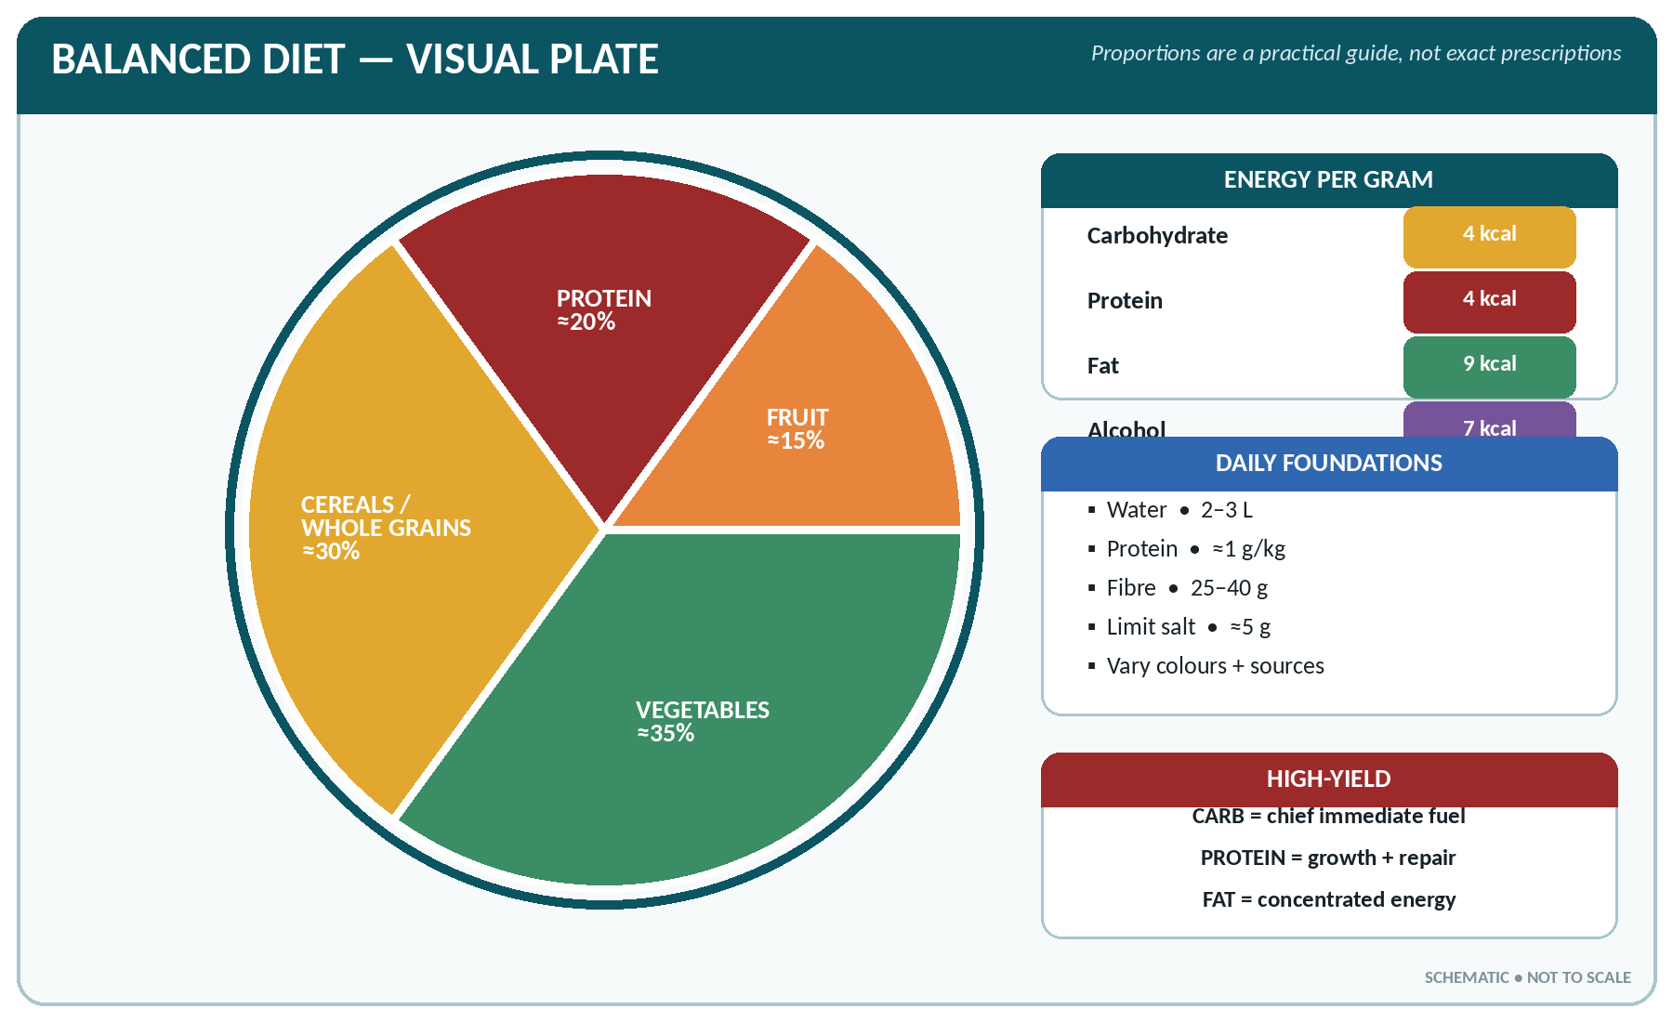
FIGURE • A practical balanced-plate visual with the energy yield and daily foundation facts

The six classes of nutrient
Nutrient | Chief function | Energy value
Carbohydrate | The chief and cheapest source of energy; 60–70% of the calories in an Indian diet | 4 kcal/g
Protein | Body building and repair; enzymes, hormones, antibodies, plasma proteins | 4 kcal/g
Fat | Concentrated energy, insulation, protection of organs, carrier of fat-soluble vitamins, essential fatty acids | 9 kcal/g
Vitamins | Regulatory — coenzymes; no energy | Nil
Minerals | Structural and regulatory; no energy | Nil
Water | Medium of all reactions, transport, temperature regulation | Nil

▪ Dietary fibre (roughage) — indigestible cellulose, hemicellulose, pectin and lignin; it adds bulk, prevents constipation, lowers cholesterol and slows glucose absorption. Alcohol yields 7 kcal/g.
▪ A balanced diet contains all the nutrients in the right proportion and quantity. A common Indian pattern: carbohydrate 55–65%, fat 20–30% and protein 10–15% of total calories.
▪ Basic food groups: cereals and millets; pulses and legumes; milk and milk products; meat, fish and eggs; fruits and vegetables; fats, oils and sugars.
RECOMMENDED DAILY ALLOWANCES (ICMR — ADULT, APPROXIMATE)
Nutrient | Adult man (sedentary) | Adult woman (sedentary) | Pregnancy / Lactation
Energy | 2320 kcal (2700 moderate, 3800 heavy work) | 1900 kcal (2230 moderate) | +350 kcal / +600 kcal
Protein | 60 g (about 1 g/kg) | 55 g | +23 g / +19 g
Fat (visible) | 25–30 g | 20–25 g | 30 g
Calcium | 600–1000 mg | 600–1000 mg | 1200 mg
Iron | 17 mg | 21 mg | 35 mg
Vitamin A (retinol) | 600 µg | 600 µg | 950 µg
Vitamin C | 40 mg | 40 mg | 60–80 mg
Folic acid | 200 µg | 200 µg | 500 µg
Iodine | 150 µg | 150 µg | 250 µg
Water | 2–3 litres (about 35 mL/kg) | — | More

Carbohydrates
▪ Classification: monosaccharides (glucose, fructose, galactose — 6 carbon; ribose, deoxyribose — 5 carbon); disaccharides (sucrose = glucose + fructose; lactose = glucose + galactose, the sugar of milk; maltose = glucose + glucose); polysaccharides (starch — plant store; glycogen — animal store, in liver and muscle; cellulose — indigestible fibre; dextrin, inulin).
▪ Sources: cereals (rice, wheat), millets, potato, sugar, jaggery, honey, fruits, milk (lactose).
▪ Digested to glucose and absorbed by active transport with sodium. Normal blood glucose 70–110 mg/dL fasting.
▪ Fate of glucose: (1) oxidised for energy; (2) stored as glycogen in liver (about 100 g) and muscle (about 250–400 g) — glycogenesis; (3) converted to fat when in excess; (4) used for synthesis of other substances.
▪ Key processes: glycolysis (glucose → pyruvate, in the cytoplasm, yielding 2 ATP); the Krebs (citric acid / tricarboxylic acid) cycle and oxidative phosphorylation (in the mitochondria) yielding a total of about 36–38 ATP per glucose aerobically. Anaerobically, pyruvate becomes lactic acid and only 2 ATP are gained.
▪ Hormones controlling blood glucose: insulin lowers it; glucagon, adrenaline, cortisol, growth hormone and thyroxine raise it.
Proteins
▪ Built of amino acids (about 20) joined by peptide bonds; they are the only nutrients containing nitrogen (about 16% N, so protein = nitrogen × 6.25).
▪ Essential (indispensable) amino acids — 9 (10 in children): isoleucine, leucine, lysine, methionine, phenylalanine, threonine, tryptophan, valine, histidine (+ arginine in growth). Mnemonic "PVT TIM HaLL".
▪ Classification by quality:
– Complete (first-class / high biological value) — contain all essential amino acids: egg (the reference protein, biological value 100), milk, meat, fish, cheese, liver.
– Incomplete (second-class) — plant proteins deficient in one or more: cereals (low lysine), pulses (low methionine). Mutual supplementation — cereal + pulse together (rice and dal) gives a complete protein.
▪ Functions: growth and repair of tissue; formation of enzymes, hormones, antibodies, haemoglobin, plasma proteins; maintenance of osmotic pressure; buffering; and energy when in excess.
▪ Nitrogen balance: intake = output in health; positive in growth, pregnancy and convalescence; negative in starvation, fever, burns, injury and after surgery.
▪ Deficiency — protein energy malnutrition (PEM):
Kwashiorkor and marasmus compared
Feature | Kwashiorkor | Marasmus
Deficiency | Mainly protein | Energy (calories) and protein
Age | 1–3 years, after weaning | Under 1 year
Oedema | Present (the hallmark) | Absent
Weight | 60–80% of expected | Below 60%
Muscle wasting | Present but masked | Gross
Subcutaneous fat | Retained | Lost — "skin and bones", old man's face
Hair and skin | Sparse, depigmented hair; flaky-paint dermatosis | Normal or thin, dry
Appetite | Poor; apathetic, miserable child | Usually good; alert but irritable
Liver | Enlarged (fatty) | Not enlarged
Serum albumin | Low | Normal or slightly low

Fats (Lipids)
▪ Composition: a triglyceride is glycerol + 3 fatty acids.
▪ Saturated fatty acids — mainly animal fats, ghee, butter, coconut and palm oil; solid; raise LDL cholesterol. Unsaturated — mono-unsaturated (groundnut, olive, mustard oil) and poly-unsaturated (PUFA) (safflower, sunflower, soya, fish oil); liquid; protective.
▪ Essential fatty acids (EFA) — cannot be synthesised: linoleic acid and α-linolenic acid (arachidonic acid is semi-essential). Deficiency gives phrynoderma (toad skin) and poor growth.
▪ Cholesterol — a sterol found only in animal foods; it is also made in the liver. It is the precursor of bile salts, vitamin D and the steroid hormones. Normal total cholesterol < 200 mg/dL; LDL < 100; HDL > 40 (HDL is "good", LDL is "bad"); triglycerides < 150 mg/dL.
▪ Functions of fat: concentrated energy (9 kcal/g); stored energy (adipose tissue); insulation and protection of organs (kidney, eye); carrier of vitamins A, D, E, K; component of cell membranes and myelin; gives satiety and palatability.
▪ Ketosis — when fat is oxidised without adequate carbohydrate ("fat burns in the flame of carbohydrate"), ketone bodies (acetoacetic acid, β-hydroxybutyric acid, acetone) accumulate — seen in starvation and uncontrolled diabetes.
Vitamins
Vitamins are organic substances required in minute amounts, which the body cannot synthesise (with minor exceptions) and whose lack causes a specific deficiency disease. The term was coined by Casimir Funk.
The fat-soluble vitamins
Vitamin | Chemical name | Rich sources | Functions | Deficiency
A | Retinol (plant precursor β-carotene) | Liver, fish liver oils (cod, shark), egg yolk, butter, milk, green leafy vegetables, carrot, papaya, mango | Forms rhodopsin (visual purple) for dim-light vision; maintains epithelium; growth; immunity | Night blindness (nyctalopia) — the earliest sign; xerophthalmia, Bitot's spots, keratomalacia (blindness), follicular hyperkeratosis. Excess is toxic
D | Calciferol (D₂ ergocalciferol, D₃ cholecalciferol) | Sunlight on the skin (7-dehydrocholesterol), fish liver oil, egg yolk, fortified milk | Promotes absorption of calcium and phosphorus from the gut; mineralisation of bone; activated in liver (25-OH) and kidney (1,25-OH₂ — calcitriol) | Rickets in children (bow legs, rickety rosary, craniotabes, delayed dentition, pot belly), osteomalacia in adults; tetany. Excess causes hypercalcaemia
E | Tocopherol | Vegetable oils, wheat germ, nuts, green vegetables | Antioxidant; protects cell membranes and red cells; reproduction | Haemolytic anaemia in the newborn; rare in adults
K | Phylloquinone (K₁), menaquinone (K₂ — from gut bacteria) | Green leafy vegetables, liver, synthesised by intestinal bacteria | Essential for the liver to make prothrombin (II) and factors VII, IX, X — clotting | Bleeding tendency, prolonged prothrombin time; haemorrhagic disease of the newborn (hence vitamin K at birth); deficiency in obstructive jaundice and prolonged antibiotics

The water-soluble vitamins
Vitamin | Name | Sources | Functions | Deficiency
B₁ | Thiamine | Whole grains, rice polishings, pulses, nuts, pork, yeast | Coenzyme in carbohydrate metabolism (as TPP); nerve function | Beri-beri — "dry" (polyneuritis, foot drop) and "wet" (oedema, heart failure); Wernicke's encephalopathy and Korsakoff's psychosis in alcoholics
B₂ | Riboflavin | Milk, egg, liver, green vegetables, yeast | Flavoprotein coenzymes (FAD) in oxidation | Angular stomatitis, cheilosis, glossitis, scrotal dermatitis, photophobia
B₃ | Niacin (nicotinic acid); can be made from tryptophan | Liver, meat, fish, groundnut, whole cereals | NAD/NADP coenzymes | Pellagra — the 3 D's: dermatitis (on exposed parts), diarrhoea, dementia (and death); common where maize/jowar is the staple
B₅ | Pantothenic acid | Widely distributed | Coenzyme A | Burning feet syndrome (rare)
B₆ | Pyridoxine | Liver, meat, whole grains, vegetables | Amino acid metabolism, haem synthesis | Peripheral neuritis (especially with isoniazid), convulsions in infants, sideroblastic anaemia
B₇ | Biotin | Liver, egg yolk, gut bacteria | Carboxylation reactions | Dermatitis, alopecia (rare)
B₉ | Folic acid (folate) | Green leafy vegetables, liver, pulses | DNA synthesis, red cell formation | Megaloblastic anaemia; in pregnancy, neural tube defects in the fetus
B₁₂ | Cyanocobalamin | Only animal foods — liver, meat, fish, egg, milk; not in plants | DNA synthesis, myelin formation; absorbed in the ileum with intrinsic factor | Pernicious (megaloblastic) anaemia with neurological damage (subacute combined degeneration); glossitis
C | Ascorbic acid | Amla (Indian gooseberry — richest), guava, citrus fruits, tomato, green chilli, sprouts, cabbage | Formation of collagen (wound healing), absorption of iron, antioxidant, immunity | Scurvy — spongy bleeding gums, loose teeth, subperiosteal haemorrhage, painful swollen joints, delayed healing, anaemia

VITAMIN FACTS WORTH MEMORISING
▪ Fat-soluble: A, D, E, K — stored in the liver, need bile for absorption, toxic in excess.
▪ Water-soluble: B complex and C — not stored (except B₁₂), excess excreted in urine, so daily intake is needed; destroyed by cooking.
▪ Vitamins synthesised in the body: D (skin with sunlight), K and some B vitamins (intestinal bacteria), niacin (from tryptophan), vitamin A (from carotene).
▪ B₁₂ is the only vitamin containing a metal (cobalt) and the only one absent from plant foods.
▪ Vitamin A deficiency is the commonest cause of preventable childhood blindness.

Minerals
The important minerals
Mineral | Requirement / normal blood level | Sources | Functions | Deficiency / excess
Calcium | 600–1000 mg/day; serum 9–11 mg/dL | Milk, cheese, ragi, green leaves, sesame, small fish | Bone and teeth (99%), clotting, muscle contraction, nerve conduction, enzyme activation | Rickets, osteomalacia, osteoporosis, tetany
Phosphorus | 600 mg; serum 3–4.5 mg/dL | Milk, cereals, pulses, meat | Bone, ATP, nucleic acids, phospholipids, buffers | Rickets
Iron | 17–21 mg; serum 50–150 µg/dL | Liver, meat, green leafy vegetables, jaggery, dates, pulses; absorbed best as haem iron with vitamin C | Haemoglobin, myoglobin, cytochromes | Iron deficiency anaemia — the commonest nutritional deficiency in the world
Iodine | 150 µg | Iodised salt, sea fish, sea weed | Synthesis of thyroxine | Goitre, cretinism in the infant, myxoedema, still-birth
Sodium | 5 g salt/day; serum 135–145 mEq/L | Common salt, processed food | Chief extracellular cation; water balance, osmotic pressure, nerve impulse | Hyponatraemia (cramps, confusion); excess → hypertension, oedema
Potassium | 3–4 g; serum 3.5–5.0 mEq/L | Fruits (banana), vegetables, coconut water, potato | Chief intracellular cation; nerve and muscle function, cardiac rhythm | Hypokalaemia (weakness, arrhythmia, ileus) with diuretics, vomiting, diarrhoea; hyperkalaemia in renal failure — cardiac arrest
Chloride | Serum 95–105 mEq/L | Salt | Gastric HCl, acid–base and water balance | Alkalosis with vomiting
Magnesium | 340–440 mg; serum 1.8–3.0 mg/dL | Cereals, nuts, green vegetables | Enzyme cofactor, bone, neuromuscular | Tremor, tetany, arrhythmia
Zinc | 12 mg | Meat, whole grains, pulses | Enzymes, wound healing, taste, immunity, growth | Poor healing, loss of taste, dwarfism, diarrhoea
Fluorine | 0.5–0.8 ppm in water | Drinking water, tea, sea fish | Hardens enamel — prevents caries | Deficiency → dental caries; excess → fluorosis (mottled teeth, skeletal fluorosis)
Copper | 2 mg | Liver, nuts, pulses | Haemoglobin formation, enzymes | Anaemia; Wilson's disease (excess)
Cobalt | Trace | — | Part of vitamin B₁₂ | Anaemia
Selenium, manganese, chromium, molybdenum | Trace | Various | Enzyme systems; chromium aids insulin action | Rare

Metabolism
▪ Metabolism = anabolism (building up, needing energy) + catabolism (breaking down, releasing energy).
Basal metabolic rate (BMR)
▪ BMR is the energy expended by the body at complete physical and mental rest, in a comfortably warm room (20–25 °C), 12–18 hours after the last meal, while awake.
▪ Normal value: about 40 kcal/m²/hour — approximately 1600–1800 kcal/day in an adult male and 1300–1500 kcal/day in a female (roughly 1 kcal/kg/hour).
▪ BMR accounts for 60–70% of total energy expenditure; physical activity 20–30%; the thermic effect of food (specific dynamic action) about 10% (highest for protein — 30%).
Factors affecting BMR
Raise BMR | Lower BMR
Thyroxine (the most important factor), adrenaline, growth hormone | Hypothyroidism (myxoedema)
Fever — a rise of 1 °C raises BMR by about 13% | Starvation, undernutrition, prolonged rest
Male sex; youth (highest in infancy and childhood) | Female sex; old age
Exercise, cold environment, pregnancy and lactation | Sleep (lowest), hot climate
Increased muscle mass (lean body mass) | Obesity with a high fat proportion
Smoking, caffeine, emotion, infection | Sedation, deficiency of thyroid hormone

Energy balance, obesity and starvation
▪ Energy balance: intake = expenditure. A surplus of 7700 kcal stores about 1 kg of fat.
▪ Body Mass Index (BMI) = weight (kg) ÷ height (m)²:
Interpretation of BMI (WHO / Asian cut-offs)
BMI | Category
< 18.5 | Underweight
18.5 – 24.9 | Normal (Asian: 18.5–22.9)
25 – 29.9 | Overweight (Asian: 23–24.9 overweight, ≥ 25 obese)
≥ 30 | Obese (30–34.9 class I, 35–39.9 class II, ≥ 40 morbid)

▪ Obesity predisposes to hypertension, type 2 diabetes, ischaemic heart disease, gall stones, osteoarthritis, fatty liver, sleep apnoea and some cancers.
▪ Starvation: the body first uses glycogen (12–24 hours), then fat (with ketosis), and finally protein (muscle wasting, oedema, fall in BMR, bradycardia, hypothermia and death).
▪ Water balance: intake about 2500 mL/day (drink 1500, food 700, metabolic water 300) equals output (urine 1500 mL, insensible loss from skin 500 and lungs 400, faeces 100).
Temperature regulation (a function of metabolism)
▪ Normal body temperature 36.1–37.2 °C (97–99 °F), oral about 37 °C (98.4 °F); rectal is 0.5 °C higher and axillary 0.5 °C lower than oral.
▪ Heat production comes from metabolism (chiefly in the liver and muscles), muscular activity, shivering, the specific dynamic action of food, and the hormones thyroxine and adrenaline.
▪ Heat loss occurs from the skin (radiation 60%, evaporation 22%, conduction and convection 15%) and in expired air, urine and faeces (3%).
▪ The thermostat is the hypothalamus — the anterior/preoptic area controls heat loss (sweating, vasodilatation) and the posterior area controls heat production and conservation (shivering, vasoconstriction, piloerection).
▪ Fever (pyrexia) — the set point is raised by pyrogens; stages: chill/rigor, fever, defervescence (crisis or lysis). Hypothermia — below 35 °C. Heat stroke — failure of the regulating mechanism with dry hot skin and a temperature above 40 °C.
NUTRITION AND METABOLISM — RAPID REVISION
▪ Energy: carbohydrate and protein 4 kcal/g, fat 9 kcal/g, alcohol 7 kcal/g.
▪ Reference protein = egg; essential amino acids 9–10; protein = nitrogen × 6.25.
▪ Kwashiorkor has oedema; marasmus has gross wasting without oedema.
▪ Night blindness — vitamin A; rickets — vitamin D; beri-beri — B₁; pellagra (3 D's) — niacin; megaloblastic anaemia — B₁₂ / folic acid; scurvy — vitamin C; bleeding — vitamin K.
▪ Richest source of vitamin C — amla; vitamin A — fish liver oil / carrot; vitamin D — sunlight.
▪ Commonest nutritional deficiency in the world — iron deficiency anaemia.
▪ BMI = weight ÷ height²; normal 18.5–24.9.
▪ BMR ≈ 40 kcal/m²/hour; the hormone with the greatest influence on BMR is thyroxine; fever raises BMR by about 13% per °C.
▪ The thermostat of the body is the hypothalamus; most heat is lost by radiation from the skin.

CHAPTER 20
Endocrine Glands and Exocrine Glands

CHAPTER OUTLINE
The Pituitary Gland (Hypophysis Cerebri) | The Thyroid Gland | The Parathyroid Glands | The Adrenal (Suprarenal) Glands | Other Endocrine Glands and Tissues | The Chief Exocrine Glands

A gland is an organ that secretes. Glands are of two kinds — exocrine, which pour their secretion through a duct, and endocrine (ductless), which pour their secretion (a hormone) directly into the blood.
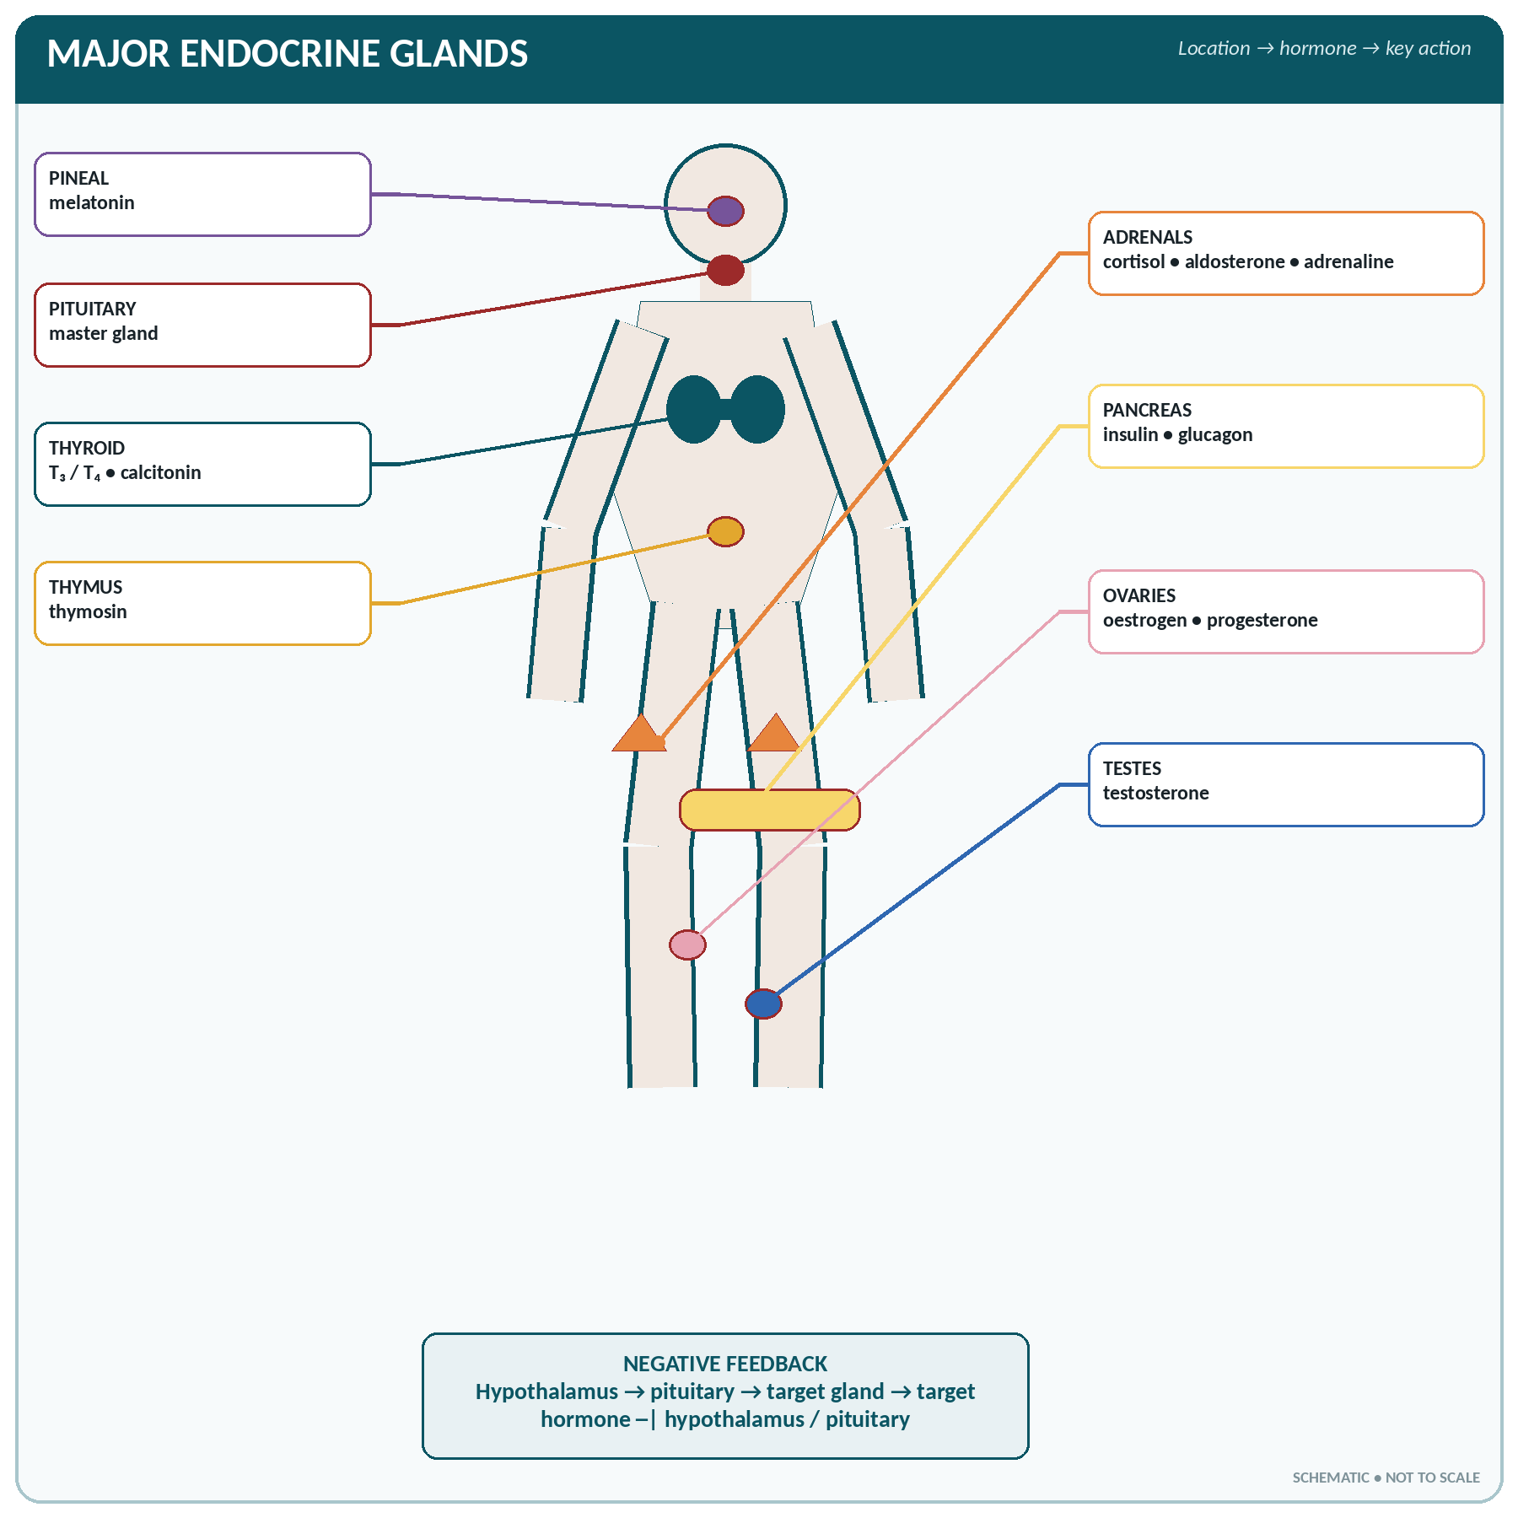
FIGURE • Body map of the principal endocrine glands and their chief hormones

Exocrine and endocrine glands compared
Feature | Exocrine gland | Endocrine gland
Duct | Present | Absent (ductless)
Secretion poured into | A surface, cavity or the exterior | The blood stream
Nature of secretion | Enzymes, mucus, sweat, sebum, milk, tears | Hormones
Speed and range of action | Local and immediate | Distant target organs; slower but widespread
Control | Chiefly nervous | Chiefly chemical (feedback) and by trophic hormones
Blood supply | Moderate | Very rich
Examples | Salivary, gastric, intestinal, pancreatic acini, sweat, sebaceous, lacrimal, mammary, liver (bile) | Pituitary, thyroid, parathyroid, adrenal, pineal, thymus, islets of Langerhans, gonads, placenta
Mixed glands (both functions) | Pancreas, testis, ovary, liver, kidney, placenta | —

▪ A hormone ("I arouse to activity") is a chemical messenger secreted by an endocrine gland into the blood, which acts on a distant target organ bearing specific receptors.
▪ Chemically, hormones are proteins/peptides (insulin, glucagon, ADH, oxytocin, all anterior pituitary hormones, parathormone, calcitonin), steroids (from the adrenal cortex, ovary, testis, placenta — derived from cholesterol; these are fat-soluble and enter the cell), amines/amino-acid derivatives (thyroxine, adrenaline, noradrenaline, melatonin) or glycoproteins (FSH, LH, TSH).
▪ Control of secretion is mainly by negative feedback: a rise in the level of the hormone (or of the substance it controls) inhibits further secretion. The hypothalamus and pituitary form the master control ("the hypothalamo-hypophyseal axis").
The Pituitary Gland (Hypophysis Cerebri)
THE PITUITARY
▪ Called the master gland or "leader of the endocrine orchestra".
▪ Size of a pea, weight 500–600 mg (0.5 g); slightly heavier in pregnancy.
▪ Position: in the hypophyseal fossa (sella turcica) of the sphenoid bone, at the base of the brain, attached to the hypothalamus by the infundibulum (pituitary stalk).
▪ Two lobes: the anterior lobe (adenohypophysis) — 75% of the gland, glandular, develops from Rathke's pouch (ectoderm of the buccal cavity), and the posterior lobe (neurohypophysis) — nervous in origin, a down-growth from the hypothalamus; with a small intermediate part.
▪ The anterior lobe is connected to the hypothalamus by the hypothalamo-hypophyseal portal system (blood vessels carrying releasing hormones); the posterior lobe by nerve fibres.

Hormones of the anterior pituitary
Hormone | Target | Chief actions | Excess | Deficiency
Growth hormone (GH, somatotropin) | All tissues, especially bone and muscle | Growth of the skeleton and soft tissue; protein anabolism; raises blood glucose; mobilises fat | Gigantism (before epiphyseal fusion); acromegaly (after fusion — large hands, feet, jaw, tongue) | Dwarfism (pituitary infantilism) in children
Thyroid stimulating hormone (TSH, thyrotropin) | Thyroid | Growth of the gland and secretion of thyroxine | Hyperthyroidism | Hypothyroidism
Adrenocorticotrophic hormone (ACTH) | Adrenal cortex | Secretion of cortisol (glucocorticoids) and androgens | Cushing's disease | Adrenal insufficiency
Follicle stimulating hormone (FSH) | Ovary / testis | Growth of the ovarian follicle and oestrogen secretion; spermatogenesis in the male | — | Infertility, failure of puberty
Luteinising hormone (LH) — called ICSH in the male | Ovary / testis | Triggers ovulation, forms the corpus luteum and progesterone; testosterone secretion by Leydig cells | — | Infertility, amenorrhoea
Prolactin (lactogenic hormone, LTH) | Breast | Initiates and maintains the secretion of milk after childbirth | Galactorrhoea, amenorrhoea, infertility | Failure of lactation
Melanocyte stimulating hormone (MSH) — intermediate lobe | Skin | Pigmentation (melanin) | Skin darkening (also in Addison's disease) | —

Hormones of the posterior pituitary (made in the hypothalamus, stored and released here)
Hormone | Chief actions | Excess / deficiency
Antidiuretic hormone (ADH, vasopressin) | Increases reabsorption of water in the distal tubule and collecting duct of the kidney, concentrating the urine; in large amounts causes vasoconstriction | Deficiency → diabetes insipidus (polyuria of 5–20 L/day of dilute urine, intense thirst); excess → water retention (SIADH)
Oxytocin | Contracts the uterine muscle during and after labour; causes the ejection (let-down) of milk from the breast; released reflexly by suckling (a positive feedback) | Used to induce labour and control post-partum haemorrhage

▪ Hypothalamic releasing hormones controlling the anterior pituitary: GHRH, TRH, CRH, GnRH, and the inhibiting hormones somatostatin (GHIH) and dopamine (prolactin-inhibiting factor).
▪ Pan-hypopituitarism (Simmonds' disease) — failure of the whole gland; Sheehan's syndrome is post-partum pituitary necrosis.
The Thyroid Gland
THE THYROID
▪ The largest purely endocrine gland; weight 20–25 g (25–30 g), slightly larger in the female and in pregnancy.
▪ Shape: butterfly or H-shaped — two lobes on either side of the trachea joined by an isthmus in front of the 2nd–4th tracheal rings; each lobe is about 5 cm long. A pyramidal lobe may be present.
▪ Position: in the front and sides of the neck at the level of C5–T1, below the larynx.
▪ The most vascular organ of the body for its size; supplied by the superior thyroid (from the external carotid) and inferior thyroid (from the subclavian via the thyrocervical trunk) arteries, and drained by the superior, middle and inferior thyroid veins.
▪ Related to the recurrent laryngeal nerve (hoarseness after thyroid surgery) and the parathyroid glands behind it.
▪ Structure: follicles lined with cuboidal cells and filled with colloid (thyroglobulin), with parafollicular (C) cells between them.

Hormones of the thyroid gland
Hormone | Source | Actions
Thyroxine (T₄) and tri-iodothyronine (T₃) — T₃ is 3–5 times more potent; T₄ is more abundant | Follicular cells; both contain iodine | Raise the basal metabolic rate and heat production; essential for normal growth and mental development; increase carbohydrate, fat and protein metabolism; increase heart rate and cardiac output; affect the nervous system, skin and menstruation
Calcitonin (thyrocalcitonin) | Parafollicular (C) cells | Lowers blood calcium — inhibits osteoclasts and bone resorption, increases calcium excretion; the antagonist of parathormone

▪ Iodine is actively trapped by the gland (iodide pump); the daily requirement is 150 µg. About one-third of the body's iodine is in the thyroid.
▪ Normal values: T₃ 70–200 ng/dL; T₄ 5–12 µg/dL; TSH 0.4–4.0 mIU/L. The thyroid is controlled by TSH, which in turn is controlled by hypothalamic TRH and by negative feedback.
Disorders of the thyroid
Disorder | Features
Hypothyroidism in the infant — cretinism | Mental retardation, dwarfism with short limbs, protruding tongue, coarse dry skin, pot belly, umbilical hernia, delayed milestones
Hypothyroidism in the adult — myxoedema | Slow pulse, weight gain, cold intolerance, dry coarse skin and hair, puffy face, hoarse voice, constipation, menorrhagia, slow mentation, low BMR
Hyperthyroidism — Graves' disease / thyrotoxicosis | Exophthalmos (protruding eyes), goitre, tachycardia and palpitation, weight loss with good appetite, heat intolerance, sweating, tremor, nervousness, diarrhoea, high BMR
Simple (endemic) goitre | Enlargement from iodine deficiency — prevented by iodised salt
Thyroid storm / crisis | Life-threatening exacerbation of thyrotoxicosis
Carcinoma of the thyroid | Papillary (commonest), follicular, medullary (from C cells — raised calcitonin), anaplastic

The Parathyroid Glands
▪ Four small glands (two superior, two inferior), each the size of a pea, weighing about 30–50 mg each (total about 120–160 mg), lying on the posterior surface of the thyroid lobes.
▪ They secrete parathyroid hormone (parathormone, PTH).
▪ Actions of PTH — it RAISES blood calcium:
1. Bone — activates osteoclasts, releasing calcium and phosphate.
2. Kidney — increases reabsorption of calcium, excretion of phosphate, and activates vitamin D (1,25-dihydroxycholecalciferol).
3. Intestine — increases calcium absorption (indirectly, through vitamin D).
▪ Secretion is controlled directly by the level of ionised calcium in the blood (negative feedback), not by the pituitary.
▪ Hypoparathyroidism (often accidental removal during thyroidectomy) → hypocalcaemia → tetany: carpopedal spasm, Trousseau's and Chvostek's signs, laryngeal stridor, convulsions.
▪ Hyperparathyroidism → hypercalcaemia: bone pain and cysts (osteitis fibrosa cystica, "stones, bones, abdominal groans and psychic moans"), renal stones, muscle weakness.
CALCIUM CONTROL — THE THREE HORMONES
Hormone | Effect on blood calcium | Main site
Parathormone | Raises | Bone, kidney
Calcitonin | Lowers | Bone
Vitamin D (calcitriol) | Raises | Intestine (absorption)

The Adrenal (Suprarenal) Glands
▪ Two glands, one on the upper pole of each kidney; the right is pyramidal, the left semilunar. Each weighs about 4–6 g (total 8–12 g) and measures 5 × 3 × 1 cm.
▪ Each has an outer cortex (80–90%, mesodermal) and an inner medulla (10–20%, ectodermal — modified sympathetic tissue). They are among the most vascular organs of the body.
The adrenal cortex — three zones, three groups of hormones
Hormones of the adrenal cortex
Zone (outer → inner) | Hormone group | Chief hormone | Actions | Control
Zona glomerulosa | Mineralocorticoids | Aldosterone | Retains sodium and water, excretes potassium (in the distal tubule); raises blood volume and blood pressure | Renin–angiotensin system and plasma potassium (not ACTH)
Zona fasciculata (widest) | Glucocorticoids | Cortisol (hydrocortisone) | Gluconeogenesis — raises blood glucose; protein and fat catabolism; anti-inflammatory and immunosuppressive; resistance to stress; maintains blood pressure; suppresses allergy | ACTH
Zona reticularis | Sex corticoids (androgens) | Dehydroepiandrosterone (DHEA) | Weak male hormones; pubic and axillary hair; in excess cause virilism in the female | ACTH

ZONES AND THEIR HORMONES
"GFR — Salt, Sugar, Sex" — zona Glomerulosa → Salt (aldosterone); zona Fasciculata → Sugar (cortisol); zona Reticularis → Sex (androgens). "The deeper you go, the sweeter it gets."

The adrenal medulla
▪ Contains chromaffin cells supplied by preganglionic sympathetic fibres; it is really a modified sympathetic ganglion, so its secretion is under direct nervous control.
▪ Secretes the catecholamines — adrenaline (epinephrine) 80% and noradrenaline (norepinephrine) 20%, with a little dopamine.
▪ These are the hormones of fight or flight (the emergency / alarm reaction):
– Heart: increased rate and force, raised cardiac output and blood pressure.
– Vessels: constriction in skin and gut, dilatation in skeletal muscle, heart and brain.
– Bronchi: dilatation (hence adrenaline in asthma and anaphylaxis).
– Metabolism: glycogenolysis — raises blood glucose; lipolysis; raises BMR.
– Eye: dilatation of the pupil; hair: piloerection; sweating; reduced gut motility.
▪ Noradrenaline is chiefly a vasoconstrictor raising blood pressure; adrenaline has more metabolic and cardiac effects.
Disorders of the adrenal glands
Disorder | Cause | Features
Addison's disease | Destruction of the cortex (autoimmune, tuberculosis) | Weakness, weight loss, hypotension, pigmentation of skin and mucosa, hyponatraemia, hyperkalaemia, hypoglycaemia; an Addisonian crisis is fatal if untreated
Cushing's syndrome | Excess cortisol (tumour, or steroid therapy) | Moon face, buffalo hump, truncal obesity with thin limbs, purple striae, hypertension, hyperglycaemia, osteoporosis, hirsutism, easy bruising
Conn's syndrome | Excess aldosterone | Hypertension, hypokalaemia, muscle weakness, alkalosis
Adrenogenital syndrome | Excess androgens (congenital adrenal hyperplasia) | Virilisation, precocious puberty, ambiguous genitalia
Phaeochromocytoma | Tumour of the medulla | Paroxysmal severe hypertension, headache, palpitation, sweating

Other Endocrine Glands and Tissues
The remaining endocrine organs
Gland | Hormone(s) | Chief actions
Islets of Langerhans (pancreas) | Insulin (β cells), glucagon (α), somatostatin (δ) | Insulin lowers, glucagon raises blood glucose
Pineal gland (epiphysis cerebri) | Melatonin | Controls the sleep–wake (circadian) rhythm; inhibits the gonads before puberty ("the biological clock"); the smallest endocrine gland (100–150 mg), in the roof of the third ventricle; calcifies with age
Thymus | Thymosin | Maturation of T lymphocytes; largest in childhood, atrophies after puberty
Testis | Testosterone (Leydig cells), inhibin (Sertoli cells) | Male secondary sex characters, spermatogenesis, protein anabolism
Ovary | Oestrogen, progesterone, relaxin, inhibin | Female secondary sex characters, menstrual cycle, pregnancy
Placenta | hCG, oestrogen, progesterone, human placental lactogen, relaxin | Maintains pregnancy; hCG is the basis of the pregnancy test
Kidney | Erythropoietin, renin, calcitriol (active vitamin D), prostaglandins | Red cell formation; blood pressure; calcium absorption
Heart (atria) | Atrial natriuretic peptide (ANP) | Excretion of sodium and water — lowers blood pressure
Stomach and intestine | Gastrin, secretin, CCK, GIP, motilin, ghrelin | Control of digestion and appetite
Liver | Angiotensinogen, somatomedins (IGF-1), thrombopoietin | Blood pressure; mediates growth hormone action
Adipose tissue | Leptin, adiponectin | Appetite control (satiety) and metabolism

The Chief Exocrine Glands
Exocrine glands of the body
Gland | Secretion | Duct / opening | Function
Salivary (parotid, submandibular, sublingual) | Saliva with amylase, mucin, lysozyme | Stensen's, Wharton's and Rivinus' ducts into the mouth | Begins starch digestion; lubricates; cleanses
Gastric glands | HCl, pepsinogen, mucus, intrinsic factor | Into the stomach | Protein digestion; sterilisation
Intestinal glands (crypts of Lieberkühn, Brunner's glands) | Succus entericus, alkaline mucus | Into the gut lumen | Completes digestion; protects the duodenum
Pancreas (acini) | Pancreatic juice — trypsin, amylase, lipase | Duct of Wirsung → ampulla of Vater | Digests all three foodstuffs
Liver | Bile | Hepatic → common bile duct | Emulsifies fat; excretes bilirubin
Sweat glands (eccrine and apocrine) | Sweat — water, NaCl, urea | Pore on the skin surface | Temperature regulation; slight excretion
Sebaceous glands | Sebum (oily) — a holocrine secretion | Into the hair follicle | Lubricates skin and hair; mildly antibacterial
Lacrimal gland | Tears with lysozyme | Conjunctival sac → nasolacrimal duct | Cleans, moistens and protects the cornea
Mammary gland (modified sweat gland) | Milk | 15–20 lactiferous ducts to the nipple | Nutrition of the infant
Ceruminous glands | Cerumen (wax) | External auditory meatus | Traps dust and repels insects
Goblet cells | Mucus | Onto the mucosal surface | Lubrication and protection (a unicellular gland)
Prostate, seminal vesicles, bulbourethral glands | Seminal fluid | Urethra | Nourishes and transports sperm

ENDOCRINE SYSTEM — RAPID REVISION
▪ Master gland — pituitary, in the sella turcica of the sphenoid, weight 0.5 g.
▪ Largest endocrine gland — thyroid (25 g); smallest — pineal; most vascular — thyroid.
▪ ADH and oxytocin are made in the hypothalamus, stored in the posterior pituitary.
▪ Deficiency of ADH → diabetes insipidus; of insulin → diabetes mellitus; of GH in a child → dwarfism; excess GH in an adult → acromegaly.
▪ Thyroxine contains iodine and controls the BMR; cretinism in infants, myxoedema in adults, exophthalmic goitre in hyperthyroidism.
▪ PTH raises and calcitonin lowers blood calcium; 4 parathyroid glands; their removal causes tetany.
▪ Adrenal cortex: GFR = salt, sugar, sex; aldosterone retains sodium; cortisol is the stress and anti-inflammatory hormone; medulla secretes adrenaline (80%).
▪ Addison's = cortical deficiency with pigmentation; Cushing's = cortisol excess with moon face; phaeochromocytoma = medullary tumour with hypertension.
▪ Sleep hormone — melatonin (pineal); hormone of the pregnancy test — hCG (placenta); hormone lowering blood pressure — ANP (heart); hormone for red cell formation — erythropoietin (kidney).
▪ Mixed glands: pancreas, testis, ovary, liver, kidney, placenta.

CHAPTER 21
The Urinary System

CHAPTER OUTLINE
The Kidneys | The Formation of Urine | Functions of the Kidney | Urine | The Ureters | The Urinary Bladder

The urinary (renal, excretory) system consists of two kidneys, two ureters, the urinary bladder and the urethra. Its chief work is the formation and excretion of urine, by which the body rids itself of nitrogenous waste and regulates the volume and composition of the body fluids.
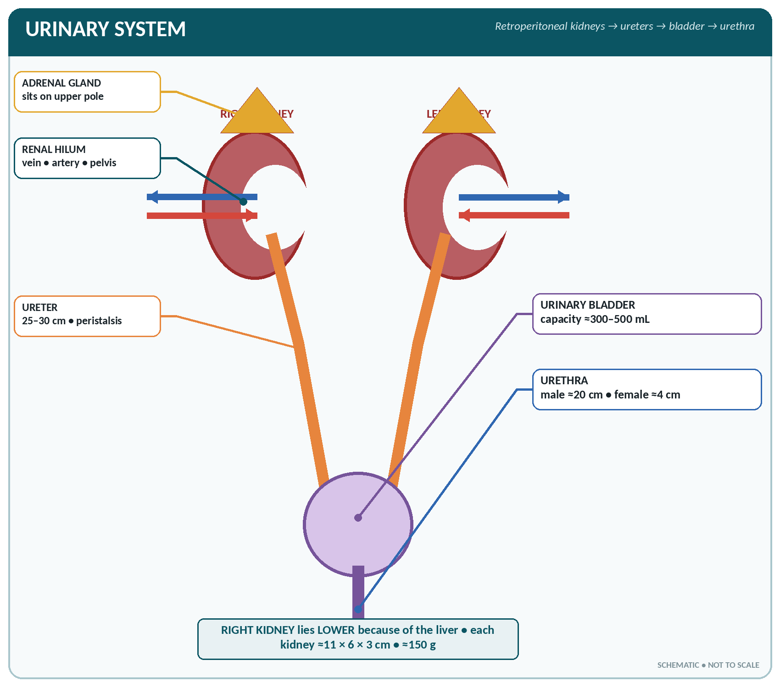
FIGURE • Location and gross arrangement of the kidneys, ureters, urinary bladder and urethra

The Kidneys
THE KIDNEY — BASIC FACTS
▪ Number: two, one on each side of the vertebral column, retroperitoneal, on the posterior abdominal wall.
▪ Level: from the 12th thoracic to the 3rd lumbar vertebra; the right kidney is about 1.25 cm lower than the left because of the liver.
▪ Size: about 11 × 6 × 3 cm (length 10–12 cm, breadth 5–6 cm, thickness 2.5–3 cm).
▪ Weight: 120–170 g in the male, 115–155 g in the female (about 150 g each).
▪ Shape: bean-shaped, with a convex lateral border and a concave medial border bearing the hilum.
▪ Blood flow: 1100–1200 mL/min — about 22–25% of the cardiac output, the greatest flow per gram of any organ. About 400 mL/min per 100 g of tissue.
▪ Coverings (from within outward): fibrous (renal) capsule, perirenal fat, renal fascia (of Gerota) and pararenal fat.

▪ Relations: the suprarenal gland caps the upper pole of each; the right kidney is related to the liver, duodenum and colon; the left to the stomach, spleen, pancreas, jejunum and colon.
▪ Structures at the hilum, from front to back: renal Vein, renal Artery, and the renal pelvis (Ureter) — mnemonic "VAU".
Internal structure
▪ Cortex — the outer dark-red part containing the glomeruli and convoluted tubules; it also dips between the pyramids as the renal columns (of Bertin).
▪ Medulla — the inner pale part made up of 8–18 renal pyramids (striated, containing the loops of Henle and the collecting ducts), each ending in a papilla.
▪ The papillae open into the minor calyces (7–14) → major calyces (2–3) → renal pelvis → ureter.
▪ Blood supply: renal artery (from the abdominal aorta at L1–L2) → segmental → interlobar → arcuate → interlobular → afferent arteriole → glomerulus → efferent arteriole → peritubular capillaries and vasa recta → veins → renal vein → inferior vena cava. Note that blood passes through two sets of capillaries in series — a portal arrangement.
▪ Nerve supply: sympathetic (vasoconstrictor) from the renal plexus (T10–L1); the kidney has no important parasympathetic supply.
The nephron — the functional unit
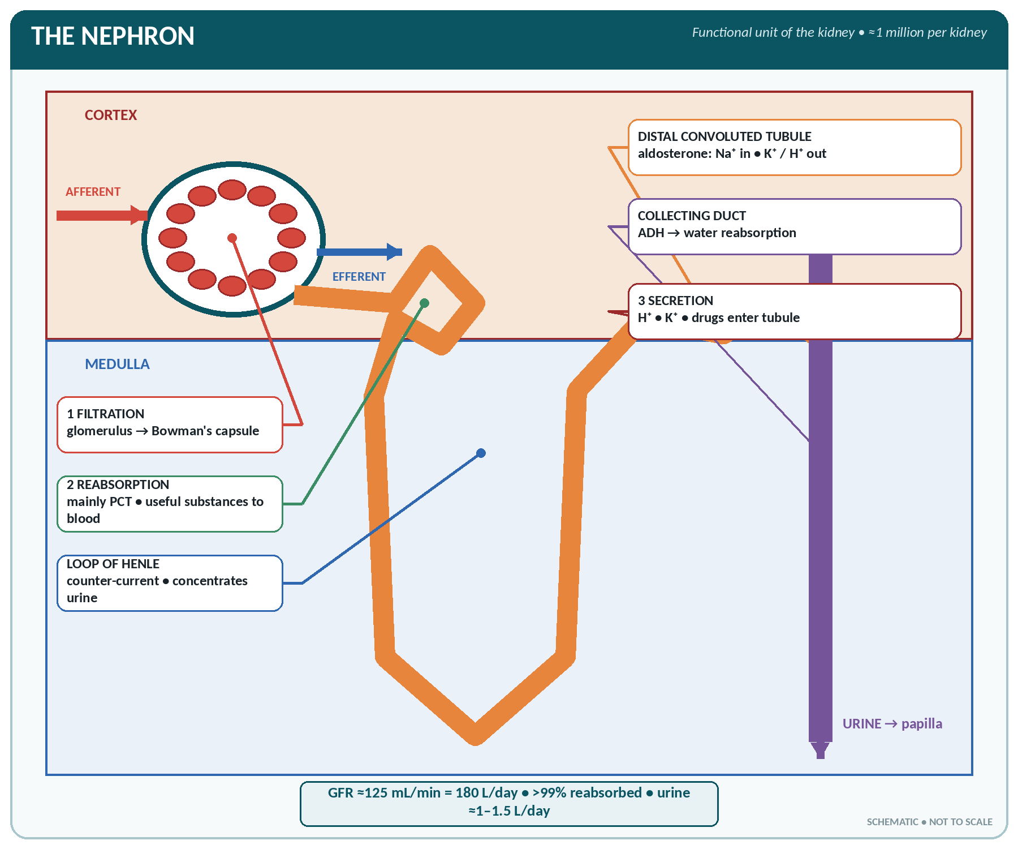
FIGURE • Nephron anatomy and the three processes of urine formation—filtration, reabsorption and secretion

▪ Each kidney contains about 1–1.3 million nephrons (total 2–2.6 million); nephrons are not replaced if destroyed. Each nephron is about 3 cm long; the total length of tubules is about 80–100 km.
▪ Two types: cortical (85%) with short loops, and juxtamedullary (15%) with long loops passing deep into the medulla — these are responsible for concentrating the urine.
The parts of a nephron and their functions
Part | Structure | Function
Glomerulus | A tuft of about 50 capillaries between the afferent (wider) and efferent (narrower) arterioles; fenestrated endothelium | Filtration of blood under high pressure
Bowman's (glomerular) capsule | Double-walled cup of simple squamous epithelium; with the glomerulus it forms the renal (Malpighian) corpuscle | Collects the filtrate
Proximal convoluted tubule (PCT) | Cuboidal cells with a brush border of microvilli, many mitochondria; the longest reabsorbing segment | Reabsorbs 65–80% of the filtrate — all glucose and amino acids, most Na⁺, Cl⁻, water, K⁺, bicarbonate, calcium, phosphate, urea; secretes H⁺, ammonia, creatinine and drugs
Loop of Henle | A hair-pin loop with a thin descending and a thick ascending limb, in the medulla | Creates the medullary osmotic gradient (counter-current multiplier) — the descending limb is permeable to water, the ascending limb reabsorbs Na⁺ and Cl⁻ but is impermeable to water; concentrates the urine
Distal convoluted tubule (DCT) | Cuboidal, no brush border | Selective reabsorption of Na⁺ (under aldosterone) and water (under ADH); secretion of K⁺ and H⁺ — fine control of acid–base and electrolyte balance
Collecting duct | Runs through the medulla to the papilla | Water reabsorption under ADH — final concentration of urine; acidification
Juxtaglomerular apparatus | Modified cells of the afferent arteriole + the macula densa of the DCT | Secretes renin in response to a fall in blood pressure, sodium or volume

The Formation of Urine
Urine is formed in three processes: glomerular filtration, selective tubular reabsorption and tubular secretion.
1. Glomerular filtration
▪ A passive, non-selective process driven by the hydrostatic pressure of the blood.
▪ Net filtration pressure = glomerular blood pressure (55–60 mmHg) − plasma oncotic pressure (30 mmHg) − capsular pressure (15 mmHg) = about 10–15 mmHg.
▪ Filtration is high because the afferent arteriole is wider than the efferent, keeping the glomerular pressure high (55–60 mmHg against about 25 mmHg in other capillaries).
▪ The filtration membrane has three layers: fenestrated endothelium, basement membrane and the podocytes of the capsule. It holds back blood cells and plasma proteins; hence proteinuria and haematuria are abnormal.
▪ Glomerular filtration rate (GFR) = 120–125 mL/minute = about 170–180 litres in 24 hours. Over 99% is reabsorbed, so that only 1–1.5 L of urine is passed.
▪ Autoregulation keeps the GFR constant despite changes in systemic blood pressure between about 80 and 180 mmHg. Filtration stops if the systolic pressure falls below about 70–80 mmHg (hence anuria in shock).
▪ Inulin clearance measures GFR exactly; creatinine clearance is used clinically; PAH clearance measures renal plasma flow.
2. Selective reabsorption
▪ Occurs mainly in the PCT, and is selective and largely active (needing ATP).
▪ Completely reabsorbed (normally absent from urine): glucose, amino acids, vitamins, small proteins, bicarbonate, ketones.
▪ Partly reabsorbed: water, sodium, chloride, potassium, calcium, phosphate, urea, uric acid.
▪ Not reabsorbed (excreted): creatinine, inulin, sulphates, most drugs.
▪ Transport maximum (Tm) and renal threshold: each substance has a maximum rate at which it can be reabsorbed. For glucose the renal threshold is about 180 mg/dL — above this, glucose appears in the urine (glycosuria), as in diabetes mellitus.
3. Tubular secretion
▪ Substances are actively added from the blood to the tubular fluid: hydrogen ions, potassium, ammonia, creatinine, urate, and drugs such as penicillin, aspirin and thiazides. This is important for acid–base regulation and for drug excretion.
Concentration of urine and the role of hormones
Hormonal control of the kidney
Hormone | Source | Action on the kidney
Antidiuretic hormone (ADH / vasopressin) | Hypothalamus → posterior pituitary | Increases water reabsorption in the DCT and collecting duct → concentrated urine, less volume. Its lack causes diabetes insipidus
Aldosterone | Adrenal cortex (zona glomerulosa) | Reabsorbs sodium (and water) and excretes potassium in the DCT
Renin (an enzyme) | Juxtaglomerular cells of the kidney | Renin → angiotensin I → angiotensin II (by ACE in the lung) → powerful vasoconstriction + aldosterone release → raises blood pressure
Atrial natriuretic peptide (ANP) | Atria of the heart | Increases excretion of sodium and water — lowers blood volume and pressure
Parathormone | Parathyroid | Increases calcium reabsorption, decreases phosphate reabsorption
Erythropoietin (secreted by the kidney) | Kidney | Stimulates red cell formation in the marrow

Functions of the Kidney
1. Excretion of nitrogenous waste — urea (the chief), uric acid, creatinine, ammonia; also drugs, toxins, hormones and pigments.
2. Regulation of water balance — through ADH.
3. Regulation of electrolytes — Na⁺, K⁺, Cl⁻, Ca²⁺, phosphate, bicarbonate.
4. Regulation of acid–base balance (pH) — by excreting H⁺ and reabsorbing/regenerating bicarbonate, and by forming ammonia — the most complete but slowest of the pH mechanisms.
5. Regulation of blood pressure — through the renin–angiotensin–aldosterone system and by control of blood volume.
6. Production of erythropoietin — control of red cell formation.
7. Activation of vitamin D — 1-hydroxylation to form calcitriol.
8. Regulation of blood osmolarity and volume.
9. Gluconeogenesis during prolonged fasting.
10. Excretion of foreign substances and metabolites of drugs.
Urine
URINE — NORMAL CHARACTERS
▪ Volume: 1–1.5 litres (1000–1800 mL) in 24 hours; minimum obligatory volume about 500 mL; normal output about 1 mL/kg/hour (30–60 mL/hour).
▪ Colour: pale straw to amber (pigment urochrome/urobilin); clear when fresh.
▪ Odour: faintly aromatic; ammoniacal on standing.
▪ Reaction: acid — pH 4.5–8.0 (average 6.0).
▪ Specific gravity: 1.010–1.030 (average 1.020).
▪ Composition: water 95–96%; solids 4–5% (about 60 g/day):
– Organic: urea 25–30 g (the largest solid constituent), creatinine 1–1.8 g, uric acid 0.6–0.7 g, ammonia, hippuric acid, urobilinogen.
– Inorganic: sodium chloride 10–15 g, potassium, phosphate, sulphate, bicarbonate, calcium, magnesium, oxalate.
▪ Normally absent: protein (albumin), glucose, ketones, blood, pus, bile, casts, bacteria, nitrites.

Abnormal constituents of urine and their significance
Finding | Term | Common causes
Protein | Proteinuria / albuminuria | Nephritis, nephrotic syndrome, pre-eclampsia, fever, heart failure
Glucose | Glycosuria | Diabetes mellitus, pregnancy, renal glycosuria
Ketone bodies | Ketonuria | Diabetic ketoacidosis, starvation, persistent vomiting
Blood | Haematuria | Stone, trauma, tumour, glomerulonephritis, tuberculosis
Haemoglobin | Haemoglobinuria | Haemolysis, incompatible transfusion, blackwater fever
Pus cells | Pyuria | Urinary tract infection
Bile pigment | Bilirubinuria | Obstructive and hepatic jaundice
Casts and crystals | — | Renal disease; stones

Terms relating to micturition
Term | Meaning
Polyuria | Excessive volume of urine (> 2.5–3 L/day) — diabetes mellitus and insipidus, diuretics
Oliguria | Diminished output — less than 400 mL/day (or < 0.5 mL/kg/hour) — dehydration, shock, renal failure
Anuria | Complete suppression — less than 100 mL/day
Dysuria | Painful or difficult micturition
Frequency | Passing urine more often than usual
Nocturia | Waking at night to pass urine
Enuresis | Bed-wetting, especially at night in children
Incontinence | Involuntary loss of urine (stress, urge, overflow, total)
Retention | Inability to empty the bladder although it is full
Micturition / diuresis | Passing urine / increased urine formation

The Ureters
▪ Two muscular tubes, each 25–30 cm long and 3 mm wide, conveying urine from the renal pelvis to the bladder; retroperitoneal, running on the psoas muscle, crossing the pelvic brim, and entering the bladder obliquely through its posterior wall.
▪ The oblique passage through the bladder wall acts as a valve, preventing reflux of urine when the bladder contracts.
▪ Three coats: outer fibrous, middle muscular (inner longitudinal, outer circular — the reverse of the gut) and inner mucous, lined with transitional epithelium.
▪ Urine is propelled by peristaltic waves (1–5 per minute), not by gravity.
▪ Three constrictions — the commonest sites where a stone impacts: at the pelvi-ureteric junction, where it crosses the pelvic brim (over the iliac vessels), and at its entry into the bladder (the narrowest point).
▪ Obstruction causes ureteric (renal) colic — severe pain radiating "loin to groin" — and hydronephrosis.
The Urinary Bladder
▪ A hollow, very distensible muscular reservoir lying in the pelvic cavity behind the symphysis pubis; when empty it is pyramidal and lies wholly within the pelvis, but as it fills it rises into the abdomen and becomes ovoid.
▪ Capacity: comfortably about 300–500 mL; the desire to micturate is felt at about 150–300 mL; maximum capacity up to 600–800 mL.
▪ Parts: apex, base (fundus), superior and two inferolateral surfaces, and the neck.
▪ Trigone — the smooth triangular area on the posterior wall between the openings of the two ureters and the internal urethral orifice; its mucosa is firmly attached and shows no folds.
▪ Muscle coat — the detrusor muscle (three interlacing layers of smooth muscle). At the neck it forms the internal urethral sphincter (involuntary, smooth muscle); the external sphincter of striated muscle is lower, in the urethra, and is voluntary (pudendal nerve, S2–S4).
▪ Lining — transitional epithelium with rugae, which allow great distension and are waterproof.
▪ Relations: in the male the prostate lies below and the rectum behind; in the female the uterus and vagina lie behind, with the urethra passing in front of the vagina.
Micturition (the act of passing urine)
▪ The bladder fills without much rise in pressure. When about 300 mL has accumulated, stretch receptors initiate the micturition reflex:
1. Impulses pass to the sacral spinal centre (S2, S3, S4).
2. Parasympathetic (pelvic splanchnic) fibres cause the detrusor to contract and the internal sphincter to relax.
3. A conscious desire to micturate reaches the brain; the cerebral cortex can inhibit or permit the act by controlling the external sphincter.
4. During micturition the abdominal muscles and diaphragm contract and the pelvic floor relaxes.
▪ Micturition is therefore a reflex act under voluntary control. In infants and in spinal cord injury it is purely reflex (automatic bladder).
DISORDERS OF THE URINARY SYSTEM
▪ Glomerulonephritis — immune inflammation of the glomeruli, often after a streptococcal sore throat; haematuria ("smoky urine"), proteinuria, oedema (periorbital), hypertension, oliguria.
▪ Nephrotic syndrome — the tetrad of massive proteinuria, hypoalbuminaemia, generalised oedema and hyperlipidaemia.
▪ Acute kidney injury (acute renal failure) — sudden fall in GFR with oliguria and rising urea and creatinine; pre-renal (shock, dehydration), renal (nephritis, toxins) or post-renal (obstruction).
▪ Chronic renal failure — progressive irreversible loss of nephrons ending in uraemia: nausea, anaemia (lack of erythropoietin), hypertension, acidosis, hyperkalaemia, bone disease, pruritus; treated by dialysis or transplantation.
▪ Urinary tract infection — commonest organism Escherichia coli; commoner in females (short urethra); cystitis (frequency, dysuria, suprapubic pain), pyelonephritis (fever, loin pain).
▪ Urinary calculi (stones) — usually calcium oxalate; colic, haematuria; prevented by a high fluid intake.
▪ Benign prostatic hypertrophy — in elderly men: hesitancy, poor stream, frequency, retention.
▪ Renal function tests: blood urea (20–40 mg/dL), serum creatinine (0.6–1.4 mg/dL), creatinine clearance, urine specific gravity and routine examination.

URINARY SYSTEM — RAPID REVISION
▪ Kidney weight about 150 g; length 11 cm; the right kidney is lower; both are retroperitoneal.
▪ Functional unit — nephron; about 1 million per kidney; blood flow 1200 mL/min (25% of cardiac output).
▪ GFR = 120–125 mL/min (170–180 L/day); urine output 1–1.5 L/day; over 99% of the filtrate is reabsorbed.
▪ Renal threshold for glucose 180 mg/dL; most reabsorption occurs in the proximal convoluted tubule; the loop of Henle concentrates urine.
▪ ADH acts on the collecting duct (water); aldosterone on the DCT (sodium and potassium).
▪ The kidney secretes renin, erythropoietin and activates vitamin D.
▪ Largest solid constituent of urine — urea; urine pH is acid (about 6); specific gravity 1.010–1.030.
▪ Ureter 25–30 cm; bladder capacity 300–500 mL; micturition centre S2, S3, S4; the trigone lies between the two ureteric openings and the internal urethral orifice.
▪ Male urethra about 20 cm with 3 parts (prostatic, membranous, spongy); female urethra only 4 cm — hence more infection.

CHAPTER 22
The Nervous System

CHAPTER OUTLINE
The Neurone — the Functional Unit | The Brain (Encephalon) | The Spinal Cord | The Peripheral Nervous System | Sensations and Pain | Sleep, Consciousness and Memory

The nervous system is the fastest controlling and coordinating system of the body. It receives information, interprets it and initiates a response, and it is the seat of the higher functions — consciousness, thought, memory, emotion and intelligence.
Divisions of the nervous system
Division | Parts | Function
Central nervous system (CNS) | Brain and spinal cord | Interpretation and integration; the "control centre"
Peripheral nervous system (PNS) | 12 pairs of cranial nerves, 31 pairs of spinal nerves, ganglia and plexuses | Conduction to and from the CNS
Somatic nervous system | Nerves to skin, skeletal muscle, joints | Voluntary control and conscious sensation
Autonomic nervous system (ANS) | Sympathetic and parasympathetic divisions; enteric system | Involuntary control of viscera, glands and vessels
Functionally | Afferent (sensory) and efferent (motor) pathways | Input and output

The Neurone — the Functional Unit
▪ A neurone consists of a cell body (soma / perikaryon), dendrites (which carry impulses towards the cell body) and a single axon (which carries impulses away).
▪ The cell body contains a large nucleus, Nissl granules (rough ER), mitochondria, neurofibrils and pigment; it has no centrioles, and therefore cannot divide.
▪ The axon may be over 1 metre long (the longest cell in the body). It ends in terminal branches with synaptic knobs containing the neurotransmitter.
▪ Myelin sheath — a fatty white insulating sheath formed by Schwann cells in the PNS and by oligodendrocytes in the CNS; it is interrupted at the nodes of Ranvier. Outside it lies the neurilemma (sheath of Schwann), which is essential for regeneration — hence peripheral nerves can regenerate but CNS fibres cannot.
▪ Myelinated fibres conduct much faster (up to 120 m/s) by saltatory conduction (jumping from node to node); unmyelinated fibres conduct at 0.5–2 m/s.
▪ Grey matter = cell bodies, dendrites and unmyelinated fibres; white matter = myelinated axons (tracts).
Classification of neurones
Basis | Types
Structure | Multipolar (most neurones of the CNS), bipolar (retina, olfactory, cochlear), unipolar/pseudo-unipolar (dorsal root ganglion cells)
Function | Sensory (afferent) — carry impulses to the CNS; motor (efferent) — carry impulses to muscles and glands; interneurones (connector, 99% of all neurones) — link the two within the CNS

▪ Neuroglia (supporting cells, 5–10 times more numerous than neurones, about half the volume of the CNS):
The neuroglial cells
Cell | Site | Function
Astrocyte | CNS | Support, repair (gliosis); their processes form the blood–brain barrier; regulate the chemical environment
Oligodendrocyte | CNS | Forms the myelin sheath in the CNS
Microglia | CNS | Phagocytosis — the macrophages of the CNS
Ependymal cell | Lining the ventricles and central canal | Circulates and helps form CSF (with the choroid plexus)
Schwann cell | PNS | Forms the myelin sheath and neurilemma in peripheral nerves
Satellite cell | PNS ganglia | Support

The nerve impulse and the synapse
▪ The resting membrane potential is about −70 mV (inside negative), maintained by the sodium–potassium pump and differential permeability.
▪ A stimulus of threshold strength opens sodium channels; Na⁺ rushes in and the membrane depolarises to about +30 to +40 mV — the action potential (spike). Then K⁺ moves out and the membrane repolarises; the original ionic distribution is restored by the pump.
▪ The all-or-none law applies: the impulse is either full-sized or absent; a stronger stimulus does not make a bigger impulse, but produces more impulses per second and recruits more fibres.
▪ During the absolute refractory period no second impulse can be generated; during the relative refractory period only a strong stimulus succeeds.
▪ A synapse is the junction between two neurones; the neurones do not touch — there is a synaptic cleft (20 nm). Transmission is chemical and one-way (unidirectional): the arriving impulse causes Ca²⁺ entry and the release of a neurotransmitter, which crosses the cleft and alters the permeability of the post-synaptic membrane.
The chief neurotransmitters
Transmitter | Where found | Remarks
Acetylcholine | Neuromuscular junction, all autonomic ganglia, all parasympathetic endings, sympathetic fibres to sweat glands, and parts of the brain | Destroyed by cholinesterase; fibres are called cholinergic
Noradrenaline (norepinephrine) | Most sympathetic post-ganglionic endings, brain stem | Fibres are called adrenergic
Dopamine | Basal ganglia, hypothalamus | Deficiency in the substantia nigra → Parkinson's disease; excess implicated in schizophrenia
Serotonin (5-HT) | Brain stem, hypothalamus | Mood, sleep, temperature, appetite
GABA and glycine | CNS | The chief inhibitory transmitters
Glutamate | CNS | The chief excitatory transmitter
Endorphins and enkephalins | CNS | Natural analgesics ("the body's own morphine")

The Brain (Encephalon)
THE BRAIN — BASIC FACTS
▪ Weight: about 1300–1400 g in the adult male (1200–1300 g female) — roughly 2% of body weight; it receives 15–20% of the cardiac output and uses 20% of the body's oxygen and glucose.
▪ Contains about 100 billion (10¹¹) neurones.
▪ Divided into forebrain (prosencephalon) — cerebrum, thalamus and hypothalamus; midbrain (mesencephalon); and hindbrain (rhombencephalon) — pons, medulla and cerebellum.
▪ The brain stem = midbrain + pons + medulla oblongata.
▪ Cerebral blood flow about 750 mL/min (50 mL/100 g/min); the brain cannot survive more than about 4–5 minutes without oxygen.

The cerebrum
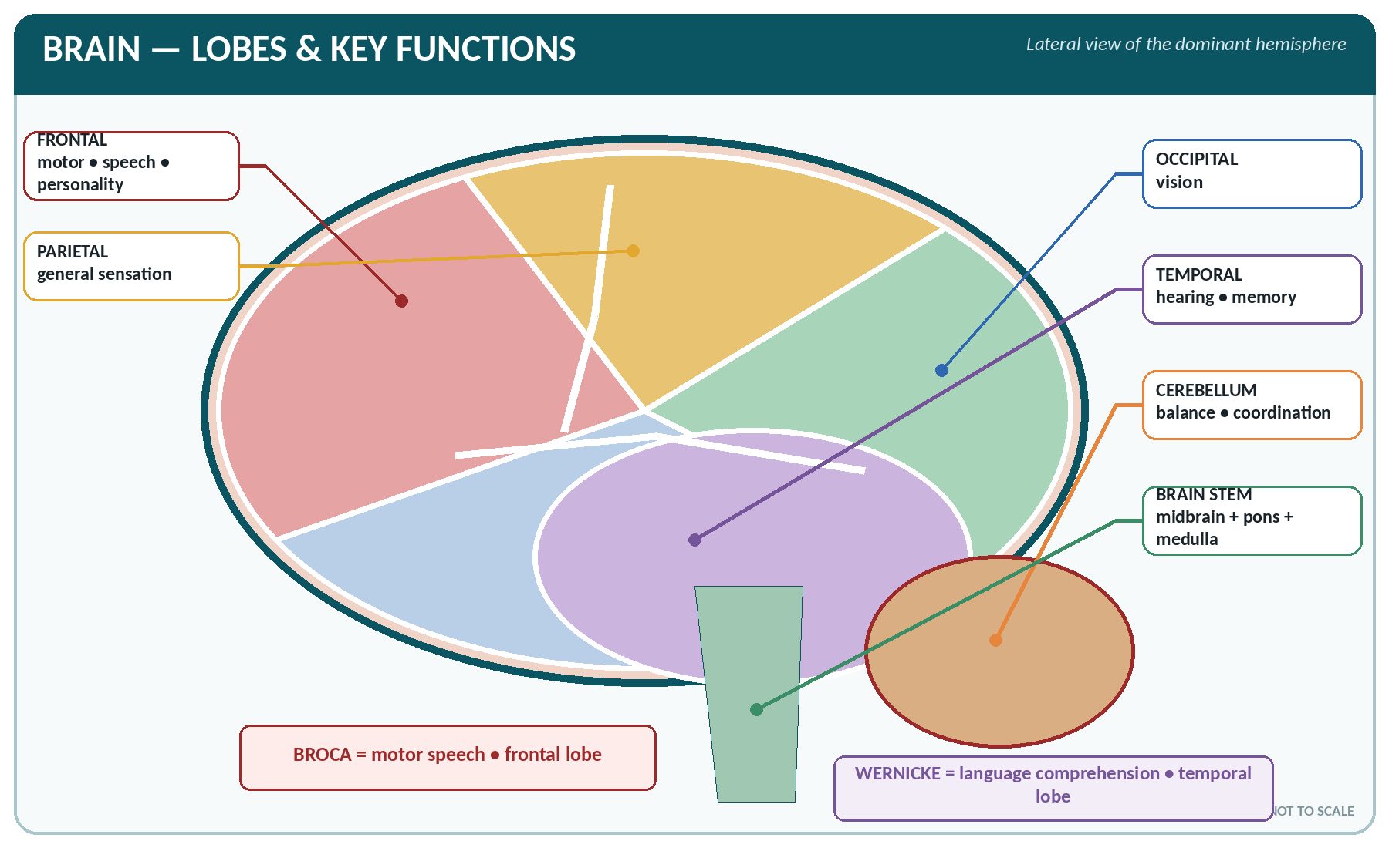
FIGURE • Cerebral lobes, cerebellum and brain stem—learn each coloured area with its principal function

▪ The largest part of the brain (about 80–85% of its weight), divided by the longitudinal fissure into two hemispheres joined at their base by the corpus callosum (the largest commissure, about 200 million fibres).
▪ Its surface is folded into gyri separated by sulci, which enormously increase the surface area (about 2200 cm², of which two-thirds is hidden in the sulci).
▪ Chief sulci: the central sulcus (of Rolando), the lateral sulcus (of Sylvius) and the parieto-occipital sulcus.
▪ Cortex — the outer grey matter, 2–4 mm thick, with about 14 billion neurones in six layers. White matter within contains association, commissural and projection fibres (the latter forming the internal capsule).
▪ Basal ganglia (nuclei) — masses of grey matter deep in the hemisphere: the caudate nucleus, putamen and globus pallidus (together the corpus striatum), with the substantia nigra and subthalamic nucleus. They control posture, muscle tone and coordinated automatic movement. Disease causes Parkinsonism (tremor, rigidity, bradykinesia, mask-like face) and chorea.
The four lobes of the cerebrum and their functional areas
Lobe | Chief areas | Functions
Frontal | Motor area (precentral gyrus, area 4); premotor area; Broca's area (motor speech, usually left); prefrontal cortex | Voluntary movement of the opposite side; speech; personality, judgement, intelligence, emotion, initiative, social behaviour; micturition control
Parietal | Sensory area (postcentral gyrus, areas 3, 1, 2); sensory association area | General sensation from the opposite side — touch, pain, temperature, pressure, proprioception; recognition of size, shape and texture (stereognosis); taste
Temporal | Auditory area; olfactory area; Wernicke's area (sensory speech); hippocampus | Hearing, smell, understanding of spoken and written language, memory, behaviour
Occipital | Visual area (area 17) and visual association areas | Sight and interpretation of what is seen

▪ The insula is a fifth, hidden lobe; the limbic system (hippocampus, amygdala, cingulate gyrus) governs emotion, behaviour and memory ("the emotional brain").
▪ Motor and sensory homunculus: the body is represented upside down and on the opposite (contralateral) side, with disproportionately large areas for the hand, face, lips and tongue.
▪ Dominance: in about 90–95% of people the left hemisphere is dominant for language and is associated with right-handedness.
The diencephalon — thalamus and hypothalamus
▪ Thalamus — two large masses of grey matter on either side of the third ventricle; it is the great relay station for all sensory impulses (except smell) on their way to the cortex, and the centre for crude awareness of sensation, especially pain; it also has a role in emotion and in the reticular activating system.
▪ Hypothalamus — small (about 4 g) but vital; lies below the thalamus, forming the floor and lower walls of the third ventricle:
FUNCTIONS OF THE HYPOTHALAMUS
1. Temperature regulation — the thermostat of the body.
2. Hunger and satiety (feeding centres) and thirst.
3. Water balance — produces ADH.
4. Control of the pituitary — releasing hormones to the anterior lobe; produces ADH and oxytocin for the posterior lobe.
5. Control of the autonomic nervous system — the "head ganglion of the ANS".
6. Emotional behaviour — rage, fear, pleasure, sexual behaviour (with the limbic system).
7. Biological clock — sleep–wake and circadian rhythms (suprachiasmatic nucleus).
8. Regulation of blood pressure, heart rate and gastrointestinal activity.

The brain stem
Parts of the brain stem and their functions
Part | Features | Functions
Midbrain (mesencephalon) | Between the cerebrum and pons; contains the cerebral peduncles, the corpora quadrigemina (4 colliculi), the red nucleus, the substantia nigra and the cerebral aqueduct; nuclei of cranial nerves III and IV | Relay for motor and sensory tracts; visual reflexes (pupillary, accommodation) in the superior colliculi; auditory reflexes in the inferior colliculi; posture and muscle tone
Pons (varolii) | A bridge of white matter in front of the cerebellum; nuclei of cranial nerves V, VI, VII and VIII | Connects the two halves of the cerebellum and links medulla with midbrain; the pneumotaxic and apneustic respiratory centres
Medulla oblongata | About 2.5 cm long, continuous with the spinal cord at the foramen magnum; contains the decussation (crossing) of the pyramids, the olivary nuclei, and nuclei of cranial nerves IX, X, XI and XII | Contains the vital centres — cardiac (cardio-inhibitory and accelerator), respiratory, vasomotor — and the reflex centres for swallowing, vomiting, coughing, sneezing, hiccupping and salivation. Injury here is rapidly fatal

▪ The reticular formation (a network through the brain stem) with the reticular activating system (RAS) maintains consciousness, wakefulness and attention; its depression causes sleep, coma or anaesthesia.
The cerebellum ("little brain")
▪ Lies in the posterior cranial fossa, below the occipital lobes and behind the pons and medulla, separated from the cerebrum by the tentorium cerebelli. It weighs about 150 g (one-tenth of the brain) but contains more than half of all its neurones.
▪ Two hemispheres joined by the vermis; its cortex is grey with a branching white core, the arbor vitae; it is connected to the brain stem by three pairs of peduncles.
▪ Functions — all involuntary and subconscious:
1. Coordination of voluntary movement — making it smooth, precise and accurate.
2. Maintenance of balance and equilibrium (with the vestibular apparatus).
3. Maintenance of posture and muscle tone.
4. Learning of skilled and repetitive movements ("muscle memory"); judgement of distance and speed.
▪ Signs of cerebellar disease (all on the same side as the lesion): ataxia (staggering, broad-based drunken gait), intention tremor, nystagmus, dysarthria (scanning speech), dysdiadochokinesia (inability to perform rapid alternate movements), hypotonia and a positive Romberg's sign.
The meninges
The three meninges, from outside inwards
Layer | Character | Features
Dura mater | Tough, fibrous, double-layered, the outermost | Forms the venous sinuses (superior sagittal, transverse, sigmoid, cavernous), the falx cerebri and tentorium cerebelli; the space outside it is the extradural space and beneath it the subdural space
Arachnoid mater | Delicate, avascular, web-like | Forms arachnoid villi (granulations) which absorb CSF into the venous sinuses
Pia mater | Thin and very vascular, adherent to the brain surface, dipping into every sulcus | Nourishes the nervous tissue; forms the choroid plexuses with the ependyma

▪ The subarachnoid space, between arachnoid and pia, contains the cerebrospinal fluid.
▪ Meningitis is inflammation of the meninges: fever, severe headache, photophobia, vomiting, neck rigidity, positive Kernig's and Brudzinski's signs, and in infants a bulging fontanelle.
The ventricles and the cerebrospinal fluid
▪ Four ventricles: two lateral ventricles (one in each hemisphere), the third (between the thalami) connected to the lateral ventricles by the foramina of Monro, and the fourth (between the pons/medulla and cerebellum), connected to the third by the cerebral aqueduct (of Sylvius).
▪ CSF escapes from the fourth ventricle into the subarachnoid space through the median foramen of Magendie and the two lateral foramina of Luschka.
CEREBROSPINAL FLUID (CSF)
▪ Site of formation: the choroid plexuses of the ventricles (chiefly the lateral ventricles) by filtration and secretion from the ependymal cells.
▪ Total volume: 120–150 mL (about 25–30 mL in the ventricles); formed at 0.35 mL/min = about 500–550 mL per day, so it is replaced 3–4 times a day.
▪ Absorption: by the arachnoid villi into the dural venous sinuses (chiefly the superior sagittal sinus).
▪ Appearance: clear, colourless — "like water"; pressure 60–150 mm H₂O (10–15 mmHg) in the lateral recumbent position.
▪ Composition: water, protein 15–45 mg/dL (much less than plasma), glucose 45–80 mg/dL (about two-thirds of blood glucose), chloride 120–130 mEq/L (more than plasma), sodium, potassium, a few lymphocytes (0–5/mm³); no red cells; specific gravity 1.005; pH 7.3–7.4.
▪ Functions: (1) acts as a water cushion, protecting the brain and cord from injury; (2) supports the weight of the brain (which "floats", weighing effectively only 50 g); (3) nourishes the nervous tissue and removes waste; (4) keeps the intracranial pressure constant; (5) a medium for the diffusion of chemicals; (6) diagnostic value (lumbar puncture).
▪ Lumbar puncture is performed between L3–L4 or L4–L5 with the patient on the side, because the spinal cord ends at L1–L2. Queckenstedt's test checks for spinal block.

▪ Hydrocephalus — excess CSF with enlargement of the ventricles and head, from obstruction (commonly of the aqueduct), over-production or defective absorption.
▪ The blood–brain barrier (formed by the tight junctions of the brain capillary endothelium and the astrocyte foot processes) allows water, oxygen, CO₂, glucose, alcohol and fat-soluble drugs to pass, but excludes most drugs, proteins, ions and toxins.
The Spinal Cord
▪ A cylindrical continuation of the medulla, beginning at the foramen magnum and ending as the conus medullaris at the level of the 1st–2nd lumbar vertebra (L3 in the newborn) — hence the vertebral canal below this contains only the cauda equina ("horse's tail") and the filum terminale.
▪ Length about 45 cm (42–45 cm) in the adult, weight about 30 g, diameter 1–1.5 cm with cervical and lumbar enlargements (for the limb plexuses).
▪ Structure on cross-section:
– Grey matter is central, H- or butterfly-shaped, with posterior (dorsal) horns — sensory, anterior (ventral) horns — motor, and lateral horns (autonomic, T1–L2).
– White matter is peripheral, arranged in ascending (sensory) and descending (motor) tracts.
– A central canal containing CSF runs through the grey commissure.
▪ 31 pairs of spinal nerves arise: 8 cervical, 12 thoracic, 5 lumbar, 5 sacral and 1 coccygeal. Each is formed by the union of a posterior (dorsal) sensory root — bearing the dorsal root ganglion — and an anterior (ventral) motor root. This is the law of Bell and Magendie.
The chief tracts of the spinal cord
Tract | Direction | Function
Lateral and anterior corticospinal (pyramidal) tracts | Descending (motor) | Voluntary movement; about 80–85% of fibres cross in the medulla (decussation of the pyramids) — so a lesion above it causes contralateral paralysis
Extrapyramidal tracts (rubrospinal, reticulospinal, vestibulospinal, tectospinal) | Descending | Muscle tone, posture and coordination; involuntary movement
Posterior (dorsal) columns — fasciculus cuneatus and gracilis | Ascending (sensory) | Fine touch, vibration, two-point discrimination and proprioception; cross in the medulla
Lateral spinothalamic tract | Ascending | Pain and temperature; crosses in the cord (one or two segments above entry)
Anterior spinothalamic tract | Ascending | Crude touch and pressure
Spinocerebellar tracts | Ascending | Unconscious proprioception to the cerebellum (uncrossed)

Functions of the spinal cord
1. Conduction — carries sensory impulses up to the brain and motor impulses down from it.
2. Reflex centre — the centre for all spinal reflexes.
Reflex action
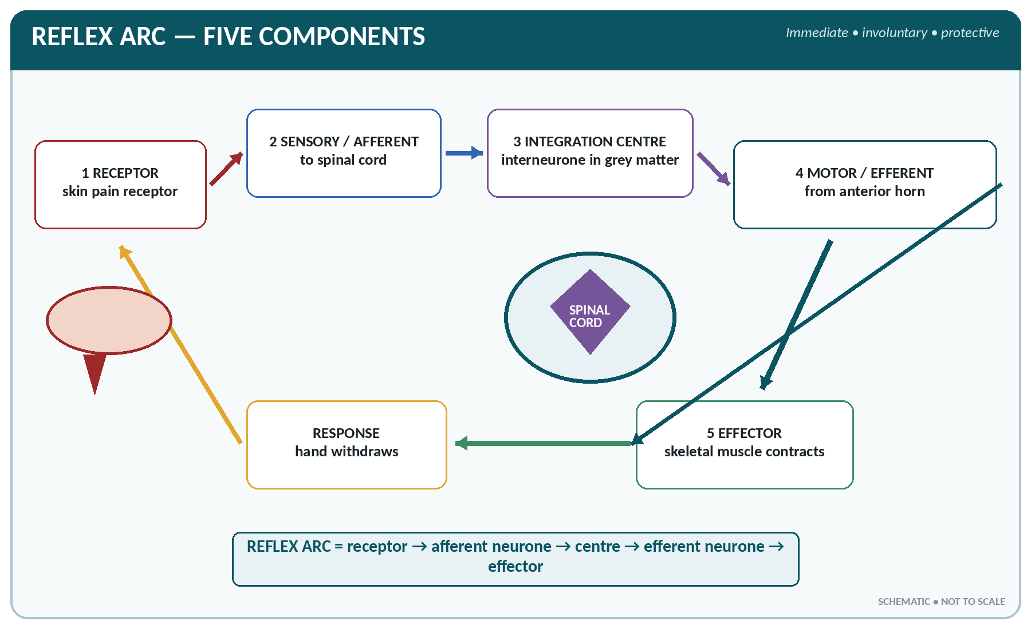
FIGURE • The five components of a reflex arc from receptor to protective motor response

▪ A reflex is an immediate, involuntary, stereotyped response to a stimulus.
▪ The reflex arc has five components: receptor → afferent (sensory) neurone → centre (with interneurones) → efferent (motor) neurone → effector (muscle or gland).
▪ Types: monosynaptic (knee jerk — only two neurones) and polysynaptic; superficial (plantar, abdominal, corneal) and deep tendon (knee, ankle, biceps, triceps); visceral/autonomic (micturition, defaecation, pupillary, vomiting); conditioned (learnt) reflexes as demonstrated by Pavlov.
▪ Examples of reflexes and their levels: biceps jerk C5–C6, triceps C7–C8, knee jerk (patellar) L2–L4, ankle jerk (Achilles) S1–S2, plantar response L5–S1, abdominal reflex T8–T12, micturition and defaecation S2–S4, corneal reflex V and VII.
▪ The Babinski sign (extension of the great toe on plantar stimulation) is normal below 1 year but indicates an upper motor neurone lesion in older children and adults.
Upper and lower motor neurone lesions compared
Feature | Upper motor neurone (UMN) lesion | Lower motor neurone (LMN) lesion
Site | Brain or spinal cord (above the anterior horn) | Anterior horn cell or peripheral nerve
Paralysis | Spastic | Flaccid
Muscle tone | Increased (hypertonia) | Lost (hypotonia)
Deep reflexes | Exaggerated (hyperreflexia) | Lost or diminished
Superficial (plantar) reflex | Babinski sign positive (extensor) | Absent
Muscle wasting | Slight (late, from disuse) | Marked and early
Fasciculation | Absent | Present
Clonus | Present | Absent

The Peripheral Nervous System
The cranial nerves
The twelve cranial nerves
No. | Name | Type | Chief function
I | Olfactory | Sensory | Smell
II | Optic | Sensory | Vision
III | Oculomotor | Motor | Moves 4 of the 6 eye muscles (superior, inferior, medial rectus and inferior oblique), raises the eyelid, constricts the pupil and accommodates (parasympathetic)
IV | Trochlear | Motor | Superior oblique muscle (looks down and inward); the smallest cranial nerve
V | Trigeminal | Mixed — the largest cranial nerve | Sensation of the face (3 divisions — ophthalmic, maxillary, mandibular); motor to the muscles of mastication; corneal reflex
VI | Abducent | Motor | Lateral rectus — abduction of the eye
VII | Facial | Mixed | Muscles of facial expression; taste from the anterior two-thirds of the tongue; secretion of saliva (submandibular, sublingual) and tears
VIII | Vestibulocochlear (auditory) | Sensory | Hearing (cochlear part) and balance/equilibrium (vestibular part)
IX | Glossopharyngeal | Mixed | Taste and sensation from the posterior third of the tongue; pharyngeal sensation (gag reflex); parotid secretion; carotid sinus reflex
X | Vagus | Mixed — the longest cranial nerve | Parasympathetic supply to the heart, lungs and most of the abdominal viscera; muscles of the pharynx and larynx (voice); sensation from the pharynx, larynx, thorax and abdomen
XI | Accessory (spinal accessory) | Motor | Sternocleidomastoid and trapezius
XII | Hypoglossal | Motor | Muscles of the tongue

CRANIAL NERVES
Names: "On Old Olympus' Towering Top, A Finn And German Viewed Some Hops" — Olfactory, Optic, Oculomotor, Trochlear, Trigeminal, Abducent, Facial, Auditory, Glossopharyngeal, Vagus, Spinal accessory, Hypoglossal. Type: "Some Say Marry Money, But My Brother Says Big Brains Matter More" — S = sensory, M = motor, B = both: I-S, II-S, III-M, IV-M, V-B, VI-M, VII-B, VIII-S, IX-B, X-B, XI-M, XII-M. Remember: purely sensory — I, II, VIII; purely motor — III, IV, VI, XI, XII; mixed — V, VII, IX, X. Nerves carrying parasympathetic fibres — III, VII, IX, X.

The spinal nerves and the plexuses
▪ Each spinal nerve divides into a posterior (dorsal) ramus to the muscles and skin of the back and an anterior (ventral) ramus to the rest of the body. Anterior rami intermingle to form plexuses.
▪ A dermatome is the area of skin supplied by one spinal nerve. Useful landmarks: C6 thumb, C7 middle finger, T4 nipple, T10 umbilicus, L1 groin, L4 medial side of the leg and great toe, S1 little toe and sole, S2–S4 perineum.
The chief nerve plexuses
Plexus | Roots | Chief nerves and supply
Cervical | C1–C4 | Skin and muscles of the neck; phrenic nerve (C3, C4, C5) to the diaphragm
Brachial | C5–C8, T1 | Musculocutaneous (flexors of the arm), axillary (deltoid), radial (extensors), median (flexors of forearm, thenar muscles), ulnar (small muscles of the hand); also long thoracic, thoracodorsal, suprascapular
Lumbar | L1–L4 | Femoral (quadriceps, front of thigh), obturator (adductors), iliohypogastric, ilio-inguinal, lateral cutaneous of the thigh, genitofemoral
Sacral | L4, L5, S1–S4 | Sciatic nerve — the longest and thickest nerve in the body, dividing into the tibial and common peroneal nerves; pudendal nerve (S2–S4) to the perineum and external sphincters; gluteal nerves
Coccygeal | S4, S5, Co | Skin over the coccyx

The autonomic nervous system
Sympathetic and parasympathetic systems compared
Feature | Sympathetic | Parasympathetic
Other name | Thoraco-lumbar; the "fight or flight" system | Cranio-sacral; the "rest and digest" system
Origin of fibres | T1 to L2 (L3) — lateral horn of the cord | Brain stem (cranial nerves III, VII, IX, X) and S2, S3, S4
Ganglia | In the two sympathetic chains beside the vertebral column, and in prevertebral plexuses (coeliac, mesenteric) — near the cord | Within or near the organ supplied
Pre-/post-ganglionic fibres | Short pre-ganglionic, long post-ganglionic | Long pre-ganglionic (the vagus supplies 75% of all parasympathetic fibres), short post-ganglionic
Transmitter at the ganglion | Acetylcholine | Acetylcholine
Transmitter at the effector | Noradrenaline (adrenergic) — except sweat glands | Acetylcholine (cholinergic)
Distribution | Widespread (one fibre to many organs — diffuse action) | Localised, discrete
Overall effect | Prepares the body for emergency; catabolic | Conserves and restores; anabolic

Autonomic effects on individual organs
Organ | Sympathetic stimulation | Parasympathetic stimulation
Heart | Rate ↑, force ↑, output ↑ | Rate ↓, force ↓
Coronary vessels | Dilate | Constrict (slightly)
Bronchi | Dilate | Constrict; secretion ↑
Pupil | Dilates (mydriasis) | Constricts (miosis)
Ciliary muscle | Relaxes (far vision) | Contracts (accommodation for near vision)
Salivary and lacrimal glands | Scanty, viscid secretion | Copious watery secretion
Stomach and intestine | Motility and secretion ↓; sphincters contract | Motility and secretion ↑ (peristalsis); sphincters relax
Liver | Glycogenolysis — blood glucose ↑ | Glycogen synthesis
Urinary bladder | Detrusor relaxes, sphincter contracts — retention | Detrusor contracts, sphincter relaxes — micturition
Skin vessels | Constrict (pallor) | No supply
Sweat glands | Secretion ↑ (cholinergic sympathetic) | No supply
Adrenal medulla | Secretes adrenaline | No supply
Blood pressure | Rises | Falls
Uterus | Contracts (pregnant) | Variable
Male genitalia | Ejaculation | Erection
Hair (arrector pili) | Contracts — gooseflesh | No supply

▪ Structures with only sympathetic supply: sweat glands, arrector pili, adrenal medulla, spleen, most blood vessels.
Sensations and Pain
▪ Sensations may be special (smell, sight, hearing, taste, balance), somatic/general (touch, pressure, pain, temperature, proprioception) or visceral.
▪ Receptors: Meissner's corpuscle (touch), Merkel's disc (light touch), Pacinian corpuscle (deep pressure and vibration), Ruffini (warmth/stretch), Krause end-bulb (cold), free nerve endings (pain — nociceptors), muscle spindle and Golgi tendon organ (proprioception).
▪ Pain is the only sensation that does not adapt; it is protective. Referred pain is felt at a site distant from its origin because of shared segmental innervation: heart pain in the left arm and jaw, gall bladder pain in the right shoulder, appendix pain first at the umbilicus, kidney pain in the groin, and diaphragmatic pain in the shoulder tip (C4).
▪ Gate control theory (Melzack and Wall) — non-painful impulses (rubbing, counter-irritation, TENS) can "close the gate" in the posterior horn to painful impulses.
Sleep, Consciousness and Memory
▪ Sleep — a recurring state of reduced consciousness from which a person can be aroused. Two kinds: NREM (slow-wave) sleep in four stages, and REM (paradoxical, rapid-eye-movement) sleep, when dreaming occurs, muscles are atonic and the EEG resembles wakefulness. REM accounts for 20–25% of adult sleep and recurs every 90 minutes. Requirement: newborn 16–20 hours, child 10–12, adult 7–8, elderly 5–6 hours.
▪ Consciousness depends on the reticular activating system; grades of impaired consciousness are drowsiness → confusion → stupor → coma (assessed by the Glasgow Coma Scale — score 3 to 15).
▪ Memory — immediate, short-term (minutes, electrical circuits) and long-term (structural changes; involves the hippocampus and temporal lobe).
▪ The EEG records cortical electrical activity as alpha (8–13 Hz, awake and relaxed with eyes closed), beta (13–30 Hz, alert), theta (4–8 Hz, drowsy/children) and delta (< 4 Hz, deep sleep; in an awake adult it indicates disease) waves.
DISORDERS OF THE NERVOUS SYSTEM
▪ Stroke (cerebrovascular accident) — thrombosis, embolism or haemorrhage causing sudden contralateral hemiplegia, aphasia (if the dominant hemisphere), facial palsy, hemianopia.
▪ Epilepsy — recurrent seizures from abnormal cortical discharge; generalised (tonic–clonic, absence) or focal.
▪ Meningitis and encephalitis; poliomyelitis (anterior horn cells — flaccid paralysis); tetanus and rabies.
▪ Parkinson's disease — dopamine deficiency in the substantia nigra: resting tremor, rigidity, bradykinesia, mask face, festinant gait.
▪ Multiple sclerosis — patchy demyelination in the CNS.
▪ Alzheimer's disease — progressive dementia with cortical atrophy.
▪ Peripheral neuropathy — diabetes, alcohol, leprosy, vitamin B₁ and B₁₂ deficiency.
▪ Paraplegia (both legs), hemiplegia (one side), quadriplegia (all four limbs), monoplegia (one limb); paresis = weakness, plegia = paralysis.
▪ Raised intracranial pressure — headache, vomiting, papilloedema, falling pulse, rising blood pressure, altered consciousness (Cushing's reflex).

NERVOUS SYSTEM — RAPID REVISION
▪ Functional unit — neurone; myelin in the PNS by Schwann cells, in the CNS by oligodendrocytes; phagocytes of the CNS — microglia.
▪ Resting potential −70 mV; conduction in myelinated fibres is saltatory, up to 120 m/s; transmission at a synapse is chemical and one-way.
▪ Brain weight 1300–1400 g; largest part — cerebrum; largest commissure — corpus callosum; thalamus is the sensory relay (except smell); hypothalamus controls temperature, thirst, hunger and the pituitary.
▪ Vital centres (cardiac, respiratory, vasomotor) are in the medulla; centres for balance and coordination in the cerebellum.
▪ CSF 120–150 mL, formed by the choroid plexus (500 mL/day), absorbed by arachnoid villi; lumbar puncture at L3–L4/L4–L5.
▪ Spinal cord 45 cm long, ends at L1–L2; 31 pairs of spinal nerves; posterior root sensory, anterior root motor.
▪ Pain and temperature — lateral spinothalamic tract (crosses in the cord); fine touch and proprioception — posterior columns (cross in the medulla); voluntary movement — corticospinal (crosses in the medulla).
▪ Cranial nerves: 12 pairs; largest trigeminal; longest vagus; smallest trochlear; purely sensory I, II, VIII; carrying parasympathetic fibres III, VII, IX, X.
▪ Longest nerve in the body — sciatic; nerve to the diaphragm — phrenic (C3, C4, C5).
▪ Sympathetic = T1–L2, transmitter noradrenaline; parasympathetic = cranio-sacral (S2–S4), transmitter acetylcholine.

CHAPTER 23
The Ear

CHAPTER OUTLINE
The External Ear | The Middle Ear (Tympanic Cavity) | The Internal Ear (Labyrinth) | The Physiology of Hearing

The ear is the organ of hearing and of equilibrium (balance). It is contained largely in the petrous part of the temporal bone and has three parts — external, middle and internal ear.
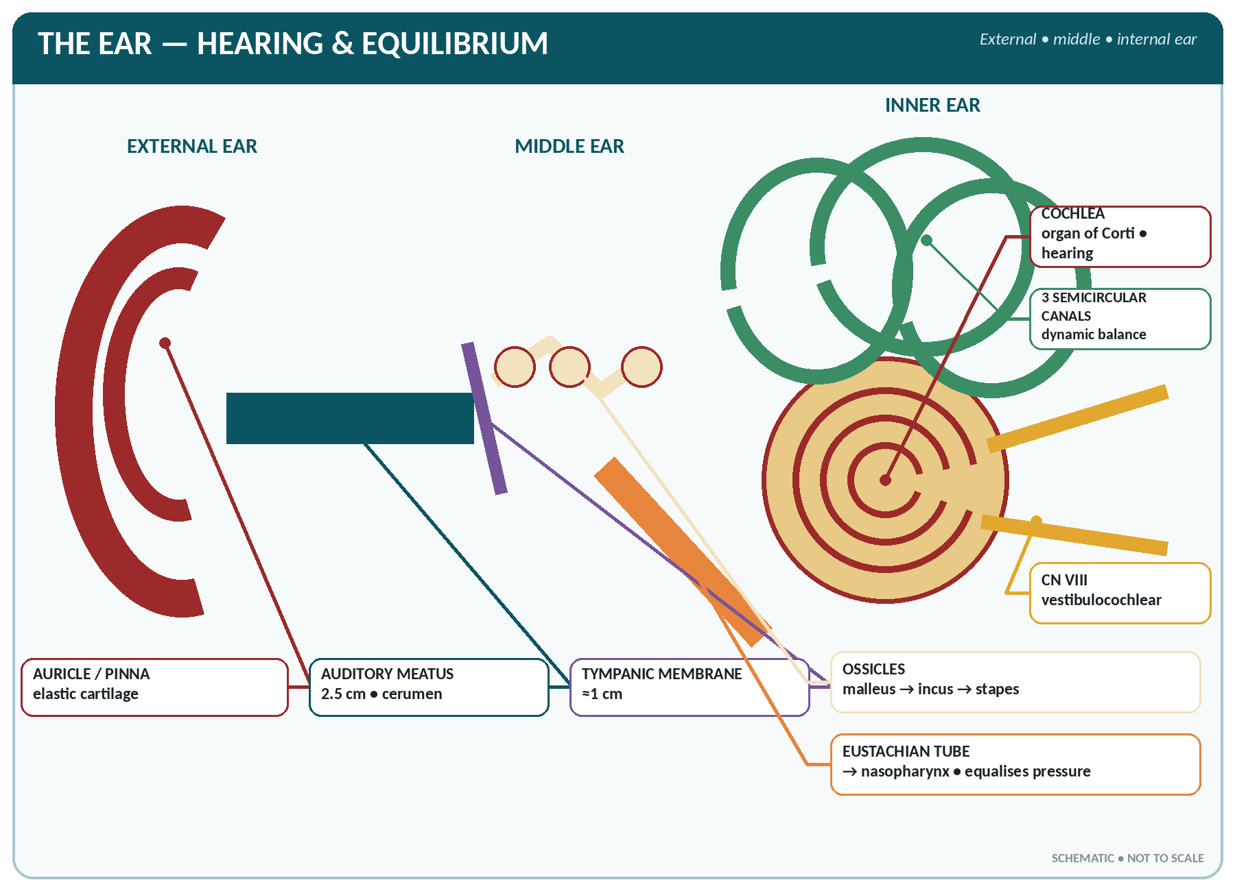
FIGURE • External, middle and internal ear—follow sound to the cochlea and identify the organs of equilibrium

The three parts of the ear at a glance
Part | Contents | Function
External ear | Auricle (pinna), external acoustic (auditory) meatus, tympanic membrane | Collects and conducts sound waves — air conduction
Middle ear (tympanic cavity) | Three ossicles — malleus, incus, stapes; two muscles; auditory (Eustachian) tube; two windows | Amplifies and transmits vibrations — bone/ossicular conduction; equalises pressure
Internal ear (labyrinth) | Cochlea (hearing) and the vestibule with three semicircular canals (balance) | Converts vibration into nerve impulses — fluid conduction

The External Ear
The auricle (pinna)
▪ A funnel of elastic cartilage covered with skin (the lobule contains no cartilage — only fat and fibrous tissue, so it is used for piercing and for taking blood in infants).
▪ Parts: helix, antihelix, tragus, antitragus, concha, lobule.
▪ Function: collects sound waves and directs them into the meatus; helps locate the direction of sound.
The external acoustic meatus
▪ A slightly S-shaped canal about 2.5 cm (1 inch) long, running inwards, forwards and slightly upwards from the concha to the tympanic membrane.
▪ The outer third is cartilaginous, the inner two-thirds bony (temporal bone). The narrowest part is the isthmus, about 2 cm from the surface.
▪ Lined with skin bearing hairs, sebaceous glands and modified apocrine ceruminous glands which secrete cerumen (wax) — this traps dust, waterproofs the canal, is mildly bactericidal and repels insects. Impacted wax is a common cause of conductive deafness.
▪ In adults the auricle is pulled upwards and backwards to straighten the canal for examination; in infants (in whom the canal is short and straight) it is pulled downwards and backwards.
The tympanic membrane (ear drum)
▪ A thin, pearly-grey, semi-transparent, oval membrane about 1 cm (9–10 mm) in diameter, set obliquely at the inner end of the meatus, separating it from the middle ear.
▪ Three layers: outer cuticular (skin), middle fibrous and inner mucous layer.
▪ It is drawn inwards at the centre — the umbo — by the handle of the malleus, which is attached to it; light reflected from it forms the cone of light seen antero-inferiorly on otoscopy.
▪ Its larger lower part is the tense pars tensa; the small upper part above the malleolar folds is the slack pars flaccida (Shrapnell's membrane).
▪ Nerve supply: outer surface chiefly by the auriculotemporal (V₃) and vagus; inner surface by the glossopharyngeal — hence the cough reflex on syringing and referred otalgia.
▪ It converts sound waves in air into mechanical vibration; its area is about 17–20 times that of the stapes footplate, which greatly increases the pressure transmitted.
The Middle Ear (Tympanic Cavity)
▪ An air-filled cavity in the petrous temporal bone, about 15 × 15 × 6 mm (narrowest in the middle), lined with ciliated columnar/cuboidal mucous membrane — continuous with that of the pharynx through the auditory tube.
▪ Boundaries (six walls):
– Lateral (outer) — the tympanic membrane.
– Medial (inner) — the labyrinth, bearing the oval window (fenestra vestibuli) closed by the footplate of the stapes, the round window (fenestra cochleae) closed by the secondary tympanic membrane, and the promontory (the first turn of the cochlea).
– Roof (tegmen tympani) — separates it from the middle cranial fossa and temporal lobe.
– Floor — the jugular wall, over the internal jugular vein.
– Anterior — the opening of the auditory tube and the canal for the tensor tympani.
– Posterior — the aditus leading to the mastoid antrum and air cells.
The ear ossicles
The three ossicles — the smallest bones in the body
Ossicle | Shape | Attachments
Malleus (hammer) | The largest ossicle (8–9 mm) | Its handle is fixed to the tympanic membrane; its head articulates with the incus
Incus (anvil) | Anvil-shaped | Between the malleus and the stapes
Stapes (stirrup) | Stirrup-shaped; the smallest bone in the body (2.5–3 mm) | Its footplate fits into the oval window

▪ The chain transmits and amplifies vibration from the tympanic membrane to the perilymph of the inner ear, magnifying the force about 18–22 times in all (lever action of the ossicles × the area ratio of the membranes).
▪ Two small muscles protect the ear from very loud sound (the attenuation / tympanic reflex):
– Tensor tympani — attached to the malleus, supplied by the trigeminal (V₃); tenses the membrane.
– Stapedius — the smallest muscle in the body, attached to the stapes, supplied by the facial nerve (VII); its paralysis in Bell's palsy causes hyperacusis.
The auditory (Eustachian / pharyngotympanic) tube
▪ Connects the middle ear with the nasopharynx; about 3.5–4 cm long (36 mm); the upper third is bony, the lower two-thirds cartilaginous.
▪ Function: equalises the air pressure on the two sides of the tympanic membrane, allowing it to vibrate freely; it also drains the middle ear. It opens on swallowing and yawning.
▪ In the infant it is shorter, wider and more horizontal, so infection spreads readily from the throat — the reason otitis media is common in children.
The Internal Ear (Labyrinth)
▪ Consists of the bony labyrinth — a system of cavities in the petrous temporal bone containing perilymph — inside which lies the membranous labyrinth, containing endolymph.
▪ Three parts: the vestibule (central), the cochlea (anterior, for hearing) and the three semicircular canals (posterior, for balance).
The cochlea
▪ A bony canal shaped like a snail shell, making 2¾ turns round a central bony pillar, the modiolus; it is about 35 mm long if uncoiled.
▪ Divided along its length into three compartments:
– Scala vestibuli (above) — perilymph; begins at the oval window.
– Scala media (cochlear duct) — endolymph; contains the organ of Corti.
– Scala tympani (below) — perilymph; ends at the round window. The two scalae communicate at the apex through the helicotrema.
▪ Membranes: the basilar membrane (below the cochlear duct — it is narrow and stiff at the base, responding to high frequencies, and wide and slack at the apex, responding to low frequencies) and the vestibular (Reissner's) membrane above.
▪ The organ of Corti is the receptor (end-organ) of hearing, resting on the basilar membrane. It contains about 16 000–20 000 hair cells (one row of inner and three to four rows of outer hair cells) with supporting cells, covered by the gelatinous tectorial membrane. Bending of the hairs generates the nerve impulse carried by the cochlear nerve.
The vestibular apparatus
▪ The vestibule contains two sacs — the utricle and the saccule — each with a patch of receptor epithelium, the macula, containing hair cells and otoliths (ear dust — calcium carbonate crystals). These respond to the position of the head in space and to linear acceleration (static equilibrium).
▪ The three semicircular canals (superior/anterior, posterior and lateral/horizontal) lie at right angles to one another, in the three planes of space. Each has a dilated end, the ampulla, containing a crista ampullaris with hair cells embedded in a gelatinous cupula. Movement of the endolymph when the head turns bends the cupula and stimulates the hair cells — they respond to rotation and angular acceleration (dynamic/kinetic equilibrium).
▪ Impulses travel by the vestibular nerve to the cerebellum, vestibular nuclei and cortex, and by the vestibulospinal tract and the nerves to the eye muscles, which is why vestibular stimulation produces nystagmus, vertigo, nausea and vomiting, and why the vestibule is involved in motion sickness.
The Physiology of Hearing
Pathway of sound
Sound waves → auricle → external acoustic meatus → tympanic membrane (vibrates) → malleus → incus → stapes → oval window → perilymph of the scala vestibuli → vestibular membrane → endolymph of the cochlear duct → basilar membrane and the hair cells of the organ of Corti → cochlear nerve → cochlear nuclei of the medulla → (crossed and uncrossed fibres) → inferior colliculus → medial geniculate body → auditory area of the temporal lobe (superior temporal gyrus, areas 41, 42).
▪ The round window bulges outward to relieve the pressure wave.
▪ Air conduction is through the external and middle ear; bone conduction is through the skull bones directly to the cochlea (the basis of Rinne's and Weber's tests and of bone-conduction hearing aids).
HEARING — NUMBERS TO REMEMBER
▪ Audible frequency range: 20 – 20 000 Hz (most sensitive between 1000 and 4000 Hz, the range of speech).
▪ Loudness is measured in decibels (dB): whisper 20–30 dB, normal conversation 60 dB, traffic 80 dB, pneumatic drill 100 dB; above 85–90 dB on long exposure damages hearing, and above 120–140 dB causes pain.
▪ Normal hearing threshold 0–25 dB; hearing loss is graded mild (26–40), moderate (41–60), severe (61–80) and profound (> 80 dB).
▪ Speed of sound in air ≈ 330–340 m/s.

Types of deafness
Type | Site of lesion | Common causes | Rinne / Weber
Conductive deafness | External or middle ear | Wax, foreign body, otitis media with effusion, perforation, otosclerosis (fixation of the stapes), ossicular disruption | Rinne negative (bone > air); Weber lateralises to the affected ear
Sensorineural (perceptive) deafness | Cochlea, VIII nerve or brain | Presbycusis (old age), noise exposure, ototoxic drugs (streptomycin, gentamicin, quinine, furosemide), congenital rubella, kernicterus, meningitis, mumps, Ménière's disease, acoustic neuroma | Rinne positive but reduced; Weber lateralises to the normal ear
Mixed | Both | Chronic suppurative otitis media | —

DISORDERS OF THE EAR
▪ Otitis externa — inflammation of the canal; painful, with discharge.
▪ Acute otitis media — common in children; earache, fever, deafness, a red bulging drum which may perforate with discharge of pus; spreads from the throat by the auditory tube.
▪ Chronic suppurative otitis media — persistent discharge and perforation; may cause mastoiditis, facial palsy, meningitis or a brain abscess.
▪ Otosclerosis — new bone fixes the stapes: progressive conductive deafness in young adults, often with tinnitus, treated by stapedectomy.
▪ Ménière's disease — dilatation of the endolymph system: recurrent attacks of vertigo, tinnitus, fluctuating deafness and a feeling of fullness.
▪ Tinnitus — ringing or buzzing in the ear. Vertigo — an illusion of movement. Presbycusis — deafness of old age, worse for high tones.
▪ Labyrinthitis — inflammation of the inner ear with severe vertigo and vomiting.
▪ Investigations: otoscopy, tuning-fork tests (Rinne, Weber), pure-tone audiometry, tympanometry, BERA (in infants).

THE EAR — RAPID REVISION
▪ The ear lies in the petrous part of the temporal bone; the external meatus is 2.5 cm long, outer third cartilaginous.
▪ Tympanic membrane is 1 cm across, pearly grey, obliquely placed, with three layers.
▪ Ossicles from outside in — malleus, incus, stapes; malleus largest, stapes smallest bone in the body; stapedius is the smallest muscle, supplied by the facial nerve.
▪ The auditory (Eustachian) tube connects the middle ear to the nasopharynx and equalises pressure; it is short, wide and horizontal in infants.
▪ Cochlea = hearing (organ of Corti on the basilar membrane); semicircular canals (three, at right angles) and the utricle and saccule = balance.
▪ Perilymph is outside the membranous labyrinth, endolymph inside.
▪ Hearing range 20–20 000 Hz; nerve of hearing and balance — vestibulocochlear (VIII); auditory centre — temporal lobe.
▪ Wax (cerumen) is secreted by ceruminous glands; the pinna is made of elastic cartilage and the lobule has no cartilage.

CHAPTER 24
The Eye

CHAPTER OUTLINE
The Orbit and the Accessory Structures | The Eyeball | The Physiology of Vision

The eye is the organ of sight. It consists of the eyeball (bulbus oculi) and the accessory (adnexal) structures — the orbit, eyelids, conjunctiva, lacrimal apparatus and the extra-ocular muscles. The optic nerve (II) carries visual impulses to the brain.
The Orbit and the Accessory Structures
The orbit
▪ A pyramidal bony cavity with its base in front and apex behind, formed by seven bones: frontal, maxilla, zygomatic, sphenoid, ethmoid, lacrimal and palatine.
▪ It contains the eyeball, the extra-ocular muscles, the lacrimal gland, vessels, nerves and orbital fat (which cushions the eye). The eyeball occupies only the anterior one-fifth.
▪ Openings: the optic canal (optic nerve and ophthalmic artery), the superior orbital fissure (III, IV, VI, ophthalmic division of V, ophthalmic veins) and the inferior orbital fissure.
The eyelids (palpebrae) and conjunctiva
▪ Movable folds protecting the front of the eye; from front to back they contain skin, subcutaneous tissue, the orbicularis oculi (closes the lid — facial nerve) and levator palpebrae superioris (raises the upper lid — oculomotor nerve, with a smooth-muscle part supplied by the sympathetic), the fibrous tarsal plate, the tarsal (Meibomian) glands and the conjunctiva.
▪ Eyelashes (cilia) have sebaceous glands of Zeis and modified sweat glands of Moll.
▪ Blinking (about 12–20 times a minute, and reflexly) spreads the tear film, keeps the cornea moist and removes dust.
▪ The conjunctiva is a thin transparent mucous membrane with a palpebral part lining the lids, a bulbar part covering the front of the sclera, and the fornices where they meet; it does not cover the cornea (which has its own epithelium). The conjunctival sac is the space so enclosed.
▪ Conjunctivitis is its inflammation; pallor of the conjunctiva indicates anaemia and yellowness indicates jaundice.
The lacrimal apparatus
▪ Lacrimal gland — the size of an almond, in the upper outer part of the orbit; secretes tears through 10–12 ducts into the upper conjunctival fornix. Its nerve supply is parasympathetic via the facial nerve (lacrimal nucleus).
▪ Tears pass across the eye, collect at the medial angle (the lacus lacrimalis) and drain through the two puncta → lacrimal canaliculi → lacrimal sac → nasolacrimal duct → the inferior meatus of the nose (which is why we sniff when we cry).
▪ Tears: about 1 mL a day, a slightly alkaline watery fluid of water, salts, mucin, albumin, and the bactericidal enzyme lysozyme (also lactoferrin and IgA).
▪ Functions of tears: wash away dust and irritants; keep the cornea and conjunctiva moist and transparent; nourish and oxygenate the avascular cornea; antibacterial; provide a smooth optical surface; express emotion.
▪ Blockage of the duct causes watering (epiphora); infection of the sac is dacryocystitis.
The extra-ocular (extrinsic) muscles
The six muscles that move the eyeball
Muscle | Action | Nerve supply
Superior rectus | Elevation (looks up) | Oculomotor (III)
Inferior rectus | Depression (looks down) | Oculomotor (III)
Medial rectus | Adduction (looks in, towards the nose) | Oculomotor (III)
Lateral rectus | Abduction (looks out) | Abducent (VI)
Superior oblique | Looks down and out (depression with abduction, intorsion) | Trochlear (IV)
Inferior oblique | Looks up and out (elevation with abduction, extorsion) | Oculomotor (III)

NERVE SUPPLY OF THE EYE MUSCLES
"LR₆ SO₄ — all the rest by 3": Lateral Rectus by the 6th nerve, Superior Oblique by the 4th nerve, and all the remaining muscles (including levator palpebrae) by the 3rd (oculomotor) nerve.

▪ Squint (strabismus) is failure of the two eyes to look in the same direction; diplopia is double vision; paralysis of the III nerve causes ptosis, a dilated pupil and an eye turned "down and out".
The Eyeball
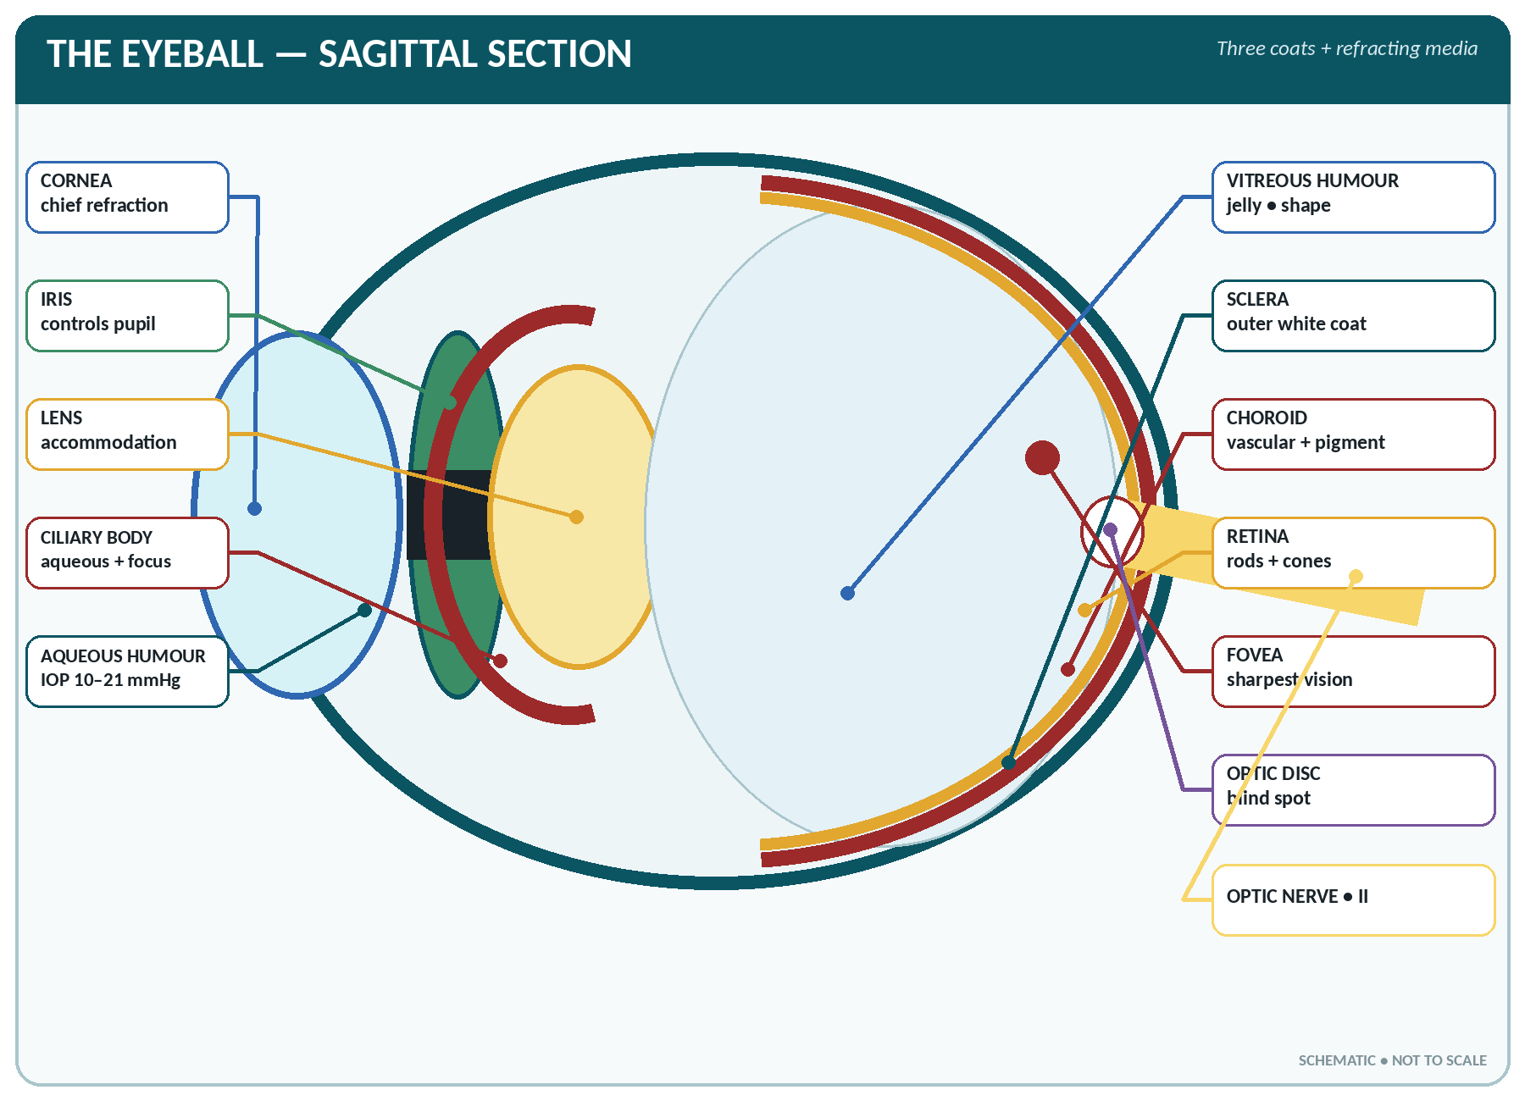
FIGURE • Sagittal section of the eyeball—three coats, refractive media, fovea, blind spot and optic nerve

THE EYEBALL
▪ Roughly spherical, diameter about 24 mm (2.4 cm) antero-posteriorly; weight about 7 g; volume 6.5–7 mL.
▪ Set in the anterior part of the orbit, embedded in fat, and moved by six muscles.
▪ Has three coats and three refracting media (contents).
▪ Only about one-sixth of the eyeball — the cornea and adjacent sclera — is visible from the front.

The three coats of the eyeball
Coat | Parts | Structure and function
1. Outer fibrous coat | Sclera (posterior five-sixths) and cornea (anterior one-sixth) | Sclera — tough, opaque, white ("the white of the eye"); maintains the shape and gives attachment to the muscles. Cornea — transparent, avascular, richly supplied with sensory nerves (V₁) — the most sensitive tissue of the body (corneal reflex); it is the chief refracting structure of the eye (about 40 of the total 60 dioptres) and is nourished by tears and aqueous humour
2. Middle vascular coat (uvea) | Choroid, ciliary body, iris | Choroid — thin, dark brown, very vascular; nourishes the retina and its pigment absorbs stray light. Ciliary body — contains the ciliary muscle (accommodation) and the ciliary processes which secrete aqueous humour; gives attachment to the suspensory ligament of the lens. Iris — the coloured diaphragm with the central pupil; contains the sphincter pupillae (circular, parasympathetic — constricts) and dilator pupillae (radial, sympathetic — dilates)
3. Inner nervous coat | Retina | The light-sensitive layer; contains the rods and cones, and continues behind as the optic nerve

The retina
▪ Has 10 layers; the outer pigmented layer is attached to the choroid and the inner nervous layer contains the photoreceptors, the bipolar cells and the ganglion cells whose axons form the optic nerve. Note that light must pass through the whole thickness to reach the receptors (the retina is "inverted").
Rods compared with cones
Feature | Rods | Cones
Number | About 110–125 million | About 6–7 million
Pigment | Rhodopsin (visual purple) — contains vitamin A | Iodopsin (three types — red, green, blue)
Function | Dim light (scotopic) and peripheral vision; black-and-white | Bright light (photopic) vision, colour and fine detail (acuity)
Sensitivity | Very sensitive to light, poor acuity | Less sensitive, high acuity
Distribution | Peripheral retina; absent at the fovea | Concentrated at the macula/fovea; few peripherally
Deficiency effect | Night blindness (vitamin A lack) | Colour blindness (commonly red–green, X-linked, in males — tested by Ishihara charts)

▪ Macula lutea — a yellowish spot at the posterior pole, with the fovea centralis at its centre — the point of greatest visual acuity, containing only cones and no rods or blood vessels.
▪ Optic disc (blind spot) — where the optic nerve and the retinal vessels leave the eye, about 3 mm medial to the macula; it contains no rods or cones and so is insensitive to light.
▪ Blood supply of the retina: the central artery of the retina (a branch of the ophthalmic artery) for the inner layers and the choroid for the outer; the central artery is an anatomical end-artery — its occlusion causes sudden permanent blindness.
The contents (refracting media) of the eyeball
The refractive media
Medium | Position | Nature and function
Cornea | Front | The chief refracting medium (about 40 D of the 58–60 D total)
Aqueous humour | In the anterior and posterior chambers, in front of the lens | A clear watery fluid secreted by the ciliary processes; circulates from the posterior chamber through the pupil into the anterior chamber and drains through the trabecular meshwork into the canal of Schlemm → the venous system. It nourishes the cornea and lens and maintains the intra-ocular pressure (normal 10–21 mmHg, average 15 mmHg). Obstruction to its drainage causes glaucoma
Lens | Behind the iris, held by the suspensory ligament to the ciliary body | A transparent, biconvex, elastic, avascular body enclosed in a capsule; about 10 mm across and 4 mm thick; adds about 15–20 D and provides the variable focus (accommodation). Its opacity is a cataract
Vitreous humour (body) | Behind the lens, filling the posterior four-fifths of the globe | A clear, soft, jelly-like mass (99% water, with collagen and hyaluronic acid); maintains the shape of the eyeball and keeps the retina in place; it is not replaced if lost

The Physiology of Vision
Refraction and image formation
▪ Light is refracted at the cornea → aqueous humour → lens → vitreous body, and forms an image on the retina which is real, inverted and smaller than the object. The brain interprets it the right way up.
▪ Total refractive power of the resting eye is about 58–60 dioptres (cornea 40 D, lens 15–20 D).
Accommodation
▪ Accommodation is the adjustment of the eye to see objects at different distances, by changing the curvature of the lens.
▪ For near vision: the ciliary muscle contracts → the suspensory ligament slackens → the elastic lens becomes more convex (more powerful); at the same time the pupil constricts and the eyes converge — the near reflex triad. The nerve involved is the oculomotor (III) — parasympathetic.
▪ For distant vision: the ciliary muscle relaxes, the ligament tightens and the lens flattens.
▪ The near point (closest point of clear vision) is about 25 cm in a young adult and recedes with age as the lens hardens — presbyopia, corrected with convex reading glasses.
Adaptation and the pupillary reflexes
▪ Dark adaptation — regeneration of rhodopsin in dim light, taking 20–30 minutes and requiring vitamin A. Light adaptation is rapid (about 5 minutes).
▪ Light (pupillary) reflex — light in one eye constricts both pupils (direct and consensual); the afferent path is the optic (II) nerve and the efferent the oculomotor (III). It is a midbrain reflex and is absent in deep coma and brain death.
▪ Corneal (blink) reflex — afferent trigeminal (V), efferent facial (VII).
The visual pathway
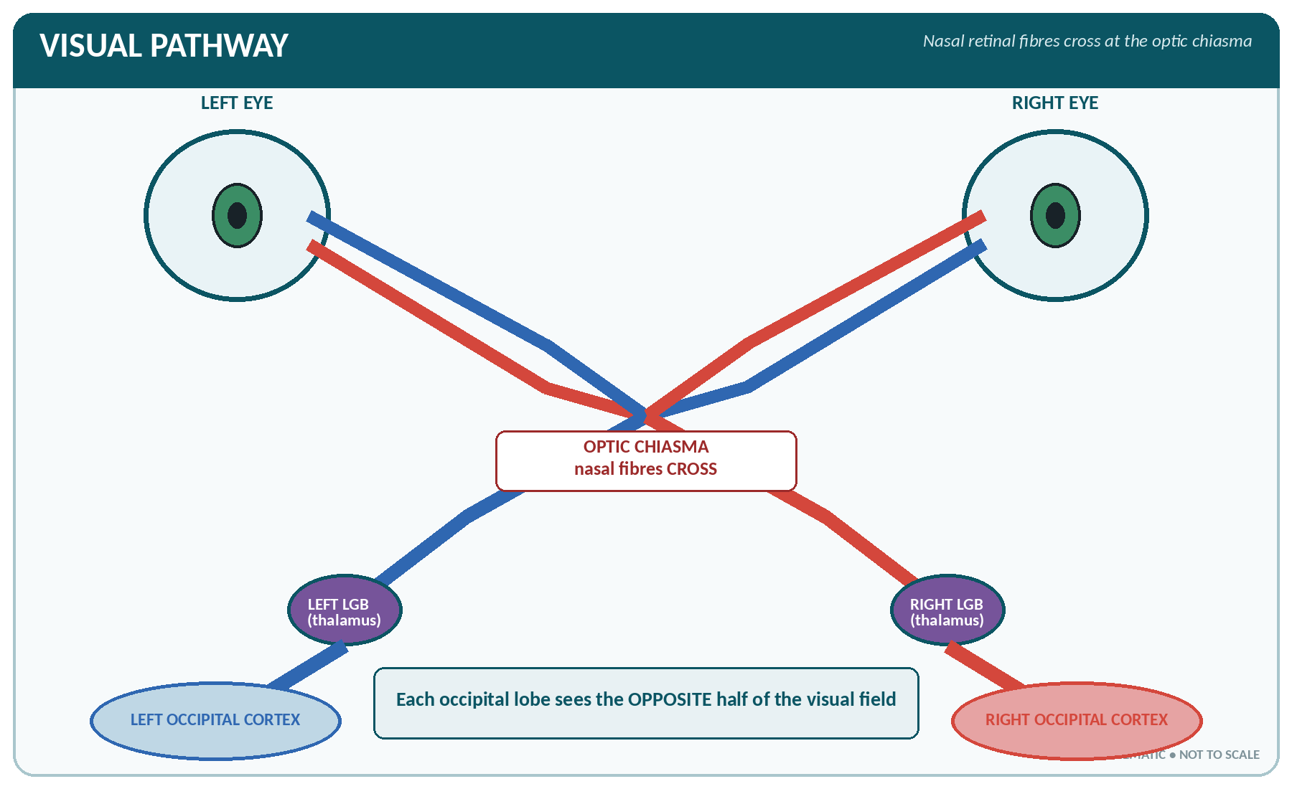
FIGURE • Visual pathway—nasal retinal fibres cross at the optic chiasma before reaching the opposite occipital cortex

Retina (rods and cones) → bipolar cells → ganglion cells → optic nerve → optic chiasma (where fibres from the nasal/medial half of each retina cross) → optic tract → lateral geniculate body of the thalamus → optic radiation → visual (occipital) cortex — area 17 of the occipital lobe.
▪ Because of the crossing at the chiasma, each occipital lobe receives information from the opposite half of the visual field.
▪ Binocular (stereoscopic) vision — the overlapping fields of the two eyes give depth perception and judgement of distance; the field of one eye is about 150° and of both together about 180–200°.
▪ Visual acuity is tested with Snellen's chart and expressed as 6/6 (normal), 6/12, 6/60 etc. Blindness in India is defined as visual acuity worse than 6/60 (or 3/60 by WHO) in the better eye.
Errors of refraction and their correction
Error | Defect | Correction
Myopia (short sight) | Eyeball too long or lens too strong — rays focus in front of the retina; distant objects blurred | Concave (diverging, minus) lens
Hypermetropia (long sight) | Eyeball too short or lens too weak — rays focus behind the retina; near objects blurred | Convex (converging, plus) lens
Presbyopia | Loss of elasticity of the lens with age (after about 40) — loss of accommodation | Convex reading lens (bifocals)
Astigmatism | Unequal curvature of the cornea or lens — distorted image in one meridian | Cylindrical lens
Aphakia | Absence of the lens (after cataract surgery) | Intra-ocular lens implant or strong convex lens
Anisometropia | Unequal refraction in the two eyes | Spectacles/contact lenses

COMMON EYE DISORDERS
▪ Cataract — opacity of the lens, the commonest cause of blindness in India; painless progressive dimness of vision; treated by extraction with intra-ocular lens implantation.
▪ Glaucoma — raised intra-ocular pressure damaging the optic nerve; acute (painful, red eye, haloes, fixed dilated pupil) or chronic simple (painless loss of the peripheral field — "tunnel vision"); an important irreversible cause of blindness.
▪ Trachoma — chronic Chlamydia conjunctivitis causing scarring, entropion, trichiasis and corneal opacity; a major preventable cause of blindness.
▪ Xerophthalmia and keratomalacia — vitamin A deficiency in children (night blindness → conjunctival xerosis → Bitot's spots → corneal ulceration and softening).
▪ Conjunctivitis ("pink eye"), stye (hordeolum), chalazion, blepharitis, pterygium, corneal ulcer, iritis (uveitis), retinal detachment, diabetic and hypertensive retinopathy, papilloedema (raised intracranial pressure), retinoblastoma (childhood malignant tumour), ophthalmia neonatorum.
▪ Refractive surgery and spectacles correct errors of refraction; the eye examination includes visual acuity, torch light examination, ophthalmoscopy (fundus), tonometry and field charting.

THE EYE — RAPID REVISION
▪ Diameter of the eyeball about 24 mm; three coats — sclera/cornea, uvea (choroid, ciliary body, iris), retina.
▪ The cornea is avascular, the most sensitive tissue of the body and the chief refracting medium; total refractive power about 60 D.
▪ Aqueous humour is secreted by the ciliary processes and drains by the canal of Schlemm; intra-ocular pressure 10–21 mmHg; its obstruction causes glaucoma.
▪ Rods (about 120 million) for dim light and contain rhodopsin (vitamin A); cones (6–7 million) for colour and acuity, most numerous at the fovea centralis.
▪ Macula lutea/fovea = point of sharpest vision; optic disc = blind spot (no rods or cones).
▪ Accommodation is by change in the curvature of the lens through the ciliary muscle — oculomotor nerve; near point about 25 cm.
▪ Pupil is constricted by the parasympathetic (III) and dilated by the sympathetic.
▪ Myopia — concave lens; hypermetropia — convex lens; astigmatism — cylindrical lens; presbyopia — convex reading glasses.
▪ Nerve supply: LR₆, SO₄, rest by III; corneal reflex — V afferent, VII efferent.
▪ Tears contain the bactericidal enzyme lysozyme and drain into the inferior meatus of the nose.
▪ Visual centre — occipital lobe; commonest cause of blindness in India — cataract.

CHAPTER 25
The Skin

CHAPTER OUTLINE
Structure of the Skin | The Appendages of the Skin | Functions of the Skin | Wound Healing and Common Terms

The skin (integument, cutis) is the largest organ of the body and also the largest sense organ. With its appendages — hair, nails, sweat and sebaceous glands — it forms the integumentary system.
THE SKIN — BASIC FACTS
▪ Surface area: 1.5–2 m² (about 1.8 m²) in an adult.
▪ Weight: about 4–5 kg (up to 16% of body weight including the subcutaneous fat) — the heaviest organ.
▪ Thickness: 0.5 mm on the eyelids to 4–6 mm on the palms, soles and upper back (average 1–2 mm).
▪ It contains about 3 million sweat glands, 5 million hairs, and receives about 6–10% of the cardiac output (300–500 mL/min), which can rise greatly in heat.
▪ It is renewed about every 4–6 weeks; vitamin D is synthesised in it under sunlight.

Structure of the Skin
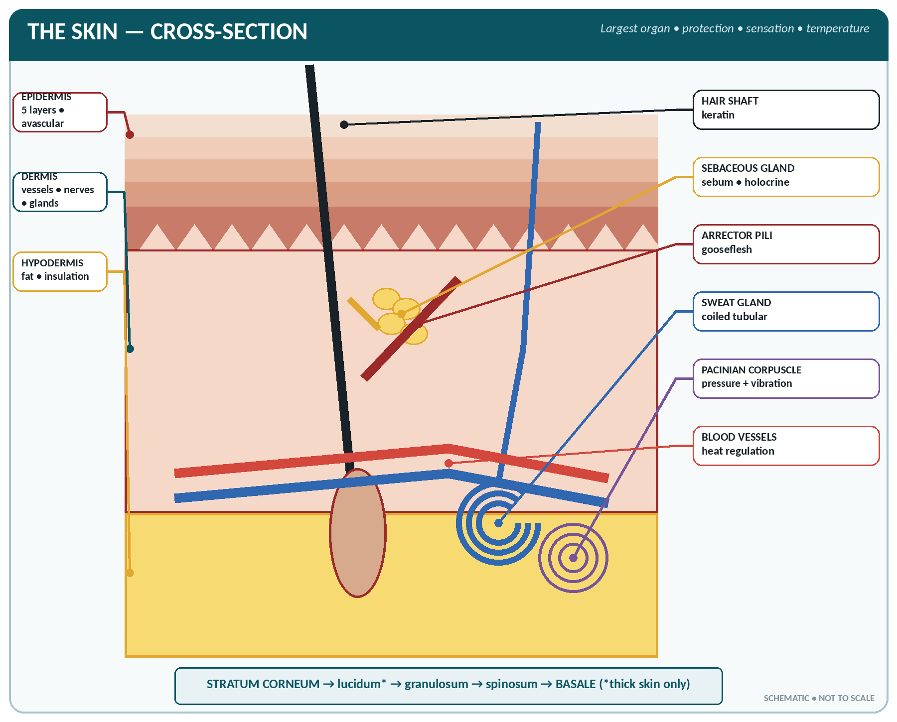
FIGURE • Cross-section of skin—epidermal layers, dermis, hypodermis, hair, glands, receptors and vessels

The skin has two main layers — the epidermis and the dermis — resting on the subcutaneous layer (hypodermis / superficial fascia).
The epidermis
▪ The outer layer: stratified squamous keratinised epithelium, avascular and without nerve endings of its own, nourished by diffusion from the dermis.
▪ Five layers, from the deepest outward:
Layers of the epidermis
Layer | Features
1. Stratum basale (germinativum) | A single layer of columnar cells on the basement membrane; the only dividing (mitotic) layer — it replaces the cells shed from the surface. Contains the melanocytes (pigment cells) and Merkel cells
2. Stratum spinosum (prickle cell layer) | Several rows of polyhedral cells with spiny processes; contains Langerhans cells (immune defence)
3. Stratum granulosum | 2–5 rows of flattened cells with granules of keratohyalin; the cells begin to die here
4. Stratum lucidum | A clear, thin, translucent layer; present only in thick (hairless) skin — palms and soles
5. Stratum corneum | 20–30 layers of dead, flat, keratin-filled cells constantly shed (desquamation); the protective waterproof barrier; thickest on palms and soles

▪ Cells take about 4 weeks to travel from the basal to the horny layer. The process of becoming keratinised is keratinisation.
▪ Melanin, the brown pigment, is made by melanocytes from the amino acid tyrosine (enzyme tyrosinase). All races have about the same number of melanocytes; colour differences depend on the amount and distribution of melanin. It is stimulated by ultraviolet light (tanning) and by MSH and ACTH. Its function is to protect against ultraviolet radiation.
▪ Other pigments contributing to skin colour: carotene (yellow) and haemoglobin (pink). Albinism is a congenital lack of melanin; vitiligo (leucoderma) is patchy loss of melanocytes.
The dermis (corium, "true skin")
▪ Dense irregular connective tissue with collagen and elastic fibres, fibroblasts, macrophages and mast cells; tough, elastic and very vascular.
▪ Two layers: a superficial papillary layer (with dermal papillae interlocking with the epidermis — these form the fingerprints/friction ridges, which are unique to every individual) and a deeper reticular layer.
▪ It contains the blood vessels, lymphatics, sensory nerve endings, hair follicles, sweat and sebaceous glands, and the arrector pili muscles.
▪ Over-stretching tears the dermis, producing striae (as in pregnancy and Cushing's syndrome); loss of elastic fibres with age causes wrinkles.
The subcutaneous layer (hypodermis)
▪ Areolar and adipose tissue; it stores fat, provides insulation and padding, anchors the skin and carries the larger vessels and nerves. It is the site of subcutaneous injection.
The Appendages of the Skin
The sweat glands
Eccrine and apocrine sweat glands
Feature | Eccrine (ordinary) sweat glands | Apocrine sweat glands
Number and site | 2–3 million, all over the body; most numerous on the palms, soles, forehead and axillae | Few — axilla, groin, areola, perineum, external auditory meatus (ceruminous)
Structure | Simple coiled tubular; the duct opens by a pore on the skin surface | Larger; the duct opens into the hair follicle
Secretion | Watery sweat | Thicker, milky, odourless at first; bacterial decomposition produces body odour
Function | Temperature regulation (thermal sweating) | Sexual/scent function; active from puberty
Nerve supply | Sympathetic, but cholinergic | Sympathetic (adrenergic)

SWEAT
▪ Amount: 500–1000 mL a day at rest in a temperate climate; up to 1–2 litres an hour (10–12 L/day) in extreme heat or hard work.
▪ Composition: water 99%, with sodium chloride (0.2–0.5%), urea, lactic acid, potassium, ammonia, and traces of uric acid, creatinine, sugar and drugs.
▪ pH 4.5–6.5 (acid — the "acid mantle" inhibits bacteria); specific gravity 1.005.
▪ Insensible perspiration (unnoticed evaporation from skin and lungs) amounts to about 500 mL from the skin and 400 mL from the lungs each day.
▪ Functions: chiefly heat loss by evaporation (each litre of sweat evaporated removes about 580 kcal); slight excretion of waste; keeps the skin supple.

The sebaceous glands
▪ Simple branched acinar glands opening into the hair follicle (except on the lips, nipple and genitalia, where they open directly onto the surface); they are holocrine — the whole cell breaks down to form the secretion.
▪ Present everywhere except the palms and soles; most numerous on the scalp, face, nose, chest and back.
▪ They secrete sebum — an oily mixture of fats, cholesterol, wax and cell debris — which:
1. Lubricates the skin and hair and keeps them soft and pliable;
2. Makes the skin water-repellent (waterproof);
3. Is mildly bactericidal and fungicidal;
4. Reduces evaporation and prevents drying and cracking.
▪ Secretion is under the control of androgens and increases at puberty; blockage of the duct produces a comedone (blackhead) and, with infection, acne vulgaris. A retention cyst is a sebaceous cyst (wen). The vernix caseosa of the newborn is largely sebum.
The hair
▪ Hairs are keratinised threads growing from a hair follicle; each has a shaft (above the surface), a root (within the follicle) and a bulb enclosing the papilla, which contains the capillaries that nourish it. Its layers are the cuticle, cortex and medulla.
▪ The arrector pili is a small smooth muscle attached to the follicle; its contraction (by the sympathetic nerves in cold or fear) makes the hair stand erect and produces "gooseflesh", trapping air for insulation.
▪ Growth is cyclical: anagen (growing, 2–6 years for scalp hair), catagen (transition) and telogen (resting); scalp hair grows about 1–1.5 cm a month and 50–100 hairs are shed daily.
▪ Colour depends on melanin; grey and white hair result from loss of pigment and air in the shaft.
▪ Hair is absent from the palms, soles, lips, glans penis and nipples. Types: lanugo (fetal), vellus (fine body hair) and terminal hair (scalp, eyebrows, and after puberty the axillary and pubic hair).
▪ Functions: protection (scalp from sun and injury; eyelashes, eyebrows and the hairs of the nose and ear from dust and insects), insulation, and touch sensation (hair follicles have nerve endings).
The nails
▪ Hard plates of keratin protecting the dorsal surface of the tips of the fingers and toes and aiding fine grasp.
▪ Parts: the nail plate (body), the free edge, the root, the nail bed below, the matrix (the growing part, at the root), the whitish lunula and the cuticle (eponychium) overlapping the root.
▪ Growth: fingernails about 0.1 mm a day (3 mm a month), taking 4–6 months to be replaced; toenails grow 3–4 times more slowly (12–18 months).
▪ Nail signs: koilonychia (spoon-shaped — iron deficiency), clubbing (chronic lung and heart disease), cyanosis (blue), pallor (anaemia), splinter haemorrhages (endocarditis), onychomycosis (fungal infection), paronychia (infection of the nail fold).
Functions of the Skin
The functions of the skin
Function | Explanation
1. Protection | A mechanical and waterproof barrier (stratum corneum); prevents entry of micro-organisms and chemicals; melanin guards against ultraviolet rays; the acid mantle and sebum are bactericidal; the subcutaneous fat cushions against injury
2. Regulation of body temperature | By sweating (evaporation), vasodilatation (increased heat loss) and vasoconstriction with piloerection (heat conservation); about 85–90% of body heat is lost through the skin
3. Sensation | It is the largest sense organ — the receptors for touch, pressure, pain, temperature and vibration
4. Excretion | Small amounts of water, salt, urea, lactic acid and some drugs in sweat and sebum
5. Synthesis of vitamin D | 7-dehydrocholesterol in the skin is converted to cholecalciferol (vitamin D₃) by ultraviolet light
6. Absorption | Limited — fat-soluble substances, steroids, some drugs (ointments, transdermal patches), and toxins such as organophosphates
7. Storage | Water, fat (subcutaneous), and blood (the skin vessels can hold a large volume)
8. Immunity | Langerhans cells present antigens; the skin is the first line of defence
9. Expression and identity | Facial expression, blushing, pallor; fingerprints for identification; secondary sex characters
10. Regulation of fluid loss | Prevents excessive loss of water and electrolytes — the reason extensive burns cause severe fluid loss and shock

The cutaneous sensory receptors
Receptor | Sensation | Site
Free nerve endings | Pain (nociceptors), itch, some touch and temperature | Throughout the epidermis and dermis
Meissner's corpuscles (tactile) | Light touch and texture | Dermal papillae, especially fingertips, lips, palm
Merkel's discs | Light touch, pressure | Basal epidermis
Pacinian corpuscles (lamellated) | Deep pressure and vibration | Deep dermis and subcutaneous tissue
Ruffini corpuscles | Continuous pressure, stretch, warmth | Dermis
Krause end-bulbs | Cold | Dermis
Hair root plexus | Movement of the hair | Around the follicle

▪ Touch is most acute on the fingertips, lips and tip of the tongue; pain receptors are the most numerous and are the only ones that do not adapt.
Wound Healing and Common Terms
▪ Stages of healing of a skin wound: haemostasis → inflammation (0–3 days) → proliferation with granulation and epithelialisation (3 days–3 weeks) → maturation/remodelling (up to 1–2 years).
▪ Healing by first intention — clean apposed edges, minimal scar; by second intention — open or infected wound, healing by granulation with a large scar; by third intention — delayed closure.
▪ Factors delaying healing: infection, poor blood supply, foreign body, movement, protein, vitamin C and zinc deficiency, anaemia, diabetes, steroids, old age, radiation.
TERMS AND DISORDERS OF THE SKIN
▪ Lesions: macule (flat coloured spot), papule (small solid elevation), nodule (larger), vesicle (small blister), bulla (large blister), pustule (pus-filled), wheal (transient oedematous swelling — urticaria), plaque, ulcer (loss of full thickness), erosion, fissure, scale, crust, scar, keloid (overgrown scar).
▪ Infections: impetigo (staphylococcal/streptococcal), boil (furuncle) and carbuncle, cellulitis, erysipelas, scabies (Sarcoptes scabiei — intense night itching, burrows in the finger web), pediculosis (lice), tinea (ringworm) — dermatophyte fungus, candidiasis, herpes simplex and zoster, warts, leprosy (hypopigmented anaesthetic patches with thickened nerves).
▪ Inflammatory: eczema/dermatitis (contact, atopic), psoriasis (silvery scaly plaques on extensor surfaces with nail pitting), urticaria, acne vulgaris, lichen planus, pemphigus.
▪ Pigmentary: vitiligo, albinism, melasma (chloasma) of pregnancy, pigmentation of Addison's disease.
▪ Tumours: basal cell carcinoma (rodent ulcer), squamous cell carcinoma, malignant melanoma (the most dangerous, arising in a mole).
▪ Burns — classified as superficial (1st degree — erythema), partial thickness (2nd degree — blisters, painful) and full thickness (3rd degree — painless, charred, needs grafting); the extent is estimated by the rule of nines (adult: head 9%, each arm 9%, each leg 18%, front of trunk 18%, back 18%, perineum 1%). The chief dangers are fluid loss and shock, then infection.
▪ Pressure (bed) sores — ischaemic necrosis over bony prominences (sacrum, heels, elbows, occiput, ischial tuberosities) from sustained pressure; prevented by two-hourly change of position, skin care, nutrition and pressure-relieving devices.

THE SKIN — RAPID REVISION
▪ Largest organ and largest sense organ — the skin; surface area 1.5–2 m²; weight about 4 kg.
▪ Epidermis is avascular, stratified squamous keratinised, with 5 layers; the only dividing layer is the stratum basale; the stratum lucidum occurs only in the palms and soles.
▪ Melanin is made by melanocytes from tyrosine and protects against ultraviolet rays.
▪ Sebaceous glands are holocrine, open into the hair follicle, secrete sebum, and are absent from the palms and soles; sweat glands are coiled tubular.
▪ Sweat is 99% water, acid (pH 4.5–6.5), and is chiefly for temperature regulation; its nerve supply is sympathetic but cholinergic.
▪ Vitamin D is formed in the skin from 7-dehydrocholesterol by sunlight.
▪ Arrector pili is smooth muscle producing gooseflesh (sympathetic).
▪ Pain receptors are free nerve endings and are the most numerous; Pacinian corpuscles sense deep pressure and vibration; Meissner's corpuscles sense light touch.
▪ Rule of nines is used for estimating the area of burns; koilonychia indicates iron deficiency.

CHAPTER 26
The Reproductive System

CHAPTER OUTLINE
The Male Reproductive System | The Female Reproductive System | The Ovarian and Menstrual Cycles | Fertilisation, Pregnancy and Lactation | Contraception — An Outline

The reproductive (genital) system is the only system that is not essential to the life of the individual — it exists for the continuation of the species. It also produces the sex hormones responsible for the secondary sex characters.
The Male Reproductive System
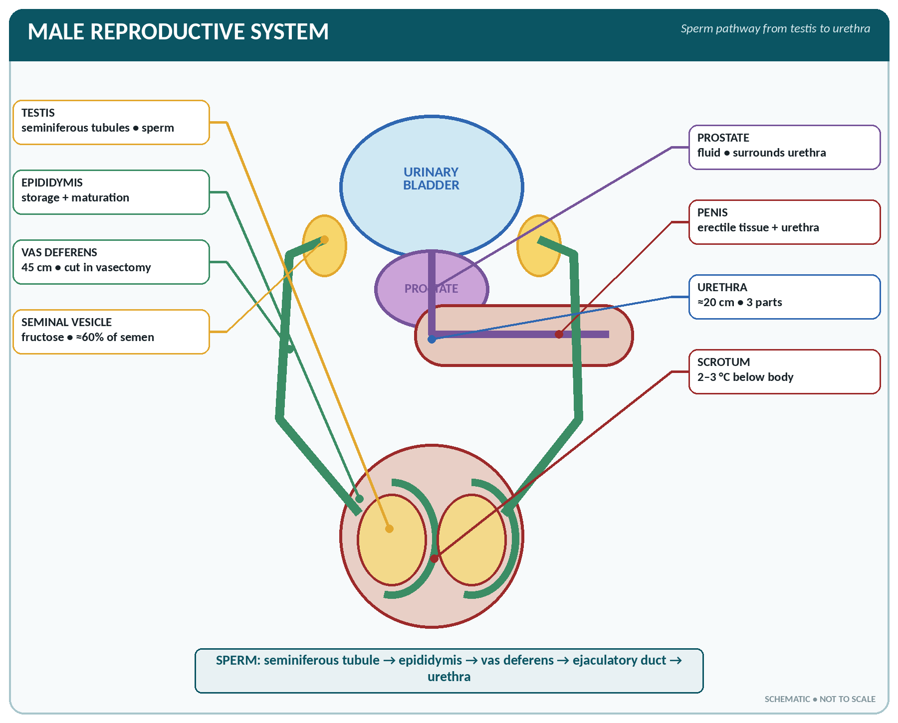
FIGURE • Male reproductive organs and the complete pathway travelled by sperm

Organs of the male reproductive system
Group | Organs
Essential organs (gonads) | Two testes
Ducts | Epididymis, vas deferens (ductus deferens), ejaculatory duct, urethra
Accessory glands | Two seminal vesicles, the prostate gland, two bulbourethral (Cowper's) glands
External genitalia | Penis and scrotum

The testes
THE TESTIS
▪ Two, oval, suspended in the scrotum by the spermatic cord; the left is usually lower.
▪ Size about 4–5 × 2.5 × 3 cm; weight 10–15 g each.
▪ Coverings: tunica vaginalis (a closed serous sac derived from peritoneum), tunica albuginea (tough fibrous capsule, whose septa divide the gland into 200–300 lobules) and tunica vasculosa.
▪ Each lobule contains 1–3 coiled seminiferous tubules; there are 400–600 tubules, each about 60–70 cm long — a total length of about 500 metres.
▪ They develop in the abdomen and descend into the scrotum through the inguinal canal in the 7th–8th month of intrauterine life. Failure of descent is cryptorchidism (undescended testis), which causes sterility and predisposes to malignancy.
▪ Blood supply: testicular artery (from the abdominal aorta); the right testicular vein drains into the inferior vena cava and the left into the left renal vein. Lymph drains to the para-aortic nodes (not the inguinal nodes).

▪ The scrotum keeps the testes at about 2–3 °C below body temperature, which is essential for spermatogenesis; the dartos muscle and cremaster adjust their position with temperature.
▪ The spermatic cord contains the vas deferens, testicular artery, pampiniform plexus of veins, lymphatics, nerves and the remains of the processus vaginalis.
The two functions of the testis
Part | Cell | Product | Control
Seminiferous tubules | Spermatogenic cells and the supporting Sertoli cells ("nurse cells" — they nourish the sperm, form the blood–testis barrier and secrete inhibin and androgen-binding protein) | Spermatozoa | FSH from the anterior pituitary
Interstitial tissue | Leydig (interstitial) cells | Testosterone | LH (ICSH) from the anterior pituitary

Spermatogenesis and the spermatozoon
▪ Spermatogenesis is the formation of spermatozoa in the seminiferous tubules. It begins at puberty and continues, with declining activity, throughout life.
▪ Sequence: spermatogonium (46) → primary spermatocyte (46) → [meiosis I] → two secondary spermatocytes (23) → [meiosis II] → four spermatids (23) → spermatozoa.
▪ One primary spermatocyte therefore yields four spermatozoa. The process takes about 64–74 days (about 2½ months), and maturation is completed in the epididymis (10–14 days).
▪ The spermatozoon is about 50–60 µm long, with a head (containing the nucleus with 23 chromosomes and, at its tip, the acrosome with enzymes for penetrating the ovum), a neck, a body (middle piece, packed with mitochondria for energy) and a tail (flagellum) for motility.
▪ Requirements for spermatogenesis: temperature below body level, FSH and testosterone, vitamins A, C and E, and adequate nutrition. It is damaged by heat, radiation, alcohol, mumps orchitis, undescended testis, varicocele and cytotoxic drugs.
The ducts and accessory glands
▪ Epididymis — a tightly coiled tube (about 6 metres long) on the posterior border of the testis, with a head, body and tail; it stores and matures the spermatozoa.
▪ Vas deferens — a firm muscular tube about 45 cm (18 inches) long, running from the tail of the epididymis through the inguinal canal into the pelvis, to end behind the bladder where it joins the duct of the seminal vesicle to form the ejaculatory duct. It is the structure divided in vasectomy.
▪ Seminal vesicles — two sacculated pouches (about 5 cm) behind the bladder; they secrete a viscid alkaline fluid rich in fructose (the energy source of sperm), prostaglandins and fibrinogen — about 60% of the volume of semen.
▪ Prostate gland — the size and shape of a chestnut, weighing about 8–20 g, surrounding the first part of the urethra just below the bladder, in front of the rectum (palpable on rectal examination). It secretes a thin, milky, slightly acid fluid containing acid phosphatase, citric acid, zinc, calcium and fibrinolysin, which forms about 20–30% of the semen and increases sperm motility. Enlargement (benign prostatic hypertrophy) obstructs urine flow in elderly men; carcinoma of the prostate raises prostate specific antigen (PSA).
▪ Bulbourethral (Cowper's) glands — two pea-sized glands secreting alkaline mucus which lubricates and neutralises acid urine in the urethra.
▪ Male urethra — about 20 cm (18–20 cm) long, with three parts: prostatic (3 cm), membranous (1–2 cm — the narrowest and least dilatable) and spongy/penile (15 cm). It carries both urine and semen.
▪ Penis — the organ of copulation; formed of three columns of erectile tissue — two corpora cavernosa and one corpus spongiosum (which contains the urethra and expands distally as the glans, covered by the prepuce). Erection is a parasympathetic (S2–S4) function (vasodilatation and engorgement of the sinuses); ejaculation is sympathetic (L1–L2).
SEMEN
▪ Volume per ejaculation: 2–5 mL (average 3 mL).
▪ Sperm count: 60–150 million/mL (normal ≥ 15–20 million/mL by current WHO criteria; a total of about 200–300 million per ejaculate).
▪ Motility: more than 50–60% actively motile; morphology: more than 30–50% normal forms.
▪ pH 7.2–8.0 (alkaline) — it neutralises the acidity of the vagina.
▪ Composition: spermatozoa (only about 5–10% of the volume) in the secretions of the seminal vesicles (60%), prostate (20–30%) and bulbourethral glands, with fructose, prostaglandins, enzymes and buffers.
▪ Sperms survive about 48–72 hours in the female genital tract (some say up to 5 days) and remain capable of fertilising for about 24–48 hours.
▪ Azoospermia = no sperm; oligospermia = reduced count; these are causes of male infertility.

Testosterone
▪ Secreted by the Leydek (interstitial) cells under the control of LH (ICSH); it is a steroid derived from cholesterol.
▪ Functions: development of the male genitalia before birth and of the secondary sex characters at puberty (deepening of the voice by enlargement of the larynx, growth of facial, axillary and pubic hair, male pattern of body build and hair line, thicker skin and sebaceous activity); spermatogenesis; protein anabolism and muscular development; closure of the epiphyses; libido and aggression.
The Female Reproductive System
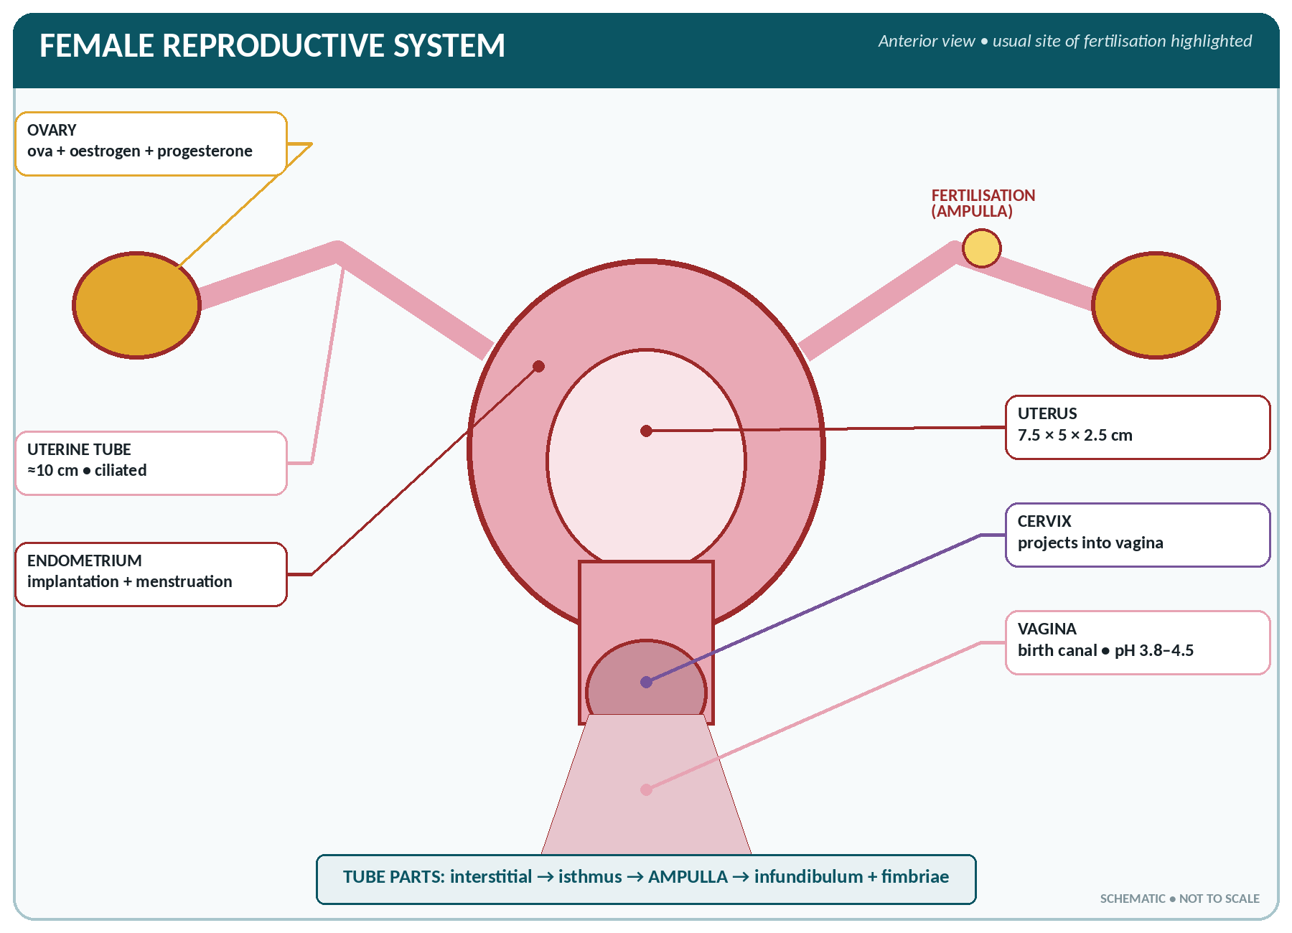
FIGURE • Female reproductive organs—ampulla of the uterine tube is the usual site of fertilisation

Organs of the female reproductive system
Group | Organs
Essential organs (gonads) | Two ovaries
Ducts / accessory organs | Two uterine (Fallopian) tubes, uterus, vagina
External genitalia (vulva) | Mons pubis, labia majora and minora, clitoris, vestibule, hymen, Bartholin's (greater vestibular) glands
Accessory gland | Mammary glands (breasts)

The ovaries
THE OVARY
▪ Two, almond-shaped, in the ovarian fossa on either side of the uterus, attached to the back of the broad ligament by the mesovarium and to the uterus by the ovarian ligament.
▪ Size about 3 × 2 × 1 cm; weight 4–8 g each.
▪ Structure: a germinal epithelium, a cortex containing the ovarian follicles in various stages, and a vascular medulla.
▪ Blood supply: ovarian artery from the abdominal aorta; the right ovarian vein drains to the IVC, the left to the left renal vein. Lymph goes to the para-aortic nodes.
▪ At birth each ovary contains about 200 000–400 000 primordial follicles (about 1–2 million in total at birth, reduced from about 7 million in fetal life); only about 400–500 ever ovulate.

▪ Functions: (1) production of ova (oogenesis); (2) secretion of oestrogen, progesterone, relaxin and inhibin.
▪ Oogenesis: oogonia multiply in fetal life; each primary oocyte begins meiosis but remains arrested until puberty. One primary oocyte forms one mature ovum and three polar bodies. The ovum is about 120–150 µm — the largest cell in the body.
▪ Ovulation — the rupture of a mature (Graafian) follicle releasing the ovum, about the 14th day of a 28-day cycle, triggered by the LH surge. The ovum survives 12–24 hours.
▪ The ruptured follicle becomes the corpus luteum, which secretes progesterone (and oestrogen) for about 10–14 days; if pregnancy does not occur it degenerates into the white corpus albicans.
The uterine (Fallopian) tubes
▪ Two tubes about 10 cm (4 inches) long in the upper free border of the broad ligament, opening into the uterus at one end and into the peritoneal cavity near the ovary at the other.
▪ Four parts: interstitial (intramural), isthmus, ampulla (the widest — the usual site of fertilisation and of ectopic pregnancy) and the infundibulum with its fimbriae.
▪ Lined with ciliated columnar epithelium; the cilia and peristalsis carry the ovum towards the uterus (a journey of 3–4 days).
▪ Functions: conveys the ovum, provides the site of fertilisation, nourishes the zygote, and carries it to the uterus. Tubal ligation is a method of permanent contraception; blocked tubes (after salpingitis) are an important cause of infertility.
The uterus
THE UTERUS
▪ A hollow, thick-walled, pear-shaped muscular organ in the pelvic cavity, between the bladder in front and the rectum behind; it is normally anteverted and anteflexed.
▪ Size in the nullipara: 7.5 × 5 × 2.5 cm (3 × 2 × 1 inch); weight 30–60 g (about 1 kg at term).
▪ Parts: fundus (above the openings of the tubes), body (corpus), isthmus, and cervix (the lower 2.5 cm, projecting into the vagina, with an internal and external os and the cervical canal).
▪ Three coats: perimetrium (peritoneum), myometrium (thick smooth muscle in three layers — the bulk of the organ) and endometrium (mucous lining, which undergoes the menstrual cycle; it has a functional layer that is shed and a basal layer that regenerates).
▪ Supports: the pelvic floor (levator ani), the transverse cervical (cardinal / Mackenrodt's) ligaments, the uterosacral, pubocervical and round ligaments, and the broad ligaments.
▪ Blood supply: uterine artery (from the internal iliac) with the ovarian artery.

▪ Functions: receives the fertilised ovum (implantation), nourishes and protects the fetus, expels it in labour by contraction of the myometrium, and menstruates.
▪ Positional abnormalities: retroversion, retroflexion; prolapse (descent through the vagina, graded 1st–3rd degree) from weak supports after childbirth.
The vagina and vulva
▪ Vagina — a muscular, very distensible canal directed upwards and backwards from the vulva to the cervix; about 7.5 cm (3 inches) along the anterior wall and 9 cm along the posterior wall (the posterior wall is longer). The recesses around the cervix are the fornices (anterior, posterior and two lateral; the posterior fornix is the deepest).
▪ Lined with stratified squamous epithelium with no glands; it is kept moist by cervical secretion. Döderlein's bacilli (lactobacilli) ferment glycogen to lactic acid, giving a protective acid pH of 3.8–4.5.
▪ Functions: the receptacle for semen, the birth canal, and the passage for menstrual flow.
▪ Vulva (external genitalia): mons pubis, labia majora and minora, the clitoris (the homologue of the penis, richly supplied with nerves), the vestibule containing the urethral and vaginal orifices, the hymen (a thin fold partly closing the vaginal orifice), and the Bartholin's glands (lubrication).
▪ Perineum — the area between the vagina and anus (about 4 cm); the perineal body is the wedge of fibromuscular tissue supporting the pelvic floor, which may be torn in childbirth (hence episiotomy).
▪ Female urethra — only 4 cm (1.5 inches) long, opening in front of the vagina; its shortness explains the frequency of urinary infection in women.
The breasts (mammary glands)
▪ Accessory glands of the female reproductive system — modified apocrine sweat glands lying on the pectoralis major from the 2nd to the 6th rib.
▪ Each contains 15–20 lobes, each with lobules of secreting alveoli draining by a lactiferous duct, which dilates as a lactiferous sinus (ampulla) before opening on the nipple. The pigmented area around the nipple is the areola, which bears the sebaceous glands of Montgomery. Fibrous suspensory ligaments of Astley Cooper support the breast.
▪ Lymph drainage — about 75% to the axillary nodes, the rest to the internal mammary (parasternal) and the opposite breast — of great importance in carcinoma of the breast.
▪ Hormonal control: oestrogen develops the ducts, progesterone the alveoli, prolactin produces milk secretion and oxytocin causes milk ejection (the let-down reflex).
▪ Colostrum is the yellowish fluid of the first 2–3 days, rich in protein, vitamin A and antibodies (IgA) and low in fat and sugar. Breast milk is the ideal food; it is rich in lactose, contains less protein than cow's milk, and provides antibodies, lactoferrin and lysozyme.
The Ovarian and Menstrual Cycles
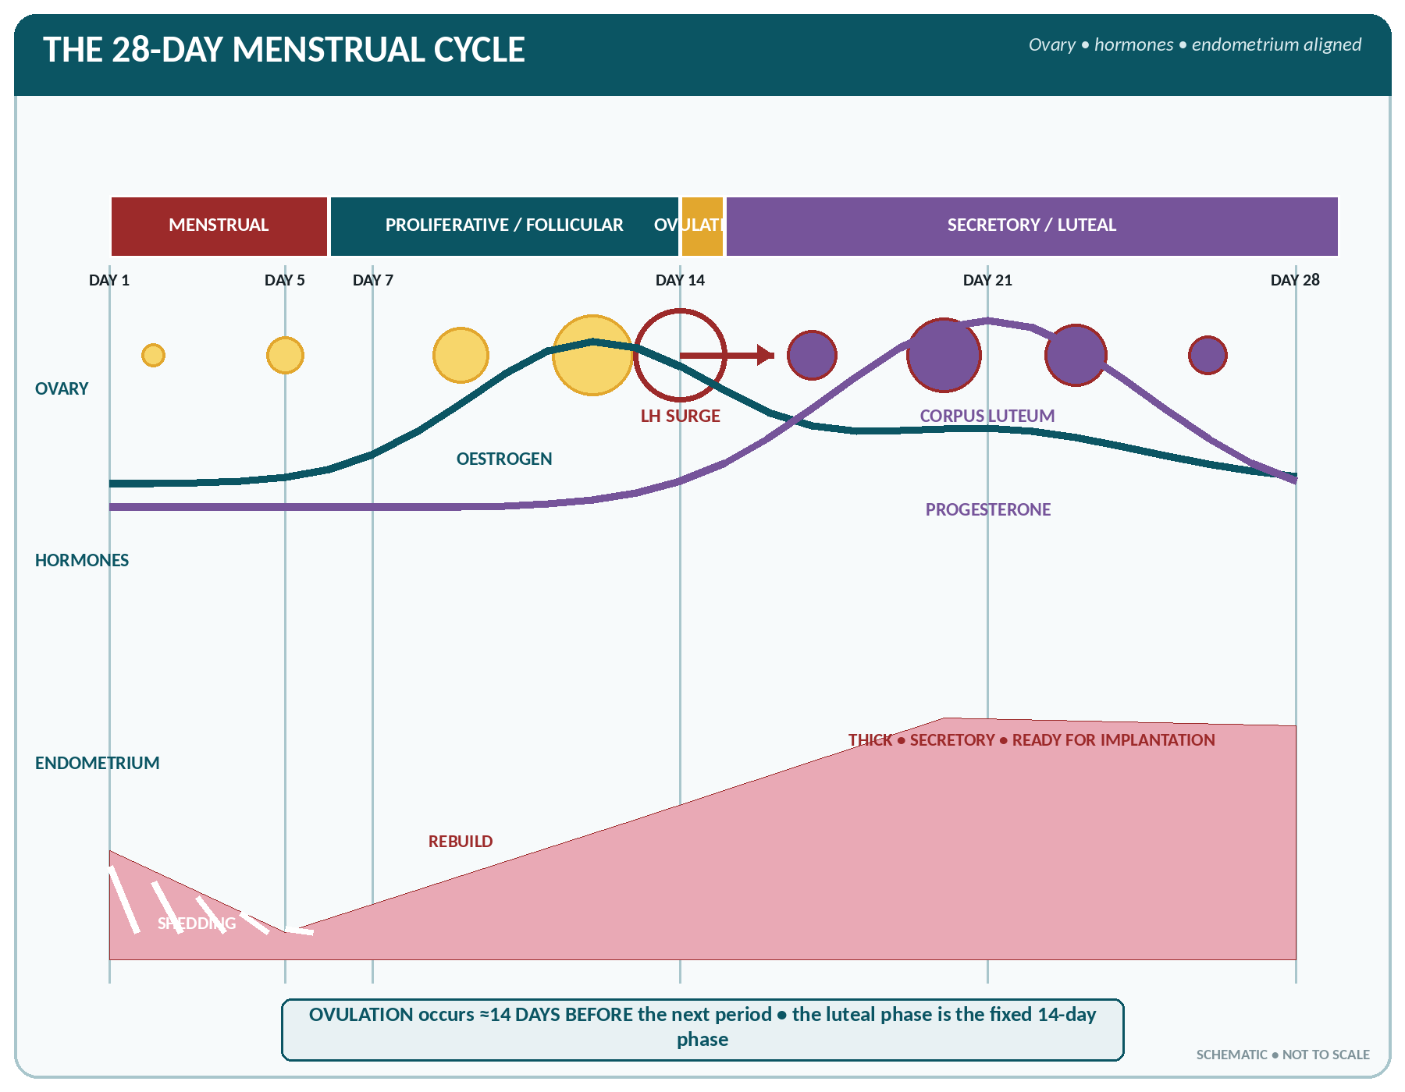
FIGURE • Ovarian events, hormone levels and endometrial changes aligned across a typical 28-day cycle

▪ Puberty in the female occurs at 10–14 years (average 12–13); the first menstrual period is the menarche. In the male, puberty occurs at 12–15 years.
▪ Menstruation is the periodic discharge of blood, mucus and the disintegrated endometrium from the uterus.
THE MENSTRUAL CYCLE
▪ Length: 28 days on average (21–35 days normal); the luteal (secretory) phase is constant at about 14 days, while the follicular phase varies.
▪ Duration of flow: 3–5 days (2–7 days).
▪ Amount of blood lost: 30–80 mL (average 50–60 mL); loss of more than 80 mL is abnormal.
▪ Ovulation occurs on about the 14th day (14 days before the next period).
▪ Menopause (cessation of menstruation) occurs at 45–55 years (average 48–50).

The phases of the menstrual cycle (28-day cycle)
Phase | Days | Ovary | Endometrium | Hormones
Menstrual phase | 1–5 | Follicles begin to develop | The functional layer breaks down and is shed with blood | Oestrogen and progesterone at their lowest
Proliferative (follicular / oestrogenic) phase | 6–13 | A Graafian follicle matures | The endometrium regenerates and thickens (to 3–4 mm); glands and vessels grow | FSH then rising oestrogen
Ovulation | 14 | Rupture of the follicle — the ovum is released | Cervical mucus becomes thin, clear and copious; body temperature dips then rises | LH surge (with an FSH peak)
Secretory (luteal / progestational) phase | 15–28 | Corpus luteum forms and secretes progesterone | The endometrium becomes thick (5–6 mm), soft, oedematous and vascular, with coiled glands secreting glycogen — ready for implantation | Progesterone (with oestrogen) from the corpus luteum

▪ If fertilisation does not occur, the corpus luteum degenerates about day 26; oestrogen and progesterone fall, the spiral arterioles constrict and the endometrium is shed — menstruation begins again.
▪ If fertilisation occurs, hCG from the developing trophoblast maintains the corpus luteum, progesterone remains high and menstruation does not occur.
The ovarian hormones
Hormone | Source | Chief actions
Oestrogen (oestradiol) | Graafian follicle, corpus luteum, placenta, adrenal cortex | Development of the female secondary sex characters (breasts, female body contour, pubic and axillary hair, growth of the uterus, tubes and vagina); proliferation of the endometrium; closure of the epiphyses; maintains bone mass (its loss causes osteoporosis); thins cervical mucus
Progesterone ("the hormone of pregnancy") | Corpus luteum, placenta | Prepares the endometrium for implantation and maintains it; relaxes uterine muscle (prevents abortion); develops the breast alveoli; raises body temperature slightly; thickens cervical mucus
Relaxin | Corpus luteum, placenta | Softens the cervix and relaxes the pelvic ligaments and symphysis pubis in late pregnancy
Inhibin | Granulosa cells | Inhibits FSH

▪ The cycle is controlled by the hypothalamus (GnRH) → anterior pituitary (FSH and LH) → ovary (oestrogen and progesterone) axis, working by negative feedback, with a positive feedback surge of LH at mid-cycle.
Terms relating to menstruation
Term | Meaning
Menarche | The first menstrual period
Menopause / climacteric | Permanent cessation of menstruation (45–55 years); with hot flushes, sweating, mood change, atrophy of the genitalia and osteoporosis
Amenorrhoea | Absence of menstruation — primary (never begun) or secondary (stopped); physiological in pregnancy, lactation and after the menopause
Dysmenorrhoea | Painful menstruation
Menorrhagia | Excessive or prolonged bleeding
Metrorrhagia | Irregular bleeding between periods
Oligomenorrhoea / polymenorrhoea | Infrequent / too frequent periods
Premenstrual syndrome | Physical and emotional symptoms in the days before a period

Fertilisation, Pregnancy and Lactation
▪ Fertilisation — the fusion of a spermatozoon with an ovum, normally in the ampulla of the uterine tube, within 12–24 hours of ovulation. The diploid number (46) is restored, and the sex of the child is determined by the sperm (X → girl, Y → boy).
▪ Sequence of development: zygote → cleavage → morula (2–3 days) → blastocyst (4–5 days) → implantation in the endometrium (about the 6th–7th day) → embryo (to 8 weeks) → fetus (9 weeks to term).
▪ The placenta is fully formed by about 12 weeks; at term it weighs about 500 g (one-sixth of the baby's weight) and is 15–20 cm across. It is the organ of respiration, nutrition and excretion for the fetus and a major endocrine gland (hCG, oestrogen, progesterone, human placental lactogen, relaxin). The umbilical cord (about 50 cm) contains two arteries and one vein in Wharton's jelly.
▪ Amniotic fluid — about 800–1000 mL at term; it protects the fetus, allows movement, maintains temperature and aids dilatation of the cervix. Excess is polyhydramnios, deficiency oligohydramnios.
PREGNANCY — NUMBERS TO REMEMBER
▪ Duration: 280 days = 40 weeks = 10 lunar months = 9 calendar months + 7 days, from the first day of the last menstrual period.
▪ Naegele's rule for the expected date of delivery: first day of the last period + 9 months + 7 days (or − 3 months + 7 days + 1 year).
▪ Trimesters: first 1–12 weeks, second 13–28 weeks, third 29–40 weeks.
▪ Fetal heart sounds are audible with a stethoscope from about 20 weeks (Doppler from 10–12 weeks); rate 120–160 beats/min.
▪ Quickening (first felt fetal movement) at 18–20 weeks in a primigravida (16–18 in a multipara).
▪ Viability from about 28 weeks (24 weeks with modern care). Term = 37–42 weeks.
▪ Normal weight gain in pregnancy 10–12 kg; average birth weight 2.5–3.5 kg.
▪ Pregnancy test detects hCG in urine, positive from about 2 weeks after conception.
▪ Stages of labour: first (onset to full dilatation of the cervix — 8–12 hours in a primipara), second (full dilatation to delivery of the baby — up to 2 hours), third (delivery of the placenta — 5–15 minutes, up to 30 minutes), and a fourth hour of observation.
▪ Lochia — the discharge after delivery: rubra (red, 1–4 days), serosa (pink-brown, 5–9 days), alba (white, 10 days–3 weeks). The uterus involutes to its normal size in about 6 weeks.

Contraception — An Outline
Methods of family planning
Group | Methods
Natural / behavioural | Abstinence, rhythm (calendar) method, basal body temperature, cervical mucus (Billings), lactational amenorrhoea, coitus interruptus
Barrier | Condom (also protects against sexually transmitted infection), diaphragm, cervical cap, spermicides
Intra-uterine devices | Copper-T 380A (10 years), Multiload, hormone-releasing IUD; act by preventing implantation
Hormonal | Combined oral pill (oestrogen + progesterone — inhibits ovulation), progestogen-only pill, injectables (DMPA), implants, emergency contraception (levonorgestrel within 72 hours)
Permanent (sterilisation) | Vasectomy (male — division of the vas deferens) and tubectomy / tubal ligation (female)

DISORDERS OF THE REPRODUCTIVE SYSTEM
▪ Male: cryptorchidism, hydrocele (fluid in the tunica vaginalis), varicocele, phimosis, epididymo-orchitis (mumps), torsion of the testis, benign prostatic hypertrophy, carcinoma of the prostate and testis, infertility.
▪ Female: pelvic inflammatory disease, fibroid (leiomyoma), endometriosis, polycystic ovary syndrome, ovarian cyst and carcinoma, carcinoma of the cervix (screened by the Pap smear; linked to human papilloma virus), carcinoma of the breast (commonest cancer in women; self-examination and mammography for early detection), uterine prolapse, infertility.
▪ Obstetric: ectopic pregnancy (commonest in the ampulla of the tube), abortion, pre-eclampsia and eclampsia (hypertension, proteinuria, oedema — convulsions in eclampsia), antepartum haemorrhage (placenta praevia, abruptio placentae), post-partum haemorrhage (commonest cause uterine atony), obstructed labour, puerperal sepsis, Rh incompatibility.
▪ Sexually transmitted infections: gonorrhoea, syphilis, chlamydia, trichomoniasis, candidiasis, herpes genitalis, HIV/AIDS, hepatitis B.

THE REPRODUCTIVE SYSTEM — RAPID REVISION
▪ Male gonad — testis (10–15 g), in the scrotum at 2–3 °C below body temperature; spermatozoa are formed in the seminiferous tubules (FSH) and testosterone in the Leydig cells (LH).
▪ Spermatogenesis takes 64–74 days; one primary spermatocyte gives 4 sperms; sperms mature in the epididymis.
▪ Semen 2–5 mL, count 60–150 million/mL, alkaline; fructose comes from the seminal vesicles; vasectomy divides the vas deferens (45 cm).
▪ Male urethra 20 cm (3 parts; membranous is narrowest); female urethra 4 cm.
▪ Female gonad — ovary (4–8 g); one primary oocyte gives 1 ovum + 3 polar bodies; ovum is the largest cell in the body.
▪ Uterus 7.5 × 5 × 2.5 cm, 30–60 g, anteverted and anteflexed; three layers — perimetrium, myometrium, endometrium.
▪ Uterine tube 10 cm; fertilisation occurs in the ampulla; implantation on about the 7th day.
▪ Menstrual cycle 28 days, flow 3–5 days, loss 30–80 mL, ovulation on day 14; the luteal phase is fixed at 14 days.
▪ Progesterone comes from the corpus luteum and is the hormone of pregnancy; hCG maintains the corpus luteum and is the basis of the pregnancy test.
▪ Pregnancy lasts 280 days (40 weeks); the placenta weighs 500 g; amniotic fluid 800–1000 mL; the cord has 2 arteries and 1 vein.
▪ Prolactin secretes milk, oxytocin ejects it; colostrum is rich in antibodies (IgA) and vitamin A.
▪ Vaginal pH is acid (3.8–4.5) owing to Döderlein's bacilli; the breast drains chiefly to the axillary lymph nodes.

