PART 0 — INSTRUMENT TRAYS
FOUNDATIONS OF INSTRUMENT TRAY PREPARATION

Complete, illustrated examination notes
General · Gynaecologic & Obstetric · Genitourinary · Thoracic
Cardiovascular · Orthopaedic · Neurologic · ENT · Ophthalmic · Paediatric

Legal (8.5 × 14 in) · 1.27 cm margins · monochrome print-ready
Every figure is an original line diagram, drawn for clarity in black and white

Table of Contents

The page numbers are live fields, shown as “—” until they are filled in. **To update them: press Ctrl+A then F9** (on a Mac, Cmd+A then Fn+F9) — or right-click any number and choose “Update Field”. Word normally offers to do this when the file opens. Once updated, each number is also a link: Ctrl+click it to jump to that tray.
Tray / Chapter | Page
FOUNDATIONS OF INSTRUMENT TRAY PREPARATION | —
0.1 Introduction, Definitions and Terminology | —
0.2 Classification of Surgical Instruments | —
0.3 Parts of an Instrument and How It Is Handled | —
0.4 Principles of Tray Preparation | —
0.5 Decontamination, Packing and Sterilisation | —
0.6 Setting the Back Table and Mayo Stand | —
0.7 The Surgical Count | —
0.8 Care, Handling and Maintenance of Instruments | —
0.9 How the Trays Relate to One Another | —

How to Read These Notes

Every tray chapter is built to the same pattern, so you can find the same kind of information in the same place each time. Read the lead paragraph and the figure first to fix the idea, then work through the contents table.
Lead paragraph | What the tray is for and the single idea that shapes it. If you remember nothing else from a chapter, remember this.
Used for / includes | The procedures the tray serves — useful for 'name three indications' questions.
Figure | An original line diagram of the tray's signature instruments — the items that identify it. Diagrams are schematic: they show the identifying feature (jaw pattern, bevel direction, footplate, curve) rather than a photographic likeness.
Callout box | The one concept, distinction or safety rule that examiners return to for that tray.
Contents of the tray | The full instrument list, grouped by function — cutting, grasping, clamping, retracting, suturing, suctioning — with quantities and the reason each item is present. Answer 'enumerate the contents' questions using these groups as headings.
Additional supplies | Position, draping, structures at risk and procedure-specific notes.
Comparison table | Where two trays or two instruments are easily confused, they are set side by side.
Examination pointers | The single most useful section for an MCQ paper: the specific, testable facts — named instruments, numbers, temperatures, sizes and the distinctions between similar items. Revise from these.
Common mistakes | Errors that lose marks, marked with ✗ — most of them are the distractors an MCQ will offer you.
A note on quantities | Instrument names, functions and groupings are standard. The numbers ("6 Allis clamps") vary between institutions — please cross-check them against your prescribed textbook.
Printing | Legal paper (8.5 × 14 in), 1.27 cm margins, monochrome throughout. No information depends on colour, so a black-and-white printer loses nothing.

PART 0

Foundations of Instrument Tray Preparation
Terminology · classification · reprocessing · set-up · counting · care

Before any individual tray can be memorised, the logic behind every tray must be clear. A tray is never a random collection of steel: it is a planned, reproducible set that guarantees the surgeon an instrument for every action the operation may demand, in a state that is sterile, functional and accounted for. Part 0 establishes that logic; Parts I–X then apply it speciality by speciality.

0.1 Introduction, Definitions and Terminology
Also called: Basic vocabulary of instrumentation
An instrument tray (also set, pack or setup) is a standardised, pre-assembled and sterilised collection of surgical instruments and accessories, listed on a count sheet, that provides everything routinely required for a defined operation or class of operations. Standardisation is what makes the theatre safe and fast: the scrub person knows exactly what is present, the sterile services department knows exactly what to reassemble, and any missing item is immediately obvious.  Used for / includes  ▪ Guarantees availability — no instrument hunting mid-case  ▪ Guarantees sterility — one validated cycle for the whole set  ▪ Guarantees accountability — a fixed count sheet makes retained items detectable  ▪ Guarantees economy — only instruments actually needed are processed  ▪ Guarantees speed — a predictable layout allows instruments to be passed without looking |  | 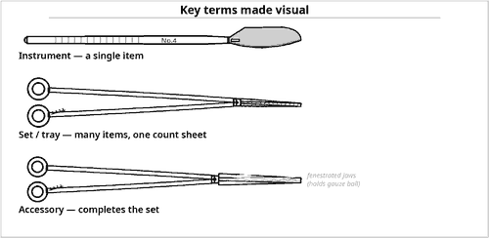  Fig 0.1 — From single instrument to complete set

Detailed notes
 | Item | Explanation
CORE VOCABULARY YOU MUST BE ABLE TO DEFINE
— | Instrument set / tray | The complete, counted, sterilised collection for a defined procedure.
— | Count sheet (tray list) | The master inventory document packed with the set; the legal record of contents.
— | Basic / standard set | The core group of instruments common to most operations of a speciality.
— | Add-on / speciality items | Instruments opened separately and added to a basic set for a particular step.
— | Back table | The large sterile table holding the bulk of the set, supplies and drapes.
— | Mayo stand | The small movable stand carrying only the instruments needed for the current step.
— | Sterile field | The area around the incision kept free of micro-organisms; includes draped tables and gowned personnel.
— | Stringer / rack | A pin or rack threading ring-handled instruments so they stay open and ordered.
— | Tip guard / protector | A latex or silicone sleeve shielding delicate or sharp tips during processing.
— | Peel pouch | A paper–plastic sealed package used for single or few small items.
— | Rigid container | A reusable perforated metal box with filters, replacing textile wrapping.
— | Event-related sterility | The modern concept that a pack stays sterile until an event (wet, torn, dropped) compromises it — not until a fixed date.

Examination pointers
▪ A tray is defined by function, not by number of pieces — the same operation may be covered by a 40-piece or a 90-piece set depending on the hospital's standardisation.
▪ The count sheet is a legal document. It travels with the set and is signed.
▪ Names are often eponymous (Kelly, Kocher, Allis) and vary regionally; always learn the descriptive name too (e.g. Kocher = toothed artery forceps).
▪ Sterile (free of all microbial life) is not the same as disinfected (free of most pathogens) or clean (free of visible soil).

0.2 Classification of Surgical Instruments
Also called: The six functional groups
Every instrument in every tray in this syllabus belongs to one of six functional groups. This single framework is the most valuable thing in the whole topic: if you can place an unfamiliar instrument into its group, you can deduce its purpose, how it is passed, how it is cleaned, and why it is in that particular tray. Examiners frequently ask you to classify rather than merely list.  Used for / includes  ▪ Group 1 — Cutting and dissecting  ▪ Group 2 — Grasping and holding  ▪ Group 3 — Clamping and occluding  ▪ Group 4 — Exposing and retracting  ▪ Group 5 — Suturing and stapling  ▪ Group 6 — Suctioning and accessory / viewing |  | 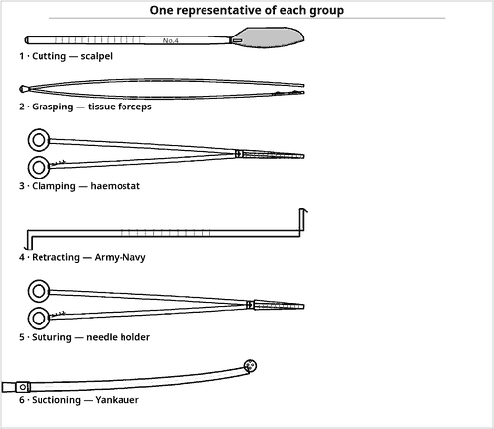  Fig 0.3 — A complete tray must satisfy all six groups
Memory hook
▪ C-G-C-E-S-S — Cut, Grasp, Clamp, Expose, Stitch, Suck.
▪ Check any tray against these six letters; a gap means the tray is incomplete.

Detailed notes
 | Item | Explanation
GROUP 1 — CUTTING AND DISSECTING
— | Scalpels (knife handle + blade) | No.3 handle takes blades 10, 11, 12, 15; No.4 handle takes 20–25; No.7 is the long fine handle.
— | Scissors | Mayo (heavy tissue/suture), Metzenbaum (delicate dissection), iris/tenotomy (fine), Potts (vascular), wire and bandage scissors.
— | Bone cutters | Osteotome, chisel, gouge, rongeur, saw, rasp, curette.
— | Others | Curettes, biopsy punches, dermatome, snares, electrosurgical pencil, laser and ultrasonic devices.
GROUP 2 — GRASPING AND HOLDING
— | Thumb (spring) forceps | Toothed = grips tough tissue; smooth/serrated = delicate tissue; Adson for skin; DeBakey atraumatic for vessels and bowel.
— | Ring-handled tissue clamps | Allis (sharp interlocking teeth, tough tissue), Babcock (fenestrated atraumatic loop, bowel/tube), Kocher (1×2 teeth, fascia), tenaculum (single sharp hook).
— | Bone and organ holders | Bone-holding forceps, Lahey (thyroid), stone forceps, lung/kidney clamps.
— | Accessory holders | Sponge-holding forceps (fenestrated jaws), towel clips, needle books.
GROUP 3 — CLAMPING AND OCCLUDING
— | Haemostats (artery forceps) | Mosquito/Halsted (finest), Crile (fully serrated, straight or curved), Kelly (serrations only over the distal half), Rochester-Péan (largest).
— | Right-angled and tonsil clamps | Mixter, Lahey and tonsil (Schnidt) for passing ligatures behind a pedicle.
— | Crushing vs non-crushing | Crushing (Kocher, Payr) on tissue to be removed; non-crushing/atraumatic (Doyen, DeBakey, bulldog, Satinsky) on tissue that must survive.
— | Vascular occluders | Bulldog, Satinsky (side-biting), aortic cross-clamps, Fogarty inserts, vessel loops.
GROUP 4 — EXPOSING AND RETRACTING
— | Hand-held retractors | Army-Navy, Richardson, Deaver, malleable/ribbon, Senn, rake, Volkmann, skin hooks — held by an assistant.
— | Self-retaining retractors | Weitlaner, mastoid, cerebellar, Balfour, Finochietto, Gelpi — hold themselves open by ratchet or rack.
— | Specula | Graves/Cusco bivalve, Sims, nasal, aural, eyelid — hold a natural orifice open.
— | Accessory exposure | Malleable ribbon, laparotomy pads, vein retractors, fibre-optic lighted retractors.
GROUP 5 — SUTURING AND STAPLING
— | Needle holders | Mayo-Hegar and Crile-Wood (ring-handled), Castroviejo (spring, microsurgery), Heaney (angled, gynaecology). Tungsten-carbide inserts give the longest life.
— | Needles and suture | Cutting/reverse-cutting for skin and fascia, taper for viscera and vessels, blunt for friable liver/kidney.
— | Staplers and clips | Linear, linear cutter (GIA), circular (EEA), skin stapler; ligating clips and appliers.
— | Accessory | Ligature carrier (Deschamps), suture boots, knot pushers.
GROUP 6 — SUCTIONING, VIEWING AND ACCESSORY
— | Suction tips | Yankauer (oral/general, bulbous fenestrated tip), Poole (perforated shield, free fluid in a cavity), Frazier (fine, angled, thumb vent — neuro/ENT/plastics).
— | Viewing / endoscopic | Sigmoidoscope, proctoscope, laparoscope, arthroscope, bronchoscope, mediastinoscope, choledochoscope, cystoscope, operating microscope.
— | Dilating and probing | Hegar and Bakes dilators, uterine sound, probes, grooved director, lacrimal probes.
— | Measuring and accessory | Rulers, calipers, kidney dish, gallipot, medicine cup, magnets, light cords, irrigation sets.

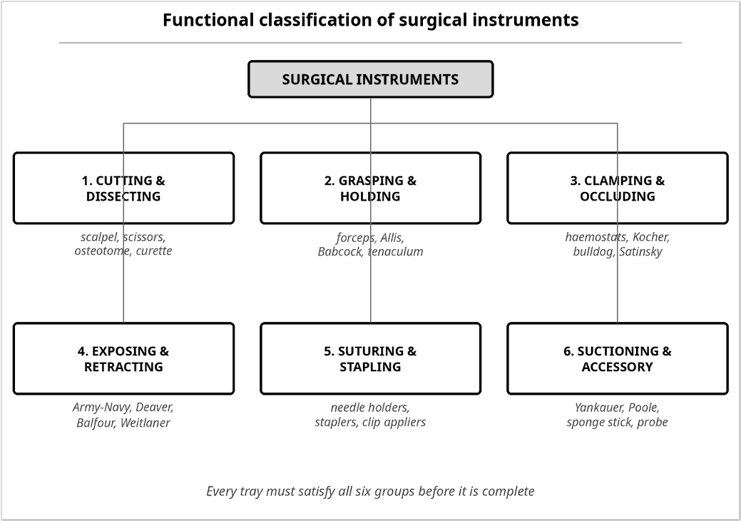
Fig 0.2 — The six functional groups with examples
Feature | Crushing clamp | Non-crushing (atraumatic) clamp
Jaw serration | Deep transverse teeth, may have 1×2 tooth | Fine longitudinal rows, or smooth
Effect on tissue | Deliberately crushes and devitalises | Preserves wall viability and blood supply
Typical examples | Kocher, Payr, Rochester-Péan | Doyen, DeBakey, bulldog, Satinsky
Applied to | Tissue that will be excised or ligated | Bowel, vessel or duct that must survive
Consequence of error | Necrosis, leak, anastomotic breakdown | Slippage and haemorrhage if too gentle

Table 0.1 — Crushing versus non-crushing clamps: the single most examined distinction in Group 3
Examination pointers
▪ Learn the six groups as your default answer skeleton for 'describe the contents of X tray'.
▪ Handle–blade pairing is a favourite one-mark question: No.3 handle → blades 10/11/12/15; No.4 handle → blades 20–25.
▪ Distinguish Crile (serrations along the whole jaw) from Kelly (serrations over the distal half only).
▪ Allis vs Babcock: Allis has sharp interlocking teeth for tough tissue; Babcock has a smooth fenestrated loop for delicate hollow structures.
▪ Suction choice follows the site: Yankauer oral/general, Poole free peritoneal fluid, Frazier fine and vented for neuro/ENT.

0.3 Parts of an Instrument and How It Is Handled
Also called: Instrument anatomy · grips · passing technique
Naming the parts of an instrument lets you describe faults precisely (a sprung box lock, a worn ratchet, misaligned tips) and is regularly asked as a labelled diagram. The ring-handled (haemostatic) pattern is the reference design from which most clamps, scissors and needle holders are derived. |  | 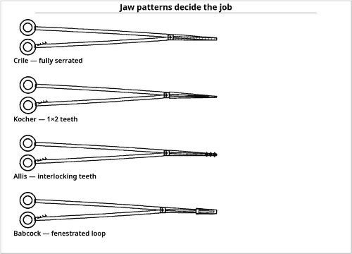  Fig 0.6 — The jaw, not the handle, defines the use
Functional tests before packing
▪ Tips must meet exactly with no light gap.
▪ Ratchet must hold on the first tooth when tapped on a hard surface.
▪ Box lock must have no side-to-side play.
▪ Scissors must cut cleanly to the very tip (test on gauze, not paper).
▪ Needle holder must grip a needle without the needle rotating.

Detailed notes
 | Item | Explanation
PARTS OF A RING-HANDLED INSTRUMENT
1 | Ring / bow (finger ring) | Takes thumb and ring finger; size must suit the operator's hand.
2 | Ratchet (lock) | Interlocking teeth on the shanks that hold the jaws closed at graded tension. Usually 3–4 teeth.
3 | Shank | The arm between ring and joint. Its length determines the working depth of the instrument.
4 | Box lock (joint) | The hinge. A box lock (one shank passing through the other) is stronger than a screw or pin joint and is the commonest wear point.
5 | Jaw / blade | The working end. Serration pattern, curvature, teeth and fenestration define the instrument's identity.
6 | Tip | The extreme end; must be in perfect apposition. Tip alignment is the key functional test.
STANDARD GRIPS
— | Pencil grip | Scalpel with No.15/No.11 blade, fine dissection, electrosurgical pencil. Maximum control, short cuts.
— | Palmar (table-knife) grip | Scalpel with No.20/No.10 blade for long skin incisions; power and a single smooth stroke.
— | Tripod / ring grip | Thumb and ring finger in the bows, index finger along the shank to steady; used for all ring-handled instruments.
— | Thumb-forceps grip | Held like a pen between thumb and index; the non-dominant hand's default instrument.
PASSING INSTRUMENTS (THE SCRUB PERSON'S CRAFT)
— | Pass decisively | A firm slap into the palm tells the surgeon the instrument has arrived without them looking away from the field.
— | Pass ready to use | Curved jaws point in the direction of use; the handle meets the palm; the surgeon should not have to reorient it.
— | Pass sharps safely | Use a neutral / hands-free zone (magnetic pad or kidney dish) for blades and needles — never hand to hand.
— | Anticipate | Watch the field, not the tray; the next instrument should already be in your hand.
— | Keep it clean | Wipe blood from jaws with a damp sponge as soon as an instrument returns; dried blood is the hardest soil to remove.

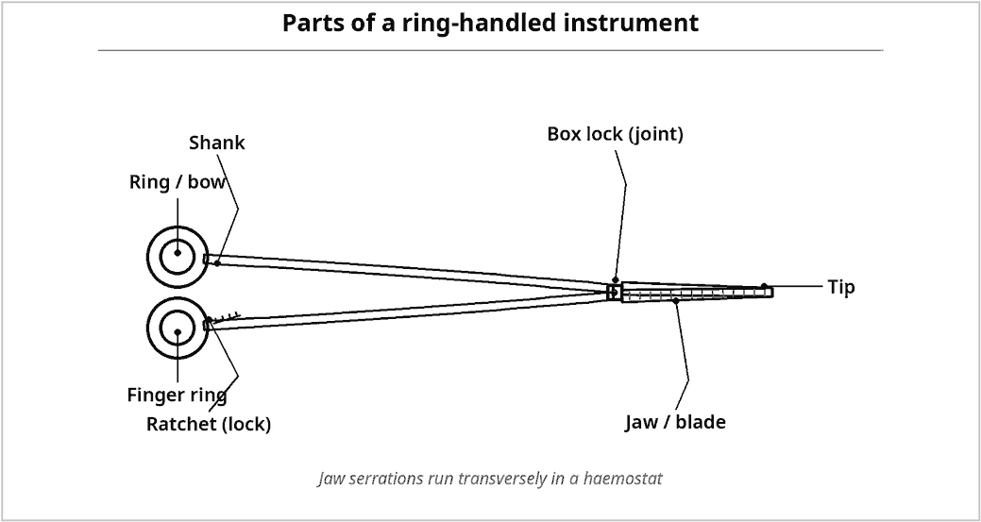
Fig 0.4 — Named parts of a ring-handled instrument
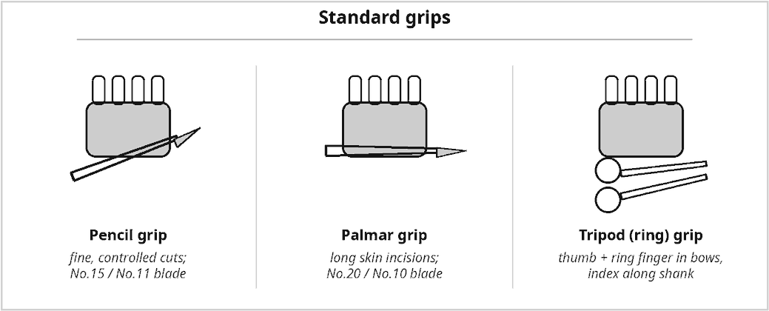
Fig 0.5 — The three standard grips
Examination pointers
▪ The box lock is the commonest site of wear and of retained soil — it must be cleaned open and lubricated.
▪ A ratchet that springs open when tapped is condemned, not repaired at ward level.
▪ Instruments are sterilised with jaws open (unlocked) — a locked ratchet prevents steam reaching the joint surfaces.
▪ Curved instruments are passed with the curve pointing the way the surgeon will work.

0.4 Principles of Tray Preparation
Also called: Rules that govern the assembly of every set
Tray preparation is governed by a small number of principles that apply equally to a 6-item limited tray and a 120-item cardiac set. Answer any 'principles of tray preparation' question with this list, then illustrate it with the specific tray you have been asked about. |  | 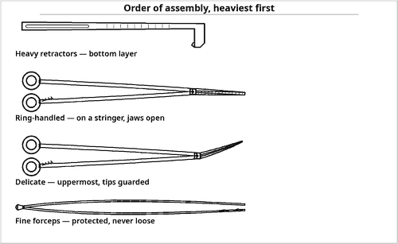  Fig 0.8 — Assemble downward in weight, upward in delicacy
Reject an item at inspection if…
▪ Tips do not meet, or overlap
▪ Ratchet springs open on tapping
▪ Box lock is loose or gritty
▪ Scissors chew instead of cutting
▪ Any crack, pit, rust, chip or burr
▪ Illegible or missing identification

Detailed notes
 | Item | Explanation
A · SELECTION PRINCIPLES
1 | Match the tray to the procedure | Include what is routinely needed. Rarely used items are kept as separate add-on packs, not carried in every set.
2 | Satisfy all six functional groups | Cut, grasp, clamp, expose, stitch, suck — a gap in any group makes the tray unusable.
3 | Match length to depth | The deeper the cavity, the longer the instrument; hence a dedicated long instruments tray for obese or deep pelvic work.
4 | Match delicacy to tissue | Atraumatic instruments for bowel, vessel and duct; heavy toothed instruments only on tissue to be discarded.
5 | Standardise and document | One agreed count sheet per tray, reviewed periodically with the surgical team; no informal substitutions.
B · ASSEMBLY PRINCIPLES
6 | Clean and dry before assembly | No item enters a tray until it is decontaminated, inspected, functional and dry.
7 | Heaviest at the bottom | Retractors and bone instruments form the base; delicate items rest on top, never underneath.
8 | Jaws open, ratchets unlocked | Thread ring-handled instruments on a stringer/rack in the open position, in a fixed order.
9 | Protect the vulnerable | Tip guards on microsurgical, ophthalmic and vascular tips; delicate items in a foam-lined inner tray.
10 | Allow steam to reach every surface | Perforated base; concave items on edge or inverted; disassemble multi-part instruments; open all stopcocks.
11 | Respect the mass limit | A wrapped instrument set should not exceed about 11 kg (25 lb) — heavier sets trap condensate and come out wet.
12 | Indicators inside and outside | A chemical indicator inside the pack and indicator tape outside; include the count sheet.
C · DOCUMENTATION AND TRACEABILITY
13 | Label every pack | Set name, contents/count sheet, date processed, sterilizer and cycle/load number, operator initials.
14 | Enable recall | The load number lets every pack from a failed cycle be traced and retrieved.
15 | Event-related sterility | Integrity, not a calendar date, determines usability: wet, torn, dropped or compressed = discard and reprocess.

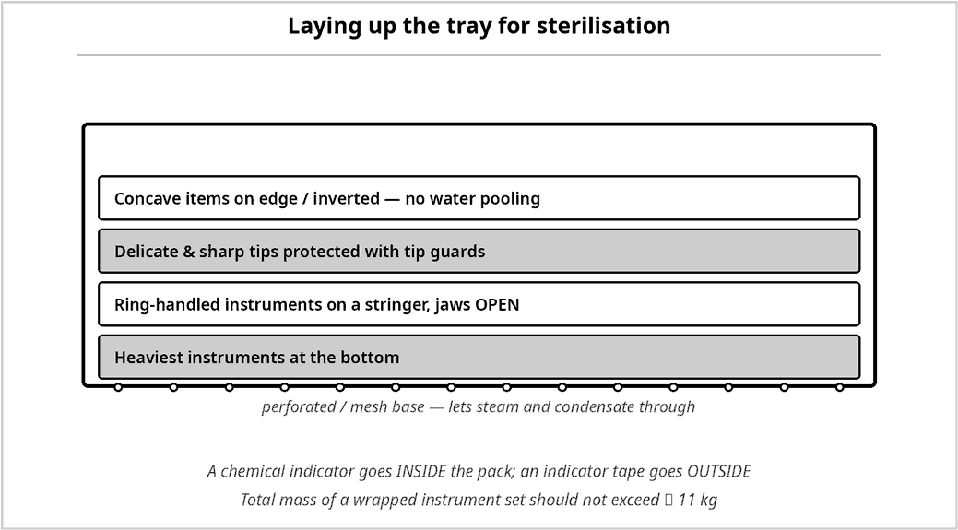
Fig 0.7 — Correct layering of instruments in the tray
Examination pointers
▪ The commonest exam framing is 'principles' — give selection, assembly and documentation as three headings.
▪ The 11 kg mass limit and the jaws-open rule are favourite factual marks.
▪ Include the count sheet inside the pack; it is both an inventory and a legal record.
▪ 'Event-related' has replaced 'time-related' shelf life in modern practice — say so explicitly.

0.5 Decontamination, Packing and Sterilisation
Also called: The instrument reprocessing cycle
A tray is only as good as the cycle that produced it. The reprocessing chain runs point of use → transport → decontamination → inspection → assembly → packaging → sterilisation → storage, and it must move in one direction, from dirty to clean, without crossing back.
Wet pack = contaminated
▪ Any moisture inside or outside a processed pack makes it unusable.
▪ Common causes: overloaded tray, exceeding 11 kg, poor drying time, cold surfaces, instruments packed wet.

Detailed notes
 | Item | Explanation
CLEANING — THE NON-NEGOTIABLE FIRST STEP
— | Point-of-use care | Wipe visible blood; keep instruments moist with water or an enzymatic gel/foam; never let blood dry.
— | Why cool water first | Hot water coagulates protein onto the surface and makes soil far harder to remove.
— | Enzymatic / proteolytic soak | Breaks down blood, fat and tissue in box locks, serrations and lumens.
— | Manual cleaning | Soft brushes, jaws open, below the water surface to avoid aerosols; lumen brushes for cannulated items.
— | Ultrasonic cleaner | Cavitation reaches serrations and box locks; not for chrome-plated, cemented optical or dissimilar metals together.
— | Washer-disinfector | Automated wash → thermal disinfection → dry; thermal disinfection is measured as an A0 value.
— | Final rinse and dry | Demineralised/distilled water prevents staining and pitting; items must be completely dry before packing.
— | Lubricate | Water-soluble, steam-permeable instrument milk on box locks and hinges. Never use oil — it blocks steam.
PACKAGING SYSTEMS
— | Textile / non-woven wrap | Sequential double wrap (envelope or square fold) — allows aseptic opening.
— | Peel pouch | Paper–plastic; for one or a few light items; place paper-to-plastic when stacking.
— | Rigid container | Perforated metal box with valve filters and a tamper seal; protects heavy sets.
— | Indicators | Class I tape outside; Class IV–VI chemical indicator or integrator inside the pack; biological indicator (Geobacillus stearothermophilus for steam) per policy.
STERILISATION METHODS
— | Steam (moist heat) — the default | 121 °C for 15 min at 15 psi (gravity) or 134 °C for 3–3.5 min (pre-vacuum). Cheap, fast, non-toxic; for all heat- and moisture-stable items.
— | Flash / immediate-use steam (IUSS) | 134 °C for 3–10 min for an urgently needed unwrapped item. Emergency use only; never for implants.
— | Ethylene oxide (EO) | Low temperature, excellent penetration; for optics, plastics, cables. Long aeration required; toxic, flammable, carcinogenic.
— | Hydrogen peroxide gas plasma | Low temperature, short cycle, no toxic residue; not for cellulose (linen, paper) or long narrow lumens.
— | Dry heat | 160 °C/2 h or 170 °C/1 h; for oils, powders, glass and sharp cutting edges.
— | Chemical (cold) sterilant | 2 % glutaraldehyde or peracetic acid for heat-sensitive endoscopes; requires sterile-water rinse.

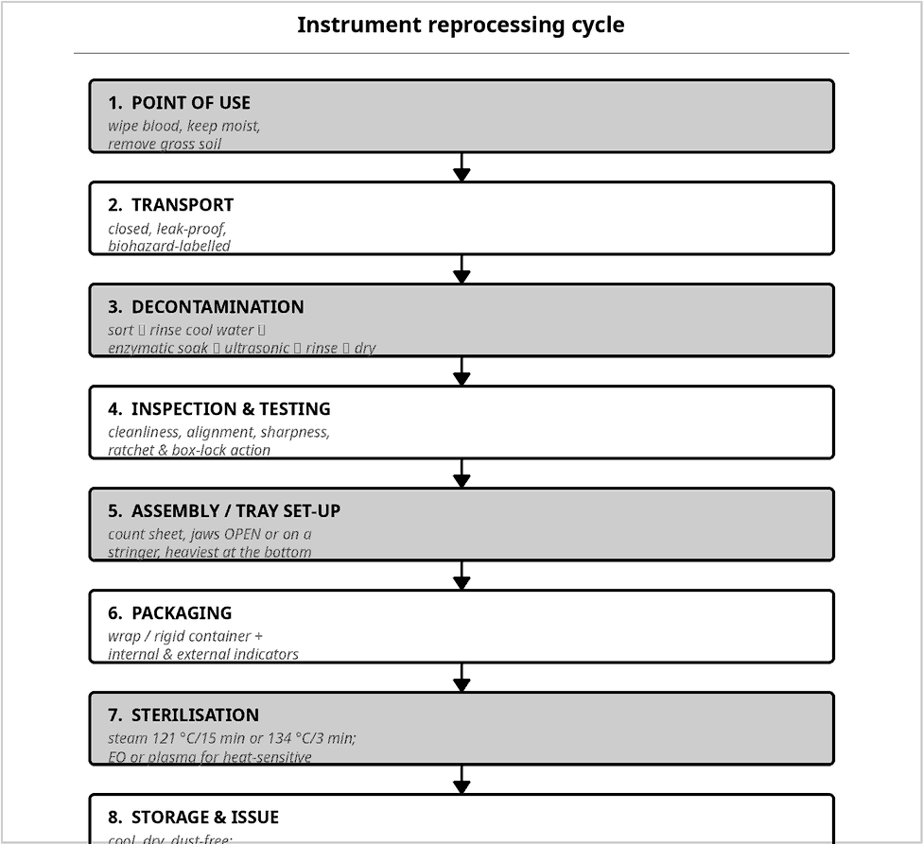
Fig 0.9 — The reprocessing cycle, step by step
Method | Conditions | Best for | Main limitation
Steam — gravity | 121 °C, 15 psi, 15–30 min | Instruments, linen, basins | Heat/moisture sensitive items
Steam — pre-vacuum | 134 °C, 3–3.5 min | Wrapped instrument sets | Requires air removal test (Bowie-Dick)
Ethylene oxide | 37–55 °C, 2–5 h + aeration | Optics, plastics, cables | Toxic; very long total cycle
H₂O₂ gas plasma | 45–50 °C, 28–75 min | Delicate scopes, cameras | No cellulose; lumen limits
Dry heat | 160 °C/2 h or 170 °C/1 h | Oils, powders, glass, sharps | Slow; damages fabrics
Chemical sterilant | 2 % glutaraldehyde, 10 h | Flexible endoscopes | Toxic; needs sterile rinse

Table 0.2 — Sterilisation methods compared
Examination pointers
▪ Cleaning precedes sterilisation — an unclean instrument cannot be sterilised, because soil shields organisms.
▪ Always state cool water first; hot water fixes protein.
▪ Learn the two steam pairs verbatim: 121 °C/15 min and 134 °C/3 min.
▪ The biological indicator for steam is Geobacillus stearothermophilus; for EO and dry heat it is Bacillus atrophaeus.
▪ Bowie-Dick test = air removal in a pre-vacuum steriliser, run daily.

0.6 Setting the Back Table and Mayo Stand
Also called: Sterile field organisation
Two surfaces carry the tray in theatre. The back table holds the bulk of the set and supplies; the Mayo stand is the immediate working surface and carries only what the current step requires. Organisation is deliberate and identical every time, so instruments can be found by feel.
Sequence of setting up
▪ Scrub, gown and glove.
▪ Drape the back table and Mayo stand.
▪ Arrange in zones; assemble blades on handles using a needle holder.
▪ Load needles onto holders; prepare suture.
▪ Perform the first count with the circulating nurse.
▪ Drape the patient; bring the Mayo stand into position last.

Detailed notes
 | Item | Explanation
BACK TABLE — RULES OF ARRANGEMENT
— | Zone by function | Sharps and suture · instruments · sponges and dressings · basins, drapes and gowns.
— | Group and align | Instruments grouped by functional class with all tips pointing the same way.
— | Segregate sharps | Blades and needles in a magnetic pad, needle book or counter — never loose among instruments or sponges.
— | Heaviest and least used furthest away | Basins, extra drapes and gowns at the far end.
— | Only the top surface is sterile | A draped table is sterile at table-top level only; anything below the edge is unsterile.
— | Never reach across | Approach the table from your own side; do not lean over the sterile field.
MAYO STAND — RULES OF USE
— | Carry only what is needed now | Knife, scissors, forceps, haemostats, needle holder and suture for the current step.
— | Fixed quadrants | Keep the same layout for every case so instruments can be picked without looking.
— | Position after draping | Never place the stand over the patient until draping is complete.
— | Replenish continuously | Return used instruments to the back table, wiped clean, and refresh the stand for the next step.
GENERAL STERILE-FIELD DISCIPLINE
— | Sterile to sterile only | Sterile items and personnel contact only sterile items.
— | Keep within view | An unobserved sterile field is considered contaminated.
— | Gown sterile zone | Front from chest to sterile-field level, and sleeves from 5 cm above the elbow to the cuff.
— | Hands in sight | Keep hands above waist and in front; never below the table edge or under the arms.
— | Moisture transmits contamination | Strike-through of a wet drape contaminates the field.
— | Open packs away from you | The far flap first, near flap last; the 2.5 cm pack margin is unsterile.

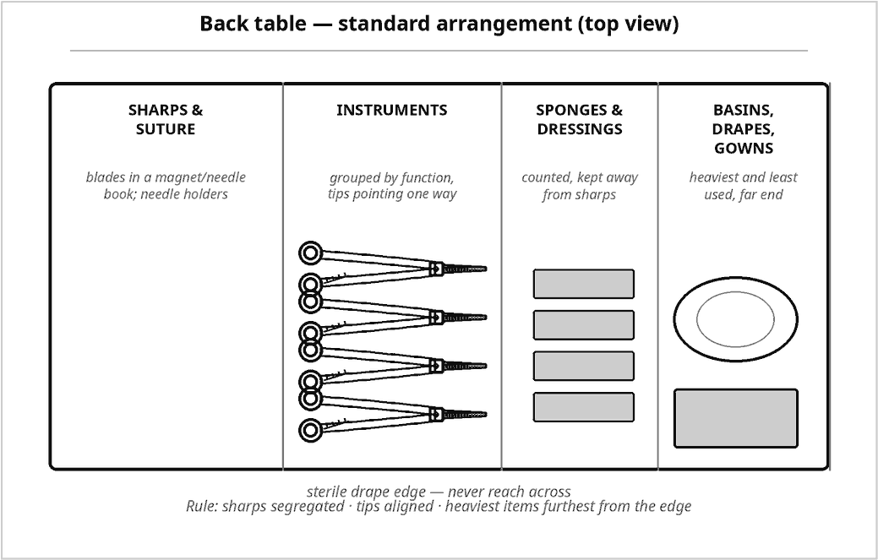
Fig 0.10 — Back table: standard zoned arrangement
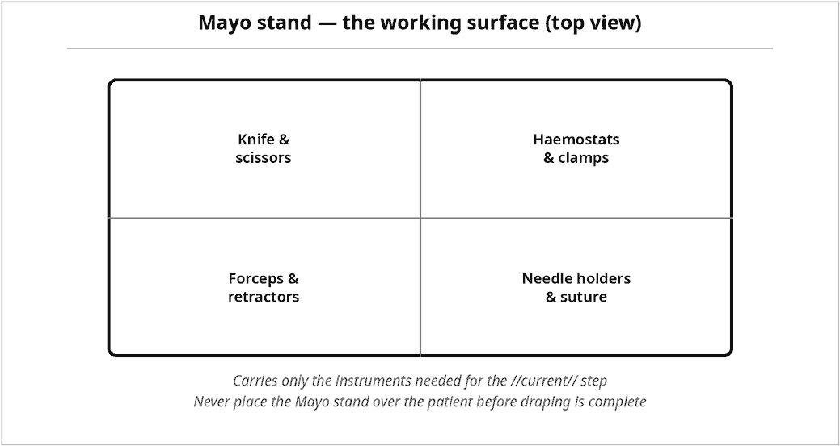
Fig 0.11 — Mayo stand: the working surface
Examination pointers
▪ Only the table top is sterile — a very common one-liner.
▪ Blades are mounted and removed with a needle holder, never fingers.
▪ The first count occurs before the skin incision.
▪ The Mayo stand comes over the patient after draping is complete.

0.7 The Surgical Count
Also called: Sponge, sharp and instrument count
The count is the systematic, audible, concurrent tally of every countable item, performed by the scrub and circulating nurse together, and recorded. Its purpose is to prevent a retained surgical item — a sentinel event.
High-risk situations
▪ Emergency and unplanned surgery
▪ Change of operative plan mid-case
▪ High BMI / deep cavity
▪ Multiple surgical teams or cavities
▪ Change of nursing staff during the case
▪ Large blood loss and rapid packing

Detailed notes
 | Item | Explanation
WHAT IS COUNTED
— | Sponges and gauze | Raytex, laparotomy pads, peanuts — all radio-opaque; counted in standard bundles of 5 or 10.
— | Sharps | Blades, suture needles, hypodermic needles, electrosurgical tips, safety pins.
— | Instruments | Every item on the count sheet, including detachable parts (blades, screws, inner tubes).
— | Miscellaneous | Umbilical and cotton tapes, vessel loops, clip cartridges, bulldogs, trocar seals, catheter guidewires.
WHEN TO COUNT
1 | Before the incision | Baseline count — establishes the reference figure.
2 | Before closure of a cavity | e.g. before the peritoneum is closed.
3 | Before closure of the wound | At the fascial / muscle layer.
4 | At skin closure | Final reconciliation and documentation.
+ | Additional counts | On any change of scrub or circulating nurse, whenever items are added, and whenever there is any doubt.
HOW TO COUNT
— | Audibly and concurrently | Both nurses see and count each item at the same time.
— | In a set sequence | Field → Mayo stand → back table → off-field receptacles; always the same order.
— | Separate and display | Sponges separated and spread; needles counted on a magnetic pad or in a needle box.
— | Record immediately | Documented on the count sheet/board as each count is completed.
— | Never remove counted items | No counted sponge or sharp leaves the theatre until the case ends.
IF THE COUNT DOES NOT RECONCILE
1 | Inform the surgeon at once | Closure pauses.
2 | Recount | Repeat the full count in sequence.
3 | Search systematically | Wound, drapes, floor, kick buckets, laundry, waste, under the table and equipment.
4 | Radiograph | Intra-operative X-ray of the surgical site if still unaccounted for.
5 | Document and report | Record the discrepancy, the actions taken and the outcome; complete an incident report.

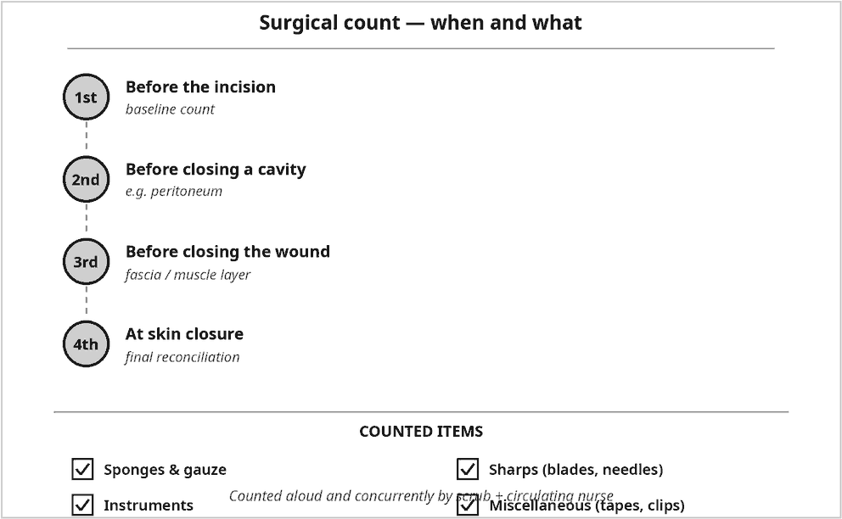
Fig 0.12 — When to count and what to count
Examination pointers
▪ The count is concurrent and audible — never performed by one person alone.
▪ Four count points are the standard answer: before incision, before cavity closure, before wound closure, at skin closure.
▪ All sponges used in theatre must be radio-opaque; plain gauze is never used inside a cavity.
▪ An incorrect count is a surgical emergency of documentation — inform, recount, search, X-ray, document.

0.8 Care, Handling and Maintenance of Instruments
Also called: Prolonging instrument life
Instruments are the most expensive reusable asset in theatre. Most damage is avoidable and arises from four causes: dried blood, wrong-use force, incompatible chemicals and careless handling. |  | 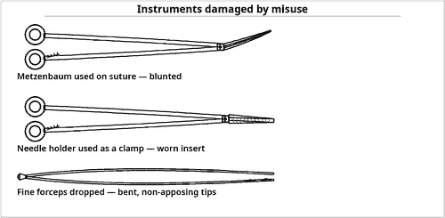  Fig 0.13 — Typical avoidable damage
Passivation
▪ Surgical stainless steel resists corrosion because of a thin chromium-oxide passive layer.
▪ Saline, dried blood, abrasives and harsh chemicals breach it — after which corrosion is progressive and irreversible.

Detailed notes
 | Item | Explanation
RULES OF CARE
1 | Use each instrument only for its purpose | Tissue scissors never cut suture; needle holders never clamp vessels; haemostats never used as towel clips.
2 | Keep blood moist, remove it early | Wipe with a damp sponge during the case; dried blood is corrosive and hard to remove.
3 | Rinse in cool water | Hot water coagulates protein onto the surface.
4 | Handle delicate items individually | Microsurgical, ophthalmic and vascular instruments are never piled loose; use tip guards and racks.
5 | Avoid saline and harsh chemicals | Sodium chloride causes pitting; bleach, iodine and strong acids/alkalis destroy passivation.
6 | Lubricate the joints | Water-soluble, steam-permeable instrument milk after each cleaning cycle.
7 | Do not mix metals | Stainless with chrome-plated or aluminium in an ultrasonic bath causes electrolytic damage.
8 | Inspect every cycle | Cleanliness, alignment, sharpness, ratchet, box lock, cracks, corrosion.
9 | Repair or retire promptly | Tag and remove faulty items; never return them to circulation.
10 | Store protected | Cool, dry, dust-free, closed cupboards; do not stack heavy sets on delicate ones.
RECOGNISING AND DEALING WITH SURFACE PROBLEMS
— | Water spots | White film from hard water — use demineralised water for the final rinse.
— | Brown/orange stain | Usually not rust but a deposit from detergent or water; test with a pencil eraser — if it wipes off, it is a stain.
— | True rust and pitting | Breach of the passive chromium-oxide layer, commonly from saline or dried blood; item is condemned.
— | Black stain | Acidic exposure or dissimilar metal contact.
— | Bluish-grey stain | Excess cold sterilant or over-lubrication.

Examination pointers
▪ Never use tissue scissors to cut suture — the single most quoted misuse.
▪ Saline is the enemy of stainless steel; blot and rinse immediately after any saline contact.
▪ Distinguish stain (wipes off) from rust/pitting (does not — condemn the item).
▪ Lubricants must be water-soluble and steam-permeable; mineral oil prevents sterilisation.

0.9 How the Trays Relate to One Another
Also called: The tray ladder and the add-on principle
The fifty trays in this syllabus are not fifty unrelated lists. Almost every speciality tray is a basic tray plus speciality add-ons. Learning the three general-surgery reference trays first — limited, basic/minor and major — reduces the remaining work enormously, because you then only have to remember what is added.
Exam strategy
▪ For any tray asked, answer in three moves:
▪ 1. Name the reference tray it is built on.
▪ 2. List contents under the six functional groups.
▪ 3. Name the speciality add-ons that make it that particular tray.
▪ This structure earns marks even where your recall of individual items is incomplete.

Detailed notes
 | Item | Explanation
THE THREE REFERENCE TRAYS
— | Limited procedures tray | The smallest set: superficial, brief procedures — skin lesion excision, biopsy, simple suturing.
— | Basic / minor procedures tray | The general-purpose small set on which most other trays are built.
— | Major procedures tray | Full laparotomy capability: deep retraction, long instruments, complete clamping range.
HOW SPECIALITY TRAYS ARE BUILT
— | Basic + length | Long instruments tray — the major tray in longer patterns for deep or obese fields.
— | Basic + regional exposure | Thyroid tray adds Lahey clamps and small right-angled retractors; rectal tray adds anal retractors and specula.
— | Basic + organ-specific instruments | Biliary tray adds gallbladder forceps, Bakes dilators and cholangiography accessories.
— | Basic + endoscopic system | Laparoscopy, sigmoidoscopy, choledochoscopy, arthroscopy, mediastinoscopy trays add a scope, light source and camera to a small open set kept for conversion.
— | Basic + power and implants | Orthopaedic and cardiac trays add powered instruments, implant-specific sets and trial components.
— | Scaled down | Paediatric trays are the adult trays in shorter, finer, lighter patterns with smaller quantities.

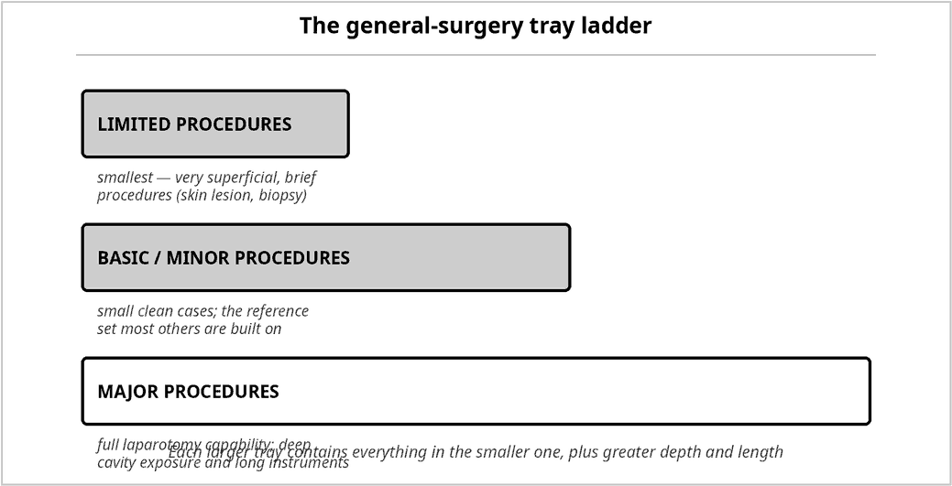
Fig 0.14 — The general-surgery tray ladder
Reference tray | Depth of field | Typical contents scale | Built upon by
Limited | Skin and subcutaneous only | ≈ 15–25 items | Minor ENT, ophthalmic, vasectomy, myringotomy
Basic / minor | Superficial cavity, small clean cases | ≈ 40–60 items | Thyroid, rectal, D&C, basic ortho, laparoscopy
Major | Deep body cavity — abdomen, chest | ≈ 80–120 items | Biliary, GI, hysterectomy, kidney, thoracotomy, cardiac

Table 0.3 — Choose the reference tray, then add the speciality items
Examination pointers
▪ Learn limited → basic → major thoroughly; the other forty-seven trays are variations.
▪ For every speciality tray, be able to state its signature instrument (the item that identifies it).
▪ Endoscopic trays always retain a small open set for conversion — a frequently forgotten mark.

