PART I — INSTRUMENT TRAYS
GENERAL SURGERY TRAYS

Complete, illustrated examination notes
General · Gynaecologic & Obstetric · Genitourinary · Thoracic
Cardiovascular · Orthopaedic · Neurologic · ENT · Ophthalmic · Paediatric

Legal (8.5 × 14 in) · 1.27 cm margins · monochrome print-ready
Every figure is an original line diagram, drawn for clarity in black and white

Table of Contents

The page numbers are live fields, shown as “—” until they are filled in. **To update them: press Ctrl+A then F9** (on a Mac, Cmd+A then Fn+F9) — or right-click any number and choose “Update Field”. Word normally offers to do this when the file opens. Once updated, each number is also a link: Ctrl+click it to jump to that tray.
Tray / Chapter | Page
GENERAL SURGERY TRAYS | —
1.1 Major Procedures Tray | —
1.2 Basic / Minor Procedures Tray | —
1.3 Limited Procedures Tray | —
1.4 Thyroid Tray | —
1.5 Long Instruments Tray | —
1.6 Biliary Tract Procedures Tray | —
1.7 Choledochoscopy Tray | —
1.8 Basic Rigid Sigmoidoscopy Tray | —
1.9 Gastrointestinal Procedures Tray | —
1.10 Rectal Procedures Tray | —

How to Read These Notes

Every tray chapter is built to the same pattern, so you can find the same kind of information in the same place each time. Read the lead paragraph and the figure first to fix the idea, then work through the contents table.
Lead paragraph | What the tray is for and the single idea that shapes it. If you remember nothing else from a chapter, remember this.
Used for / includes | The procedures the tray serves — useful for 'name three indications' questions.
Figure | An original line diagram of the tray's signature instruments — the items that identify it. Diagrams are schematic: they show the identifying feature (jaw pattern, bevel direction, footplate, curve) rather than a photographic likeness.
Callout box | The one concept, distinction or safety rule that examiners return to for that tray.
Contents of the tray | The full instrument list, grouped by function — cutting, grasping, clamping, retracting, suturing, suctioning — with quantities and the reason each item is present. Answer 'enumerate the contents' questions using these groups as headings.
Additional supplies | Position, draping, structures at risk and procedure-specific notes.
Comparison table | Where two trays or two instruments are easily confused, they are set side by side.
Examination pointers | The single most useful section for an MCQ paper: the specific, testable facts — named instruments, numbers, temperatures, sizes and the distinctions between similar items. Revise from these.
Common mistakes | Errors that lose marks, marked with ✗ — most of them are the distractors an MCQ will offer you.
A note on quantities | Instrument names, functions and groupings are standard. The numbers ("6 Allis clamps") vary between institutions — please cross-check them against your prescribed textbook.
Printing | Legal paper (8.5 × 14 in), 1.27 cm margins, monochrome throughout. No information depends on colour, so a black-and-white printer loses nothing.

PART I

General Surgery Trays
Major · Basic/Minor · Limited · Thyroid · Long instruments · Biliary · Choledochoscopy · Sigmoidoscopy · Gastrointestinal · Rectal

Part I contains the three reference trays of the whole syllabus — limited, basic/minor and major — followed by seven general-surgical trays built upon them. Master these ten and the remaining forty become a matter of noting the speciality additions.

1.1 Major Procedures Tray
Also called: Laparotomy tray · basic major tray · general exploratory tray
The major procedures tray is the largest and most complete general set. It is designed for entry into a deep body cavity — usually the peritoneal cavity — and must provide instruments in every functional group, in both short and medium lengths, sufficient to open, explore, resect, repair and close without opening a second tray. Every other abdominal tray in this syllabus is this tray plus specific additions.  Used for / includes  ▪ Exploratory laparotomy and trauma laparotomy  ▪ Bowel resection and anastomosis  ▪ Splenectomy, cholecystectomy, gastrectomy  ▪ Appendicectomy (difficult or perforated)  ▪ Abdominal hernia repair, incisional and recurrent  ▪ As the base tray for biliary, GI, gynaecologic and urologic abdominal procedures |  | 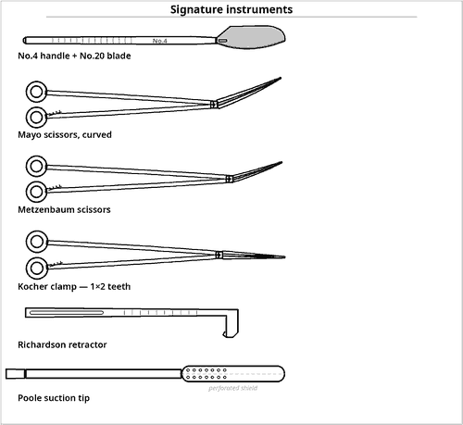  Fig 1.1 — Instruments that define the major tray
Why it is 'major'
▪ Not because of the number of pieces but because it provides depth — long instruments, deep retractors and a self-retaining retractor.
▪ It carries atraumatic clamps (DeBakey, Babcock) as well as crushing clamps, because bowel and vessels must survive.

Contents of the tray
Qty | Instrument | Key feature / rationale
CUTTING AND DISSECTING
2 | Knife handle No.3 | for No.10 / No.15 blades
1 | Knife handle No.4 | for No.20 blade — skin incision
1 | Knife handle No.7 | long, fine — deep dissection
1 | Mayo scissors, straight | cutting suture
2 | Mayo scissors, curved | heavy tissue, fascia
2 | Metzenbaum scissors, curved | 17 cm and 23 cm — delicate dissection
1 | Wire / suture scissors | protects fine scissors
GRASPING AND HOLDING
2 | Tissue forceps, 1×2 teeth, 15 cm | skin, fascia
2 | Tissue forceps, 1×2 teeth, 20 cm | deeper layers
2 | Dressing (thumb) forceps, serrated, 15 cm | general handling
2 | DeBakey forceps, 20 cm & 24 cm | atraumatic — bowel, vessels
2 | Adson forceps, 1×2 teeth | skin closure
6 | Allis tissue forceps | tough tissue, wound edges
4 | Babcock forceps | atraumatic — bowel, appendix
8 | Towel clips (Backhaus) | securing drapes
4 | Sponge-holding forceps | prep, swabbing, retraction
CLAMPING AND OCCLUDING
12 | Mosquito (Halsted) forceps, curved | fine bleeding points
12 | Crile forceps, 14 cm, straight & curved | general haemostasis
8 | Kelly forceps, 16 cm, curved | deeper vessels
6 | Rochester-Péan forceps, 20 cm | large pedicles and omentum
6 | Kocher (Ochsner) clamps | crushing — fascia, tissue to be excised
4 | Right-angled (Mixter) forceps | passing ligatures behind a pedicle
2 | Tonsil (Schnidt) forceps | deep ligature work
EXPOSING AND RETRACTING
2 | Army-Navy retractors | superficial layers
2 | Richardson retractors, medium & large | abdominal wall
2 | Deaver retractors | deep, narrow exposure
2 | Malleable (ribbon) retractors, 2.5 & 5 cm | shaped to need; protects viscera
1 | Balfour self-retaining retractor | with bladder blade — maintains laparotomy exposure
2 | Weitlaner retractor | self-retaining, superficial
4 | Skin hooks / Senn retractors | fine exposure
SUTURING AND STAPLING
4 | Needle holders, Mayo-Hegar, 15 cm & 20 cm | tungsten-carbide inserts preferred
1 | Needle holder, long 25 cm | deep pelvic suturing
— | Suture and needles | absorbable for viscera and fascia; non-absorbable for skin; taper for bowel, cutting for skin
1 | Ligature carrier (Deschamps) | deep pedicles
— | Linear and linear-cutting staplers | available for bowel work
SUCTIONING, ACCESSORY AND MEASURING
1 | Poole suction tip | free peritoneal fluid
1 | Yankauer suction tip | localised suction
2 | Suction tubing | wide-bore, kink-resistant; a spare set is kept because clot blocks the line
1 | Electrosurgical pencil with holster and tip cleaner | holster prevents accidental activation; the tip is scraped clean of eschar to keep cutting efficiency
2 | Probe and grooved director | tracts and sinuses
2 | Kidney dish / gallipot | specimens, irrigation
1 | Ruler / measuring tape | specimen and defect size
— | Laparotomy pads, radio-opaque | counted in fives

Additional supplies and accessories
Position — Supine, arms as required; table may be tilted for exposure.
Draping — Four-towel square around the incision, then a laparotomy sheet.
Add-on packs kept ready — Bowel/GI stapler set, biliary set, vascular clamps, self-retaining ring retractor, retrieval bags.
Haemostat | Length | Jaw serration | Typical use
Mosquito (Halsted) | 12–13 cm | Fine, full length | Small subcutaneous bleeders
Crile | 14 cm | Full length, transverse | General haemostasis
Kelly | 16 cm | Distal half only | Deeper vessels
Rochester-Péan | 20 cm | Full length, heavy | Large pedicles, omentum
Kocher (Ochsner) | 16–20 cm | Full length + 1×2 teeth | Fascia; tissue to be excised

Table 1.1 — The haemostat family in the major tray, in increasing order of size
Mnemonic — building the major tray
▪ "3-4-7" knife handles: No.3 (small blades), No.4 (No.20 blade), No.7 (long fine).
▪ "M-M-M" scissors: Mayo straight (suture), Mayo curved (tissue), Metzenbaum (delicate).
▪ "Mo-Cr-Ke-Ro-Ko" clamps in increasing size: Mosquito → Crile → Kelly → Rochester → Kocher (toothed).

Examination pointers
▪ State clearly that the major tray must satisfy all six functional groups in two or more lengths.
▪ The Balfour self-retaining retractor with bladder blade is the item that marks a tray as a true laparotomy set.
▪ Poole suction (not Yankauer) is the answer for free fluid in the peritoneal cavity.
▪ Include radio-opaque laparotomy pads and the four-point count in any answer about a major tray.
▪ Long (25 cm) needle holder and No.7 handle are the instruments that give depth; mention them to distinguish major from basic.

Common mistakes to avoid
✗ Listing only clamps and forceps and forgetting retractors and suction.
✗ Saying 'Yankauer' for free peritoneal fluid.
✗ Omitting the self-retaining retractor.
✗ Forgetting accessory items (electrosurgical pencil, pads, kidney dish) which carry easy marks.

1.2 Basic / Minor Procedures Tray
Also called: Minor set · general minor tray · basic soft-tissue tray
The basic (minor) procedures tray is the general-purpose small set and the single most widely used tray in any hospital. It covers clean, superficial, short-duration procedures that do not enter a major body cavity. It is the reference set from which most speciality trays are constructed, so its contents must be known exactly.  Used for / includes  ▪ Excision of superficial lumps, cysts and lipomata  ▪ Incision and drainage of abscesses  ▪ Wound debridement and secondary suturing  ▪ Lymph node and soft-tissue biopsy  ▪ Simple hernia repair in a thin patient  ▪ Insertion of central venous access devices and ports  ▪ Base tray for minor ENT, ophthalmic, orthopaedic and gynaecologic procedures |  | 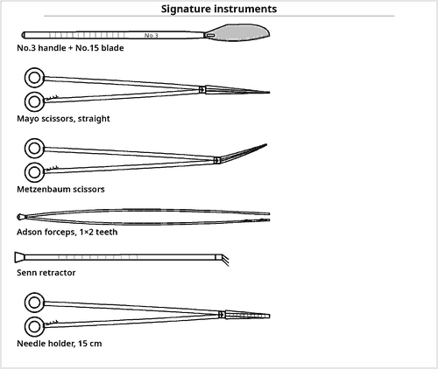  Fig 1.2 — The core of the basic/minor tray
Why this tray matters most
▪ It is the commonest tray in the hospital, and the reference set for the majority of speciality trays.
▪ Examiners often ask you to convert it: 'what would you add to a minor tray for a thyroidectomy / a D&C / a tracheostomy?'

Contents of the tray
Qty | Instrument | Key feature / rationale
CUTTING AND DISSECTING
2 | Knife handle No.3 | with No.10 and No.15 blades
1 | Mayo scissors, straight | suture cutting
1 | Mayo scissors, curved | tissue
1 | Metzenbaum scissors, 14 cm | fine dissection
1 | Iris scissors | very fine trimming
GRASPING AND HOLDING
2 | Adson forceps, 1×2 teeth | skin
2 | Tissue forceps, 1×2 teeth, 13 cm | fascia
2 | Dressing forceps, serrated, 13 cm | general handling
4 | Allis tissue forceps | wound edges, specimens
4 | Towel clips | drapes
2 | Sponge-holding forceps | prep and swabbing
CLAMPING AND OCCLUDING
6 | Mosquito forceps, curved | fine bleeders
6 | Crile forceps, 14 cm | haemostasis
2 | Kelly forceps, curved | slightly deeper vessels
2 | Kocher clamps | tough fascia
EXPOSING AND RETRACTING
2 | Senn (double-ended) retractors | blade one end, rake the other
2 | Army-Navy retractors | small wounds
1 | Weitlaner self-retaining retractor | frees an assistant's hands
2 | Skin hooks | delicate skin edges
SUTURING
2 | Needle holders, Mayo-Hegar 15 cm | ring-handled with a ratchet; tungsten-carbide inserts grip the needle without rotation
— | Suture with needles | absorbable subcutaneous; non-absorbable or staples to skin
SUCTIONING AND ACCESSORY
1 | Yankauer or Frazier suction tip | Frazier if the field is small and fine
1 | Electrosurgical pencil | hand-controlled cut and coagulate; the workhorse for haemostasis in small clean wounds
1 | Probe and grooved director | sinus and fistula tracts
1 | Curette, small | abscess cavity, granulation
1 | Kidney dish and gallipot | kidney dish for specimens and used items, gallipot for antiseptic
— | Gauze swabs, radio-opaque | counted

 | Limited tray | Basic / minor tray | Major tray
Depth of field | Skin and subcutaneous only | Superficial + small cavity | Deep body cavity
Longest instrument | ≈ 14 cm | ≈ 16 cm | ≈ 25 cm
Retractors | Skin hooks, Senn | Senn, Army-Navy, Weitlaner | Richardson, Deaver, malleable, Balfour
Suction | Often none | Yankauer / Frazier | Poole + Yankauer
Approx. item count | 15–25 | 40–60 | 80–120

Table 1.2 — Where the basic tray sits between limited and major
Examination pointers
▪ Learn this tray item by item — it is the commonest single-tray question and the base for conversions.
▪ The basic tray does not contain a self-retaining abdominal retractor, long instruments or Poole suction — these mark the major tray.
▪ Senn retractor is double-ended: a flat blade at one end and three sharp prongs at the other.
▪ Always mention counted radio-opaque swabs even in a minor tray.

1.3 Limited Procedures Tray
Also called: Minimal set · local procedures tray · 'cut-down' tray
The limited procedures tray is the smallest standard set. It carries only what is needed for a very superficial, brief procedure performed under local anaesthesia, usually outside the main theatre — in a treatment room, day-case unit or emergency department. Its purpose is economy: processing a full minor tray for a two-minute procedure wastes instruments and money.  Used for / includes  ▪ Excision or shave biopsy of a small skin lesion  ▪ Punch biopsy and simple skin suturing  ▪ Removal of a foreign body from soft tissue  ▪ Toenail avulsion; simple nail-bed procedures  ▪ Venous cut-down; removal of a tunnelled line  ▪ Suture removal and minor wound care |  | 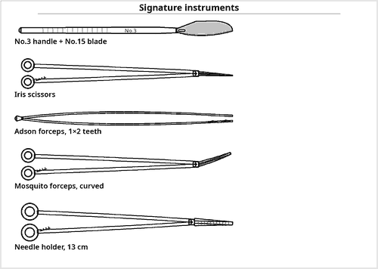  Fig 1.3 — Everything the limited tray really needs
Defining feature
▪ No cavity is entered. The tray has no deep retractor, no long instrument and usually no suction.
▪ If suction, self-retaining retraction or instruments longer than ≈14 cm are needed, the correct choice is a minor tray, not a limited tray.

Contents of the tray
Qty | Instrument | Key feature / rationale
CUTTING AND DISSECTING
1 | Knife handle No.3 | with No.15 blade
1 | Iris scissors, curved | fine tissue and trimming
1 | Suture / Mayo scissors, straight | cutting suture only
GRASPING AND HOLDING
1 | Adson forceps, 1×2 teeth | skin edges
1 | Adson forceps, serrated | atraumatic handling
2 | Allis forceps, small | holding the specimen (optional)
2 | Towel clips, small | securing a small drape
CLAMPING
4 | Mosquito forceps, curved | the only haemostats required
2 | Crile forceps, small | if slightly deeper
RETRACTING
2 | Skin hooks, single or double | gentle skin-edge retraction
1 | Senn retractor | if any depth is anticipated
SUTURING
1 | Needle holder, 13 cm | short pattern to match a shallow field and fine suture
— | Suture with swaged cutting needle | monofilament to skin
ACCESSORY
1 | Gallipot | antiseptic solution
1 | Kidney dish | specimen and used items
1 | Small curette | curetting a lesion base
— | Gauze swabs, counted | radio-opaque and counted, however small the procedure
— | Local anaesthetic, syringe and needle | kept off the sterile field until required

Examination pointers
▪ Define it by what it lacks: no deep retractors, no long instruments, typically no suction.
▪ Its justification is economy and turnaround, not clinical limitation.
▪ Even here the count applies — swabs and the blade must be accounted for.
▪ Commonly used outside the main theatre, so the tray must be self-sufficient (gallipot, kidney dish, swabs).

1.4 Thyroid Tray
Also called: Thyroidectomy tray · neck exploration tray
The thyroid gland is superficial but extremely vascular and lies among structures that must not be injured — the recurrent laryngeal nerve, the parathyroid glands, the trachea and the great vessels. The thyroid tray is therefore a basic tray upgraded for meticulous haemostasis in a shallow but crowded field: many fine haemostats, special gland-holding forceps and small right-angled retractors.  Used for / includes  ▪ Total, subtotal and hemi-thyroidectomy  ▪ Isthmusectomy and excision of a thyroid nodule  ▪ Parathyroidectomy and parathyroid exploration  ▪ Excision of a thyroglossal cyst  ▪ Neck node biopsy and branchial cyst excision  ▪ Retrosternal goitre (with a sternal saw available) |  | 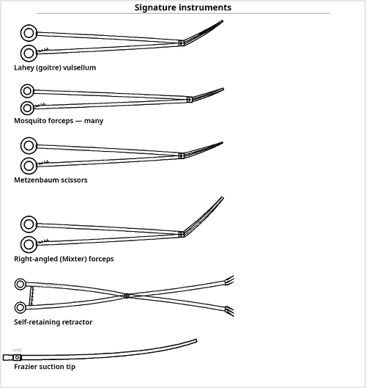  Fig 1.4 — Fine haemostasis and gland traction define this tray
Bedside emergency set
▪ Post-thyroidectomy haematoma causes rapid airway obstruction.
▪ A clip/suture removal set and a tracheostomy set must stay at the bedside — a very commonly examined point.

Contents of the tray
Qty | Instrument | Key feature / rationale
CUTTING AND DISSECTING
2 | Knife handle No.3 | No.10 for skin, No.15 for fine work
1 | Mayo scissors, straight | suture
2 | Metzenbaum scissors, curved 14 & 18 cm | the principal dissecting instrument
1 | Fine dissecting scissors | close to the recurrent laryngeal nerve
1 | Sternal saw / Gigli saw | kept available for retrosternal extension
GRASPING AND HOLDING
4 | Lahey goitre (vulsellum) forceps | signature item — traction on the gland
2 | Adson forceps, 1×2 teeth | skin
2 | DeBakey forceps | vessels, trachea, atraumatic
2 | Dressing forceps, fine | handles tissue without puncturing the vascular thyroid capsule
4 | Allis forceps | strap muscles, specimen
6 | Towel clips | sharp crossed points securing drapes to the collar incision field
2 | Sponge-holding forceps | fenestrated jaws holding a gauze ball for skin preparation and swabbing
CLAMPING AND OCCLUDING
20 | Mosquito forceps, curved | large numbers — the gland bleeds from many small vessels
8 | Crile forceps, fine | haemostasis
4 | Right-angled (Mixter) forceps | superior and inferior thyroid pedicles
2 | Kocher clamps | strap muscle and fascia
— | Ligating clips and applier | increasingly replace ties on small vessels
EXPOSING AND RETRACTING
2 | Green (thyroid) retractors | small right-angled blades, hand-held
2 | Army-Navy retractors | skin flaps
1 | Weitlaner or mastoid self-retaining retractor | holds the strap muscles apart
2 | Skin hooks / Senn retractors | flap elevation
2 | Malleable retractor, narrow | protects the trachea and oesophagus
SUTURING
2 | Needle holders, 15 cm | standard length for the shallow neck field
1 | Needle holder, fine 13 cm | vessel and capsule suturing
— | Suture | absorbable to strap muscles and platysma; fine monofilament or subcuticular to skin
SUCTIONING AND ACCESSORY
1 | Frazier suction tip, fine | keeps the small field dry without soft-tissue trauma
1 | Yankauer suction tip | rigid bulbous tip for larger volumes, used with the finer Frazier tip
1 | Electrosurgical pencil, fine tip | used cautiously near the nerve
— | Nerve monitor / stimulator | identifies the recurrent laryngeal nerve
— | Closed suction drain | haematoma is the feared early complication
— | Tracheostomy set | must be immediately available in the recovery area

Additional supplies and accessories
Position — Supine, neck extended over a sandbag or head-ring, 15–20° head-up to reduce venous engorgement.
Incision — Transverse collar (Kocher) incision, two finger-breadths above the sternal notch.
Structures at risk — Recurrent laryngeal nerve, external branch of the superior laryngeal nerve, parathyroid glands, trachea, oesophagus, carotid sheath.
Examination pointers
▪ The signature instrument is the Lahey goitre vulsellum; name it first.
▪ Emphasise the large number of mosquito forceps — the quantity itself is characteristic.
▪ Frazier suction, not Poole, because the field is small and delicate.
▪ Always mention the tracheostomy set at the bedside and the risk of haematoma → airway obstruction.
▪ Name the structures at risk; marks are given for the recurrent laryngeal nerve and parathyroids.

1.5 Long Instruments Tray
Also called: Deep instruments tray · bariatric or deep-cavity supplement
The long instruments tray is not a stand-alone set: it is a supplementary tray of extended-length patterns opened in addition to a major tray whenever the operative field is unusually deep. Standard 14–20 cm instruments cannot reach, and forcing them causes poor control, tissue trauma and loss of haemostasis.  Used for / includes  ▪ Obese or muscular patients (high BMI, thick abdominal wall)  ▪ Deep pelvic surgery — low rectal, radical hysterectomy  ▪ Retroperitoneal and para-aortic dissection  ▪ High subphrenic and hiatal work; deep splenic hilum  ▪ Deep thoracic and mediastinal exposure  ▪ Any procedure where a standard instrument 'bottoms out' |  | 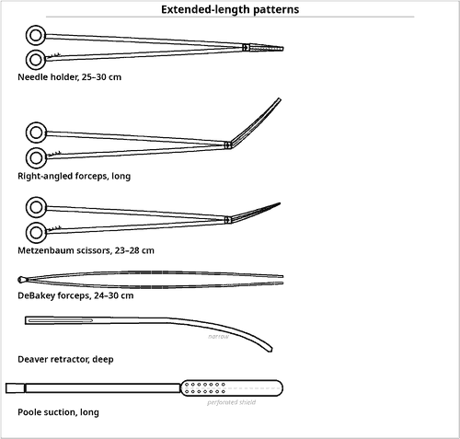  Fig 1.5 — The same instruments, in longer patterns
The rule of reach
▪ An instrument must be long enough that the operator's hand stays outside the wound.
▪ Working with a short instrument at depth obstructs the view, tires the hand and causes tissue injury.
▪ Illumination must be extended with the instruments — a lighted retractor or head-light.

Contents of the tray
Qty | Instrument | Key feature / rationale
CUTTING AND DISSECTING — LONG PATTERNS
1 | Knife handle No.7, long | fine deep incision
2 | Metzenbaum scissors, 23 cm & 28 cm | deep delicate dissection
1 | Mayo scissors, curved 23 cm | deep heavy tissue
1 | Long dissecting scissors, right-angled | pelvic side-wall
GRASPING AND HOLDING — LONG PATTERNS
2 | DeBakey forceps, 24 cm & 30 cm | atraumatic at depth
2 | Dressing forceps, 25 cm | extended length so the hand stays outside a deep wound
2 | Tissue forceps, 25 cm, 1×2 teeth | toothed grip on fascia at depth
4 | Allis forceps, long | interlocking teeth reaching tissue at the bottom of a deep cavity
4 | Babcock forceps, long | deep bowel handling
2 | Sponge-holding forceps, 25 cm | swab-on-a-stick at depth
CLAMPING — LONG PATTERNS
8 | Crile / Kelly forceps, 20–24 cm | standard haemostats in extended lengths for deep vessels
6 | Right-angled (Mixter) forceps, 22–26 cm | deep pedicles — the key item
4 | Tonsil (Schnidt) forceps, long | passing deep ligatures
4 | Rochester-Péan forceps, 24 cm | large pedicles
2 | Kocher clamps, long | crushing 1x2-toothed clamp for deep fascia and specimen pedicles
EXPOSING AND RETRACTING — DEEP PATTERNS
2 | Deaver retractors, deep and extra-deep | narrow curved blade giving depth without a wide incision
2 | Richardson retractors, large | right-angled blade holding the abdominal wall in a thick patient
2 | Malleable retractors, wide and long | shaped to the cavity
1 | Self-retaining ring retractor system | Balfour, Bookwalter or O'Sullivan-O'Connor
2 | Lighted / fibre-optic retractor | illumination at depth is as important as reach
SUTURING — LONG PATTERNS
2 | Needle holders, 25 cm & 30 cm | allows suturing at the pelvic floor with the hand clear of the field
1 | Ligature carrier (Deschamps), long | blunt eyed hook passing a ligature around a deep pedicle
1 | Knot pusher | tying at depth
— | Long staplers and clip appliers | extended shafts to reach and divide deep structures
SUCTION AND ACCESSORY
1 | Poole suction tip, long | perforated shield clearing free fluid from a deep cavity
1 | Yankauer suction tip, long | localised suction at depth
1 | Electrosurgical pencil with extended tip | reaches the base of a deep wound without arcing to retractors
— | Head-light and long light cord | illumination must extend as far as the instruments; theatre lights will not reach the bottom of a deep cavity

Examination pointers
▪ State explicitly that this is a supplementary tray used with a major tray, not an independent set.
▪ The instruments are the same patterns in longer lengths — you need only add the word 'long'.
▪ Long right-angled (Mixter) forceps and a long needle holder are the two most valuable additions.
▪ Mention illumination at depth (lighted retractor or head-light) — an easily earned mark others forget.

1.6 Biliary Tract Procedures Tray
Also called: Cholecystectomy tray · common bile duct exploration (CBDE) tray · gallbladder tray
The biliary tree lies deep beneath the right costal margin and consists of thin-walled ducts that must be handled without injury. The biliary tract tray is a major tray with three specific additions: instruments to grasp and extract stones, instruments to calibrate and dilate the common bile duct, and equipment for intra-operative cholangiography.  Used for / includes  ▪ Open cholecystectomy; conversion from laparoscopic  ▪ Common bile duct exploration for choledocholithiasis  ▪ Operative cholangiography  ▪ Choledochoduodenostomy and biliary-enteric bypass  ▪ Repair of bile-duct injury; hepaticojejunostomy  ▪ Excision of a choledochal cyst |  | 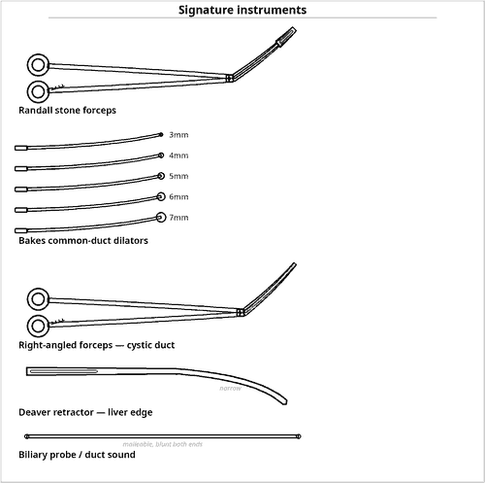  Fig 1.6 — Stone extraction and duct calibration
Two names to never confuse
▪ Randall forceps = curved forceps to grasp stones.
▪ Bakes dilators = graduated olive-tipped rods to calibrate and dilate the duct.
▪ Both are 'biliary', but one grasps and one dilates.

Contents of the tray
Qty | Instrument | Key feature / rationale
BASE SET
1 | Complete major procedures tray | see 1.1 — the entire set is required
1 | Long instruments tray | if the patient is obese or the field is deep
STONE EXTRACTION AND DUCT INSTRUMENTS
4 | Randall stone (gallstone) forceps | signature item — curved sets in graded angles for grasping calculi
1 | Set of Bakes common-duct dilators, 3–10 mm | signature item — malleable, olive-tipped; calibrate and gently dilate the duct
2 | Biliary probes / duct sounds | explore the duct
1 | Desjardins gallstone forceps | long, fine, curved
1 | Biliary Fogarty / balloon catheter | sweeps stones distally
1 | Scoop / stone spoon | retrieves fragments
2 | Gallbladder trocar | decompresses a tense gallbladder
1 | Cholangiogram catheter and clamp | with three-way tap and contrast
1 | Choledochoscope | available — see 1.7 if planned
CLAMPING AND DISSECTING ADDITIONS
4 | Right-angled (Mixter) forceps, fine and long | dissecting and encircling the cystic duct and artery
2 | Fine Metzenbaum / duct scissors | choledochotomy
2 | DeBakey forceps, long | atraumatic duct handling
— | Ligating clips and appliers | cystic artery and duct
2 | Fine mosquito forceps, extra | Calot's triangle haemostasis
RETRACTION ADDITIONS
2 | Deaver retractors | retract the liver edge
1 | Upper-hand / Harrington 'sweetheart' retractor | liver retraction
1 | Self-retaining costal-margin retractor | elevates the right costal margin
2 | Malleable retractors | protects the duodenum
DRAINAGE AND CLOSURE
— | T-tube (Kehr), various sizes | drains the duct after exploration
— | Fine absorbable suture, 4-0/5-0 | duct closure over the T-tube
— | Closed suction drain | subhepatic space
— | Specimen container | gallbladder and calculi

Additional supplies and accessories
Position — Supine, slight left tilt; a radiolucent table section is required for cholangiography.
Radiography — Image intensifier or C-arm, lead protection for all staff, contrast medium diluted and checked.
Structures at risk — Right hepatic artery, common hepatic duct, portal vein, duodenum; the classical injury is misidentification of the CBD as the cystic duct.
Examination pointers
▪ The three defining additions are stone forceps, Bakes dilators and cholangiography equipment — say all three.
▪ Mention the T-tube and fine duct suture; T-tube drainage after CBD exploration is a standard exam point.
▪ Deaver / Harrington retractors for the liver edge are characteristic.
▪ Note that radiolucent table and lead protection are part of the preparation, not just instruments.

1.7 Choledochoscopy Tray
Also called: Common bile duct endoscopy tray
Choledochoscopy is direct visual inspection of the interior of the bile ducts with a fine rigid or flexible endoscope, performed through a choledochotomy (or through the cystic duct) to confirm complete stone clearance. The tray is a biliary tray plus a complete endoscopic system with continuous irrigation, and it must remain capable of open surgery throughout.  Used for / includes  ▪ Confirming duct clearance during CBD exploration  ▪ Retrieval of retained or impacted calculi under vision  ▪ Biopsy of an intraductal lesion or stricture  ▪ Post-operative choledochoscopy through the T-tube tract  ▪ Assessment of a biliary anastomosis |  | 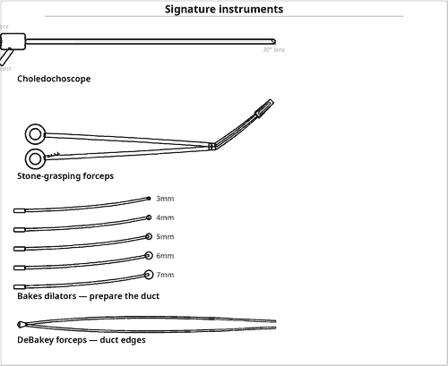  Fig 1.7 — Endoscopic vision added to the biliary set
Why irrigation is 'signature'
▪ A bile duct is a collapsed tube. Without continuous saline distension there is nothing to see.
▪ So the irrigation set is as much a defining part of this tray as the scope itself.

Contents of the tray
Qty | Instrument | Key feature / rationale
BASE SET
1 | Complete biliary tract procedures tray | see 1.6 — open capability must be retained throughout
THE ENDOSCOPIC SYSTEM
1 | Choledochoscope, rigid or flexible | signature item — fine calibre (3–5 mm) with a working channel
1 | Fibre-optic light cable and light source | high-intensity, cold light
1 | Camera head, coupler and monitor | with recorder for documentation
1 | Irrigation set — warm saline under pressure | essential: the duct must be distended with fluid to be seen
1 | Three-way tap and pressure tubing | controls irrigation flow
— | Sterile drapes for the camera and cable | keeps the non-sterile camera and cable out of the sterile field
INSTRUMENTS PASSED THROUGH THE SCOPE
1 | Flexible stone-grasping (basket) forceps | Dormia basket — retrieves calculi under vision
1 | Flexible biopsy forceps | intraductal lesions and strictures
1 | Balloon extraction catheter | sweeps stones toward the choledochotomy
1 | Electrohydraulic or laser lithotripsy probe | fragments an impacted stone (where available)
— | Guidewire | maintains access across a stricture
DUCT ACCESS AND CLOSURE
1 | Set of Bakes dilators | gently calibrate the duct to admit the scope
2 | Fine DeBakey / duct forceps | hold the choledochotomy edges open
2 | Stay sutures, 4-0/5-0 | hold the duct edges apart — a practical necessity
— | T-tube and fine absorbable suture | closure after inspection
— | Closed suction drain | subhepatic

Additional supplies and accessories
Critical practical point — The scope is delicate and expensive. It is passed and received by hand, never left on the tray where an instrument may be placed on it, and it is sterilised by a low-temperature method (EO, plasma) or high-level chemical disinfection — never by steam, unless the manufacturer specifies autoclavability.
Fluid management — Irrigation volume in and out should be monitored; over-pressurisation can cause bacteraemia and cholangitis.
Examination pointers
▪ Name the choledochoscope + light source + camera + irrigation as one integrated system.
▪ The Dormia basket and flexible biopsy forceps are the working instruments passed through the channel.
▪ Emphasise low-temperature sterilisation of the scope — a very common question.
▪ Stress that the open biliary tray remains open — conversion to open exploration must be immediate.
▪ Stay sutures on the choledochotomy are a small but frequently rewarded detail.

1.8 Basic Rigid Sigmoidoscopy Tray
Also called: Rigid sigmoidoscopy and proctoscopy tray
Rigid sigmoidoscopy inspects the rectum and distal sigmoid (to about 25 cm) with a straight illuminated tube. The tray is small, self-contained and centred on the instrument itself: a rigid sigmoidoscope with an obturator, light carrier and insufflation bulb, plus long instruments to reach down the tube for suction, swabbing and biopsy.  Used for / includes  ▪ Diagnostic inspection of rectum and distal sigmoid colon  ▪ Biopsy of a rectal lesion or suspicious mucosa  ▪ Investigation of rectal bleeding, tenesmus, discharge  ▪ Removal of a small foreign body or polyp  ▪ Assessment before and after anorectal surgery  ▪ Decompression / detorsion of a sigmoid volvulus (with a flatus tube) |  | 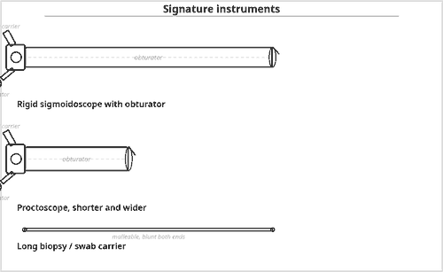  Fig 1.8 — The scope, obturator, light and insufflator form one unit
Obturator rule
▪ The obturator is used only to pass the anal canal.
▪ It is removed at about 5 cm, after which the scope is advanced only under direct vision.
▪ Advancing with the obturator in place risks perforation.

Contents of the tray
Qty | Instrument | Key feature / rationale
THE SCOPE ASSEMBLY — THE CORE OF THE TRAY
1 | Rigid sigmoidoscope, 25 cm | signature item — adult and paediatric calibres
1 | Obturator for the sigmoidoscope | blunt introducer; removed once past the anal canal
1 | Proctoscope, short and wider | for the anal canal and lower rectum
1 | Fibre-optic light carrier with cable and source | or an integral bulb
1 | Insufflation bulb with tubing | gently distends the lumen to open it
1 | Eyepiece / viewing window with bellows seal | maintains distension while viewing
LONG INSTRUMENTS PASSED DOWN THE SCOPE
2 | Rectal biopsy forceps, long | cup or punch pattern
1 | Long suction tube / rectal sucker | clears liquid faeces and blood
2 | Long swab (cotton-wool) carriers | cleans the mucosa for a clear view
1 | Long dissecting forceps | retrieves small foreign bodies
1 | Snare and cautery lead | small polypectomy where available
1 | Silver nitrate stick / cautery | haemostasis at a biopsy site
ACCESSORY AND PREPARATION ITEMS
— | Water-soluble lubricant jelly | generously applied to scope and anus
— | Disposable gloves and apron | the procedure is contaminated and the lavage return can be forceful
— | Gauze swabs and receiver | cleans the lens and mucosa; receiver catches faecal return
1 | Kidney dish | specimens
— | Specimen containers with fixative | labelled with the level of the biopsy
— | Flatus tube | sigmoid volvulus decompression
— | Enema / rectal washout equipment | bowel preparation before the procedure

Additional supplies and accessories
Position — Left lateral (Sims) with knees drawn up is usual; the knee-elbow or lithotomy position may be used.
Sequence of use — Digital rectal examination first → insert the scope with the obturator in place, directed toward the umbilicus → remove the obturator at about 5 cm → advance under direct vision only, insufflating gently → withdraw slowly, inspecting circumferentially.
Safety — Never advance blindly or against resistance — perforation is the principal hazard. Minimal insufflation reduces discomfort and vagal response.
Examination pointers
▪ The tray is defined by the scope + obturator + light carrier + insufflation bulb — list all four as one unit.
▪ Digital rectal examination always precedes instrumentation — a reliable mark.
▪ Rigid sigmoidoscope reaches about 25 cm; a proctoscope is shorter and wider for the anal canal.
▪ The complications to quote are perforation and bleeding; the safeguard is advancing only under vision.
▪ All accessory instruments are long, because they must work down a 25 cm tube.

1.9 Gastrointestinal Procedures Tray
Also called: Bowel tray · GI resection and anastomosis tray
The gastrointestinal tray is a major tray plus the instruments needed to divide the gut, control its contents and rejoin it. Its logic rests on one principle: the bowel end that will be kept is held only with non-crushing (atraumatic) clamps, while the end that will be removed may be held with crushing clamps. Contamination control and stapling devices complete the set.  Used for / includes  ▪ Small and large bowel resection with anastomosis  ▪ Gastrectomy, gastrojejunostomy, pyloroplasty  ▪ Formation and closure of ileostomy or colostomy  ▪ Right, left and sigmoid colectomy; Hartmann's procedure  ▪ Repair of perforated peptic ulcer or bowel injury  ▪ Adhesiolysis for obstruction |  | 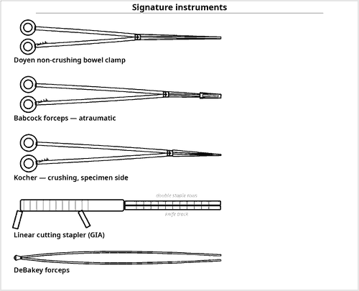  Fig 1.9 — Crushing versus non-crushing is the central idea
Crushing or not?
▪ Retained bowel → non-crushing (Doyen, rubber-shod, Babcock).
▪ Specimen side → crushing (Payr, Kocher).
▪ Reversing this causes necrosis and anastomotic leak — the classic examination trap.

Contents of the tray
Qty | Instrument | Key feature / rationale
BASE SET
1 | Complete major procedures tray | see 1.1
1 | Long instruments tray | for deep pelvic or obese cases
BOWEL CLAMPS — THE DEFINING GROUP
6 | Doyen intestinal clamps, straight & curved | non-crushing — occlude the bowel to be preserved
4 | Rubber-shod clamps / clamp guards | further softens the grip on retained bowel
4 | Payr or Kocher crushing clamps | applied to the specimen side only
4 | Babcock forceps | atraumatic handling and gentle traction
2 | Right-angled forceps | mesenteric vessels
2 | Allen / Lang-Stevenson anastomosis clamp | where used, holds the ends in apposition
STAPLING AND ANASTOMOSIS DEVICES
1 | Linear cutter (GIA-type) with reloads | divides and staples simultaneously
1 | Transverse linear stapler (TA-type) with reloads | closes a stump or enterotomy
1 | Circular stapler (EEA-type), sized set | end-to-end colorectal anastomosis
1 | Purse-string clamp with straight needle | prepares the bowel end for a circular stapler
1 | Anvil grasper / sizers | for the circular stapler
— | Ligating clips and appliers | mesenteric vessels
CONTAMINATION CONTROL
— | Bowel-technique ('dirty') set | a separate small set of instruments used only after the bowel is opened, then discarded from the field
— | Extra towels and drapes to isolate the bowel | packing off protects the peritoneal cavity
— | Suction with a dedicated tip | for enteric content
— | Antiseptic-soaked swabs | cleansing the divided ends
— | Separate specimen and 'dirty' receivers | prevents enteric organisms reaching the clean part of the field
— | Change of gloves after the enteric stage | removes bowel organisms before the abdomen is closed
SUTURING AND CLOSURE
2 | Needle holders, standard and long | two lengths: standard for the abdominal wall, long for a deep pelvic anastomosis
— | Absorbable suture 3-0/4-0 on a round-bodied needle | seromuscular anastomotic layers
— | Non-absorbable seromuscular suture | where a two-layer technique is used
— | Stay sutures | hold the bowel ends in apposition
— | Closed suction drain | detects an early anastomotic leak and prevents a collection
— | Stoma appliance and marking pen | if a stoma is planned

Additional supplies and accessories
Position — Supine; lithotomy or Lloyd-Davies for rectal and low colonic work with stapled anastomosis.
Preparation — Nasogastric tube, urinary catheter, mechanical or antibiotic bowel preparation per protocol, prophylactic antibiotics, thromboprophylaxis.
Anastomotic principles — Adequate blood supply, tension-free apposition, accurate serosa-to-serosa contact, no distal obstruction, no faecal loading, no tissue crushing on the retained side.
Mnemonic — the anastomosis checklist
▪ "BATS-N" — Blood supply, Apposition without tension, Technique accurate (serosa to serosa), Sepsis controlled, No distal obstruction.

Examination pointers
▪ Open with the crushing vs non-crushing distinction; it is the core of the answer.
▪ Doyen is the name to give for a non-crushing bowel clamp; Payr / Kocher for crushing.
▪ Name the three stapler families — linear cutter (GIA), transverse linear (TA), circular (EEA).
▪ Describe the 'dirty' bowel-technique set and glove change — marks are specifically allotted to contamination control.
▪ Mention the purse-string clamp for circular stapling; candidates rarely do.

Common mistakes to avoid
✗ Applying a crushing clamp to the bowel that will be kept.
✗ Forgetting contamination-control measures entirely.
✗ Listing staplers without naming their function.
✗ Omitting stay sutures and drains.

1.10 Rectal Procedures Tray
Also called: Anorectal tray · haemorrhoidectomy and fistula tray
The anorectal region is a short, narrow, highly sensitive and heavily contaminated field. The rectal tray is therefore built on a minor tray with three specific needs: specialised retractors and specula to open the anal canal, probes and directors to trace fistula tracts, and generous haemostasis in a very vascular area.  Used for / includes  ▪ Haemorrhoidectomy; banding and stapled haemorrhoidopexy  ▪ Lateral internal sphincterotomy for anal fissure  ▪ Fistula-in-ano — fistulotomy, fistulectomy, seton insertion  ▪ Incision and drainage of perianal and ischiorectal abscess  ▪ Excision of anal tags, warts, polyps and fibro-epithelial papillae  ▪ Excision of a pilonidal sinus (an adjacent procedure using the same set) |  | 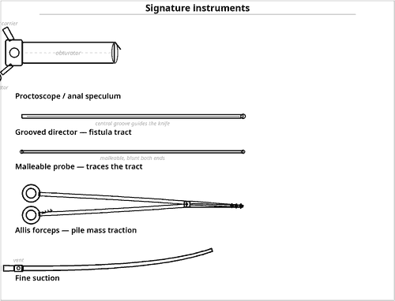  Fig 1.10 — Exposure of the canal and tracing of tracts
Goodsall's rule
▪ Predicts the course of a fistula tract:
▪ Anterior external opening → tract runs radially (straight) to the canal.
▪ Posterior external opening → tract curves to the posterior midline.
▪ Guides how the probe is directed — commonly asked alongside this tray.

Contents of the tray
Qty | Instrument | Key feature / rationale
BASE SET
1 | Basic / minor procedures tray | see 1.2
ANAL EXPOSURE — RETRACTORS AND SPECULA
2 | Proctoscope / anal speculum | signature item — Kelly, Sims or bivalve pattern
1 | Eisenhammer or Parks self-retaining anal retractor | opens the canal and holds itself
2 | Hill-Ferguson retractor | the standard haemorrhoidectomy retractor
1 | Rigid sigmoidoscope | proctosigmoidoscopy always precedes anorectal surgery
2 | Small Langenbeck / Army-Navy retractors | perianal tissue
FISTULA AND TRACT INSTRUMENTS
2 | Malleable fistula probes, fine and stout | signature item — trace the tract from external to internal opening
1 | Grooved director | guides the knife safely along the tract
1 | Lockhart-Mummery fistula probe | curved, for high tracts
— | Seton material | silk, nylon or a soft silicone loop for a high tract
— | Hydrogen peroxide / methylene blue with syringe | delineates a tract that cannot be probed
1 | Small curette / spoon | curettes granulation tissue
GRASPING, CLAMPING AND CUTTING
6 | Allis forceps | traction on the pile mass and skin tags
4 | Artery forceps, fine curved | pedicle haemostasis
2 | Kocher clamps | crushing toothed clamp on the pile pedicle and specimen side
1 | Knife handle No.3 with No.11 and No.15 blades | abscess incision and precise cuts
1 | Fine dissecting scissors | precise division in a shallow, narrow and very sensitive field
1 | Diathermy pencil with fine and needle tips | the principal haemostatic and cutting tool
1 | Anal dilator set | graded, for controlled dilatation
— | Haemorrhoid banding applicator with bands | if banding is planned
— | Circular stapling device for haemorrhoidopexy | if stapled technique is planned
SUTURING, PACKING AND ACCESSORY
2 | Needle holders, short | the field is shallow and narrow
— | Absorbable suture 2-0/3-0 on a round needle | transfixion of the pile pedicle
1 | Fine suction tip (Frazier) | small calibre with a thumb vent for the confined anal canal
— | Anal pack / dressing with lubricant | haemostasis after haemorrhoidectomy
— | Local anaesthetic with adrenaline and syringe | infiltration reduces bleeding and gives analgesia
— | Specimen containers | separate and labelled
— | Culture swabs | pus from an abscess

Additional supplies and accessories
Position — Lithotomy is usual; prone jack-knife is preferred for posterior lesions and pilonidal sinus; left lateral for simple procedures.
Preparation — Rectal washout or enema; hair removal as required; prophylactic antibiotics for abscess and fistula work.
Contamination status — This is a contaminated field. Instruments used in the anal canal are kept separate from any clean part of the procedure, and the tray is handled as contaminated at the end.
Examination pointers
▪ Name the exposure instruments precisely: proctoscope, Eisenhammer/Parks self-retaining retractor, Hill-Ferguson retractor.
▪ The fistula probe and grooved director are the signature pair for fistula work.
▪ State that proctosigmoidoscopy precedes any anorectal operation, to exclude proximal disease.
▪ Quote Goodsall's rule — it is frequently paired with this tray.
▪ Emphasise that this is a contaminated field and the positioning options (lithotomy / prone jack-knife).

