PART II — INSTRUMENT TRAYS
GYNAECOLOGIC AND OBSTETRIC TRAYS

Complete, illustrated examination notes
General · Gynaecologic & Obstetric · Genitourinary · Thoracic
Cardiovascular · Orthopaedic · Neurologic · ENT · Ophthalmic · Paediatric

Legal (8.5 × 14 in) · 1.27 cm margins · monochrome print-ready
Every figure is an original line diagram, drawn for clarity in black and white

Table of Contents

The page numbers are live fields, shown as “—” until they are filled in. **To update them: press Ctrl+A then F9** (on a Mac, Cmd+A then Fn+F9) — or right-click any number and choose “Update Field”. Word normally offers to do this when the file opens. Once updated, each number is also a link: Ctrl+click it to jump to that tray.
Tray / Chapter | Page
GYNAECOLOGIC AND OBSTETRIC TRAYS | —
2.1 Dilatation of the Cervix and Curettage of the Uterus (D&C) Tray | —
2.2 Cervical Cone Tray | —
2.3 Laparoscopy Tray (Gynaecologic) | —
2.4 Abdominal Hysterectomy Tray | —
2.5 Caesarean Section Tray | —
2.6 Vaginal Hysterectomy Tray | —

How to Read These Notes

Every tray chapter is built to the same pattern, so you can find the same kind of information in the same place each time. Read the lead paragraph and the figure first to fix the idea, then work through the contents table.
Lead paragraph | What the tray is for and the single idea that shapes it. If you remember nothing else from a chapter, remember this.
Used for / includes | The procedures the tray serves — useful for 'name three indications' questions.
Figure | An original line diagram of the tray's signature instruments — the items that identify it. Diagrams are schematic: they show the identifying feature (jaw pattern, bevel direction, footplate, curve) rather than a photographic likeness.
Callout box | The one concept, distinction or safety rule that examiners return to for that tray.
Contents of the tray | The full instrument list, grouped by function — cutting, grasping, clamping, retracting, suturing, suctioning — with quantities and the reason each item is present. Answer 'enumerate the contents' questions using these groups as headings.
Additional supplies | Position, draping, structures at risk and procedure-specific notes.
Comparison table | Where two trays or two instruments are easily confused, they are set side by side.
Examination pointers | The single most useful section for an MCQ paper: the specific, testable facts — named instruments, numbers, temperatures, sizes and the distinctions between similar items. Revise from these.
Common mistakes | Errors that lose marks, marked with ✗ — most of them are the distractors an MCQ will offer you.
A note on quantities | Instrument names, functions and groupings are standard. The numbers ("6 Allis clamps") vary between institutions — please cross-check them against your prescribed textbook.
Printing | Legal paper (8.5 × 14 in), 1.27 cm margins, monochrome throughout. No information depends on colour, so a black-and-white printer loses nothing.

PART II

Gynaecologic and Obstetric Trays
D&C · Cervical cone · Laparoscopy · Abdominal hysterectomy · Caesarean section · Vaginal hysterectomy

Gynaecological trays divide naturally into vaginal-route sets (D&C, cone biopsy, vaginal hysterectomy) and abdominal-route sets (laparoscopy, abdominal hysterectomy, caesarean section). Vaginal sets are dominated by specula, tenaculums, dilators and curettes; abdominal sets are major trays with additions for the uterine pedicles and the vaginal vault.

2.1 Dilatation of the Cervix and Curettage of the Uterus (D&C) Tray
Also called: D&C tray · dilatation and curettage set
D&C consists of graduated dilatation of the cervical canal followed by systematic curettage of the endometrial cavity. The tray is small, entirely vaginal, and is the reference set for all vaginal gynaecological procedures — cone biopsy, evacuation, hysteroscopy and vaginal hysterectomy are all built on it.  Used for / includes  ▪ Diagnostic curettage for abnormal uterine bleeding  ▪ Evacuation of retained products of conception; missed or incomplete miscarriage  ▪ Endometrial sampling for suspected malignancy  ▪ Removal of an endometrial polyp or small submucous fibroid  ▪ Cervical stenosis — therapeutic dilatation  ▪ As the base set for hysteroscopy and cone biopsy |  | 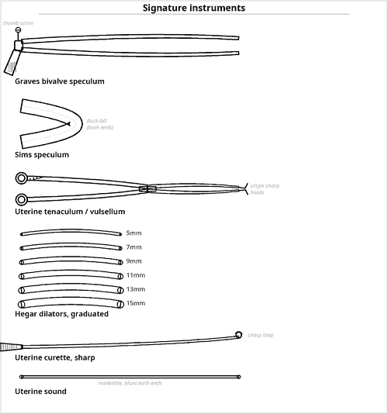  Fig 2.1 — Expose, steady, sound, dilate, curette
Why sound before dilating
▪ The sound establishes the depth and the direction of the uterine axis.
▪ Dilating without knowing the direction is the commonest cause of perforation.
▪ Dilators are passed in ascending order, never skipping sizes.

Contents of the tray
Qty | Instrument | Key feature / rationale
EXPOSURE OF THE CERVIX
1 | Graves (or Cusco) bivalve self-retaining speculum | opens the vagina and holds itself
1 | Sims speculum, double-ended | posterior vaginal wall retraction
1 | Anterior vaginal wall retractor / Auvard weighted speculum | weighted blade retracts posteriorly
2 | Sponge-holding forceps | antiseptic preparation and swabbing
STEADYING THE CERVIX AND UTERUS
2 | Vulsellum forceps (Duplay / Teale) | grasp the cervix atraumatically
1 | Single-tooth uterine tenaculum (Schroeder) | signature item — traction to straighten the uterocervical angle
2 | Allis forceps | cervical lip
1 | Cervical (Littlewood) forceps | light-grip cervical forceps, less traumatic than a tenaculum
SOUNDING AND DILATATION
1 | Uterine sound (graduated) | measures cavity depth and direction — normal ≈ 6–8 cm
1 | Set of Hegar dilators, 5–20 mm | signature item — double-ended, graduated; passed in ascending order
1 | Set of Hawkin-Ambler dilators | alternative pattern with handles
1 | Cervical dilator (Goodell) | screw-action dilator, where used
CURETTAGE AND EVACUATION
2 | Uterine curette, sharp, small & large | signature item — systematic endometrial curettage
2 | Uterine curette, blunt | safer in the pregnant or soft uterus
1 | Flushing curette | irrigating pattern
2 | Ovum (sponge) forceps | removal of retained products
1 | Suction curette with cannulae and tubing | suction evacuation — safer than sharp curettage in pregnancy
1 | Endometrial biopsy curette (Pipelle / Novak) | targeted sampling
ACCESSORY
1 | Kidney dish and gallipot | antiseptic and specimens
— | Gauze swabs, counted | radio-opaque
— | Specimen containers with formalin | labelled; separate endocervical and endometrial samples
— | Urinary catheter | bladder emptied before starting
1 | Needle holder with suture | cervical tear repair if needed
— | Local / general anaesthetic equipment | dilatation is painful; anaesthesia also relaxes the cervix

Additional supplies and accessories
Position — Lithotomy, buttocks at the table edge, under anaesthesia; bladder emptied first.
Sequence — Examine bimanually to determine uterine size and version → expose and clean the cervix → grasp with vulsellum/tenaculum → sound the cavity → dilate progressively with Hegar dilators → curette systematically (anterior, posterior, lateral walls, then fundus and cornua) → inspect and send specimens.
Complications — Uterine perforation (commonest), cervical tear, haemorrhage, infection, Asherman's syndrome from over-vigorous curettage, and false passage.
Examination pointers
▪ The four signature items are speculum, tenaculum, Hegar dilators, curette — name them in that order of use.
▪ Sound the uterus before dilating — the single most examined safety point.
▪ In pregnancy prefer blunt curette or suction evacuation; sharp curettage risks perforation and Asherman's syndrome.
▪ Perforation is the commonest complication; the uterus is softest at the fundus.
▪ Hegar dilators are double-ended and graduated and are used in ascending order.

2.2 Cervical Cone Tray
Also called: Cone biopsy tray · conisation of the cervix set
Cone biopsy (conisation) excises a cone of cervical tissue with its apex in the endocervical canal, both to diagnose and to treat cervical intraepithelial neoplasia. The tray is a D&C tray plus the means to define the lesion, excise a cone and control a very vascular cut surface.  Used for / includes  ▪ Diagnosis and treatment of CIN 2/3 and adenocarcinoma in situ  ▪ Unsatisfactory colposcopy or cytology–histology mismatch  ▪ Suspected microinvasive carcinoma requiring assessment of depth  ▪ Lesion extending into the endocervical canal  ▪ LLETZ / LEEP as the electrosurgical equivalent |  | 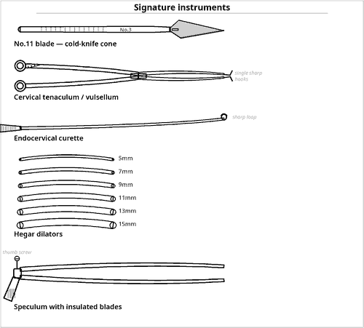  Fig 2.2 — Excision of a cone with haemostatic control
Two non-negotiables
▪ Insulated speculum whenever diathermy is used — a metal speculum conducts current to the vaginal wall.
▪ Orientation suture at 12 o'clock — without it the pathologist cannot report which margin is involved.

Contents of the tray
Qty | Instrument | Key feature / rationale
BASE SET
1 | Complete D&C tray | see 2.1 — dilatation and curettage complete the procedure
EXPOSURE AND LESION DEFINITION
1 | Insulated / non-conductive vaginal speculum | essential if electrosurgery is used — prevents vaginal burns
1 | Lateral vaginal wall retractors, insulated | non-conductive, so diathermy current cannot burn the vaginal wall
1 | Colposcope | defines the transformation zone
— | Acetic acid 3–5 % and Lugol's iodine (Schiller's test) | delineates the lesion before excision
— | Cotton-tipped applicators and swabs | apply acetic acid and iodine and dry the cervix for inspection
1 | Endocervical speculum (Kogan) | inspects the canal
EXCISION OF THE CONE
1 | Knife handle No.3 with No.11 blade | cold-knife conisation
1 | LLETZ / LEEP diathermy loop electrode set | signature item in current practice — assorted loop sizes
1 | Electrosurgical generator with blend/coagulation settings | blend cuts the cone; coagulation controls the vascular crater
1 | Ball / needle-point electrode | haemostasis of the crater
2 | Tenaculum or vulsellum forceps | traction and rotation of the cervix
2 | Long fine dissecting forceps and scissors | orientating and freeing the specimen
1 | Cervical (Hulka) tenaculum with stay sutures | lateral cervical stay sutures reduce bleeding
HAEMOSTASIS OF THE CONE BED
1 | Diathermy with ball electrode | primary method
— | Monsel's solution (ferric subsulphate) paste | chemical haemostasis of the crater
— | Silver nitrate sticks | chemical haemostasis of a small persistent bleeding point
2 | Needle holders with 2-0 absorbable suture | Sturmdorf or figure-of-eight haemostatic sutures
— | Vaginal pack with lubricant | tamponade if oozing persists
— | Adrenaline-containing local anaesthetic / vasopressin | infiltrated to reduce bleeding
SPECIMEN HANDLING — CRITICALLY IMPORTANT
— | Marking suture at the 12 o'clock position | orientates the specimen for the pathologist
— | Separate labelled containers | cone specimen and endocervical curettings kept apart
1 | Endocervical curette | samples the canal above the cone
— | Formalin and request forms | state the site and orientation

Additional supplies and accessories
Position — Lithotomy under general, regional or local anaesthesia with sedation.
Smoke evacuation — LLETZ produces surgical plume; a smoke evacuator and appropriate masks are required.
Complications — Primary and secondary haemorrhage, infection, cervical stenosis, cervical incompetence with mid-trimester loss and preterm labour in later pregnancy, and incomplete excision.
Examination pointers
▪ State that this is a D&C tray + cone excision and haemostasis items.
▪ Lugol's iodine (Schiller's test) and acetic acid to delineate the lesion are frequently rewarded.
▪ The insulated speculum with electrosurgery is a safety mark.
▪ Monsel's solution and Sturmdorf sutures are the named haemostatic measures.
▪ The 12 o'clock orientation suture and separate endocervical curettings are the specimen-handling marks.
▪ Late complications — cervical stenosis and cervical incompetence — are commonly asked.

2.3 Laparoscopy Tray (Gynaecologic)
Also called: Diagnostic and operative gynaecological laparoscopy set
Laparoscopy inspects and operates within the peritoneal cavity through small ports under video vision, after creating a pneumoperitoneum. The tray is a complete endoscopic system — access, insufflation, optics, energy and hand instruments — and it must always be accompanied by an open tray for immediate conversion.  Used for / includes  ▪ Diagnostic laparoscopy for pelvic pain, infertility, endometriosis  ▪ Tubal patency testing (chromopertubation) and tubal sterilisation  ▪ Ovarian cystectomy, oophorectomy, adhesiolysis  ▪ Management of ectopic pregnancy — salpingostomy or salpingectomy  ▪ Laparoscopic-assisted vaginal hysterectomy (LAVH) and total laparoscopic hysterectomy  ▪ Myomectomy and treatment of endometriotic deposits |  | 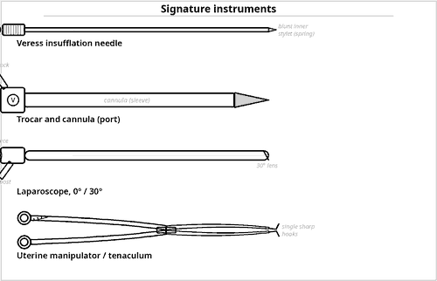  Fig 2.3 — Access, insufflation, vision, manipulation
Numbers to remember
▪ Insufflation pressure 12–15 mmHg.
▪ Gas used is carbon dioxide — non-combustible and rapidly absorbed.
▪ Trendelenburg 15–30° for pelvic laparoscopy.
▪ Veress = closed entry; Hasson = open entry.

Contents of the tray
Qty | Instrument | Key feature / rationale
ACCESS AND PNEUMOPERITONEUM
1 | Veress needle | signature item — spring-loaded blunt stylet for closed entry
1 | Hasson cannula | for open (direct-vision) entry — safer in the previously operated abdomen
1 | Primary trocar and cannula, 10–12 mm | umbilical camera port
3 | Secondary trocars and cannulae, 5 mm | working ports
1 | CO₂ insufflator with tubing and filter | pressure limited to 12–15 mmHg
1 | Gas cylinder / supply, checked | contents confirmed before starting; running out mid-case collapses the pneumoperitoneum
2 | Towel clips or skin-elevating forceps | lift the abdominal wall during entry
1 | Knife handle with No.11 blade | port incisions
OPTICS AND IMAGING
1 | Laparoscope 10 mm, 0° and 30° | 0° for diagnosis, 30° for angled views
1 | Laparoscope 5 mm | for a secondary port
1 | Fibre-optic light cable and xenon/LED source | cold light; a damaged cable loses fibres and dims the image
1 | Camera head, coupler, control unit and monitor(s) | white-balanced and focused before insertion
1 | Insufflator/scope warmer and anti-fog solution | prevents lens misting
— | Sterile camera and cable drapes | keeps the non-sterile camera and light cable out of the field
1 | Image recorder / printer | documentation
HAND INSTRUMENTS (LONG, 5 MM SHAFTS)
2 | Atraumatic grasping forceps | bowel, tube and ovary
2 | Toothed grasping forceps | tough tissue, specimen
1 | Laparoscopic Babcock forceps | tube and appendix
1 | Laparoscopic scissors, hook and straight | hook pattern for a controlled pull-cut, straight for general division
1 | Maryland dissecting forceps | fine curved dissector
1 | Bipolar and monopolar electrosurgical instruments | with cables and generator
1 | Suction–irrigation cannula with pump | clears blood and lavages
1 | Needle holders, laparoscopic pair | intracorporeal suturing
1 | Knot pusher and pre-tied ligature loops (Endoloop) | secures a pedicle without intracorporeal knot tying
1 | Clip applier with clips | rapid vessel and duct control through a 5 mm port
1 | Specimen retrieval bag | prevents port-site seeding and spillage of cyst contents
1 | Tissue morcellator | where used, with caution
1 | Fascial closure device | port-site closure
GYNAECOLOGY-SPECIFIC ADDITIONS
1 | Uterine manipulator / Hulka tenaculum | signature item — moves the uterus from below
1 | Cannula for chromopertubation (Spackman / Rubin) | with methylene blue or indigo carmine
1 | Tubal sterilisation applicator | Filshie clip or Falope ring applicator
1 | Vaginal speculum and cervical tenaculum | for the vaginal component of LAVH
1 | Colpotomiser / vaginal tube | delineates the vault in total laparoscopic hysterectomy
1 | Uterine morcellation containment bag | contains tissue fragments; reduces the risk of disseminating an unsuspected malignancy
CONVERSION CAPABILITY — NEVER OMITTED
1 | Complete major / abdominal hysterectomy tray, open and ready | mandatory — vascular or bowel injury requires immediate laparotomy
— | Vascular clamps and suture | for immediate control if a major vessel is injured at entry
— | Blood cross-matched and available | entry injury to a great vessel causes sudden heavy loss

Additional supplies and accessories
Position — Lithotomy with Trendelenburg tilt (head down 15–30°) to displace the bowel from the pelvis; arms tucked; shoulder supports to prevent sliding.
Preparation — Bladder catheterised, stomach decompressed, bimanual examination performed, vagina and abdomen prepared.
Complications — Entry injury to bowel or great vessels, gas embolism, surgical emphysema, hypercapnia, shoulder-tip pain, port-site hernia and bleeding, thermal injury recognised late, and injury to bladder or ureter.
Examination pointers
▪ Describe the tray as five systems: access, insufflation, optics/imaging, energy, hand instruments — then add the gynaecological items.
▪ CO₂ at 12–15 mmHg is a standard factual mark.
▪ Distinguish Veress (closed) from Hasson (open) entry and know that open entry is preferred after previous surgery.
▪ The uterine manipulator and chromopertubation cannula are the gynaecology-specific signatures.
▪ Always state that an open tray is kept ready for conversion — marks are specifically allocated to this.
▪ Mention port-site fascial closure to prevent hernia.

Common mistakes to avoid
✗ Forgetting the open conversion tray.
✗ Omitting the insufflation pressure limit.
✗ Listing scopes but not the light source, camera and monitor.
✗ Forgetting anti-fog and scope warming — a practical detail examiners like.

2.4 Abdominal Hysterectomy Tray
Also called: Total abdominal hysterectomy (TAH) tray · pelvic clearance set
Abdominal hysterectomy removes the uterus through a laparotomy, dividing a series of vascular pedicles — round ligament, adnexal pedicle, uterine artery and cardinal/uterosacral complex — before opening the vaginal vault. The tray is a major tray plus strong angled pedicle clamps and instruments for the vault.  Used for / includes  ▪ Fibroid uterus; menorrhagia unresponsive to treatment  ▪ Adenomyosis and chronic pelvic pain  ▪ Endometrial and cervical malignancy (with staging)  ▪ Ovarian pathology requiring hysterectomy  ▪ Postpartum haemorrhage — emergency hysterectomy  ▪ Pelvic inflammatory disease with tubo-ovarian masses |  | 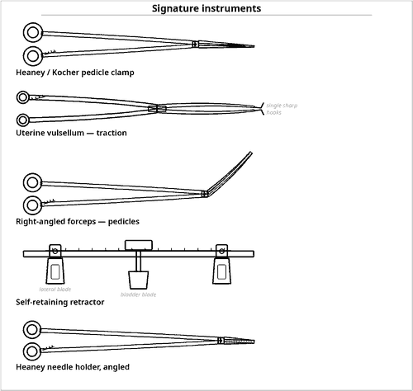  Fig 2.4 — Pedicle control is the whole operation
The ureter
▪ The ureter passes beneath the uterine artery at the base of the broad ligament — *water under the bridge*.
▪ This is the site of the classic surgical injury, and the reason the tray carries atraumatic DeBakey forceps, malleable retractors and available ureteric stents.

Contents of the tray
Qty | Instrument | Key feature / rationale
BASE SET
1 | Complete major procedures tray | see 1.1
1 | Long instruments tray | for a deep pelvis or obese patient
PEDICLE CLAMPS — THE DEFINING GROUP
6 | Heaney clamps, curved and angled | signature item — heavy, angled, atraumatic tip for the uterine and cardinal pedicles
4 | Zeppelin / Wertheim hysterectomy clamps | long angled pedicle clamps
4 | Rogers / Kocher heavy crushing clamps | round ligament and specimen side
4 | Right-angled (Mixter) forceps | encircling pedicles for ligation
6 | Long Rochester-Péan forceps | broad ligament
2 | Ovarian / adnexal clamps | infundibulopelvic ligament
GRASPING AND UTERINE MANIPULATION
2 | Uterine vulsellum (Teale / Duplay) forceps | traction on the uterine fundus
2 | Myoma screw / corkscrew | traction on a large fibroid uterus
2 | Lahey or tenaculum forceps | cervix and vault angles
4 | Allis forceps, long | vaginal vault edges
2 | DeBakey forceps, long | ureter and bladder — atraumatic
RETRACTION AND EXPOSURE
1 | Balfour self-retaining retractor with bladder blade | the standard pelvic self-retainer
1 | O'Sullivan-O'Connor or Bookwalter ring retractor | alternative self-retaining system
2 | Deaver retractors, deep | narrow deep blade exposing the pelvic side wall
2 | Malleable retractors | protect bladder, bowel and ureter
2 | Richardson retractors | abdominal wall
— | Moist laparotomy packs | pack the bowel out of the pelvis
VAULT, SUTURING AND CLOSURE
2 | Heaney needle holders, angled | signature item — suturing deep in the pelvis at an angle
2 | Needle holders, long 25 cm | reaches the vaginal vault from an abdominal incision
— | Absorbable suture 0 and 1 on a heavy round needle | pedicle ligation and vault closure
— | Transfixion and stay sutures | angles of the vault
1 | Ligature carrier (Deschamps) | deep pedicles
— | Ligating clips and appliers | rapid alternative to ties on the infundibulopelvic pedicle
1 | Long fine scissors and diathermy extension | division and haemostasis deep in the pelvis
— | Vaginal pack and antiseptic | vagina prepared before the abdomen
— | Urinary catheter | bladder must be empty and catheterised
— | Closed suction drain and specimen container | drain for the pelvic dead space; uterus labelled and orientated
— | Ureteric stents / catheters | available when the anatomy is distorted

Additional supplies and accessories
Position — Supine, slight Trendelenburg; lithotomy or Lloyd-Davies if vaginal access is needed.
Preparation — Vaginal and abdominal antiseptic preparation, urinary catheter, prophylactic antibiotics, thromboprophylaxis, cross-matched blood.
Structures at risk — Ureter (crosses beneath the uterine artery at the cardinal ligament — 'water under the bridge'), bladder at the vesicouterine fold, rectum posteriorly, and the internal iliac vessels.
Examination pointers
▪ The Heaney clamp and Heaney angled needle holder are the signature pair — name them first.
▪ State the sequence of pedicles: round ligament → adnexal (infundibulopelvic or ovarian) → bladder reflection → uterine artery → cardinal and uterosacral → vault.
▪ The ureter beneath the uterine artery is the anatomical point most often awarded marks.
▪ Mention vaginal preparation and a urinary catheter as part of tray preparation.
▪ Myoma screw for a large fibroid uterus is a distinguishing detail.

2.5 Caesarean Section Tray
Also called: LSCS tray · lower segment caesarean section set
Caesarean section delivers the fetus through the abdominal and uterine walls. Two features make its tray distinctive: it must be fast — assembled and checked for possible emergency use at any moment — and it must serve two patients, so a complete neonatal resuscitation set is part of the preparation.  Used for / includes  ▪ Elective LSCS — malpresentation, placenta praevia, previous sections, maternal request  ▪ Emergency LSCS — fetal distress, failure to progress, cord prolapse, abruption  ▪ Classical (upper segment) section for a transverse lie or anterior praevia  ▪ Caesarean hysterectomy for uncontrollable haemorrhage  ▪ Concurrent sterilisation or myomectomy |  | 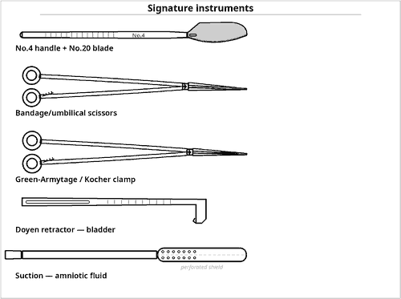  Fig 2.5 — Speed, exposure and haemostasis
Two patients, one tray
▪ The caesarean tray is the only tray in this syllabus prepared for two patients simultaneously.
▪ Neonatal resuscitation equipment is part of the tray preparation and must be checked before the skin incision — a mark that is very often missed.

Contents of the tray
Qty | Instrument | Key feature / rationale
BASE SET
1 | Basic to major procedures tray | hospital-standard 'caesarean set' — a reduced major tray
UTERINE INCISION AND DELIVERY
2 | Knife handle No.4 with No.20 blade | skin and a second for the uterus
1 | Bandage / blunt-tipped scissors | extending the uterine incision without injuring the fetus
1 | Doyen retractor | signature item — retracts and protects the bladder from the lower segment
6 | Green-Armytage clamps | signature item — atraumatic clamps on the uterine incision edges; control bleeding and mark the angles
4 | Allis or sponge forceps | membrane and edge handling
1 | Amniotomy hook / artery forceps | rupturing the membranes
1 | Wrigley's obstetric forceps or vacuum cup | assists a deeply engaged or floating head
1 | Fetal pillow / disimpaction device | where available for a deeply impacted head
CORD AND NEONATE
2 | Umbilical cord clamps | plus a spare for a second twin
1 | Umbilical / cord scissors | blunt-tipped
2 | Straight artery forceps | clamping the cord before division
— | Cord-blood sampling tubes and syringe | pH, blood group, Coombs
— | Warm dry towels and a hat | thermal care
1 | Complete neonatal resuscitation trolley | overhead heater, suction, bag-valve-mask, laryngoscope, ET tubes, oxygen, drugs — checked before the skin incision
HAEMOSTASIS AND UTERINE CLOSURE
2 | Needle holders | heavy pattern to drive a large round-bodied needle through myometrium
— | Absorbable suture 1 or 0 on a large round needle | single- or double-layer uterine closure
6 | Rochester-Péan / Kocher clamps | angles of the uterine incision
2 | Long right-angled forceps | extending an angle tear
— | Uterotonic drugs — oxytocin, ergometrine, carboprost, misoprostol | checked and drawn up before delivery
— | Intrauterine balloon tamponade (Bakri) device | for atonic postpartum haemorrhage
— | B-Lynch suture material | compression suturing
— | Vascular clamps and hysterectomy clamps available | if caesarean hysterectomy becomes necessary
SUCTION, ACCESSORY AND CLOSURE
1 | Poole or Yankauer suction with wide-bore tubing | large volumes of amniotic fluid and blood
2 | Large suction reservoirs | amniotic fluid volume greatly exceeds that of any other operation
— | Abdominal packs, counted | radio-opaque; counted before uterine closure
— | Placenta receiver / bowl | placenta examined and weighed
— | Urinary catheter with drainage bag | inserted before starting
— | Skin closure — subcuticular suture or staples | cosmetic closure of a Pfannenstiel incision
— | Cross-matched blood available | obstetric haemorrhage can be sudden and massive

Additional supplies and accessories
Position — Supine with a 15° left lateral tilt or manual uterine displacement to avoid aortocaval compression.
Incision — Pfannenstiel (transverse suprapubic) is usual; a midline vertical incision is used for extreme urgency or difficult access.
Preparation — Antacid prophylaxis, urinary catheter, prophylactic antibiotics, cross-matched blood, two wide-bore intravenous lines, and a paediatrician/neonatal team present.
Critical timing — For a category-1 emergency the decision-to-delivery interval target is 30 minutes; the tray must therefore be pre-assembled and checked, never built from scratch.
Examination pointers
▪ Name Green-Armytage clamps and the Doyen retractor — the two instruments unique to this tray.
▪ Uterotonics drawn up in advance and cross-matched blood are part of preparation, not afterthoughts.
▪ State the left lateral tilt to prevent aortocaval compression.
▪ Wide-bore suction with large reservoirs — amniotic fluid volume is unlike any other operation.
▪ Include the neonatal resuscitation trolley, checked beforehand, and the 30-minute decision-to-delivery target.
▪ Have PPH escalation items ready: Bakri balloon, B-Lynch suture, hysterectomy clamps.

2.6 Vaginal Hysterectomy Tray
Also called: VH tray · vaginal route hysterectomy set · pelvic floor repair tray
Vaginal hysterectomy removes the uterus entirely through the vagina. The whole operation is performed in a narrow, deep, poorly lit tube, working from below upward — the reverse of the abdominal sequence. The tray is therefore built around angled, curved and long instruments, self-retaining vaginal retraction and good illumination.  Used for / includes  ▪ Uterine prolapse (the classic indication) with or without cystocele/rectocele  ▪ Benign uterus of modest size with adequate descent  ▪ Dysfunctional uterine bleeding in a multiparous woman  ▪ Combined with anterior and posterior colporrhaphy (pelvic floor repair)  ▪ Combined with sacrospinous fixation for vault support |  | 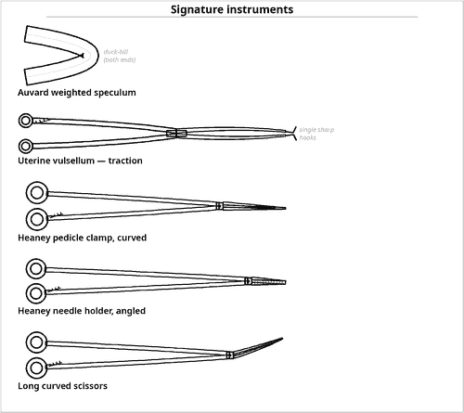  Fig 2.6 — Angled instruments for a deep narrow field
Why everything is angled
▪ The operative field is a deep narrow tube entered from below.
▪ Straight instruments cannot reach the pedicles at the correct angle, so Heaney clamps and Heaney angled needle holders are used.
▪ The Auvard weighted speculum replaces an assistant's retractor.

Contents of the tray
Qty | Instrument | Key feature / rationale
BASE SET
1 | Complete D&C tray | see 2.1 — provides the vaginal exposure instruments
1 | Abdominal hysterectomy tray, open and available | for conversion if descent is inadequate or haemorrhage occurs
VAGINAL EXPOSURE
1 | Auvard weighted vaginal speculum | signature item — its weight retracts the posterior wall without an assistant
2 | Sims or Landon lateral vaginal retractors | lateral walls
1 | Anterior vaginal wall retractor | bladder retraction
1 | Deaver retractor, narrow | deep lateral exposure
1 | Head-light or lighted retractor | illumination is a genuine problem in this operation
4 | Allis forceps, long | vaginal wall and vault edges
TRACTION AND PEDICLE CONTROL
2 | Uterine vulsellum (Teale) forceps | progressive downward traction on the cervix and uterus
2 | Cervical tenaculum / Littlewood forceps | initial grip on the cervix before the vulsellum takes over
6 | Heaney clamps, curved and angled | signature item — the pedicle clamp of vaginal surgery
4 | Zeppelin / Wertheim clamps, long curved | long curve reaching the cardinal ligament from below
4 | Long Rochester-Péan / Kocher clamps | uterosacral and cardinal ligaments
2 | Right-angled forceps, long | encircling deep pedicles
2 | Myoma screw | traction on a bulky uterus
CUTTING, DISSECTING AND SUTURING
2 | Knife handle No.3 with No.10 / No.15 blades | circumferential vaginal incision
2 | Long curved Metzenbaum / Mayo scissors | opening the pouch of Douglas and the vesicouterine space
2 | Heaney needle holders, angled | signature item — suturing at depth around a curve
2 | Needle holders, long straight | complements the angled Heaney holder for vault sutures
— | Absorbable suture 0 and 1 on heavy curved needles | pedicle ligation, vault closure, McCall culdoplasty
1 | Ligature carrier (Deschamps / Miya hook) | sacrospinous fixation
— | Long stay sutures | vault angles
1 | Long fine-tipped diathermy extension | haemostasis at the top of a deep narrow vaginal field
PELVIC FLOOR REPAIR ADDITIONS
2 | Allis and Kocher forceps | defining the vaginal flaps
1 | Fascial dissecting scissors | anterior and posterior colporrhaphy
— | Delayed absorbable suture 2-0 | plication of pubocervical and rectovaginal fascia
— | Mesh / graft material | only if specifically planned
1 | Perineal repair set | perineorrhaphy where indicated
ACCESSORY
1 | Suction tip, long fine | clears blood from a tube-like field without obscuring the view
— | Vaginal pack with antiseptic or oestrogen cream | haemostasis and support
— | Urinary catheter | indwelling; bladder injury risk is significant
— | Specimen container | uterus and cervix
— | Counted swabs and packs | a pack left in the vagina is a classic retained item — count and document

Additional supplies and accessories
Position — Lithotomy with the buttocks projecting slightly beyond the table edge, thighs well flexed and abducted; Trendelenburg tilt aids exposure.
Prerequisites — Adequate uterine descent, a mobile uterus of no more than about 12 weeks' size, and no adnexal mass — otherwise the abdominal route is chosen.
Structures at risk — Bladder anteriorly (during the vesicouterine dissection), rectum posteriorly, ureters at the cardinal ligament, and the vaginal vault vessels.
 | Abdominal hysterectomy | Vaginal hysterectomy
Access | Laparotomy — direct view | Through the vagina — deep narrow tube
Pedicle sequence | Round ligament first, downward | Uterosacral/cardinal first, upward
Key retractor | Balfour self-retaining with bladder blade | Auvard weighted speculum
Key clamp | Heaney / Zeppelin (straight approach) | Heaney curved and angled
Key needle holder | Long straight | Heaney angled
Illumination | Adequate from theatre lights | Often needs a head-light
Main advantages | Any uterine size; adnexa accessible | No abdominal scar; faster recovery

Table 2.1 — Abdominal versus vaginal hysterectomy trays
Examination pointers
▪ The three signatures are the Auvard weighted speculum, Heaney curved clamp and Heaney angled needle holder.
▪ The pedicle sequence is the reverse of the abdominal route — uterosacral and cardinal ligaments first, working upward to the adnexal pedicle.
▪ Illumination (head-light) is a genuine requirement — mention it.
▪ Always state that an abdominal tray is available for conversion.
▪ The vaginal pack must be counted and documented — a classic retained-item scenario.
▪ Note that VH is frequently combined with pelvic floor repair, so colporrhaphy instruments are included.

