PART III — INSTRUMENT TRAYS
GENITOURINARY TRAYS

Complete, illustrated examination notes
General · Gynaecologic & Obstetric · Genitourinary · Thoracic
Cardiovascular · Orthopaedic · Neurologic · ENT · Ophthalmic · Paediatric

Legal (8.5 × 14 in) · 1.27 cm margins · monochrome print-ready
Every figure is an original line diagram, drawn for clarity in black and white

Table of Contents

The page numbers are live fields, shown as “—” until they are filled in. **To update them: press Ctrl+A then F9** (on a Mac, Cmd+A then Fn+F9) — or right-click any number and choose “Update Field”. Word normally offers to do this when the file opens. Once updated, each number is also a link: Ctrl+click it to jump to that tray.
Tray / Chapter | Page
GENITOURINARY TRAYS | —
3.1 Vasectomy Tray | —
3.2 Open Prostatectomy Tray | —
3.3 Kidney Tray | —

How to Read These Notes

Every tray chapter is built to the same pattern, so you can find the same kind of information in the same place each time. Read the lead paragraph and the figure first to fix the idea, then work through the contents table.
Lead paragraph | What the tray is for and the single idea that shapes it. If you remember nothing else from a chapter, remember this.
Used for / includes | The procedures the tray serves — useful for 'name three indications' questions.
Figure | An original line diagram of the tray's signature instruments — the items that identify it. Diagrams are schematic: they show the identifying feature (jaw pattern, bevel direction, footplate, curve) rather than a photographic likeness.
Callout box | The one concept, distinction or safety rule that examiners return to for that tray.
Contents of the tray | The full instrument list, grouped by function — cutting, grasping, clamping, retracting, suturing, suctioning — with quantities and the reason each item is present. Answer 'enumerate the contents' questions using these groups as headings.
Additional supplies | Position, draping, structures at risk and procedure-specific notes.
Comparison table | Where two trays or two instruments are easily confused, they are set side by side.
Examination pointers | The single most useful section for an MCQ paper: the specific, testable facts — named instruments, numbers, temperatures, sizes and the distinctions between similar items. Revise from these.
Common mistakes | Errors that lose marks, marked with ✗ — most of them are the distractors an MCQ will offer you.
A note on quantities | Instrument names, functions and groupings are standard. The numbers ("6 Allis clamps") vary between institutions — please cross-check them against your prescribed textbook.
Printing | Legal paper (8.5 × 14 in), 1.27 cm margins, monochrome throughout. No information depends on colour, so a black-and-white printer loses nothing.

PART III

Genitourinary Trays
Vasectomy · Open prostatectomy · Kidney

Urological trays span the extremes of scale. Vasectomy is one of the smallest sets in surgery; open prostatectomy works in the deepest, least accessible part of the pelvis; the kidney tray must handle a retroperitoneal organ approached through the flank, often requiring rib resection. All three share one need — the ability to control urine and blood and to leave drainage behind.

3.1 Vasectomy Tray
Also called: Male sterilisation set · no-scalpel vasectomy tray
Vasectomy divides and occludes the vas deferens on each side to produce permanent male sterilisation. It is a limited tray procedure performed under local anaesthesia through a tiny scrotal opening. The tray's only special requirement is a means to isolate and hold the vas without damaging the surrounding vessels.  Used for / includes  ▪ Elective permanent male sterilisation  ▪ Conventional (incisional) vasectomy  ▪ No-scalpel vasectomy (NSV) technique  ▪ Vasectomy with fascial interposition or cautery occlusion  ▪ Occasionally: vasectomy before prostatectomy to prevent epididymo-orchitis |  | 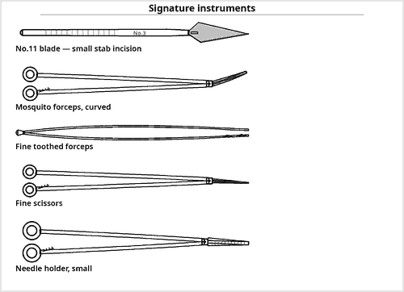  Fig 3.1 — A limited tray plus vas-specific forceps
No-scalpel vasectomy
▪ Uses only two special instruments:
▪ the ringed vas fixation clamp, and
▪ the sharp-pointed curved dissecting forceps that puncture and spread instead of cutting.
▪ Result: less bleeding, less haematoma, no sutures, faster recovery.

Contents of the tray
Qty | Instrument | Key feature / rationale
BASE SET
1 | Limited procedures tray | see 1.3
VAS-SPECIFIC INSTRUMENTS
1 | Vas deferens fixation (ring) clamp | signature item — an extracutaneous ringed clamp that traps and holds the vas against the scrotal skin
1 | Vas dissecting forceps, sharp-pointed curved | signature item of the no-scalpel technique — punctures the skin and spreads the tissues, avoiding a scalpel entirely
2 | Fine mosquito artery forceps, curved | isolating and occluding the divided ends
1 | Small Allis forceps | holds the vas sheath
2 | Fine toothed and non-toothed forceps | skin and sheath handling
CUTTING AND OCCLUSION
1 | Knife handle No.3 with No.11 or No.15 blade | conventional technique only
1 | Fine iris / tenotomy scissors | excising a segment of vas
1 | Fine needle-point cautery | intraluminal (mucosal) cautery occlusion
— | Ligating clips or fine non-absorbable ties | occluding the cut ends
— | Suture for fascial interposition | interposes the sheath between the ends — reduces recanalisation
ANAESTHESIA AND ACCESSORY
— | Local anaesthetic (lignocaine 1–2 %) with syringe and fine needle | skin weal and vasal nerve block
1 | Gallipot with antiseptic | scrotal skin preparation
— | Small drape with a central aperture | isolates a very small operative field
— | Gauze swabs, counted | radio-opaque and counted, however small the procedure
— | Two labelled specimen containers | separate left and right vas segments for histological confirmation
— | Scrotal support and dressing | compression reduces haematoma, the commonest complication
1 | Needle holder with fine absorbable suture | skin closure — often not required in NSV

Additional supplies and accessories
Position — Supine, legs slightly apart; the scrotum shaved, prepared and supported on a towel.
Counselling — The procedure must be regarded as permanent and irreversible; informed written consent, discussion of failure rate (≈1 in 2000) and the need for post-operative semen analysis are part of preparation.
Post-operative — Contraception must continue until azoospermia is confirmed, usually at 12 weeks or after about 20 ejaculations.
Complications — Haematoma, infection, sperm granuloma, chronic post-vasectomy pain, and recanalisation causing failure.
Examination pointers
▪ This is a limited tray plus two instruments — the ring clamp and the sharp dissecting forceps.
▪ Know the no-scalpel technique by name and its two instruments; it is the commonly examined modern method.
▪ Two separate labelled specimen pots — left and right — for histological confirmation of vas.
▪ Fascial interposition and mucosal cautery reduce recanalisation — name at least one.
▪ Semen analysis at ~12 weeks before relying on the procedure is a standard mark.

3.2 Open Prostatectomy Tray
Also called: Retropubic / suprapubic (transvesical) prostatectomy tray
Open prostatectomy enucleates the benign prostatic adenoma either through the bladder (suprapubic/transvesical) or through the prostatic capsule (retropubic, Millin). The field is the deepest and narrowest in general surgery, surrounded by a rich venous plexus. The tray is a major tray built for depth, illumination, enucleation and control of venous bleeding.  Used for / includes  ▪ Benign prostatic hyperplasia with a very large gland (>80–100 g)  ▪ BPH with a large bladder stone or diverticulum requiring open removal  ▪ When TURP is unsuitable — urethral stricture, inability to position, ankylosis of hips  ▪ Failed endoscopic surgery  ▪ Simple prostatectomy for chronic retention with obstructive renal impairment |  | 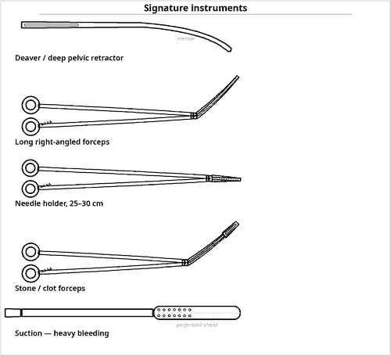  Fig 3.2 — Depth, retraction and venous control
Three-way catheter
▪ Its three channels are: balloon inflation, irrigation inflow and drainage outflow.
▪ Continuous bladder irrigation through it prevents clot retention — the commonest early post-operative emergency.
▪ Always name it as a 22–24 Fr with a 30 mL balloon.

Contents of the tray
Qty | Instrument | Key feature / rationale
BASE SET
1 | Complete major procedures tray | see 1.1
1 | Complete long instruments tray | mandatory — the retropubic space is very deep
EXPOSURE OF THE RETROPUBIC SPACE
1 | Self-retaining retractor — Millin, Balfour or Bookwalter ring system | signature item — holds the deep pelvic exposure
2 | Deaver retractors, extra-deep | the retropubic space is among the deepest fields in surgery
2 | Malleable retractors | protect the bladder and rectum
1 | Bladder (Judd-Mason) retractor | purpose-made prostatectomy retractor
1 | Head-light or fibre-optic lighted retractor | illumination is essential at this depth
— | Long moist packs | pack the space and tamponade
ENUCLEATION AND GLAND HANDLING
1 | Prostatic enucleator / adenoma spoon | signature item — develops the plane between adenoma and capsule
2 | Long Allis / Babcock forceps | traction on the adenoma
1 | Millin capsule-incising scalpel with long handle | retropubic capsulotomy
1 | Boomerang / capsule needle | haemostatic capsular sutures
2 | Long curved Metzenbaum scissors | urethral division
1 | Stone / clot forceps | bladder calculi and organised clot
1 | Bladder neck (Denis Browne) retractor | purpose-shaped blade exposing the bladder neck after enucleation
VENOUS HAEMOSTASIS — THE CENTRAL PROBLEM
6 | Long right-angled (Mixter) forceps | under-running the dorsal venous complex
4 | Long Rochester-Péan clamps | heavy long clamp for the dorsal venous complex
2 | Needle holders, 25 cm and 30 cm | deep suture ligation
— | Absorbable suture 0/1 on a large half-circle needle | capsular and bladder-neck haemostatic sutures
— | Ligature carrier and knot pusher | tying at depth
— | Haemostatic agents — cellulose, gelatin sponge, fibrin sealant | adjuncts for capsular ooze
— | Diathermy with long extension tip | reaches the prostatic cavity without arcing to retractors
— | Cross-matched blood, at least 2 units | blood loss can be substantial and rapid
DRAINAGE AND CATHETERS — ALWAYS REQUIRED
— | Three-way irrigating Foley catheter, 22–24 Fr, 30 mL balloon | signature requirement — allows continuous bladder irrigation to prevent clot retention
— | Continuous bladder irrigation set with warm normal saline | warm fluid avoids clot formation and bladder spasm
— | Suprapubic (Malecot) catheter | in the transvesical approach
— | Closed suction drain | retropubic space (prevents urinoma)
— | Catheter introducer / stylet and lubricant | guides a large three-way catheter through a distorted urethra
— | Bladder syringe | clot evacuation
— | Urine drainage bags | large capacity, since irrigation volumes are high
1 | Specimen container | adenoma weighed and sent
ENDOSCOPIC CAPABILITY KEPT AVAILABLE
1 | Cystoscope with light source | assessing the bladder and urethra
1 | Resectoscope | if the plan may change to TURP
— | Irrigation fluid on a stand | gravity feed; bag height sets the irrigation pressure

Additional supplies and accessories
Position — Supine with slight Trendelenburg; legs slightly apart. A sandbag under the sacrum improves retropubic access.
Approaches — Retropubic (Millin) — through the prostatic capsule, better visualisation of the prostatic bed and bladder neck. Suprapubic (transvesical, Freyer) — through the bladder, preferred when there is a large bladder stone or diverticulum to deal with.
Complications — Haemorrhage and clot retention (commonest early), urinary infection, incontinence, retrograde ejaculation, bladder-neck stenosis, urethral stricture, impotence, and osteitis pubis.
 | Retropubic (Millin) | Suprapubic (transvesical, Freyer)
Route | Through the prostatic capsule | Through the bladder wall
Bladder opened? | No | Yes
Best when | Pure prostatic enlargement | Large bladder stone or diverticulum
View of prostatic bed | Excellent — direct | Limited — from above
Extra catheter | Urethral only | Urethral plus suprapubic
Key retractor | Millin self-retaining retractor | Bladder (Judd-Mason) retractor

Table 3.1 — The two open approaches compared
Examination pointers
▪ State the two approaches by name — retropubic (Millin) and suprapubic/transvesical (Freyer) — and one indication for each.
▪ The long instruments tray is mandatory, not optional.
▪ Venous haemostasis dominates: long right-angled forceps, long needle holders, capsular sutures, haemostatic agents and cross-matched blood.
▪ The three-way irrigating catheter with continuous bladder irrigation is the most reliably examined item.
▪ Illumination (head-light) and a retropubic drain are easily earned marks.
▪ Name the prostatic enucleator as the gland-specific instrument.

3.3 Kidney Tray
Also called: Nephrectomy tray · renal / flank exploration set
The kidney lies retroperitoneally, high under the diaphragm and behind the ribs. The standard flank approach frequently requires removal or division of the 12th (or 11th) rib, so the kidney tray is unique among abdominal trays in carrying bone and rib instruments alongside major and vascular instruments — and it must handle the short, high-pressure renal pedicle.  Used for / includes  ▪ Simple and radical nephrectomy for tumour or non-function  ▪ Partial nephrectomy; nephron-sparing surgery  ▪ Pyelolithotomy and nephrolithotomy for renal calculi  ▪ Pyeloplasty for pelviureteric junction obstruction  ▪ Nephroureterectomy; donor and transplant nephrectomy  ▪ Drainage of a perinephric abscess; renal trauma exploration |  | 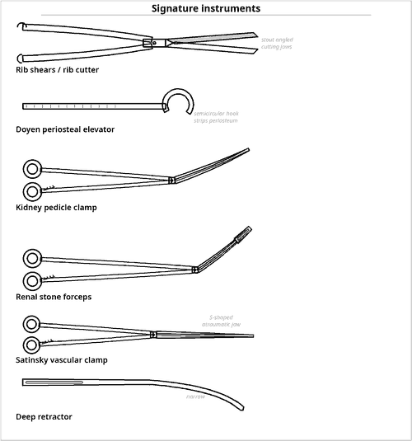  Fig 3.3 — Bone, vascular and stone instruments together
Why bone instruments are on a kidney tray
▪ The kidney lies behind the 11th and 12th ribs.
▪ The standard flank approach resects or divides the 12th rib for adequate exposure.
▪ Hence rib shears, periosteal elevator, rongeur, rasp and bone wax — and a chest drain kept ready because the pleura is often opened.

Contents of the tray
Qty | Instrument | Key feature / rationale
BASE SET
1 | Complete major procedures tray | see 1.1
1 | Long instruments tray | the renal pedicle is deep and high
RIB AND BONE INSTRUMENTS — UNIQUE TO THIS TRAY
1 | Rib shears / rib cutter | signature item — divides the 12th or 11th rib
1 | Periosteal elevator (Doyen rib raspatory) | signature item — strips periosteum from the rib before division
1 | Rib rongeur / bone nibbler | trims the cut rib end smooth
1 | Bone rasp / file | smooths a sharp rib edge
1 | Rib spreader (Finochietto), small | if the pleura is entered or the space widened
1 | Gigli saw with handles | alternative rib division
1 | Bone wax | haemostasis of the cut rib
VASCULAR CONTROL OF THE RENAL PEDICLE
2 | Satinsky (side-biting) vascular clamps | signature item — partial occlusion of the renal vein or vena cava
4 | Kidney pedicle clamps (Herrick / Guyon) | signature item — heavy clamps for the pedicle
4 | Bulldog clamps | temporary small-vessel occlusion
4 | DeBakey vascular forceps, long | atraumatic vessel handling
2 | Potts-Smith angled vascular scissors | arteriotomy or venotomy
6 | Long right-angled (Mixter) forceps | encircling the artery and vein separately
— | Vessel loops and umbilical tapes | slinging the pedicle and ureter
— | Vascular suture 4-0/5-0 on a double-armed needle | non-absorbable monofilament; double-armed for the renal pedicle
— | Vascular staplers / clip appliers | pedicle control
— | Cross-matched blood | renal haemorrhage is rapid and heavy
STONE AND COLLECTING-SYSTEM INSTRUMENTS
4 | Randall renal stone forceps, graded angles | signature item — extracting calculi from the pelvis and calyces
1 | Stone scoop and stone spoon | retrieves fragments and small calculi from the calyces
1 | Nephroscope with light source | intra-renal inspection for residual stones
1 | Ureteric catheters / stents (JJ) | splint the repair or the ureter
1 | Bougies and probes | calibrate the pelvis and ureter
— | Fine absorbable suture 4-0/5-0 | pelvis and ureteric closure — watertight
— | Intra-operative ultrasound / radiography | locates residual calculi
RETRACTION AND EXPOSURE
2 | Deaver retractors, deep | reaches the renal pedicle, which lies deep and high in the flank
2 | Richardson retractors, large | flank muscle layers
2 | Malleable retractors | protects liver, spleen, colon and duodenum
1 | Self-retaining ring / Bookwalter retractor | holds the flank exposure open without an assistant
1 | Kidney (Gil-Vernet) retractor | elevates the kidney
— | Head-light | the renal pedicle lies deep and high; theatre lights do not reach it
DRAINAGE AND CLOSURE
— | Closed suction drain | always — retroperitoneal collections and urine leak
— | Chest drain with underwater seal | kept ready — the pleura is commonly opened during rib resection
— | Nephrostomy tube | where the collecting system is drained
— | Urinary catheter | monitors output and decompresses the bladder during pelvic work
— | Specimen container | kidney orientated and labelled; calculi sent separately for analysis

Additional supplies and accessories
Position — Lateral decubitus (flank) position with the affected side up, the table broken to open the space between the 12th rib and the iliac crest, a kidney rest or bolster beneath the flank, the lower leg flexed and the upper leg straight, with an axillary roll. Anterior transperitoneal or thoraco-abdominal approaches are used for large tumours.
Structures at risk — Pleura and diaphragm superiorly (pneumothorax), colon and duodenum medially, spleen on the left, liver and vena cava on the right, and the ureter inferiorly.
Order of pedicle ligation — In radical nephrectomy the renal artery is ligated before the vein, to prevent venous engorgement of the kidney.
Examination pointers
▪ The kidney tray is the only abdominal tray carrying rib instruments — explain why (retroperitoneal position behind the 12th rib).
▪ Name the three signature groups: rib instruments, pedicle/vascular clamps, Randall stone forceps.
▪ Artery before vein in radical nephrectomy — a classic one-liner.
▪ A chest drain must be immediately available because the pleura is frequently breached.
▪ Describe the lateral flank position with the table broken and a kidney rest — positioning marks are commonly given.
▪ A retroperitoneal drain is always left, and calculi go for stone analysis.

