PART IV — INSTRUMENT TRAYS
THORACIC TRAYS

Complete, illustrated examination notes
General · Gynaecologic & Obstetric · Genitourinary · Thoracic
Cardiovascular · Orthopaedic · Neurologic · ENT · Ophthalmic · Paediatric

Legal (8.5 × 14 in) · 1.27 cm margins · monochrome print-ready
Every figure is an original line diagram, drawn for clarity in black and white

Table of Contents

The page numbers are live fields, shown as “—” until they are filled in. **To update them: press Ctrl+A then F9** (on a Mac, Cmd+A then Fn+F9) — or right-click any number and choose “Update Field”. Word normally offers to do this when the file opens. Once updated, each number is also a link: Ctrl+click it to jump to that tray.
Tray / Chapter | Page
THORACIC TRAYS | —
4.1 Mediastinoscopy Tray | —
4.2 Thoracotomy Tray | —
4.3 Pacemaker Tray | —

How to Read These Notes

Every tray chapter is built to the same pattern, so you can find the same kind of information in the same place each time. Read the lead paragraph and the figure first to fix the idea, then work through the contents table.
Lead paragraph | What the tray is for and the single idea that shapes it. If you remember nothing else from a chapter, remember this.
Used for / includes | The procedures the tray serves — useful for 'name three indications' questions.
Figure | An original line diagram of the tray's signature instruments — the items that identify it. Diagrams are schematic: they show the identifying feature (jaw pattern, bevel direction, footplate, curve) rather than a photographic likeness.
Callout box | The one concept, distinction or safety rule that examiners return to for that tray.
Contents of the tray | The full instrument list, grouped by function — cutting, grasping, clamping, retracting, suturing, suctioning — with quantities and the reason each item is present. Answer 'enumerate the contents' questions using these groups as headings.
Additional supplies | Position, draping, structures at risk and procedure-specific notes.
Comparison table | Where two trays or two instruments are easily confused, they are set side by side.
Examination pointers | The single most useful section for an MCQ paper: the specific, testable facts — named instruments, numbers, temperatures, sizes and the distinctions between similar items. Revise from these.
Common mistakes | Errors that lose marks, marked with ✗ — most of them are the distractors an MCQ will offer you.
A note on quantities | Instrument names, functions and groupings are standard. The numbers ("6 Allis clamps") vary between institutions — please cross-check them against your prescribed textbook.
Printing | Legal paper (8.5 × 14 in), 1.27 cm margins, monochrome throughout. No information depends on colour, so a black-and-white printer loses nothing.

PART IV

Thoracic Trays
Mediastinoscopy · Thoracotomy · Pacemaker

Thoracic trays are governed by one anatomical fact: the chest is a rigid bony cage containing a negative-pressure space. Every tray therefore needs instruments to get through or between the ribs, and every thoracic procedure ends with restoration of negative intrapleural pressure through an underwater-seal chest drain. A pacemaker tray is the exception — a small subcutaneous set that nevertheless carries the same pneumothorax risk.

4.1 Mediastinoscopy Tray
Also called: Cervical mediastinoscopy · Carlens procedure tray
Mediastinoscopy inspects and biopsies the paratracheal and tracheobronchial lymph nodes through a small suprasternal incision, using a tapered open scope passed down the pretracheal plane by blunt finger dissection. It is a small set with a very large potential complication: the scope lies between the great vessels, so the tray must be able to support immediate thoracotomy or sternotomy.  Used for / includes  ▪ Staging of bronchogenic carcinoma — mediastinal node sampling  ▪ Diagnosis of mediastinal lymphadenopathy — lymphoma, sarcoidosis, tuberculosis  ▪ Biopsy of a mediastinal mass  ▪ Assessment before thoracotomy for resectability  ▪ Drainage of a mediastinal abscess (rarely) |  | 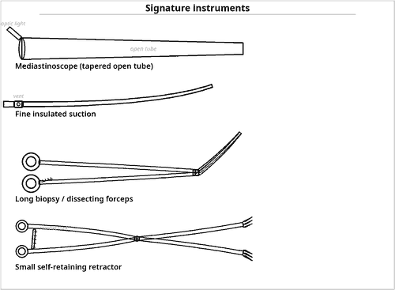  Fig 4.1 — A small set with major back-up requirements
Aspirate before you biopsy
▪ In the mediastinum a node and a vessel can look identical through a narrow scope.
▪ A fine needle is passed and aspirated first: blood means vessel — do not biopsy.
▪ This single step is the most examined safety point of the procedure.

Contents of the tray
Qty | Instrument | Key feature / rationale
BASE SET
1 | Basic / minor procedures tray | see 1.2 — the incision itself is small
THE SCOPE SYSTEM
1 | Mediastinoscope, tapered open tube | signature item — slightly flattened, open-ended, with an integral or attachable light
1 | Fibre-optic light carrier, cable and source | cold light
1 | Camera, coupler and monitor | for video-assisted mediastinoscopy and teaching
1 | Suction–coagulation (insulated) cannula | combined suction and cautery down the scope
INSTRUMENTS PASSED DOWN THE SCOPE
2 | Long mediastinal biopsy forceps, cup pattern | node sampling
2 | Long aspirating (fine) needle with syringe | a node is aspirated before it is biopsied — to confirm it is not a vessel
2 | Long blunt dissectors / peanut carriers | sweeping tissue off the node
1 | Long insulated suction tip | insulation prevents current tracking to the great vessels
2 | Long clip applier with clips | haemostasis at depth
— | Long swab carriers with gauze pledgets | pressure haemostasis in a narrow channel
NECK EXPOSURE
2 | Small Langenbeck / Army-Navy retractors | suprasternal incision
1 | Weitlaner self-retaining retractor | holds the strap muscles apart
2 | Fine artery forceps and Adson forceps | superficial haemostasis and skin handling at the neck incision
1 | Fine Metzenbaum scissors | dividing the pretracheal fascia
2 | Malleable retractor, narrow | protects the trachea
EMERGENCY BACK-UP — THE DEFINING REQUIREMENT
1 | Complete thoracotomy tray, open and ready | see 4.2 — for uncontrollable bleeding
1 | Sternal saw and sternotomy set available | median sternotomy gives the fastest access to the great vessels
— | Vascular clamps, vascular suture and haemostatic agents | for control if the innominate artery or azygos vein is injured
— | Cross-matched blood immediately available | haemorrhage from the innominate artery or azygos vein is catastrophic
— | Chest drain with underwater seal | the pleura may be entered

Additional supplies and accessories
Position — Supine with the neck extended over a head-ring and slight head-up tilt, as for thyroidectomy; a small transverse incision one finger-breadth above the sternal notch.
Technique — The pretracheal plane is opened by blunt finger dissection anterior to the trachea, the scope is passed along the finger track, and nodes are identified, aspirated with a needle first and then biopsied.
Structures at risk — Innominate (brachiocephalic) artery, aortic arch, azygos vein, superior vena cava, pulmonary artery, recurrent laryngeal nerve, trachea and oesophagus. This concentration of great vessels in a blind narrow channel is what makes the procedure hazardous.
Complications — Major haemorrhage, pneumothorax, recurrent laryngeal nerve palsy, oesophageal or tracheal injury, wound infection, mediastinitis and air embolism.
Examination pointers
▪ The signature item is the tapered open mediastinoscope; all working instruments are long.
▪ State the aspirate-before-biopsy rule explicitly.
▪ The thoracotomy tray and sternal saw must be open and ready — marks are given for recognising this.
▪ Name the vessels at risk, particularly the innominate artery and azygos vein.
▪ Access is by blunt finger dissection in the pretracheal plane — mention it.

4.2 Thoracotomy Tray
Also called: Posterolateral thoracotomy tray · lung resection set
Thoracotomy opens the chest between the ribs to reach the lung, pleura, oesophagus or mediastinum. The tray is a major tray plus three distinct groups: rib instruments to enter and spread the chest, pulmonary vascular and bronchial instruments to divide the hilum, and closure/drainage equipment to restore negative intrapleural pressure.  Used for / includes  ▪ Lobectomy, pneumonectomy and wedge resection for carcinoma  ▪ Decortication and pleurectomy for empyema or trapped lung  ▪ Open lung biopsy; excision of a bulla or blebs  ▪ Oesophagectomy (thoracic component)  ▪ Repair of thoracic trauma; drainage of a haemothorax  ▪ Excision of a mediastinal mass |  | 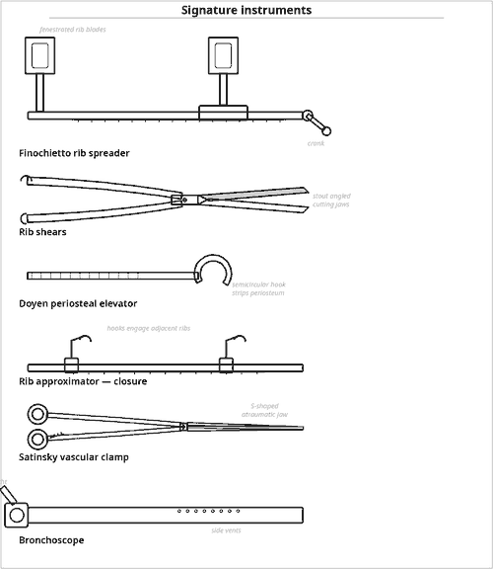  Fig 4.2 — Enter, spread, divide, close, drain
Chest drain rules
▪ Drains are placed apically for air and basally for fluid.
▪ The underwater seal acts as a one-way valve, letting air out and none in.
▪ Two clamps travel with every chest drain.
▪ The bottle is kept below the level of the chest at all times.

Contents of the tray
Qty | Instrument | Key feature / rationale
BASE SET
1 | Complete major procedures tray | see 1.1
1 | Long instruments tray | the hilum is deep within the cage
RIB INSTRUMENTS — ENTERING AND SPREADING THE CHEST
1 | Finochietto rib spreader (self-retaining) | signature item — rack-and-crank retractor that spreads the intercostal space
1 | Rib shears / rib cutter | divides a rib
1 | Doyen periosteal elevator (rib raspatory) | signature item — semicircular hook stripping periosteum from the rib
1 | Rib rongeur / bone nibbler | trimming the cut rib end
1 | Rib approximator | signature item — pulls adjacent ribs together for closure
1 | Bone rasp and bone wax | rasp smooths the cut rib so it cannot lacerate lung; wax seals bleeding marrow
1 | Gigli saw with handles | alternative rib division
1 | Sternal saw and sternal wire set | if the approach is converted to sternotomy
1 | Alexander / Matson periosteotome | raising periosteum along the rib
LUNG, HILAR AND BRONCHIAL INSTRUMENTS
4 | Lung (Duval / Pennington) grasping forceps | signature item — triangular atraumatic jaws for holding lung tissue
2 | Bronchus clamp (Sarot / Lees) | occludes the bronchus before division
2 | Satinsky (side-biting) vascular clamps | pulmonary artery and vein
4 | Bulldog clamps | small pulmonary vessels
4 | DeBakey vascular forceps, long | atraumatic
2 | Potts-Smith angled vascular scissors | angled blades to open a pulmonary vessel accurately
6 | Long right-angled (Mixter) forceps | encircling hilar structures
— | Vessel loops and umbilical tapes | sling and gently occlude hilar structures without clamping
1 | Bronchial / pulmonary stapler with reloads | the modern method of dividing bronchus and vessels
1 | Bronchoscope with light source | available — checks the bronchial stump and clears secretions
— | Vascular suture 3-0 to 5-0 double-armed | non-absorbable monofilament for the pulmonary artery and vein
RETRACTION AND EXPOSURE
2 | Deaver retractors, deep | narrow blade reaching the pulmonary hilum between spread ribs
2 | Malleable retractors | protects lung and pericardium
2 | Richardson retractors | chest wall layers
1 | Scapular retractor | elevates the scapula in a posterolateral approach
— | Moist packs / lung swabs | packing the lung away
— | Head-light | directs light into the depth of the chest cavity
CLOSURE AND DRAINAGE — NEVER OMITTED
— | Chest drain(s), 28–32 Fr, with trocar or clamp | signature requirement — apical drain for air, basal drain for fluid
1 | Underwater-seal drainage system | restores and maintains negative intrapleural pressure
2 | Chest drain (tube) clamps | two clamps must accompany every chest drain
— | Heavy non-absorbable suture / sternal wire | pericostal closure
— | Rib approximator | brings the ribs together
1 | Wire twister and wire cutter | if sternotomy was performed
— | Absorbable suture for muscle layers | closes latissimus dorsi and serratus in layers
— | Suction source and tubing | two circuits: one for the field, one for the chest drain
— | Specimen container | lung specimen orientated and labelled; nodes sent separately by station

Additional supplies and accessories
Position — Lateral decubitus with the operative side up, arm forward on an arm-board, axillary roll, table flexed to open the intercostal spaces; the lower leg flexed with padding between the knees.
Anaesthesia — Double-lumen endotracheal tube for one-lung ventilation, allowing the operative lung to be collapsed.
Incision — Posterolateral thoracotomy through the 5th or 6th intercostal space is standard; anterolateral for trauma; median sternotomy for bilateral or mediastinal access.
Complications — Haemorrhage, persistent air leak, bronchopleural fistula, empyema, atelectasis and pneumonia, post-thoracotomy pain, arrhythmia and chylothorax.
Examination pointers
▪ Name the four rib instruments: Finochietto spreader, rib shears, Doyen periosteal elevator, rib approximator.
▪ Duval lung forceps is the lung-specific grasper.
▪ Chest drain + underwater seal + two clamps must appear in every answer.
▪ Mention one-lung ventilation via a double-lumen tube — an easy mark showing you understand the operation.
▪ Describe the lateral decubitus position with the table flexed and an axillary roll.
▪ Bronchoscope available to check the bronchial stump.

Common mistakes to avoid
✗ Omitting the chest drain and underwater seal.
✗ Forgetting the rib approximator for closure — candidates remember how to open but not how to close.
✗ Not mentioning cross-matched blood.
✗ Confusing Finochietto (spreads ribs apart) with the rib approximator (brings them together).

4.3 Pacemaker Tray
Also called: Permanent pacemaker insertion tray · PPM implantation set
A permanent pacemaker consists of a pulse generator implanted in a subcutaneous or subpectoral pocket, connected to one or more leads positioned in the heart. Transvenous implantation is a small-tray procedure performed under fluoroscopy — so the tray is a minor set plus vascular access equipment, the device itself, and radiation protection.  Used for / includes  ▪ Symptomatic bradycardia; sick sinus syndrome  ▪ Complete (third-degree) and symptomatic second-degree atrioventricular block  ▪ Atrial fibrillation with slow ventricular response  ▪ Cardiac resynchronisation therapy (biventricular pacing)  ▪ Implantable cardioverter-defibrillator insertion  ▪ Generator change (elective replacement for battery depletion) and lead revision |  | 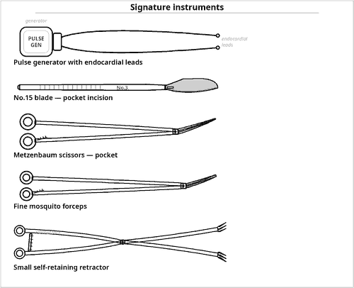  Fig 4.3 — A minor set plus the device and imaging
Small parts, big risk
▪ The torque wrench is a tiny item that is easily lost in the pocket — include it in the count.
▪ Lead stylets and anchoring sleeves are also small and countable.
▪ Pneumothorax is the classic early complication of subclavian puncture — a chest X-ray follows every implant.

Contents of the tray
Qty | Instrument | Key feature / rationale
BASE SET
1 | Basic / minor procedures tray | see 1.2 — the pocket is a superficial dissection
VENOUS ACCESS
1 | Introducer needle with syringe | subclavian, axillary or cephalic vein puncture
— | Guidewires (J-tipped) | Seldinger technique
2 | Peel-away introducer sheaths and dilators, sized | signature item — admit the lead, then peel away
1 | Vein pick / cephalic vein cut-down set | for the cephalic vein approach
1 | Fine vascular dissecting forceps and scissors | cephalic vein cut-down needs vascular-quality instruments
— | Heparinised saline flush | keeps the sheath and lead lumen free of thrombus
THE DEVICE AND LEADS
1 | Pulse generator (single- or dual-chamber) | checked for model, serial number and battery status before opening
2 | Endocardial pacing leads — active (screw-in) or passive (tined) fixation | right atrium and right ventricle
— | Lead stylets, straight and curved | shape the lead for positioning
1 | Torque wrench / hex screwdriver | signature item — tightens the set-screw in the generator header; it is tiny and must be counted
— | Lead anchoring sleeves and non-absorbable ties | secure the lead to the pectoral fascia
1 | Pacing system analyser (PSA) with cables | measures threshold, impedance and R-wave amplitude
1 | Programmer / telemetry wand | interrogates and programmes the device
— | Epicardial lead set and screw-in electrodes | for the surgical/epicardial route
POCKET FORMATION AND CLOSURE
1 | Knife handle No.3 with No.15 blade | infraclavicular incision
2 | Metzenbaum scissors | blunt dissection of the pocket
2 | Weitlaner / small self-retaining retractor | holds the pocket open so both hands are free to handle the leads
2 | Army-Navy or Langenbeck retractors | retracts the pocket edges during generator insertion
8 | Fine mosquito and Crile forceps | haemostasis
1 | Diathermy pencil | used with caution — interference with the device
2 | Needle holders | absorbable to fascia and subcutaneous tissue, subcuticular to skin
— | Antibiotic irrigation / antibacterial envelope | device infection is a serious complication
IMAGING AND RADIATION PROTECTION
1 | Image intensifier (C-arm) with sterile drape | essential — lead position is confirmed fluoroscopically
— | Lead aprons, thyroid shields and dosimeters for all staff | radiation protection is part of tray preparation
— | Radiolucent operating table and arm-boards | allows unobstructed fluoroscopic screening of the lead path
1 | ECG monitor, defibrillator and external pacing capability | must be immediately available — lead placement can provoke arrhythmia or asystole
— | Contrast medium | venography if venous access is difficult
— | Chest drain and thoracotomy back-up available | for pneumothorax or cardiac perforation/tamponade

Additional supplies and accessories
Position — Supine with the arm on the operative side adducted or slightly abducted; the head turned away; left infraclavicular site is usual (favourable lead curve to the right ventricle).
Preparation — Antibiotic prophylaxis, ECG monitoring, intravenous access, anticoagulation reviewed, skin prepared widely from the neck to the nipple, and the device model confirmed against the plan.
Complications — Pneumothorax and haemothorax (subclavian puncture), pocket haematoma, lead displacement, cardiac perforation with tamponade, arrhythmia during lead placement, diaphragmatic pacing, device infection and erosion, and Twiddler's syndrome.
Examination pointers
▪ This is a minor tray procedure — say so, then list the additions.
▪ Name the peel-away introducer sheath and the torque wrench; both are unique to this tray.
▪ Fluoroscopy with an image intensifier and lead aprons for all staff is part of tray preparation.
▪ A defibrillator with external pacing must be immediately available.
▪ Pneumothorax is the complication to quote, with a post-procedure chest X-ray.
▪ The pacing system analyser confirms thresholds before closure — a detail that distinguishes a good answer.

