Solution

Question 01

|  |
| --- |
| System Log |
| [start_transaction,T3]  [read_item, T3, C, 40]  [write_item, T3, B, 15,12]  [start_transaction, T2]  [read_item, T2, B, 15]  [write_item, T2, B, 12,18]  [start_transaction,T1]  [read_item, T1, A, 30]  [read_item, T1, D, 20]  [write_item, T1, D, 20,25]  [commit, T1]  [read_item, T2, D, 25]  [write_item, T2, D, 25,26]  [read_item, T3, A, 30]  System crash |

T3 is rolled back because it did not reach its commit point.

T2 is rolled back because it reads the value of item B written by T3.

T1 is redone.

A=30, B=15, C=40,D=25

Question 02

A.

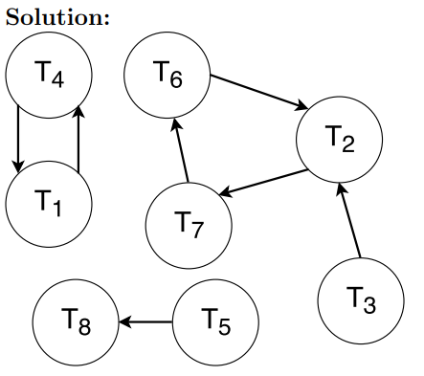

B.

T1, T2, T3, T4, T6, and T7.

C.



D.

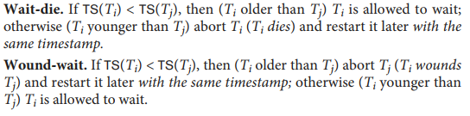

Question 03:

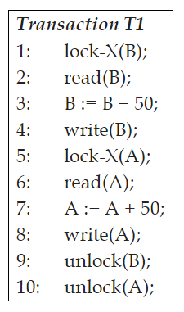

Question 04:

A.

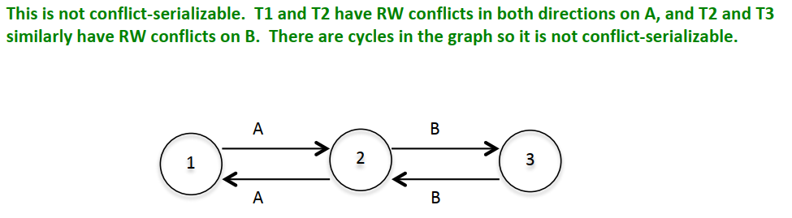

Non Recoverable

B.

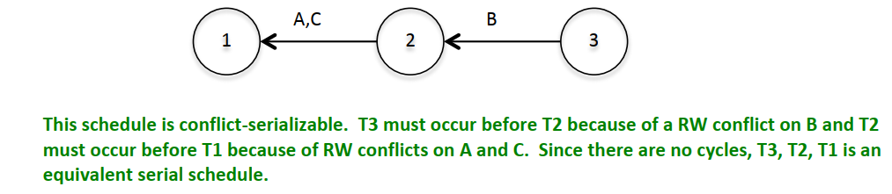

Recoverable

Question 05:

**Second Normal Form:**

MemberDinnerFood (*MemberNum*, DinnerNum, FoodCode)

MEMBER(*MemberNum*, MemberName, MemberAddress)

DINNER(*DinnerNum*, DinnerDate, VenueCode, VenueDescription)

FOOD (*FoodCode*, FoodDescription)

**Third Normal Form:**

MemberDinnerFood (*MemberNum*, DinnerNum, FoodCode)

MEMBER(*MemberNum*, MemberName, MemberAddress)

DINNER(*DinnerNum*, DinnerDate, VenueCode)

FOOD (*FoodCode*, FoodDescription)

VENUE (*VenueCode*, VenueDescription)

Question 06:

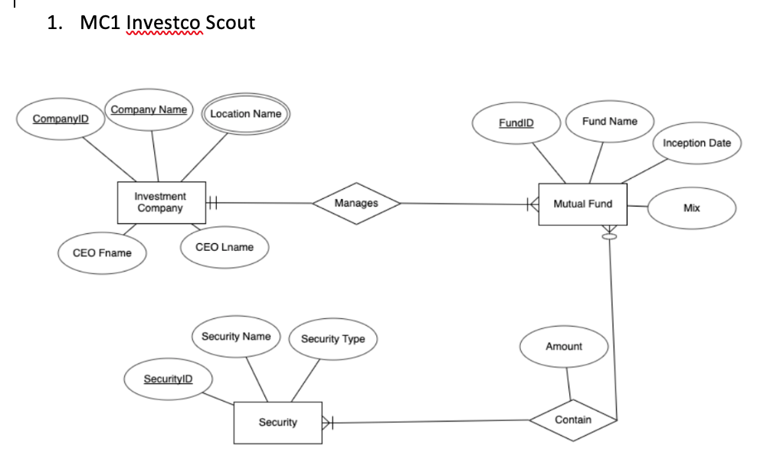

Question 07:

a.

**select title, author, publisher from**

**books inner join publishers**

**inner join publishes using (bno,pno)**

b.

**select * from books as b1,**

**books as b2**

**where b1.title=b2.title and**

**b1.author != b2.author**

c.

**select title,author from**

**books inner join publishes using (bno)**

**where pages = (select max(pages) from publishes);**

d.

**select publisher from publishers**

**where city**

**in (select city from publishers**

**group by city having count(city) >= 2);**

e.

**select title from books**

**where bno not in**

**(select distinct bno from publishes)**