Create a Lambda Function for thumbnail creation.

Image uploaded to Source bucket: srikanth-naidu65

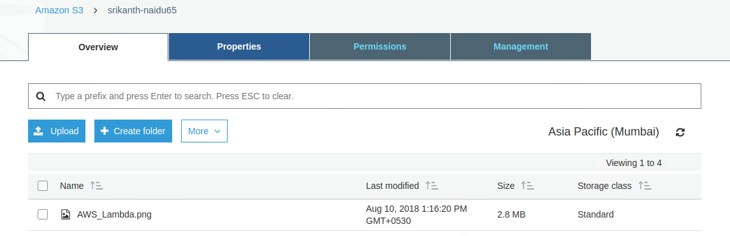

The thumbnail image is created in the destination bucket: Srikanth-naidu65-resized

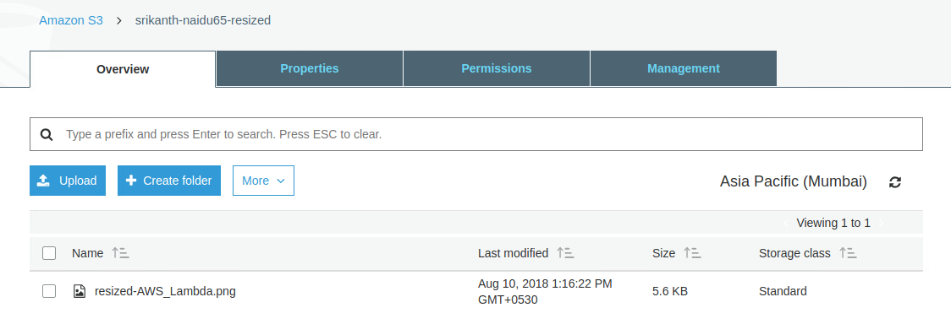

Cloudwatch Logs:

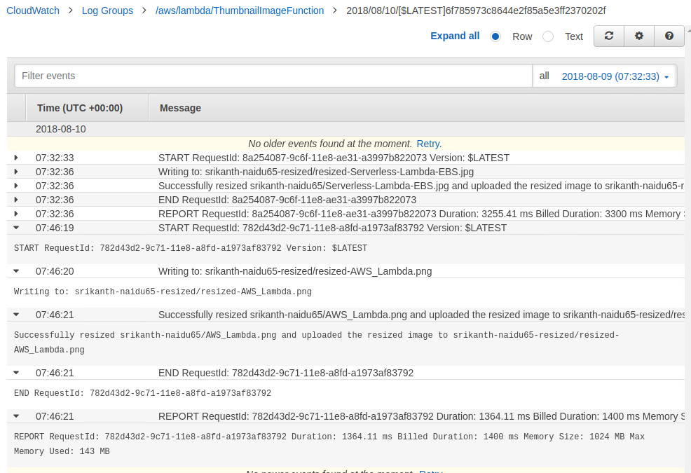

Alternatively, we can test it from AWS Lambda Console by providing the sample event source data in JSON.

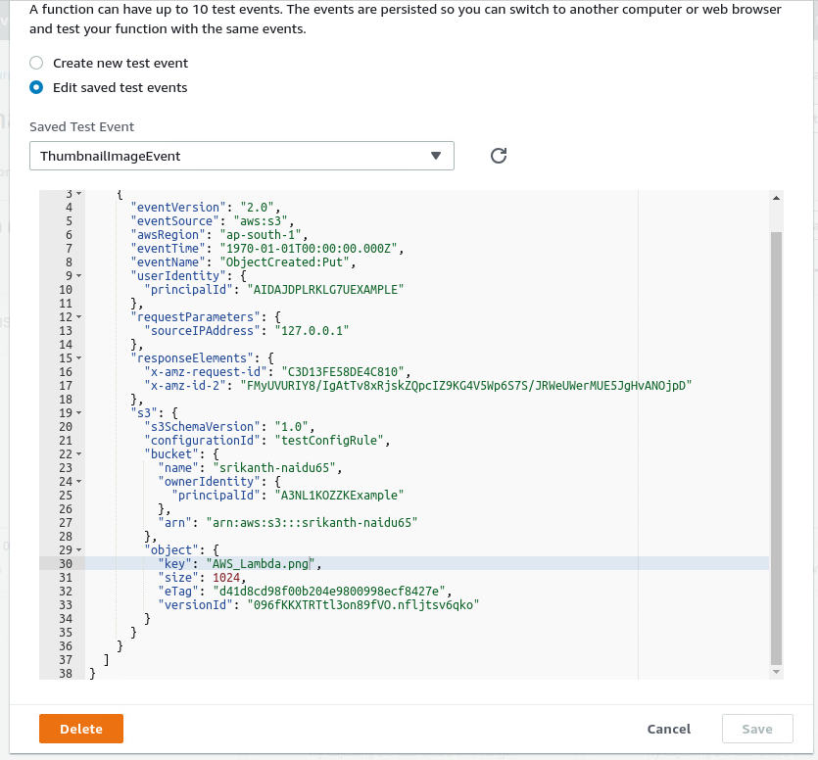

Test Results:

