**Minutiae**

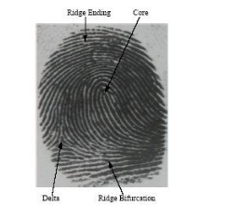

In biometrics and fingerprint scanning, minutiae refers to specific plot points on a fingerprint. This includes characteristics such as ridge bifurcation or a ridge ending on a fingerprint.

Key functionalities that should be considered in fingerprint SDK

* Matching Speed: how much time it takes to match extracted data. For example: best performing scanners can examine over 1 million fingerprint records per second
* Accuracy ( FRR- False Rejection Rate and FAR – False acceptance Rate) : The accurately the device recognizes the matched one should be a concern
* fingerprint reside on your servers or ours: