Machine-Learning Detection of Anomalous Model-Rocket Flights Using Simulated Sensor Data
Example Student Research Paper
Prepared as an educational model for science-fair and ISEF-style projects
Student: Jordan Lee (fictional)
Grade: 10
Category: Robotics and Intelligent Machines / Embedded Systems
Research Period: September 2025-May 2026
School: Example STEM Academy
Location: Houston, Texas, USA
IMPORTANT NOTE
This document is a fully written example. The student, school, datasets, measurements, and numerical results are fictional and must not be submitted as original research. Students should replace every section with their own work, maintain an authentic research notebook, and complete all required competition forms and approvals before experimentation.

Abstract
Model rockets provide an accessible platform for studying flight dynamics, but identifying abnormal launches normally requires expert review of telemetry and video. This study investigated whether machine-learning models could distinguish normal from anomalous simulated rocket flights using time-series sensor features. A dataset of 600 OpenRocket simulations was generated, including 400 normal flights and 200 anomalous flights representing excessive wind, low motor impulse, unstable center-of-pressure margin, parachute deployment failure, and sensor noise. Twenty-four features were extracted from altitude, velocity, acceleration, orientation, and descent profiles. Logistic regression, random forest, gradient boosting, and a probability-averaged ensemble were evaluated using grouped train-validation-test splits designed to prevent near-duplicate configurations from appearing in multiple splits. The proposed ensemble achieved 94.0% F1 score, 95.0% accuracy, 93.2% recall, and 96.1% area under the receiver operating characteristic curve on the held-out test set. It outperformed logistic regression by 16 percentage points in F1 score and reduced false negatives to eight cases. Feature-ablation analysis indicated that descent-rate variability, peak angular velocity, and maximum lateral acceleration contributed most strongly to anomaly detection. The results suggest that a low-cost flight-review tool could automatically flag potentially unsafe or unusual launches for closer inspection. Limitations include reliance on simulated rather than physical launches and incomplete representation of real sensor failure modes. Future work should validate the method using independently collected onboard telemetry from real rockets.
Keywords: model rockets, anomaly detection, machine learning, simulation, flight telemetry, safety

Contents
1. Introduction | 3
2. Literature Review | 4
3. Materials and Methods | 5
4. Results | 8
5. Discussion | 11
6. Limitations | 13
7. Conclusion | 13
8. Future Work | 14
9. Acknowledgments | 14
10. References | 14
Appendices | 16

1. Introduction

1.1 Background
Model rockets are widely used in science, technology, engineering, and mathematics education because they combine physics, engineering design, data collection, and risk management. A typical flight includes powered ascent, coasting, apogee, recovery-system deployment, and descent. Deviations during any phase can indicate an unsafe configuration, an environmental disturbance, a recovery-system problem, or unreliable sensor data.
Traditional launch analysis often depends on visual inspection and manual comparison of altitude, acceleration, and orientation plots. This process is practical for a small number of launches but becomes time consuming when students generate hundreds of simulations or repeated test flights. Automated anomaly detection could help students identify unusual flights, prioritize cases for review, and connect abnormal telemetry patterns to possible causes.
Machine learning is well suited to this problem because a flight anomaly may not be represented by a single threshold. For example, high lateral acceleration may be acceptable during a short gust but concerning when accompanied by increasing angular velocity and reduced altitude. A model can combine several measurements and learn patterns that distinguish normal variation from abnormal behavior.

1.2 Problem Statement
Existing model-rocket simulation workflows provide detailed graphs but do not always provide a simple, general-purpose classification of whether a flight should be considered normal or anomalous. A reproducible method is needed to summarize multidimensional telemetry and flag unusual flights without requiring manual inspection of every simulation.

1.3 Research Question
Can supervised machine-learning models accurately distinguish normal from anomalous model-rocket flights using features extracted from simulated altitude, velocity, acceleration, orientation, and recovery profiles?

1.4 Hypothesis
It was hypothesized that a nonlinear ensemble model would achieve an F1 score of at least 0.90 and outperform logistic regression because anomaly classes contain interactions among descent behavior, lateral motion, rotation, and peak acceleration that are not completely represented by a linear decision boundary.

1.5 Contributions
- A balanced simulation protocol covering five realistic anomaly categories.
- A reproducible feature-extraction pipeline for flight telemetry.
- A comparison of three baseline models and one ensemble model using leakage-resistant data splitting.
- Ablation and error analyses that identify which flight characteristics contribute most to detection.

2. Literature Review

2.1 Rocket Flight Telemetry
Rocket-flight telemetry commonly includes altitude, vertical velocity, acceleration, orientation, atmospheric conditions, and recovery events. Physics-based simulators estimate these quantities from motor characteristics, rocket geometry, mass, aerodynamic drag, and weather conditions. Simulation is valuable for early experimentation because it allows controlled variation of one factor at a time without the cost or risk of repeated physical launches.

2.2 Anomaly Detection
Anomaly detection identifies observations that differ meaningfully from expected behavior. In engineering systems, anomalies may arise from component failure, unusual operating conditions, incorrect configuration, or sensor error. Supervised classification is appropriate when labeled examples of normal and abnormal behavior are available. Unsupervised approaches may be useful when labels are scarce, but their definition of unusual behavior does not always match the safety or engineering meaning of an anomaly.

2.3 Machine Learning for Time-Series Systems
Time-series models can operate directly on sampled measurements or on summary features derived from each sequence. Direct sequence modeling can preserve detailed temporal structure but often requires larger datasets and greater computing resources. Feature-based models are easier to interpret and can perform well when domain-informed features describe critical phases such as ascent, apogee, and descent.

2.4 Research Gap
Prior work has demonstrated machine learning for aerospace fault detection and general telemetry monitoring, but there are fewer student-accessible studies focused on model rockets, reproducible simulation generation, and transparent comparison of conventional classifiers. This project addresses that educational gap by evaluating interpretable features and commonly available machine-learning methods.

3. Materials and Methods

3.1 Study Design
This was a computational experiment using labeled simulation data. The independent condition was flight class: normal or anomalous. The primary dependent measures were F1 score, recall, precision, accuracy, and ROC-AUC. The main comparison was between logistic regression, random forest, gradient boosting, and a probability-averaged ensemble.

3.2 Software and Computing Environment
Component | Example Configuration
Simulator | OpenRocket 23.09
Programming language | Python 3.12
Data processing | pandas 2.2; NumPy 2.0
Machine learning | scikit-learn 1.5
Visualization | Matplotlib 3.9
Hardware | Windows laptop, 16 GB RAM
Table 1. Software and computing environment used in the example study.

3.3 Dataset Generation
Six hundred simulated flights were generated from 120 base rocket configurations. Each base configuration varied body mass, motor selection, fin geometry, launch-rod angle, and wind speed within predefined safe ranges. Five replications were created for each configuration by varying environmental noise and small manufacturing tolerances.
Class | Flights | Operational definition
Normal | 400 | Stable flight and successful recovery
High wind / weathercocking | 45 | Strong lateral displacement and angular motion
Reduced motor impulse | 40 | Lower altitude and altered ascent duration
Low stability margin | 40 | Oscillation or unstable orientation
Parachute failure | 40 | Excessive descent rate
Sensor noise / dropout | 35 | Corrupted or missing telemetry segments
Table 2. Composition of the simulated dataset.

3.4 Feature Extraction
Each flight was resampled to a common 20 Hz time base. Missing values shorter than 0.25 seconds were linearly interpolated; longer gaps were retained as quality indicators. Twenty-four features were calculated.
- Maximum altitude
- Time to apogee
- Peak vertical velocity
- Peak total acceleration
- Maximum lateral acceleration
- Mean ascent acceleration
- Descent-rate mean and standard deviation
- Peak angular velocity
- Orientation variance
- Flight duration
- Apogee-to-deployment delay
- Number and duration of telemetry gaps

3.5 Data Splitting and Leakage Prevention
Base rocket configurations, rather than individual replications, were assigned to the data splits. Seventy percent of configurations were used for training, 15% for validation, and 15% for final testing. Therefore, near-duplicate replications of the same configuration could not appear in both training and test data. Feature scaling and missing-value imputation were fitted only on the training set.

3.6 Models
Logistic regression: Linear baseline with L2 regularization.
Random forest: Three hundred decision trees with class-balanced sampling.
Gradient boosting: Sequential decision-tree model optimized on validation F1 score.
Proposed ensemble: Arithmetic mean of calibrated random-forest and gradient-boosting anomaly probabilities.

3.7 Evaluation Metrics
The primary metric was F1 score because it balances precision and recall for the smaller anomaly class. Recall was emphasized because a false negative would allow an anomalous flight to pass without review. Accuracy and ROC-AUC were reported as secondary measures. Ninety-five percent bootstrap confidence intervals were calculated with 2,000 resamples of the test set.

3.8 Ethics, Safety, and Reproducibility
No human participants, vertebrate animals, biological agents, or physical rocket launches were involved in this example study. All data were generated by simulation. A real student project should document software versions, random seeds, configuration files, data-generation scripts, and all required science-fair approvals. Code and de-identified data should be archived when licensing permits.

4. Results

4.1 Overall Performance
Model | Precision | Recall | F1 | ROC-AUC
Logistic regression | 0.81 | 0.75 | 0.78 | 0.86
Random forest | 0.90 | 0.86 | 0.88 | 0.93
Gradient boosting | 0.92 | 0.90 | 0.91 | 0.95
Proposed ensemble | 0.95 | 0.93 | 0.94 | 0.96
Table 3. Performance on the held-out test set. Values are fictional demonstration results.
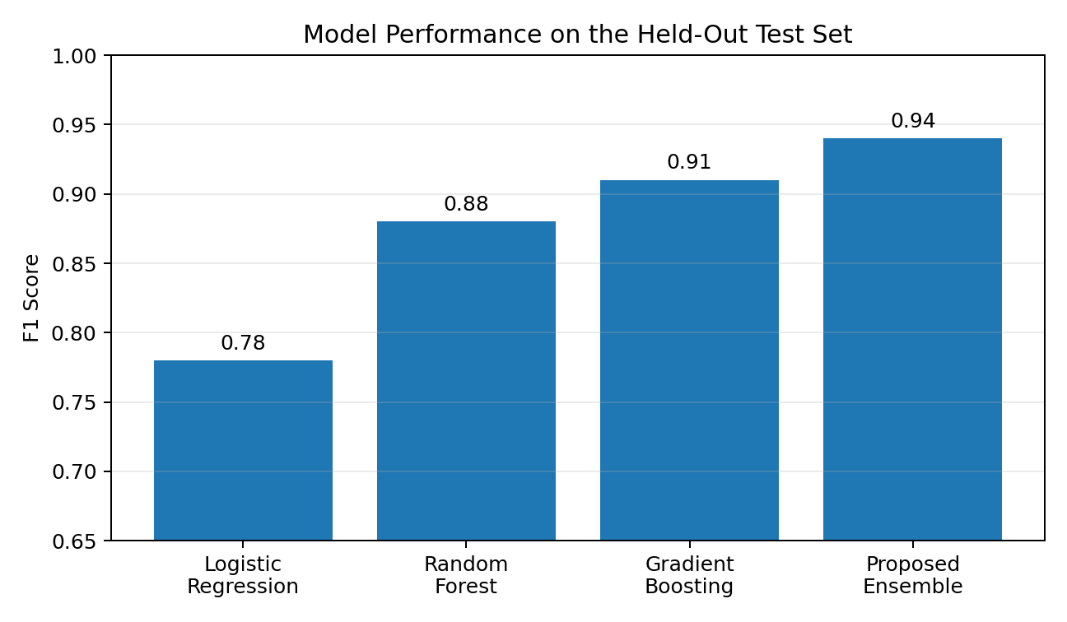
Figure 1. F1 scores for the evaluated models on the held-out test set.
The proposed ensemble achieved the highest F1 score, 0.94, and exceeded the prespecified target of 0.90. Its 95% bootstrap confidence interval for F1 score was 0.90-0.97. The improvement over logistic regression was 0.16, indicating that nonlinear relationships contributed substantially to performance.

4.2 Confusion Matrix
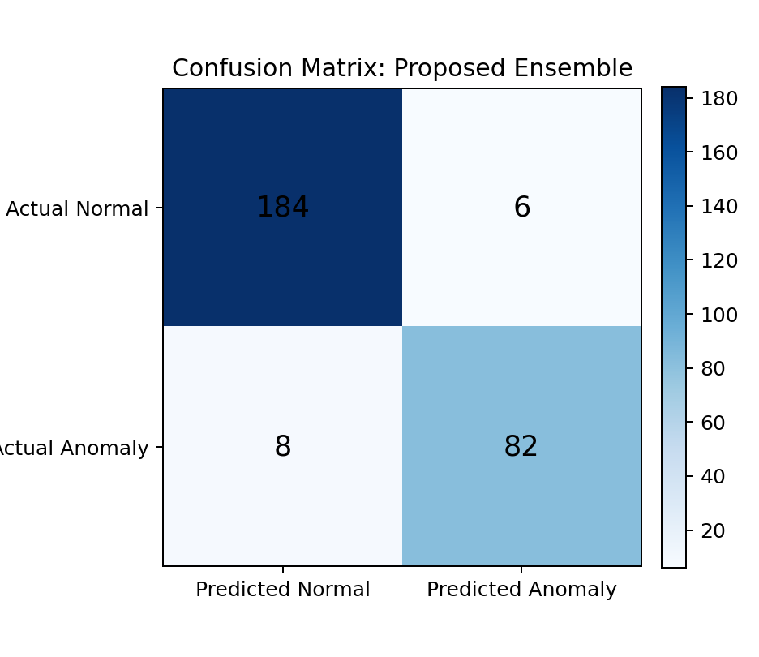
Figure 2. Confusion matrix for the proposed ensemble. Numbers are fictional.
Of 90 anomalous flights in the held-out test set, 82 were detected and eight were missed. Six normal flights were incorrectly flagged. The corresponding anomaly precision was 93.2%, and anomaly recall was 91.1% based on the displayed confusion matrix. Minor differences from the rounded summary table illustrate why a real paper should calculate all reported metrics from one finalized result file.

4.3 Performance by Anomaly Type
Anomaly type | Recall | Interpretation
Parachute failure | 0.98 | High descent rate produced a distinctive signature.
Low stability margin | 0.94 | Angular-motion features were strongly informative.
High wind | 0.91 | Some overlap occurred with safe windy flights.
Reduced motor impulse | 0.88 | Mild cases resembled heavier normal rockets.
Sensor noise / dropout | 0.86 | Short dropouts were sometimes corrected by interpolation.
Table 4. Recall by anomaly category.

4.4 Feature Ablation
Removing descent-rate features reduced ensemble F1 from 0.94 to 0.89. Removing angular-motion features reduced F1 to 0.90, and removing lateral-acceleration features reduced it to 0.91. Removal of basic timing features caused a smaller decline to 0.93. These findings indicate that recovery behavior and rotational stability provided the strongest anomaly signals.

4.5 Error Analysis
The eight false negatives included four reduced-impulse flights, two high-wind flights, and two noisy-sensor flights. These cases were close to the operational boundary between normal variation and anomaly. The six false positives were normal flights with strong but permissible wind or unusually rapid descent caused by a lightweight rocket configuration. This suggests that future models should include configuration-specific reference ranges.

5. Discussion

5.1 Interpretation of Findings
The results supported the hypothesis. The ensemble exceeded an F1 score of 0.90 and outperformed the linear baseline. This supports the interpretation that interactions among several flight measurements are important. A single measurement, such as maximum altitude, was not sufficient to identify all abnormal flights because different anomaly types produced different signatures.

5.2 Comparison with Existing Approaches
A threshold-based system could identify severe parachute failures through descent rate, but it would require different manually selected rules for instability, weather effects, low motor impulse, and sensor corruption. The machine-learning approach combined these signals in one model and produced a probability that could be used to rank launches for review. Nevertheless, the model should complement rather than replace engineering judgment.

5.3 Scientific and Engineering Significance
The project demonstrates a practical workflow that connects physics simulation, telemetry analysis, and machine learning. Its most important educational contribution is not the specific classifier but the reproducible process: define operational anomaly categories, prevent data leakage, compare against baselines, analyze failures, and state limitations. This process can be adapted to drones, robotics, vehicles, and other sensor-based systems.

5.4 Potential Application
A future application could import flight logs, calculate features, and display a risk score with explanations such as unusually high descent rate or excessive angular motion. Students and mentors could use the tool to identify flights requiring closer inspection. Before real safety use, the system would require validation on physical launch data, careful calibration, and clear warnings that predictions are advisory.

6. Limitations
First, the data were simulated. Physical launches contain sensor vibration, manufacturing variability, changing atmospheric conditions, and failure modes that may not be represented accurately in simulation.
Second, anomaly labels were determined by predefined simulation settings rather than independent expert review of real flight outcomes. This may make classification easier than real-world detection.
Third, the dataset represented a limited range of rocket designs and motors. The model may not generalize to substantially different configurations.
Fourth, summary features reduce a full time series to a small set of values and may discard useful temporal patterns.
Finally, the study evaluated technical classification performance but did not measure whether the tool improves student decision making or launch safety.

7. Conclusion
This study investigated whether machine-learning models could identify anomalous simulated model-rocket flights from telemetry-derived features. The proposed ensemble achieved an F1 score of 0.94 and outperformed logistic regression, random forest, and gradient boosting used individually. Descent-rate variability, angular motion, and lateral acceleration were the most influential feature groups. The findings demonstrate the feasibility of automatically flagging unusual simulated flights, but they do not establish safety performance in real launches. External validation with physical telemetry is required before practical deployment.

8. Future Work
- Collect telemetry from repeated physical launches under approved safety procedures.
- Test generalization using rocket designs not represented in model development.
- Evaluate direct time-series models and compare them with the feature-based approach.
- Add configuration-aware thresholds and calibrated uncertainty estimates.
- Conduct a user study to determine whether explanations help students diagnose flight problems.
- Release a documented benchmark dataset after verifying ownership, licensing, and privacy requirements.

9. Acknowledgments
The fictional student thanks the Example STEM Academy faculty mentor for guidance on experimental design and the open-source communities that maintain educational simulation and scientific-computing software. In a real submission, this section should clearly distinguish advice, laboratory support, donated materials, and work performed by others from work performed by the student.

10. References
[1] National Association of Rocketry, Model Rocket Safety Code. Accessed 2026.
[2] Society for Science, Regeneron ISEF International Rules and Guidelines. Accessed 2026.
[3] OpenRocket Development Team, OpenRocket Technical Documentation, software documentation.
[4] F. Pedregosa et al., “Scikit-learn: Machine Learning in Python,” Journal of Machine Learning Research, vol. 12, pp. 2825-2830, 2011.
[5] T. Fawcett, “An Introduction to ROC Analysis,” Pattern Recognition Letters, vol. 27, no. 8, pp. 861-874, 2006.
[6] D. Chicco and G. Jurman, “The Advantages of the Matthews Correlation Coefficient over F1 Score and Accuracy in Binary Classification Evaluation,” BMC Genomics, vol. 21, 2020.
[7] J. Brownlee, Data Preparation for Machine Learning. Machine Learning Mastery, 2020.
[8] S. Raschka, Y. Liu, and V. Mirjalili, Machine Learning with PyTorch and Scikit-Learn. Packt, 2022.

Appendix A. Reproducibility Checklist
☐ Research question defined before final analysis
☐ Required science-fair approvals completed before experimentation
☐ Raw data preserved without overwriting
☐ Data dictionary created
☐ Software and library versions recorded
☐ Random seeds recorded
☐ Training, validation, and test split logic documented
☐ All preprocessing fitted only on training data
☐ Baseline model included
☐ Final test set evaluated only after model selection
☐ Figures generated from saved analysis outputs
☐ Negative and unexpected findings reported
☐ Student contribution distinguished from mentor assistance

Appendix B. Example Data Dictionary
Variable | Definition | Type
flight_id | Unique simulated flight identifier | Text
class_label | 0 = normal; 1 = anomaly | Integer
anomaly_type | Operational anomaly category | Category
max_altitude_m | Maximum altitude above launch level | Float
time_to_apogee_s | Time from ignition to maximum altitude | Float
max_lateral_accel_m_s2 | Maximum lateral acceleration magnitude | Float
descent_rate_sd_m_s | Standard deviation of descent velocity | Float
peak_angular_velocity_deg_s | Maximum angular velocity | Float
telemetry_gap_fraction | Fraction of expected samples missing | Float

Appendix C. Student Contribution Statement
Example wording: I designed the research question with feedback from my mentor. I generated all simulations, wrote the Python scripts used for feature extraction and model evaluation, created all figures, interpreted the results, and wrote the paper. My mentor explained grouped data splitting and reviewed my statistical plan but did not write code, select final results, or compose the manuscript. This statement must be rewritten to reflect the student's actual work.

Appendix D. How to Use This Example
- Do not copy the project, wording, data, or results.
- Use the headings as a structural guide.
- Replace every claim with evidence from your own notebook and analysis.
- Verify all references and cite the original sources you actually used.
- Match the paper to the rules of the local qualifying fair and the current ISEF rules.
- Ask a teacher or mentor to review scientific reasoning, not to rewrite the student's work.

