Owen Hope

UCID: Oeh3

[Oeh3@njit.edu](mailto:Oeh3@njit.edu)

**CS634 Data Mining**

**Midterm Project**

**Apriori Algorithm**

**Database 1:**

|  |
| --- |
| **pots,trashbins,cookies,soda,beans,steak,sheets,blanket,underwear,chips,cookies**  **shampoo,keyboard,toiletpaper,soap,steak,socks,beans,pans,blanket,trashbins**  **salsa,pants,socks,bananas,underwear,pizza,cookies,pillow**  **pillow,toiletpaper,underwear**  **pans,trashbins,blanket,apples,salsa,steak**  **keyboard**  **steak,beans,bananas,mouse,blanket**  **shirt,tv,keyboard,chips,salsa,pans,shampoo,knives,pants,oj**  **chips**  **apples,rice,shampoo**  **cookies,pizza,rice**  **trashbins,knives,oj,pants,pots,shirt,sheets,computer,steak,blanket**  **pots,trashbins,shampoo,sheets,underwear,steak,blanket,papertowels,rice**  **pants,pans,tv,underwear,steak,chips,keyboard,shirt,apples,soap,rice**  **soap,trashbins**  **soda,toiletpaper,blanket,steak,mouse,blanket**  **pillow,mouse,oj,keyboard**  **shampoo,rice,cookies,chips,underwear,papertowels,bananas,salsa,oj,apples,soap,pans**  **underwear,blanket,soap**  **computer,beans,blanket,soap,underwear,chips,pants** |

**Database 2:**

|  |
| --- |
| **steak,pants,sheets,computer,pizza,salsa,cookies,pans,mouse**  **soda,oj,mouse,sheets,cookies**  **trashbins,shirt,apples,oj,pots,chips,sheets,salsa,knives,rice,soap,mouse,steak,keyboard,tv,underwear,shampoo**  **oj,soda,keyboard,apples,salsa,rice,papertowels,underwear,pizza,computer,tv,pants,cookies,beans,socks,chips**  **soap,pots,cookies,knives,salsa,apples,trashbins,chips,oj,steak,tv,papertowels,rice,computer,blanket,underwear,socks,beans,mouse,pizza,pants**  **soda,shirt,rice,tv,pizza,pans,steak,chips,bananas,pots,beans,blanket,papertowels,soap,cookies,toiletpaper,socks**  **pants,beans,pizza,chips,oj,steak**  **bananas,shirt,sheets,pants,cookies,pillow,socks,rice,apples,pots,pans,computer,trashbins,shampoo,pizza,salsa,soap**  **bananas,blanket,trashbins,apples,toiletpaper,rice**  **pots,knives,trashbins,soda,toiletpaper,cookies,keyboard,pans,tv,sheets,oj,socks,shirt,papertowels,blanket,steak,apples**  **blanket,bananas,pots,shirt**  **beans,socks,sheets,keyboard,rice,steak,soda,mouse,tv,papertowels,chips,cookies,pots,apples,oj,bananas,pants,shirt,soap,underwear**  **knives,soap,bananas,apples,pillow,keyboard,socks**  **soda,oj,knives,pants,chips**  **pizza**  **soda,oj,tv,mouse,apples,cookies,underwear,papertowels,pillow,sheets,beans,shirt,toiletpaper,blanket,socks,trashbins,shampoo,salsa**  **soap,salsa,pants,pillow,shirt,toiletpaper,tv,socks,underwear,blanket,beans,steak,oj,chips,trashbins,papertowels,rice,keyboard,knives**  **computer,rice,beans,pillow,underwear,soda,pants,apples,sheets,cookies**  **pizza,apples,soda,shampoo,steak,mouse,salsa,socks,pants,keyboard,blanket,beans,knives,sheets,toiletpaper,oj**  **soda,steak,pots,pants,pizza,socks,trashbins,beans,pans,toiletpaper,blanket,bananas,knives,soap,underwear,rice** |

**Database 3:**

|  |
| --- |
| **bananas,shirt,pillow,toiletpaper**  **mouse,shampoo,rice,blanket,trashbins**  **chips,shirt,rice,beans,blanket,trashbins,papertowels,pants,keyboard,salsa,toiletpaper,knives,sheets,computer,shampoo,tv**  **soda,sheets,pants,trashbins,computer,blanket,pans,soap**  **papertowels,apples,soda,rice,beans,socks,shampoo,soap,pizza,sheets,pillow,chips,knives,oj,blanket,mouse,computer,pots,shirt,salsa,underwear,trashbins,keyboard,tv**  **sheets,socks,soda,oj,salsa**  **soda,salsa,pizza,rice,blanket,shampoo,sheets,socks,pans,beans,keyboard,apples,toiletpaper,pots,mouse,pants,computer,soap,trashbins,oj,chips,shirt,underwear**  **soda,underwear,beans,toiletpaper,salsa,pants**  **toiletpaper,keyboard**  **soda,oj,cookies,salsa,socks,bananas,pots,beans,computer,shampoo,mouse,soap,trashbins,toiletpaper,chips,papertowels,pizza,pillow,blanket,sheets,pants,underwear,knives**  **mouse,soap,pizza,knives,computer,pots,beans,tv,papertowels,socks,bananas,salsa,blanket,cookies,pillow,shirt,chips**  **chips,papertowels,soda,trashbins**  **pillow,pants,trashbins,beans,shirt,keyboard,apples,shampoo,bananas,pans,papertowels**  **pizza,cookies,shirt,soap,salsa,socks,sheets,trashbins,blanket,beans,oj,mouse,soda,papertowels,computer,apples,chips,pans,rice,shampoo**  **socks,toiletpaper,tv,shirt,mouse,pillow,rice,knives,pizza,papertowels,trashbins,keyboard,beans,blanket,sheets,oj,computer,pans,pots,bananas,cookies,apples,chips**  **toiletpaper,bananas,underwear,trashbins,rice,socks,sheets,pizza,shampoo,cookies**  **trashbins,oj,soap,underwear,chips**  **oj,pillow,computer,rice,underwear,chips,soda,pots,blanket,shampoo,papertowels,pants,pans,knives,keyboard,toiletpaper,shirt,socks,pizza,cookies**  **mouse,pizza,toiletpaper,knives,soap,computer,underwear,socks,sheets,tv,shirt,pillow,keyboard,papertowels,pants,apples,oj**  **soap,pizza,trashbins,chips,bananas,papertowels,soda,blanket,keyboard** |

**Database 4:**

|  |
| --- |
| **apples,pizza,underwear,sheets,keyboard,knives,pans,mouse,toiletpaper,beans,blanket,shirt,pants,cookies,oj,soap,papertowels**  **cookies,soda,beans,pillow,computer,chips**  **bananas,oj,salsa,pillow,keyboard,sheets,rice,underwear,chips,papertowels,shampoo,pizza,socks**  **pizza,toiletpaper,salsa,apples**  **pizza,knives,shirt,computer,pillow,tv,soap,salsa,pants,socks,papertowels,chips,pans,soda,trashbins,beans,bananas**  **computer,pants,pans,socks,knives,pizza,underwear,shampoo,tv,keyboard,oj,shirt,chips,rice,bananas,trashbins,salsa,pillow**  **computer,oj,bananas,socks,mouse,sheets,pans,tv,chips,pillow,pizza,cookies,pants,beans,toiletpaper,papertowels,salsa,knives,underwear,shirt,blanket,soda,pots,trashbins,keyboard,rice**  **computer,knives,pizza,rice,soap,shirt,cookies,apples,oj,pots,papertowels,underwear,shampoo,chips,soda,trashbins,bananas,keyboard,socks,toiletpaper**  **cookies,pans,socks,sheets,pants,trashbins,blanket**  **computer,pans,underwear,papertowels,mouse,salsa,trashbins,oj,sheets,socks,pizza,shampoo,toiletpaper,bananas,pots,keyboard,apples,chips,soda,shirt,beans,rice,tv,pillow,pants**  **pants,toiletpaper,blanket,bananas,sheets,trashbins,papertowels,soap,chips,mouse,underwear,apples,computer,tv,pizza,cookies,shampoo,socks,beans,knives,keyboard,pillow,pans,oj,salsa,shirt,pots**  **pizza,rice,socks,computer,oj,tv,blanket,apples,papertowels,mouse,soda,pans,soap**  **oj,trashbins,shampoo,knives,blanket,pants,underwear,tv,cookies,socks,mouse,papertowels,beans,toiletpaper,sheets,salsa,soap,pots,keyboard,bananas,computer**  **underwear,rice**  **soda,shirt**  **pots,socks,sheets,beans,underwear,pans**  **socks,sheets,soda,mouse,apples,shirt,papertowels,pillow,toiletpaper,keyboard,shampoo,trashbins,pans,salsa,pizza,computer,bananas,cookies,soap,blanket,chips,oj,rice,pots**  **pots,salsa,pans**  **soap,pillow,tv,chips,shirt,apples,pots,salsa,trashbins,shampoo,blanket,oj,pans,socks,knives,rice,papertowels,pizza,bananas,cookies,keyboard**  **trashbins,salsa,soap,pots,sheets,bananas,beans,soda,chips,pizza,toiletpaper,rice,knives,mouse,apples,cookies,pants,socks,blanket,keyboard,pillow,pans,oj,papertowels,tv,shampoo,underwear,computer** |

**Database 5:**

|  |
| --- |
| **soap,sheets,pots,keyboard,trashbins,pants,socks,computer,pizza,tv,shampoo,papertowels**  **shampoo,toiletpaper,computer,soda,pizza,pants,beans,mouse,pans,soap,trashbins,shirt,oj,pots**  **pillow,blanket,underwear,salsa,shampoo,oj,pizza,toiletpaper,bananas,cookies,computer,socks,beans,soda,shirt,pants,pans,pots,papertowels**  **pants,blanket,trashbins,underwear,mouse,apples,shirt,soda,rice,tv,computer,pans**  **salsa,toiletpaper,soda,knives,shirt,bananas,cookies,trashbins,pans,blanket,socks,soap,apples,underwear,mouse,pots,sheets,rice,beans**  **pillow,papertowels,chips,salsa,apples,oj,socks**  **tv,soda,chips,oj,pants,pots,shirt,bananas,salsa,trashbins,rice,computer,pizza,papertowels,underwear,mouse,knives,socks**  **papertowels,bananas,trashbins,chips,pants,rice,soap,apples,cookies,knives,tv,beans,salsa**  **pants,socks**  **salsa,shampoo,pants,shirt,sheets,bananas,cookies,soda,pillow,underwear,toiletpaper,keyboard,beans,apples**  **rice,tv,soap,computer,soda,pants**  **soda,computer,beans,socks,tv,apples,underwear**  **shampoo,papertowels,socks,pants**  **blanket,shirt,toiletpaper,trashbins,apples,pizza,oj,pots,knives,rice,chips,cookies,computer,sheets,pants,tv,soda,underwear,soap,bananas,papertowels,pans,socks,mouse**  **tv,socks,pants**  **soap,pizza,shirt,blanket,pots,papertowels,apples,knives,mouse,bananas,socks,tv,keyboard,pillow,salsa,underwear,computer,sheets,toiletpaper,rice,trashbins,beans,shampoo,chips,cookies,oj**  **cookies,apples,shampoo,socks,pants**  **keyboard,pants,shampoo,socks,pants**  **sheets,tv,trashbins,papertowels,soap,pots,chips,mouse,shirt,knives,soda,bananas**  **pillow,tv,oj,trashbins,pants,keyboard,pots,pans,beans,soap,computer,apples,mouse,knives,socks,soda,shirt,chips,sheets,blanket,salsa,papertowels,underwear,bananas,pizza,toiletpaper,cookies,shampoo** |

**Source Code:**

|  |
| --- |
| import csv  import time  min_support = float(input("Enter the minimum support value: "))  min_confidence = float(input("Enter the minimim confidence value: "))  # Replacement for itertools combinations  # Use of recursion  def join_step(keys_list, k):      # Used as recursion check      if k == 0:          return [[]]        return_list = []      for key_index in range(0, len(keys_list)):          n = keys_list[key_index]          remList = keys_list[key_index + 1:]          for m in join_step(remList, k - 1):              return_list.append([n] + m)      return return_list  def read_file(file):      file_list = []      with open(file, mode='r') as csv_file:          csv_reader = csv.reader(csv_file, delimiter=',')          for row in csv_reader:              file_list.append(row)      return file_list  def support_calc(min_support, freq_dict, transacton_num):      support_dict = {}      for item, freq_num in freq_dict.items():          support_val = freq_num / transacton_num          if support_val >= min_support:              support_dict[item] = support_val      return support_dict  def confidence_calc(min_confidence, combination_support_dict):      association_dict = {}      for item_set, support_val in combination_support_dict.items():          if isinstance(item_set,str):              continue          list_item = list(item_set)            #print("Association rules {}".format(association_rule))          item_set_size = len(item_set)          if len(item_set) == 2:              support_left_val = combination_support_dict[item_set[0]]              conf = round(support_val / support_left_val,2)              association = str(item_set[0]) + "=>" + str(item_set[1])              if conf >= min_confidence:                  association_dict[association] = [support_val, conf]              support_left_val = combination_support_dict[item_set[1]]              flipped_rule_conf = round(support_val/support_left_val,2)              flipped_association = str(item_set[1]) + "=>" + str(item_set[0])              if flipped_rule_conf >= min_confidence:                  association_dict[flipped_association] = [support_val, flipped_rule_conf]          else:              while item_set_size-1 > 1:                  association_rule = join_step(list_item, item_set_size-1)                  for x in association_rule:                      left_side = set(x)                      right_side = set(item_set) - set(x)                        conf = round(support_val / combination_support_dict[tuple(sorted(x))],2)                      if conf >= min_confidence:                          association = str(left_side) + "=>" + str(right_side)                          association_dict[association] = [support_val, conf]                  item_set_size -= 1      return association_dict    def apriori_alg(min_support, min_confidence, file):      freq_dict = {}      transacton_num = 0      # Get data set initially      file_values = read_file(file)      for row in file_values:          transacton_num += 1          for item in row:              if item in freq_dict.keys():                  val = freq_dict[item]                  freq_dict[item] = val + 1              else:                  freq_dict[item] = 1      # We need to get support value after we have added up the number of same items      sup_dic_l1 = support_calc(min_support, freq_dict, transacton_num)      item_sets = []      item_sets.append(list(sup_dic_l1.keys()))      comb_itemset_dic = {}      comb_itemset_dic.update(sup_dic_l1)      # Since range is n-1 we need to do 21 to run for 20 transactions      keys = list(sup_dic_l1.keys())        for i in range(2,21):          # Need to do the join step          if keys == []:              break          keys_item_set = join_step(keys, i)          #print("Keys item set {}".format(keys_item_set))          item_sets.append(keys)          if keys_item_set == []:              break          freq_dict_c2 = {}          # Scan dataset each time when we try to calculate the support.          # This is so we don't keep this information in memory.          file_values = read_file(file)          for row in file_values:              for item_set in keys_item_set:                  item_set = tuple(sorted(item_set))                  check = all(item in row for item in item_set)                  if check is True:                      if tuple(item_set) in freq_dict_c2.keys():                          val = freq_dict_c2[tuple(item_set)]                          freq_dict_c2[tuple(item_set)] = val + 1                      else:                          freq_dict_c2[tuple(item_set)] = 1          sup_dic_l = support_calc(min_support, freq_dict_c2, transacton_num)          if not sup_dic_l:              keys = []              continue          comb_itemset_dic.update(sup_dic_l)          list_item_set = list(sup_dic_l.keys())          keys = []          for item_set in list_item_set:              for item in item_set:                  if item not in keys:                      keys.append(item)        #print(comb_itemset_dic)      conf_dict = confidence_calc(min_confidence, comb_itemset_dic)      print(conf_dict)    def brute_force(min_support, min_confidence, file):      k_items_frequent = True      k = 2      support_dict = {}        single_item_transactions = {}      transaction_num = 0      file_values = read_file(file)      for row in file_values:          transaction_num += 1          for item in row:              if item in single_item_transactions.keys():                  val = single_item_transactions[item]                  single_item_transactions[item] = val + 1              else:                  single_item_transactions[item] = 1      single_item_support = support_calc(min_support, single_item_transactions, transaction_num)      single_item_keys = list(single_item_transactions.keys())      support_dict.update(single_item_support)      while k_items_frequent:          list_item_set = join_step(single_item_keys, k)            item_freq = {}          # Scan dataset each time when we try to calculate the support.          # This is so we don't keep this information in memory.          # As said in the frequently asked questions section          file_values = read_file(file)          for item_set in list_item_set:              item_set = tuple(sorted(item_set))              for row in file_values:                  key_list = item_freq.keys()                  if set(item_set).issubset(row):                      if item_set in key_list:                          val = item_freq[item_set]                          item_freq[item_set] = val + 1                      else:                          item_freq[item_set] = 1          #print(double_item_freq)          item_support = support_calc(min_support, item_freq, transaction_num)            support_dict.update(item_support)          if not item_support:              break          k += 1      conf_dict = confidence_calc(min_confidence, support_dict)      print(conf_dict)  '''  # Database 1  print("Running Database 1")  db1_start_apriori_time = time.time()  apriori_alg(min_support, min_confidence, 'db1.txt')  db1_time_apriori_alg = time.time() - db1_start_apriori_time  print("Apriori Algorithm Runtime: {}".format(db1_time_apriori_alg))  db1_start_brute_time = time.time()  brute_force(min_support, min_confidence, 'db1.txt')  db1_time_brute_alg = time.time() - db1_start_brute_time  print("Brute Force Runtime: {}".format(db1_time_brute_alg))  # Database 2  print("Running Database 2")  db2_start_apriori_time = time.time()  apriori_alg(min_support, min_confidence, 'db2.txt')  db2_time_apriori_alg = time.time() - db2_start_apriori_time  print("Apriori Algorithm Runtime: {}".format(db2_time_apriori_alg))  db2_start_brute_time = time.time()  brute_force(min_support, min_confidence, 'db2.txt')  db2_time_brute_alg = time.time() - db2_start_brute_time  print("Brute Force Runtime: {}".format(db2_time_brute_alg))  # Database 3  print("Running Database 3")  db3_start_apriori_time = time.time()  apriori_alg(min_support, min_confidence, 'db3.txt')  db3_time_apriori_alg = time.time() - db3_start_apriori_time  print("Apriori Algorithm Runtime: {}".format(db3_time_apriori_alg))  db3_start_brute_time = time.time()  brute_force(min_support, min_confidence, 'db3.txt')  db3_time_brute_alg = time.time() - db3_start_brute_time  print("Brute Force Runtime: {}".format(db3_time_brute_alg))  # Database 4  print("Running Database 4")  db4_start_apriori_time = time.time()  apriori_alg(min_support, min_confidence, 'db4.txt')  db4_time_apriori_alg = time.time() - db4_start_apriori_time  print("Apriori Algorithm Runtime: {}".format(db4_time_apriori_alg))  db4_start_brute_time = time.time()  brute_force(min_support, min_confidence, 'db4.txt')  db4_time_brute_alg = time.time() - db4_start_brute_time  print("Brute Force Runtime: {}".format(db4_time_brute_alg))  '''  # Database 5  print("Running Database 5")  db5_start_apriori_time = time.time()  apriori_alg(min_support, min_confidence, 'db5.txt')  db5_time_apriori_alg = time.time() - db5_start_apriori_time  print("Apriori Algorithm Runtime: {}".format(db5_time_apriori_alg))  db5_start_brute_time = time.time()  brute_force(min_support, min_confidence, 'db5.txt')  db5_time_brute_alg = time.time() - db5_start_brute_time  print("Brute Force Runtime: {}".format(db5_time_brute_alg)) |

Each database is run by commenting out the specific code pertaining to it then running the midter_proj.py file.

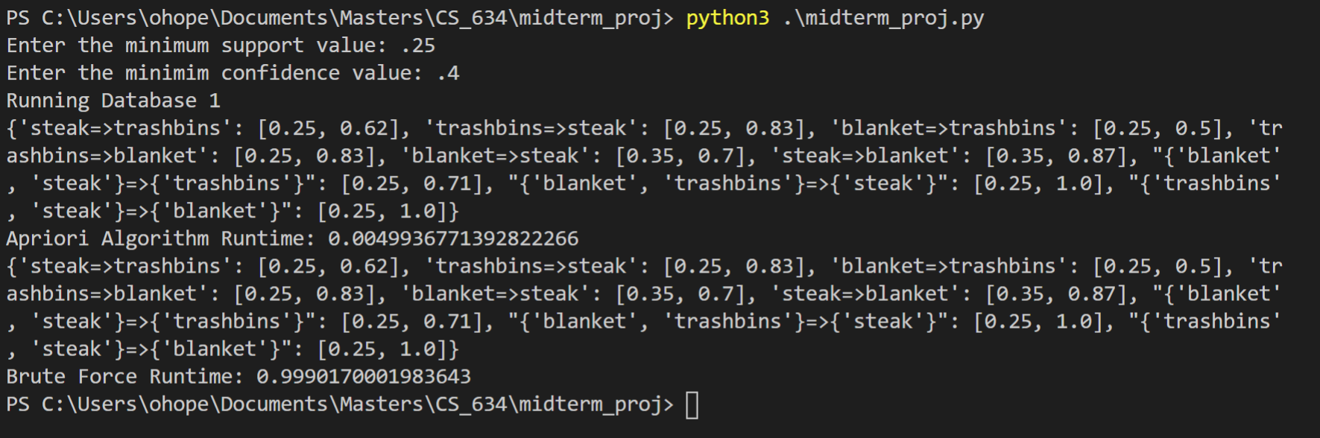**Database 1 Execution Screenshot:**

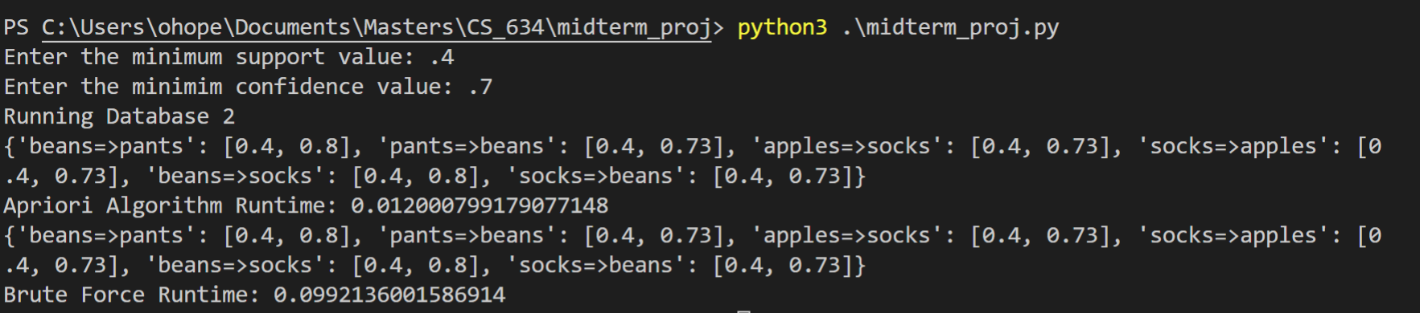**Database 2 Execution Screenshot:**

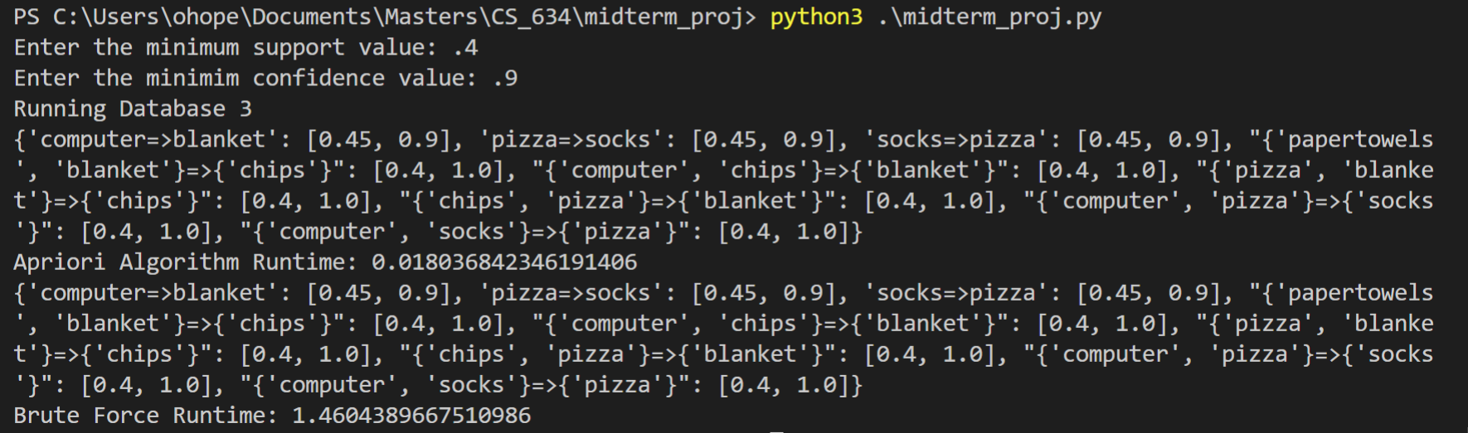**Database 3 Execution Screenshot:**

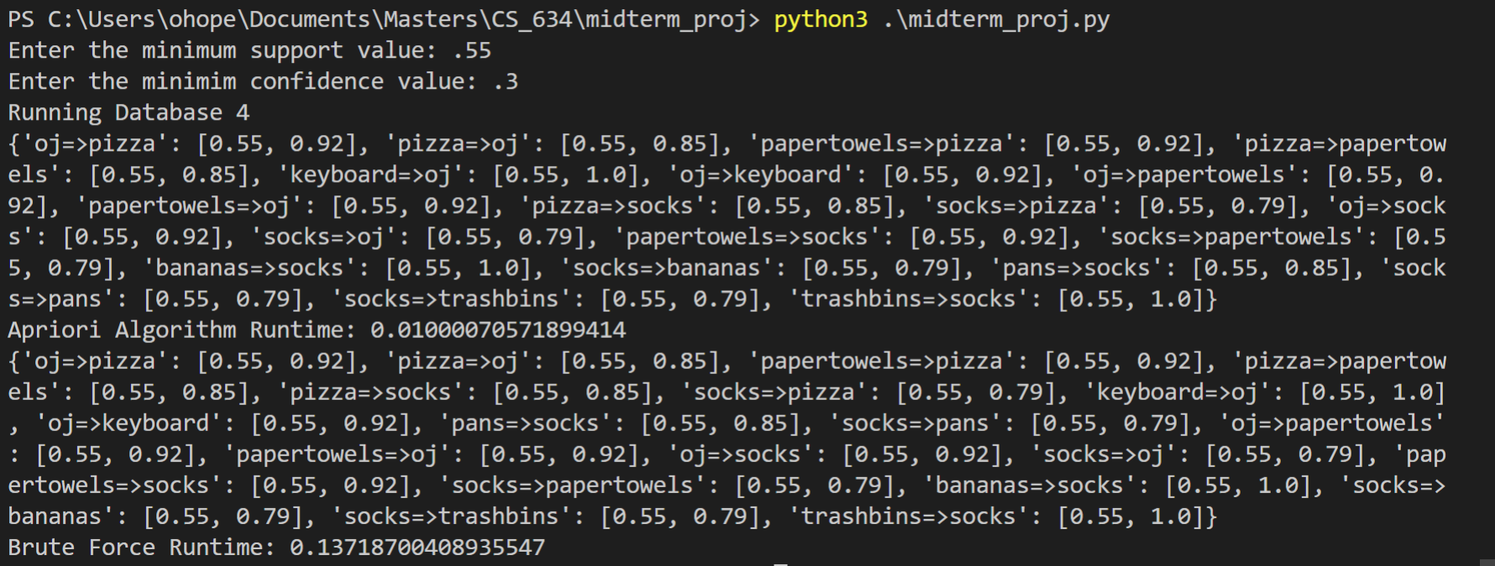**Database 4 Execution Screenshot:**

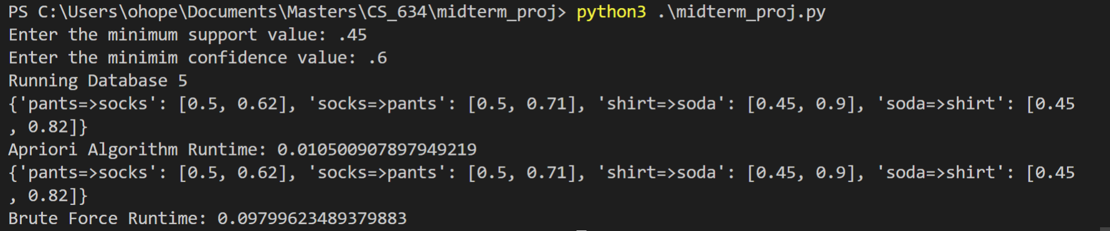**Database 5 Execution Screenshot:**